

Business Product Conceptualization
Peer To Peer Financing

Version 2.0

Name | Student No | Contact
Augustine Goh |  | <renaissm@hotmail.com>
Choo Zhi Min |  | <zm@nus.edu.sg>
Ryan Teoh | HT0502433H | <Ryan_Teoh@adp.com>

Table of Contents

1 Outline 3
2 Scenario of typical use 4
3 Who is expected to use Karz 5
3.1 Borrower 5
3.2 Lender 5
4 Explanation of the technology background 5
5 Reason why you believe this product will sell 6
5.1 Borrower 6
5.2 Lender 6
5.3 Group Feature 7
6 Why this product, if it is so good, does not already exist 8
7 Risk and Mitigation 8

Peer To Peer Financing

Name of Product or Product Line
KARZ Cash (www.karz.com)

Outline

Whenever one needs cash or some kind of finance credit, the first thing that comes into the mind is undisputedly the Bank.

Unfortunately, the answer does not stop there. Let’s assume there is one financially sounds and secured man, just resign and quit his job. He is thinking to secure some loan to purchase some furniture for the newly rented house, as he has limited cash since he has just migrated from overseas to Singapore. Now, if this same man tries to apply for a loan via a traditional bank, imagine how many hassles, how many forms, how many times he need to engage with the traditional bank officer just to get the fund?

Traditional bank has a lot of cash waiting to be lending out, but only to eligible customer that comply with hundreds of bank rules/policies. There is nothing wrong with this approach but that many rules and regulations usually bias strongly towards the bank.

On the other hand, there is a huge untapped market demanding for short-term finance that tries to avoid the traditional bank. Just pay attention to never ending complains from the startups and small SME. One of the main and loudest complains from them is always finance, where they are not able to secure a loan from traditional loan market. Indeed, to help the SME and thus the economy, government has been consistently roll out incentives and micro-financing products.

KARZ is indeed designed to fill the huge gap between tradition bank and the illegal loan market. It is designed to create a totally new loan marketplace where both the borrower and lender, are in control of the lending process, without the major overhead of the traditional loan market. It is a pioneered way for borrower to request lenders to fund the loan at competitive, market-driven interest rates, while allowing affluent individual to act as mini bank, earning a return significantly higher than FD /CD under a manageable risk.

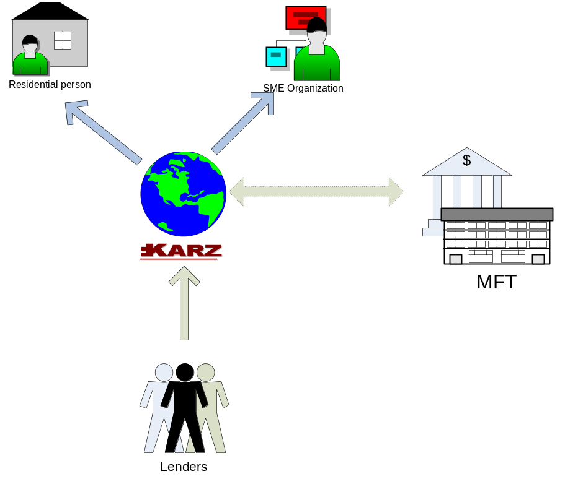
Borrowers
Lenders
Credit rating check

Scenario of typical use
Becky is 36 and lives in Serangoon with her partner, David. She has left her previous job and likes to fulfill a lifelong aspiration by setting up her own catering business. She had some training before as a chef at a mid-range restaurant 5 years ago. She logged into www.karz.com and register as borrower. As a basic requirement, she needs to submit a photocopy of her Identity Card and Passport for Karz’s validation. She keys in loan period and request for the loan interest rate up to a maximum 8%. Her listing will now be saved and appear in borrowers list. At the back, Karz officer will do a quick check on her credit rating by requesting the information from Credit Bureau of Singapore.

At the same time, Simon is a new graduates that just fresh out of school. He has his mind set on setting up a new interior design studio. With no rich parents to turn to, he reached out to Karz for help.

On the other hand, Zhi Min and Augustine are professionals with some spare cash. Due to the volatility and turmoil of the market, they refuse to invest in the stock market, or anything related to it. However they are also very frustrated with the 0.25% interest provided by the conventional bank. All three of them, together with up to 50 others, bids down Becky and Simon rate at www.karz.com. They believe they have a good deal as Becky’s credit history is clean and like her business idea. When the bids end, the bids with lowest rates are then combined into single loan for Becky. At the same time, Zhi Min has initiated contact with Simon and requested his copy of graduation records. Only after validation, Zhi Min post his own public review on Simon’s case. Together with other lender, they also bid down Simon loan.

Simon and Becky will provide a bank account to Karz, which will then be validated. Tools under Karz.com are also available to help to arrange for a GIRO payment which deduct form her bank account and deposit into lender’s accounts until the loan is fully repaid.

Who is expected to use Karz

Borrower
              - SME which looking for a quick cash to inject into the business as cash flow problem appeal from time to time
              - Small startup which is looking to finance their operating cost
              - People with lower credit grade due to job loss or other unforeseen reason although the have good financial habit

Lender
              - Affluent professional who has spare cash and not happy with the 0.25% interest rate with the CD in Singapore
              - Affluent investor who would like to spread their investment into other investment instrument to avoid the volatile stock market

Explanation of the technology background
It is an infrastructure providing a platform to link both lenders and borrowers. We have found that there has been competitor (after we discussed about this idea). Refer to www.prosper.com .

Internet – convenience.

?Web services – integration of services, like querying credit grade.

P2P technology such as peer review, blog, forum to access borrower’s credit worthiness, to discuss loan.

RSS to get feed on loan status.

Traditional payment method such as GIRO, cheque, bank draft.

Reason why you believe this product will sell

Borrower

GST, higher living cost, credit card debt, school fee, start up business, is life putting you down? looking for that loan to set it straight again?

You can look of bank but since you are already in low credit grade, chances are you are going to be rejected.

Borrowers who've been shut out of the loan market find money at reasonable interest rates, and people with money to lend get a return that can surpass that of other investments.

The Internet might transform the credit industry into a fairer, more equitable business. It also makes lending process more transparent. Bank charges everyone a high rate with the expectation that some will default, and others will live forever in lucrative, revolving debt.

Take founder of Zope for example: People with tons of money but left a job, so not credit worthy. Good people are being overlooked. Traditional creditors use a trove of data to assess us all, thoroughly scrutinizing our financial records and giving each of us a score. But because these scores are determined by algorithm rather than human beings, they invariably miss important aspects of our financial lives.

Can help instill financial discipline in people who've had trouble with money all their lives. Higher risk mean higher processing fee and lower chance to get loan. For example, Garza with bad credit grade, posted several loan request, got questioned by forumers who are financially savvy, learn about money management. He finally got a loan.

No early payment fee. Lower interest rate. Personal loan from GE Money is 16 to 20%.

You can put your loan for bid, together with your story to explain why and how you should get the loan. Get friend to endorse. All these are not available through traditional mean of borrowing with bank.

Pay by GIRO (no fee) or cheque (no processing fee).

Lender
Some people aren't who they say they are, and that they won't pay you back. So we are explicit about default to lender – spread your loan.

Bear the default risk by diversify. For late payment, we provide collection agencies to help to collect payment with a fee.

Earn more, let your spare money work harder.

Charge higher interest to cover loss. For example, f you give $50 to 100 people who have a credit grade of C, chances are that over the course of three years, some people -- about three, according to Experian -- will default on their loans. But if you get a 14 percent return on your money from those who do pay you back, you'll make more than $1,000 on your $5,000 investment, enough to cover your losses.

Group Feature
The sense of community it fosters between lenders and borrowers. You can get better rates if you belong to a group. Your default and late payment will have adverse impact on other group members. The idea is that people who belong to a group will feel an enhanced obligation to pay back a loan to remain in the good graces of their fellow Apple users or Harvard alumni. This sort of peer pressure has long been used as a tool to goad borrowers into paying back micro-loans in the developing world.

Why this product, if it is so good, does not already exist

Financial institutions appear to be making exorbitant profits from loan products -- payday loans and credit cards -- that are by all measures overpriced.

Customers don't really know the true price they're paying, and don't have any real alternative to these products.

Borrowers are not able to provide true story about their financial situation. Credit report does not tell all and often overlook such details.

While it exists in the US, it is not in Asia yet. Why? Need to explain.

Internet and P2P technology is the enabler. Borrower and lender are able to meet in one place (cyberspace) to bid for loan. The process makes it transparent and competitive.

Risk and Mitigation
To kick start and help build up critical mass, we will provide checking of credit rating of borrowers and lenders from Credit Bureau of Singapore, as and when required by borrower or lender at a small fee payable to (CBS). This helps potential customers to gain confidence to lend out their money.

Risk can be spread as well; by using the security method adopted by www.zopa.com and www.prosper.com . However, as unsecured loan, more research will be required by analyzing both zopa and prosper and comparing it within the framework in Singapore and Asia mainly, for the behavior of lender and borrower, and how to minimize risk faced by the borrowers.

