

Product Description
Peer To Peer Financing

Version 2.3

Name | Matric No | Contact
Augustine Goh | HT042194H | <renaissm@hotmail.com>
Choo Zhi Min | HT052430X | <zm@nus.edu.sg>
Ryan Teoh | HT052433H | <Ryan_Teoh@adp.com>

Table of Contents

1 Outline 3
1.1 Scenario of typical use 4
2 Who is expected to use Karz 5
2.1 Borrower 5
2.2 Lender 5
2.3 Web community 5
3 The technology background 6
3.1 Internet as the enabling technology 6
3.2 P2P technology for a pleasant customer experience 6
3.3 Interactive media for customer service 6
3.4 Interaction with other business 6
4 Why this product will sell 7
4.1 Borrower 8
4.2 Lender 8
4.3 Karz Groups 9
5 Why this product, if it is so good, does not already exist 9
6 References 10

Peer To Peer Financing

Name of Company
KARZ (www.karz.com)

Name of Product or Product Line
Kash

Outline

Whenever one needs cash or some kind of finance credit, the first thing that comes into the mind is undisputedly the Bank.

Unfortunately, the answer does not stop there. Let’s assume there is one financially sound and secured man who has just quitted his job. He is thinking to secure a loan to purchase some furniture for his newly rented house, as he has limited cash since he has just migrated from overseas to Singapore. Now, if this same man tries to apply for a loan via a traditional bank, imagine how many hassles, how many forms, how many times he need to engage with the traditional bank officer just to get the fund? Moreover, he is unlikely to get a loan as his credit worthiness is low without a job.

Traditional bank has a lot of cash waiting to be lent out, but only to eligible customer that comply with hundreds of bank rules/policies. There is nothing wrong with this approach but that many rules and regulations usually bias strongly towards the bank. Banks also assess borrower’s credit worthiness with figures and numbers, which overlook important aspects of our financial life, such as the above example.

On the other hand, there is a huge untapped market demand for short-term finance that is not satisfied by traditional bank. Just pay attention to never ending complaints from the startups and small-medium enterprise (SME). One of the main and loudest complaints from them is always finance, where they are not able to secure a loan from traditional loan market. Indeed, to help the SME and thus the economy, government has been consistently roll out incentives and micro-financing products.

Our product, Kash, is indeed designed to fill the huge gap between tradition bank and the illegal loan market. Kash is designed to create a totally new loan marketplace where both the borrower and lender, are in control of the lending process, without the major overhead of the traditional loan market. It is a pioneered way of lending money, in which borrowers put up credible case to compete for loan; and lenders scrutinize the loan request by asking question while spreading the default risk by diversifying loan (loan out in multiple small amounts instead of in one big sum). As lenders bid down interest rate of a loan, the loan becomes competitive and the interest rate becomes market driven. Lenders are also able to earn a return significantly higher than saving/fixed deposit under a manageable risk. All loans in Karz last for three years.

As a tool for lenders to assess a borrower’s credit worthiness, Karz obtains a borrower’s credit score from Credit Bureau Singapore when the borrower signs up with Karz. When the borrower bid for loan in Karz, his/her credit score will be displayed on the bid page.

What Karz charges its users is very straightforward. For borrower, Karz charges 1-3% closing fee depending on their credit grade. For lender, Karz charges 0%-1% annual loan servicing fee. There are no fees to use the site, post a listing or place bids.

The figure below illustrates how Karz works.

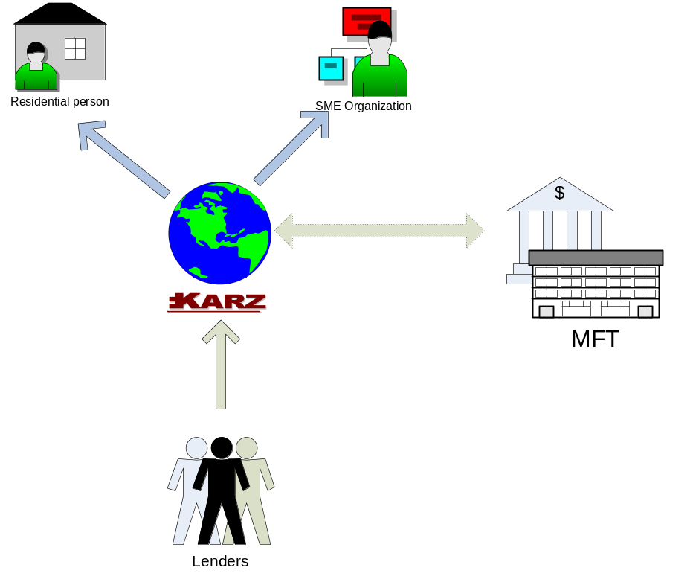
Borrowers
Lenders
Credit rating check

Scenario of typical use

Becky is 36 and lives in Serangoon with her partner, David. She has left her previous job and likes to fulfill a lifelong aspiration by setting up her own catering business. She had experience as a chef at a mid-range restaurant 5 years ago. She logon into www.karz.com and registers as borrower. As a basic requirement, she needs to submit a photocopy of her Identity Card and Passport for Karz’s validation. She keys in loan period and request for the loan interest rate up to a maximum 8%. Her listing will now be saved and appear in borrowers list. At the backend, Karz officer will do a quick check on her credit rating by requesting the information from Credit Bureau of Singapore.

At the same time, Simon is a new graduates that just fresh out of school. He has his mind set on setting up a new interior design studio. With no rich parents to turn to, he reaches out to Karz for help.

On the other hand, Zhi Min and Augustine are professionals with some spare cash. Due to the volatility and turmoil of the market, they are reluctant to invest in the stock market, or anything related to it. However they are also very frustrated with the 0.25% interest provided by the conventional bank. Zhi Min and Augustine, together with up to 50 other lenders in Karz, bids down Becky and Simon rate atK Karz. They believe they have a good deal as Becky’s credit history is clean and her business idea sounds viable. When the bids end, the bids with lowest rates are then combined into single loan for Becky.
At the same time, Zhi Min initiates contact with Simon in Karz forum to request for a copy of graduation record. After validation of the record, Zhi Min posts his own public review on Simon’s case. Together with other lender, they also bid down Simon loan.

When Simon and Becky put up loan listing in Karz, they also provide bank account to Karz to set up GIRO for loan repayment (they can also choose to pay the loan by bank draft, at a fee). Every month on the loan payment date, the monthly payment will be deducted from Simon and Becky’s bank account and deposited into their lenders’ accounts in Karz until the loan is repaid. Whenever Simon and Becky have spare cash, they can choose to make early payment and even pay off the entire loan balance, at zero fees.

Who is expected to use Karz
In the initial stage, Karz targets all internet-savvy adults in Singapore who are above 21 years old, and who desire to take control of their own finance, with the following demographic segment:

Borrower
              - SME which looking for a quick cash to inject into the business as cash flow problem appeal from time to time
              - Small startup which is looking to finance their operating cost
              - People with lower credit grade due to job loss or other unforeseen reason but with good financial habit

Lender
              - Affluent professional who has spare cash and not happy with the 0.25% saving deposit rate in Singapore
              - Affluent investor who would like to spread their investment into other investment instrument to avoid the volatile stock market

Web community
              - Anyone who is interested to use our tools to develop third party application. For example, a website that tracks the statistics in Karz, such interest rate movement, top 10 lenders, late loan list, etc.

In the later stage, we plan to extend our services to other Asian countries.

The technology background

Internet as the enabling technology
Although Kash P2P lending works similarly to lending that has centuries of history, the Internet is the enabling technology. It uses the Internet as the platform for borrower and lender to negotiate loan and to arrange for loan payment. Internet is chosen because it is readily accessible, low cost and fast. This feature allows borrower and lender to overcome geographical and time restriction to make loan transaction.

P2P technology for a pleasant customer experience
Karz will leverage on P2P technology to make loan transaction as transparent and as pleasant as possible for our customers. Lender can post question to scrutinize borrower loan request; borrower can get endorsement from friends and relatives to boost the credibility of their loan listing; both parties can join the forum to discuss lending strategies and tips for creating loan listings. Karz will also provide RSS feed for each loan listing, so that lender and any one who is interested can track the loan bidding status and loan payment status.

To encourage third party application development, Karz will make open a set of API so that anyone interested party can develop website on loan statistics in Karz or plug-in for their favourite application, such as loan status tracking plug-in for Firefox. We view third party application as a complement to our service, because it makes our service more transparent and this helps customer to gain confidence to start using Karz services.

Interactive media for customer service
On the customer service side, Karz will use email support and interactive media such as flash video to webcast events, to provide webinars, and to provide animated tutorials. This encourages customers to self help and self educate, so that the saving in customer services can be passed back to the customers.

A blog will be set up for customers and Karz staff to news, tips and customer stories. Customers’ posts are valuable to Karz because it tells us the market trend and customer need, which are evolving constantly. Karz can use the feedback from customer to identify new market and to improve our services. Posting from Karz staff will be mainly educational such as tips and tutorials, and news such as announcement and press release.

Interaction with other business
For money transfer between borrower and Karz, and between Karz and lender, Karz will use the traditional payment method such as GIRO, internet fund transfer and bank draft. When opportunity arises, Karz will be keen to explore new technology to cut down the overhead.

For the retrieval of crediting score from Credit Bureau of Singapore (CBS), Karz will use the current process specified by CBS. Nevertheless, Karz will look out for opportunity to interact with CBS credit query service using web technology such as web services.

Why this product will sell

GST hike, taxi fee hike, bus fee hike, higher living cost, credit card debt, tuition fee, start up business, is life putting you down? Looking for that loan to set it straight again? You can look for banks but if you have low credit grade, chances are you are going to be rejected. You might have a good case for borrowing money that is beyond the numbers your credit report discloses, but it is a labour-intensive task to assess each individual case by case. What credit cards and banks do is to charge a high one-size-fit-all interest rate, with the expectation that some will default, and some others will live forever in lucrative, revolving debt. However, the process is not transparent and not fair to those who have a credible case that deserve lower interest rate. Consider the example below.

Late in 2003, Richard Duvall, a technology entrepreneur in the U.K., left Egg, the world's largest online bank, which he had founded in 1998. At the time, he says, he had more money in the bank than he'd ever had in his life. To the credit bureau, however, Duvall apparently looked like a risk. "Two days after I left Egg, I went into a cell shop, and after spending two hours choosing a phone, I went up to the counter and said, 'I'd like this one,'" Duvall recalls. The sales clerk asked Duvall a series of questions to assess his credit-worthiness: Was he employed? How long had he lived in his home? (As it happened, he'd recently moved.) The answers were not satisfactory. "They said, 'We can't give you that phone. You don't meet our requirements for a loan.'"

Duvall's story expresses the idea that animates person-to-person lending: Good people are being overlooked. Traditional creditors use a trove of data to assess us all, thoroughly scrutinizing our financial records and giving each of us a score. But because these scores are determined by algorithm rather than human beings, they invariably miss important aspects of our financial lives. In Duvall's case, the mobile phone shop's credit program overlooked the money he had in the bank.

Even if one succeeds in getting a loan from banks, there are more hurdles to overcome. One thing for sure is that banks charge penalty fee for early loan repayment. There are sometimes processing fee for loan application too. How these fees are charged is not transparent to consumer, and banks are happy to keep it this way to earn fat commission from every loan transaction.

All these point to a demand for loan that is not satisfied by traditional financial institution. But where is the supply side of money for such loan? The low deposit rate environment and widening income gap in Singapore create such supply. Wealthy individuals who are dissatisfied with low deposit rate are seeking high yield financial instrument. Lending money to individuals who are shunned by banks, at an interest rate lower than bank but higher than deposit rate, would be an attractive proposition for the idle money held by wealthy individuals. The default risk does exist but can be minimized by diversifying to multiple loans, each with small amount. Because lenders are able to lend in small amount (typically $50 onwards), anyone who has spare cash and seeking for return is potential supply for loan money.

To help lenders to overcome the late payment woes, Karz sends frequent emails to overdue borrowers and their friends (if they have any). Once the borrower is more than 15 days late, the borrower will be charged a late fee. Once the loan is one month past due, it is turned over to a collection agency to pursue collection from the borrower. If the collection agency fail to collect the payment after a reasonable period of time (~ 3 months), the loan will be considered as "Defaulted" and sold to a debt buyer. The borrower will not be able to borrow ever again from Prosper,

Here are the reasons we think borrower, lender and Karz Groups will like to use Kash P2P lending:

Borrower
- Borrowers who've been shut out of the loan market can find money at reasonable interest rates and in a much more transparent lending process.

- Lower interest rate subject to bidding. Comparison: Interest rate of a personal loan from GE Money Singapore is 16 to 20%.

- Besides putting your loan for bid, borrowers must give credible case to convince lenders why should get the loan. Borrowers can also improve the credibility of their loan listing and improve their chances of getting funded by getting endorsement from friends. All these are not available through traditional mean of borrowing from bank.

- No penalty fee on early repayment of loan.

- Because the constant securitization of borrower’s credit history in peer to peer lending, Kash can help instill financial discipline in people who've had trouble with money all their lives. For example, Garza who has a bad credit grade, posted a loan request and got questioned by potential lenders who are financially savvy. Garza learns about money management from Kash forum, improves his financial health and finally presents a well thought out repayment plan on his second loan request. He finally got a loan.

- The P2P tools in Karz let fellow borrowers exchange ideas on loan listing and repayment scheme.

Lender
- People with money to lend can get a return that can surpass that of other investments.

- Lenders are able to lend in small amount for multiple loans, hence reduce the risk of default. Consider the example below.

If you give $50 to 100 people who have a credit grade of C, chances are that over the course of three years, some people -- about three, according to Experian -- will default on their loans. But if you get a 14 percent return on your money from those who do pay you back, you'll make more than $1,000 on your $5,000 investment, enough to cover your losses.

- Karz will take care of the collection of late payment for lenders. Karz will block borrowers who have defaulted on their loans, in order to keep lenders and Karz from bad loans.

- The P2P tools in Karz let fellow lenders exchange ideas on lending strategies and risk management.

Karz Groups
Karz Groups are a way for tightly affiliated communities to help their members through person to person lending. Groups allow people to join together for the common goal of borrowing money at better rates and give borrowers an additional incentive—the group's reputation—to meet their obligation to repay a Kash loan.

If a borrower default on his/her obligations, the borrower’s actions will adversely impact others in the group. This is meant to keep borrowers in line. The idea is that people who belong to a group will feel an enhanced obligation to pay back a loan to remain in the good graces of their fellow users or alumni. This sort of peer pressure has long been used as a tool to goad borrowers into paying back micro-loans in the developing world.

Why this product, if it is so good, does not already exist

P2P lending product exists in some countries but not yet in Singapore. There are several reasons for this:

- Lack of awareness. Consumers perceive lending money to strangers is unsafe because they are not used to P2P lending concept and they still trust banks. But with attractive return and P2P tools in the form of forum, blog, videos and webinars, consumers can be persuaded and convinced to participate in P2P lending offered by Karz. Tony Fernandes’s Airasia is a good example on how consumers’ perception of budget airline can be persuaded to change from unsafe to their favourite way to travel in the region.

- Web-based P2P lending is quite new. Existing P2P lending web sites in other countries started only from 2005. People are still finding way and new business model to profit from it.

- There is an alternative to bank loans. When people fail to obtain loan from bank, they turn to relatives and friends for loan, which is a kind of social lending. However, not everyone has rich aunt or buddy to lend them money. P2P lending brings social lending to the Internet, hence widens the opportunity for borrowers to obtain loans at competitive rate, and for lenders to compete for loan.

With a vacuum in Singapore P2P lending market and the present of supply and demand for loan money (elaborated in section 4), we strongly believe there is a business opportunity for Kash, Karz P2P lending service.

References
- Hulme, Michael K., Internet Based Social Lending: Past, Present and Future, Social Futures Observatory, October 2006.
- Farhad Manjoo, The Virtual Moneylender, www.salon.com, May 22, 2006.
- Prosper Marketplace, Inc., www.prosper.com.

