Review Inputs

Product Development Time

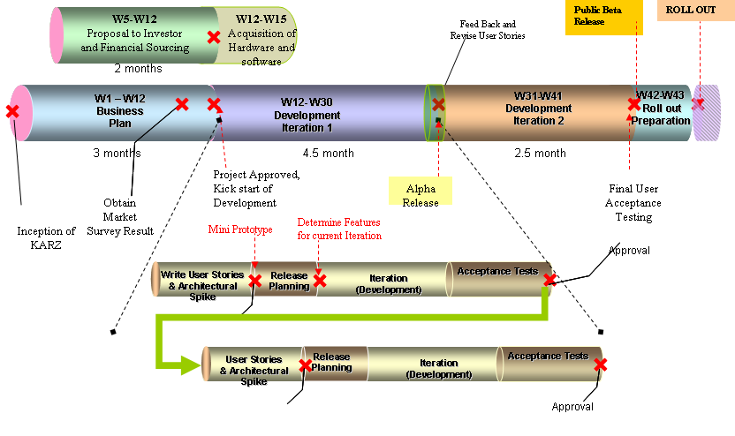
Project Timeline

Project Milestones

 | Activities | Description | Date of  Completion
1. Inception Phase
1 | Market Survey Result | Obtaining Market Survey Result | Month 2.50
2 | Business Plan | Approval of Business | Month 3.00
3 | Proposal and Financial Sourcing | Obtaining Financial and other HR Resources | Month 3.00
4 | Acquisition of Services & Software | Complete the acquisition of development software, online server hosting services. | Month 3.75
2. Development Phase
1 | Alpha Release | Alpha Release of website for User test, and also testing of concept | Month 7.50
2 | Beta Release | Beta Release of product | Month 10.00
3. Roll Out Phase
1 | Final roll out | After user acceptance test | Month 10.50

With the product development time reflected in the above project timeline and milestone, it is paramount in determining who and what to be engaged during which part of the project phase. In this way, the running costs and production costs are more easily worked out.

Production Costs
The production costs come from mainly the acquisition of building platforms. The acquisition of hardware as outlined in the technical plan has been reviewed for its plausibility and feasibility. As a startup, especially an internet startup entering uncharted business (social lending) in Singapore, we have decided to lower our risk of failure and conserve capital by utilizing online server hosting services.

There are no costs in the procurement of software, product components, integration and testing technologies since they are all open-source freeware. Our team has done a thorough cost-benefit analysis and evaluation of the open source and felt that at the inaugural stage of the project, it is wiser to leverage on the huge source of stable open-source software already deployed widely in the market because of the low cost and to avoid vendor lock-in. We will also acquire two PCs and one printer for product development.

Building Platforms

Usage | Specification | Cost and Quantity | Total Cost | When to acquire | When to setup
Web 2.0/AJAX development | MyEclipse 4.1 GA | US$32  X1 | US$32 = S$45 | Before the architectural spike activity of the application development phase | Before the architectural spike activity of the application development phase
Flash video maker | Adobe Flash CS3 Professional | US$699  X1 | US$699 = S$967 | Same as above | Same as above
Development PC | Dual core processor.  2GB RAM.  250GB hard disk. | S$2000  X2 | S$4000 | Same as above | Same as above
Printer | Inkjet printer | S$200  X1 | S$200 | Same as above | Same as above

Running Costs (Operating Costs)
The operating costs will mainly include the costs of employing staff for the running of the company and the infrastructure costs (server hosting space, internet service, utilities)

Labour

Skills | Labour | Quantity | When to acquire
Project Manager | One of the founders of Karz | 1 | N.A.
Business Analyst | One of the founders of Karz | 1 | N.A.
System Analyst | One of the founders of Karz | 1 | N.A.
GUI design and review | Consultant | 1 | Before the user stories development activity of the application development phase
Developers/System Admin/Database Admin | The three founders of Karz and two full time staff | 5 | For the two full time staff, acquire before the architectural spike activity of the application development phase
Testers for acceptance test | Contracted staff | 2 | Before the Alpha release of the application

Proposed Monthly Rates
Skills | Quantity | Monthly Rate | Duration of service
Project Manager | 1 | $3000 | Permanent
Business Analyst | 1 | $3000 | Permanent
System Analyst | 1 | $3000 | Permanent
GUI consultant | 1 | $100 per hour | Outsourced
Developers/System Admin/Database Admin | 2 | $3500 | Permanent
Testers for acceptance test | 2 | $30 per hour | Outsourced

Infrastructure
For office space, we assume that we can get a small office of 500 square feet at a rate of $4 per square feet per month. For utilities, internet, phone and office overhead, we project an expense of $1000 per month.

For online server hosting services, we will engage a Singapore based hosting company for a dedicated server at a monthly fee of $600. The hardware specification is as follow:
- AMD Quad Opteron 844 Processor
- 8GB RAM
- 2x 146GB SCSI (hardware RAID 1)
- 2x 146GB SCSI (JBOD)

Marketing and Promotion Costs
From our marketing plan, the costs come from printed advertisement and seminars. For printed advertisement in newspapers, it will start at the beginning of beta phase at month 7.5. We project the cost to be $300 per advertisement per day for newspaper ads.

For brochures to be sent together with utilities bills, it will start after the website goes live. We plan to engage DM Rocket, a division of Singapore Post Ltd at a rate of $20,000 per delivery to reach 250,000 households. We plan to use their service once per quarter.

For seminars and road shows, we will start after the website goes live. We budget $1000 per month for renting seminar and road show facility.

Product Price
Kash’s charging plan is straightforward. For borrower, Kash charges 1-3% closing fee depending on their credit grade. For lender, Kash charges 0%-1% annual loan servicing fee. There are no fees to use the site, post a listing or place bids.
Kash’s fees are very straightforward. There are no fees to use the site, post a listing or place bids. Fees only result from obtaining a loan as a borrower or receiving payments on a loan as a lender.

Borrower Fees

1-3% closing fee
If you are a borrower and your loan is funded, you will be charged a percentage of the amount borrowed or $25, whichever is greater, depending on your credit grade:
- AA: 1% closing fee
- A - B: 2% closing fee
- C - HR: 3% closing fee
For example, if you are a borrower with a B credit grade and you take a loan for $5,000 to help pay for your wedding, you will be charged $100. The 2% is taken from your loan immediately, so in this example your loan is for $5,000 and you'd receive $4,900 in cash deposited into your bank account.
This means that if you're using Kash to purchase something specific (like a wedding dress), make sure you ask for enough to cover the dress and the closing fee.

Lender Fees

0%-1% annual loan servicing fee
The annual servicing fee is accrued daily, and is based on the current outstanding loan principal. This fee is accrued the same way that regular interest is accrued on the loan. The amount of the servicing fee depends on the borrower's credit grade:
- AA: 0% annual loan servicing fee
- A - HR: 1% annual loan servicing fee
For example, on a $5,000 A credit grade loan at 10% interest, the servicing fee would be $80.70 over its full 3 year length. Because the servicing fee is based on the daily principal balance (which is an amortized value), it will change on a monthly basis, and the servicing fee for a loan will vary based on the prevailing bank interest rate and the length of the loan (if the borrower happens to pay it back in less than 3 years).

Collection agency recovery fee
In the event that one of the loans becomes more than 1 month late, Kash will assign a professional collection agency to attempt to collect the overdue amount. Each collection agency has its own fee structure, but will only collect a fee for their services if funds are recovered.

Delinquency Fees

$15 failed payment fee
If the borrowers’ automatic monthly payment fails due to insufficient funds or because they closed their bank account and forgot to inform Kash, they will be charged $15 on the first failed payment of each billing period. This fee may vary depending on the prevailing bank interest rate. This fee is paid to Kash, and covers the fees that Kash's bank charges for failed payments.

Late payment fee
If the borrowers’ monthly payment is 15 days late. Late fees are passed on to lenders; Kash does not profit from late fees. Any payment later than 15 months, please refer to the next section for more details of the fee scheme.

Sales Revenue
We revise our sales target as follow:
- Revenue: 100 completed loan deals per month in the first month of operation as we expect initial low pick up rate for social lending in Singapore.
- Revenue growth: with our aggressive marketing campaign we project a spike in growth of completed loan deals, followed by a stable growth, as shown below.
  - 10% growth per month on completed loan deals for the first 6 months of operation,
  - 12 % for the following 6 months
  - 15% for the following 6 months
  - 10% for the following 6 months
  - 5% for the following 12 months
  - 3% for the rest of the months

Below are our assumptions:
- For our customer base, we assume ¼ AA graders, ¼ A-B graders, ½ C-HR graders.
- An average of $5,000 per loan as we target medium-high income group.

