SG5013 SOFTWARE ENTREPRENEURSHIP

CASE STUDY 2 – INTERACTIVE DIGITAL MEDIA

MagSIM
Internet Housing Platform with Interactive 3D Modeling

Name | Matric No | Contact
Augustine Goh | HT042194H | <renaissm@hotmail.com>
Choo Zhi Min | HT052430X | <zm@nus.edu.sg>
Ryan Teoh | HT052433H | <Ryan_Teoh@adp.com>
19 March 2008

TABLE OF CONTENTS

1 Opportunity 3
2 Technologies 4
2.1 A survey on current technologies 4
2.2 Desired technology features 4
2.3 Proposed technologies 5
2.3.1 Ajax + X3D 5
2.3.2 Ajax + Sketchup 6
3 Possible Markets 6
3.1 Home Buyers 6
3.2 Home Sellers 7
3.3 Home Builders 8
3.4 Home Owners 8
3.5 Contractors / Interior Design Firms 9
4 Proposed Products 10
4.1 Home owner, Interior Designer 11
4.2 Home Builders/Property Developers 13
5 Critique 15
5.1 Technology 15
5.2 Marketability 18
6 Conclusion 22
7 References 23
8 Glossary 24
9 Annex 25

Opportunity
Traditionally, goods and services are delivered through physical means, such as shops, delivery man, etc. It works in the old economy, where pace of city life were slower and more relaxed. The provision of goods and services in the old economy is mainly unidirectional, i.e. from producer to consumer, resulting in much less interactivity.

Nowadays, faster pace and longer working hours in many cities demand the delivery of goods and services in a timely manner while maintaining the same quality. Moreover, consumers want to have more say in the final products or services. Consumers want to have the freedom of customizing what they potentially want to buy. Finally, consumers also want to have wider perspective (not just from the producers because it may be biased) in choosing a product or service. In the old economy, it is done by asking friends after the first round of window shopping, or by shopping together with friends. To summarize, consumers in the new economy want the following for goods and services:
- Fast delivery
- Freedom of customization
- Wider perspective in product selection

Interactive digital media, in our opinion, has made the above possible for many goods and services. Interactive digital media (IDM) “is evolving and is a term we use to encapsulate digitized media that are highly interactive in the way it engages with users. It is related to the use of new media, multimedia and interactive services.” (Source: www.idm.sg). The participants in the interactive digital media are the producers of the goods and services and the corresponding consumers. However, the line between producers and consumers are blurring at times and they are sometimes collectively called “prosumers”.

For goods and services that can be converted to digital format or are in digital format, IDM not only makes the delivery faster, the potential of letting consumers customize it and invite opinion can be exploited to satisfy consumers’ need. The Internet enables the delivery of digital products almost instantaneously. The digital nature of digital media also makes customization relatively easy and fast. For example, users in a forum are able to customize their avatar; players in online games are able to customize the look of their hero; for music and photo lovers, music and photos in digital formats can be cropped, resized, remixed.

When it comes inviting opinions in product feature and product selection, the “interactivity” in interactive digital media makes it possible. Take the photos at Flickr.com for example; users are able to give opinion on the photo in general and also in specific area of the photo. To the producer, getting opinion on physical photos is very possible in the old economy (just hold a gathering for friends at Starbuck), but getting opinion from millions of eyeballs, with comments on specific corner of a photo recorded for future reference, can only be possible with interactive digital media. This gives rise to “peer review” on digital media. Another example of “peer review” is reader’s review at online book store Amazon.com. Although some products are not in digital format, the website facilitates interactivity among fellow book buyers to exchange review on books. Reviewers who produce book review are also book buyers, hence participants in Amazon’s review space are all prosumers.

With consumers’ demand for faster delivery, freedom in customization and wider perspective in production selection, all enabled by interactive digital media, we see the opportunity in providing an interactive service for home buyers, home sellers as well as businesses involved in home building and interior/exterior renovation. The service will provide a 3D platform through which all participants will become prosumers. They will interact over a 3D home model produced/uploaded by a user to exchange opinion. They are also able to modify others’ 3D home model on the web, such as moving furniture, adding a picture on a wall, enlarging a window frame, etc. As a result, the user receives faster delivery of a proposed home model from the producer, or visual customization of a home model without numerous meetings, or wide spectrum of opinion on a proposed home renovation plan. More details will be revealed in the later part of this report.

Technologies

A survey on current technologies
With the opportunities identified in the last section, we made a quick survey for 3D technology. The most famous example is the Second Life (www.secondlife.com) online virtual world that was launched in 2003, developed by Linden Research, Inc. The 3D world is written by Silicon Graphics’ OpenGL 3D API. To join the virtual world, users are required to download and install a client on their PC, and then connect to Second Life server. Users in Second Life are known as Residents and all of them are represented in human form known as avatars. Residents in Second Life interact with each other as they would in the real world – chat, buy land, build home, attend concert, etc.

Another example is Sketchup (www.sketchup.com) is a 3D modeling program created with a mission of “3D for Everyone”. It is designed for professional architects, civil engineers, filmmakers, game developers, as well as for novice. One of the technologies in Sketchup that make its learning curve shorter than other 3D CAD program is their patented Push/Pull Tool. This tool enables designers to click on a shape and simply push or pull it to create the desired 3D geometry, hence allows the designer to create complex forms quickly and efficiently. To see this tool in action, view the Flash animated banner at <http://www.sketchup.com/?sid=484>.

Desired technology features
The opportunities we identified are directed to home buyer/seller, home owner, and businesses in home building/renovation. Some of these consumers are one-time consumers, for example, home owner looking for renovation ideas. They will use our service to gather renovation ideas but will likely to stop using the service when the renovation is completed. Some consumers may use our service at public PC where installation of client software is restricted. Therefore, potential consumers should be able to get started in using our service as hassle-free as possible. To meet the need of this group of consumers, we define the first desired technology feature: the 3D technology will browser-based instead of client-server based (e.g. Second Life). The advantage of browser-based 3D technology is that it can be used in any PC with internet connection, be it home, office or cyber café. Moreover, web browser is ubiquitous in every PC.

We also anticipate different level of skills in 3D modeling among consumers. To attract our different groups of consumers, the second desired technology feature is: the user interface must be friendly, intuitive and responsive.

Traditionally, the target audiences of many 3D modeling programs are restricted to professional designers as the learning curve are quite steep: knowledge in geometry, so many different functions represented by so many different tool icons, programming and scripting language for rendering task, etc. In a way, these 3D modeling programs requires its users to think like a computer. Again, as we target consumers from all sorts of background, we want our service to have the third desired technology feature: a 3D engine that is friendly, intuitive and easy to use.

Proposed technologies
With the three desired technology features in mind, we propose two alternative combinations of technologies.

Ajax + X3D
To make the service web-based and its user interface friendly and rich, Ajax (see section 8 Glossary) is proposed. The scripting nature of Ajax enables rapid web application development. The language and API are also ubiquitous, reliable and robust. The resulting Ajax applications are dynamic and responsive. Many familiar websites that we see today use Ajax. For example: GMail, Flickr, Yahoo Mail and Amazon.

For the 3D engine, we propose to write it in X3D language and API. X3D is the ISO standard XML-based file format for representing 3D computer graphics. With over 10 years in development, it is now mature, robust and reliable. Compared with other 3D language and API, such as OpenGL and Direct3D, X3D is open source and royalty-free. This lowers the risk of vendor lock-in. Free X3D editor and browser plug-in are available, e.g. Flux.

X3D can be programmed in JavaScript, which is the native language of Ajax. This makes the integration of Ajax as the user interface and X3D as the backend 3D engine easier. Such solution is already available in the market. Ajax3D (www.ajax3d.org) is one such solution. Ajax3D combines the visual richness and interactivity of X3D with the ease of use and ubiquity of Ajax for developing 3D web applications.

Although the Ajax + X3D solution already exists, development of a 3D engine is still required. The process of the engine development must be rigorous to ensure it is user friendly, intuitive and easy to use.

Ajax + Sketchup
Instead of going through the process of developing a 3D engine in the Ajax + X3D solution, we propose to bring the Sketchup application mentioned above to the web. The 3D modeling application Sketchup has the advantage of ease of use and short learning curve. However, it is currently available as a desktop application. We propose to replace its user interface with Ajax, thereby web-enable it, while keeping its 3D engine.

By combining Ajax and Sketchup, we are able to meet the three desired technology features. The downside of this is that Sketchup application is not open source, so we can either license it or form partnership with Sketchup. Either way, Sketchup has more bargaining power than we do.

Possible Markets

Frustrated with expressing your ideal home to the contractor verbally? Losing deals because your clients do not quite understand your artistic expression or your proposal of their homes? Spending time and resources on employing draftsmen and in the end, getting frustrated over the quality of work simply because of misunderstanding your description? If you face any one of the above or related problems, you have a good case to have a hit at our product, “3D Housing Modeling services”. Because of the ease of churning out 3D representations of the house in a flash, the possibility of satisfying many end users is substantial.

The primary users of drafting interior designs of homes are home buyers, home sellers, home builders (developers), home owners who are renovating their homes, contractors and interior design firms. Ensuing paragraphs will highlight the main activities revolving around the users, why and how they can employ our 3D Housing Modeling services.

Home Buyers

Activities

- Scouting for ideal houses through several modes for e.g. showroom open house, private viewing, HDB hub scaled-down modeling, viewing of friends’ or relatives’ houses.
- Selecting the right house to buy
- Selecting and engaging the right contractor for the renovation
- Discussing and finalizing the house design with the contractor
- Inspection and verification of the house during the milestone stages of the renovation
- Acceptance of the house upon renovation completion

Why employ our 3D Housing Modeling services?

- Users are often working personnel and spending time and resources on the strenuous and tedious activities might be demanding
- Users do not know how they want their homes to look like
- Even if they do know, they have a difficult time expressing their desires to the contractor
- During the renovation, users might have to remember what have been promised to them for the renovation, especially when there are many changes in the design along the numerous design discussions. It will be a difficult and laborious verification process

How to employ our 3D Housing Modeling services?

- Users can piece up all the information about their desired components of the houses viewed to form a 3D representation of their ideal house
- Even if users do not have a concrete idea of what they, they can take pictures of the houses they fancy, and from the generated 3D images, they can fine-tune until they are satisfied with the final result
- With the 3D image, users can better express their desires to the contractor
- Users can use the 3D images for inspection and verification of the actual works as it is easier to refer to the objects of the design drawing in 3D

Home Sellers
Activities

- Placing advertisements for their houses
- Scouting for and selecting real estate agents
- Give tours/private viewing to potential buyers
- Negotiation with potential buyers
- Close deals with buyers

Why employ our 3D Housing Modeling services?

- Users are often working personnel and spending time and resources on the strenuous and tedious activities might be demanding
- Users normally will pose pictures of their houses and pictures do not portray an attractive image of the houses

How to employ our 3D Housing Modeling services?

- Users can portray an attractive image of the houses by showing a 3D representation of their ideal house with good image editing skills
- At agents’ or buyers’ request, sellers can easily pan, tilt, zoom into the image to produce the 3D representation. It saves the sellers extra to whip out the camera and take pictures

Home Builders
Activities

- Managing land estate
- Marketing the houses to attract clients and investors
- Engaging contractors for design and construction
- Building the houses to user or/and design requirements
- Verification and fine-tuning of contractors’ works
- Launching an open house showroom
- Clinch and close deals

Why employ our 3D Housing Modeling services?

- Developers have many big tasks on hand and streamlining processes will certainly save time and resources.
- Developers have to sell their concepts to investors and buyers in marketing campaigns and during open-house.
- Developers have a difficult time expressing their desires to the contractor
- For Built-To-Order houses, developers have to keep track of the designs promised to the buyers
- During the renovation, developers might have to remember what have been promised to them for the renovation, especially when there are many changes in the design along the numerous design discussions. It will be a difficult and laborious verification process

How to employ our 3D Housing Modeling services?

- Developers can piece up all the information about their desired components of the houses viewed to form a 3D representation of their ideal houses
- Developers can take pictures of the houses they fancy or from competitors, and from the generated 3D images, they can fine-tune until they are satisfied with the final result
- With the 3D image, developers can better express their desires to the contractors
- Developers can use the 3D images for inspection and verification of the actual works as it is easier to refer to the objects of the design drawing in 3D

Home Owners
Activities

- Selecting and engaging the right contractor for the renovation
- Discussing and finalizing the house design with the contractor
- Inspection and verification of the house during the milestone stages of the renovation
- Acceptance of the house upon renovation completion

Why employ our 3D Housing Modeling services?

- Users are often working personnel and spending time and resources on the strenuous and tedious activities might be demanding
- Users do not know how they want their homes to look like
- Even if they do know, they have a difficult time expressing their desires to the contractor
- During the renovation, users might have to remember what have been promised to them for the renovation, especially when there are many changes in the design along the numerous design discussions. It will be a difficult and laborious verification process

How to employ our 3D Housing Modeling services?

- Users can piece up all the information about their desired components of the houses viewed to form a 3D representation of their ideal house
- Even if users do not have a concrete idea of what they, they can take pictures of the houses they fancy, and from the generated 3D images, they can fine-tune until they are satisfied with the final result
- With the 3D image, users can better express their desires to the contractor
- Users can use the 3D images for inspection and verification of the actual works as it is easier to refer to the objects of the design drawing in 3D

Contractors / Interior Design Firms
Activities

- Discussing with home buyers and owners (customers) for design and construction
- Building the houses to user or/and design requirements
- Verification and fine-tuning of sub-contractors’ works
- Sign off with customers

Why employ our 3D Housing Modeling services?

- Contractors have many big tasks on hand and streamlining processes will certainly save time and resources.
- Contractors have to sell their concepts to customers
- Contractors have a difficult time expressing their desires to the sub-contractors
- During the renovation, contractors might have to remember what have been promised to the customers for the renovation, especially when there are many changes in the design along the numerous design discussions. It will be a difficult and laborious verification process, especially within the budget constraints

How to employ our 3D Housing Modeling services?

- Contractors can piece up all the information about the customers’ desired components of the houses viewed to form a 3D representation of their ideal houses
- Contractors can take pictures of the houses they fancy or from competitors, and from the generated 3D images, they can impress on the customers
- Contractors can use the 3D images for inspection and verification of the actual works done by sub-contractors as it is easier to refer to the objects of the design drawing in 3D

Proposed Products

The proposed product, MagSIM will be designed around the core concepts of community, with multiple users with multiple roles participating actively in the design of dream house. As in the previous chapter for potential market, the website will not only designed to encourage users to form community related to the most basic need of human being – accommodation, but also allow them to sketch the interior design of the house. Further more, user will be able to post comments link to any house, or just part of the house (area of the 3D picture). In short, it had the combined features of flickr, facebook and Google Sketchup.

To explain further the idea, we have prepared the following mockups, depicting 4 different use cases to elaborate our ideas.

Home owner, Interior Designer

To assist the amateur but more willing user, the website will also provide tools similar to that of Google Sketch (light version), that allow user to do simple sketching and save their design for others to review. Highly flexible building tools allow manipulation of geometric primitives in a simple interface. User can stretch these “prims” into new shapes, change their texture and physical qualities, link them to other prims. From this easy-to-learn process, user can create objects of all kinds and sizes, from a jeweled navel ring to a five hundred meter skyscraper. With this tool, User would thus able to extend their idea into a design that can be commented and shared in the community.
Importable Textures:
User would be able to import jpegs and other standard graphic files into the texture

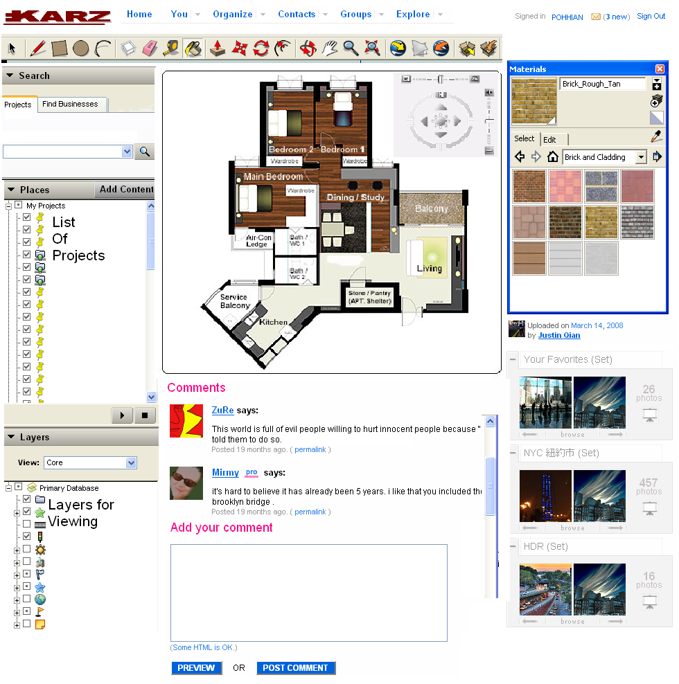

Collaboration: Similar to Flickr, user should be able to insert comments at any point in the 2D or 3D media

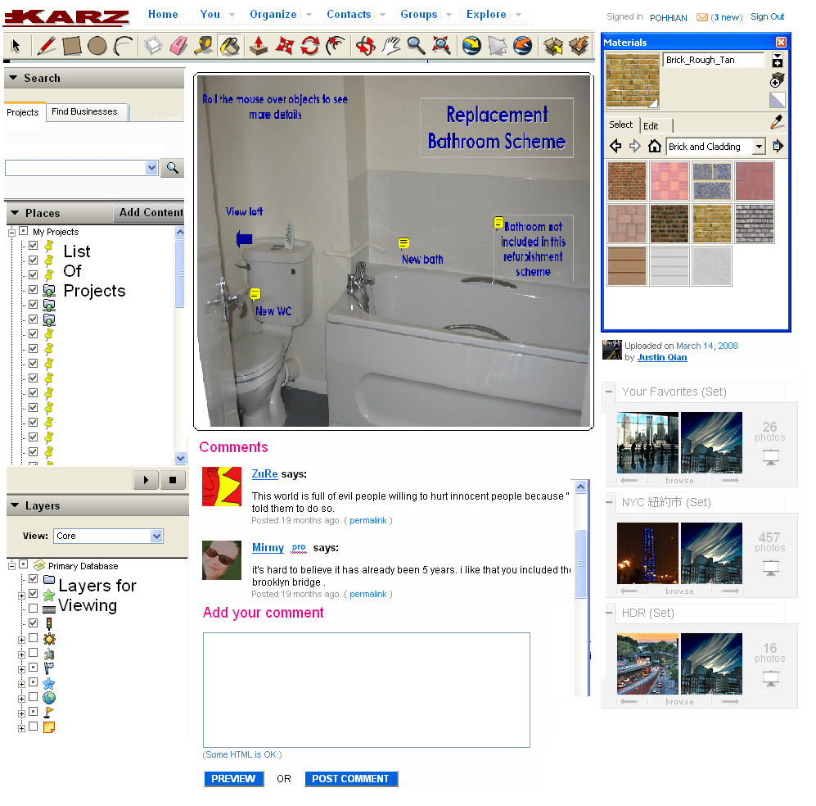

For contractor, they would be able to post 3D view of their proposal to prospective customers.

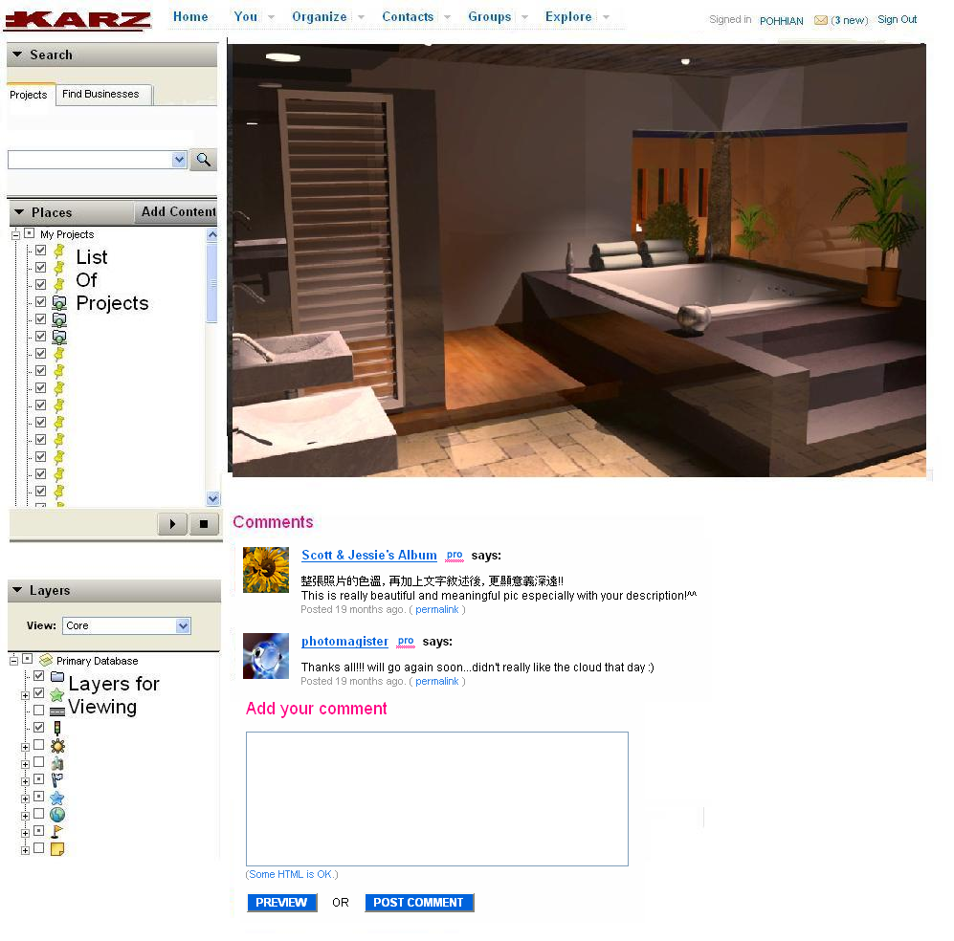

Home Builders/Property Developers

MagSim can also be used by Property Developer to show case their upcoming project. User should be able to post comments and suggestions to developers. The Property developers can “test” if the project has been welcomed by existing community, and also whether the proposed project is attractive to would be buyers/investors.

In short, interested users may be able to participate in shaping the final outcome of the project while property developer can fine tune their project to fully realize the potential of the project.

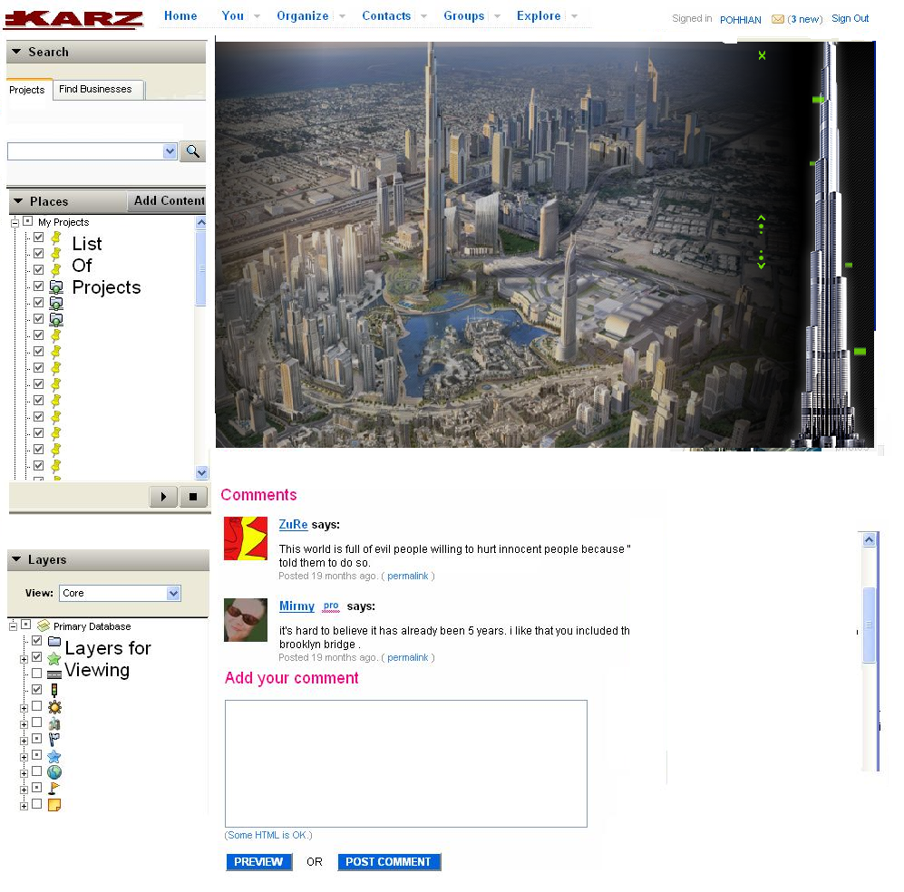

Critique

Technology

- Hardware Requirements
3D graphics often requires high performance hardware (often good graphics card) which is not prevalent in use by normal users. It has been stated that Second Life may not run on graphics/video cards other than the ones listed in the following specifications requirements and we assume that all other 3D graphical applications, in our case our 3D Home Modeling service, will require similar standards. Hence, the run-of-the-mill systems found in most homes, cyber cafes and offices will not be able to run the 3D features and as such the allowable user group will greatly shrink due to this hardware constraint. Hardware specifications requirements in order to run Second Life successfully and smoothly are as follow:
PC Minimum System Recommendations:
- Internet Connection*: Cable or DSL
- Computer Processor: 1.6GHz Pentium 4 or Athlon 2000+ or better
- Computer Memory: 512MB or better
- Video/Graphics Card: nVidia GeForce FX 5600, GeForce 6600, or better
  - OR ATI Radeon 9600, X600, or better
Mac Minimum System Recommendations:
- Operating System: Mac OS X 10.4.3 or better
- Computer Processor: 1.25 GHz G4 or better
- Computer Memory: 768MB or better
- Video/Graphics Card: nVidia GeForce FX 5600, GeForce 6600, or better
  - OR ATI Radeon 9600, X600, or better
We have tried running Second Life client on a PC of the following specifications and face extreme lag in the machine performance and tardy response of the client application.
PC Specifications:
- Internet Connection*: ADSL 50MBps
- Computer Processor: 1.5GHz Pentium 4
- Computer Memory: 512MB
- Video/Graphics Card: Intel(R) 82852/82855 GM/GME Graphics 64MB

- Network Bandwidth Requirements
Further to the hardware requirements, it is normally found that 3D graphics games are not compatible with dial-up internet, satellite internet, and some wireless internet services. The recommended internet connection is often Cable or DSL. Although it is debatable that ADSL is fast becoming a de facto internet connection means, it is still common to find dial-up connections in homes and offices.
Moreover, most offices have firewalls which may bar activities that are consuming tremendous bandwidth. Graphics-intensive activities may be disallowed, and, if not disallowed, will face slow responses since the bandwidth are shared amongst the staff.
- Web 3D environment is still in its infancy
Strictly speaking, granted that the end users are equipped with the PCs with the recommended system specifications, much of the infrastructure has been put into place to enable professional Web 3D deployment in a cross-platform, open, royalty-free environment. Interoperability standards such as ISO standard Extensible 3D Graphics (X3D) are now mature, fully functional and robust, and supported by multiple open source implementations and affordable production pipelines. However, those technologies only go so far, in that they are focused on the transportability of embedded rich content, and not on the applications that embed it. The industry is in need of a rapid development environment for creating scalable, highly interactive client-server 3D applications on the web.
Ajax3D combines the power of X3D, the standard for real-time 3D on the web, with the ease of use and ubiquity of Ajax. With the simple addition of an X3D plugin to today’s web browsers, we can bring the awesome power of video game technology to the everyday web experience. The initial development has begun. Media Machines has created the first showcase applications and tutorials, and has launched a web site, www.ajax3d.org, as an open industry forum to explore technologies, techniques and best practices.
With Ajax3D, immersive virtual worlds can be deployed within a web browser, integrated with pages and other media. Ajax3D worlds can communicate with standard web servers using XML and Ajax technologies, enabling professional, scalable, industrial strength applications with high production value and visual impact.
Ajax3D is in its infancy. In the coming months, it will need to be nurtured and actively developed. If the initiative can take on a life of its own and become a world wide forum for research and development of this exciting new technology, can Ajax3D grow into a big phenomenon?

- User Interface Limitation
Until a new stable platform, perhaps Ajax3D, is erected, most of the 3D applications, for e.g. Second Life, Xbox live, Google Earth and World of Warcraft, tend towards using the server-client platforms, since there is much user interaction. Second Life is open source, but the environment is not as users need to download a client application to be installed on their PCs. After installation, users need to be registered as members and login with accounts. With heavy engagement with users, these platforms are more feasible in terms of payload handling.
As client applications need to be installed and users be registered, the UI introduces inconvenience to the users. There should be a means where users can just surf and go without the hassle of downloading and installation of client programs or even the plug-ins. Currently, projects in www.ajax3d.org require such a plug-in for web browser (Flux Player), which can be downloaded free. We would think the next big browser will allow users to interact in 3D with any website. Shouldn't there be protocols and filters and standards for a 3D web browsing experience just like we have with a 2D experience of words and static photographs?
As we propose our 3D Home Modeling service be a web portal solution, we foresee that our existence hinges heavily on the browser technological trend. This is a critical success factor of our business.

Marketability

- Potential in Web 3D
Visionaries have been discussing Web 3D for around 15 years. The 3D web has really been around since the Sims went online and allowed people to virtually live next to each other. However, things like Second Life, Xbox live, Google Earth and World of Warcraft, are just beginning to show the power of networks and engagement of the 3D web. Now things like Moove and Kaneva are cropping up. The MetaVerse roadmap first met last year to discuss the "pathway to the 3D web." On their website, they state:
"Among social virtual worlds, the 2.5D world Habbo Hotel now has 7 million youth users in 18 countries. The leading open-ended 3D virtual world platform, Second Life, doubled from 160,000 to 330,000 accounts in four months (March to July 2006) and has recently been doubling every two months, to 2.5 million by Jan 2007, when they announced their viewer to be open source. The global market for asset trading, object creation, and services rendered in virtual worlds is estimated at anywhere from $700 million to $2 billion per year (mostly undocumented and untaxed at present). In Japan, social networking sites like GaiaX entice their users into online games and virtual worlds as just one of many social options. Early location-based games are emerging in Asia.”
A recent study on Second Life also observed that as of September 2007, there are 10 millions registrants, 24 millions hours logged, 37% aged 35-44, 25% aged 18-24 and USD$6 millions exchanged. An average of USD$1.2k are spent daily. Although the study is a global study, it serves a good guide that tells the take-up of virtual reality is quite encouraging and there is tremendous prospect in 3D animations and its acceptance and prevalent use in time to come.
- Paradigm Shift of Web 3D
As what have been learned from our team’s research and understanding, we feel that many of the experts are focusing too much on the semantic web (Web 2.0) which is inherently perceived as a part of the future of the web, but we think there is one overarching evolution happening right now under our feet that is inexorably enmeshed with the semantic web.
As Web 3D is often associated with video games and "fun things", most users from other industries are not so driven to look further into its potential and beyond what it is currently used for. In 1992, VRML was created, and after some discussion about the 3D web and work on standards by the W3C the X3D consortium has been created and X3d has officially replaced VRML. Progress, since then, had not been explosive. As most of the web initiatives are user-need driven and with this trickling demand for Web 3D in more diversified industries, much drive is needed to accelerate the growth, rev up the investments in the R&D and looking into the business values that gives rise to potential revenues and other benefits. Fortunately, there have been burgeoning efforts in other industries. For e.g. in the simulation space, virtual humans are being explored for their online educational ability. Virtual prototyping software is making great strides in industry, bringing us closer to an era of Fab Lab prototyping and product hacking/customization. 3D navigation systems are emerging in the automotive market in Japan and Europe. Local-positioning systems, like 3M's RFID Tracking Solution, and modeling advances like ArcGIS, Google Earth, and SketchUp are allowing us to create "mirror world" versions of physical space like never before...
Web 3D, together Web 2.0, should be perceived as the next big thing, as the next evolution of the web, we predict.
Only with a paradigm shift and the attraction of the potential benefits derived from the business values, can there be parties and consortiums with vested interest coming together in an excitement to pull together a common set of standards and technologies to facilitate a good environment for further research into Web 3D.
- Housing Markets in Singapore
Back to Singapore in the housing context, according to the statistic and figures as quoted in HDB 2005-2006, 2006-2007 annual reports in Annex, it is reported that the following figures are as shown:
 | FY2005/06 (units) | FY2006/07 (units)
Flats sold | 10,100 | 5,712
Resale transactions completed | 31,300 | 29,063
Bookings for new flats | 7,884 | 8,455
Applications registered for resale flats | 31,123 | 29,034
Total | 80,407 | 72,264
Assuming that there are 70% of the residents, who will renovate, and of these, 50% will opt for 3D representations of the houses for their renovation efforts, there will be 28,142 units & 25,292 units that will engage 3D modeling services for FY2005/06 & FY2006/07 respectively.
According to a quotation from one of the top local interior design, a request for 3D modeling at the final stage of the design for a flat will cost a fee of S$2,000. Hence, the total possible revenue that can be reaped from the 3D modeling services for FY2005/06 & FY2006/07 is S$56.3 millions & S$50.6 millions respectively.
It is obvious that the 3D housing modeling industry is a lucrative trade. Especially, when the current industry is still fledging, the potential of it going further with better advancements in tools and services like our product, 3D Housing Modeling service, is certainly great. Not forgetting that our projection assumes that 50% of the renovations will require 3D modeling, there is another half a pie that can balloon the revenue by another 100%. Most importantly, the projections are only for HDB flats. Private housing is not included due to the unavailability of figures.

- Directions set by HDB
In housing, there is always a strong demand for aesthetics and finishing quality began to emerge. This trend carried on to the 80s and in the 90s, seeing new concepts like mass customization emerging.
To enable it to reap the benefits of higher productivity and quality, while maintaining the cost effectiveness of its public housing, HDB has embarked on an industrialisation programme using innovative construction technologies that has enabled the construction industry to break new inroads in productivity and quality. These initiatives are the incorporation of modular co-ordination of its public housing designs, design standardisation and customisation, prefabrication, and the mechanisation of site operations.
The HDB Prefabrication Technology Centre (PTC) was set up in 1994 to spearhead the use of prefabrication technology in Singapore. PTC's main activities are to design, develop and produce prefabricated building products; conduct research and development of advanced and innovative construction materials and systems; manage and supply prefabricated building products; conduct training and license its intellectual property rights.
As HDB's Centre of Excellence for R&D, PTC champions HDB's development of R&D capabilities and promote a culture of innovation by being a catalyst and leader for related activities. In addition to conducting R&D, PTC will also be involved in brand development, patenting, development of international standards, benchmarking with world leaders and publishing world-class technical papers. It will also establish a world-class testing facility, by providing services not only for the local market but also for the international community. To improve its global visibility, it will forge partnerships and strategic alliances among current and potential R&D partners.
Our business is just in line with the directions set by PTC and hopefully, with a tie-up with PTC, there is endless possibility of how our services can be integrated into their services.
- Existing Platform for Virtual Tours
HDB currently has a portal for virtual showflats which display the actual 360 degrees panoramic view of the flats. The portal has the features to give users a realistic experience of walking around the flat without the hassle of traveling to all corners of the island (See picture in the Annex).
HDB has already taken the first step by introducing virtual reality into the portal. It has clearly set the direction of virtual tour for the future. With the government agency setting the direction, it is only sensible to heed the call by adding more value into their virtual tours. Currently, the tour is only for viewing (Java Ptviewer) and the technology used is a Java applet patching numerous real-life photographs together to give the “3D” feel. This concept can be further brought forward with the capability of annotation and user customization of the room and the furniture through a better feasible technology.
- Business Values in 3D housing
3D rendering capability helps user to better appreciate the layout in a realistic manner. Our modeling services help users understand their requirements better through simulations and 3D representations of their imaginations. Very often, laymen do not know what they want. They can only know it when they ‘see’ it. And, with 3D modeling, users can ‘see’ their imaginations and fine-tune them to their whims and fancies. And, when they are satisfied with their finalized concept, they can present it to the contractor and he can better deliver based on the firmer set of requirements. As most disagreements between contractors and residents arise from misunderstanding and subsequent mismatching of expectations, our modeling services can greatly reduce this risk.
With most of the home-owners being in the middle-age working group, time and resources are of essence. Our services will only require users taking pictures of the desired rooms at certain specific perspectives and angles, and upload these photographs to our portal. With a smart rendering engine, it will churn out the corresponding 3D representation of the rooms. The users can then use their creativity to customize the dimensions, colors and the positions of the furniture, features and the room itself.
From contractor’s and home builder’s perspectives, our services will make interior designing and drafting much easier and faster. Especially when they already have engaged experienced draftsmen, customization will just be a few minutes of work.

Conclusion
Real-time 3D is emerging as a first-class media type for the web. Network bandwidth and graphics hardware processing power are now sufficiently advanced to enable compelling web-based 3D experiences, including games, online virtual worlds, simulations, education and training. Commercial developers are expressing increasing interest in exploiting real-time 3D in web applications to enhance production value, create engaging immersive experiences, and deliver information in a more meaningful way. With great business values that lie in the housing industry, going Web 3D in housing is a good move, especially in the light of 3D housing having many unexplored boundaries. As what has always been true, money goes to the successful pioneers who can hold their forts.

In the midst of optimistic markets, the technology aspect needs to be affirmed more before this 3D Housing Modeling services can go into full swing of things. Again, there are always human factors that need to be considered as well. For e.g. there are some old-school contractors who still prefer hand sketches. Hand sketches may serve well in the initial stage of negotiation. However, when customers have been engaged, 3D drafting will impress more and will be more professional. There might also be some security and legal issues involved if house layout can be churned out so easily with just a few pieces of photographs. All these issues can be studied further after the services are deployed in the real-life environment.

References
- http://en.wikipedia.org/wiki/Second_Life

- http://en.wikipedia.org/wiki/SketchUp

- http://en.wikipedia.org/wiki/X3D

- http://www.ajax3d.org
- http://www.slideshare.net/Netwoman/virtual-environments-and-web-3d-new-worlds-with-old-problems
- http://teen.secondlife.com/whatis/technology
- http://www101.hdb.gov.sg/hdbvsf/eaap006p.nsf/images/main/$file/main_VT.htm
- http://ialja.blogspot.com/2007/03/thinking-about-3d-web-or-is-it-web-30.html

Glossary
- Ajax – Asynchronous JavaScript and XML—has emerged as a preferred method for developing sophisticated web applications. Ajax makes client-server programming available to JavaScript developers via Dynamic HTML, resulting in rich, responsive applications hosted in a web browser. While Ajax is being used to deploy some of the industry’s leading applications, such as Google Maps™ and Netflix™, current browsers are limited in their capabilities to render dynamic content, in particular high performance real-time 3D.

Annex

