Cash Flow

Cash Flow Out
Table 1 shows the various cost extracted from chapter 1. The “Rem” column refers to the section in this document.
Table 1: Various startup cost
 | Rem | QTY | COST ($) | TOTAL ($) | NOTE1 | NOTE2
Hardware/Software
Development PC | 1.2 | 2 | 2000 | 4000
MyEclipse 4.1 GA | 1.2 | 1 | 45 | 45
Adobe Flash CS3 Pro | 1.2 | 1 | 967 | 967
Printer | 1.2 | 1 | 200 | 200
Development Cost
Project Manager | 1.3.1 | 1 | 3000 | 3000 | per month | Karz founder
Business Analyst | 1.3.1 | 1 | 3000 | 3000 | per month | Karz founder
System Analyst | 1.3.1 | 1 | 3000 | 3000 | per month | Karz founder
GUI Consultant | 1.3.1 | 40 | 100 | 4000 | per month | Contract staff working 40 hour per month at $100 per hour
Developers | 1.3.1 | 2 | 3500 | 7000 | per month | Karz staff
Tester | 1.3.1 | 160 | 30 | 4800 | per month | Two contract staff working total 160 hour per month at $30 per hour
Running Cost (Recurring, Monthly)
Human Resource
Project Manager | 1.3.1 | 1 | 3000 | 3000 | per month
Business Analyst | 1.3.1 | 1 | 3000 | 3000 | per month
System Analyst | 1.3.1 | 1 | 3000 | 3000 | per month
Developers | 1.3.1 | 1 | 3500 | 3500 | per month | For maintenance job
Infrastructure
Web Hosting | 1.3.2 | 1 | 600 | 600 | per month
Office Rental | 1.3.2 | 1 | 2000 | 2000 | per month
Utilities, Overhead | 1.3.2 | 1 | 1000 | 1000 | per month
Marketing
Printed Media | 1.4 | 4 | 300 | 1200 | one ad per week
Brochures | 1.4 | 0.333 | 20000 | 6660 | 20k per quarter
Seminar, Roadshow | 1.4 | 1 | 1000 | 1000 | per month
Total Running Cost |  |  |  | 24960 |  | per month

Hence, the monthly cash flow out is as follow.
Table 2: Monthly cash flow out
Month | Infra | HR | MKTing | TOTAL
1 |  | 9000 |  | 9000 | Only 3 founders for HR
2 | 3000 | 9000 |  | 12000 | Only 3 founders for HR
3 | 8212 | 20000 |  | 28212 | Hire Developers and GUI consultant. All development hardware ready
4 | 3000 | 20000 |  | 23000
5 | 3000 | 20000 |  | 23000
6 | 3000 | 20000 |  | 23000
7 | 3600 | 24800 |  | 28400 | Hire tester. Start paying for server hosting.
8 | 3600 | 24800 | 1200 | 29600 | Start newspaper ads
9 | 3600 | 20000 | 1200 | 24800
10 | 3600 | 20000 | 1200 | 24800
11 | 3600 | 20000 | 8860 | 32460 | Karz goes live. Start full marketing.
12 | 3600 | 12500 | 8860 | 24960 | Retain only one developer
13 | 3600 | 12500 | 8860 | 24960
14 | 3600 | 12500 | 8860 | 24960
15 | 3600 | 12500 | 8860 | 24960
16 | 3600 | 12500 | 8860 | 24960
17 | 3600 | 12500 | 8860 | 24960
18 | 3600 | 12500 | 8860 | 24960
19 | 3600 | 12500 | 8860 | 24960
20 | 3600 | 12500 | 8860 | 24960
21 | 3600 | 12500 | 8860 | 24960
22 | 3600 | 12500 | 8860 | 24960
23 | 3600 | 12500 | 8860 | 24960
24 | 3600 | 12500 | 8860 | 24960
25 | 3600 | 12500 | 8860 | 24960
26 | 3600 | 12500 | 8860 | 24960
27 | 3600 | 12500 | 8860 | 24960
28 | 3600 | 12500 | 8860 | 24960
29 | 3600 | 12500 | 8860 | 24960
30 | 3600 | 12500 | 8860 | 24960
31 | 3600 | 12500 | 8860 | 24960
32 | 3600 | 12500 | 8860 | 24960
33 | 3600 | 12500 | 8860 | 24960
34 | 3600 | 12500 | 8860 | 24960
35 | 3600 | 12500 | 8860 | 24960
36 | 3600 | 12500 | 8860 | 24960
37 | 3600 | 12500 | 8860 | 24960
38 | 3600 | 12500 | 8860 | 24960
39 | 3600 | 12500 | 8860 | 24960
40 | 3600 | 12500 | 8860 | 24960

Cash Flow In
We table the cash flow in as below, staring from the first month of operation at month 11. The “Rem” column refers to the section in this document. We include only closing fee as income as this is the major source of income.
Table 3: Monthly cash flow in
Num Loan for first income |  |  | 100
Average Loan Amount |  |  | 5000
AA credit grade |  |  | 1.0% | closing fee
A-B credit grade |  |  | 2.0% | closing fee
C-HR credit grade |  |  | 3.0% | closing fee
 |  |  | Borrower's Credit Grade
Month | Growth | Num Loan | AA | A-B | C-HR | Total | Rem
 |  |  | 0.25 | 0.25 | 0.50 |  | 1.7 (a)
11 |  | 100 | 1250 | 2500 | 7500 | 11250
12 | 10% | 110 | 1375 | 2750 | 8250 | 12375
13 | 10% | 121 | 1513 | 3025 | 9075 | 13613
14 | 10% | 133 | 1664 | 3328 | 9983 | 14974
15 | 10% | 146 | 1830 | 3660 | 10981 | 16471
16 | 10% | 161 | 2013 | 4026 | 12079 | 18118
17 | 10% | 177 | 2214 | 4429 | 13287 | 19930
18 | 12% | 198 | 2480 | 4960 | 14881 | 22322
19 | 12% | 222 | 2778 | 5556 | 16667 | 25000
20 | 12% | 249 | 3111 | 6222 | 18667 | 28000
21 | 12% | 279 | 3484 | 6969 | 20907 | 31360
22 | 12% | 312 | 3903 | 7805 | 23416 | 35124
23 | 12% | 350 | 4371 | 8742 | 26226 | 39338
24 | 15% | 402 | 5027 | 10053 | 30159 | 45239
25 | 15% | 462 | 5781 | 11561 | 34683 | 52025
26 | 15% | 532 | 6648 | 13295 | 39886 | 59829
27 | 15% | 612 | 7645 | 15290 | 45869 | 68803
28 | 15% | 703 | 8792 | 17583 | 52749 | 79124
29 | 15% | 809 | 10110 | 20220 | 60661 | 90992
30 | 10% | 890 | 11121 | 22243 | 66728 | 100091
31 | 10% | 979 | 12233 | 24467 | 73400 | 110100
32 | 10% | 1077 | 13457 | 26913 | 80740 | 121111
33 | 10% | 1184 | 14802 | 29605 | 88814 | 133222
34 | 10% | 1303 | 16283 | 32565 | 97696 | 146544
35 | 10% | 1433 | 17911 | 35822 | 107465 | 161198
36 | 5% | 1505 | 18806 | 37613 | 112839 | 169258
37 | 5% | 1580 | 19747 | 39494 | 118481 | 177721
38 | 5% | 1659 | 20734 | 41468 | 124405 | 186607
39 | 5% | 1742 | 21771 | 43542 | 130625 | 195937
40 | 5% | 1829 | 22859 | 45719 | 137156 | 205734
41 | 5% | 1920 | 24002 | 48005 | 144014 | 216021
42 | 5% | 2016 | 25202 | 50405 | 151215 | 226822
43 | 5% | 2117 | 26463 | 52925 | 158775 | 238163
44 | 5% | 2223 | 27786 | 55571 | 166714 | 250071
45 | 5% | 2334 | 29175 | 58350 | 175050 | 262575
46 | 5% | 2451 | 30634 | 61267 | 183802 | 275703
47 | 5% | 2573 | 32165 | 64331 | 192992 | 289489
48 | 3% | 2650 | 33130 | 66261 | 198782 | 298173
49 | 3% | 2730 | 34124 | 68249 | 204746 | 307118
50 | 3% | 2812 | 35148 | 70296 | 210888 | 316332

Cash Flow Projection
Combine cash flow out and in, and apply discount rate of 0.8% per month, we arrive at the cash flow projection below. We also show the accumulated cash in the table below.
Table 4: Cash flow projection
Discount rate |  | 0.8% | per month
Month | Income | Expense | Net Cash (A) | Accumulated Cash (B) | Discounted (A) | Discounted (B)
1 | 0 | 9000 | -9000 | -9000 | -9000 | -9000
2 | 0 | 12000 | -12000 | -21000 | -11905 | -20833
3 | 0 | 28212 | -28212 | -49212 | -27766 | -48434
4 | 0 | 23000 | -23000 | -72212 | -22457 | -70506
5 | 0 | 23000 | -23000 | -95212 | -22278 | -92225
6 | 0 | 23000 | -23000 | -118212 | -22102 | -113595
7 | 0 | 28400 | -28400 | -146612 | -27074 | -139768
8 | 0 | 29600 | -29600 | -176212 | -27994 | -166652
9 | 0 | 24800 | -24800 | -201012 | -23268 | -188598
10 | 0 | 24800 | -24800 | -225812 | -23084 | -210185
11 | 11250 | 32460 | -21210 | -247022 | -19586 | -228103
12 | 12375 | 24960 | -12585 | -259607 | -11529 | -237821
13 | 13613 | 24960 | -11348 | -270955 | -10313 | -246246
14 | 14974 | 24960 | -9986 | -280941 | -9004 | -253296
15 | 16471 | 24960 | -8489 | -289430 | -7593 | -258878
16 | 18118 | 24960 | -6842 | -296271 | -6071 | -262895
17 | 19930 | 24960 | -5030 | -301301 | -4428 | -265236
18 | 22322 | 24960 | -2638 | -303940 | -2304 | -265435
19 | 25000 | 24960 | 40 | -303899 | 35 | -263294
20 | 28000 | 24960 | 3040 | -300859 | 2613 | -258591
21 | 31360 | 24960 | 6400 | -294459 | 5457 | -251081
22 | 35124 | 24960 | 10164 | -284295 | 8598 | -240491
23 | 39338 | 24960 | 14378 | -269917 | 12066 | -226516
24 | 45239 | 24960 | 20279 | -249638 | 16883 | -207835
25 | 52025 | 24960 | 27065 | -222573 | 22354 | -183831
26 | 59829 | 24960 | 34869 | -187704 | 28571 | -153801
27 | 68803 | 24960 | 43843 | -143861 | 35639 | -116941
28 | 79124 | 24960 | 54164 | -89697 | 43679 | -72334
29 | 90992 | 24960 | 66032 | -23665 | 52828 | -18933
30 | 100091 | 24960 | 75131 | 51466 | 59630 | 40848
31 | 110100 | 24960 | 85140 | 136607 | 67038 | 107561
32 | 121111 | 24960 | 96151 | 232757 | 75106 | 181814
33 | 133222 | 24960 | 108262 | 341019 | 83895 | 264266
34 | 146544 | 24960 | 121584 | 462603 | 93471 | 355640
35 | 161198 | 24960 | 136238 | 598841 | 103906 | 456723
36 | 169258 | 24960 | 144298 | 743139 | 109180 | 562278
37 | 177721 | 24960 | 152761 | 895900 | 114666 | 672481
38 | 186607 | 24960 | 161647 | 1057547 | 120373 | 787517
39 | 195937 | 24960 | 170977 | 1228524 | 126310 | 907577
40 | 205734 | 24960 | 180774 | 1409298 | 132488 | 1032862

Positive cash flow is realized starting from month 19 or 1.6 years after inception. Breakeven is realized in month 30 or 2.5 years after inception. The figure below illustrates this.

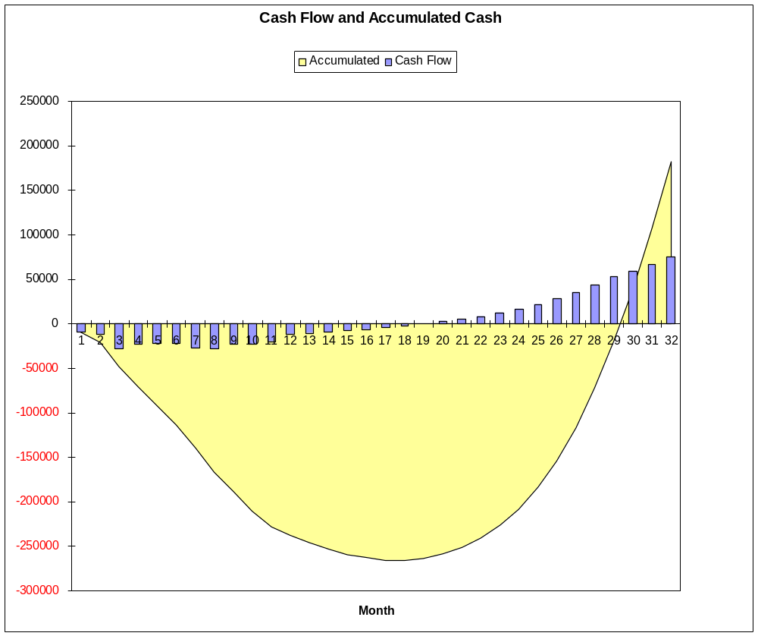
Figure 1: Cash flow and accumulated cash

