**.а..&. KEVSIGHT**

уут- ТECHNOLOGI ES

|  |  |  |  |  |  |  |  |
| --- | --- | --- | --- | --- | --- | --- | --- |
| Index |  | | | | | | |
|  |  | **Digits of** | **Measurement speed (reading/s** | **Basic 1-yr** | **Basic** | **Connectivity &** |  |
| **Model** | **Description** | **resolution** | **at 4½ digits)** | **DCV accuracy** | **measurements** | **software** | **Page:** |
|  | Benchtop DMM, dual | 4½ (U3401A) | N/A | 0.0120% | DCV, ACV, DCI, ACI, 2-wire | N/A | 4 |
|  | display | 5½ (U3402A) |  |  | resistance (4-wire on |  |  |

U3401A/U3402A

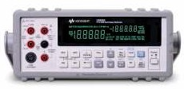

Elegantly simple and affordable DMMs with basic and good capabilities

U3402A), frequency, continu- ity, and diode

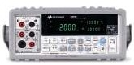

U3606A/U3606B

5.5-digit DMM with built-in 30 W power supply

Halves bench/rack- space need

for two instruments

5½ 26 0.0250% DCV, ACV, DCI, ACI,

2- and 4-wire resistance, frequency, continuity, diode, and capacitance

30-W with four output ranges, OVP/OCP, auto scan/ramp and square wave generator

USB 2.0, GPIB 5

34450A

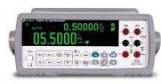

5.5 digit bench digital

multimeter

OLED dual display

5½

190

0.0150%

DCV, ACV, DCI, ACI,

2- and 4-wire resistance, frequency, continuity, diode, capacitance, and temperature

USB 2.0,

Serial Interface (RS-232), GPIB

BenchVue software enabled (page 25)

6

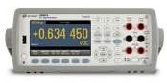

34460A/34461A

Bench/System DMM Graphical color

dual-line display with

histogram and trend charts

6½ 300/1000 0.0075/0.0035% DCV, ACV, DCI, ACI, 2- and

4-wire resistance, frequency, period, continuity, diode, temperature, capacitance

USB, LAN/LXI Core, 7

GPIB,

BenchVue software enabled (page 25)

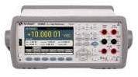

Bench/System DMM

Includes 34461A features plus data logging, digitizing and auto calibration

6½

50,000

0.0030%

DCV, ACV, DCI, ACI, 2- and

4-wire, resistance, frequency, period, continuity, diode, temperature, capacitance, DC ratio

USB, LAN/LXI Core,

GPIB optional, Bench- Vue software enabled (page 25)

8

34465A

34470A

Bench/System DMM

Includes 34461A features plus data logging, digitizing and auto calibration

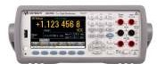

7½ 50,000 0.0016% DCV, ACV, DCI, ACI, 2- and

4-wire, resistance, frequency, period, continuity, diode, temperature, capacitance, DC ratio

USB, LAN/LXI Core, 8

GPIB optional, Bench- Vue software enabled (page 25)

34401A

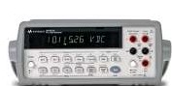

Bench/System DMM

Industry standard for accuracy, speed,

measurement ease and versatility

6½

1000

0.0035%

DCV, ACV, DCI, ACI, 2- and

4-wire resistance, frequency, period, continuity, and diode.

GPIB, RS-232, DMM

Connectivity BenchVue software enabled (page 25)

9

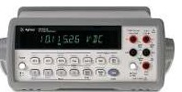

Bench/System DMM, 6½

dual-line display

Highest through-put of benchtop DMMs

10,000

(34410A)

50,000 (34411A)

0.0030%

DCV, ACV, DCI, ACI, 2- and

4-wire resistance, frequency, period, continuity test, capaci- tance, temperature

USB, LAN/LXI Core,

GPIB, BenchVue software enabled (page 25)

10

34410A/34411A

## Index

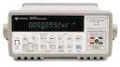

**Model**

**Description**

Nanovolt/µΩ meter

Very accurate, low-level measurements

**Digits of**

**resolu- tion**

7½

**Measurement**

**speed (reading/s Basic 1-yr DCV at 4½ digits) accuracy**

250 0.0030%

**Basic**

**measurements**

DCV, DCI, 2- and 4-wire resistance, 2 channel scanning, temperature

**Connectivity &**

**software**

GPIB, RS-232,

Intuilink software

**Page:**

11

34420A

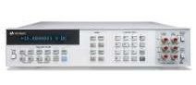

3458A

Bench/System DMM

The fastest, most lexible and most accurate multimeter by Keysight

Ideal multimeter for demanding applications

8½ 100000

(@ 4½ digits)

0.0008%

(0.0004% optional)

DCV, ACV, DCI, ACI, 2- and 4-wire

resistance, frequency, period, and temperature

GPIB 12

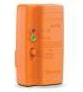

U1177A

Infrared (IR)-to-*Bluetooth* Adapter

Enables *Bluetooth* connec- tion to compatible Keysight handhelds.

N/A N/A N/A N/A Keysight Mobile 13

Meter

Keysight Mobile Logger

U1190 Series



Handheld clamp meter 3½

For convenient high current measurements

7

0.5%

DCV, ACV, DCI, ACI, 2-wire IR-USB, *Bluetooth*

resistance, frequency, continu- ity, diode test, capacitance, temperature

15

U1210 Series



Handheld DMM

Illuminate test area and measure in safer manner

3½

3

0.5%

DCV, ACV, DCI, ACI, 2- and

4-wire resistance, frequency, period, continuity, diode, capacitance, temperature

N/A

14

U1230 Series

U1240 Series

U1250 Series

U1270 Series

Handheld DMM



Retool your expectations with the Keysight U1230 Series handheld DMM



Handheld DMM

Feature-rich and robust DMMs

Handheld DMM



Versatile, high performance DMMs

Handheld DMM



More functionality in a single tool

3½ 5 0.5% DCV, ACV, DCI, ACI, resistance, frequency, continuity, diode test, capacitance, temperature

4 7 0.09% DCV, DCI, ACV, ACI, 2-wire resistance, frequency, continu- ity, diode test, switch counter, harmonic ratio, capacitance, temperature, 4-20 mA % scale

4½ 7 0.025% DCV, DCI, ACV, ACI, 2-wire

resistance, frequency, continu- ity, diode test, dB, capacitance, temperature, frequency counter, 4-20 mA % scale

4½ 7 0.05% DCV, DCI, ACV, ACI, 2-wire

resistance, frequency, continuity, diode test, dB, capacitance, temperature, 4-20 mA % scale

IR-USB, *Bluetooth* 16

IR-USB, *Bluetooth* 17

IR-USB, *Bluetooth* 18

IR-USB, *Bluetooth* 19

U1401B

Handheld multi-function calibrator/meter

Calibrator and DMM in one tool



4½ 3 0.003% DCV, ACV, DCI, ACI, 2-wire

resistance, temperature, frequency, diode test, continuity, pulse width, duty cycle

IR-USB 20

U2741A

USB Modular DMM

Compact, with plug-and- play simplicity



5½ 100 0.02% DCV, ACV, DCI, ACI, 2- and

4-wire resistance, frequency and period, continuity, diode test, temperature

USB 2.0 21

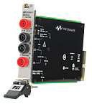

M9181A

PXI DMM - basic features.

Best for functional test when there are multiple tests with range or function changes.

6½ 150 .009% DCV, DCI, ACV, ACI, 2- and

4-wire resistance

PXI module; IVI-C, IVI- 22

COM, LabVIEW, MATLAB

drivers. Signametrics compatible driver is also available

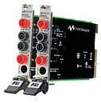

PXI DMM - enhanced

performance models.

Best for functional test when there are multiple tests with range or function changes.

6½

4,500 for M9182A .004%

15,000 for M9183A

All M9181A measurements, plus

frequency/period, capacitance, and temperature. M9183A includes duty cycle, counter/ totalizer, and DC source.

PXI-hybrid module; IVI-

C, IVI-COM, LabVIEW,

MATLAB drivers. Signametrics compatible driver is also available

22

M9182A/M9183A

Accessories compatibility chart 23-25

# Basic + good = elegant simplicity

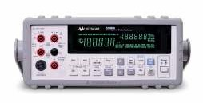

## U3400 Series 4½ and 5½ digit multimeters

Key features

* Up to 120,000 counts resolution
* Up to six built-in math functions – dBm, Relative, Min/Max, Compare, Hold
* Dual display on bright VFD
* Selectable resolutions for variable measurement

speeds

* Kensington lock slot security

Primary display Secondary display

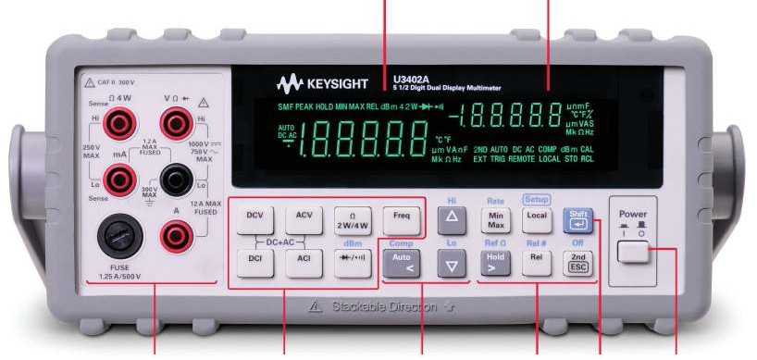

Input terminals and current fuse

Measurement function keypads

Autoranging, manual range and comparator operation

Math operation keypads

Shift Power on/off switch

## Key speciications

DCV accuracy 0.02%

Reading speed N/A

Measurement functions DCV, ACV, DCI, ACI, 2-wire and

4-wire resistance, frequency,

diode, continuity Type of connectivity N/A

Technical datasheet:

Literature number 5990-3970EN

## Ordering information

U3401A 4½ digit dual display digital multimeter U3402A 5½ digit dual display digital multimeter

Each U3400 Series includes:

* Quick start guide
* Product reference CD
* Certiicate of calibration (CoC)
* 34138A test lead kit
* AC power cord

Options:

* U3400A-100 USB to RS232 cable
* U3400A-1CM Rack mount kit
* U3400A-1CN Dual lange kit

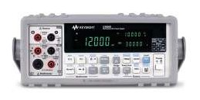

Key features

Full-featured DMM

* 8 built-in math functions
* 120,000 counts resolution
* 4-wire mΩ measurement with 0.001 mΩ
* resolution

Full-featured DC power supply

– 30 W, 30 V/1 A, 100 mA/30 V, 8 V/3 A and

* 1000 mV/3 A ranges
* OVP and OCP load protection
* Auto ramp and scan for multi-level DC bias testing
* Up to 4.8 kHz square-wave output

Two instruments in one

U3606A/U3606B multimeter|DC power supply

VFD display

Local/shift key

Source terminals

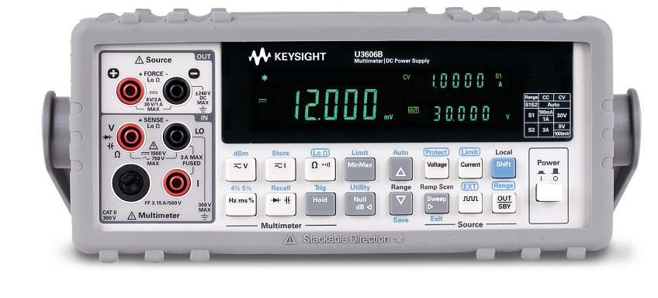

Multimeter terminals

Power On/Off button

Multimeter operation

keys Autorange and manual range keys

Source operation keys

## Key speciications

DCV accuracy 0.025%

Reading speed 26 readings/second Measurement functions DCV, ACV, DCI, ACI, 2-wire and

4-wire resistance, frequency,

diode, continuity, and capacitance

Type of connectivity GPIB, USB 2.0

Technical datasheet:

Literature number 5991-2849EN

## Ordering information

U3606A 5½ digit digital multimeter|DC power supply U3606B 5½ digit digital multimeter|DC power supply

Each unit includes:

* Quick start guide
* Product reference CD
* Keysight Technologies, Inc. IO Library Suite
* Certiicate of calibration
* U8201A combo test lead kit
* USB 2.0 high-speed type A to type B cable
* AC power cord

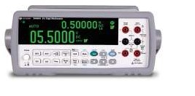

Key features

* Fast reading speed up to 190 readings/sec
* Multiple connectivity options – USB 2.0, Serial
* Interface (RS-232) and GPIB
* Up to 50,000 memory points for data logging
* Built-in histogram function
* With Fluke 45 and Fluke 8808A code compatibility

Turbo charge your measurements with

one of the fastest tools in its class

34450A bench digital multimeter

5.5 digit OLED dual display allows clear and quick view of measurements

Fast 190 readings/sec and 0.015% DCV accuracy to help you achieve throughput breakthrough

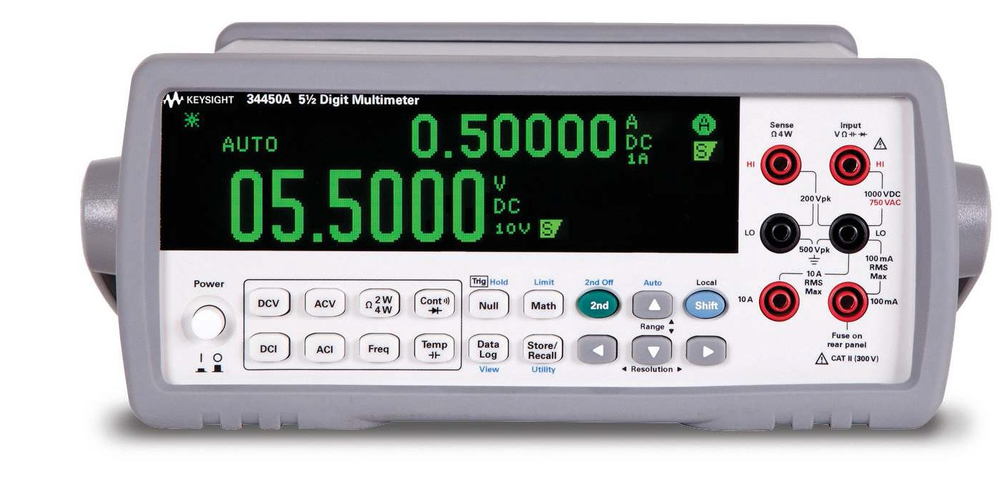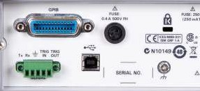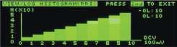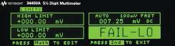

Input terminals

Kensington lock to better secure the unit

Multiple choices of connectivity and trigger in/out capability for production data analysis

Eleven measurement func- tions

Up to 50,000 memory points for data logging and histogram function

Built-in math func- tions

## Key speciications

DCV accuracy 0.015%

Reading speed 190 readings/s Measurement functions DCV, ACV, DCI, ACI, 2-wire and

4-wire resistance, frequency,

diode, continuity, capacitance, temperature

Type of connectivity USB 2.0, Serial Interface (RS-232)

and GPIB

Technical datasheet:

Literature number 5991-1133EN

## Ordering information

34450A 5½ digit dual display digital multimeter

Each 34450A includes:

* Test lead kit
* Power cord
* USB interface cable
* Quick start guide
* Product reference CD
* Keysight IO Library Suite CD-ROM

Upgradable options:

* 3445GPBU GPIB connectivity upgrade
* 3445MEMU 50,000 memory points upgrade for data logging
* BenchVue software enabled (see page 25)

# The new standard for uncompromising performance in bench and system test

## 34460A/34461A 6½ digit Truevolt DMMs

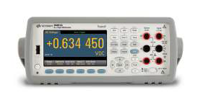

11 Truevolt measurement functions

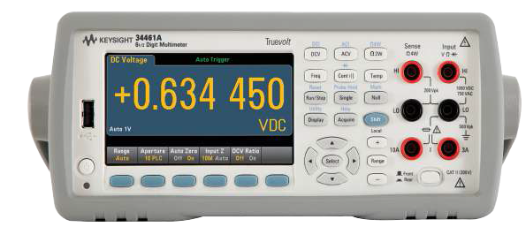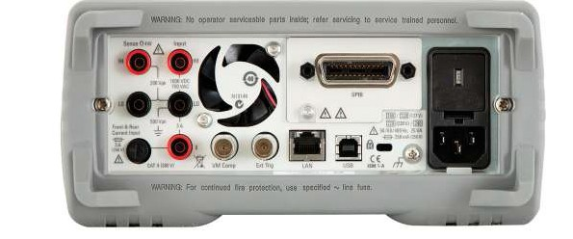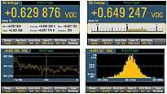

Color, graphical

display with built-in math and statistical

views

Rear measurement

terminals

100% drop-in

SCPI

compatible with industry-standard 34401A DMM

Key features

Display DMM results in ways you never have before – 1000 V max voltage input, 3 A/10 A (34461A) max

* Color, graphical display with built-in bar chart, current input

histogram, trend (34461A only), math, and statistics Move to the next generation 34401A DMM with 100% as-

* Save and document your DMM’s data from your PC, surance

mobile device, or IO of choice – Industry’s only 100% drop-in, SCPI compatible

Measure with unquestioned Truevolt conidence replacement for the Keysight 34401A DMM (34461A)

* Digital AC, lowest measurement noise, ISO/IEC de-

rived and compliant speciications

Familiar access to all measurements and set-up

10 A current measurement capability (34461A only)

I/O: USB, LAN/LXI

Autorange and manual range keys

Core, GPIB (optional)

## Key speciications

DCV accuracy 0.0075/0.0035% Reading speed – 4½ Digits 300/1000 readings/s

Measurements DCV, ACV, DCI, ACI, 2- and

4-wire resistance, frequency, period, diode, continuity, temperature

Type of connectivity USB, LAN/LXI Core (Option on 34460A, Std on 34461A)

GPIB (Optional)

Technical datasheet:

Literature number 5991-1983EN

## Ordering information

34460A 6½ digit, basic Truevolt DMM

34461A 6½ digit, 34401A replacement, Truevolt DMM

Upgradeable options:

* 3446ACCU – Accessory kit for 34460A (documentation, test leads, USB cable)
* 3446GPBU – GPIB user installable interface module
* 3446LANU – Enable rear panel LAN/LXI web interface, external triggering for 34460A
* 3446SECU – Enable NISPOM and ile security
* BenchVue software enabled (see page 25)

# The new standard for uncompromising performance in bench and system test

## 34465A 6½, 34470A 7½ digit performance Truevolt DMMs

Color, graphical display with built-in math and statistical

views

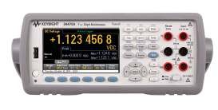

14 Truevolt measurement functions

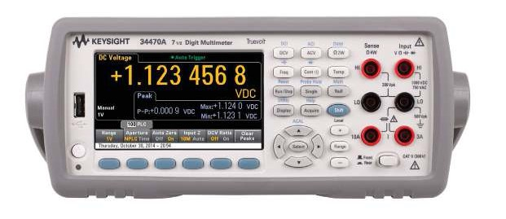

Key features

Get more insight quickly

*Truevolt* DMM’s graphical capa- bilities such as trend and histogram charts offer more insights quickly. Both models also provide a data log- ging mode for easier trend analysis and a digitizing mode for capturing transients.

Low-current measurements

The ability to measure very low cur- rent, 1 µA range with pA resolution, allows you to make measurements on very low power devices.

Maintaining calibration

Auto calibration allows you to com- pensate for temperature drift so you can maintain measurement accuracy throughout your workday.

Familiar access to all measurements and set-up

10 A current measurement capability

Rear measurement

terminals

SCPI

compatible with industry-standard 34401A DMM

I/O: USB, LAN/LXI

Autorange and manual range keys

Core, GPIB (optional)

## Key speciications

DCV accuracy 0.0030/0.0016%

Reading speed – 4½ Digits 50,000 readings/s Measurements DCV, ACV, DCI, ACI, 2- and

4-wire resistance, frequency,

period, diode, continuity, tem- perature capacitance,

DC ratio

Type of connectivity USB, LAN/LXI Core GPIB (Optional)

## Ordering information

34465A 6½ digit, performance Truevolt DMM (34410A/11A replacement)

34470A 7½ digit, performance Truevolt DMM

Upgradeable options:

* 3446GPBU – GPIB user installable interface module
* 3446SECU – Enable NISPOM and ile security
* 3446DIGU - Enable digitizing and advanced triggering
* 3446MEMU - Enable 2 million readings of memory
* BenchVue software enabled (see page 25)

Technical datasheet:

Literature number 5991-1983EN

# Uncompromising performance for benchtop and system testing

34401A 6½ digit multimeter (Replaced by 34461A 61/2 digit Truevolt multimeter)

Key features

* 1000 V maximum input
* SCPI commands standard
* Intuilink Connectivity Software included

Perform continuity and diode tests easily with thetouch of a button

Remove lead resistance with Null feature

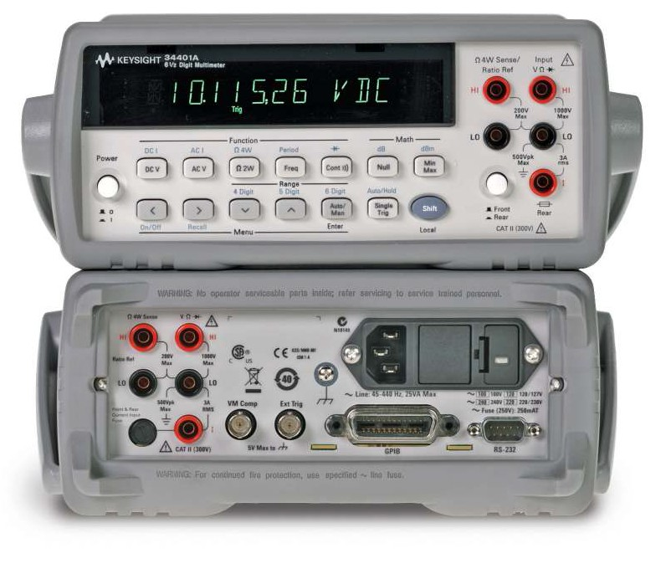

Measure up to 1000 volts with 6½ digits

resolution

## Key speciications

Ordering information

34401A 6½ digit digital multimeter

DCV accuracy 0.0035%

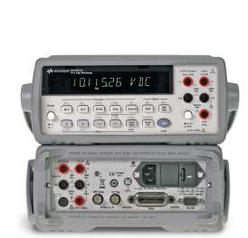

Reading speed – DCV 1000 readings/second

Measurements DCV, ACV, DCI, ACI, 2- and 4-wire resistance, diode, continuity

Type of connectivit y GPIB, RS-232

Technical datasheet:

Literature number 5968-0162EN

Each 34401A includes:

* Test lead kit with probe, alligator and grabber
* Operating manual
* Service manual
* Certiicate of calibration
* Test report
* AC power cord

BenchVue software enabled (see page 25)

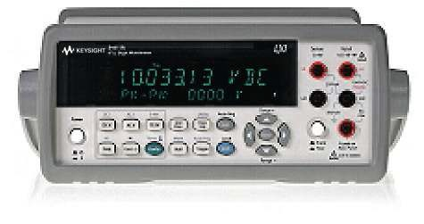

Key features

Keysight 34410A 6½ digit high-performance DMM

* Expanded measurement ranges
* Data logger with 50k reading non-volatile memory

Keysight 34411A 6½ digit enhanced-performance DMM

* All features of the 34410A plus:
* 50,000 readings/s at 4½ digits direct to PC
* 1 million volatile reading memory
* Analog level triggering
* Programmable pre/post triggering

Affordable yet feature-rich measurement tool

34410A/34411A 6½ digit multimeter

Dual display enables more information to be displayed

Easy-to-access measurementsion

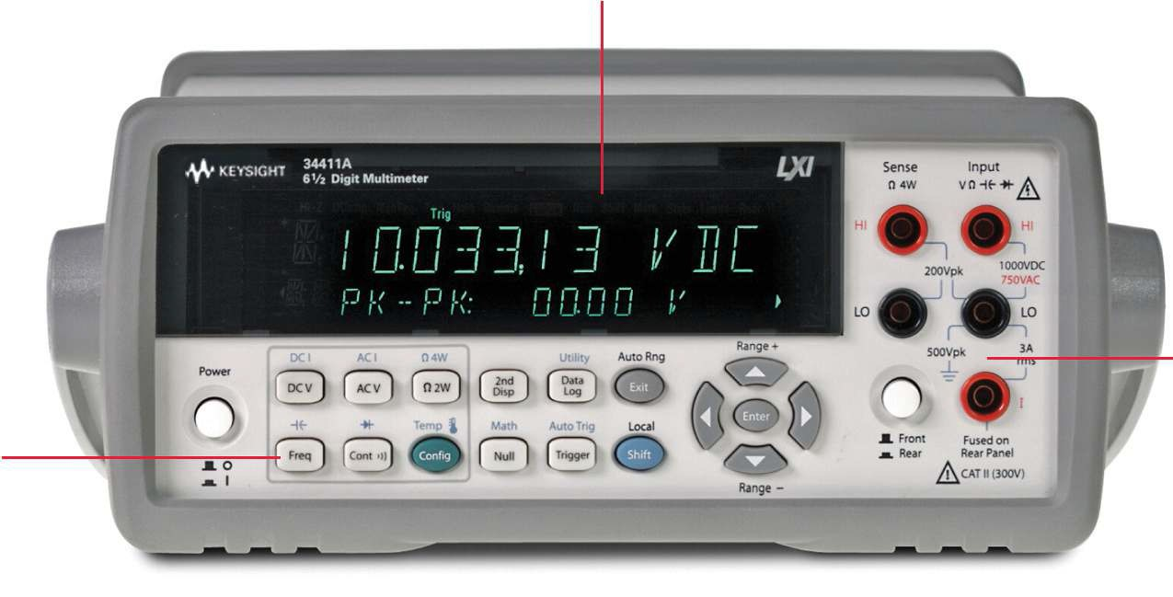

Front (and rear) input terminals provide ideal environment for bench and system testing

## Key speciications

Ordering information

34410A 6½ digit digital multimeter

DCV accuracy 0.0030%

Reading speed – DCV 34410A 10,000 readings/s

34411A 50,000 readings/s

Measurements DCV, ACV, DCI, ACI, 2- and

4-wire resistance, continuity, diode, capacitance, tempera- ture

Type of connectivity GPIB, USB 2.0, LAN (LXI Core)

34411A 6½ digit digital multimeter

Each 34410A/34411A includes:

* Test lead kit with probes and SMT attachments
* Test report
* AC power cord
* USB interface cable

BenchVue software enabled (see page 25)

Technical datasheet:

Literature number 5989-3738EN

# Nanovolt performance at a micro-volt price

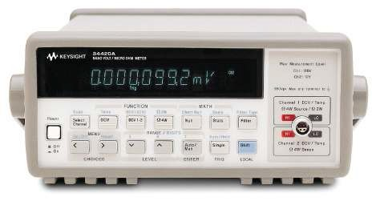

## 34420A 7½ digit multimeter

Key features

* 100 pv/ 100 n1/2 sensitivity
* 1.3 nVrms/8 nVpp noise performance
* Built-in low noise 2-channel scanner
* Direct SPRT, RTD, thermistor, and therrmocouple measurements

7½ digit resolution

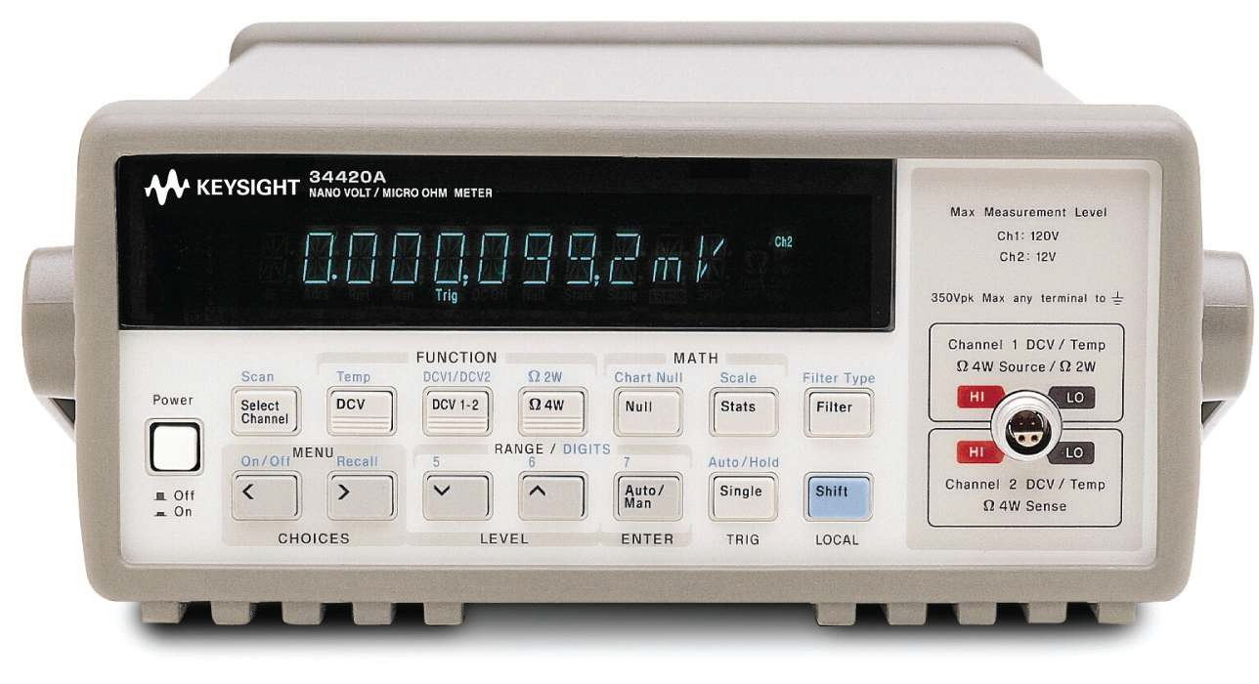

Three resistance modes are included:

Selectable analog

Built-in low noise two

* + Standard
  + Low-power

or digital iltering

channel scanner with ratio and difference

* + Voltage-limited for dry-circuit testing

functions

## Key speciications

Ordering information

34420A nanovolt/micro-ohm meter

DCV accuracy 0.0030%

Reading speed – DCV 250 readings/s

Measurements DCV, 2- and 4-wire resistance, temperature

Type of connectivity GPIB, RS-232

Technical datasheet:

Literature number 5968-0161EN

Each 34420A includes:

* Low-thermal input cable (34102A)
* Low-thermal shorting plug (34103A)
* Kelvin clip set (11062A)
* Operating manual
* Service manual
* Quick reference guide
* Test report with cal

# Shattering performance barriers of speed and accuracy

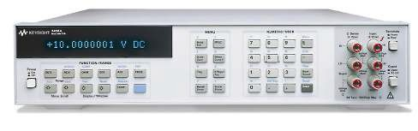

## 3458A 8½ digit multimeter

Key features

* Maximum sensitivity: 10 nV
* Programmable integration times from 500 ns to 1 sec
* Two-source (10 V, 10 kΩ) calibration, including AC
* Self-adjusting, self-verifying auto-calibration

for all functions and ranges, including AC

* Multimeter Language (ML) compatible

16 character alpha-numeric display to easily read data, messages and commands

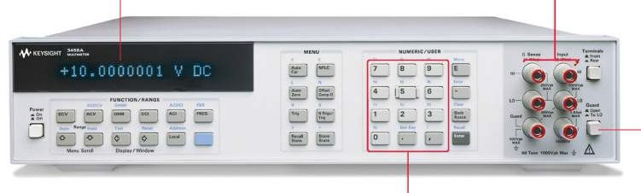

Gold-plated tellurium copper terminals

(volts/ohms/ratio) for minimum thermal emf

Shifted keys (f0 through f9) access up to ten user-deined

setups

Guard terminal and switch for maximum com- mon mode noise rejection

## Key speciications

Ordering information

3458A multimeter

DCV accuracy 0.0008% (Optional 0.0004%)

Reading speed DVC Up to 100,000 readings/second (41/2 digits)

Measurements DCV, ACV, DCI, ACI, 2-wire and 4-wire resistance,

frequency

Type of connectivity GPIB

Each 3458A includes:

* Test lead set (34118B)
* Power cord
* Operating manual
* Calibration manual
* Assembly level repair manual
* Quick reference guide

Technical datasheet:

Literature number 5965-4971E

# Go further with Keysight handheld digital multimeters

U1177A Infrared (IR)-to-*Bluetooth* Adapter

Monitoring multiple measurements simultaneously and wirelessly is now made possible with the U1177A Infrared (IR)-to-*Bluetooth* adapter. To achieve this, simply install the free software on your Android smart phone or tablet,

and connect it to any Keysight handheld digital multimeter

(HHDMM) that is attached to a U1177A. With this, you not only get real-time measurement monitoring and data logging, both apply to Android devices and PCs as well.

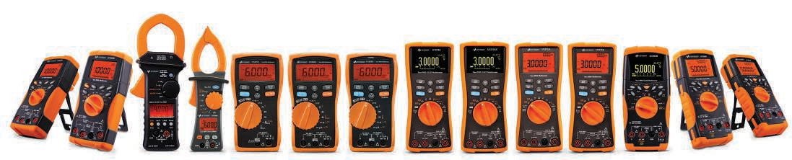

Key features

* Compatible with all Keysight U1200 Series handheld meters and U1210 Series handheld clamp meters
* Monitor up to 3 multimeter measurements at the same time with Keysight Mobile Meter software

– Perform real-time data logging with Keysight Mobile

Logger software

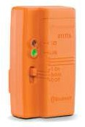  

Keysight U1177A Infrared



(IR)-to-*Bluetooth* adapter

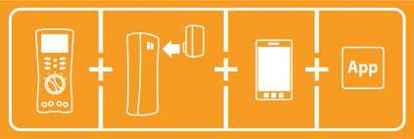

Keysight wireless remote connectivity solution

# Ergonomically designed for safer measurements

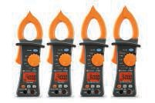

## U1190 Series handheld clamp meters

Key features

* Vsense to perform non-contact voltage detection1
* Built-in LED lashlight to illuminate test area1
* Current measurement up to 600 A2
* Digital multimeter (DMM) with Resistance,

Capacitance1, DCV, ACV, DCμA3, ACμA3, Continuity and Diode test measurements

* CAT III 600 V / CAT IV 300 V safety ratings

1. Only for U1192A, U1193A and U1194A
2. Only for U1193A and U1194A
3. Only for U1194A

Unique wire separator to

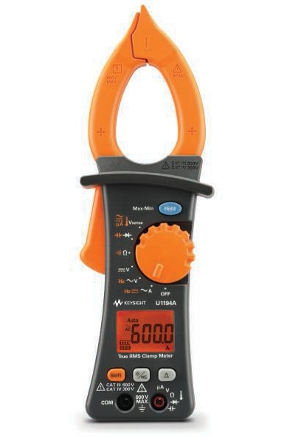

separate and clamp wires from a bundle

Vsense performs non-contact voltage detection1, DCμA2, and ACμA2 current measurements

Capacitance/diode test measurements Resistance/continuity measurements

DCV, ACV, DCA2, ACA, and

frequency measurement capabilites

Data Hold, Min,

or Max recording capability

LCD display with maximum reading of 6,000 counts

Backlight display and

built-in LED lashlight1

1. Exclusive to U1192A, U1193A, and U1194A
2. Exclusive to U1194A

## Key speciications

Ordering information

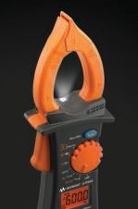

U1191A clamp meter

DCV accuracy 0.5+3

Reading speed 3 readings/s

Measurement functions DCV, ACV, DCI, ACI, resistance,

capacitance, diode test, tem- perature,

frequency, continuity

U1192A clamp meter U1193A clamp meter U1194A clamp meter

Each handheld includes:

* Certiicate of calibration
* Quick start guide

Built-in LED lashlight to illumi- nate test area

Type of connectivit y N/A

Technical datasheet:

Literature number 5990-8646EN

* K-type thermocouple (only for U1194A)
* 1.5 V AAA alkaline battery
* Soft carrying case
* Test leads with 4-mm tips
* Test report with cal

# Handle big currents – safely

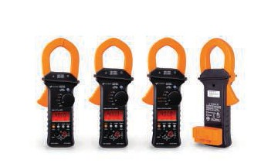

## U1210 Series handheld clamp meters

Key features

* Large clamp opening of 52 mm or 2” – Includes full-featured DMM with resistance, capaci-
* High measurement capability of up to 1000 A for AC, tance, frequency and temperature functions

DC or AC+DC – High resolution measurements – measure current as

* CAT III 1000 V/CAT IV 600 V safety rating low as 0.01 A

*Bluetooth* wireless connectivity (optional U1177A Infrared (IR)-to-*Bluetooth* Adapter required)

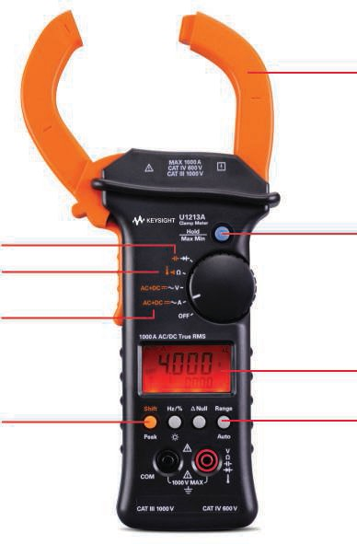



Capacitance/diode measurement

Temperature and audible continuity functions

High measurement capability of up to 1000 A for AC, DC or AC+DC

Peak hold function for in-rush current testing

Large jaw opening of 2” to test thick current sources

Max or Min recording capability

Large LCD display with maximum reading of 4000 counts

Manual or auto ranging

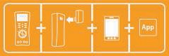

## Key speciications

Ordering information

DCV accuracy 0.50%

Reading speed 7 readings/s Measurements DCV, ACV, DCI, ACI, 2-wire

resistance, capacitance,

temperature, frequency, diode test, continuity

Type of connectivity IR-USB and *Bluetooth*

Technical datasheet:

Literature number 5990-5083EN

U1211A clamp meter U1212A clamp meter U1213A clamp meter

Each clamp meter is shipped with::

* Test leads with 4-mm tips
* Soft carrying case
* Standard alkaline 9 V battery
* Quick start guide
* Certiicate of calibration

# Robust and feature-packed

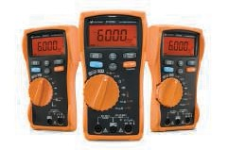

## U1230 Series handheld digital multimeters

Key features

* Built-in LED lashlight to illuminate test area
* Flashing backlight as additional visual alert duringcontinuity tests in noisy areas
* Vsense performs non-contact voltage detection
* Data logging capability (stores up to 10 readings)
* IR-to-USB connectivity to transfer data to PC for record

*Bluetooth* wireless connectivity (optional U1177A Infrared (IR)-to-*Bluetooth* Adapter required)

Flashing light and audible beep during presence of voltage1

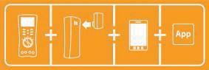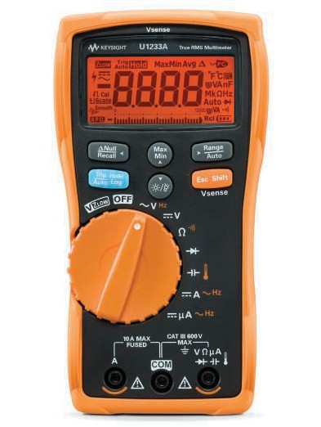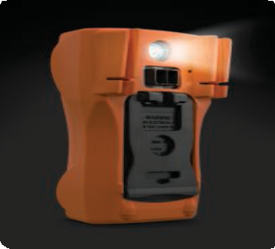

Bar graph indication and frequency measurement path

measurement value Allows lexibility to change measurement range

Freezes and stores current

Low input impedance to eliminate ghost voltage measurement

Anti-slip rotary dial for easy measurement function

selection

Vsense performs non- contact voltage detection1

Ease viewing with display

backlight or built-in lashlight

1.Only applicable for the U1233A model





## Key speciications

Ordering information

The built-in lashlight as illustrated

U1231A digital multimeter

DCV accuracy 0.5%+2

Reading speed 5 readings/s

Measurement functions DCV, ACV, ACI, DCI, diode test,

capacitance, resistance, temperature*, frequency, continuity test

*Applies to U1233A only

Type of connectivity IR-USB and *Bluetooth*

U1232A digital multimeter U1233A digital multimeter

Each handheld comes with:

* Quick start guide
* Certiicate of calibration
* U1167A 4 mm tips probes test leads
* 4 x 1.5 V batteries

Technical datasheet:

Literature number 5990-7550EN

# Check more, ix more, spend less

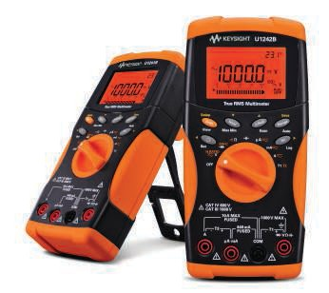

## U1240 Series handheld multimeters

Key features

* True RMS AC measurement
* Advanced functions – capacitance, temperature, MINMAX recording
* Manual data logging (U1242B only)
* Built-in switch counter, harmonic ratio (U1242B

only),dual/differential temperature capabilities (U1242B only)

* CAT III 1000 V and CAT IV 600 V safety protection

*Bluetooth* wireless connectivity (optional U1177A Infrared (IR)-to-*Bluetooth* Adapter required)

Ambient Temperature

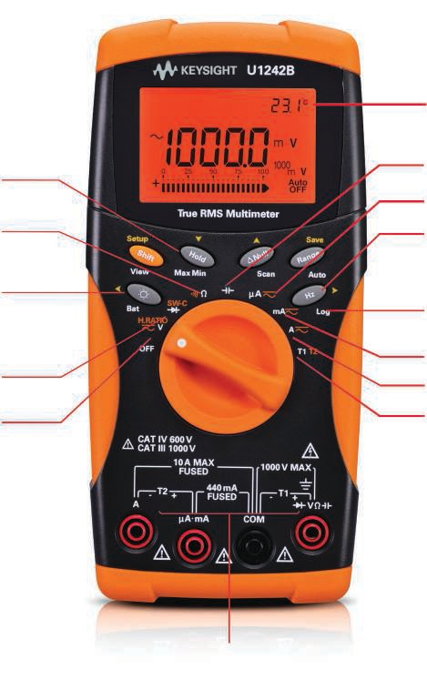

T1–T2 Differential

Temperature (U1242B only)

MINMAX recording Resistance: 0.1 Ω to 100 MΩ Backlight: 2 intensity levels

Diode test switch counter DCV/ACV: 0.1 mV to

1000 V

Harmonic ratio

(U1242B only)



## Key speciications

DCV accuracy 0.09%

Reading speed 7 readings/s Measurement functions DCV, ACV, DCI, ACI, 2-wire resis-

tance, frequency,

capacitance, temperature, diode, continuity tests

Type of connectivity IR-USB and *Bluetooth*

Capacitance: 0.1 nF to 10 mF

ACμA: 0.1 μA to 10 μA

Frequency : 1 Hz to 200 kHz

Manual data logging (U1242B only)

ACmA: 0.01 mA to 1000 mA

ACA: 0.01 A to 10 A

Temperature: –40° C to 1000° C

## Ordering information

U1241B digital multimeter U1242B digital multimeter

Each handheld comes with:

* Four 1.5 V AAA alkaline batteries
* Certiicate of calibration
* Test probe leads (4-mm tips)
* Quick start guide
* Free test data (Option UK6)

Technical datasheet:

Literature number 5989-7040EN

# Be well equipped from the start

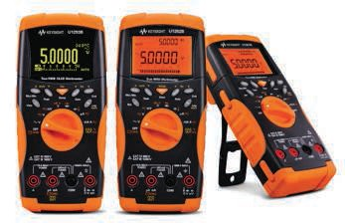

## U1250 Series handheld multimeters

Key features

* High contrast ratio of 2000:1 and wide viewing angle – Smoothing function to stabilize erratic readings* of 160°* – Data logging to instrument and PC *with U1253B
* Built-in square-wave generator and frequency counter
* Includes all essential accessories for electronics troubleshooting

*Bluetooth* wireless connectivity (optional U1177A Infrared (IR)-to-*Bluetooth* Adapter required)

## Key speciications

DCV accuracy 0.25%

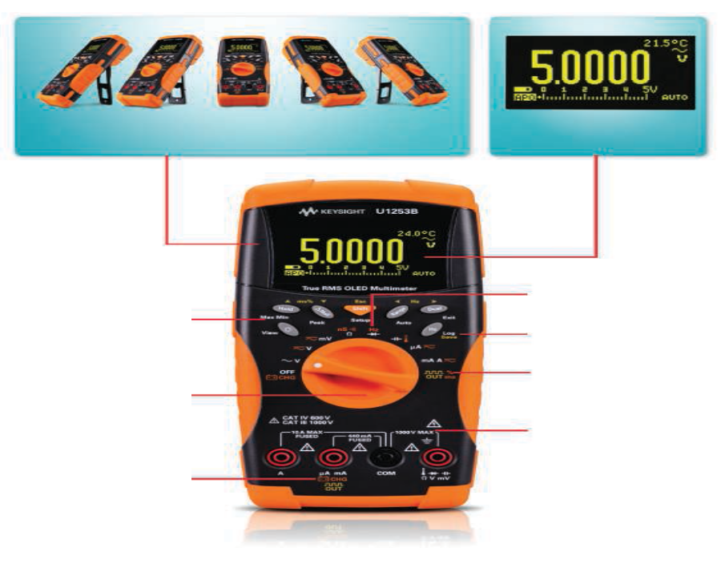

Speed 100 readings/s

OLED display with approximately 160° viewing angle,

and high contrast ratio of 2000:1 for crystal-clear viewing1

50,000 count dual display with true-RMS reading capability

Measurement functions

Type of connectivity

DCV, ACV, DCI, ACI,

2-wire

and 4-wire resistance, frequency, capaci- tance, temperature, diode, continuity tests

IR-USB and

*Bluetooth*

SHIFT key and one-stop func- tion keys for easy

access

20 MHz frequency counter

Data logging to internal or external memory

2

## Ordering information

U1251B digital multimeter

Broad range of measurement functions, including temperature and capacitance

Built-in battery charging for optimum capac-

ity

1. U1253B only

2. U1252B/U1253B only

Programmable square-wave

generator for stimulation of digital circuits2

CAT III 1000 V and CAT IV

600 V overvoltage protection for assurance of your safety while you go about your tasks

U1252B digital multimeter U1253B digital multimeter

Each U1251B/U1252B includes:

* + Four 1.5 V AAA alkaline batteries
  + Certiicate of calibration
  + Test probe leads (4-mm tips)
  + Quick start guide
  + Free test data (Option UK6)

Each U1251B/U1252B includes:

* + Four 1.5 V AAA alkaline batteries
  + Certiicate of calibration
  + Test probe leads (4-mm tips)
  + Quick start guide
  + Free test data (Option UK6)

Best Value Portable Test Equipment, 2006

A testament to innovation and credibility, 2006

General-purpose instruments category, 2009

Category Winner, EC&M Product of the Year competition, 2009

Technical datasheet:

Literature number 5989-5509EN



# Shaped to it, tailored to perform, built to last

## U1270 Series handheld digital multimeters

*Bluetooth* wireless connectivity (optional U1177A Infrared (IR)-to-*Bluetooth* Adapter required)

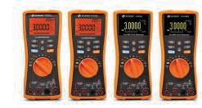

## Key speciications

Key features

* OLED display with 2000:1 contrast ratio and 160 degree viewing angle*
* Measure up to 1000 V AC/DC and 10 A

(20 A for 30 s)

* Down to −40 °C operating temperature*
* Water and dust resistance (IP 54)
* CAT III 1000 V / CAT IV 600 V

*with U1273AX

OLED display ensures clear and distinct display

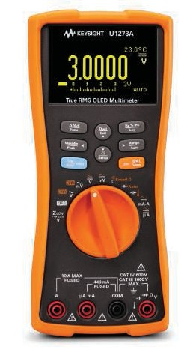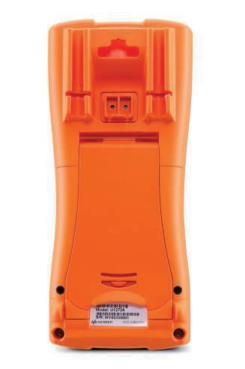

DCV accuracy 0.05%

Speed 7 readings/s

Peak detect records

transients as fast as 250 µs

Low Pass Filter (LPF) removes unwanted high frequency signals

readings

Smart Ω1 removes residual voltage of up to 1000 mV

Auto diode1 automatically determines diode polarity

Temperature measurement: J type thermocouple

Measurement functions

Type of

DCV, DCI, ACV,

ACI, 2-wire resistance, frequency, capacitance, continuity, diode test

IR-USB and

Z 1 provides both high

–210 to 1200° C1,

connectivity *Bluetooth*

LOW

and low impedance

K type thermocouple

–200 to 1732° C

## Ordering information

modes to eliminate stray

voltages

AC + DC1 capability

U1271A digital multimeter U1272A digital multimeter

1. U1272A, U1273A and

U1273AX only

Front panel

Large knob for ease of use

U1273A digital multimeter U1273AX digital multimeter

Hang hole Probe holder/storage

Slim, ergonomic design

for better grip

IR-USB connectivity with

optional IR-USB cable

Easy fuse and battery

access from battery cover beneath the stand

Each handheld comes with:

* Standard test leads
* Test probes with 4-mm tips
* K-type thermocouple and adapter
* 4 x AAA alkaline batteries

(for U1271A, U1272A, U1273A)

* 4 x AAA lithium batteries

(for U1273AX)

* Certiicate of calibration
* UK 6 (test report)
* Quick start guide

Technical datasheet:

Literature number 5990-6425EN

Back panel



# Calibrate and measure with just one tool

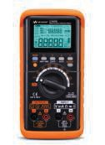

## U1401B handheld multi-function calibrator/meter

Key features

* Dual display with bright LCD backlight
* Simultaneous source and measure
* Bipolar voltage and current, square-wave, auto scan and ramp outputs
* Full-span DMM capability, including temperature

andfrequency measurements

* Data logging to PC with optional

Robust protective

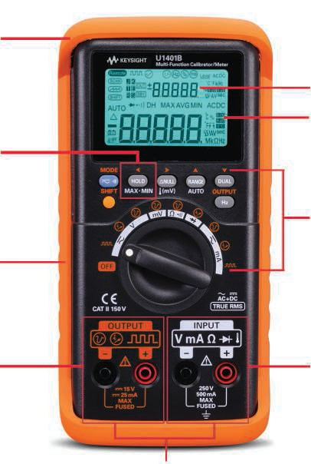

holster

Dual display with backlight

Hold and Min/Max/Avg recordings

Built-in battery-charging

capability

Bipolar voltage and current, square-wave,

auto scan and ramp

## Key speciications

DCV accuracy 0.003%

4-20 mA and 0-20 mA percentage scale readout

Easy function access through intuitive buttons and rotary switch

Voltage, current, resistance, temperature, frequency, pulse width, duty cycle, diode and continuity

Simultaneous source and measure

## Ordering information

U1401B multi-function calibrator/meter

Each U1401B is shipped with:

Reading speed 3 readings/s

Measurement DCV, ACV, DCI, ACI, 2-wire resistance, temperature, frequency, diode test, continuity,

pulse width, duty cycle

Type of connectivity IR-USB

Technical datasheet:

Literature number 5990-3459EN

* Calibrator/meter standard test
* Lead kit
* Yellow test lead for mA simulation
* Protective holster
* Rechargeable battery pack
* AC power adapter and cord (according to country)
* Quick start guide
* Certiicate of calibration
* Soft carrying case is included for U1401A

# A bench that its into your bag

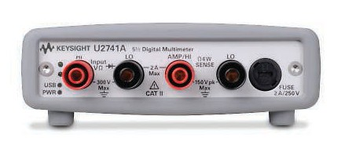

## U2741A 5½ digit USB modular multimeter

Key features

* Up to 300 VDC with 5½ digit resolution
* Wide measurement ranges: 100 mVDC to 300 VDC, 10 mA to 2 A
* Compatibility with high-speed USB 2.0,

USBTMC-USB488 standard

* Standalone and modular capabilities

Bundled software - Keysight Measurement Manager (AMM)

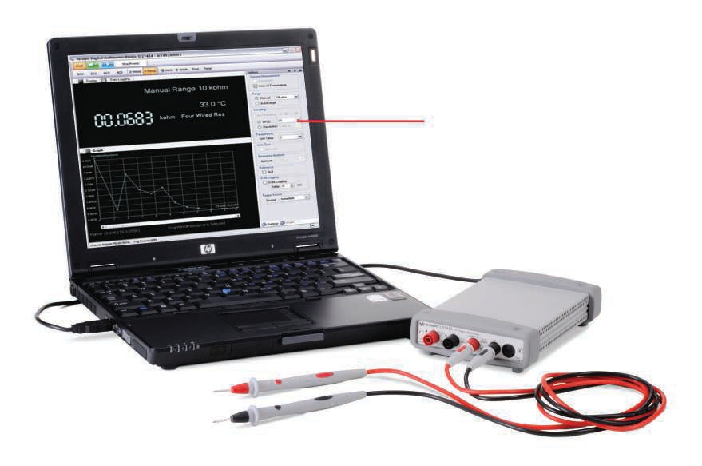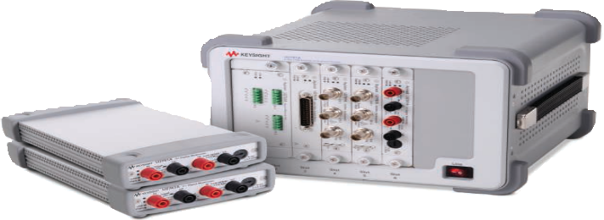

View voltage

along with time using dual display mode

## Key speciications

DCV accuracy 0.02%

Reading speed - DCV 100 readings/s Measurement DCV, ACV, DCI, ACI, 2-wire and

4-wire resistance, frequency,

temperature, diode, continuity

tests Type of connectivity USB 2.0

Technical datasheet:

Literature number 5991-0042EN

## Ordering information

U2741A digital multimeter

Each U2741A includes:

* 12 V, 2A AC/DC power adapter
* Power cord
* Standard test lead
* USB standard-A to mini-B interface cable
* L-mount kit (used with modular product chassis)
* Keysight USB modular products quick start guide
* Keysight Measurement Manager quick reference card
* Certiicate of calibration
* Keysight USB modular products reference CD-ROM
* Keysight automation-ready CD-ROM

(contains the Keysight IO Libraries Suite)

# Challenge the boundaries of test

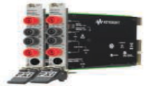

## M9181A/M9182A/M9183A PXI 6½ digit multimeters

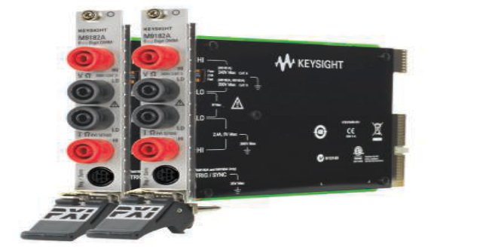

**Model Description**

M9181A

M9182A M9183A

PXI digital multimeter, 6½ digit, basic features

PXI-H digital multimeter, 6½ digit, high performance

PXI-H digital multimeter, 6½ digit, enhanced performance

Comparison of Keysight PXI DMM models

|  |  |  |  |
| --- | --- | --- | --- |
|  | **M9181A** | **M9182A** | **M9183A** |
| Resolution |  | 6½ digits |  |
| Maximum reading rate @ 4½ digits | 150 readings/s | 4,500 readings/s | 15,000 readings/s |

Maximum transactional speed

(single reading interval time) 6.7 ms 222 µs 66 µs

Measurements and functions DCV, DCI,

True RMS ACV and ACI, 2- and 4-wire resistance

All M9181A measurements, plus frequency/period, temperature, and

capacitance

All M9182A measurements plus duty cycle, counter/totalizer, DC source, and extended measurement ranges

Basic 1 year DCV accuracy 0.009% 0.004% 0.004% Floating isolation (CAT II) Up to 240 V Up to 300 V Up to 300 V

|  |  |  |
| --- | --- | --- |
| Triggering | Immediate | Immediate, analog level, programmable pre/post triggering, PXI trigger bus |
| Reading storage | none | Circular buffer, 80 readings |
| Connecter capability | cPCI, PXI-1 | cPCI, PXI-H, PXI-1 |

Software

Drivers IVI-C, IVI-COM, LabVIEW, MATLAB

Supported software development environments

Visual Studio® (VB.NET, C#, C/C++), VEE, LabVIEW, LabWindows/CVI, MATLAB

Included GUI Soft front panel

Application code examples C/C++, Visual Basic

M9181A Technical datasheet and lyer: Literature number 5990-9035EN (DS) Literature number 5990-9024EN (FL)

M9182A and M9183A Technical datasheet and lyer:

Literature number 5990-7580EN (DS) Literature number 5990-6550EN (FL)

|  |  |  |  |  |  |  |  |  |  |  |  |  |  |  |  |  |  |  |  |  |
| --- | --- | --- | --- | --- | --- | --- | --- | --- | --- | --- | --- | --- | --- | --- | --- | --- | --- | --- | --- | --- |
| **Ordering number** | **Description** | **Handheld clamp meters** | **Handheld DMMs** | | | | | **Bench DMMs** | | | | | | | | | | | **Modular DMM** | **Handheld calibrator/meter** |
| **U1210 Series** | **U1190 Series** | **U1230 Series** | **U1240 Series** | **U1250 Series** | **U1270 Series** | **U3401A** | **U3402A** | **U3606A/B** | **34401A** | **34410A** | **34411A** | **34420A** | **34450A** | **34460A/61A** | **34465A/70A** | **3458A** | **U2741A** | **U1401B** |

**Kits/rack mounts**

|  |  |  |  |  |  |  |  |  |  |  |  |  |  |  |  |  |  |  |  |  |
| --- | --- | --- | --- | --- | --- | --- | --- | --- | --- | --- | --- | --- | --- | --- | --- | --- | --- | --- | --- | --- |
| 34137A | Deluxe test lead set |  |  |  |  |  |  |  |  |  |  |  |  |  |  |  |  |  |  |  |
| 34190A | Rackmount kit |  |  |  |  |  |  |  |  |  |  |  |  |  |  |  |  |  |  |  |
| 34191A | 2U dual lange kit |  |  |  |  |  |  |  |  |  |  |  |  |  |  |  |  |  |  |  |
| 34194A | Dual lock link kit |  |  |  |  |  |  |  |  |  |  |  |  |  |  |  |  |  |  |  |
| 34307A | Thermocouple kit |  |  |  |  |  |  |  |  |  |  |  |  |  |  |  |  |  |  |  |
| 34308A | Thermistor kit |  |  |  |  |  |  |  |  |  |  |  |  |  |  |  |  |  |  |  |
| E3600A-100 | Test lead kit |  |  |  |  |  |  |  |  |  |  |  |  |  |  |  |  |  |  |  |
| U1161A | Extended test lead kit |  |  |  |  |  |  |  |  |  |  |  |  |  |  |  |  |  |  |  |
| U1168A | Standard test lead kit |  |  |  |  |  |  |  |  |  |  |  |  |  |  |  |  |  |  |  |
| U1180A | Thermocouple adapter+lead kit (for U1242B only)  (for U1252/53B only) (for U1272A/73/73AX) |  |  |  |  |  |  |  |  |  |  |  |  |  |  |  |  |  |  |  |
| U8201A | Combo test lead kit |  |  |  |  |  |  |  |  |  |  |  |  |  |  |  |  |  |  |  |
| U8202A | Electronic test lead kit |  |  |  |  |  |  |  |  |  |  |  |  |  |  |  |  |  |  |  |
| Y1133A | Low-thermal external DMM scanning kit |  |  |  |  |  |  |  |  |  |  |  |  |  |  |  |  |  |  |  |

**Probes/leads/clamps/bocks/shunts/connectors**

|  |  |  |  |  |  |  |  |  |  |  |  |  |  |  |  |  |  |  |  |  |
| --- | --- | --- | --- | --- | --- | --- | --- | --- | --- | --- | --- | --- | --- | --- | --- | --- | --- | --- | --- | --- |
| 11059A | Kelvin prob set |  |  |  |  |  |  |  |  |  |  |  |  |  |  |  |  |  |  |  |
| 11060A | Surface mount device probe |  |  |  |  |  |  |  |  |  |  |  |  |  |  |  |  |  |  |  |
| 11062A | Kelvin clip set |  |  |  |  |  |  |  |  |  |  |  |  |  |  |  |  |  |  |  |
| 34103A | Low thermal shorting plug |  |  |  |  |  |  |  |  |  |  |  |  |  |  |  |  |  |  |  |
| 34104A | Low thermal input connector |  |  |  |  |  |  |  |  |  |  |  |  |  |  |  |  |  |  |  |
| 34131A | Transit case |  |  |  |  |  |  |  |  |  |  |  |  |  |  |  |  |  |  |  |
| 34133A | Precision electronic test leads |  |  |  |  |  |  |  |  |  |  |  |  |  |  |  |  |  |  |  |
| 34134A | DC coupled current probe |  |  |  |  |  |  |  |  |  |  |  |  |  |  |  |  |  |  |  |
| 34136A | High voltage probe |  |  |  |  |  |  |  |  |  |  |  |  |  |  |  |  |  |  |  |
| 34138A | Test lead set |  |  |  |  |  |  |  |  |  |  |  |  |  |  |  |  |  |  |  |
| 34171B | Input terminal block |  |  |  |  |  |  |  |  |  |  |  |  |  |  |  |  |  |  |  |
| 34172B | Calibration short |  |  |  |  |  |  |  |  |  |  |  |  |  |  |  |  |  |  |  |
| 34330A | 30 A current shunt |  |  |  |  |  |  |  |  |  |  |  |  |  |  |  |  |  |  |  |
| E2308A | Thermister temperature probe |  |  |  |  |  |  |  |  |  |  |  |  |  |  |  |  |  |  |  |
| U1162A | Alligator clips |  |  |  |  |  |  |  |  |  |  |  |  |  |  |  |  |  |  |  |
| U1163A | SMT grabbers |  |  |  |  |  |  |  |  |  |  |  |  |  |  |  |  |  |  |  |
| U1164A | Fine-tip test probes |  |  |  |  |  |  |  |  |  |  |  |  |  |  |  |  |  |  |  |
| U1169A | Test probe leads |  |  |  |  |  |  |  |  |  |  |  |  |  |  |  |  |  |  |  |
| U1176A | Probe clip light |  |  |  |  |  |  |  |  |  |  |  |  |  |  |  |  |  |  |  |
| U1177A | Infared (IR)-to-*Bluetooth* adapter |  |  |  |  |  |  |  |  |  |  |  |  |  |  |  |  |  |  |  |
| U1580A | DMM terminal test lead set |  |  |  |  |  |  |  |  |  |  |  |  |  |  |  |  |  |  |  |
| U1583B | AC current clamp |  |  |  |  |  |  |  |  |  |  |  |  |  |  |  |  |  |  |  |

|  |  |  |  |  |  |  |  |  |  |  |  |  |  |  |  |  |  |  |  |  |
| --- | --- | --- | --- | --- | --- | --- | --- | --- | --- | --- | --- | --- | --- | --- | --- | --- | --- | --- | --- | --- |
| **Ordering number** | **Description** | **Handheld clamp meters** | **Handheld DMMs** | | | | | **Bench DMMs** | | | | | | | | | | **Modular DMM** | **PXI modular DMMs** | **Handheld calibrator/meter** |
| **U1210 Series** | **U1190 Series** | **U1230 Series** | **U1240 Series** | **U1250 Series** | **U1270 Series** | **U3401A/02A** | **U3606A/06B** | **34401A** | **34410A** | **34411A** | **34420A** | **34450A** | **34460A/61A** | **34465A/70A** | **3458A** | **U2741A** | **M9180 Series** | **U1401B** |

**Probes/adapters/leads for temperature measurement**

|  |  |  |  |  |  |  |  |  |  |  |  |  |  |  |  |  |  |  |  |  |
| --- | --- | --- | --- | --- | --- | --- | --- | --- | --- | --- | --- | --- | --- | --- | --- | --- | --- | --- | --- | --- |
| U1179A | IR connectivity/bracket |  |  |  |  |  |  |  |  |  |  |  |  |  |  |  |  |  |  |  |
| U1181A | Imersion temperature probe (for U1212A/13A only)  (for U1194A only) (for U1233A only) |  |  |  |  |  |  |  |  |  |  |  |  |  |  |  |  |  |  |  |
| U1182A | Industrial surface temperature probe (for U1212A/13A only)  (for U1194A only) (for U1233A only) |  |  |  |  |  |  |  |  |  |  |  |  |  |  |  |  |  |  |  |
| U1183A | Air temperature probe (for U1212A/13A only) (for U1194A only)  (for U1233A only) |  |  |  |  |  |  |  |  |  |  |  |  |  |  |  |  |  |  |  |
| U1184A | Temperature probe adapter (for U1212A/13A only)  (for U1194A only) (for U1233A only) |  |  |  |  |  |  |  |  |  |  |  |  |  |  |  |  |  |  |  |
| U1185A | J-type thermocouple and adapter (for U1242A only)  (for U1252A /53B only)  (for U1272A/73A/73AX) |  |  |  |  |  |  |  |  |  |  |  |  |  |  |  |  |  |  |  |
| U1186A | K-type themocouple and adapter (for U1212A/13A only)  (for U1194A only) (for U1233A only) |  |  |  |  |  |  |  |  |  |  |  |  |  |  |  |  |  |  |  |
| U1586B | Temperature module (for U1233A only) |  |  |  |  |  |  |  |  |  |  |  |  |  |  |  |  |  |  |  |

**Carry case/ hanging kit/brackets**

|  |  |  |  |  |  |  |  |  |  |  |  |  |  |  |  |  |  |  |  |  |
| --- | --- | --- | --- | --- | --- | --- | --- | --- | --- | --- | --- | --- | --- | --- | --- | --- | --- | --- | --- | --- |
| 34131A | Transit case |  |  |  |  |  |  |  |  |  |  |  |  |  |  |  |  |  |  |  |
| 34161A | Accessory pouch |  |  |  |  |  |  |  |  |  |  |  |  |  |  |  |  |  |  |  |
| 34162A | Accessory pouch |  |  |  |  |  |  |  |  |  |  |  |  |  |  |  |  |  |  |  |
| 34398A | RS-232 cable, 9-pin (F) to 9-pin (F) |  |  |  |  |  |  |  |  |  |  |  |  |  |  |  |  |  |  |  |
| 82350A | Interface card, high-performance PCI to GPIB |  |  |  |  |  |  |  |  |  |  |  |  |  |  |  |  |  |  |  |
| 82357B | USB/GPIB interface |  |  |  |  |  |  |  |  |  |  |  |  |  |  |  |  |  |  |  |
| U1171A | Magnetic hanging kit |  |  |  |  |  |  |  |  |  |  |  |  |  |  |  |  |  |  |  |
| U1172A | Transit case (aluminum-clad) |  |  |  |  |  |  |  |  |  |  |  |  |  |  |  |  |  |  |  |
| U1580A | DMM terminal test lead set |  |  |  |  |  |  |  |  |  |  |  |  |  |  |  |  |  |  |  |
| U1174A | Soft carrying case |  |  |  |  |  |  |  |  |  |  |  |  |  |  |  |  |  |  |  |
| U1175A | Soft carrying case |  |  |  |  |  |  |  |  |  |  |  |  |  |  |  |  |  |  |  |
| U1178A | Soft carrying case |  |  |  |  |  |  |  |  |  |  |  |  |  |  |  |  |  |  |  |

**Power/cables/interface card**

|  |  |  |  |  |  |  |  |  |  |  |  |  |  |  |  |  |  |  |  |  |
| --- | --- | --- | --- | --- | --- | --- | --- | --- | --- | --- | --- | --- | --- | --- | --- | --- | --- | --- | --- | --- |
| 10833A/B/  C/D/F/G | GPIB cable |  |  |  |  |  |  |  |  |  |  |  |  |  |  |  |  |  |  |  |
| 34102A | Low thermal input cable |  |  |  |  |  |  |  |  |  |  |  |  |  |  |  |  |  |  |  |
| U1170A | Battery charger adapter (for U1250/52/53B only) |  |  |  |  |  |  |  |  |  |  |  |  |  |  |  |  |  |  |  |
| U1173A | IR-to-USB cable |  |  |  |  |  |  |  |  |  |  |  |  |  |  |  |  |  |  |  |

Linking up your instruments to the PC

Keysight GPIB and Instrument Control Products helps connect your instruments to PC easily, reliably and

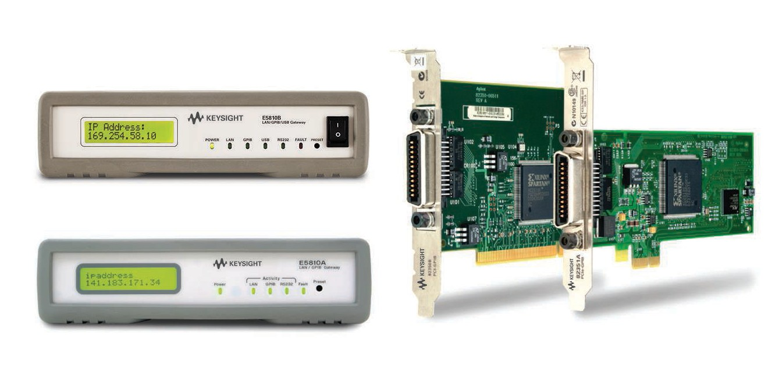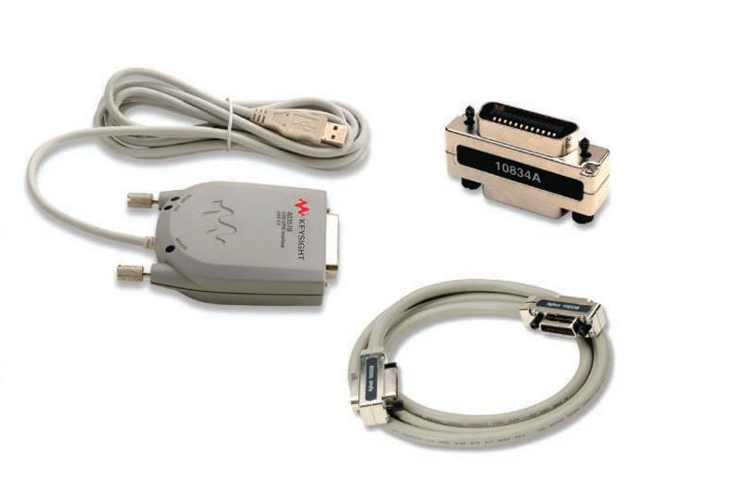

E5810B

82350B

82351A

E5810A

10834A

82357B

10833X

affordably. From legendary GPIB cables to the one-box connectivity gateway, see how each provides seamless integration of your instrument no matter where they are placed in your system.

[www.keysight.com/ind/gpib](http://www.keysight.com/ind/gpib)



## BenchVue Software

Data capture simplied. Click. Capture. Done.

BenchVue software for the PC makes it simple to connect, control, capture and view Keysight’s DMMs simulta- neously with other Keysight bench instruments and with no additional programming. BenchVue is an all-in- one application that enables you to:

* Visualize multiple measurements simultaneously
* Easily log data, screen shots and system state
* Recall past state of your bench to replicate results
* Export measurement data in de- sired format fast
* Quickly access manuals, drivers, FAQs and videos
* Monitor and control bench from mobile devices

The Digital Multimeter App within BenchVue enables control of digital multimeters to visualize measure- ments, perform data logging1 and annotate captured data (included in model BV0000A). Upgrading to the Pro version (model #BV0001A) provides histograms, digitizer capability and unrestricted data logging with limit checking and alerts.

1. One hour limit in no cost version.

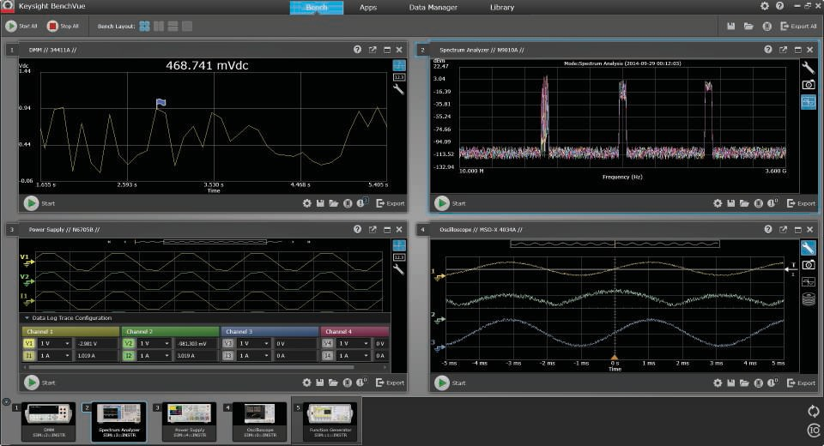

See your measurements across instruments in one place to quickly correlate measurement activities and obtain actionable insights.

## Download BenchVue software at no cost today

[www.keysight.com/ind/benchvue](http://www.keysight.com/ind/benchvue)



myKeysight

[www.keysight.com/find/mykeysight](http://www.keysight.com/find/mykeysight)

A personalized view into the information most relevant to you.

[www.axiestandard.org](http://www.axiestandard.org/)

AdvancedTCA® Extensions for Instrumentation and Test (AXIe) is an

open standard that extends the AdvancedTCA for general purpose and semiconductor test. Keysight is a founding member of the AXIe consortium. ATCA®, AdvancedTCA®, and the ATCA logo are registered US trademarks of the PCI Industrial Computer Manufacturers Group.

[www.lxistandard.org](http://www.lxistandard.org/)

LAN eXtensions for Instruments puts the power of Ethernet and the Web inside your test systems. Keysight is a founding member of the LXI consortium.

[www.pxisa.org](http://www.pxisa.org/)

PCI eXtensions for Instrumentation (PXI) modular instrumentation delivers a



rugged, PC-based high-performance measurement and automation system.

Three-Year Warranty

[www.keysight.com/find/ThreeYearWarranty](http://www.keysight.com/find/ThreeYearWarranty)



Keysight’s commitment to superior product quality and lower total cost of ownership. The only test and measurement company with three-year warranty standard on all instruments, worldwide.

Keysight Assurance Plans

[www.keysight.com/find/AssurancePlans](http://www.keysight.com/find/AssurancePlans)



Up to five years of protection and no budgetary surprises to ensure your instruments are operating to specification so you can rely on accurate measurements.

[www.keysight.com/go/quality](http://www.keysight.com/go/quality)

Keysight Technologies, Inc.

 DEKRA Certified ISO 9001:2008

Quality Management System

Keysight Channel Partners

[www.keysight.com/find/channelpartners](http://www.keysight.com/find/channelpartners)

Get the best of both worlds: Keysight’s measurement expertise and product breadth, combined with channel partner convenience.

*Bluetooth* and the *Bluetooth* logo are registered trademarks owned by *Bluetooth* SIG, Inc.,

U.S.A. and licensed to Keysight Technologies, Inc.

[www.keysight.com/find/dmm](http://www.keysight.com/find/dmm)

For more information on Keysight Technologies’ products, applications or services, please contact your local Keysight office. The complete list is available at: [www.keysight.com/find/contactus](http://www.keysight.com/find/contactus)

|  |  |
| --- | --- |
| Americas Canada | (877) 894 4414 |
| Brazil | 55 11 3351 7010 |
| Mexico | 001 800 254 2440 |
| United States | (800) 829 4444 |
| Asia Paciic |  |
| Australia | 1 800 629 485 |
| China | 800 810 0189 |
| Hong Kong | 800 938 693 |
| India | 0124 229 2010 |
| Japan | 0120 (421) 345 |
| Korea | 080 769 0800 |
| Malaysia | 1 800 888 848 |
| Singapore | 1 800 375 8100 |
| Taiwan | 0800 047 866 |
| Other AP Countries | (65) 6375 8100 |
| Europe & Middle East |  |
| Austria | 0800 001122 |
| Belgium | 0800 58580 |
| Finland | 0800 523252 |
| France | 0805 980333 |
| Germany | 0800 6270999 |
| Ireland | 1800 832700 |
| Israel | 1 809 343051 |
| Italy  Luxembourg Netherlands | 800 599100  +32 800 58580  0800 0233200 |
| Russia | 8800 5009286 |
| Spain | 800 000154 |
| Sweden | 0200 882255 |
| Switzerland  United Kingdom | 0800 805353  Opt. 1 (DE)  Opt. 2 (FR)  Opt. 3 (IT)  0800 0260637 |

For other unlisted countries: [www.keysight.com/find/contactus](http://www.keysight.com/find/contactus)

(BP-02-06-15)

This information is subject to change without notice.

© Keysight Technologies, 2011 - 2015

Published in USA, February 19, 2015 5990-5315EN

[www.keysight.com](http://www.keysight.com/)