npx create-react-app client --template typescript --use-npm

**npm WARN deprecated** [tar@2.2.2](mailto:tar@2.2.2) **-> npm i tar**

**index.tsx -> app.tsx**

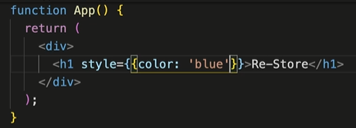

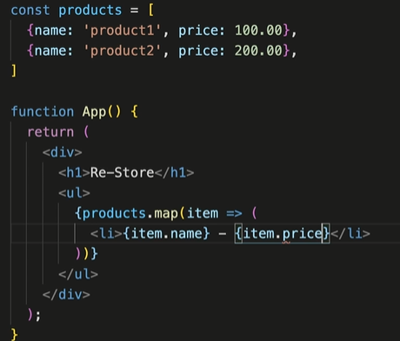

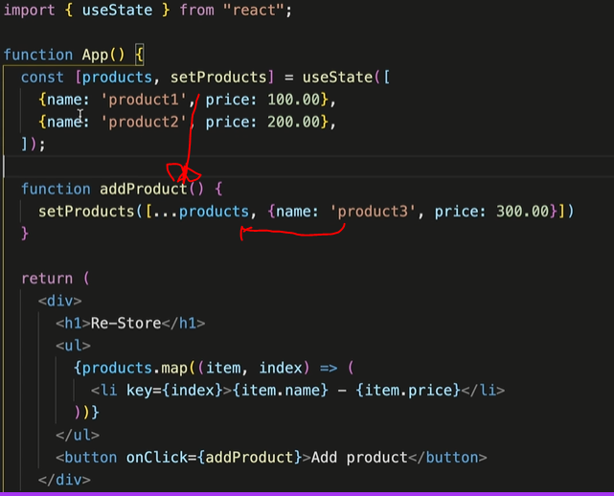

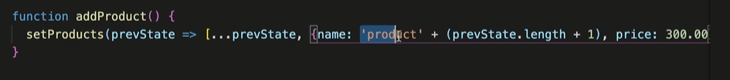

---------

COURS in startup,cs : service + middleware (order important)

---------------

<http://json2ts.com/>

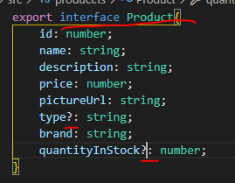

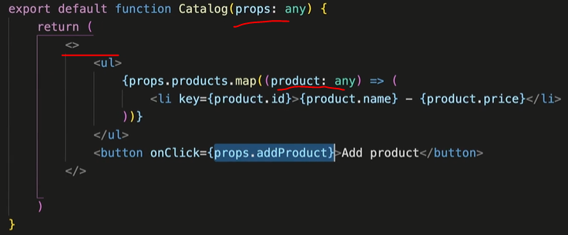

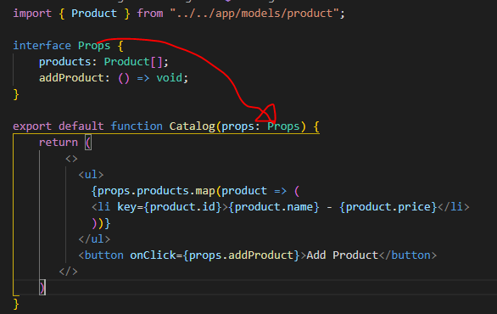

npm install @mui/material @emotion/react @emotion/styled

**Links в линию:**

