**AMY JANE S. QUINTIN**

001 Camella Homes Subdivision, San Antonio I, Noveleta Cavite

☎️ +63 926 593 9709

[Mheej.quintin@gmail.com](mailto:Mheej.quintin@gmail.com)

A long, thin rectangle to divide sections of the document

**CAREER OBJECTIVE:**

To be part of company that indulges professional growth which provides challenging and rewarding career while allowing myself to utilize my knowledge, skills and exceed team goals.

A long, thin rectangle to divide sections of the document

**STRENGTHS:**

* Fast-learner and dedicated in delivering team success.
* Reliable, good team player and multi-tasking capabilities.
* Proven initiative and ability to work with minimal supervision.

**PERSONAL INFORMATION:**

**Age:** 22 years old

**Date of Birth:** January 29, 1997

**Gender:** Female

**Birthplace:** Cavite City, Cavite

**Civil Status:** Single

**Height:** 5’ 5”

**Weight:** 70 kg

**Nationality:** Filipino

**Religion:** Roman Catholic

**EMPLOYMENT BACKGROUND:**

**Service Crew**

Cestaves Coffee, Tea and Food

June 2014 - Part Time

**Cashier**

Sanford Marketing Corp,. (Save more - Primark)

September 2018 - Present

**EDUCATIONAL BACKGROUND:**

**TERTIARY:**

Cavite State University - Cavite City Campus

June 2013 - March 2014

Bachelor of Science in Secondary Education

Major in English

Cavite State University - Imus Campus

June 2015 - March 2017

Bachelor of Science in Psychology

**SECONDARY:**

Patnubay Academy

San Juan I, Noveleta Cavite

June 2009 - March 2013

**ELEMENTARY:**

Patnubay Academy

San Juan I, Noveleta Cavite

June 2003 - March 2009

**CHARACTER REFERENCES:**

Joemar Ballenas

+63 949 014 9564

Bryce Adem Piang

+63 905 647 0723

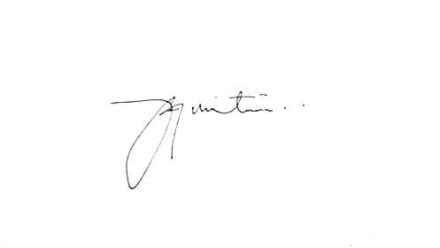

*I hereby certify that the above information are true and correct to the best of my knowledge and belief.*

Signature