**MICRO STRATEGY**

https://www.microstrategy.com/us/services

**Services**

MicroStrategy provides a fast and intuitive analytics experience across web, desktop, and mobile interfaces. Business analysts, IT developers, and administrators can seamlessly create logical data models with Architect and deliver custom applications using a powerful set of APIs.

**Product**

Web is a browser-independent web interface providing query, reporting, and analysis functionality. Using this intuitive web solution, users can execute, access, analyze, and share reports and dashboards. Web also allows users to access MicroStrategy applications through a Microsoft Office interface. This product also includes Web SDK functionality, which allows organizations to customize their web interface. All Web licenses also include a complimentary license to the Desktop product.

**Capabilities include:**

* Save or design dashboards, reports, and documents
* Perform advanced operations such as: subtotaling, formatting, thresholding, drilling, filtering
* Export to PDF, .mstr, Excel, HTML, etc.
* Report debugging
* View SQL
* Create metadata objects
* Access Web SDK function

**VIRON IT**

<https://vironit.com/>

**Services**

### **Consulting services of VironIT**:

1. Help to define project requirements according to a client’s needs;
2. Help to choose a platform, hardware and technical solutions;
3. Provide comprehensive grounding in solutions related to development, deployment, implementation and updating of software;
4. Deal with the issues of software choice to solve specific tasks of a client;
5. Help to deploy IT-projects providing business efficiency enhancement;
6. Help to select an optimal technical solution for the program maintenance.

**Product**

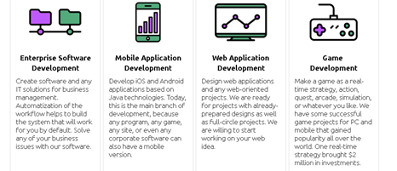

**YARDDIANT**

<https://www.yarddiant.com/>

**Services**

* [E commerce Development](https://www.yarddiant.com/e-commerce-development/)
* [Web Application Security](https://www.yarddiant.com/web-application-security/)
* [Web Development](https://www.yarddiant.com/web-development/)
* [WordPress Development](https://goo.gl/VTwBEw)
* [Fashion Blog Development & Blogger Web Designer](https://www.yarddiant.com/fashion-blogger-development-web-designer/)
* [PSD to WordPress](https://www.yarddiant.com/psd-to-wordpress/)

**Product**

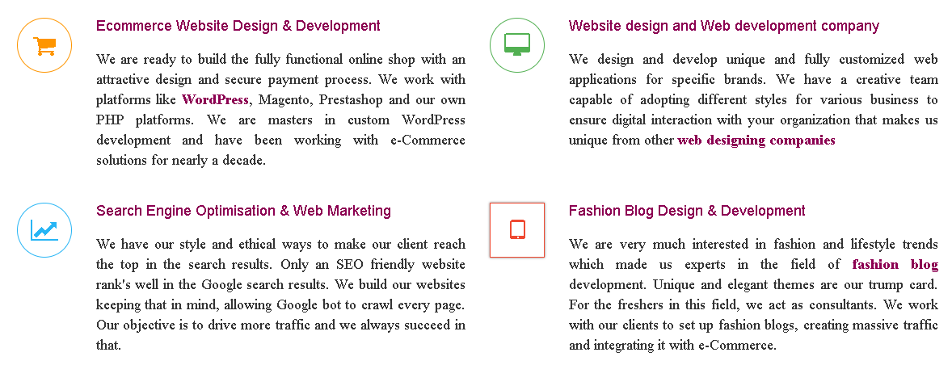

**CONTUS**

https://www.contus.com/

**Services**

* [Full Stack Development](https://www.contus.com/full-stack-web-development.php)
* [Mobility](https://www.contus.com/mobile-application-development.php)
* [eCommerce](https://www.contus.com/ecommerce-web-development.php)
* [IoT](https://www.contus.com/internet-of-things-app-development.php)
* [Cloud Solutions](https://www.contus.com/cloud-solutions.php)

**Products**

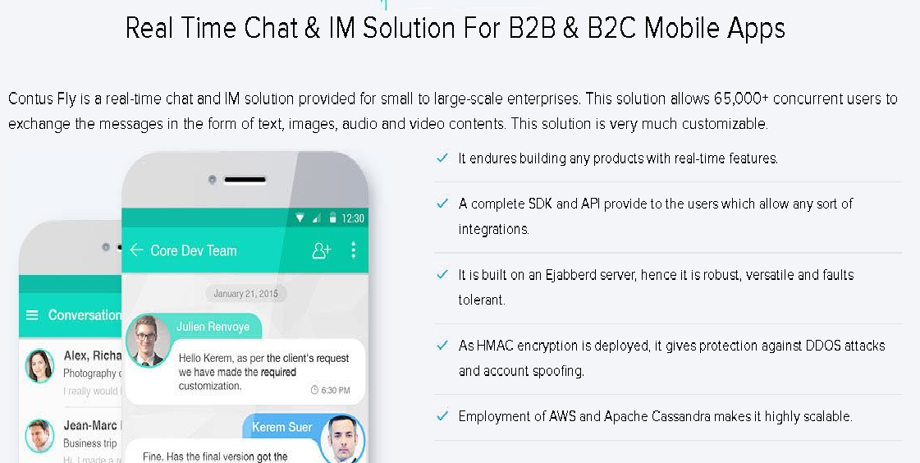

**PIXELCRAYONS**

https://www.pixelcrayons.com/#

* Web Development
* Blockchain Development
* Iot Development
* Custom Software Development Services
* Mobile App Development
* Software Product Development
* IT Consulting & Strategy
* UI/UX Design
* Dedicated Development Teams
* Ecommerce Development
* Frontend Development
* CMS Development
* Application Maintenance & Support

**Product**

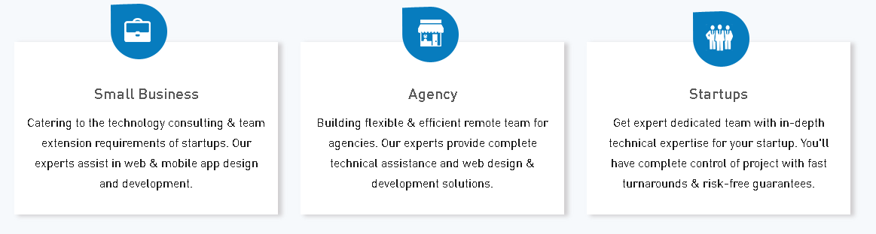

**HYPERLINK INFOSYSTEM**

<https://www.hyperlinkinfosystem.com/>

**Services**

* Web Development
* PHP website development
* Mobile app development
* Wearable App Development
* UI/UX Design
* Unity 2D/3D Game Development

**Product**

