**Ivan Ashley F. Jaminal**

**Definition**

 is any service made available to users on demand via the Internet from a [cloud computing](https://www.webopedia.com/TERM/C/cloud_computing.html) provider's servers as opposed to being provided from a company's own [on-premises](https://www.webopedia.com/TERM/O/on-premises.html)servers. Cloud services are designed to provide easy, scalable access to applications, resources and services, and are fully managed by a [cloud](https://www.webopedia.com/TERM/C/cloud.html) services provider.

**Types of Clouds**

**1.Public Cloud** -  is a type of computing in which a service provider makes resources available to the public via the internet. Resources vary by provider but may include storage capabilities, applications or virtual machines. Public cloud allows for scalability and resource sharing that would not otherwise be possible for a single organization to achieve.

**2.Private Cloud -** provides the same benefits of Public Cloud, but uses dedicated, private hardware. Private cloud means using a cloud infrastructure (network) solely by on e customer/organization. It is not shared with others, yet it is remotely located.  The companies have an option of choosing an on-premise private cloud as well, which is more expensive, but they do have a physical control over the infrastructure.

**3.Community Cloud -** implies an infrastructure that is shared between organizations, usually with the shared data and data management concerns. For example, a community cloud can belong to a government of a single country. Community clouds can be located both on and off the premises.

**4.Hybrid Cloud -** is a cloud computing environment that uses a mix of on-premises, [private cloud](https://searchcloudcomputing.techtarget.com/definition/private-cloud) and third-party, [public cloud](https://searchcloudcomputing.techtarget.com/definition/public-cloud) services with orchestration between the two platforms. By allowing workloads to move between private and public clouds as computing needs and costs change, hybrid cloud gives businesses greater flexibility and more data deployment options.

**Types of Cloud Services**

1. **Infrastructure as a Service (IaaS) -** IaaS is the lowest level of cloud solution and refers to cloud-based computing infrastructure as a fully-outsourced service. An IaaS provider will deliver pre-installed and configured hardware or software through a virtualized interface. What the customers accessing the cloud services do with the service is up to them. Examples of IaaS offerings are managed hosting and development environments.
2. **Platform as a Service (PaaS) -** This type of cloud computing is similar to IaaS but is more advanced. With PaaS, apart from simply providing infrastructure, providers also offer a computing platform and solution stack as a service.The IT infrastructure may come with a graphic user interface, run-time system libraries, programming languages or an operating system.
3. **Software as a Service (SaaS) -** SaaS providers provide fully functionally web-based applications on demand to customers. The applications are mainly targeted at business users and can include web conferencing, ERP, CRM, email, time management, project tracking among others.
4. **Recovery as a Service (RaaS) -**RaaS providers protect and can help companies recover entire data centers, servers (OS, applications, configuration and data), and data (files and databases).

**Involvement**

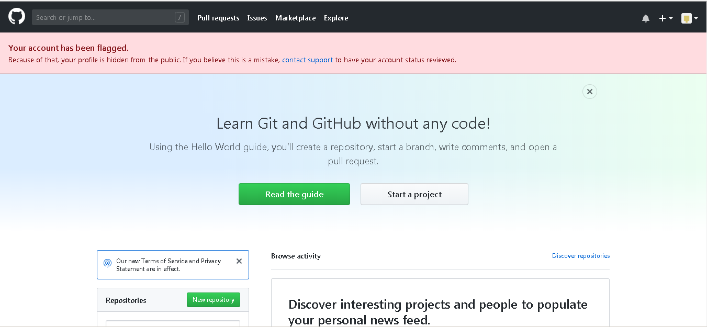

**Github Account**

This website was I used during my ojt in bacoor. This github was enable me to access and to put my data. Its allows me to gathered data of my co workers.

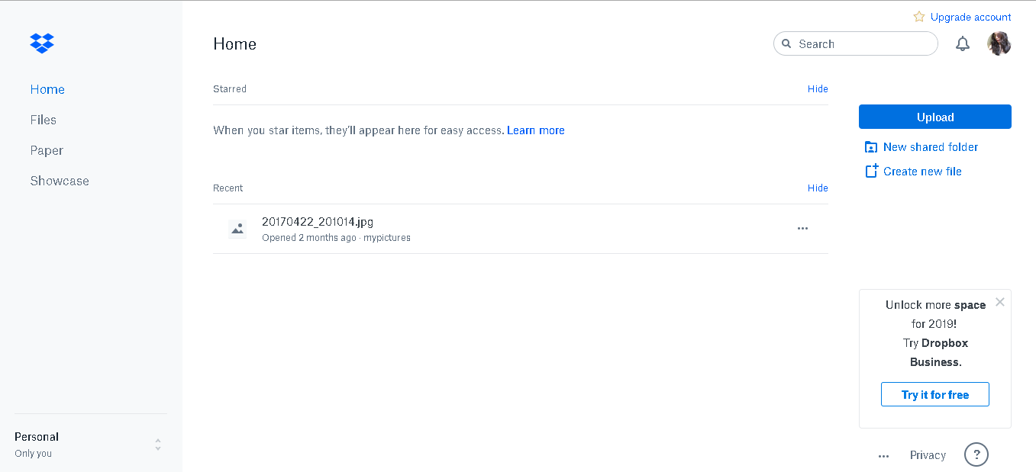

**Dropbox Account**

I used to put my work in here to easily get my data. My example is when I go to computer shop to print my softcopy, I don’t need to put my data on flashdrive because I have dropbox account. I will only login my account in their pc to get the data.