**2. METHODOLOGY**

**2.1 Research Design**

This study used descriptive method of research since the existing processes of the Recoletos Community Outreach Program (ReCOP) Office must be defined first in order to design and create a mobile – responsive web application that will centralized the transactions regarding outreach activities.

According to Ritchiet. al. (2013), descriptive research is a method where the researchers will be able to observe a large mass of target population and will make required conclusions about the variables.

In its essence, descriptive studies are used to describe various aspects of the phenomenon. In its popular format, descriptive research is used to describe characteristics and behavior of the subject. Three main purposes of descriptive studies can be explained as describing, explaining and validating research findings.

The goal of descriptive research is to describe a phenomenon and its characteristics. This research is more concerned with what rather than how or why something has happened. (Gall, Gall, & Borg, 2007).

The most common descriptive research method is the survey sampling which includes questionnaire, personal interviews, phone surveys and normative surveys (Koh & Owen. 2011).

**2.2 Data Gathering Tools**

The researchers designed an interview questionnaire for the data gathering process to get both qualitative and quantitative data.

The primary aim of the interview questionnaire is to identify the processes regarding the outreach activities and to further characterize each procedures if it is vitally important or not.

The questionnaire was structured in such a way that respondents will be able to answer it easily.

**2.3 Data Gathering Procedures**

**Web Development Life Cycle**

Since the output of the project was a mobile-responsive web application, the treatment for data gathered as well as constructing the data-access layer, business logic layer and presentation layer of the entire website much differs with what is done in a typical software. In this case, the researchers used the spiral model under the Web Development Life Cycle.

As the name of the model suggests, the activities done can be organized like a spiral. The spiral has many cycles. The radial dimension represents the cumulative cost incurred in accomplishing the steps come so far and the angular dimension represents the progress made in completing each cycle of the spiral. Each cycle in the spiral begins with the identification of objectives for that cycle and the different alternatives are possible for achieving the objectives and the imposed constraints. (Bhosale, 2014)

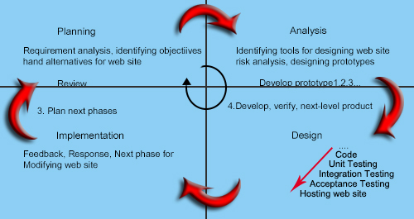**Figure 1.** Spiral Model for Website Designing

**Planning.** The researchers performed an initial meeting in which they were able to identify the scope, objectives and approaches that will be vital for the completion of the project. In addition the project leader and the team members’ individual tasks were assigned. A Gantt chart was constructed to detail the activities.

Afterwards, transaction forms and letters were collected for analysis. The researchers also conducted interviews using their devised questionaires in order for the scope, objectives and approaches to be validated.

**Analysis*.***After the researchers validated all the requirements, they chose the appropriate web development life cycle model for the project.

The spiral model was chosen for the project because of the constant change in requirements. In addition, the client has different approaches when it comes to their processes and are continually changing their standards in adherence to the current school administration’s rules and by-laws. In this case, it is inferable that cycles of continuous planning, analysis, designing and testing must be done to satisfy the client’s feedbacks and needs.

Furthermore, the team had constructed a database structure which will serve as the backbone of the system. The structure, together with other diagrams like use-case, class and activity diagram, was documented and compiled. A project documentation was made afterwards.

Flask and Bulma were the development tools to be used in the completion of the actual web application. Flask is a micro framework from Python which provides simplicity, flexibility and fine-grained control. It also using several plugins which allows developer to freely choose how to implement security, database and design for the project. Bulma is a CSS framework which allows responsive mobile designs which is required for the project.

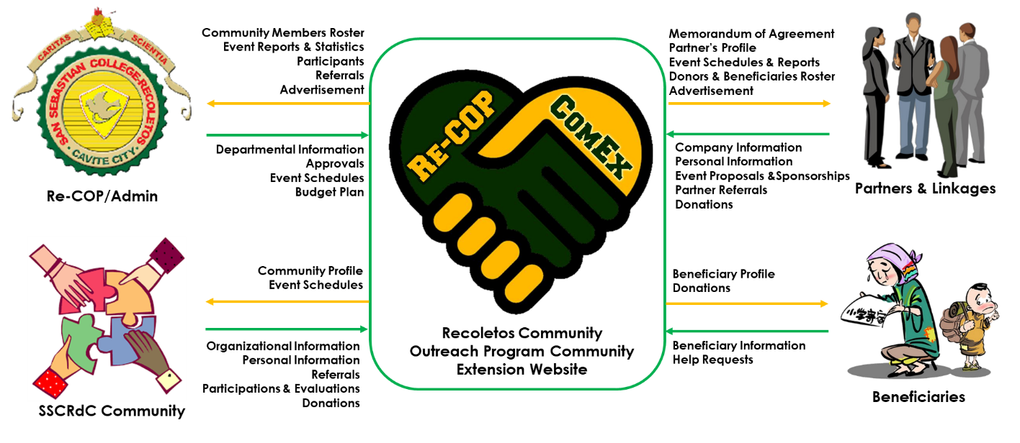**Design*.***The researchers began developing the web application using the tools stated above. Moreover, the researchers constructed a conceptual framework which will detail out the

**Figure 2.** ReCOP-ComEx Conceptual Framework

Each modules were tested in order to assure that the features and requirements stated in the diagrams were satisfied. After all the modules were finished, it is then presented as an initial prototype to client for acceptance.

Users’ Acceptance Test (UAT) Questionnaire was prepared in order to test the initial prototype. The UAT Questionnaire utilizes the Likert format which has the five-point response scale.

**Implementation.** Once the initial prototype passed the test, it is then deployed online. The researchers will also get the feedback and issues encountered from the client once the web application was implemented in a quarterly basis. From these, they will go back to the analysis phase, designing, development and testing of the new prototype.

Additionally, the school’s Information Communication Technology (ICT) Department will be the one in-charge for the back-up and maintenance for the system to ensure that updates and changes in the transaction is implemented.

**2.4 Development Tools**

**Table 1.** Hardware Development Tools

|  |  |
| --- | --- |
| I/O Device | Monitor, Mouse, Keyboard, CPU |
| Processor | Intel Core i5 – 8250U 1.60GHz processor |
| Motherboard | ASPIRE E5-576G-59AB |
| Memory | 4GB DDR3 |
| Hard Disk Drive | 2Tb |
| Auxiliaries | NVIDIA GeForce MX150 with 2 GB of dedicated GDDR5 VRAM  15.6" Full HD 1920 x 1080 high-brightness resolution  8X DVD-Super Multi double-layer drive  WLAN: 802.11a/b/g/n/ac wireless LAN  41.4 Wh 2800 mAh 14.8 V 4-cell Li-ion battery pack |

**Table 2.** Software Development Tools

|  |  |
| --- | --- |
| Compiler | Python |
| Database Server | MySQL |
| Database Integrated Development Environment | phpMyAdmin |
| Design of User Interface | Bulma and Adobe Photoshop |
| Text Editor | Sublime text |
| System Documentation | Microsoft Word 2016 |
| Operating System | Microsoft Windows 10 Home |

**2.5 Respondents and Evaluators**

The respondents and evaluators for the interview and the users’ acceptance test were the administrator, staffs and student assistants from the Recoletos Community Outreach Program (Re-COP) Office of San Sebastian College – Recoletos de Cavite (SSCRdC).

Moreover, the school’s ICT department was also interviewed to determine existing technologies that are already available in the campus. This helped the researchers in planning the budget and implementation of the system.

The SSCRdC’s organizational leaders as well as its partners and linkages were also involved in the completion of the study.

**2.6 Statistical Treatment of Data**

As mentioned in earlier parts, the UAT Questionnaire that the researchers will be using to test the system follows the Likert’s format with a five-point response scale.

A Likert Scale is a rating scale that requires the subject to indicate his or her degree of agreement or disagreement to a statement. In this type of questionnaire, the respondents were given five response choices. These options served as the quantification of the participants’ agreement or disagreement on each question item. The table below shows the designated qualifications used.

**Table 3:** The Five-Point Response Scale

|  |  |
| --- | --- |
| 1 | Strongly agree |
| 2 | Agree |
| 3 | Neutral |
| 4 | Disagree |
| 5 | Strongly disagree |

In order to analyze the data gathered from this test, the weighted mean for each question item will be computed. Weighted mean is the average wherein every quantity to be averaged has a corresponding weight. These weight will represent the significance of each quantity to the average.

To compute for the weighted mean, each value must be multiplied by its weight. Products should then be added to obtain the total value. The total weight should also be computed by adding all the weights. The total value is then divided by the total weight. The computed mean was then compared to the scale below for interpretation:

**Table 4:** Weighted Mean Interpretation

|  |  |
| --- | --- |
| **Range** | **Interpretation** |
| 0.10 – 1.00 | Strongly agree |
| 1,10 – 2.00 | Agree |
| 2.10 – 3.00 | Neutral |
| 3.10 – 4.00 | Disagree |
| 4.10 – 5.00 | Strongly disagree |

Results of the survey will be presented in tables. Excerpts from the interview process will be integrated based on the analysis outline. Relevant literatures to support the findings will also be included.

**2.7 Project Schedule**

The researchers followed these schedules and time frames in order to complete the stages and tasks connected to the project. The Gannt Chart and PERT-CPM diagram were also prepared to detail out and to determine the shortest and the longest possible duration the team will take to finish the project.

**1. Planning**

1.1 Form Project Team (1 day)

1.2 Initial Meeting (1 day)

1.3 Data Gathering (5 days)

**2. Analysis**

2.1 Data Analysis (2 days)

2.2 Budget Analysis (2 days)

2.3 Select Web Methodology (2 days)

2.4 Project Scheduling (2days)

2.5 Create Project Documentation (10days)

**3. Design**

3.1 Procurement (5 days)

3.2 Coding (60 days)

3.3 Testing and Debugging (10 days)

3.4 Finalized Initial Prototype (5 days)

**4. Implementation**

4.1 Contact Signing (1 day)

4.2 Deployment (5 days)

4.3 Support and Maintenance (Quarterly)