**3. IMPLEMENTATION**

**3.1 Conceptual Framework**

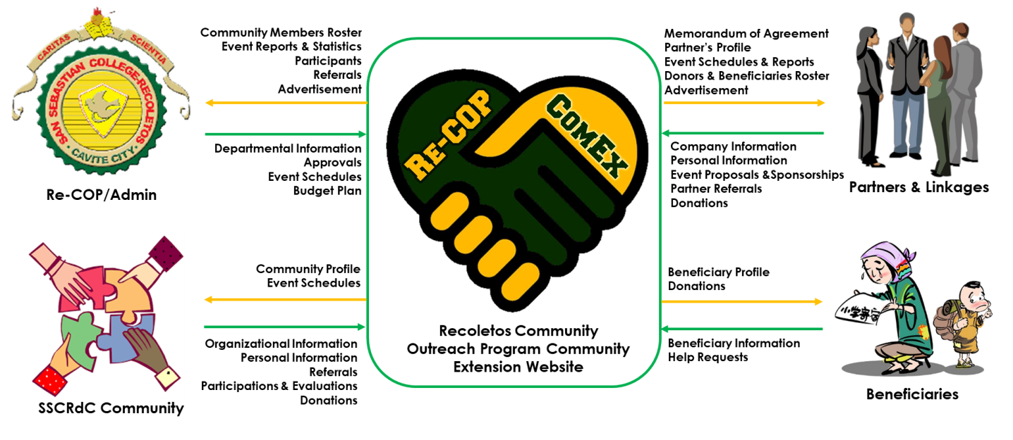

**Figure 2.** ReCOP-ComEx Conceptual Framework

**3.2 Project Budget**

A total of ₱ 51, 148.00 will be spent for the completion of the project. These include the purchase of the domain name of the website and the development costs. Furthermore, the benefits is also listed to assess if the project would be worthwhile. Note that all of these figures are the values gained or lost over a year.

**Table 5.** Cost and Benefit Analysis for ReCOP-ComEx Website

|  |  |  |  |  |  |  |  |  |
| --- | --- | --- | --- | --- | --- | --- | --- | --- |
| **COSTS** | | |  | **BENEFITS** | | | |  |
|  |  |  |  |  |  |  |  |  |
| **\*One-Time Cost** | | |  | **\*Tangible** | | | |  |
|  |  |  |  |  |  |  |  |  |
| Development Cost | | | 50,000.00 | Less Papers | | | | 5,160.00 |
|  |  | **Total:** | **50,000.00** | Additional donations | | | | 43,333.33 |
|  |  |  |  |  |  |  | **Total:** | **48,493.33** |

**Table 5** (continued)

|  |  |  |  |  |  |  |  |  |
| --- | --- | --- | --- | --- | --- | --- | --- | --- |
| **\*Recurring Cost** | | |  | **\*Intangible** | | | |  |
|  |  |  |  |  |  |  |  |  |
| Domain Name | | | 1,148.00 | Faster approval for proposals | | | | 0.00 |
|  |  | **Total:** | **1,148.00** | Donors & beneficiaries visibility | | | | 0.00 |
|  |  |  |  | Improve brand image | | | | 0.00 |
|  |  |  |  | Increase partners and linkages | | | | 0.00 |
|  |  |  |  | Improve event success rate | | | | 0.00 |
|  |  |  |  |  |  |  | **Total:** | **0.00** |

**3.3 Budget Narrative**

Since the desktop units, hard drives, network infrastructure, web hosting and cloud backup were readily available and was established already by the Information Communications Technology (ICT) Department of the institution, the researchers did not find the need to purchase these items.

In this case, the researchers will be utilizing the existing technologies and equipment for the implementation phase of the project. However, the following were the items that the project team will still be adding and procuring.

**Development costs.** This is the fee that the project team will be charging for the four months of working on with the project. The cost was divided and will be distributed among five members of the project team, having ₱ 10,000 salary each.

**Domain Name.** This is the actual purchase for the website’s address. The project team will be purchasing this from GoDaddy.com and has an annual subscription amount of ₱ 1,148.00.

**3.4 Budget Feasibility**

In order to prove that cost spent by the project would be worthwhile, a Net-Present Value and Payback Analysis were done. However, the benefits of the project must be enumerated and justified before proceeding to the analysis.

**Less Papers.** The researchers multiplied the average paper rim usage of the department for its outreach transactions which is 2 rims per month by the paper rim price of ₱ 215.00. The product was multiplied by 12 to get the annual value of ₱5,160.00.

**Additional Donors.**Based on an interview with an officer from the Re-COP Office, an average donor donates an estimated amount of ₱2,000.00. The Facebook page of SSCRdC Re-COP currently has 1,300 followers which shows the amount of people interested in its outreach program activities and having access to internet. Thus, this can be calculated by dividing the number of social media followers by number of months in five years then multiplying it by the average donation amount. Doing the math, a value of ₱43,333.33 was gained.

Lastly, the ReCOP Office is a non-profit department, meaning the organization’s main goal is to provide welfare and service among the people who are in need. The intangible benefits that the project will provide: faster approval for proposals, donors and beneficiaries visibility, improved brand image, increased partners and linkages and improved event success rate will reflect to the mission and vision of this institution.

**Table 6.** Net Present Value and Payback Analysis for the ReCOP Website



The table above is the NPV and Payback Analysis with a discount rate of ten (10) percent. This shows that the project has payback in its third year. Moreover, a Return of Investment (ROI) of 181% percent was also calculated. This shows that the project will be a worthwhile one.

**3.5 Risk Management Plan**

In order to minimize the number and occurrences of the project risks, the project team had arrived in the following plan.

First, the group performed data gathering and data analysis. Conduct interview, request forms and other documents related to the study were collected which aid in narrowing down the scope of the project into the expected outcome of the client.

Aside from the weekly status reports and meetings, each team member was expected to report daily and update tasks via dashboard. Through this dashboard, the team can report and tracked bugs that occur in the system. This is to ensure that all the works and deliverables occur with the project arrives in good shape and help co-member who are in difficulty of the task. Moreover, the project manager can identify and prevent upcoming and additional risks.

Furthermore, the project manager will update the risk register and formulate solution overhand if an unavoidable risk is certain to occur. In this case, the project team will have a greater chance of surviving the problem.

The table below shows the possible risks that the project team may encounter as the project progresses. In addition, the counter precautions are also indicated.

**Table 7.** Risk Register for the ReCOP Website

|  |  |  |  |  |  |  |
| --- | --- | --- | --- | --- | --- | --- |
| **ID** | **Description** | **Probability** | **Impact** | **Ranking** | **Response** | **Trigger** |
| 1 | Unfamiliarity to the technology | Medium | High | High | Integrate lectures about the website in the organization’s activities and seminars as well as in its social media pages. | Stakeholders has no knowledge how the website works. |
| 2 | Slow internet connection | Medium | High | Medium | Configure type of internet access and limit the time of users connected the internet. | Having many people are connected to the internet. |
| 3 | Web traffic | Medium | High | High | Increase monitoring of pages which pages are triggering to visitors, how long visitors are sticking around. | Cause by recent website changes. |
| 4 | Scope inflates | Medium | Low | Low | Focus and finish first the initial objectives and features of the project. Since the methodology is prototyping, changes or additions can be integrated in the next update. | The scope uncontrollably change and grow due to client requests and other factors. |
| 5 | Resistance due to budget | Medium to High | Medium | High | Consider utilizing the existing hardware in the organization instead of buying new ones. Use open–source software if the security will not be compromised. | Sponsor has no enough financial capability to support the project further. |
| 6 | Conflict over changes | Medium | High | Medium | Review the organization’s vision, mission and objectives before planning or implementing certain change. | Changes made by the application conflicts with the interests and rules of the organization. |

**3.6 Roles and Responsibilities**

**3.7 New Procedures**