(046) 431-0861 local 774 🖀

www.sscr.edu 🖄

#### Computer Studies Department

San Sebastian College Recoletos de Cavite, Inc.

Mla-Cavite Blvd., Sta. Cruz, Cavite City 4100

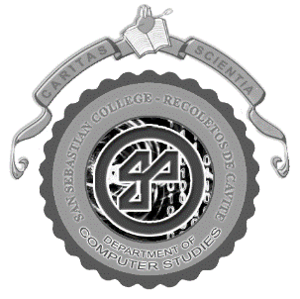

# November 27, 2018

**Rev. Fr. Joseph Dexter D. Palagtiosa, OAR**

*Vice President for Formation, Mission and Identity*

San Sebastian College ­- Recoletos de Cavite

Cavite City

Fr. Palagtiosa:

*Pleasant Greeting!*

The fourth year students of BSIT (Bachelor of Science in Information Technology) of San Sebastian College in Cavite City are presently working on their Capstone Thesis as partial requirement to their degree program of study.

With their thesis entitled “Recoletos Community Outreach Program Community Extension Website (ReCOP – ComEx)”, I humbly ask permission from your good office to allow the following student researchers to conduct interview or survey at your convenient and favorable time:

1. Austria, Marian T.
2. Jaminal, Ivan Ashley F.
3. Majillo, Serge Angelo I.
4. Quintin, Alex Austin S.
5. Sotto, Marie Leen S.

Any help and information you could extend to them is highly appreciated. Rest assure that whatever acquired information will be used only for academic purpose with confidentiality.

*Many Thanks and God Bless.*

Sincerely,

**Mr. Antonio C. Co, MBA**

Head, Computer Studies Department