Structural Identifiability of Epistemic Value
in Active Inference
Adversarial Model Comparison and a Matched-Channel Experimental Design
Research note · Version 1.1 · 28 September 2026
METHOD PROPOSED + SYNTHETICALLY IDENTIFIABLE + HUMAN VALIDATION PENDING
Public title: Structural Identifiability of Epistemic Value · matched-channel design

Abstract
Active Inference (AIF) assigns policies both pragmatic/extrinsic and epistemic/intrinsic value. An empirical difficulty is that information-seeking choices can be generated by many non-AIF mechanisms, so successful model fit need not imply theory-specific support. We report an adversarial sequence of synthetic tests designed to determine what choice behavior can and cannot identify. A reduced one-step policy-ranking model is related here to the expected-free-energy (EFE) decomposition under stated assumptions. Reward-only and flexible Bayes-adaptive rivals were separable for sufficiently strong epistemic effects, but a generic curiosity bonus rendered ordinary symmetric-cue tasks nearly observationally equivalent. A search over 175,821 condition pairs did not yield a fully robust sign-reversal discriminator against the tested curiosity family. We therefore propose a matched asymmetric-channel design: pairs with equal prior, equal mean cue accuracy, and equal instrumental sampling value, but different exact mutual information. In the tested synthetic model class, this design generated substantial exact-MI sampling contrasts while the mean-accuracy curiosity rival generated approximately none, and model-family recovery exceeded 96% for both families by 240 trials. However, an alternative controller implementing the same exact mutual-information objective and policy mapping is behaviorally indistinguishable from the reduced AIF controller. The proposed human study therefore targets exact-MI-sensitive epistemic valuation relative to specified alternatives. A close human OED precedent already exists (Nelson et al., 2010). The remaining question is what an Active Inference framing adds beyond that contrast. The design is not a test of the entirety of Active Inference, and it cannot uniquely verify the universal Free Energy Principle.
Keywords: Active Inference; expected free energy; epistemic value; mutual information; identifiability; model comparison; curiosity; experimental design; preregistration.

1. Introduction

1.1 Motivation: from a general principle to an identifiable prediction
The Free Energy Principle, taken as a general statement about self-organizing systems, is too coarse to be the object of this study. Scientific content appears only when a specific expected-free-energy / Active Inference instantiation yields an identifiable prediction that a strong rival can fail. The intended inference ladder is therefore
general FEP → specific EFE/AIF model → identifiable prediction → strong rival
Compatibility with exploratory data is not confirmation of the principle. A 2026 review of the empirical science of Active Inference makes the same demand: theory-driven experiments that adjudicate between accounts, rather than treating fit as support for the framework as a whole [7]. The present note occupies only the third and fourth rungs of that ladder, and only for epistemic value.

1.2 The identifiability problem for epistemic value
Active Inference proposes that policies are selected by minimizing expected free energy, a quantity that can be expressed in terms of pragmatic/extrinsic and epistemic/intrinsic value. In standard discrete-state formulations, epistemic value corresponds to expected information gain about hidden states or parameters, linking Active Inference to optimal Bayesian design, active learning, and broader information-seeking frameworks [1,2].
This creates an identifiability problem. Observing exploration, uncertainty reduction, or even behavior consistent with mutual information does not uniquely identify the theoretical framework that produced it. Intrinsic-motivation and curiosity models predate much of the contemporary Active Inference literature [3]. Information-directed sampling uses mutual information explicitly to balance exploration and exploitation [4]. Human information-gathering research distinguishes competing norms such as information gain, probability gain, diagnosticity, and impact [5]. The relevant competitor class is therefore not merely reward-based reinforcement learning, but alternative information-seeking objectives.
Recent work reinforces the same discipline. A 2026 complexity-matched comparison of AIF and reinforcement-learning models found overlapping but partially distinct explanations and similar predictive accuracy [6]. That overlap is expected if a general principle is too coarse and only specific instantiations can be tested.
The present note develops a candidate discriminative design and, equally importantly, specifies what that design cannot establish. We do not claim a first demonstration, a first structural discriminator, or a theoretical breakthrough. We propose a matched asymmetric-channel design and report an adversarial synthetic sequence that delimits its interpretive reach. All numerical results reported here are synthetic. No human empirical data have been collected.
Scope of this note
This paper is one kill-test of epistemic-value identifiability. It is not a test of the Free Energy Principle as a general statement, not a closed-loop causal intervention experiment, not a coarse-graining / scale-gap result, and not clinical evidence. A later positive human contrast would still sit on the third and fourth rungs of the ladder in Section 1.1.

2. The identifiability problem
The project began from a strong empirical ambition:
Initial claim C0 — not treated as a premise
AIF produces behaviorally distinctive epistemic choices that cannot be reproduced by strong non-AIF alternatives.

C0 was not treated as a premise. Each stage introduced a stronger rival or a stricter identifiability test. An earlier PASS was allowed to lose interpretive force when a later rival reproduced the same observables. The resulting discipline is that a positive fit licenses only the weakest conclusion still standing after the strongest implemented rival has been confronted.
Result | Maximum licensed conclusion
Exact-MI model beats reward-only control | Information value improves prediction relative to that rival.
Exact-MI model beats a flexible reward-based Bayes-adaptive rival | The effect is not absorbed by the tested reward/uncertainty nuisance parameters.
Generic curiosity matches the exact-MI model | Information seeking is not mechanism-specific.
Matched-channel exact-MI model beats tested coarse curiosity | Behavior is sensitive to information geometry beyond mean accuracy in the tested model class.
Another controller uses the same exact-MI objective and policy mapping | Behavior cannot identify the theoretical derivation.

Table 1. Allowed versus forbidden inferences after the adversarial sequence.
The remainder of the note follows this discipline. Version 1.1 adds an explicit EFE derivation for the reduced controller, recasts the v7 equivalence as an interpretation boundary, downgrades the human protocol from “ready” to a candidate, and expands the rival set that a later confirmatory study must confront.

3. Relation of the reduced model to expected free energy
The main technical revision in Version 1.1 is to state how the reduced controller relates to expected free energy, and where that relation stops. A reviewer can otherwise say, correctly, that a generic information-gain controller was compared rather than Active Inference as such.

3.1 General EFE decomposition
For a future policy π, a standard discrete-state formulation expresses expected free energy as containing an extrinsic/preference term and an epistemic expected-information-gain term, up to an expected-evidence-bound (ambiguity) term [1,2,10]. Under idealized model alignment, the policy ranking can be written schematically as
−G(π) ≈ E_Q[log P_C(o) | π] + I_Q(S; O | π) + constant (1)
Here P_C(o) encodes prior preferences over outcomes and I_Q(S;O|π) is the expected mutual information between hidden state and future observation under the policy. Equation (1) is the starting point of the reduction, not an additional assumption that information gain is unique to Active Inference.

3.2 When the pragmatic term becomes instrumental value
Assume outcome preferences take the exponential form P_C(o) ∝ exp(κ r(o)), where r(o) is the task reward and κ > 0 sets preference precision. Then
E_Q[log P_C(o) | π] = κ · E_Q[r(o) | π] − log Z (2)
Because −log Z is policy-independent, ranking policies by −G becomes equivalent to ranking
E_Q[r(o) | π] + (1/κ) · I_Q(S; O | π) (3)
After rescaling, the reduced score used in the simulations is therefore
V_red(π) = V_instr(π) + α_epi · I(S; O | π) (4)
In the one-step task, only SAMPLE has a nonzero epistemic term. The other actions (SAFE, COMMIT_L, COMMIT_R) are scored by instrumental value alone. This is the reduced Active-Inference controller used throughout v1–v8. It is a model of an EFE-derived epistemic-value component, not a process-level implementation of full Active Inference.

3.3 Status of α_epi
The parameter α_epi must not be conflated with softmax temperature. Decision precision β maps scores to choice probabilities and is a property of the policy mapping, not of EFE. Under the derivation above, α_epi = 1/κ is the inverse preference precision: a derived relative scale between reward units and nats of expected information gain. In that reading it is not a phenomenological curiosity slider added on top of Active Inference.
In the reported simulations, however, the reward scale is held fixed and α_epi is varied as a free parameter. That usage is a phenomenological extension of the reduced ranking model. It is useful for recovery and identifiability analysis, but it is not a claim that a freely weighted information-gain term is the unique or canonical parameterization of full Active Inference.

3.4 Assumptions required for the reduction
- Discrete binary hidden state Z ∈ {L, R}.
- Finite observation alphabet Y ∈ {L, R}.
- One-step sampling policy: acquire a cue, then make a terminal commitment.
- Fixed outcome preferences; no preference learning during the decision.
- Bayesian posterior updating under a known observation channel.
- Epistemic term expressed as expected information gain I(Z; Y).
- Pragmatic term identified with expected instrumental reward when log-preferences are proportional to reward.
- No parameter-learning / novelty term in the confirmatory choice contrast.
- Terminal reward outcomes are not additionally counted as an epistemic signal; the designed cue is the information-bearing observation of interest.
- Policy comparison uses the reduced expected score rather than a full process-level implementation of belief updating and neuronal dynamics.
- The expected-evidence-bound / ambiguity term is treated as negligible or constant under the idealized model-matching assumptions used for this discrimination exercise.
Scope of the reduced model
The reduced model tests an EFE-derived epistemic-value component. It does not test the entirety of Active Inference, nor every formulation or process-level implementation of expected free energy.

4. Competing information-seeking mechanisms
The candidate contribution must be positioned within a literature in which information gain is not unique to Active Inference. The main competitor is no longer “RL versus AIF” in the abstract, but alternative information-seeking objectives that can generate similar sampling.

4.1 Relation to information-theoretic exploration and experimental design
Framework | Information-seeking principle | Role in this project
Active Inference / EFE | Expected epistemic value / information gain | Source of the reduced exact-MI target under Section 3 assumptions.
Bayesian experimental design | Expected information gain as a design utility [11,12] | Shows that exact MI has a broader non-AIF normative role.
Intrinsic motivation / curiosity | Prediction improvement, novelty, competence, or other intrinsic rewards [3] | Shows that exploration is not theory-specific.
Information-gain exploration | Policies scored by expected reduction in uncertainty | Closest generic cousin of the reduced controller.
Information-directed sampling | Mutual information used directly in exploration/exploitation [4] | Strong conceptual rival to any claim that MI sensitivity identifies AIF.
Bayes-adaptive RL | Planning in a belief MDP; exploration as value of information | v3 already used a flexible reward-based member of this family as a rival.

Table 2. Neighboring information-seeking traditions. None is claimed to be exhausted by the current synthetic comparisons.
Version 1.1 therefore makes no “first”, “breakthrough”, or universal novelty claim. A close human precedent already exists. Nelson et al. (2010, Experiment 3, Condition 1) constructed two binary features with the same prior and the same probability gain (0.25) but different information gain, and tested them in humans [16]. An independent recalculation recovers equal Bayes-optimal accuracy (0.75) and unequal mutual information (approximately 0.2158 vs 0.1308 nats). That is the same design class as v6 — same prior, same instrumental classification value, different exact MI — though not the same task. Design-class novelty of v6 is therefore not supported. What remains open is whether an Active Inference decision framing adds an empirically distinct prediction beyond this older optimal-experimental-design contrast (Section 11).

4.2 Programme-level rival hypotheses
A further, programme-level alternative is that any engineering or behavioral success of Active Inference is explained by its information-seeking objective family without the physical or metaphysical claims sometimes attached to the Free Energy Principle — for example as an intrinsic-motivation or Bayes-adaptive control scheme [3,4]. That hypothesis is why the rival set cannot stop at generic curiosity. Information-directed sampling, Bayes-adaptive RL, Thompson sampling, UCB, Bayesian surprise, and mixture heuristics are not optional extras; they are the controls that keep an AIF-labeled fit from being re-read as support for the principle.
Hypothesis | Content | Status in this note
Exact-MI valuation | Sampling tracks I(Z;Y) after coarse summaries are matched. | Synthetically identifiable vs the tested curiosity family; human test open; weakened as a first-discovery claim by Nelson et al. [16].
Probability-gain valuation | Sampling tracks expected increase in correct-classification probability. | Supported in a close OED human cell [16]; not yet implemented as a v6 rival in our code.
Engineering-without-FEP | AIF successes are explained as RL / intrinsic-motivation analogues. | Not tested here; it is the reason the rival set must keep growing.
FEP-as-principle | A positive epistemic-value result confirms the general Free Energy Principle. | Out of scope and already blocked by the Section 1.1 ladder and by v7.

Table 2b. Programme-level hypotheses. None of these rows is new v6 evidence.

5. Adversarial sequence v1–v5
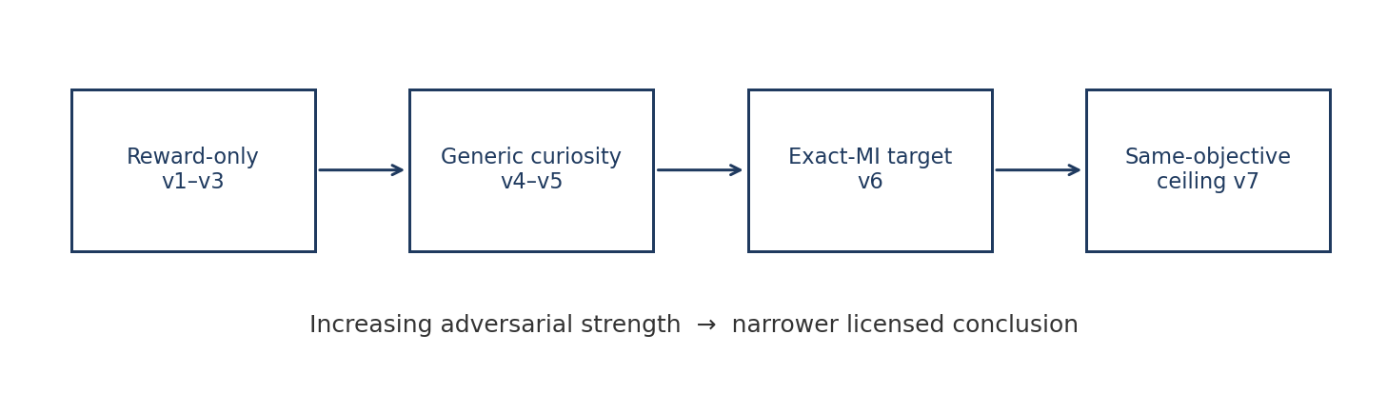
Figure 1. Adversarial sequence. Each later rival narrows the conclusion that a positive result may license.

5.1 v1–v3: progressively stronger reward-based rivals
The base task is a one-step hidden-context decision. A binary hidden state Z ∈ {L, R} is drawn from prior P(Z = L) = p. The agent may take a safe option, commit immediately to L or R, or pay a cost c to observe a cue and then commit. In v1–v3 the cue is a symmetric channel with reliability q = P(Y = Z).
v1 separated the reduced exact-MI controller from a reward-only Bayesian controller in selected conditions. v2 then introduced parameter recovery and revealed weak-effect regions where the generating family was not reliably identifiable. v3 strengthened the reward-based rival by fitting decision precision, subjective cue reliability, and subjective information cost — a flexible Bayes-adaptive instrumental rival. Strong epistemic effects remained recoverable; weak effects did not.
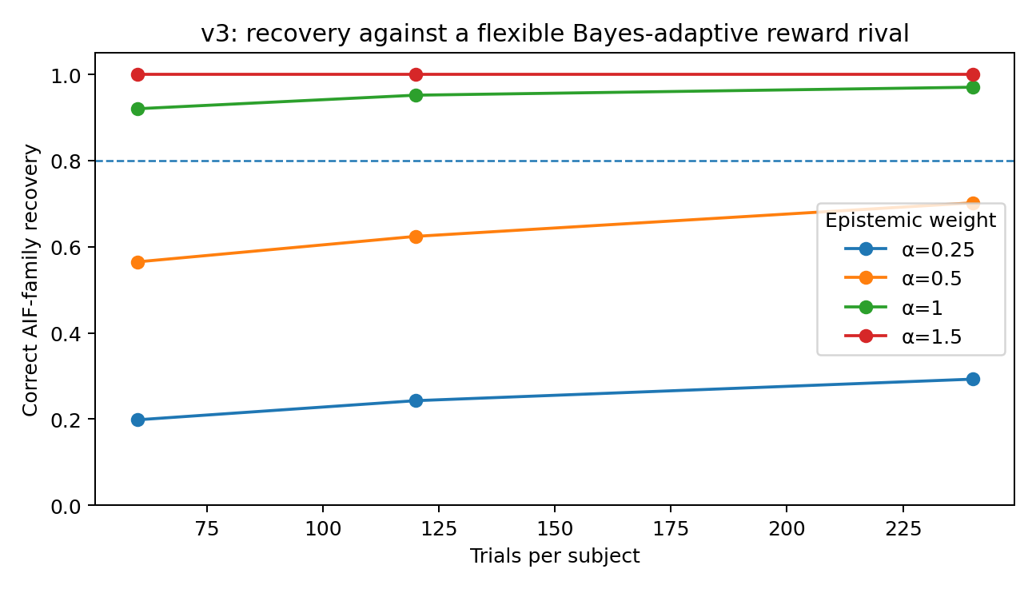
Figure 2. v3 recovery against a flexible Bayes-adaptive reward rival. Strong epistemic weights survive the tested instrumental rival; weak weights remain an identifiability problem. These are synthetic recovery rates, not a human sample-size calculation.

5.2 v4: generic curiosity destroys specificity
v4 is the crucial negative result and must remain visible. Once the rival was allowed an intrinsic information-seeking bonus of a different functional form, ordinary symmetric-cue tasks became nearly observationally equivalent. The tested coarse curiosity family scored sampling as
V_curiosity(SAMPLE) = V_instr + κ · H(Z) · (2q − 1)^γ (5)
In the tested grid, the median minimum Jensen–Shannon divergence was approximately 5.5×10⁻⁷, the 90th percentile approximately 5.9×10⁻⁶, and the maximum approximately 2×10⁻⁵. A flexible coarse curiosity family can therefore closely mimic the reduced exact-MI model in the symmetric-cue task. Information seeking, as such, is not mechanism-specific.
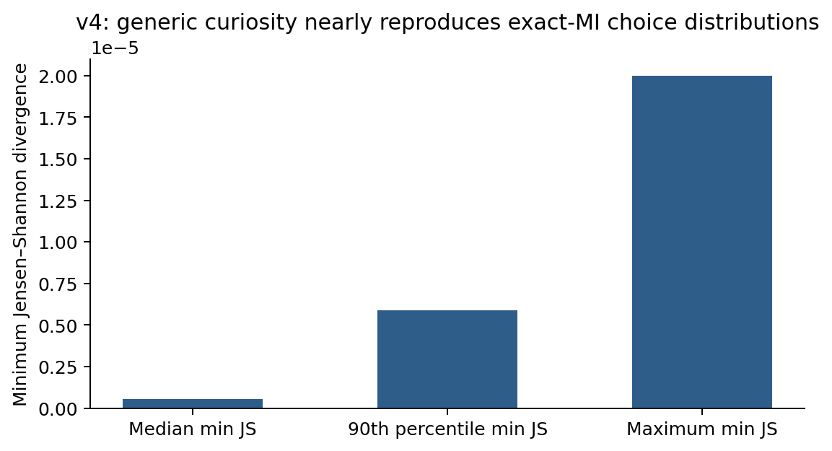
Figure 3. v4 equivalence diagnostic. Minimum Jensen–Shannon divergence between the reduced exact-MI controller and the best-fitting tested curiosity parameterization, across the symmetric-cue grid.

5.3 v5: unsuccessful structural search in the symmetric task
v5 is the unsuccessful structural search and should remain visible as such. A search over 175,821 pairs of symmetric-cue conditions sought robust ordering reversals between the exact-MI and curiosity families. No pair produced a 100% sign reversal across the full tested curiosity parameter grid; the best pair reversed the ordering for approximately 71.8% of rival parameterizations. This motivated a change in task geometry rather than further parameter tuning.

6. Matched asymmetric-channel design (v6)
We propose a matched asymmetric-channel design. The observation channel is expanded from a single symmetric reliability q to sensitivity a = P(Y = L | Z = L) and specificity b = P(Y = R | Z = R). This makes it possible to hold coarse summaries fixed while changing the full channel geometry.
Selected matched pairs satisfy:
- the same prior P(Z = L);
- the same mean cue accuracy q̄;
- the same instrumental value of sampling, achieved by cost matching;
- a material difference in exact mutual information I(Z; Y).
I(Z; Y) = H(Y) − H(Y | Z) (6)
Under these constraints, a controller that scores sampling by exact mutual information predicts a sizable within-pair sampling contrast. A controller that scores sampling by a coarse uncertainty×accuracy bonus, using only q̄, predicts approximately none.
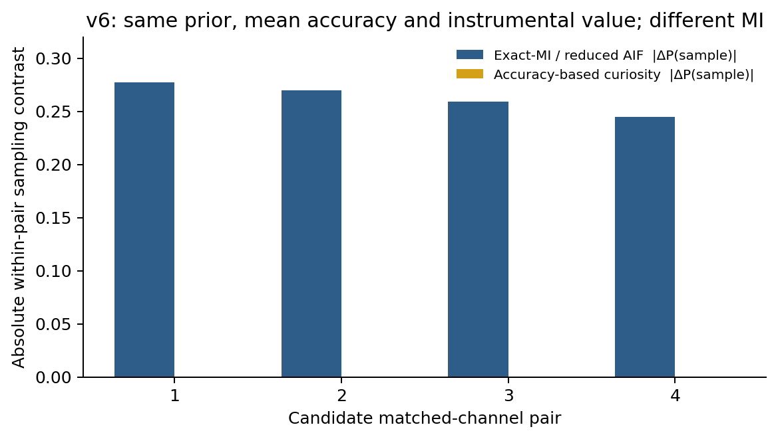
Figure 4. Matched-pair structural contrast for the four candidate confirmatory pairs in Table 3. Under the tested coarse curiosity model the pair is approximately indistinguishable; the exact-MI model predicts a sizable sampling contrast.

7. Structural identifiability results
Table 3 reports the four candidate matched pairs retained for a later confirmatory protocol. Predicted ΔP is the absolute difference in sampling probability between the two channels of a pair, under the stated synthetic parameterization. These values are model predictions, not human data.
Pair | Prior p | Mean accuracy | ΔMI (nats) | Pred. ΔP exact-MI | Pred. ΔP coarse curiosity
1 | 0.70 | 0.780 | 0.143 | 0.277 | 0
2 | 0.80 | 0.846 | 0.138 | 0.270 | 2.22×10⁻¹⁶
3 | 0.70 | 0.738 | 0.140 | 0.259 | 0
4 | 0.80 | 0.798 | 0.136 | 0.245 | 0

Table 3. Candidate matched-channel conditions. ΔMI and predicted sampling contrasts are synthetic.
Table 4 reports synthetic family recovery in the tested parameterization. At 240 trials, correct recovery was approximately 98.3% for exact-MI/AIF-generated data and 96.7% for the tested coarse-curiosity-generated data.
Trials | True exact-MI / reduced AIF family | True coarse-curiosity family
60 | 97.2% | 80.0%
120 | 96.1% | 89.6%
240 | 98.3% | 96.7%
480 | 99.4% | 100.0%

Table 4. v6 family recovery in the tested synthetic parameterization. Toy recovery only.
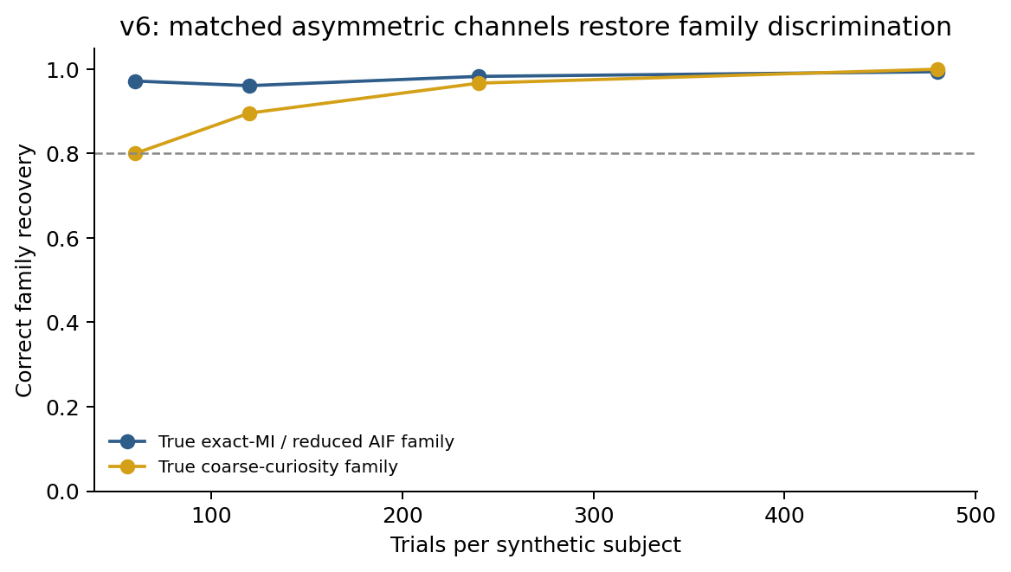
Figure 5. v6 family recovery in the tested synthetic parameterization. These percentages must not be used to determine participant sample size.
Sampling-size gate
The current synthetic recovery rates must not be used to determine participant sample size. They are toy/synthetic recovery values under a restricted individual-agent parameterization, not a hierarchical power surface.

v6 discriminates the tested accuracy-based curiosity family. It does not discriminate all conceivable information-seeking algorithms. That restriction is essential to the claim that can be defended after a later human study.

8. Equivalence and interpretation boundary (v7)
v7 is not a standalone theoretical result and is not offered as a mathematically surprising theorem. Its role is to delimit the interpretation of any positive behavioral finding.
Write the reduced AIF controller and an alternative information-seeking controller as
V_AIF = V_instr + α · I(Z; Y) (7)
V_ALT = V_instr + λ · I(Z; Y) (8)
If α = λ and both controllers use the same policy mapping Q(a | x) — in the simulations, the same softmax with the same decision precision — then for every action a and every task condition x,
Q_AIF(a | x) = Q_ALT(a | x) (9)
The numerical grid check returned zero difference to floating-point precision. Consequently,
behavioral data ⇏ unique theoretical derivation (10)
The equivalence result is not intended as a mathematically surprising theorem; its role is to delimit the interpretation of any positive behavioral finding. A later human contrast, even if clean, can support sensitivity to an exact-MI objective relative to specified alternatives. It cannot uniquely identify Active Inference when another theory implements the same objective and the same observation-to-action map.
Interpretation boundary
A positive behavioral result can support exact-MI-sensitive valuation relative to specified alternatives. It cannot uniquely identify Active Inference or the Free Energy Principle.

9. Candidate empirical protocol (v8)
Version 1.1 changes the status of the human study from a preregistration-ready empirical protocol to a preregistration-oriented candidate protocol. The protocol is not final until the following gates have been completed:
hierarchical model → parameter recovery → false-positive analysis → power surface (11)
Frozen candidate empirical claim
When instrumental value and mean cue accuracy are matched, sampling choices track exact channel mutual information rather than a generic uncertainty × accuracy proxy.

9.1 Current primary competitors
- Exact-MI epistemic model: instrumental value plus a weight on I(Z; Y).
- Instrumental-only Bayesian controller.
- Coarse uncertainty × accuracy curiosity model used in v4–v6.
These three models do not exhaust the relevant alternatives. The confirmatory comparison currently excludes, until implemented, at least Thompson sampling, upper-confidence-bound (UCB) rules, information-directed sampling, Bayesian-surprise variants, heuristic cue-sampling strategies, and mixture strategies. v6 discriminates the tested accuracy-based curiosity family; it does not discriminate all conceivable information-seeking algorithms.

9.2 Candidate decision rules
Status | Candidate rule
PASS | Exact-MI model outpredicts both current primary rivals on held-out confirmatory trials; ≥3 of 4 matched pairs show the preregistered direction; aggregate paired contrast lies outside a simulation-defined equivalence region.
FAIL | A current primary rival predicts held-out choices equally well or better, or the confirmatory matched-pair contrast is absent or reversed.
UNRESOLVED | Final hierarchical recovery is inadequate, manipulation checks fail, or effects fall inside the preregistered equivalence region.

Table 5. Candidate confirmatory decision rules. Thresholds remain unfrozen until hierarchical calibration.

10. Human feasibility and hierarchical-analysis requirements

10.1 Next empirical gate: human feasibility is now the bottleneck
The dominant uncertainty is no longer whether the toy models can be separated in simulation. It is whether human participants can learn and use the asymmetric contingencies well enough for the structural contrast to survive. This is why a collaborator with access to human participants is needed before any confirmatory claim.
Three risks cannot be settled by further synthetic search:
R1: participants may fail to learn asymmetric contingencies
R2: between-subject heterogeneity may attenuate the contrast
R3: simple heuristics may reproduce the signature
Risk | Why simulation cannot settle it | Pilot measurement
R1. Channel learnability | Synthetic agents know the likelihood structure by construction. | Learning curves; subjective estimates of a and b; interface comprehension checks.
R2. Participant heterogeneity | Toy recovery uses a restricted parameter grid, not a population distribution. | Empirical variance in sampling, decision precision, subjective reliability, and information cost.
R3. Heuristic substitution | Humans may use simple cue heuristics not represented in the model set. | Candidate heuristic discovery via strategy probes, belief reports, and explicit heuristic rivals.
Usability / floor–ceiling | Interface and costs can alter sampling independently of theory. | Completion rate, sampling-rate floor and ceiling, attrition, usability diagnostics.

Table 6. Human-feasibility risks and the corresponding pilot measurements.
The pilot should therefore estimate learnability, interface comprehension, empirical variance, subjective estimates of a and b, sampling-rate floor and ceiling, and candidate heuristics. It is a feasibility and model-development study, not a confirmatory hypothesis test. No fixed participant number is claimed here.

10.2 Planned v9: hierarchical participant model
Results of a hierarchical v9 analysis are not reported here because that analysis has not been run. What can be fixed now is the planned form. Before confirmatory recruitment, the individual-agent model must be embedded in a hierarchical population model. A representative parameterization is
log β_i ∼ N(μ_β, σ_β²) (12)
and analogously for epistemic weights and subjective channel estimates, for example
logit(α_i / α_max) ∼ N(μ_α, σ_α²) (13)
logit(a_i), logit(b_i) ∼ transformed population distributions (14)
The exact transforms and priors must be chosen before confirmatory data are opened. The purpose is not merely to fit heterogeneity but to test whether the discriminative signature remains recoverable under plausible population variation, including misperception of a and b.
The v9 simulation grid should estimate, for combinations of participants N and trials T:
- P(PASS | exact-MI data-generating process);
- P(false PASS | each rival data-generating process);
- P(UNRESOLVED | model and sample size);
- parameter-recovery bias and interval coverage;
- confusion matrices under heuristic and mixture misspecification.
Confirmatory calibration rule
Final participant-level sample size and confirmatory decision thresholds will be set only after simulation-based calibration of this hierarchical model.

10.3 Additional observables
Reaction time, confidence, pupil responses, EEG/MEG/fMRI, or belief reports could become useful only if competing process theories make preregistered quantitative predictions for those observables. The current document does not claim such predictions. In particular, a statement such as “higher mutual information should cause longer reaction time under AIF” does not follow automatically from the EFE objective. A process model connecting latent inference dynamics to those measures would be required. Version 1.1 therefore treats them as future routes around the v7 equivalence ceiling, not as current evidence.

11. Prior art and scope of novelty
The proposed matched-channel construction may be methodologically useful, but design-class novelty is not supported. Nelson (2005) already searched for environments in which information-gain, probability-gain, diagnosticity, and impact diverge [5]. Nelson et al. (2010) then used computer optimization to build such environments and ran them in humans [16]. Their Experiment 3, Condition 1 ties probability gain while varying information gain — the same structural idea as v6. After experience-based learning, only 12 of 22 participants (55%) preferred the higher-information-gain feature. That result is a small-N human cell, not a decisive null, but it is a relevant anti-context for any claim that exact-MI preference will be large once classification value is matched. Bayesian experimental design had already treated expected information gain as a design utility [11,12].
Current novelty status: design-class claim not supported
Nelson et al. (2010) already tested a same-prior, same-probability-gain, different-information-gain contrast in humans. v6 is an AIF-framed analogue, not a historically first discriminator.

A dedicated novelty audit should search at least the following literatures:
- Bayesian experimental design and optimal sensing;
- human question selection, diagnosticity, probability gain, and information gain;
- intrinsic motivation and curiosity;
- information-directed sampling and information-theoretic reinforcement learning;
- Bayes-adaptive RL and value-of-information experiments;
- asymmetric binary observation channels and matched diagnostic tests.

12. Limitations
- The current exact-MI controller is a reduced policy-ranking special case, not a full process-level Active Inference implementation.
- All reported v1–v8 results are synthetic; no human empirical data have been collected.
- The v6 comparison is against specified rival families and does not exclude all possible information-seeking algorithms.
- Sequential learning, temporal credit assignment, and model learning are deliberately absent from the one-step task.
- The strongest positive result is objective-level discrimination, not theory-level identification.
- Human participants may mislearn or simplify the asymmetric channels, which could erase the predicted contrast.
- The current recovery results are not a substitute for a hierarchical power and false-positive analysis.
- RT, confidence, and neural measures require separate process-level predictions before they can be used as discriminators.
Supported synthetically | Not established
Reward-only rivals can be too weak to assess epistemic specificity. | Humans implement exact mutual-information valuation.
A tested generic curiosity family can be nearly observationally equivalent in symmetric tasks. | The v6 design is historically first.
Matched asymmetric channels can synthetically separate exact-MI sensitivity from the tested coarse-curiosity family. | A positive v6 result would uniquely validate Active Inference or FEP.
A same-objective alternative is behaviorally equivalent under the same policy map. | The final confirmatory sample size is known.

Table 7. What the present evidence does and does not establish.

13. Discussion

13.1 Level of inference
The adversarial sequence changes the research question from “Does Active Inference fit exploratory behavior?” to “Which information-sensitive objective, if any, is required to explain behavior under a task designed to separate coarse accuracy from full channel information geometry?” This is a narrower question, but it is also more falsifiable. It occupies the identifiable-prediction and strong-rival rungs of the Section 1.1 ladder. It does not move a result from a specific EFE model back up to the Free Energy Principle.
The main candidate methodological contribution is the matched asymmetric-channel manipulation. Rather than search for extreme parameters within a structurally non-identifying symmetric task, the design holds coarse summaries constant and varies the property of interest — exact mutual information. The main conceptual contribution is the interpretation boundary: even an exact-MI-sensitive behavioral signature identifies an objective only relative to alternatives; it does not identify a unique theoretical derivation.
The current rival set is still too small to support a sweeping claim. Instrumental Bayes plus one curiosity proxy do not exhaust the alternatives. At minimum, a later analysis should treat as open rivals Thompson sampling [13], UCB [14], information-directed sampling [4], Bayesian surprise [15], heuristic cue sampling, and mixture strategies. Until those families are implemented, the honest statement is that v6 discriminates the tested accuracy-based curiosity family; it does not discriminate all conceivable information-seeking algorithms.
The appropriate next step for this paper is therefore not another unbounded synthetic search. It is a sequence of gates already named above: formal mapping to Nelson et al. (2010), attempted reanalysis of existing human OED data, hierarchical v9 calibration, and only then an AIF-framed feasibility pilot.

13.2 Place in a broader research programme
Epistemic-value identifiability is one kill-test, not the whole FEP/AIF programme. Neighboring tests — a preregistered closed-loop intervention comparison against named control algorithms, a coarse-graining / scale-gap analysis, independent clinical replication, and process-level discrimination — answer different questions and are not licensed by a v6 result. This note does not claim those tests, and the strategic FEP-audit used to draw the map is not evidence for the synthetic v6 contrasts.
Programme slot | Question | Role of this note
Epistemic-value identifiability | Can exact information gain be distinguished from specified information-seeking alternatives? | This paper: synthetic v1–v7; human feasibility pending.
Closed-loop intervention | Does a preregistered generative AIF model beat named controls on new interventions? | Out of scope. Different estimand.
Coarse-graining / scale-gap | Do variational or Markov-blanket properties survive changes of scale? | Out of scope.
Clinical replication | Do information-seeking or precision accounts replicate in independent cohorts? | Out of scope.
Process-level discrimination | Do RT, confidence, or neural measures split AIF process theory from same-objective alternatives? | Named as a future route around v7; no predictions claimed.

Table 8. Research programme. Rows other than the first are positioning, not results.

14. Conclusion
Version 1.1 reframes the project as a methodological proposal with synthetic identifiability evidence and pending human validation. The reduced exact-MI controller is now explicitly tied to an EFE decomposition under stated assumptions; its limits are equally explicit. Generic information seeking is not unique to AIF, and a same-objective alternative creates an unavoidable behavioral equivalence ceiling.
The proposed human target is therefore modest but testable: determine whether sampling choices are sensitive to exact observation-channel mutual information after matching prior, mean accuracy, and instrumental value, relative to specified instrumental and coarse-curiosity alternatives. If this contrast survives hierarchical calibration and human feasibility testing, it becomes a defensible preregistered experiment. If it does not, the design should be revised rather than the claim rescued post hoc.
Current status
METHOD PROPOSED + SYNTHETICALLY IDENTIFIABLE + HUMAN VALIDATION PENDING. This is not a preregistration-ready confirmatory protocol.

Appendix A. Full equations
Hidden state and actions. Z ∈ {L, R} with P(Z = L) = p. Actions at stage 0:
- SAFE → deterministic reward r_safe;
- COMMIT_L → r_win if Z = L else r_lose;
- COMMIT_R → r_win if Z = R else r_lose;
- SAMPLE → pay cost c, observe cue Y, then commit optimally.
Symmetric channel (v1–v5). P(Y = Z) = q, and
P(Y = L) = p q + (1 − p)(1 − q) (A1)
I(Z; Y) = H(P(Y = L)) − H(q) (A2)
Asymmetric channel (v6). Sensitivity a = P(Y = L | Z = L), specificity b = P(Y = R | Z = R), and
P(Y = L) = p a + (1 − p)(1 − b) (A3)
H(Y | Z) = p H(a) + (1 − p) H(b) (A4)
I(Z; Y) = H(P(Y = L)) − H(Y | Z) (A5)
Instrumental value of sampling. After observing Y the agent commits to the posterior-optimal side:
V_instr(SAMPLE) = −c + Σ_y P(y) max{V(COMMIT_L | y), V(COMMIT_R | y)} (A6)
Reduced AIF score and policy mapping.
V_AIF(SAMPLE) = V_instr(SAMPLE) + α_epi I(Z; Y) (A7)
Q(a | x) = exp(β V_a(x)) / Σ_{a′} exp(β V_{a′}(x)) (A8)
Tested coarse curiosity family.
V_curiosity(SAMPLE) = V_instr(SAMPLE) + κ H(Z) (2 q̄ − 1)^γ (A9)
Binary entropy uses the natural logarithm, so all information quantities are in nats: H(u) = −u log u − (1 − u) log(1 − u), with H(0) = H(1) = 0.

Appendix B. Verification note: units of mutual information
All entropies in the simulation code use natural logarithms and are therefore reported in nats. For the previously discussed symmetric example p = 0.64 and q = 0.95:
P(Y = L) = 0.64 × 0.95 + 0.36 × 0.05 = 0.626 (B1)
H(Y) = H(0.626) ≈ 0.6610 nats (B2)
H(Y | Z) = H(0.95) ≈ 0.1985 nats (B3)
I(Z; Y) ≈ 0.4625 nats (B4)
A value near 0.953 for H(0.626) corresponds to bits, not nats. Mixing the two units creates a false discrepancy. The implemented CSV value of approximately 0.4625 nats is consistent with the formula above. Entropies are reported in nats (natural logarithms).

Appendix C. Simulation parameters
The following values are those used for the reported synthetic claims. They are recorded here so that an independent reimplementation can target the same grid. They are not human-protocol parameters.
Quantity | Value used in reported simulations
Actions | SAFE, COMMIT_L, COMMIT_R, SAMPLE
Default reward scale | r_win = 1, r_lose = 0, r_safe = 0.55
Default decision precision | β = 8
Default epistemic weight (v1 grid) | α_epi = 1
v1 search grid (from reduced_aif_v1.py) | p ∈ [0.50, 0.95], q ∈ [0.55, 0.95], c ∈ [0.00, 0.40]
Information units | nats (natural log)
v5 pair search size | 175,821 symmetric-cue pairs
v5 best reversal coverage | approximately 71.8% of tested curiosity parameterizations
v6 recovery trial counts | 60, 120, 240, 480 synthetic trials
v7 numerical check | zero difference to floating-point precision under α = λ and identical softmax

Table C1. Recorded simulation parameters for the synthetic claims. Hierarchical v9 priors are not yet fixed.

Appendix D. Reproducibility artifacts and current state
Publicly shipped and reproducible in this repository:
- artifacts/reduced_aif_v1.py — v1 symmetric-cue reduced controller and grid
- artifacts/reduced_aif_v1_top_conditions.csv — v1 grid output used by scripts/reproduce.py
- artifacts/nelson2010.py and tests/test_nelson2010.py — independent Nelson 2010 E3C1 recalculation
- scripts/reproduce.py — one-command check of the shipped v1 and Nelson invariants
- scripts/recompute_nelson_condition1.py — standalone Nelson Condition 1 printer
Not currently available as versioned public artifacts: the v3–v8 result files (for example former working names such as v4_equivalence_stats.csv, v5_all_structural_pairs.csv, v6_selected_channel_pairs.csv, v6_family_recovery.csv, v7_equivalence_summary.csv) were not preserved in this repository. The v3–v8 numbers reported in the main text therefore rest on the narrative of this note alone and must be treated as UNVERIFIED pending a public re-run. Releasing that pipeline as executable code plus versioned outputs is a required gate before any confirmatory human study. Independent reimplementation of the shipped v1/Nelson checks is already possible via python scripts/reproduce.py.

Appendix E. Changes from Version 1.0
- Removed AIF-KILL branding from public-facing titles and PDF headers; public name is Epistemic ID / matched-channel design.
- Added a formal relation between the reduced score and the expected-free-energy decomposition, with explicit assumptions and an explicit status for α_epi.
- Identified Nelson et al. 2010 Experiment 3 Condition 1 as a close human OED precedent; design-class novelty of v6 is not supported.
- Added a subsection relating the design to information-theoretic exploration and experimental design.
- Recast v7 as an interpretation/identifiability boundary rather than a standalone theoretical result, with the formal Q1 = Q2 statement.
- Changed v8 status from “preregistration-ready” to “preregistration-oriented candidate protocol”.
- Made the synthetic-recovery sampling-size prohibition a central gate.
- Added a Next empirical gate section with human-feasibility risks R1–R3 and explicit pilot tasks.
- Added planned hierarchical v9 as an analysis plan only, with no invented results.
- Expanded the rival set to Thompson sampling, UCB, information-directed sampling, Bayesian surprise, heuristic cue sampling, and mixture strategies.
- Added a units verification note for mutual information (nats versus bits).
- Clarified that RT, confidence, and neural measures require separate process-level predictions before they can be used as discriminators.
- Changed the external status from PREREGISTRATION READY to METHOD PROPOSED + SYNTHETICALLY IDENTIFIABLE + HUMAN VALIDATION PENDING.
- Added a FEP→model→identifiable-prediction→rival motivation ladder, an explicit scope box, programme-level rival hypotheses, and a research-programme map. These are positioning, not new v6 evidence.

References
[1] Friston K, Rigoli F, Ognibene D, Mathys C, Fitzgerald T, Pezzulo G. Active inference and epistemic value. Cognitive Neuroscience. 2015;6(4):187–214. doi:10.1080/17588928.2015.1020053.
[2] Da Costa L, Parr T, Sajid N, Veselic S, Neacsu V, Friston K. Active inference on discrete state-spaces: A synthesis. Journal of Mathematical Psychology. 2020;99:102447. doi:10.1016/j.jmp.2020.102447.
[3] Oudeyer P-Y, Kaplan F. What is intrinsic motivation? A typology of computational approaches. Frontiers in Neurorobotics. 2007;1:6. doi:10.3389/neuro.12.006.2007.
[4] Russo D, Van Roy B. Learning to optimize via information-directed sampling. Advances in Neural Information Processing Systems 27. 2014.
[5] Nelson JD. Finding useful questions: on Bayesian diagnosticity, probability, impact, and information gain. Psychological Review. 2005;112(4):979–999. doi:10.1037/0033-295X.112.4.979.
[6] Chou K-P, Hakimi N, Hsu T-Y, Smith R. A systematic empirical comparison of active inference and reinforcement learning models in accounting for decision-making under uncertainty. Journal of Mathematical Psychology. 2026;130:103011. doi:10.1016/j.jmp.2026.103011.
[7] Lageman J, Fahrenfort JJ, Slagter HA. Prediction in action: Toward an empirical science of active inference. Neuroscience & Biobehavioral Reviews. 2026;188:106817. doi:10.1016/j.neubiorev.2026.106817.
[8] Van Wallendael LR. Implicit diagnosticity in an information-buying task. Journal of Behavioral Decision Making. 1995;8:245–264. doi:10.1002/bdm.3960080403.
[9] Skov RB, Sherman SJ. Information-gathering processes: Diagnosticity, hypothesis-confirmatory strategies, and perceived hypothesis confirmation. Journal of Experimental Social Psychology. 1986;22(2):93–121. doi:10.1016/0022-1031(86)90031-4.
[10] Friston K. Action and behavior: a free-energy formulation. Biological Cybernetics. 2010;102:227–260. doi:10.1007/s00422-010-0364-z.
[11] Lindley DV. On a measure of the information provided by an experiment. Annals of Mathematical Statistics. 1956;27(4):986–1005.
[12] Chaloner K, Verdinelli I. Bayesian experimental design: A review. Statistical Science. 1995;10(3):273–304.
[13] Thompson WR. On the likelihood that one unknown probability exceeds another in view of the evidence of two samples. Biometrika. 1933;25(3/4):285–294.
[14] Auer P, Cesa-Bianchi N, Fischer P. Finite-time analysis of the multiarmed bandit problem. Machine Learning. 2002;47:235–256.
[15] Itti L, Baldi P. Bayesian surprise attracts human attention. Vision Research. 2009;49(10):1295–1306. doi:10.1016/j.visres.2008.09.007.
[16] Nelson JD, McKenzie CRM, Cottrell GW, Sejnowski TJ. Experience matters: Information acquisition optimizes probability gain. Psychological Science. 2010;21(7):960–969. doi:10.1177/0956797610372637.

