**Homework1. Manipulating tables**

**Task:** organize and analyze a database of four thousand past projects in order to uncover any hidden trends related to success and failure on Kickstarter.

**What are three conclusions we can make about Kickstarter campaigns given the provided data?**

With the provided data we can see that at least half of the Kickstarter projects doesn’t succeed. Majority of Kickstarter are in category Technology/Hardware. The hype of all kick starters was between 2014 and 2016. Technology and theater categories have the largest average donation per backer.

**What are some of the limitations of this dataset?**

This data set only shows the performance of the Kickstarter as a platform. It doesn’t provide any information on what people did to achieve success and acquire supporters. Seems like the Kickstarter is biased towards some disciplines over the others.

**What are some other possible tables/graphs that we could create?**

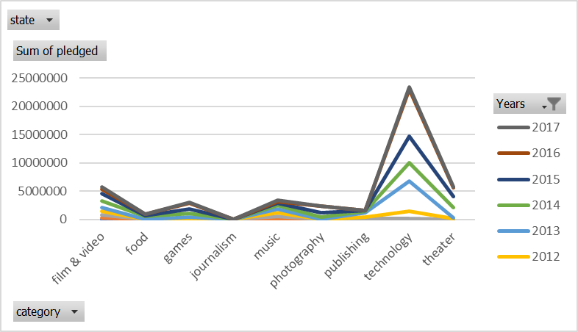

This graph shows that projects on Kickstarter website under technology and theater pledged a lot more money with every year and increasing.

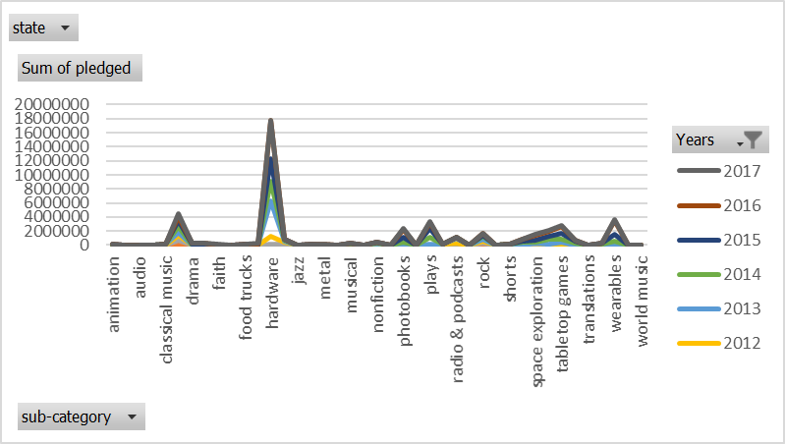This graph shows that projects related to technology, but specifically in hardware, pledged a significant more amount of money in comparison to other successful niches over the years.

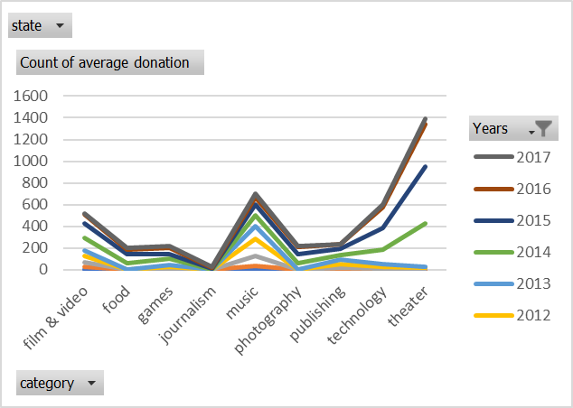

Over the years the average amount of donation per backer for all project categories increases over the years. However, theater, technology, music, and film&video categories express higher rate at which that’s happening.

Majority of projects started on Kickstarter were between years 2013 and 2017.



**Bonus:** Projects with low goal have higher chance of succeeding over the projects with higher goals. The percentage of projects failing is ranging between 30% and 50% until the goal exceeds 50k, then risk of failing is between 50% and 60%. Percent of projects canceled shows a linear behavior.