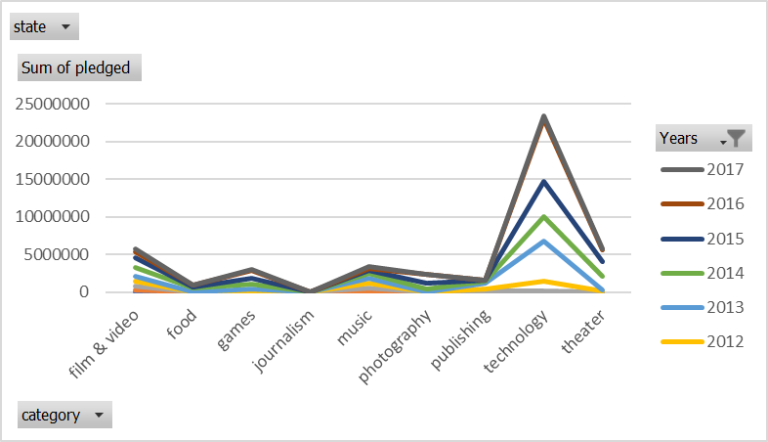

This graph shows that projects on Kickstarter website under technology and theater pledged a lot more money with every year.

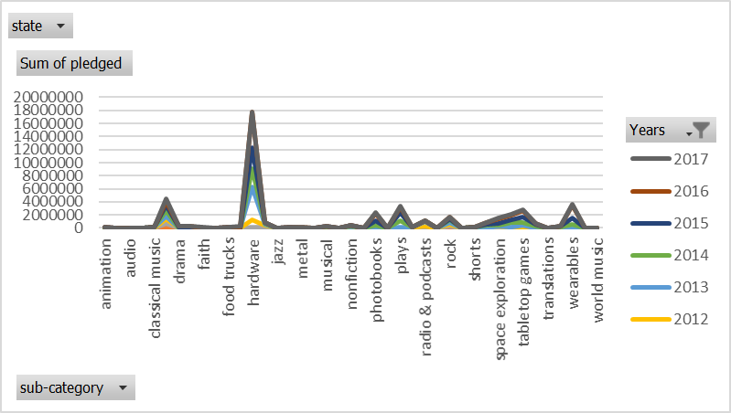This graph shows that projects related to technology, but specifically in hardware, pledged a significant more amount of money in comparison to other successful niches over the years.

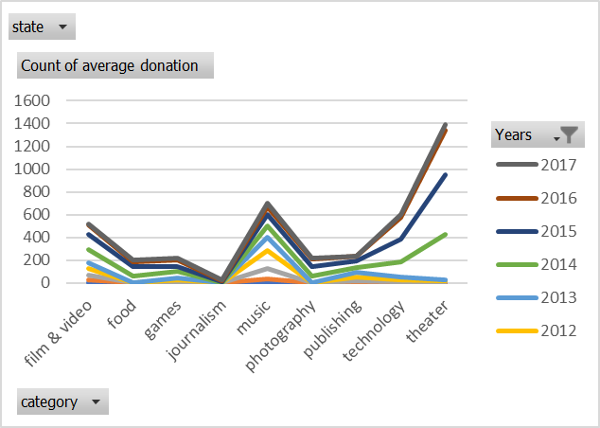

Over the years the average amount of donation per backer for all project categories increases over the years. However, theater, technology, music, and film&video categories express higher rate at which that’s happening.

Majority of projects started on Kickstarter were between years 2013 and 2017.



**Bonus:** Projects with low goal have higher chance of succeeding over the projects with higher goals. The percentage of projects failing is ranging between 30% and 50% until the goal exceeds 50k, then risk of failing is between 50% and 60%. Percent of projects canceled shows a linear behavior.