CS 85 · PHP PROGRAMMING
Module 7 Assignment 7B
Basic Routing: A Simple Personal Website
Siarhei Hancharou
Santa Monica College · Web Development (A.S.)
July 13, 2026

Project Overview
This project is a four-page personal Laravel website. It demonstrates closure-based and controller-based routes, data passed into Blade views, a reusable master layout, a dynamic route parameter, named navigation, active-link styling, and 404 error handling.
The standalone application lives in assignments/module7b and can also be opened from the main CS85 Module 7 roadmap. This app-inside-an-app structure keeps the submission complete while connecting it to the larger coursework portfolio.

Route List
URL | Route Name | Type | Purpose
/ | home | Closure | Show the welcome page and pass my name and title to the view.
/about | about | Closure | Show information about me and pass student data to the view.
/hobbies | hobbies.index | Controller | List all personalized hobbies through HobbyController@index.
/hobbies/{id} | hobbies.show | Controller | Show one hobby by numeric ID or return a 404 response.

Customization
Personal information added: Siarhei Hancharou, Santa Monica College, and Web Development (A.S.). The About page also introduces my coursework platform, Lens Lounge microservices project, photography portfolio, and GitHub profile. It uses the privacy-safe value “Prefer not to disclose” for age until a numeric value is intentionally provided.
Photography: I selected photography because it combines technical camera skills, creativity, communication, and my SERGIOARTG portfolio work.
Web Development: I selected web development because I enjoy turning ideas into accessible interfaces and learning how frontend and backend systems work together.
Technology Projects: I selected technology projects because hands-on experiments help me practice debugging, version control, documentation, and product presentation.

Screenshots and Evidence
Replace each evidence panel with the matching screenshot. Keep the figure title and caption below the image so the submission remains easy to grade.
Figure 1. Routes File
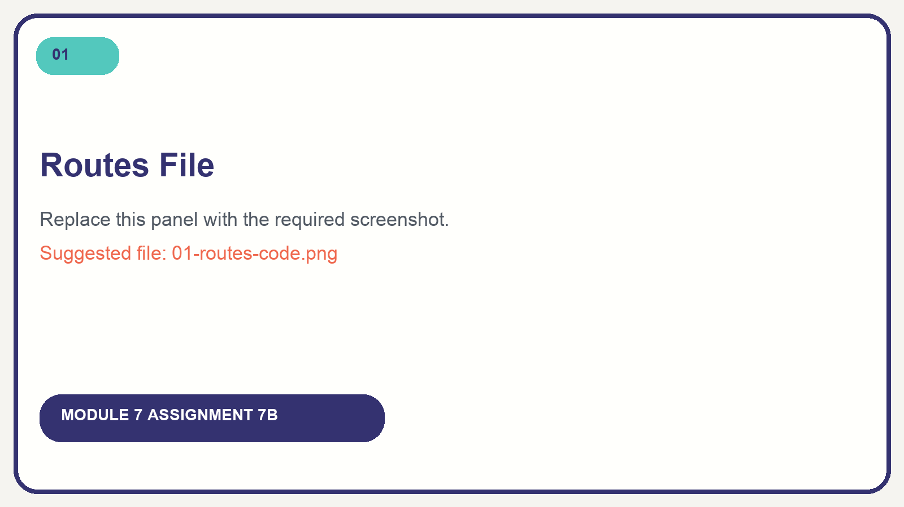
The routes/web.php file defines two closure routes, two controller routes, four named routes, and the dynamic {id} parameter.
Figure 2. HobbyController Code
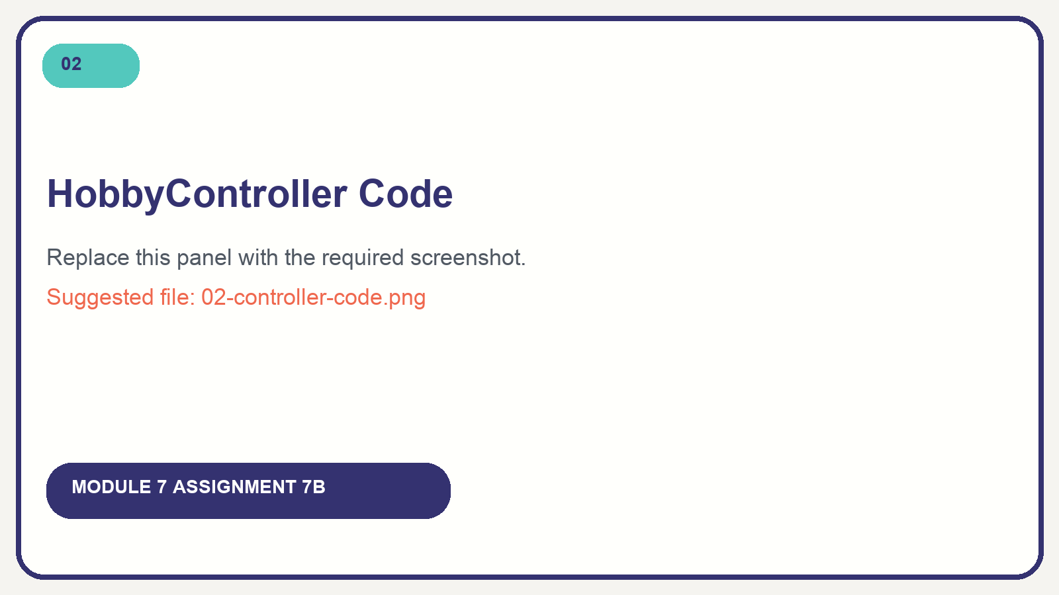
HobbyController organizes the personalized array and provides the index() and show() actions with 404 handling.
Figure 3. Home Page
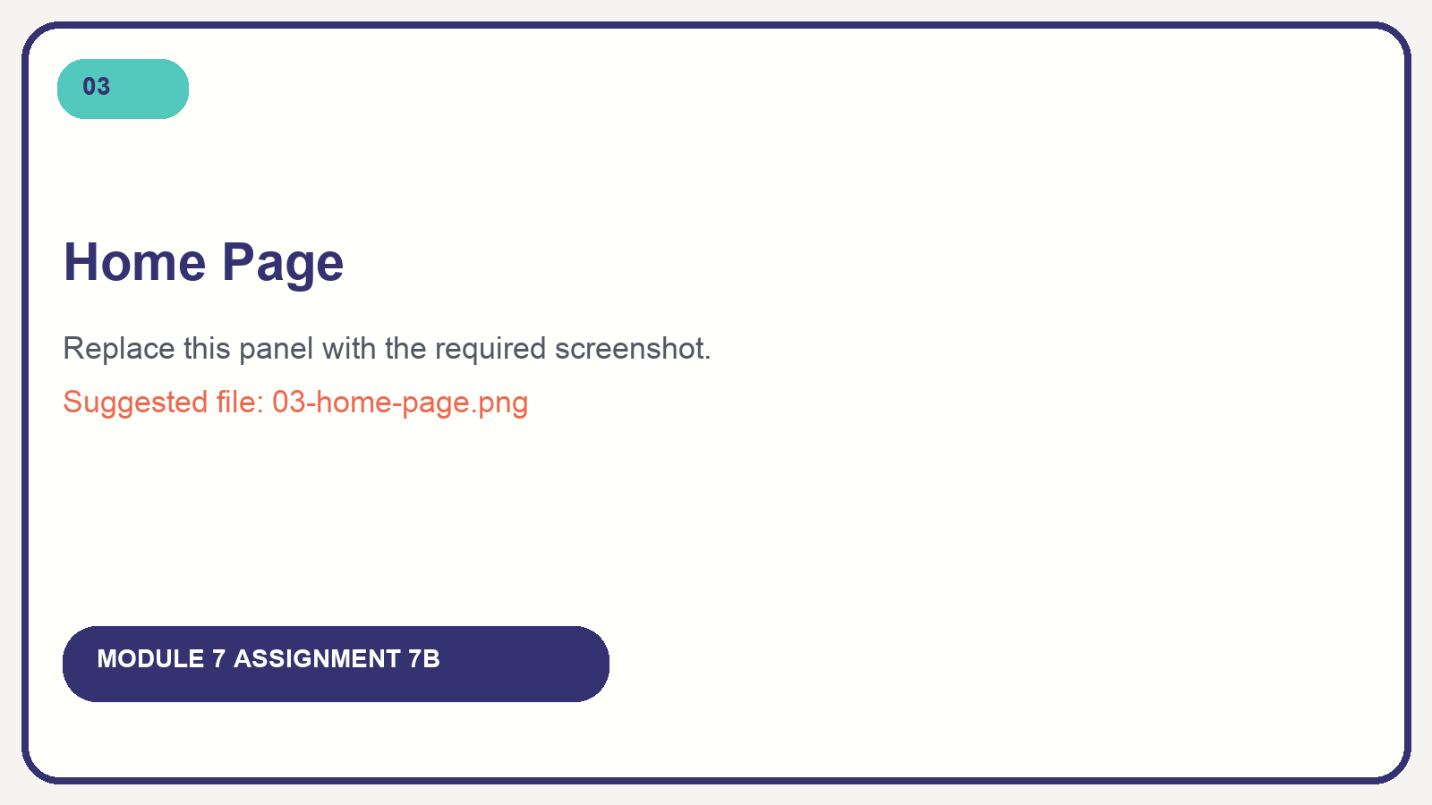
The Home closure passes my name and page title into a Blade view that extends the master layout.
Figure 4. About Page
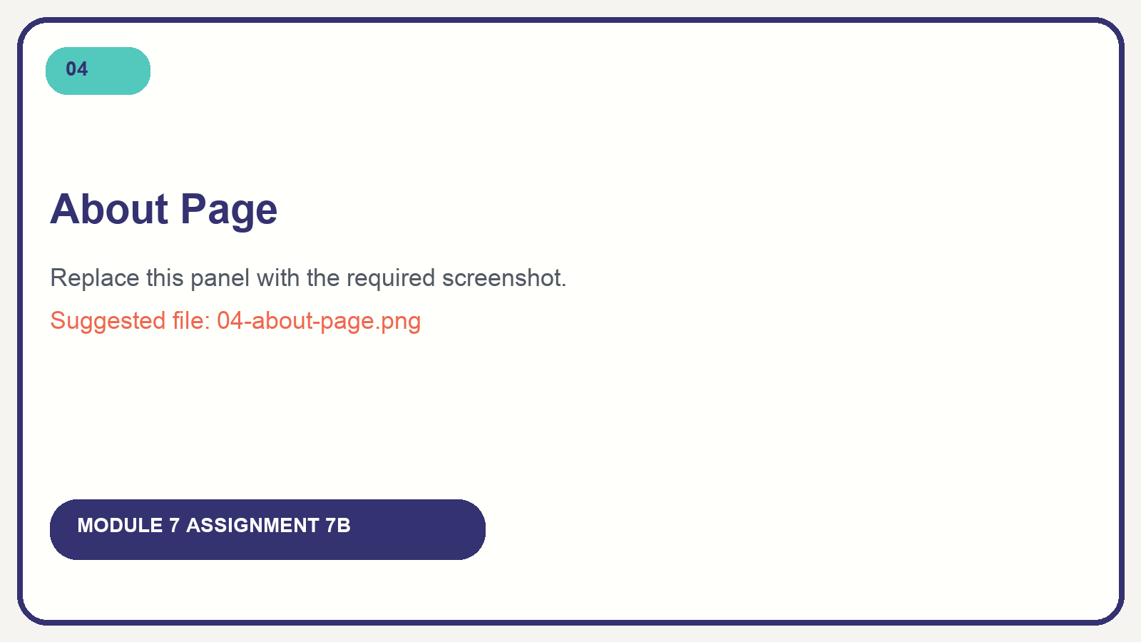
The About closure passes my school, major, and age display value into the About Blade template.
Figure 5. Hobbies Page
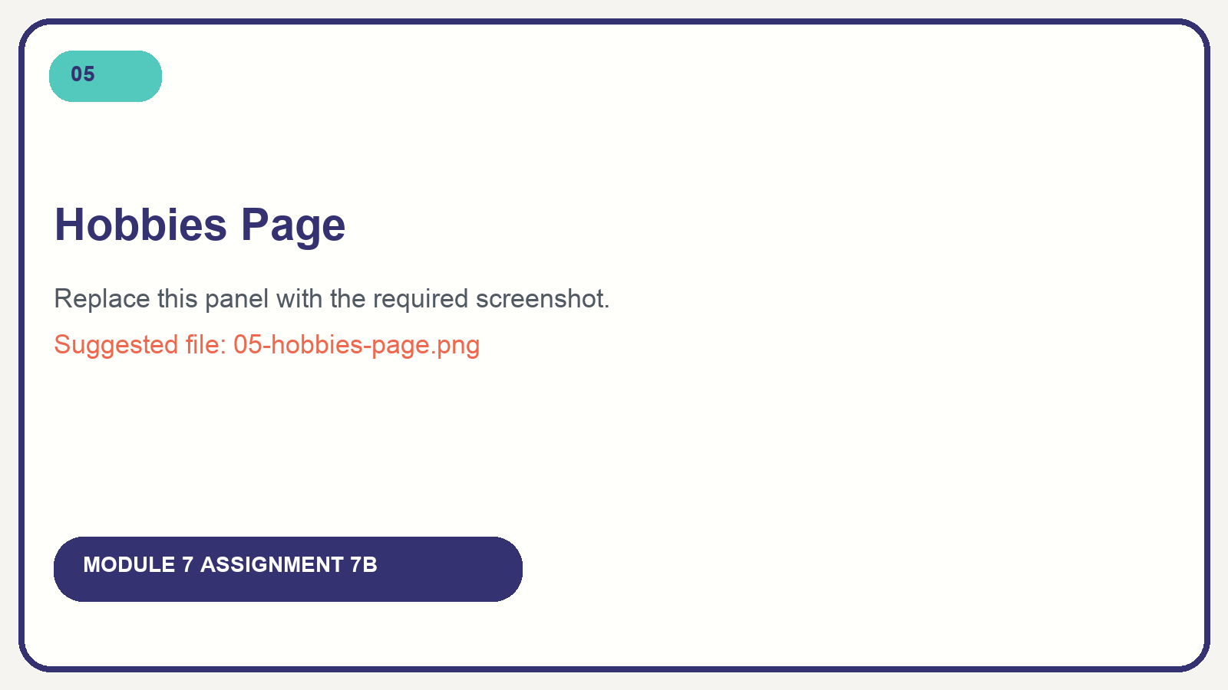
HobbyController@index passes three personalized hobbies to an @foreach loop in the Hobbies view.
Figure 6. Dynamic Hobby Detail
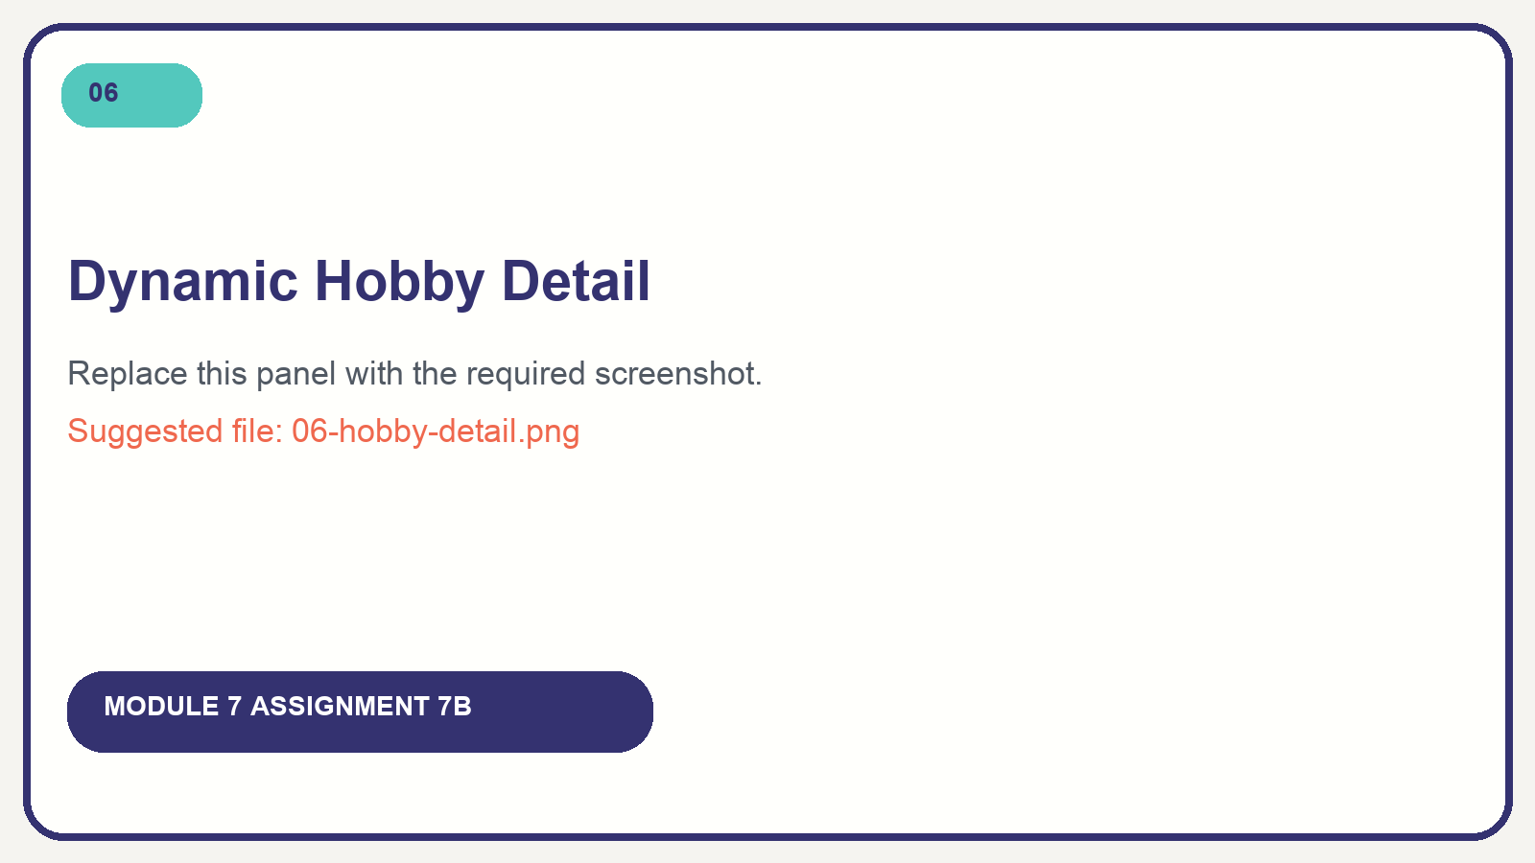
The /hobbies/1 request passes ID 1 to HobbyController@show and renders the Photography record.
Figure 7. 404 Error Page
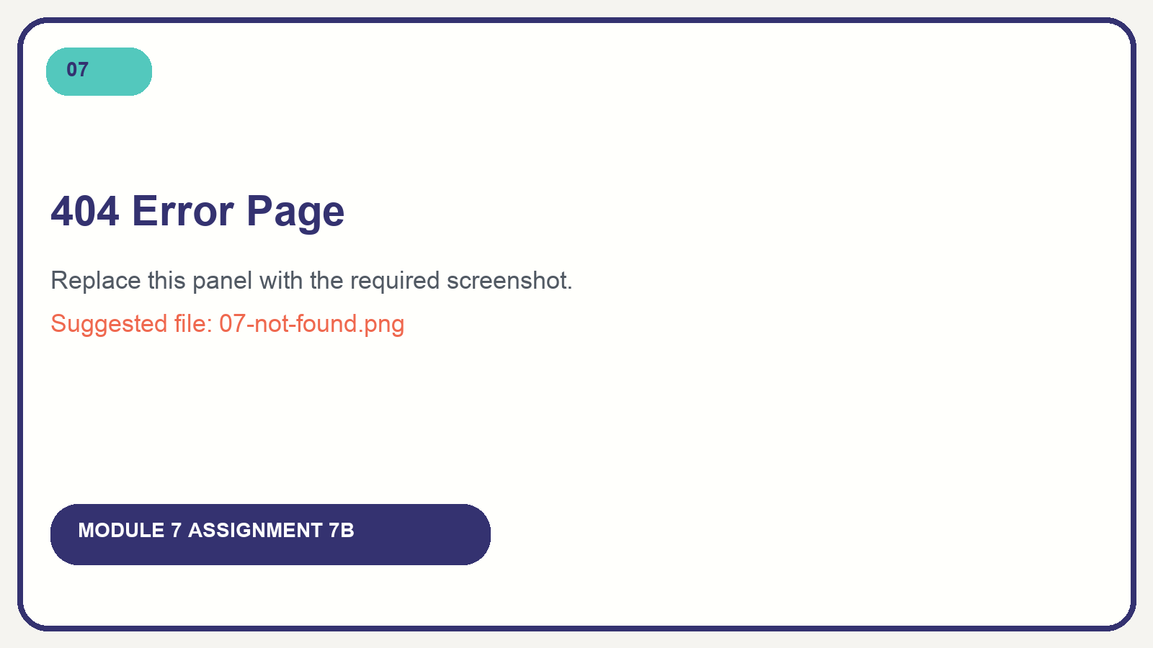
The required /hobbies/999 request correctly returns a 404 Not Found response for a missing record.
Figure 8. Active Navigation
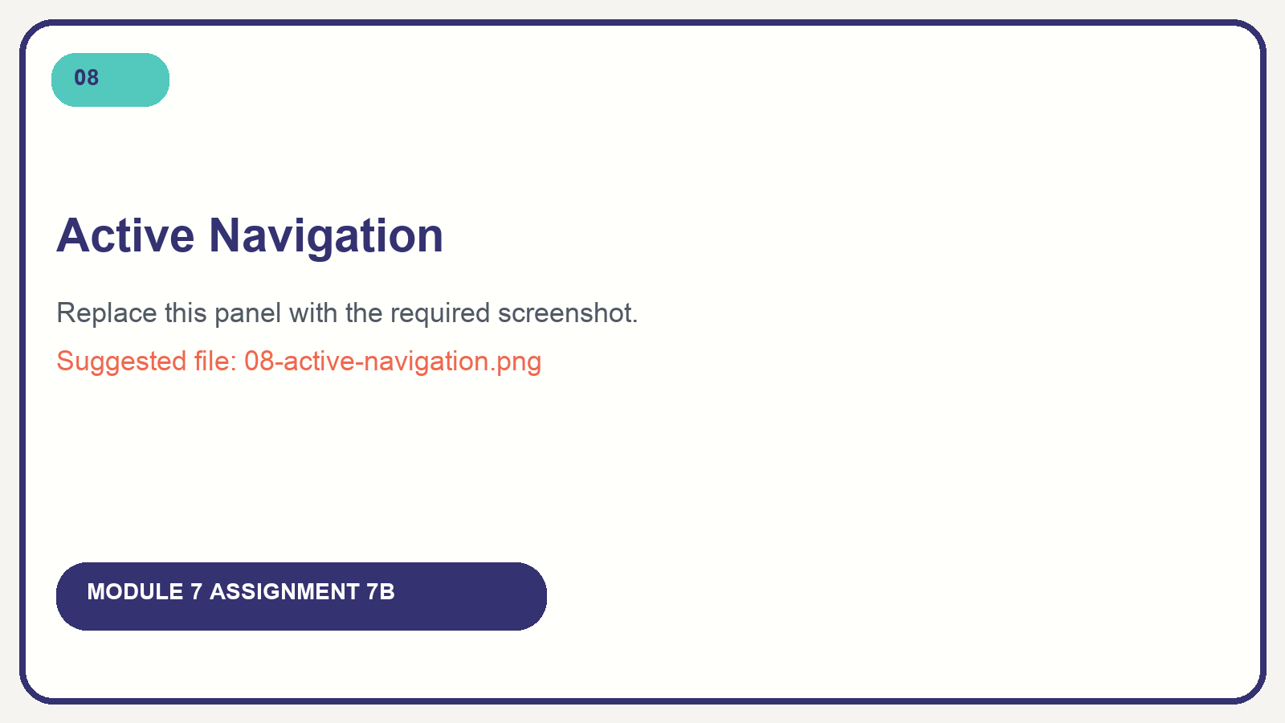
Named-route navigation highlights the current page and keeps Home, About, and Hobbies available.
Figure 9. Artisan Route List
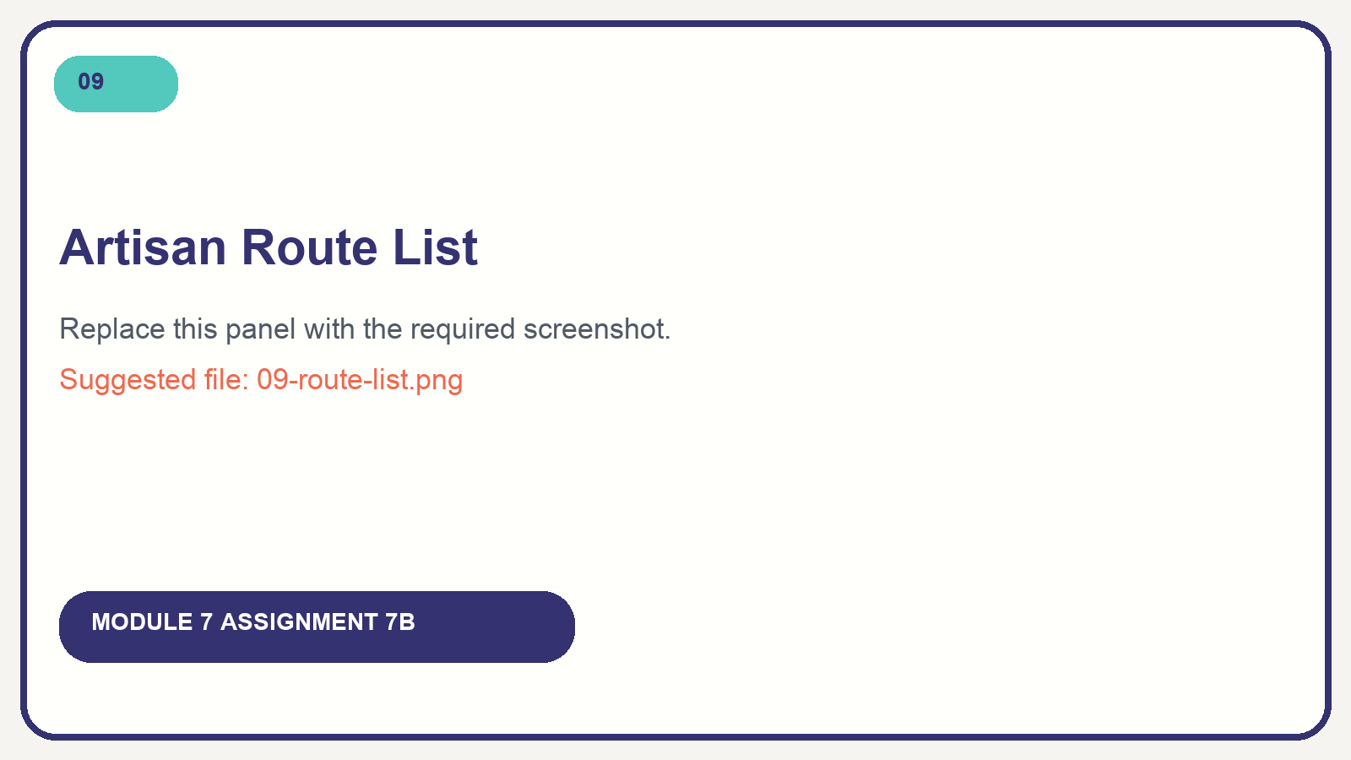
The Artisan route table confirms the required GET routes, route names, parameter, and controller actions.

Reflection

What was the easiest part of this assignment?
The easiest part was personalizing the page content after the routes and views were connected. Blade’s escaped {{ }} syntax made it simple to display my name, school, major, and hobby fields. The route() helper also made the navigation links clear because I could refer to meaningful route names instead of repeating URLs.

What was the most challenging part?
The most challenging part was understanding the complete request flow for the dynamic hobby page. The {id} value starts in the URL, is passed into HobbyController::show(), is checked against the hobbies array, and then determines which record Blade receives. Testing /hobbies/999 helped me confirm why checking that a record exists before displaying it is important.

What did I learn about Laravel routing?
I learned that a Laravel route connects an HTTP method and URL to the code that prepares a response. A short closure works well for a simple page, while a controller keeps related request logic organized when a feature needs multiple actions or more data. Naming each route also makes navigation easier to maintain because Blade templates do not need to repeat literal URLs.

Submission Files
Project archive: Hancharou_Siarhei_Simple_Website.zip
Documentation PDF: Hancharou_Siarhei_Routing_Documentation.pdf

