CS85 PHP PROGRAMMING · MODULE 11

Assignment 11A: API Data
  - Static JSON Weather Forecast + Advanced API Implementation
Course-aligned answers, implementation evidence, professional extension, and screenshot plan
Document field | Value
Student | Serge Hall
Course | CS85 PHP Programming
Module | Module 11 — Assignment 11A: API Data
Prepared | July 27, 2026

Submission scope: The course-aligned /weather page satisfies the required static JSON exercise. The /roadmap/module-11 page is a separate advanced track that demonstrates how the same data flow evolves into a resilient live API integration.

Document Map
- 1. Main Assignment Questions and Answers
- 2. Course-Aligned Implementation Walkthrough
- 3. Required Browser and Code Evidence
- 4. Advanced Implementation Questions and Answers
- 5. Architecture, Security, and Reliability
- 6. Comparison, Reflection, and Submission Checklist

1. Main Assignment Questions and Answers
The main Assignment 11A is a warm-up for live API integration. A static file imitates a weather API response so the JSON-to-Blade workflow can be learned without network failures, authentication, or provider limits.
What is JSON?
JSON stands for JavaScript Object Notation. It is a lightweight text format for storing and transporting structured data. APIs commonly return JSON because it is readable by people and easy for programming languages to decode.
What does json_decode() do?
The PHP json_decode() function converts a JSON string into a PHP value. In this assignment, json_decode($json, true) converts the weather JSON array into PHP associative arrays that can be accessed with keys such as $day['high'].
Why is true passed as the second argument?
Passing true tells PHP to return JSON objects as associative arrays instead of stdClass objects. This matches the required Blade syntax: $day['day'], $day['high'], $day['low'], and $day['condition'].
Why is weather.json stored in storage/app/private?
Laravel 11 and later configure the default local disk to use storage/app/private. Therefore Storage::get('weather.json') resolves to that private directory. The file is also not directly public through a URL, so Laravel controls when and how it is read.
What does the Storage facade provide?
The Storage facade gives the controller a Laravel-native filesystem API. Storage::get('weather.json') reads the file from the configured local disk and returns its contents as a string without hard-coding an absolute filesystem path.
How does the controller pass data to Blade?
WeatherController reads and decodes the file, then returns view('weather.index', ['weather' => $weatherData]). The weather key becomes the $weather variable inside resources/views/weather/index.blade.php.
How does Blade display the structured records?
The @foreach ($weather as $day) directive creates one table row for every forecast record. Blade's escaped {{ }} output syntax safely prints the day, high temperature, low temperature, and condition.
Which optional improvements were implemented?
Rainy rows receive blue conditional formatting, sunny rows receive amber formatting, and a query control can sort the days alphabetically. The default view preserves the original Monday-to-Wednesday order.

2. Course-Aligned Implementation Walkthrough

Step 1 — Static JSON data
The weather dataset contains three records. Each record uses the same four fields, which makes the data predictable and easy to display as table columns.
[
{"day": "Monday", "high": 75, "low": 60, "condition": "Sunny"},
{"day": "Tuesday", "high": 72, "low": 58, "condition": "Partly Cloudy"},
{"day": "Wednesday", "high": 68, "low": 55, "condition": "Rain"}
]

Step 2 — Controller logic
The controller intentionally uses the two-step method from the instructions. JSON_THROW_ON_ERROR strengthens the example by making malformed JSON fail explicitly instead of silently returning null.
$json = Storage::get('weather.json');
$weatherData = json_decode($json, true, flags: JSON_THROW_ON_ERROR);
return view('weather.index', [
'weather' => $weatherData,
]);

Step 3 — Blade table
The view uses semantic table headings and a Blade loop. Each temperature adds the Fahrenheit symbol, while the condition controls the optional row color.
@foreach ($weather as $day)
<tr>
<td>{{ $day['day'] }}</td>
<td>{{ $day['high'] }}°F</td>
<td>{{ $day['low'] }}°F</td>
<td>{{ $day['condition'] }}</td>
</tr>
@endforeach

Step 4 — Route and result
GET /weather is named assignments.module11a.weather and calls WeatherController@index. The resulting page includes the required forecast table, explanation, optional sort control, and a link to the advanced track.
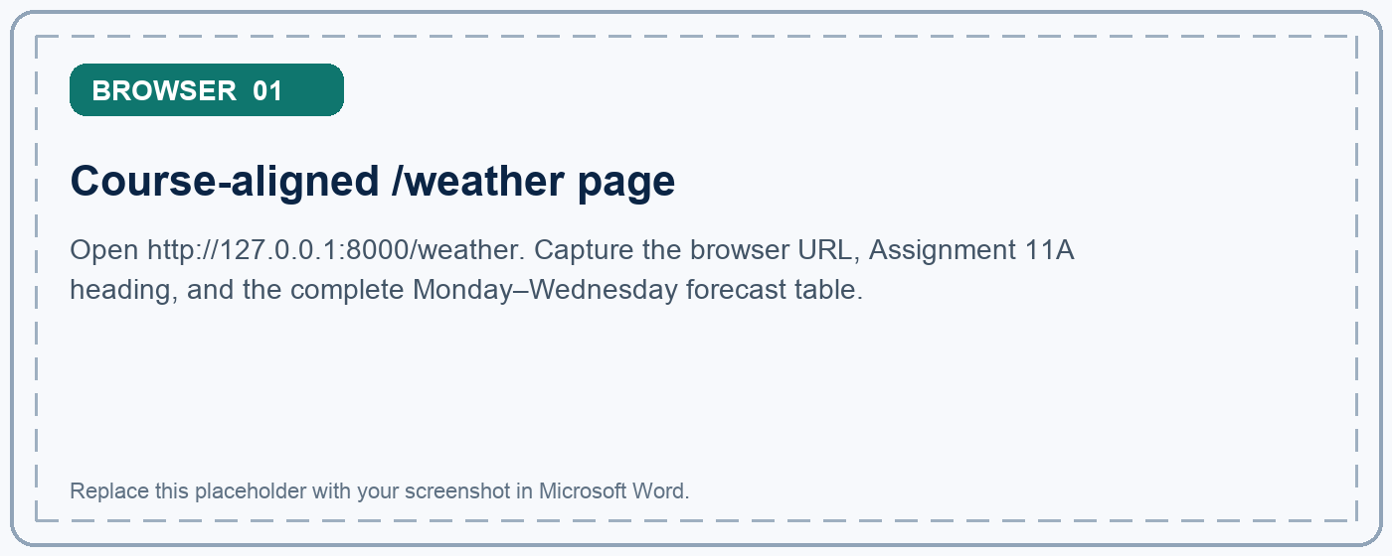
Figure 1. Course-aligned /weather page

What this screenshot should prove
- The required /weather route loads successfully in Laravel.
- All three decoded JSON records appear in the styled table.
- The assignment title and course-aligned track are clearly visible.

3. Main Assignment Screenshot Evidence
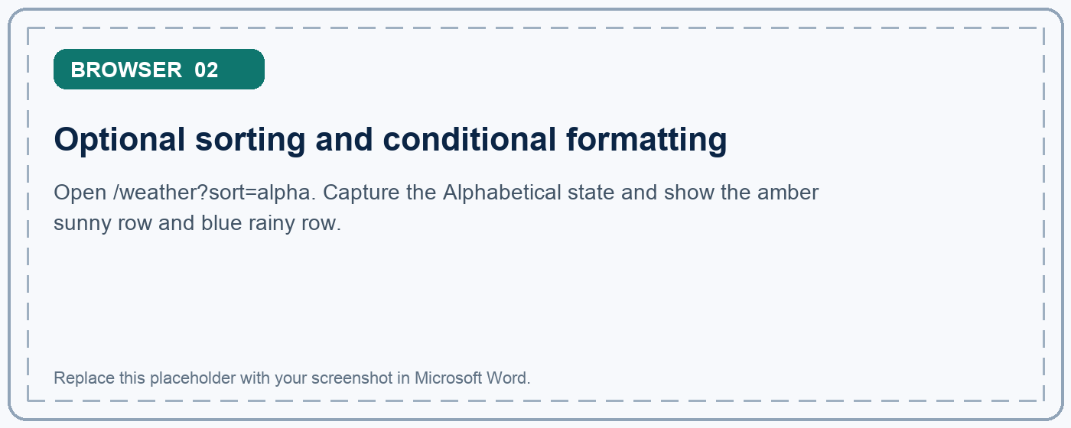
Figure 2. Optional sorting and conditional formatting
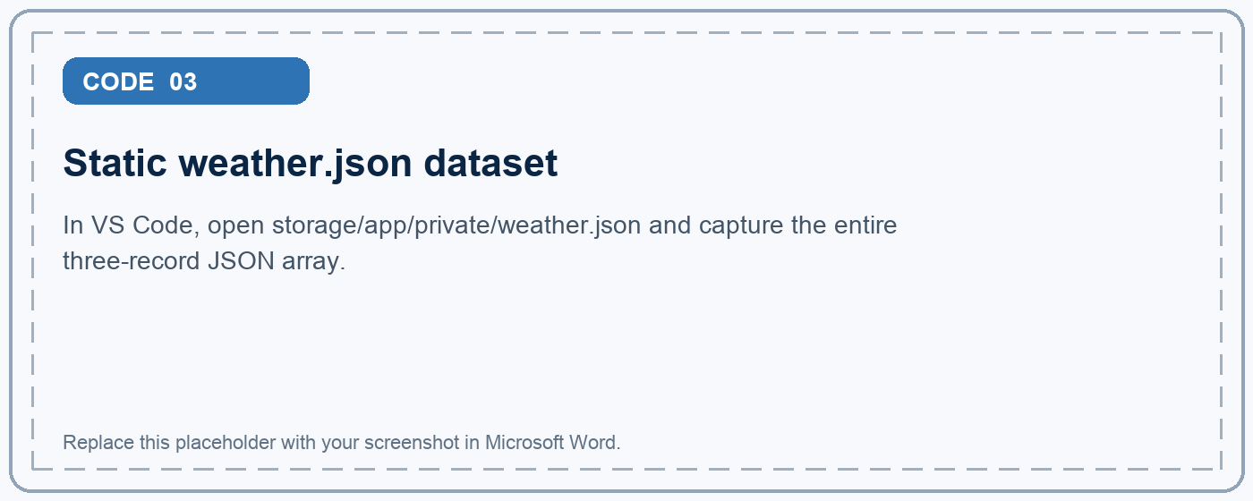
Figure 3. Static weather.json dataset

4. Main Assignment Code Evidence
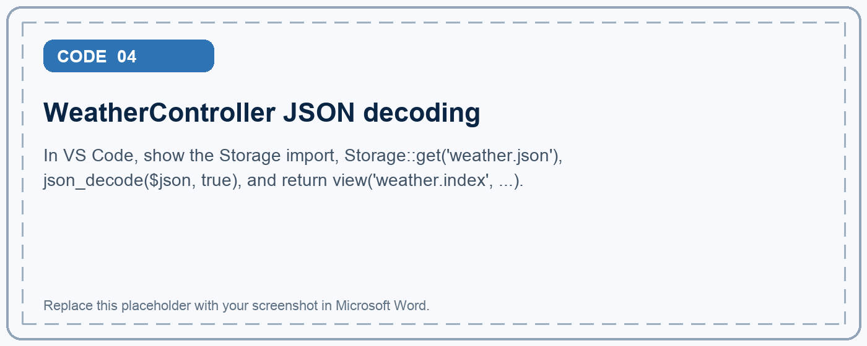
Figure 4. WeatherController JSON decoding
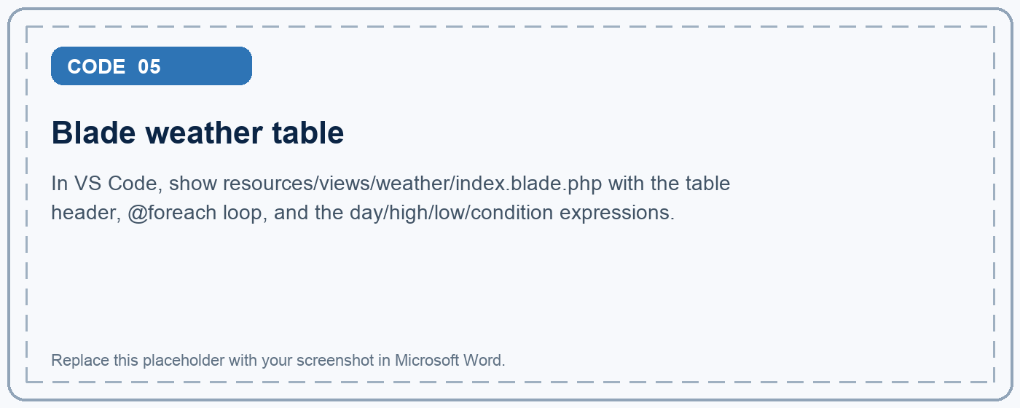
Figure 5. Blade weather table

5. Advanced Implementation Questions and Answers
The advanced track does not replace the required exercise. It demonstrates how the same JSON workflow can be designed for a real third-party provider, where data can be unavailable, malformed, slow, or structurally different.
What does the advanced implementation build?
Laravel fetches users from the JSONPlaceholder API, validates and normalizes each record into an ApiContact object, then exposes searchable contact cards and a normalized JSON endpoint at /roadmap/module-11/data.
Why is the API request performed on the server?
Server-side requests keep provider configuration inside Laravel, create one controlled trust boundary, and prevent browser code from depending directly on a third party. This also makes caching, fallback, validation, and testing easier.
Why is the endpoint fixed in configuration?
Allowing visitors to submit an arbitrary server-side URL could create a Server-Side Request Forgery (SSRF) vulnerability. The trusted endpoint is configured under services.module11a instead of being accepted from query input.
Why map the response into ApiContact objects?
A provider response is untrusted input, not an application model. ApiContact accepts only complete, valid records and exposes a stable set of fields. The view and JSON endpoint no longer depend on JSONPlaceholder's nested payload.
What is the difference between cache and fallback?
The ten-minute cache reuses a previously validated live response to reduce latency and provider traffic. The fallback is a versioned local dataset used when no usable live response is available. Cache is an optimization; fallback is a resilience mechanism.
How are search and sorting protected?
BrowseModule11ApiDataRequest limits search text to 80 characters and allowlists sort and result-limit values. BrowseApiContacts applies those operations only to normalized ApiContact objects.
What does the JSON endpoint return?
GET /roadmap/module-11/data returns a meta object with source, degraded state, timestamp, counts, and active filters, followed by a data array containing only the normalized contact contract.

Clean Architecture responsibilities
Layer | Implementation | Responsibility
Presentation | Module11AApiDataController + Blade | Coordinates the request and chooses HTML or JSON output.
Application | BrowseApiContacts | Searches, sorts, limits, and summarizes normalized contacts.
Domain | ApiContact | Defines the trusted typed contract accepted by the application.
Infrastructure | JsonPlaceholderUserClient | Owns HTTP, timeout, cache, response validation, and fallback.

Advanced request lifecycle
- Validate the allowed search, sort, limit, and refresh query values.
- Fetch a configured HTTPS endpoint or reuse a validated cached response.
- Normalize complete provider records into ApiContact objects.
- Search, sort, limit, and summarize the trusted application data.
- Render escaped Blade cards or return the normalized JSON contract.
Why the boundaries matter: Each layer owns one kind of change. A provider change belongs to infrastructure, filter behavior belongs to the application service, the trusted shape belongs to the domain, and HTML/JSON delivery belongs to presentation.

6. Advanced Browser Evidence
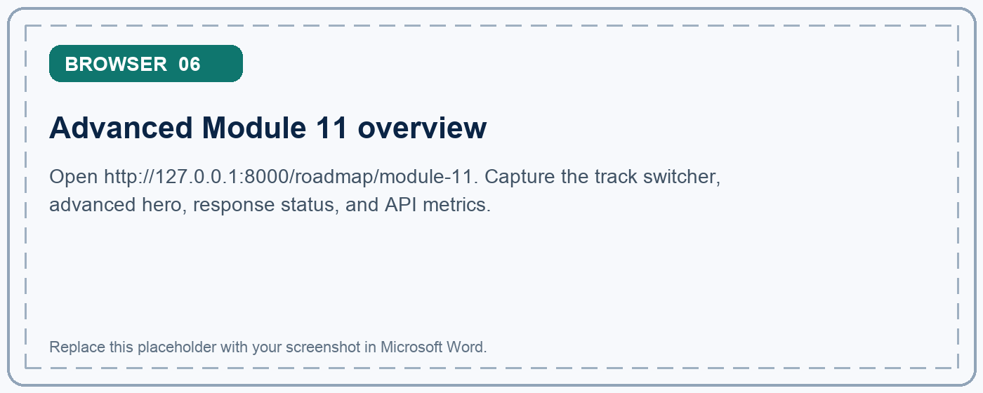
Figure 6. Advanced Module 11 overview
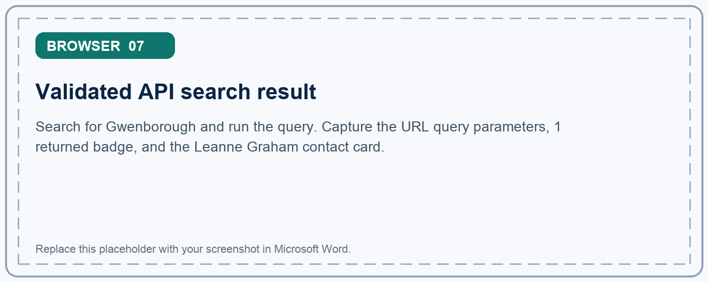
Figure 7. Validated API search result

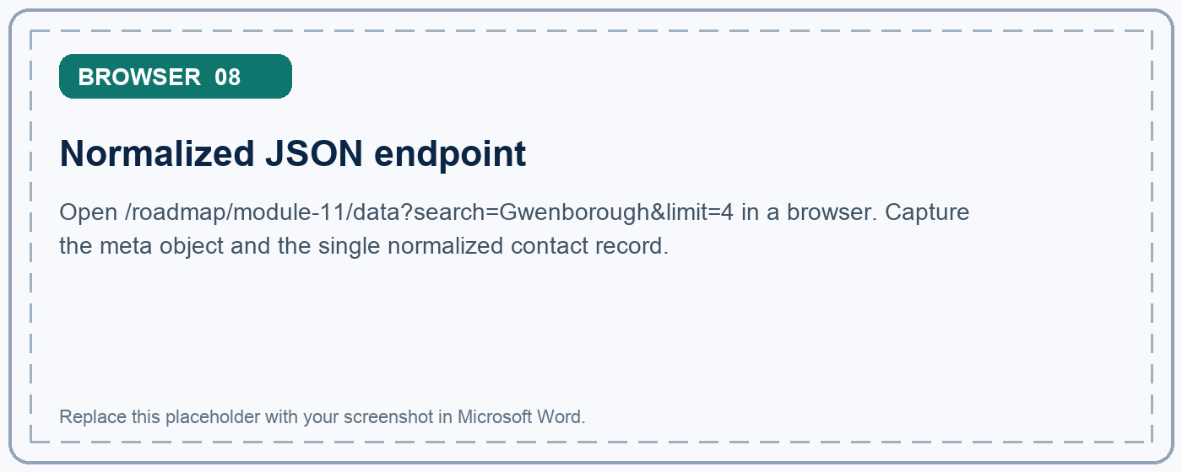
Figure 8. Normalized JSON endpoint

Reliability and security summary
- HTTPS provider endpoint with Accept: application/json.
- Short configurable timeout so the page does not wait indefinitely.
- DTO validation rejects incomplete or malformed provider records.
- Ten-minute Laravel cache reduces repeated remote calls.
- Versioned fallback data keeps the assignment demonstrable offline.
- Blade escapes provider values before rendering.
- Fixed server-side endpoint avoids an arbitrary-URL SSRF surface.
- Http::fake() keeps automated tests deterministic and independent of the internet.

7. Advanced Code Evidence
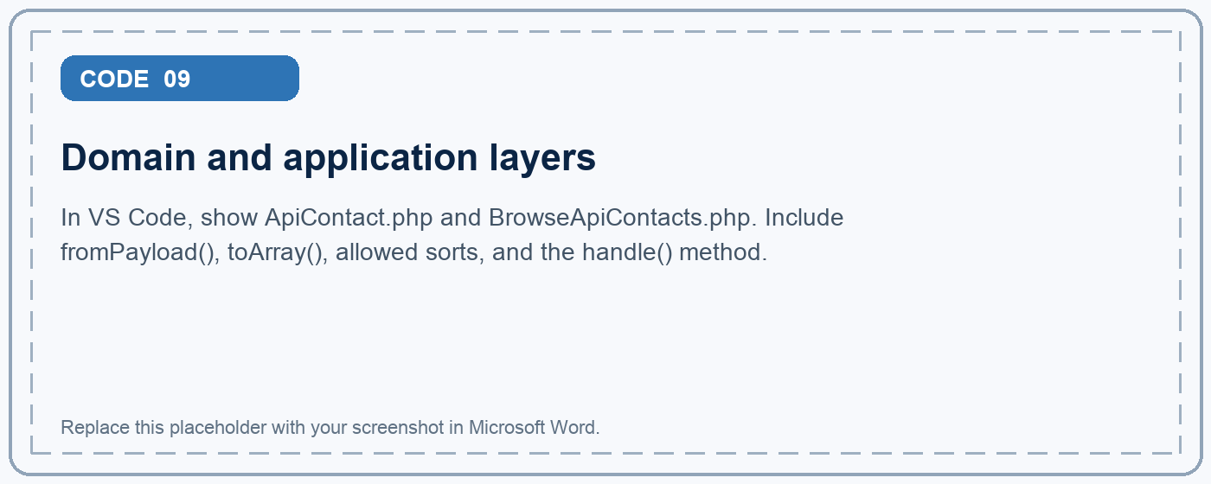
Figure 9. Domain and application layers
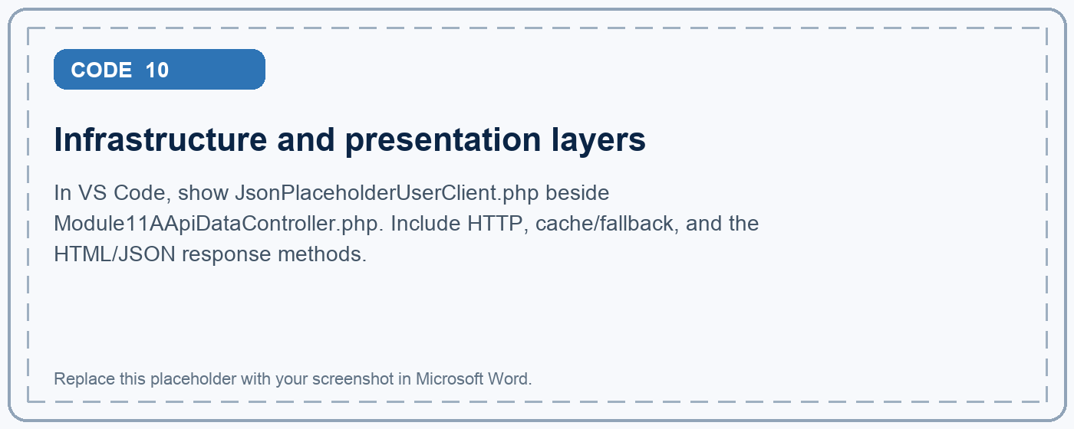
Figure 10. Infrastructure and presentation layers

8. Comparison and Reflection
Concern | Course-aligned track | Advanced implementation
Data source | Static weather.json file | Live JSONPlaceholder endpoint
Decode step | json_decode($json, true) | Laravel HTTP client response JSON
Data shape | Associative arrays | Typed ApiContact objects
Transformation | Optional alphabetical sort | Validated search, sort, limit, and statistics
Reliability | File is always local | Timeout, ten-minute cache, and local fallback
Output | Styled Blade weather table | Blade workbench plus normalized JSON endpoint
Purpose | Learn the JSON → PHP → Blade flow | Demonstrate production-oriented API boundaries

Reflection
The main assignment made the JSON lifecycle visible by keeping every step small: a known file, one controller, an associative array, and one Blade loop. This is the correct level for learning what JSON decoding actually does.
The advanced implementation showed why production API work needs additional boundaries. Remote data must be treated as untrusted, outages must be expected, and the presentation layer should not know provider-specific details. The DTO, application service, API client, cache, and fallback each solve a distinct problem.
Final takeaway: The course-aligned track proves the required JSON, controller, and Blade skills. The advanced track proves that the same foundation can evolve into a secure, testable, and resilient Laravel API integration.

Submission Checklist
- The /weather page is visible and shows all three forecast rows.
- weather.json is included from storage/app/private.
- WeatherController shows Storage::get() and json_decode(..., true).
- The Blade file shows @foreach and the four required columns.
- The optional conditional formatting and alphabetical sort are documented.
- The advanced page and normalized JSON endpoint are documented separately.
- README setup instructions and reflections are included.
- Automated tests pass before submission.
- All screenshot placeholders in this document are replaced with real screenshots.
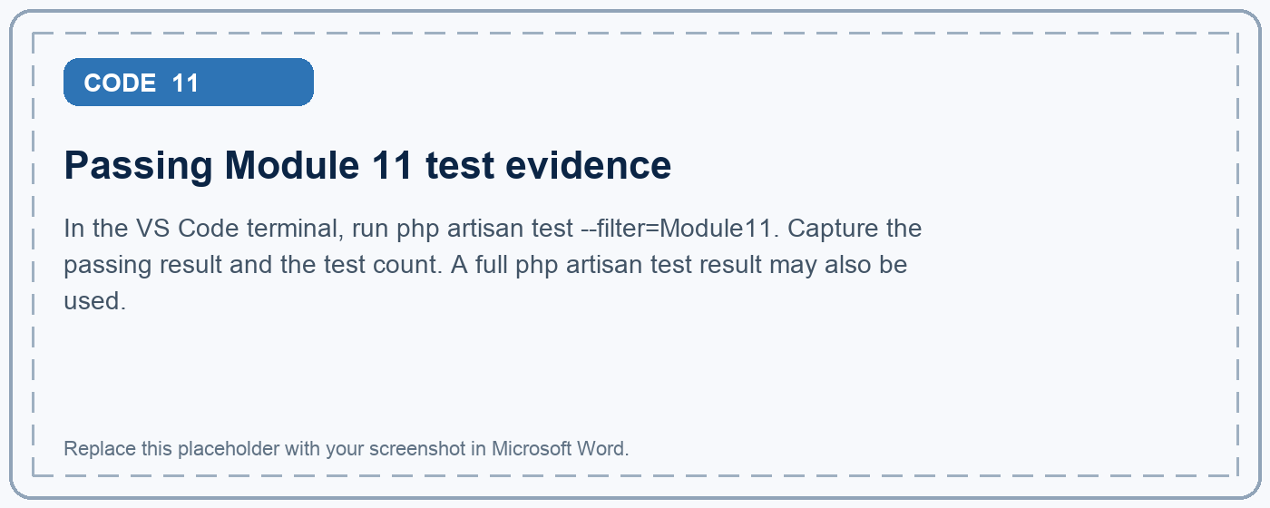
Figure 11. Passing Module 11 test evidence

Project URLs and Files
Course-aligned page: http://127.0.0.1:8000/weather
Advanced page: http://127.0.0.1:8000/roadmap/module-11
Normalized JSON: http://127.0.0.1:8000/roadmap/module-11/data
Documentation: assignments/module11a/README.md

