CS60 Problem Set 1 – Fall 2025
Due – Midnight Sept 19th, 2025
Total 37.5 Pts
1712666_1749_CS60_Hancharou_Siarhei.docx.
To complete the Problem Set, create spaces below each of the problems and add your answers. After completing, load the file using the Problem Set 1 Upload option in Canvas.
Note:- If you end up with multiple files for your Problem Set, create a zipped folder and load using the Problem Set 1 upload option.

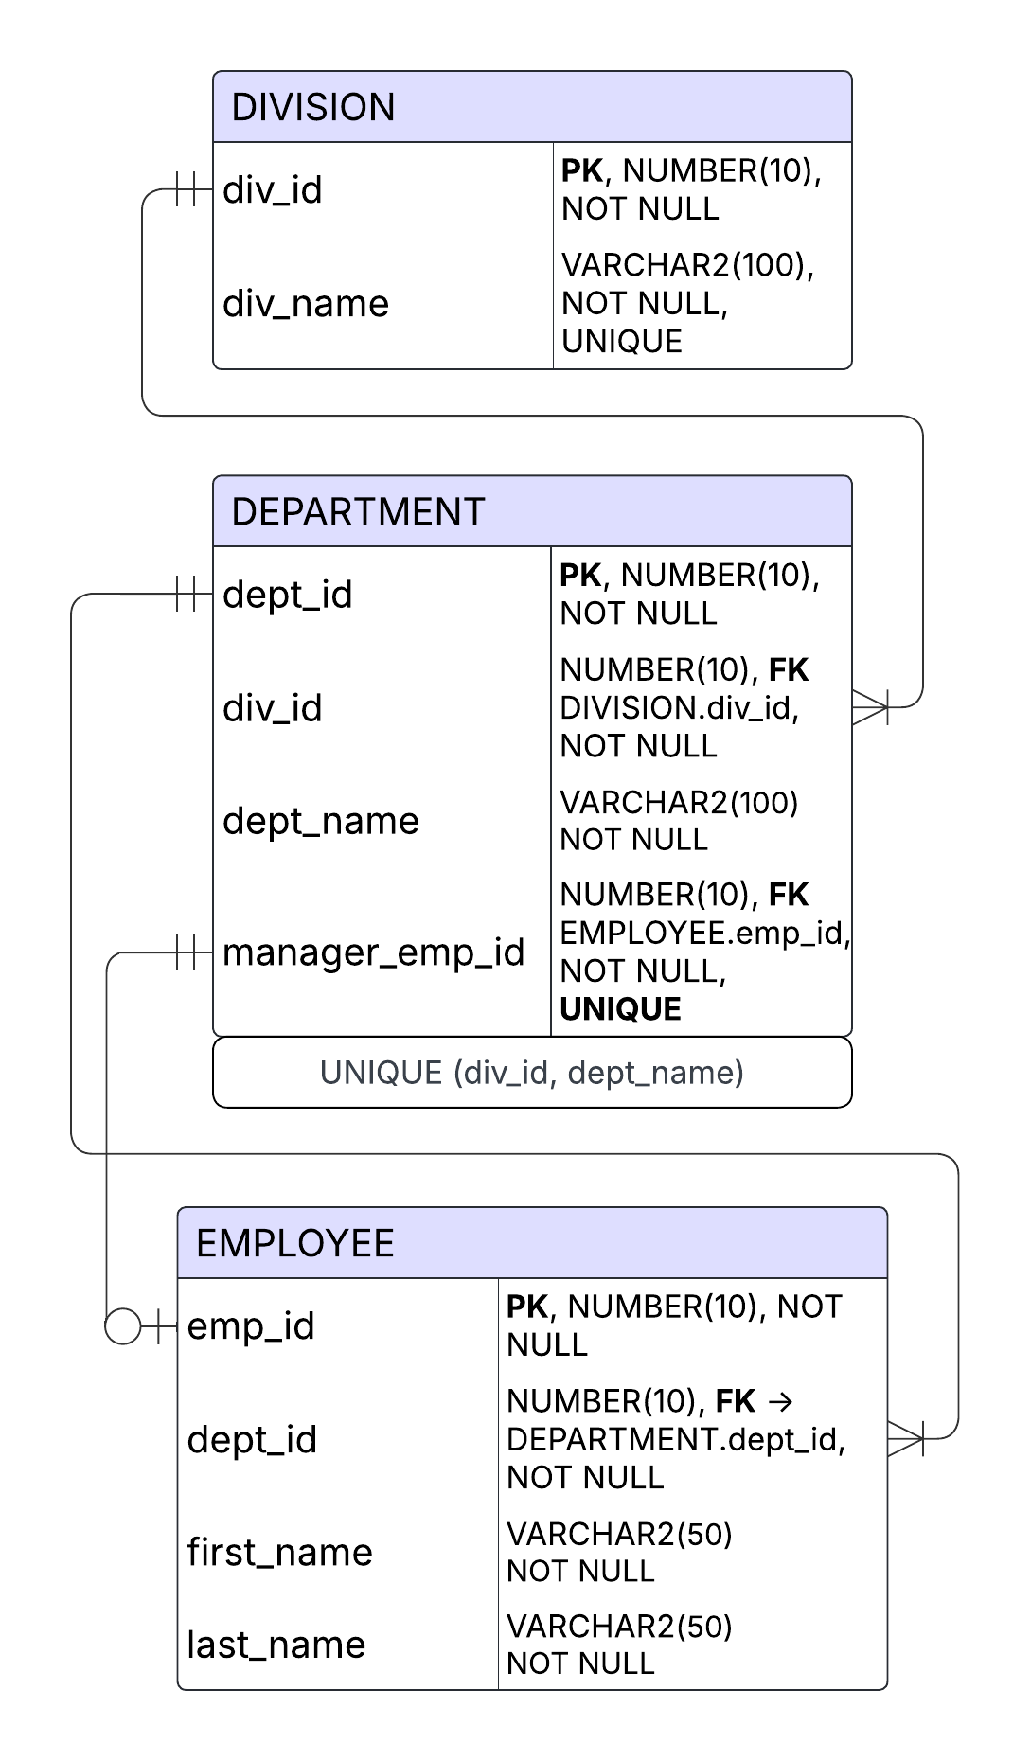
- Create an ERD for each of the following descriptions. (Note the work many merely means more than one in the database modeling environment.)
- Each of the ABC Corp’s divisions is composed of many departments. Each department has many employees assigned to it, but each employee works for only one department. Each department is managed by one employee and each of the managers can manage only one department at a time. (3 Pts)

Business rule & ERD (text + relationships):
Division || ──── |{ Department
- One Division contains many Departments.
- Each Department belongs to exactly one Division.
Cardinality: 1 → 1.. M

Department || ──── |{ Employee
- One Department has many Employees.
- Each Employee works for exactly one Department.
Cardinality: 1 → 1.. M

Department || ─── |o Employee (Manager)
- Each Department is managed by exactly one Employee.
- Each Employee can manage 0 or 1 Department.
Cardinality: 1 ↔ 0..1

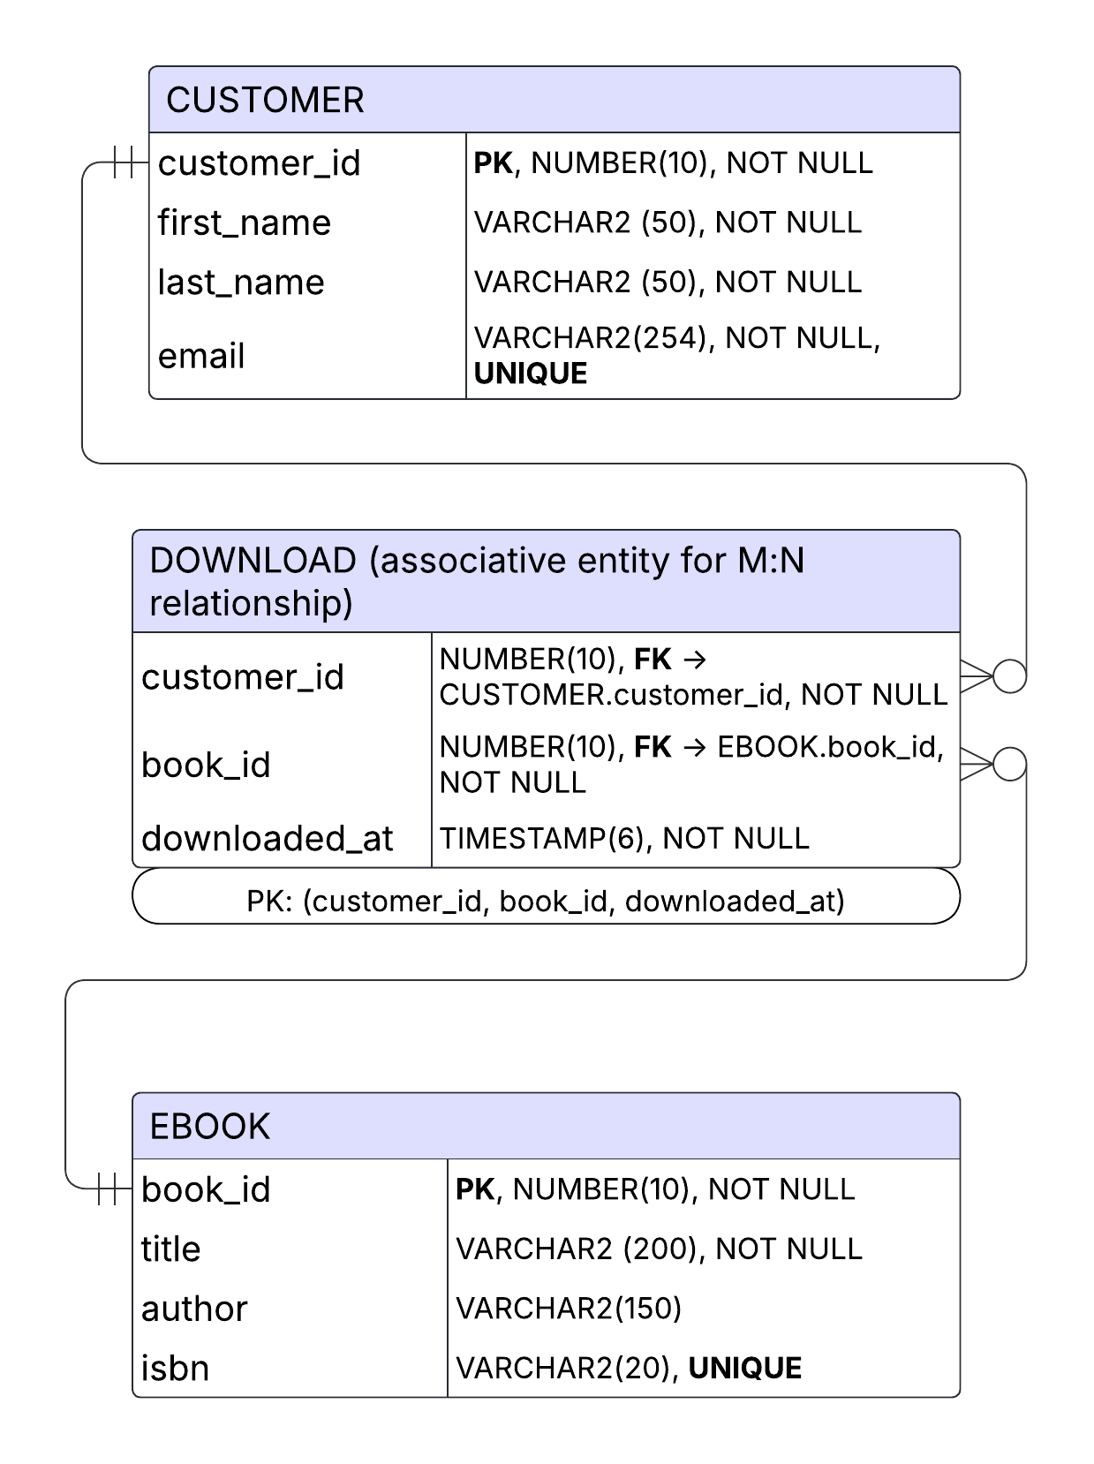
- During some period of time, a customer can download many ebooks from BooksOnline. Each of the books can be downloaded by many customers during this period of time. (3 Pts)

During a given period of time, one Customer can download zero or many Ebooks, and each Ebook can be downloaded by zero or many Customers. This is a many-to-many (M:N) relationship, which in the relational model is implemented through an associative entity such as Download.

Business rule & ERD (text + relationships):
Customer || ──── o{ Download
- One Customer may be linked to zero or many Downloads.
- Each Download belongs to exactly one Customer.
Cardinality: 1 → 0..M
Ebook || ──── o{ Download
- One Ebook may be linked to zero or many Downloads.
- Each Download belongs to exactly one Ebook.
Cardinality: 1 → 0..M

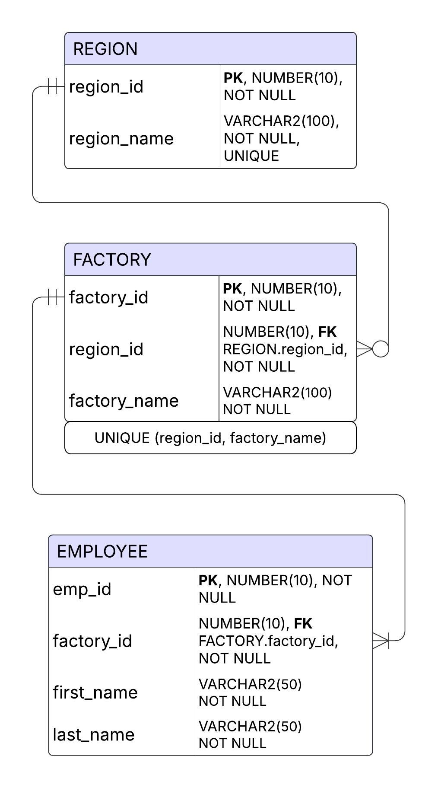
- QuickTime Corp operates many factories. Each factory is located in a region and each region can be home to many QuickTime factories. Each factory has many employees but each employee is employed by only one factory. (3 Pts)

Business rule & ERD (text + relationships):
Region || ──── o{ Factory
- Each Factory is located in exactly one Region (mandatory).
- Each Region may contain zero or many Factories.
Cardinality: 1 → 0..M
Factory || ──── |{ Employee
- Each Factory employs one or many Employees (mandatory).
- Each Employee works for exactly one Factory.
Cardinality: 1 → 1..M

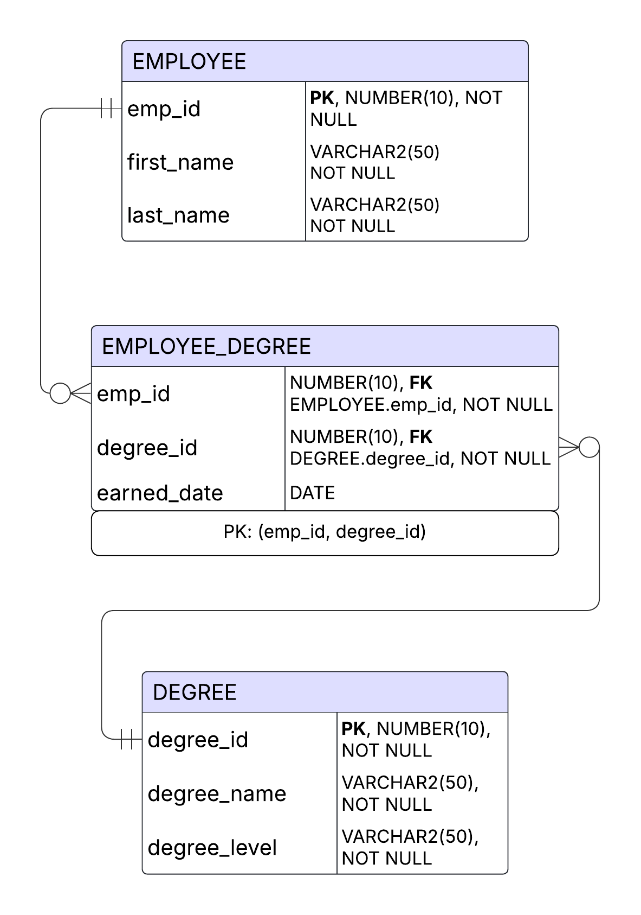
- An employee may have earned many degrees and each degree may have been earned by many employees. (3 Pts)

Business rule & ERD (text + relationships):
Employee || ──── o{ EmployeeDegree }o ──── || Degree
- One Employee may be linked to zero or many EmployeeDegree records; each EmployeeDegree belongs to exactly one Employee.
Cardinality: 1 → 0..M (Employee → EmployeeDegree)
- One Degree may be linked to zero or many EmployeeDegree records; each EmployeeDegree belongs to exactly one Degree.
Cardinality: 1 → 0..M (Degree → EmployeeDegree)

2. Write the business rules that are reflected in the ERD shown. Note that the ERD reflects some simplifying assumptions. ERD is always read from the “1” to the “M” side, regardless of the orientation of the ERD components.). Relations are bi-directional – for full points, include all relations.

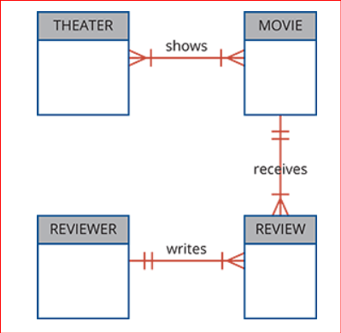

- Write the Business Rules that are reflected in the ERD. (4 Pts)
1. THEATER — shows — MOVIE (M:N, mandatory both ways)
- One theater shows one or many movies.
- One movie is shown in one or many theaters.
2. MOVIE — receives — REVIEW (1:M, mandatory)
- One movie receives one or many reviews.
- One review belongs to one and only one movie.
3. REVIEWER — writes — REVIEW (1:M, mandatory)
- One reviewer writes one or many reviews.
- One review is written by one and only one reviewer.

- create the UML class diagram that reflects the entities and relationships you identified in the relational diagram.
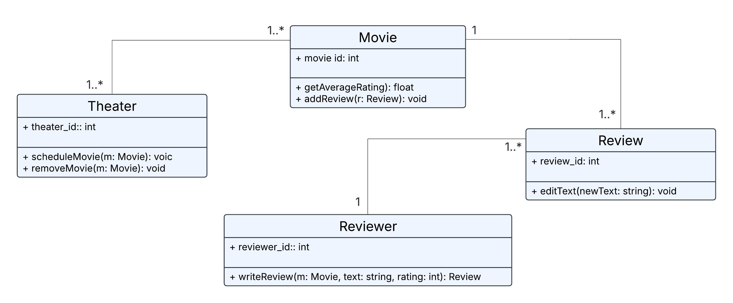
(3 Pts)

3. Typically, a hospital patient receives medications that have been ordered by a particular doctor. Because the patient often receives several medications per day, there is a 1:M relationship between PATIENT and ORDER. Similarly, each order can include several medications, creating a 1:M relationship between ORDER and MEDICATION.

- Identify the business rules for PATIENT, ORDER, and MEDICATION. (3 pts)

1. PATIENT ↔ ORDER
- One patient may have zero or many orders.
- Each order belongs to one and only one patient.
2. ORDER ↔ MEDICATION
- One order includes one or many medications.
- Each medication (administration/line item) belongs to one and only one order.
3. PATIENT ↔ MEDICATION (implied via ORDER)
- A medication is administered to the patient of its parent order; medications cannot exist without an order for that patient.

Note: The narrative also implies each order is written by a single doctor, and a doctor can write many orders, but DOCTOR is outside the three entities requested.

- Create a Crow’s Foot ERD that depicts a relational database model to capture these business rules. (3 pts)
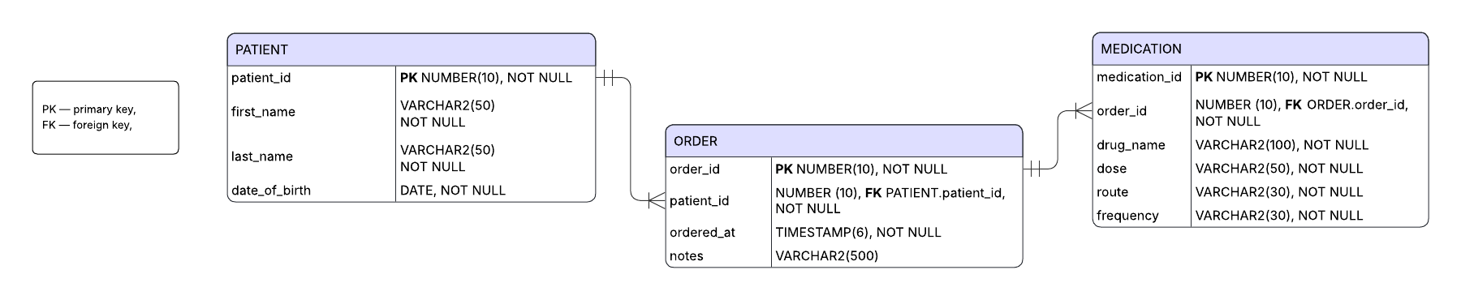

4. Use the database tables shown to answer Problems (a) to (d) below.

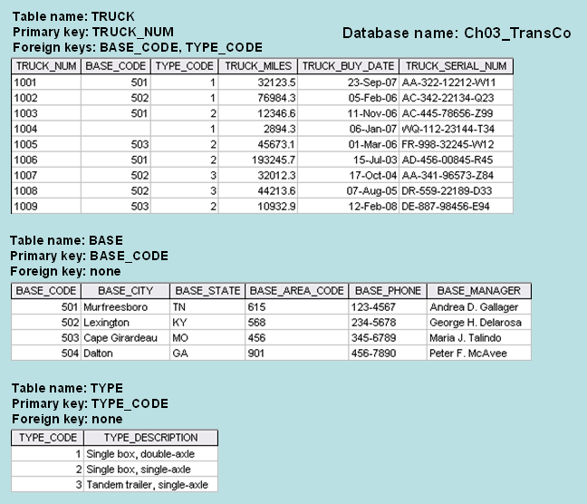

- For each table, identify the primary key and the foreign key(s). If a table does not have a foreign key, write None in the space provided. [2]

TABLE | PRIMARY KEY | FOREIGN KEY(S)
TRUCK | TRUCK_NUM | BASE_CODE → BASE.BASE_CODE,  TYPE_CODE → TYPE.TYPE_CODE
BASE | BASE_CODE | None
TYPE | TYPE_CODE | None

- Do the tables exhibit entity integrity? Answer yes or no and then explain your answer. [2.5]

TABLE | ENTITY INTEGRITY | EXPLANATION
TRUCK | Yes | TRUCK_NUM is defined as the PRIMARY KEY, so it must be NOT NULL and unique. In the sample data every row has a distinct non-null TRUCK_NUM.
BASE | Yes | BASE_CODE is the PRIMARY KEY; values are NOT NULL and unique across rows.
TYPE | Yes | TYPE_CODE is the PRIMARY KEY; values are NOT NULL and unique.

- For each table, identify a superkey and a secondary key. [2]

TABLE | SUPERKEY | SECONDARY KEY
TRUCK | TRUCK_NUM or TRUCK_SERIAL_NUM | BASE_CODE
BASE | BASE_CODE | BASE_CITY
TYPE | TYPE_CODE | TYPE_DESCRIPTION

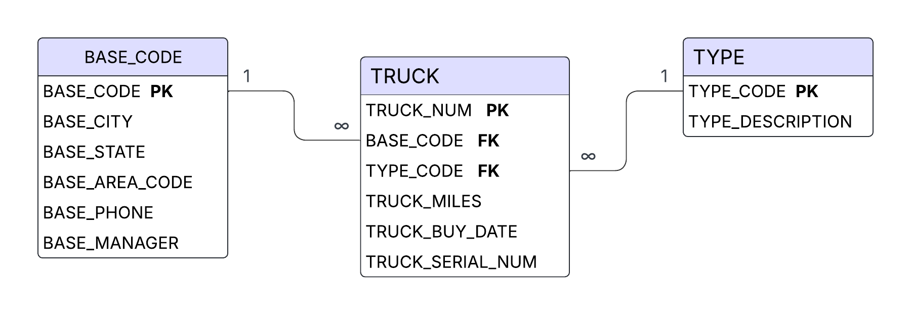
- Create the relational diagram for this database. Include all key attributes such as Primary and Foreign keys and include all relations. [3]

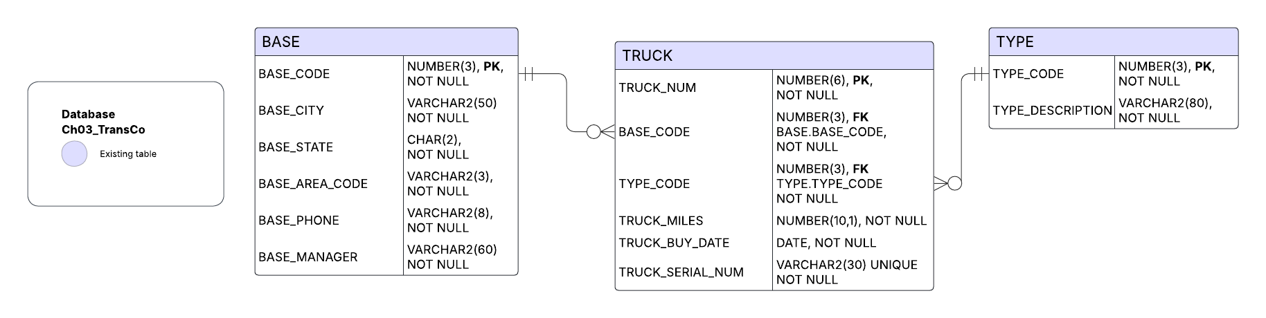
- Create a Crow’s Foot ERD for this database. Include all key attributes such as Primary and Foreign keys and include all relations. [3]

