CS60 Problem Set 2 – Fall 2025
Due Date:- 11.59pm on Oct 10th, 2025
Total 37.5 Pts
1712666_1749_CS60_PS2_Hancharou_Siarhei.docx.
Total –37.5 Points
Instructions:- This Problem Set covers materials from Chapters 2, 3 and 4.
a. For Problems that require explanations, create space below the question and write your answers.
b. For drawing type problems, you can use MS Word, Lucid Charts, ERD Plus or Visio. Refer to Problem Set 1 for links to access Lucid Charts, ERD Plus or Visio. Be sure to name your files appropriately.
Submission:- Download the file available under Problem Set 2

Question 1:- Use the following tables to answer Parts (a) to (c) below:- [10 Points]
Create a complete ERD in Crow’s Foot notation that can be implemented in the relational model using the following description of operations. Hot Water (HW) is a small start-up company that sells spas. HW does not carry any stock. A few spas are set up in a simple warehouse so customers can see some of the models available, but any products sold must be ordered at the time of the sale.
- HW can get spas from several different manufacturers.
- Each manufacturer produces one or more different brands of spas.
- Each and every brand is produced by only one manufacturer.
- Every brand has one or more models.
- Every model is produced as part of a brand. For example, Iguana Bay Spas is a manufacturer that produces Big Blue Iguana spas, a premium-level brand, and Lazy Lizard spas, an entry-level brand. The Big Blue Iguana brand offers several models, including the BBI-6, an 81-jet spa with two 6-hp motors, and the BBI-10, a 102-jet spa with three 6-hp motors.
- Every manufacturer is identified by a manufacturer code. The company name, address, area code, phone number, and account number are kept in the system for every manufacturer.
- For each brand, the brand name and brand level (premium, mid-level, or entry-level) are kept in the system.
- For each model, the model number, number of jets, number of motors, number of horsepower per motor, suggested retail price, HW retail price, dry weight, water capacity, and seating capacity must be kept in the system.
For maximum scores, make sure to clearly label your entities, relations, primary key, foreign key, any weak or strong relations. For the entities, be sure to at least indicate the Primary Key and Foreign key. If there are any M:N relations, create a composite entity to break the M:N into a 1:M or 1:1 relation.

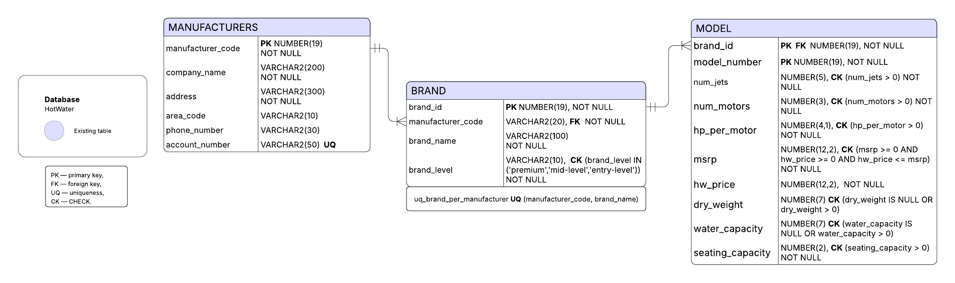
Business Rules (HotWater ERD)
Manufacturers
  - Each manufacturer is uniquely identified by manufacturer_code (Primary Key).
  - A manufacturer must have at least one brand.
  - Attributes include: company name (mandatory), address, area code, phone number, and account number (unique).
Brands
  - Each brand belongs to exactly one manufacturer.
  - A manufacturer can have one or more brands.
  - Within a manufacturer, each brand name must be unique.
  - Attributes include: brand_level (with values restricted to premium, mid-level, or entry-level).
  - A brand must have at least one model.
Models
  - Each model is associated with exactly one brand.
  - A brand can have one or more models.
  - Each model is uniquely identified within its brand by the pair (brand_id, model_number).
  - Attributes include: number of jets, number of motors, horsepower per motor, MSRP, HW retail price, dry weight, water capacity, seating capacity.
  - Data integrity rules: values must be positive; HW retail price must not exceed MSRP.
General
  - Hot Water does not carry stock; therefore, no inventory entity is modeled.
  - All relationships are one-to-many (1:N) with mandatory participation on both sides of the relationship (per problem description).
  - No many-to-many relationships exist in this scenario, so no associative entities are required.
Relationships (Crow’s Foot Notation)
Manufacturer — Brand
  - One manufacturer produces one or more brands.
  - Each brand belongs to exactly one manufacturer.
  - Relationship: Manufacturer (1) ——< Brand (1..*), mandatory on both sides.
Brand — Model
  - One brand offers one or more models.
  - Each model is part of exactly one brand.
  - Relationship: Brand (1) ——< Model (1..*), mandatory on both sides.

Problem 2:- [13.5 Points]
Using the Crow’s Foot notation, create an ERD that can be implemented for a medical clinic, using the following business rules:-
- A patient can make many appointments with one or more doctors in the clinic, and a doctor can accept appointments with many patients. However, each appointment is made with only one doctor and one patient.
- Emergency cases do not require an appointment. However, for appointment management purposes, an emergency is entered in the appointment book as “unscheduled.”
- If kept, an appointment yields a visit with the doctor specified in the appointment. The visit yields a diagnosis and, when appropriate, treatment.
- With each visit, the patient’s records are updated to provide a medical history.
- Each patient visit creates a bill. Each patient visit is billed by one doctor, and each doctor can bill many patients.
- Each bill must be paid. However, a bill may be paid in many installments, and a payment may cover more than one bill.
- A patient may pay the bill directly, or the bill may be the basis for a claim submitted to an insurance
company.
- If the bill is paid by an insurance company, the deductible is submitted to the patient for payment.

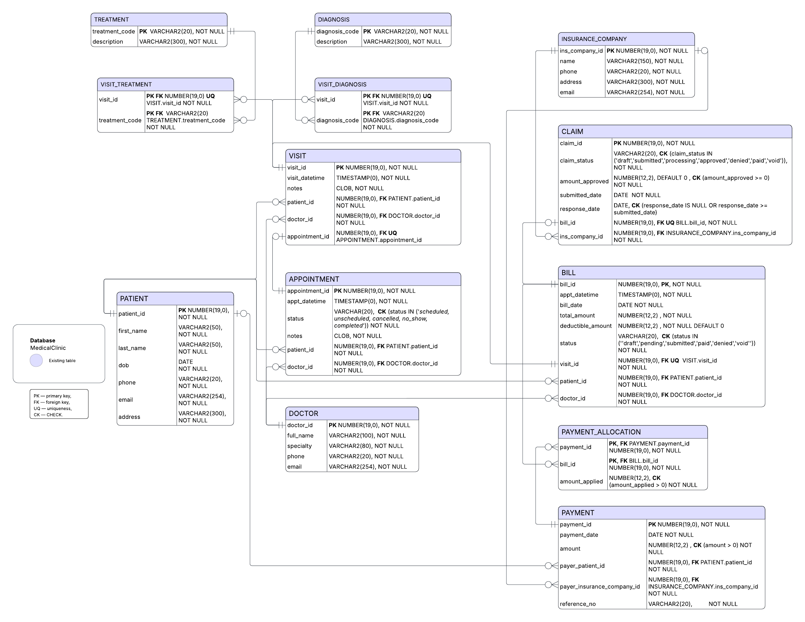
For maximum scores, make sure to label your entities clearly, include at least the primary and foreign keys and indicate how the entities are related. If you are making any assumptions, include a note at the bottom of your ERD.

Business Rules (Medical Clinic ERD)
Patients and Doctors
- A patient may have zero, one, or many appointments.
- A doctor may have zero, one, or many appointments.
- Each appointment must be linked to exactly one patient and exactly one doctor.

Appointments and Emergency Visits
- An appointment may lead to zero or one visit (if cancelled or missed, no visit is created).
- A visit may exist without an appointment (emergency cases). In this case, the appointment_id in Visit is NULL.

Visits
- Every visit is linked to exactly one patient and exactly one doctor.
- Each visit updates the patient’s medical record.
- A visit may or may not be tied to an appointment (emergencies are stored directly as visits).

Clinical Content
- The relationship between visits and diagnoses is many-to-many, implemented via the associative entity VisitDiagnosis.
- The relationship between visits and treatments is many-to-many, implemented via the associative entity VisitTreatment.
- Each associative row references exactly one visit and exactly one diagnosis or treatment code.

Billing and Payments
- Each visit generates exactly one bill, and each bill corresponds to exactly one visit (1:1), enforced by a unique foreign key on Bill.visit_id.
- Each bill references the patient and doctor associated with the visit (consistency rule: Bill.patient_id and Bill.doctor_id must match the related visit).
- Every bill must be paid.
- A bill may be paid in multiple installments, and a single payment may cover multiple bills — modeled as a many-to-many relationship resolved by PaymentAllocation.

Insurance
- A bill may have zero or one claim.
- Each claim references exactly one bill (Claim.bill_id is NOT NULL, UNIQUE, and a foreign key to Bill.bill_id).
- Each claim is submitted to exactly one insurance company.
- An insurance company may handle zero, one, or many claims.
- If a bill is paid by insurance, any deductible amount remains the patient’s responsibility and is recorded in the bill to be settled through patient payments.

Data Integrity Highlights
- Appointment statuses include at least: scheduled, unscheduled, cancelled, no_show, completed.
- Monetary amounts must be non-negative; payment allocations cannot exceed the bill total.
- Consistency rules:
  - Visit.patient_id and Visit.doctor_id must match the related appointment (if present).
  - Bill.patient_id and Bill.doctor_id must match the related visit.

Relationships (Medical Clinic ERD Crow’s Foot Notation )
Appointments and participants
[PATIENT] || —— o{ [APPOINTMENT]
(a patient may have zero or many appointments; each appointment belongs to exactly one patient)
[DOCTOR] || —— o{ [APPOINTMENT]
(a doctor may have zero or many appointments; each appointment belongs to exactly one doctor)

Appointment ↔ Visit
[APPOINTMENT] || —— o| [VISIT]
(an appointment may lead to zero or one visit)
[VISIT] o| —— || [APPOINTMENT]
(a visit may exist without an appointment — emergencies; if present, exactly one)

Visit ownership
[PATIENT] || —— o{ [VISIT]
(a patient may have zero or many visits; each visit belongs to exactly one patient)
[DOCTOR] || —— o{ [VISIT]
(a doctor may have zero or many visits; each visit belongs to exactly one doctor)

Clinical M:N via associative entities
[VISIT] || —— o{ [VISIT_DIAGNOSIS]
[DIAGNOSIS] || —— o{ [VISIT_DIAGNOSIS]
(a visit may have zero or many diagnoses; a diagnosis may appear in zero or many visits)
[VISIT] || —— o{ [VISIT_TREATMENT]
[TREATMENT] || —— o{ [VISIT_TREATMENT]
(a visit may have zero or many treatments; a treatment may appear in zero or many visits)

Billing and payments
[VISIT] || —— || [BILL]
(Each visit generates exactly one bill; each bill corresponds to exactly one visit)
[PATIENT] || —— o{ [BILL]
(a patient may have zero or many bills; each bill belongs to exactly one patient)
[DOCTOR] || —— o{ [BILL]
(a doctor may generate zero or many bills; each bill is issued by exactly one doctor)
[BILL] || —— o{ [PAYMENT_ALLOCATION]
[PAYMENT] || —— o{ [PAYMENT_ALLOCATION]
(bills and payments are related M:N through PaymentAllocation)

Who paid (one of them: patient or insurer)
[PATIENT] o| —— o{ [PAYMENT]
[INSURANCE_COMPANY] o| —— o{ [PAYMENT]
(a payment has exactly one payer: either a patient or an insurance company; modeled with XOR at the PAYMENT table)

Insurance (claims)
[BILL] || —— o| [CLAIM]
(a bill may have zero or one claim; each claim references exactly one bill)
[INSURANCE_COMPANY] || —— o{ [CLAIM]
(an insurance company may handle zero or many claims; each claim belongs to exactly one insurance company)

Question 3:- [14 Points]
The Jonesburgh County Basketball Conference (JCBC) is an amateur basketball association. Each city in the county has one team as its representative. Each team has a maximum of 12 players and a minimum of 9 players. Each team also has up to 3 coaches (offensive, defensive, and physical training coaches). During the season, each team plays 2 games (home and visitor) against each of the other teams. Given those conditions, do the following:
- Identify the cardinality between teams and players and between teams and city. [4 Points]
- Draw the Crow’s Foot ERD to represent the JCBC database. [10 Points]
For maximum scores, make sure to label your entities clearly, include at least the primary and foreign keys and indicate how the entities are related. If you are making any assumptions, include a note at the bottom of your ERD.

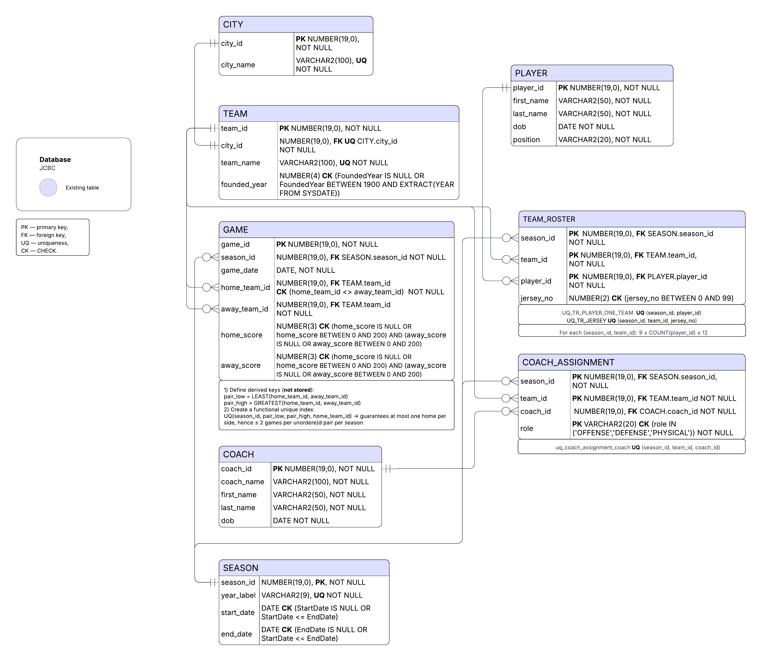

Business Rules (JCBC)
Cities & Teams
- Each city has exactly one team; each team belongs to exactly one city (1:1, mandatory).
Implementation: TEAM.city_id NOT NULL FK → CITY.city_id + UNIQUE(TEAM.city_id).
Seasons
- A season contains many games, roster entries, and coach assignments.
Keys: GAME.season_id, TEAM_ROSTER.season_id, COACH_ASSIGNMENT.season_id are NOT NULL FKs SEASON.
Team–Player membership (per season)
- For each (season, team), the roster size must be between 9 and 12 players.
Enforcement: business rule (trigger/procedure) on TEAM_ROSTER grouped by (season_id, team_id).
- In any single season, a player belongs to at most one team.
Constraint: UNIQUE(season_id, player_id) on TEAM_ROSTER.
- Keys (typical): TEAM_ROSTER PK = (season_id, team_id, player_id); all three FKs NOT NULL.
Coaches (per team-season)
- Allowed roles: OFFENSE, DEFENSE, PHYSICAL.
Constraint: CHECK (role IN (‘OFFENSE’,'DEFENSE','PHYSICAL')).
- Cardinality: For each (season, team), there is at most one coach per role (⇒ up to 3 assignments per team-season).
- Primary key: (season_id, team_id, role). The PK guarantees uniqueness and NOT NULL.)
- At most one coach per role for a given team-season (⇒ ≤3 total per team-season).
- Foreign keys (all NOT NULL): season_id → SEASON, team_id → TEAM, coach_id → COACH
- To prevent a coach from holding multiple roles for the same team-season, add UNIQUE (season_id, team_id, coach_id).
Games & Scheduling
- Ownership: Each game belongs to exactly one season and has exactly one home team and one away team.
FKs: GAME.season_id → SEASON, GAME.home_team_id → TEAM, GAME.away_team_id → TEAM.
Check: home_team_id <> away_team_id (both NOT NULL).
- Scheduling rule (per season): For every unordered pair of teams {A, B}, schedule two games:
A(home) vs B(away) and B(home) vs A(away).
- Schema enforcement (practical):
Define derived pair keys (not stored):
pair_low = LEAST(home_team_id, away_team_id)
pair_high = GREATEST(home_team_id, away_team_id)
Add a unique constraint/index:
UNIQUE (season_id, pair_low, pair_high, home_team_id) → guarantees at most one home per side, therefore ≤ 2 games per unordered pair per season.
- Scores (optional): Must realistic.
Checks: home_score BETWEEN 0 AND 200 and away_score BETWEEN 0 AND 200 (allow NULL before the game is played).
Player & Team data sanity
- PLAYER.dob (if stored) should be in the past.
- TEAM.founded_year realistic: 1900 ≤ founded_year ≤ current_year.

Relationships (JCBC ERD — Crow’s Foot Notation)
City ↔ Team (1:1 mandatory)
[CITY] || —— || [TEAM]
(one city has exactly one team; each team belongs to exactly one city)

Season scope
[SEASON] || —— o{ [GAME]
[SEASON] || —— o{ [TEAM_ROSTER]
[SEASON] || —— o{ [COACH_ASSIGNMENT]
(a season has many games, roster rows, and coach assignments)

Team ↔ Player (membership via season roster)
[TEAM] || —— o{ [TEAM_ROSTER] : "9..12 players per (season, team)"
[PLAYER] || —— o{ [TEAM_ROSTER] : "unique (season, player)"
(teams list players through TEAM_ROSTER; players appear through TEAM_ROSTER)

Coaches (role per team-season)
[TEAM] || —— o{ [COACH_ASSIGNMENT] : "roles: OFFENSE/DEFENSE/PHYSICAL"
[COACH] || —— o{ [COACH_ASSIGNMENT]
(up to one coach per role per team-season; ≤3 total)

Games (home/away per season)
[TEAM] || —— o{ [GAME] : home_team
[TEAM] || —— o{ [GAME] : away_team
[SEASON] || —— o{ [GAME]
(each game has exactly one home and one away team; games are per season)

