Problem Set 4
Instruction:- Create a single .sql file for the problems below and name it as your First_LastName_PS4.sql. Upload your .sql file using the Problem Set 4 Upload option in Canvas.
Use the ERD diagram below to answer parts Q1-10 below. You can create tables and insert data using the file PS4_Datafile.txt provided under the Problem Set 4 section in Canvas.
Bonus Questions (11-13) - Complete these questions for extra credit – questions are worth 3 points each.
Due Date:- Midnight Nov 25th, 2025
ERD:-
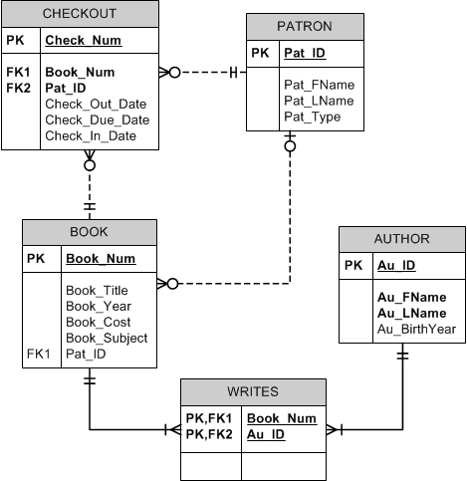

Note:- Sample output is provided for each of the Problems.
- Write a query that displays the first and last name of every patron, sorted by last name and then first name. Ensure the sort is case insensitive (50 rows)

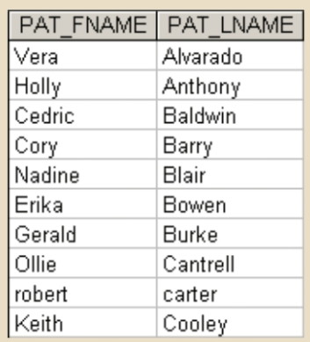

- Write a query to display the checkout number, checkout date, and due date for every book that has been checked out sorted by checkout number
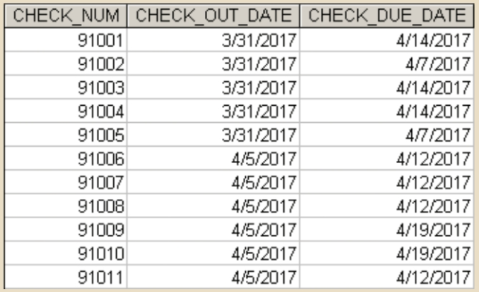

- Write a query to display the book number, book title, and subject for every book sorted by book number
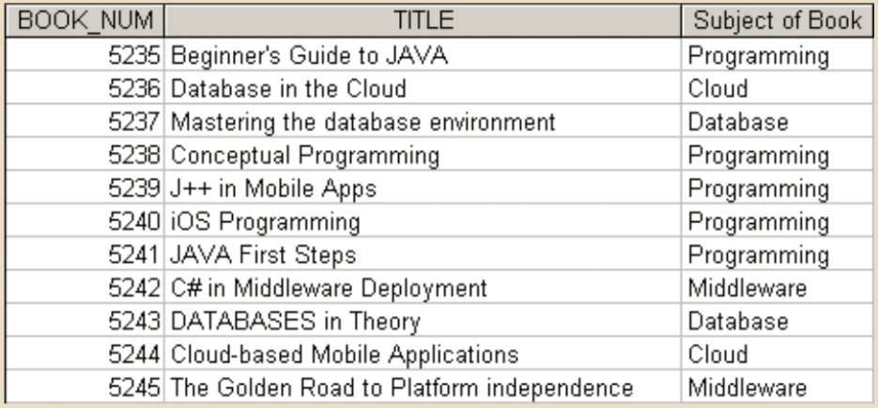
- Write a query to display the book number, title, and cost of each book sorted by book number
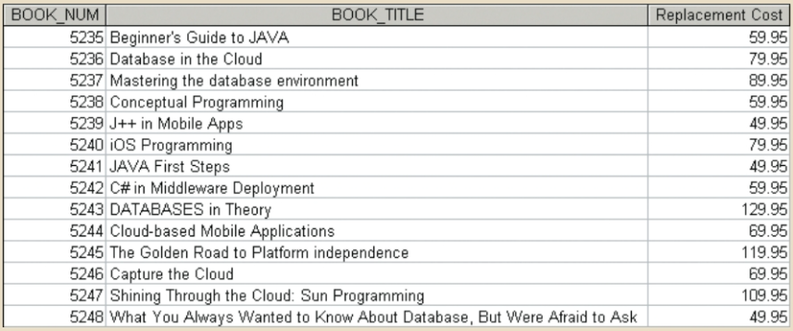

- Write a query to display the checkout number, book number, patron ID, checkout date, and due date for every checkout that has ever occurred in the system. Sort the results by checkout date in descending order and then by checkout number in ascending order.
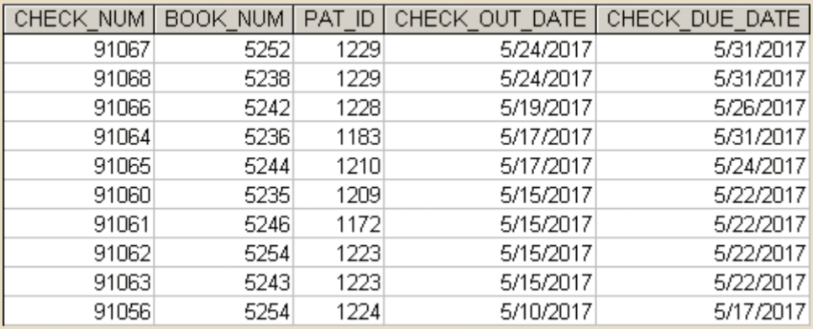
- Write a query to display the book number, title, and replacement cost for all books in the “Database” subject sorted by book number
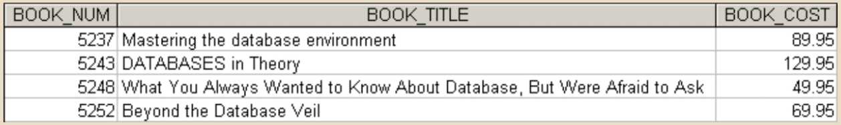
- Write a query to display the checkout number, book number, and checkout date of all books checked out before April 5, 2017 sorted by checkout number
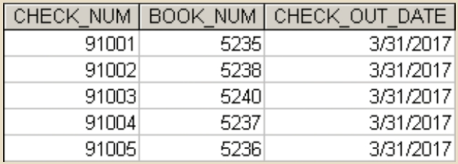

- Write a query to display the book number, title, subject, average cost of books within that subject, and the difference between each book’s cost and the average cost of books in that subject. Sort the results by book title
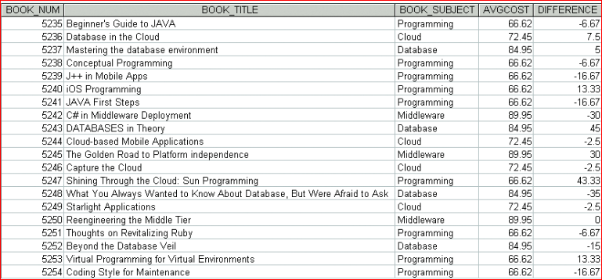

- Write a query to display the author ID, first name, last name, and year of birth for all authors. Sort the results in descending order by year of birth, and then in ascending order by last name
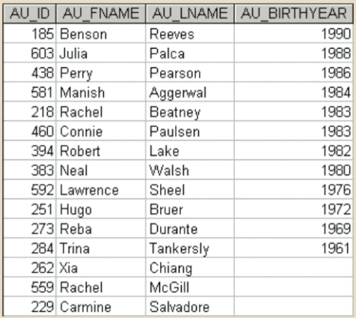

- Write a query to display the subject and the number of books in each subject. Sort the results by the number of books in descending order and then by subject name in ascending order
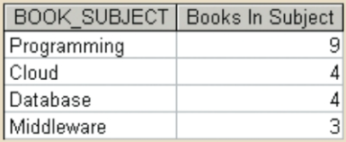

Optional Bonus Problems:- Complete these questions for extra credit – questions are worth 3 points each.
- Write a query to display the author ID and the number of books written by that author. Sort the results in descending order by number of books, then in ascending order by author ID.
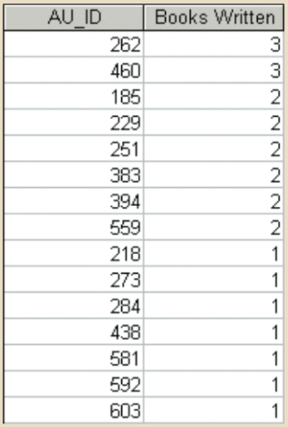

- Write a query to display the patron ID, book number, and days kept for each check-out. “Days Kept” is the difference from the date on which the book is returned to the date it was checked out. Sort the results by days kept in descending order, then by patron ID, and then by book number.
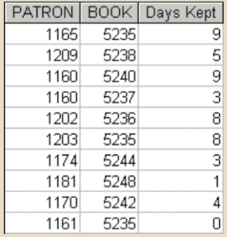

- Write a query to display the book number and the number of times each book has been checked out. Do not include books that have never been checked out. Sort the results by the number of times checked out in descending order and then by book number in descending order
