Hello,
I am sending a *.rar file containing my attempt to create a RI of the TMF028 Party Component, including the component CTK BDD tests.

If you have time, please review it. Any comments and suggestions are welcome.

Basically, the way I did it was as follows:
- Created the TMFC028 RI component:
  - I followed the tutorial “Build an ODA Component from OpenAPI Reference Implementation.”
https://tmforum-oda.github.io/oda-ca-docs/docs/ODAComponentTutorial/README.html
  - I downloaded the TMF632 Party OpenAPI, and dockerized it following the above tutorial.
I used the existing TMFC002 POCV as a template, copying and adjusting all the corresponding Helm chart k8s template files such as service, deployment, etc.
- Created the CTK BDD tests:
  - First BDD scenario: run a test with a valid PartyRole that really exists in the dependent PartyRole stub, expecting SUCCESS.
  - Second BDD scenario: run a test with a PartyRole that does not exist in the dependent PartyRole stub, expecting FAILURE.

TMF028 has a dependency on a TMF669 PartyRole stub API. Following the advice of Mr. Biancardi Gaetano (via email), I also implemented the TMFC035 component as a stub to expose the required PartyRole API, using the same approach as for the TMFC028 component.
See the attached emails for reference.

Doker images used/referenced by Helm chars
For the TMF632 Party Api I published the docker image under:
- cr.marand.si/sergejp/tmf/partyapi:0.1
For the TMF672 Permission Api I published the docker image under:
- cr.marand.si/sergejp/tmf/userrolepermissionapi:0.1
For the TMF669 PartyRole API, I reused the implementation available in the Docker image:
- lesterthomas/partyroleapi:1.0
I no longer remember exactly where I originally found this image, but it was either part of one of the reference TMF components or discovered while browsing the ODA Canvas GitHub repositories.

How to run CTK tests

To run the CTK tests, read the instructions in the file within the RAR archive:
README-running-ctk-on-TMFC028-RI-and-TMFC035-RI

Overall issues, comments and questions:

There is a deployment dependency cycle:
- TMFC028 exposes the Party API and requires the PartyRole API (in TMFC035).
- TMFC035 exposes the PartyRole API and requires the Party API.
- First I deploy TMFC028, and it waits for the dependent PartyRole API in TMFC035.
- Then I deploy TMFC035, which deploys successfully, but TMFC028 is still waiting for its dependent PartyRole API.
- Consequently, deployment to the ODA Canvas does not complete.

Possible solutions:
- Solution 1: restart the depapi operator:
  - kubectl rollout restart deployment canvas-depapi-op -n canvas
- Solution 2 (alternative): uninstall the first Party component and install it again. Now both components will reach the status Completed.

TMFC035 component has two PartyRole apis?

TMFC035 exposes the TMF669 PartyRole API as a part of the Core Fuction, but every ODA component also has TMF669 PartyRole exposed as part of the Security Function.

Question: I it OK and expected for TMFC035 to expose two PartyRole APIs—one in the Core function and another in the Security function? See the image below.

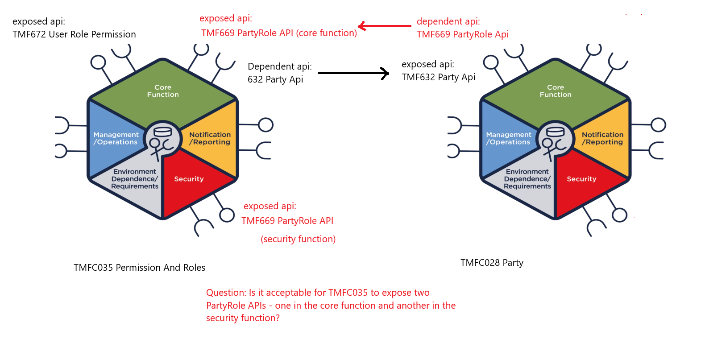
I assume the Core and Security functions should each have their own PartyRole API exposed. Therefore, I created separate Helm chart service & deployment templates for each one (see picture).

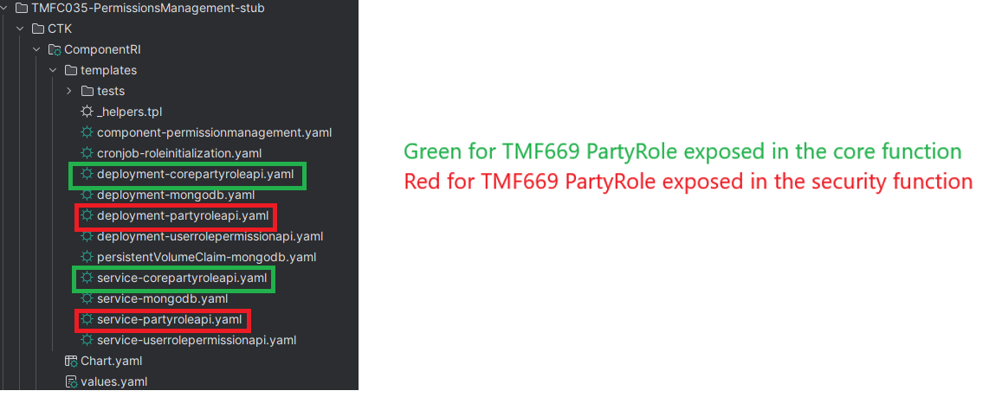

Separate MongoDB for PartyRole APIs

When PartyRole initialization in the Security function of the TMFC035 component is performed, it POSTs an Admin role to the (security) PartyRole API. But I assume it would be wrong for that Admin role to also appear in the Core (non-security) PartyRole database.
Therefore, I separated the two databases by setting a different MongoDB name in the MONGO_DATABASE environment variable in deployment-corepartyroleapi.yaml.

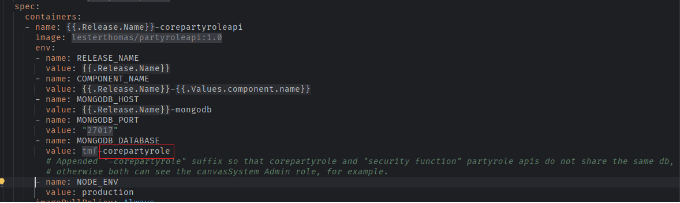

Exact changes to the dockerized OpenAPIs

It is quite time-consuming to list all the details of the changes I made when dockerizing the TMF632 and TMF672 OpenAPI reference implementations.
The easiest approach is to use a diff tool to compare the original code with the modified (dockerized) code.

I have included both the original and the dockerized OpenAPI implementations in the .rar file.
You can open them in any diff viewer and compare the two versions to see all the modifications I applied.

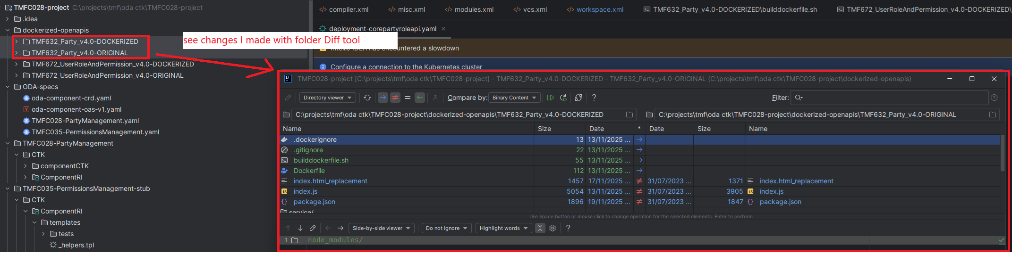

How does the TMFC028 Party component validate the href of the dependent API (“party → relatedParty → partyRole.href”) for the BDD Success and Failure test scenarios?

The TMFC028 Party component reference implementation checks whether a PartyRole href points to an existing role in the TMFC035 component. I followed the approach from the TMFC002 POCV component, which validates an existing prodSpec href.
However, the original logic for validating the href during order creation does not work - the BDD tests fail - because inside the k8s oda-canvas environment, one service cannot call another service using external URLs like https://localhost/per-permission/tmf-api/partyRoleManagement/v4/partyRole/UUID

I assume this issue is caused by the current ODA Canvas version - perhaps it worked in an older version?

Therefore, I rewrote the logic in utils/ruleUtils.js for the TMF632 Party service by ading the validateRelatedPartyHref method which:
- rewrites the input href so that it is accessible internally within k8s using istio-ingress.istio-ingress.svc.cluster.local gateway,
- validates that the rewritten URL is reachable,
- returns the payload or throws an error if the href is invalid.

Example:
- External href (not reachable inside ODA Canvas):
  - https://localhost/per-permission/tmf-api/partyRoleManagement/v4/partyRole/UUID
- Internal href (after rewrite, and reachalbe inside ODA Canvas):
  - http://istio-ingress.istio-ingress.svc.cluster.local/per-permission/tmf-api/partyRoleManagement/v4/partyRole/UUID

See the validateRelatedPartyHref method at:
TMFC028-project\dockerized-openapis\TMF632_Party_v4.0-DOCKERIZED\utils\ruleUtils.js

Was using the internal gateway the correct approach?
I know that using istio-ingress.istio-ingress.svc.cluster.local may not be how href validation is supposed to be done. A more correct approach might be to introspect the ODA Canvas's Resource and/or Service Inventory APIs.
But I am not sure how to use them. Perhaps the ODA tutorial could be updated to explain this?

BDD scenarios

I added a BDD scenarios file:
TMFC028-project\TMFC028-PartyManagement\CTK\componentCTK\src\features\TMFC028_ProductInventory.feature

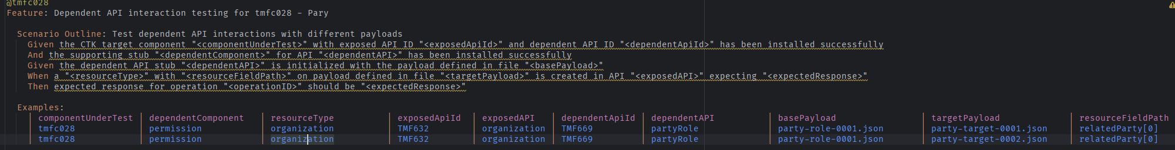

I also added bddPayload to the CTK CHANGE_ME.json.

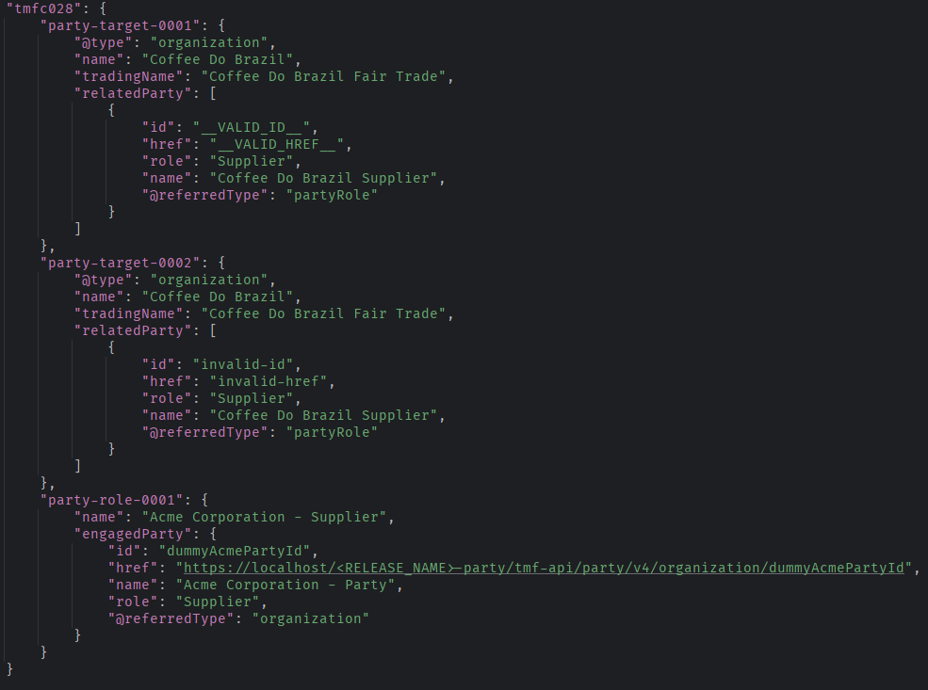

Question – how configurable is the BDD Test Preparation Phase if we need to POST additional data?

From what I understand, the CTK tests validate the dependent API in the following way:

- Test Preparation Phase:
The CTK inserts the required PartyRole by POST-ing party-role-0001.json, ensuring that the dependent service has the necessary data in its database before the test runs.
- Execution Phase:
  - party-target-0001.json verifies that the Party points to an existing PartyRole – expected to succeed.
  - party-target-0002.json verifies that the Party points to a non-existing PartyRole – expected to fail.

However, when examining party-role-0001.json, a question arises: where is the engagedParty “Acme Corporation”?
This Party entity is never POST-ed to the Party service during the Preparation Phase. Yet the BDD tests still pass, because they do not validate whether party-role-0001.json contains a valid href reference back to an existing Party.

So my question is: is there a way to configure the BDD tests so that they can also POST additional setup data - for example, the Party “Acme Corporation” - during the Test Preparation Phase?
This would allow the tests to fully validate cross-resource references instead of relying on incomplete or non-existent data.

PartyRole Swagger-UI Issue

TMFC028: The TMF632 Party Swagger-UI is accessible at:
https://localhost/par-party/tmf-api/party/v4/docs/

TMFC035: The TMF672 Permission Swagger-UI is accessible at:
https://localhost/per-permission/userrolepermission/v4/docs/

TMFC035: The TMF669 PartyRole Swagger-UI is accessible at:
https://localhost/per-permission/tmf-api/partyRoleManagement/v4/docs/

However, the PartyRole Swagger definition uses the http scheme instead of https. As a result, issuing requests directly from Swagger-UI does not work.

The issue likely comes from the Docker image lesterthomas/partyroleapi:1.0, which probably needs to override the Swagger document’s host and schemes values in index.js, similar to the following:

const swaggerDoc = swaggerUtils.getSwaggerDoc();

// force host override
swaggerDoc.host = `localhost:${serverPort}`;
swaggerDoc.schemes = ["https"]; // prevents UI from trying http from the original scheme

