<https://www.youtube.com/watch?v=Tb7TOxEXisY>

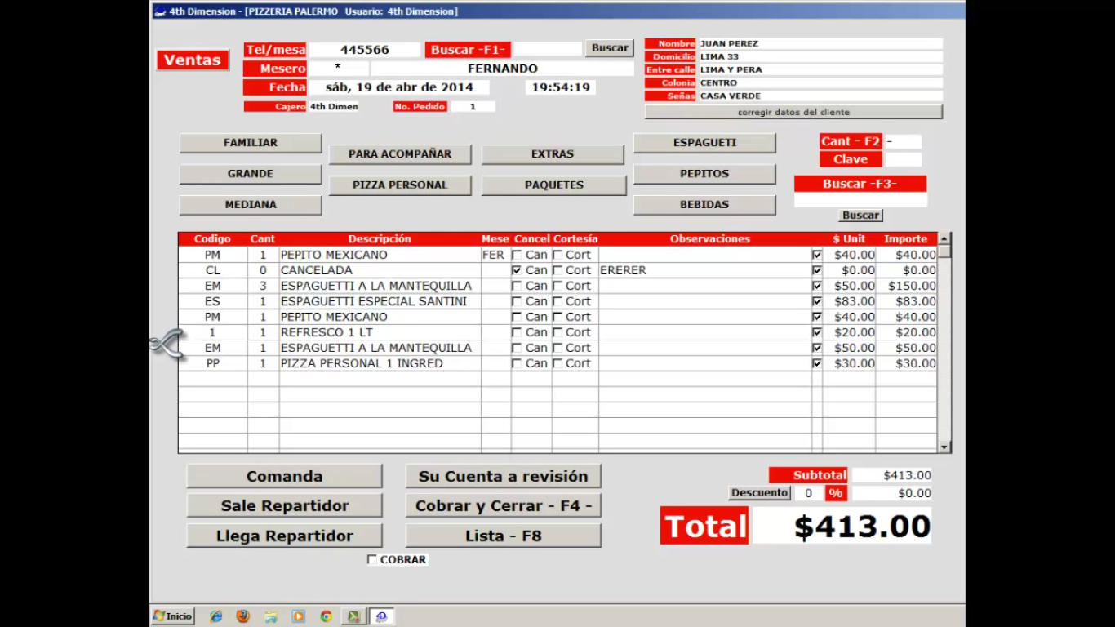

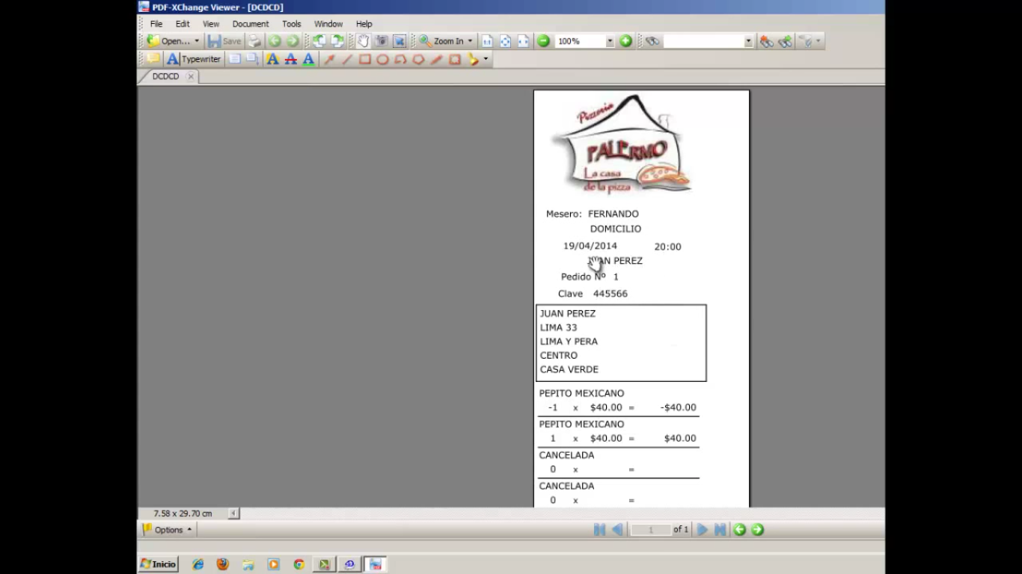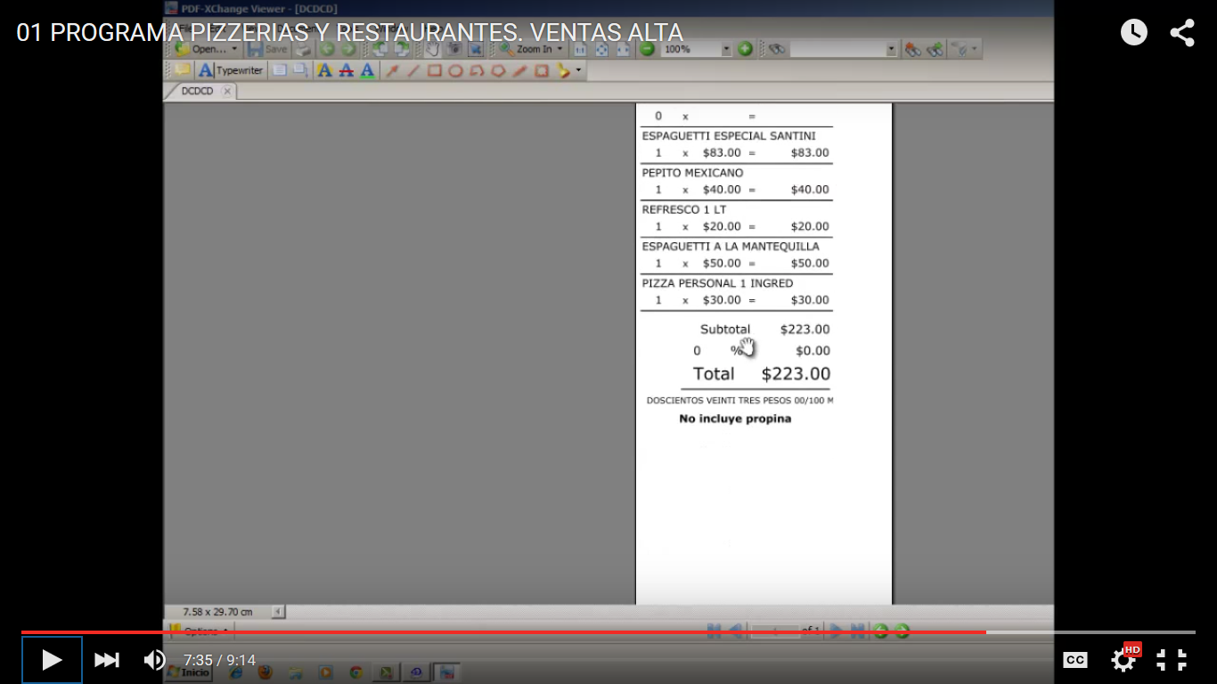

<https://www.youtube.com/watch?v=Dsc_Ot6i_Iw>

