**Running script in R studio**

First, open the script and to run press Source.

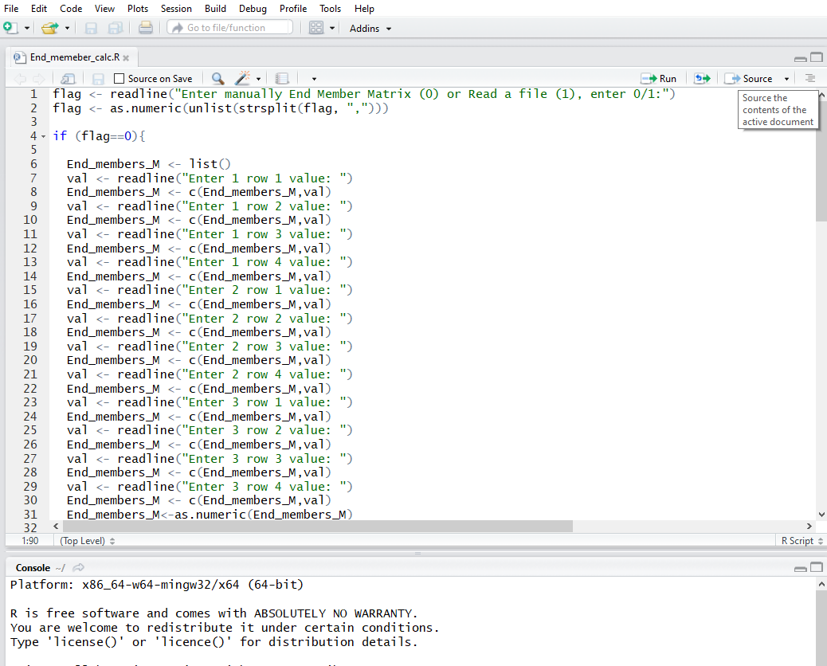

First the script will ask whether the end member matrix should be entered manually (enter 0) or read from the file (enter 1). In this example we read end member matrix from file, so we input 1.

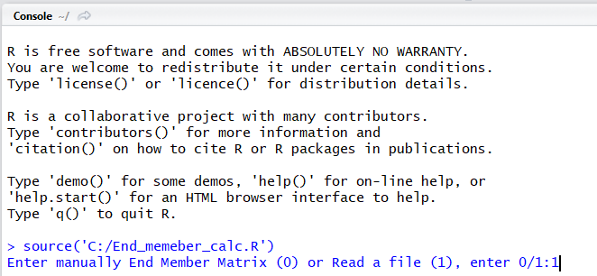

Next, in the console you would be asked to select End Member Matrix file. This file should contain the δ13C, C:N, OC%, and N% of the end-members that you have defined.

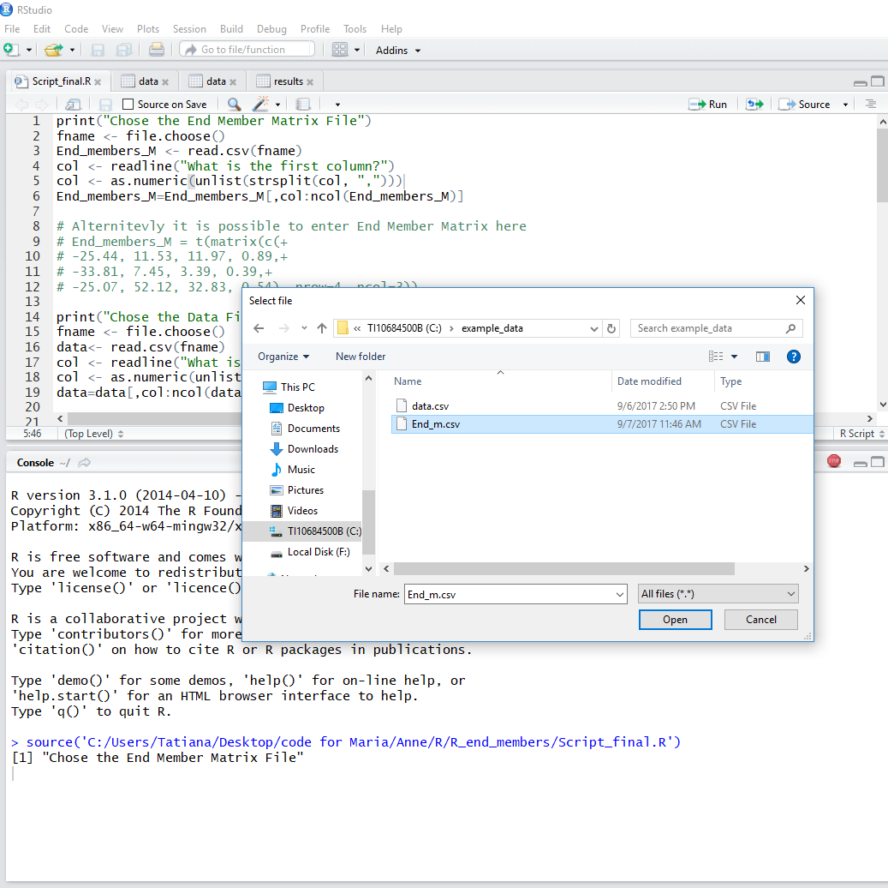

Then, the console will ask which the first column of data in the file is. In our example, data within the End Member Matrix file starts with the second column (B).

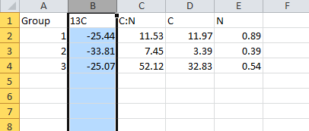

So, we entered 2 as an index for the first column of data from the End Member Matrix file.

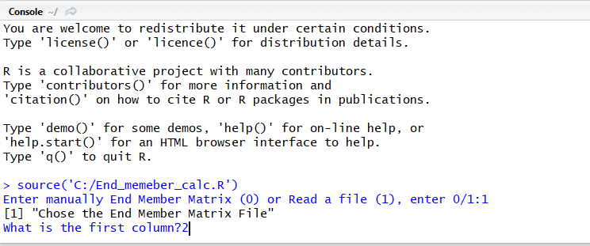

Next, in the console you would be asked for the Data file (which will contain at least δ13C, C:N for each sample you would like to analyze).

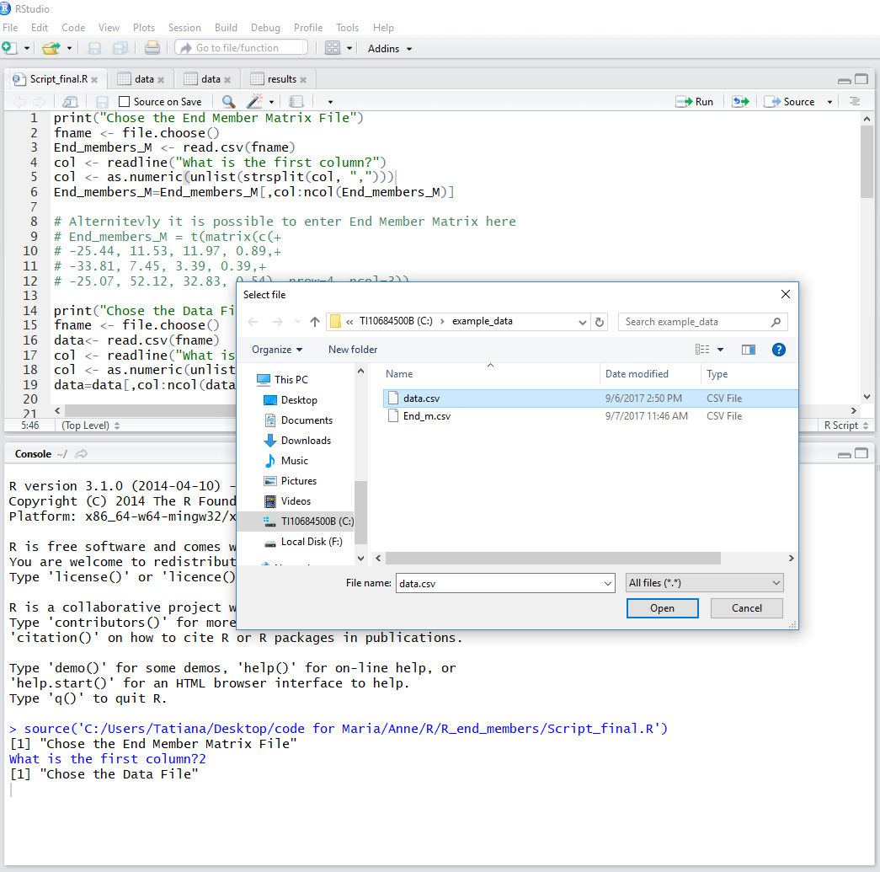

Enter the first column of data within the file. In our example, it is again 2.

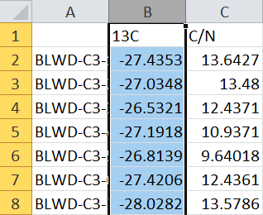

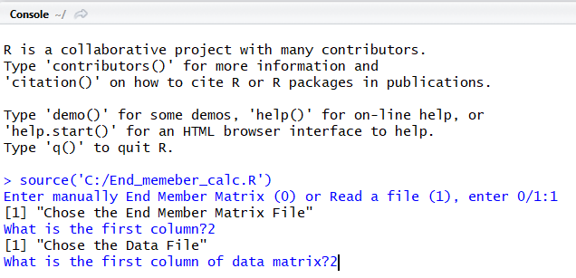

At the end of the script, write the name of the output file. The file will be saved in the current working directory.

