# Jupiter

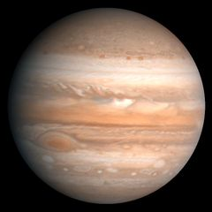

Figure Jupiter

## How big is Jupiter

Jupiter is 142,984 km or about 11 Earths in diameter at the **equator**. That makes it about one tenth as big as the Sun! You could fit about 1,400 Earths into the volume of Jupiter. It is 133,709 km or 10 Earths in diameter from pole to pole. Jupiter's rapid **rotation** makes it bulge out at the equator.

Jupiter's magnetic field is the largest single planetary thing in the Solar System. It is 26 million kilometers across, making it about 20 times bigger than the Sun. It has a tail that extends past Saturn's orbit. If it could be seen from Earth, it would appear to be five times the size of the full moon.

## How long is a day on Jupiter

One Jupiter day is about 10 Earth hours long. You have to say "about" because different parts of Jupiter rotate about its axis at different speeds. This is caused by the fact that Jupiter is mostly gases that are in constant motion and sometimes going in opposite directions. Some efforts have been made to try and measure the rotation speed of the inner rocky core of Jupiter, but that has proved to be quite difficult to accomplish due to the magnetic fields that surround Jupiter and the very active radio energy that is generated by the atmosphere of Jupiter, which interferes with measuring techniques like radar that has been used to measure the surface of Venus and Mars.

## Jupiter’s moons

Jupiter has 63 known moons. Io is the closest one.

## Who is it named after

Jupiter is named after the chief of the Roman gods, also called Zeus in ancient Greece. It was so named because of the planet's enormous size.d

## Jupiter Facts



* Due to its magnetic field trapping particles from the Sun, Jupiter is surrounded by very powerful radiation belts which would kill anyone who entered them.
* Jupiter's moon Europa is thought to have a giant ocean below its surface.