# Mars

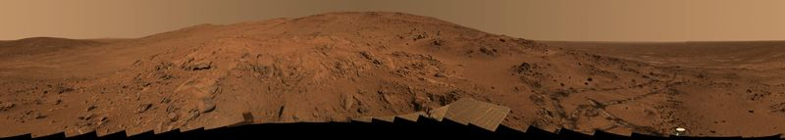

Figure A panorama view from the Mars rover *Spirit*

## How big is Mars

Mars is the second smallest of the eight major planets in the Solar System[1]. It is nearly 7,000 kilometres (km) wide; just over half the width of the Earth. Its volume is about 15% of the Earth. Since a lot of the Earth is covered by water, the total surface area of the Mars is nearly as large as all of the land on the Earth.

## How long is a day or year on Mars

One day on Earth is only 39 minutes and 35 seconds shorter than a day on Mars (1.026 Earth days). A year on Mars is almost two Earth years long (687 Earth days).

Much like the Earth, the axis of rotation of Mars is tilted at an angle. This tilt causes seasons on Mars as it travels around the Sun. Summer occurs on the half of the planet that is tilted toward the Sun, and winter on the other half. After half a Martian year has passed the seasons are reversed. But these seasons are about twice as long as on Earth.

## What is Mars made of

The outer, rocky surface of Mars is called the crust. Most of the crust is made from basalt, a type of rock made when lava grows cold.

Like the Earth, Mars has a thick layer of rock below the crust called the mantle. The mantle is much hotter than the crust, and the mantle rock is partly molten. But the crust on Mars has grown thick, so the lava from the mantle no longer reaches the surface. There are volcanoes on Mars, but they are no longer active.

At the center of Mars is a core made of the metals iron and nickel. If Mars were the same size as the Earth, the core of Mars would be smaller then the Earth's core. So a larger amount of Mars is made out of rock. Because rock is lighter than the metals in the core, Mars has a lower density than the Earth.

## Mars Facts



* Mars is red because of rust in the surface rocks.
* A volcano on Mars called Olympus Mons is the highest mountain in our Solar System.
* Mars has polar ice caps just like Earth.
* Mars has ancient river beds where scientists think liquid water flowed millions or billions of years ago

1. Only Mercury is smaller.