|  |  |
| --- | --- |
| **Российский университет транспорта (МИИТ)**  **Институт транспортной техники и систем управления**  **Кафедра «Управление и защита информации»** | |
| **Отчет**  **по практическому заданию**  **по теме «Структуры данных»**  **по дисциплине «Системы управления базами данных»** | |
|  | Выполнили:  Студенты группы ТКИ-442  Белов С.В.  Проверил:  Доцент кафедры УиЗи, к.т.н., с.н.с.  Васильева М.А. |
| Москва 2023 | |

Оглавление

Задание 3

1. Текст программы на языке C++ 3

1.1. Код файла Node.h 3

1.2. Код файла BST.h 5

1.3. Код файлов Node.cpp и BST.cpp 10

1.4. Код файлa main.cpp 10

1.5. Код файлa UnitTest1.cpp – тесты для Node.h 11

1.6. Код файлa UnitTest2.cpp – тесты для BST.h 13

2. Результат работы программы 16

3. UML диаграмма классов 18

Заключение 19

# Задание

Разработать структуру данных на языке программирования С++ в ООП парадигме. В нашем случае структура данных – это бинарное дерево поиска (далее - БДП), основные операции которого будут поиск элемента, добавление элемента, удаление узла и обход дерева. Структура способна обрабатывать любые типы данных (template).

# 1. Текст программы на языке C++

## Код файла node.h

#pragma once

#include <iostream>

#include <sstream>

namespace tree {

/**

* @brief Structure node, for implematation of BST

*/

template <typename T>

struct Node {

/**

* @brief value

*/

T data;

/**

* @brief pointer on parent node

*/

Node<T>* parent;

/**

* @brief pointer on left node

*/

Node<T>* left;

/**

* @brief pointer on right node

*/

Node<T>* right;

/**

* @brief Constructor with param

* @param value - value of inserted node

*/

Node(const T& value);

Node(const Node<T>& node) = delete;

Node& operator =(const Node<T>& node) = delete;

/**

* @brief Move constructor

* @param node

*/

Node(Node<T>&& node) noexcept = default;

/**

* @brief Move operator

* @param node

*/

Node<T>& operator =(Node<T>&& node) noexcept = default;

/**

* @brief Destrucor.

*/

~Node();

/**

* @brief Method for get info is current node root

* @return true/false root/not root

*/

bool is_root() const noexcept;

/**

* @brief leaf check

* @return true/false is leaf or not

*/

bool is_leaf() const noexcept;

/**

* @brief Operator to comparison

* @param left - left node.

* @param right - right node, with that we compare

* @return result of comparison

*/

friend auto operator <=>(const Node<T>& l, const Node<T>& r) {

if (std::less<T>()(l.data, r.data)) {

return -1;

}

if (std::greater<T>()(l.data, r.data)) {

return 1;

}

return 0;

}

/**

* @brief Operator to comparison

* @param left - left node.

* @param right - right node, with that we compare

* @return result of comparison

*/

friend bool operator ==(const Node<T>& l, const Node<T>& r) {

return (operator<=>(l, r) == 0);

}

/**

* @brief Operator not equel

* @param left - left node.

* @param right - right node, with that we compare

* @return result of comparison

*/

friend bool operator !=(const Node<T>& l, const Node<T>& r) {

return (operator<=>(l, r) != 0);

}

/**

* @brief Operator for output node

* @param stream - input stream

* @param node, that we output

* @return output stream

*/

friend std::ostream& operator<<(std::ostream& stream, const Node<T>& node) {

std::ostringstream buffer{};

buffer << node.data;

stream << buffer.str();

return stream;

};

};

template <typename T>

Node<T>::Node(const T& value) : data{ value }, parent{ nullptr }, left{ nullptr }, right{ nullptr } {}

template <typename T>

Node<T>::~Node() {

if (!this->is_root()) {

if (this == this->parent->left) {

this->parent->left = nullptr;

}

else {

this->parent->right = nullptr;

}

this->parent = nullptr;

}

this->left = nullptr;

this->right = nullptr;

}

template <typename T>

bool Node<T>::is_root() const noexcept {

return this->parent == nullptr;

}

template <typename T>

bool Node<T>::is_leaf() const noexcept {

return this->left == nullptr && this->right == nullptr;

}

}

## Код файла binary_tree.h

#pragma once

#include "Node.h"

#include <vector>

#include <sstream>

#include <exception>

namespace tree {

/**

* @brief BST - binary search tree

*/

template <typename T>

class BinaryTree {

public:

/**

* @brief default constructor

*/

BinaryTree();

/**

* @brief param constructor

* @param list of values for node in bst

*/

BinaryTree(std::initializer_list<T> list);

/**

* @brief copy constructor

* @param other - tree from what we copy

*/

BinaryTree(const BinaryTree& other);

/**

* @brief move constructor

* @param other - tree from what we move

*/

BinaryTree(BinaryTree&& other) noexcept;

/**

* @brief copy operator

* @param other - tree from what we copy

*/

BinaryTree& operator=(const BinaryTree& other);

/**

* @brief move operator

* @param other - tree from what we move

*/

BinaryTree& operator=(BinaryTree&& other) noexcept;

/**

* @brief Destructor

*/

virtual ~BinaryTree();

/**

* @brief insert new node

* @param value - value of new node

* @return true/false result of working method(sussess or fail)

*/

bool add_node(const T& value);

/**

* @brief remove selected node

* @param value - value of node for delete

* @return true/false result of working method(sussess or fail)

*/

bool remove_node(const T& value);

/**

* @brief Exist node with value

* @param value - value of node.

* @return true/false result of working method(sussess or fail)

*/

bool has_value(const T value) const noexcept;

/**

* @brief Method for check exist tree or not(exist root or not)

* @return true/false result of working method(sussess or fail)

*/

bool is_empty() const noexcept;

/**

* @brief get number of nodes in tree

*/

size_t get_size() const noexcept;

/**

* @brief Output of tree values

* @return string with values

*/

std::string in_order_print() const noexcept;

protected:

/**

* @brief root node

*/

Node<T>* root;

/**

* @brief number of nodes in tree

*/

size_t size;

/**

* @brief find node with min data

* @param current - node from what we start search

* @return adress of min node

*/

Node<T>* find_min_node(Node<T>* current) const noexcept;

/**

* @brief find node with max data

* @param current - node from what we start search

* @return adress of min node

*/

Node<T>* find_max_node(Node<T>* current) const noexcept;

/**

* @brief Change current node on son.

* @param deleted - old node

* @param son - new node

*/

void transplant(Node<T>* deleted, Node<T>* son);

/**

* @brief swap nodes

* @param other tree

*/

void swap(BinaryTree& other) noexcept;

/**

* @brief find node by value

* @param current - node for start search

* @param target - value of node target

* @return adress of node / nullptr, if not exist

*/

Node<T>* find_by_value(Node<T>* current, const T& target) const noexcept;

private:

/**

* @brief Recurse delete tree

* @param current - by default root

*/

void in_order_remove_tree(Node<T>* current);

//

/**

* @brief Recurse form values

* @param current node, from what we start values formation

*/

void in_order(Node<T>* current);

/**

* @brief sort by data

*/

std::vector<T> values;

/**

* @brief recurse call form values

*/

void make_values();

};

template <typename T>

void BinaryTree<T>::in_order_remove_tree(Node<T>* current) {

if (current == nullptr) {

return;

}

--this->size;

this->in_order_remove_tree(current->left);

this->in_order_remove_tree(current->right);

delete current;

current = nullptr;

}

template <typename T>

void BinaryTree<T>::in_order(Node<T>* current) {

if (current == nullptr) {

return;

}

this->in_order(current->left);

this->values.push_back(current->data);

this->in_order(current->right);

}

template <typename T>

void BinaryTree<T>::make_values() {

this->values.clear();

this->in_order(root);

}

template <typename T>

Node<T>* tree::BinaryTree<T>::find_min_node(Node<T>* current) const noexcept {

Node<T>* min = current;

while (min->left != nullptr) {

min = min->left;

}

return min;

}

template <typename T>

Node<T>* tree::BinaryTree<T>::find_max_node(Node<T>* current) const noexcept {

Node* max = current;

while (max->right != nullptr) {

max = max->right;

}

return max;

}

template <typename T>

void BinaryTree<T>::transplant(Node<T>* deleted, Node<T>* son) {

if (deleted == son) {

return;

}

int tree_data = son->data;

Node<T>* tree_parent = son->parent;

Node<T>* tree_right = son->right;

delete son;

if (tree_parent == deleted) {

tree_parent->right = tree_right;

}

else {

tree_parent->left = tree_right;

}

if (tree_right != nullptr) {

tree_right->parent = tree_parent;

}

deleted->data = tree_data;

}

template <typename T>

void BinaryTree<T>::swap(BinaryTree& other) noexcept {

std::swap(this->root, other.root);

std::swap(this->root->left, other.root->left);

std::swap(this->root->right, other.root->right);

}

template <typename T>

Node<T>* BinaryTree<T>::find_by_value(Node<T>* current, const T& target) const noexcept {

if (current != nullptr) {

Node<T>* node = new Node<T>(target);

Node<T>* ptr = current;

while (*node != *ptr && ptr != nullptr) {

if (*node < *ptr) {

if (ptr->left != nullptr)

ptr = ptr->left;

else

return nullptr;

}

else if (*node > *ptr) {

if (ptr->right != nullptr)

ptr = ptr->right;

else

return nullptr;

}

}

return ptr;

}

return nullptr;

}

template <typename T>

BinaryTree<T>::BinaryTree() : root{ nullptr }, size{ 0 } {

}

template <typename T>

BinaryTree<T>::BinaryTree(std::initializer_list<T> list) : BinaryTree() {

for (auto& item : list) {

this->add_node(item);

}

}

template <typename T>

BinaryTree<T>::BinaryTree(const BinaryTree& other) : BinaryTree() {

for (auto& item : other.values) {

this->add_node(item);

}

}

template <typename T>

BinaryTree<T>::BinaryTree(BinaryTree&& other) noexcept : BinaryTree() {

*this = other;

}

template <typename T>

BinaryTree<T>& BinaryTree<T>::operator=(const BinaryTree& other) {

if (this != &other) {

BinaryTree node{ other };

this->swap(node);

}

return *this;

}

template <typename T>

BinaryTree<T>& BinaryTree<T>::operator=(BinaryTree&& other) noexcept {

if (this != &other) {

this->swap(other);

}

return *this;

}

template <typename T>

BinaryTree<T>::~BinaryTree() {

this->in_order_remove_tree(this->root);

this->root = nullptr;

}

template <typename T>

bool BinaryTree<T>::add_node(const T& value) {

Node<T>* new_node = new Node<T>( value );

if (this->is_empty()) {

this->root = new_node;

}

else {

Node<T>* current = this->root;

Node<T>* parent = nullptr;

while (current != nullptr && *current != *new_node) {

parent = current;

if (*new_node < *current) {

current = current->left;

}

else if (*new_node > *current) {

current = current->right;

}

}

if (*new_node < *parent) {

parent->left = new_node;

}

else {

parent->right = new_node;

}

new_node->parent = parent;

}

++this->size;

this->make_values();

return true;

}

template <typename T>

bool BinaryTree<T>::remove_node(const T& value) {

Node<T>* node = new Node<T>(value);

if (this->is_empty()) {

throw std::logic_error("Empty tree");

}

Node<T>* current = this->root;

while (current != nullptr && *node != *current) {

if (*node < *current) {

current = current->left;

}

else if (*node > *current) {

current = current->right;

}

}

if (current == nullptr) {

throw std::logic_error("Node with this value doesnt exist");

}

if (current->is_leaf() == false) {

if (current->right != nullptr && current->left != nullptr) {

Node<T>* min_right = this->find_min_node(current->right);

transplant(current, min_right);

}

else {

if (current->right != nullptr) {

current = current->right;

}

else {

current = current->left;

}

T data_in_tree = current->data;

Node<T>* parent_node = current->parent;

Node<T>* right_node = current->right;

Node<T>* left_node = current->left;

delete current;

parent_node->data = data_in_tree;

parent_node->right = right_node;

parent_node->left = left_node;

}

}

else {

delete current;

current = nullptr;

}

--this->size;

this->make_values();

return true;

}

template <typename T>

bool BinaryTree<T>::has_value(const T value) const noexcept {

return this->find_by_value(this->root, value) != nullptr;

}

template <typename T>

bool BinaryTree<T>::is_empty() const noexcept {

return this->root == nullptr;

}

template <typename T>

size_t BinaryTree<T>::get_size() const noexcept {

return this->size;

}

template <typename T>

std::string BinaryTree<T>::in_order_print() const noexcept {

std::ostringstream buffer{};

if (this->size == 0) {

buffer << "Empty tree";

}

else {

buffer << "{ ";

for (auto it = this->values.cbegin(); it != this->values.cend(); ++it) {

buffer << (*it) << " ";

}

buffer << "}";

}

return buffer.str();

}

}

## Код файлов node.cpp и binary_tree.cpp

Файл node.cpp:

#include "Node.h"

Файл binary_tree.cpp:

#include "BST.h"

## Код файлa main.cpp

#include "tree_container/binary_tree.h"

#include <iostream>

void show_work();

int main()

{

show_work();

return 0;

}

void show_work()

{

auto node = new tree::Node<int>(8);

auto tree = new tree::BinaryTree<int>();

tree->add_node(8);

tree->add_node(10);

tree->add_node(11);

tree->add_node(4);

std::cout << "Sorted bst: " << tree->in_order_print();

std::cout << "\nSize:" << tree->get_size();

tree->remove_node(4);

std::cout << "\nSorted bst(after delete node 4): " << tree->in_order_print();

bool has_val = tree->has_value(4);

std::cout << "\nHas value 4: " << has_val;

}

## Код файлa Test_node.cpp – тесты для node.h

#include "pch.h"

#include "CppUnitTest.h"

#include "../DBMS_FINAL/New_BST/tree_container/binary_tree.h"

using namespace Microsoft::VisualStudio::CppUnitTestFramework;

namespace Nodetest

{

TEST_CLASS(NODE)

{

public:

TEST_METHOD(PARAM_INIT_NODE_SUCCESS)

{

//Arrange

auto node = new tree::Node<int>(5);

auto expected = 5;

//Act

auto real_value = node->data;

//Assert

Assert::AreEqual(expected, real_value);

Assert::IsTrue(real_value);

}

TEST_METHOD(EQUEL_OPERATOR_NODE_SUCCESS)

{

//Arrange

auto left_node = new tree::Node<int>(5);

auto right_node = new tree::Node<int>(4);

auto expected = false;

//Act

auto result = (left_node == right_node);

//Assert

Assert::IsTrue(result == expected);

}

TEST_METHOD(NOT_EQUEL_OPERATOR_NODE_SUCCESS)

{

//Arrange

auto left_node = new tree::Node<int>(5);

auto right_node = new tree::Node<int>(6);

auto expected = true;

//Act

auto result = (left_node != right_node);

//Assert

Assert::AreEqual(expected, result);

Assert::IsTrue(result);

}

TEST_METHOD(LESS_OPERATOR_NODE_SUCCESS)

{

//Arrange

auto left_node = new tree::Node<int>(5);

auto right_node = new tree::Node<int>(60);

auto expected = true;

//Act

auto result = (left_node < right_node);

//Assert

Assert::IsTrue(result == expected);

}

TEST_METHOD(GREATER_OPERATOR_NODE_SUCCESS)

{

//Arrange

auto left_node = new tree::Node<int>(4);

auto right_node = new tree::Node<int>(6);

auto expected = false;

//Act

auto result = (left_node > right_node);

//Assert

Assert::IsTrue(result == expected);

}

};

}

## Код файлa Test.cpp – тесты для binary_tree.h

#include "pch.h"

#include <list>

#include "CppUnitTest.h"

#include "../DBMS_FINAL/New_BST/tree_container/binary_tree.h"

using namespace Microsoft::VisualStudio::CppUnitTestFramework;

namespace Test

{

TEST_CLASS(BST)

{

public:

TEST_METHOD(IS_EMPTY_SUCCESS)

{

//Arrange

auto tree = new tree::BinaryTree<int>();

auto expected = true; // default init - empty tree

//Act

auto is_empty = tree->is_empty();

//Assert

Assert::AreEqual(expected, is_empty);

Assert::IsTrue(is_empty);

}

TEST_METHOD(GET_SIZE_SUCCESS)

{

//Arrange

std::initializer_list<int> list{ 1, 5 };

auto tree = new tree::BinaryTree<int>(list);

auto expected = 2;

//Act

auto actual_size = tree->get_size();

//Assert

Assert::AreEqual(expected, int(actual_size));

Assert::IsTrue(actual_size);

}

TEST_METHOD(PRINT_SUCCESS)

{

//Arrange

std::initializer_list<int> list{ 1, 5, 9 };

auto tree = new tree::BinaryTree<int>(list);

std::string expected = "{ 1 5 9 }";

//Act

auto print = tree->in_order_print();

//Assert

Assert::AreEqual(expected, print);

Assert::IsTrue(tree);

}

TEST_METHOD(HAS_INT_VALUE_SUCCESS)

{

//Arrange

std::initializer_list<int> list{ 1, 5, 9 };

auto tree = new tree::BinaryTree<int>(list);

auto expected = true; // has value - true

//Act

auto actual = tree->has_value(5);

//Assert

Assert::AreEqual(expected, actual);

Assert::IsTrue(actual);

}

TEST_METHOD(ADD_INT_NODE_SUCCESS)

{

//Arrange

auto tree = new tree::BinaryTree<int>();

auto expected = true; // has value - true

//Act

auto added = tree->add_node(5);

auto actual = tree->has_value(5); // tested upper

//Assert

Assert::AreEqual(expected, actual);

Assert::IsTrue(added);

}

TEST_METHOD(REMOVE_INT_NODE_SUCCESS)

{

//Arrange

std::initializer_list<int> list{ 1, 5 };

auto tree = new tree::BinaryTree<int>(list);

auto expected = false; // has value - false

//Act

auto remove = tree->remove_node(5);

auto actual = tree->has_value(5);

//Assert

Assert::AreEqual(expected, actual);

Assert::IsTrue(remove);

}

TEST_METHOD(HAS_DOUBLE_VALUE_SUCCESS)

{

//Arrange

std::initializer_list<double> list{ 1.1, 5.1, 9.1 };

auto tree = new tree::BinaryTree<double>(list);

auto expected = true; // has value - true

//Act

auto actual = tree->has_value(5.1);

//Assert

Assert::AreEqual(expected, actual);

Assert::IsTrue(actual);

}

TEST_METHOD(ADD_DOUBLE_NODE_SUCCESS)

{

//Arrange

auto tree = new tree::BinaryTree<double>();

auto expected = true; // has value - true

//Act

auto added = tree->add_node(5.1);

auto actual = tree->has_value(5.1); // tested upper

//Assert

Assert::AreEqual(expected, actual);

Assert::IsTrue(added);

}

TEST_METHOD(REMOVE_DOUBLE_NODE_SUCCESS)

{

//Arrange

std::initializer_list<double> list{ 1.1, 5.1};

auto tree = new tree::BinaryTree<double>(list);

auto expected = false; // has value - false

//Act

auto remove = tree->remove_node(5.1);

auto actual = tree->has_value(5.1);

//Assert

Assert::AreEqual(expected, actual);

Assert::IsTrue(remove);

}

};

}

# 2. Результат работы программы

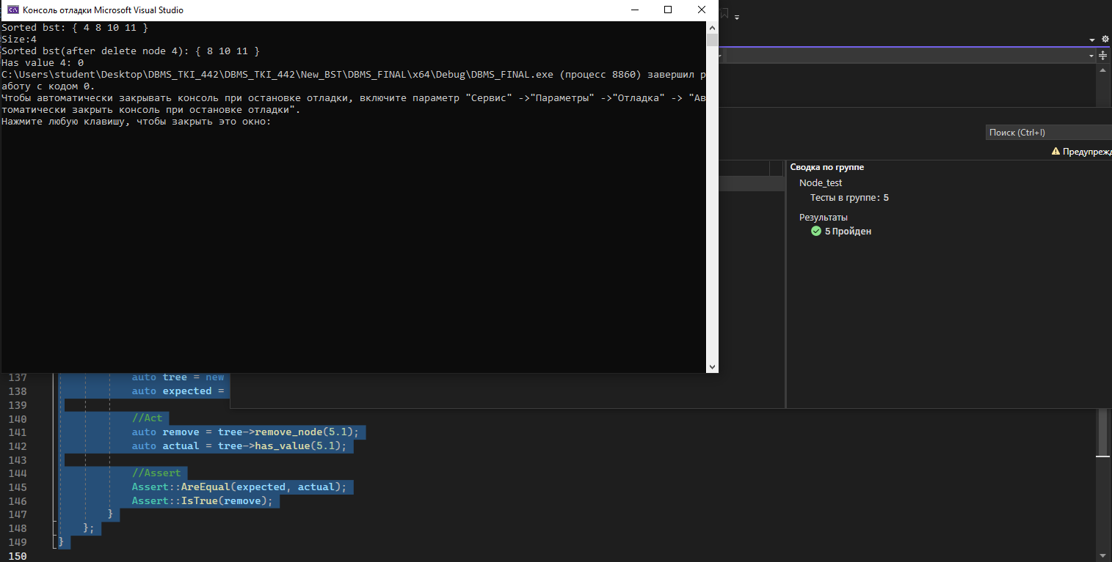

Рисунок 1 – Результат отладки программы

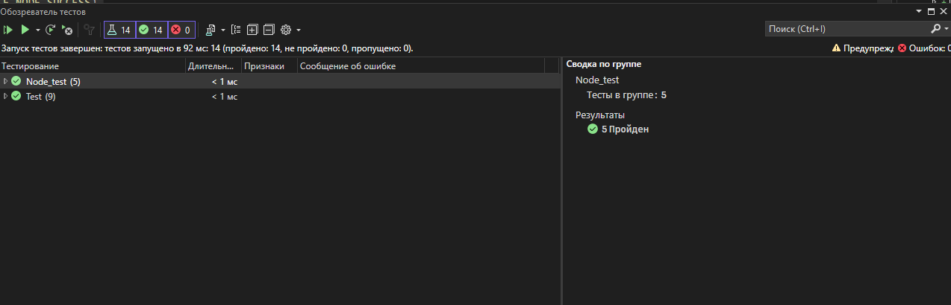

Рисунок 2 – Обозреватель тестов

# 3. UML диаграмма классов

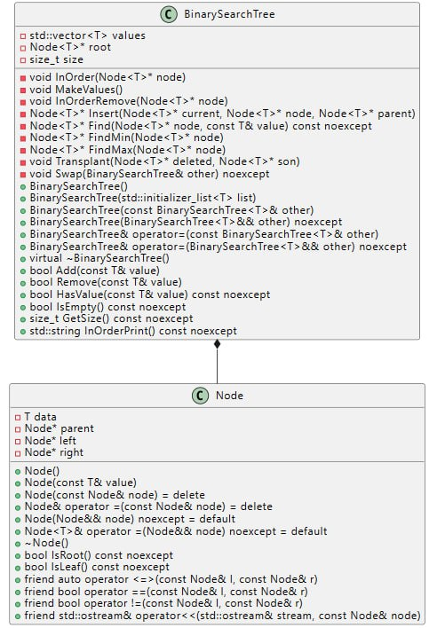

Рисунок 3 – UML диаграмма классов Node и BST

# Заключение

В результате выполнения практического задания была разработана структура данных - бинарное дерево поиска. Для обеспечения обработки различных типов данных была использована техника шаблонов, что позволило использовать данную структуру с любым типом данных.