Investigation of the electric dipole moment of light nuclei at the NICA accelerator complex
Yu.V. Senichev ^{a, b,*} S.D. Kolokolchikov ^{a, b}, A.E. Aksentyev, ^{a, c}, A.A. Melnikov ^{a, b, d},
P.I. Palamarchuka ^{a,c}, V.P. Ladygin ^{e}, E.M. Syresin ^{e}

ªInstitute for Nuclear Research RAS, Moscow, Russia,
^{b}Moscow Institute of Physics and Technology, Dolgoprudny, Russia,
^{c}Moscow Engineering Physics Institute, Moscow, Russia,
^{d} Landau Institute for Theoretical Physics, Chernogolovka, Russia,
^{e}Joint Institute for Nuclear Research, Dubna, Russia
*e-mail: y.senichev@inr.ru
INTRODUCTION

Conducting an experiment to search for an electric dipole moment (EDM) using the NICA collider necessitates an alternative spin-control method based on the "quasi-frozen spin" concept. Unlike the "frozen spin" method proposed at BNL—which requires the construction of a dedicated storage ring—the "quasi-frozen spin" method is applicable to virtually any accelerator, even those not originally designed for EDM searches. In this method, the spin does not maintain a fixed orientation along the direction of motion throughout the entire revolution; instead, after traversing an arc containing magnetic dipoles, it regains its original orientation along a straight section. This is achieved by using elements that combine electric and magnetic fields—known as Wien filters—within the straight section. The spin rotation occurring in the arc is compensated for by a corresponding rotation within the Wien filter. Furthermore, the fields can be selected to produce zero net Lorentz force, thereby leaving the particle orbit undisturbed; this allows for their installation in straight sections. Consequently, polarimeters positioned downstream of the Wien filters will detect the same spin-vector orientation—effectively a "frozen" state from their perspective.
To accommodate this, it is proposed to install bypass sections on the NICA collider to house the Wien filters. Beyond the EDM research objectives, there are two primary reasons for this modification of the magneto-optical structure. First, there is insufficient space for Wien filters in the existing straight sections. Second, the current magneto-optical design is optimized for the NICA ring's operation in collider mode. Therefore, a modification to the NICA collider has been proposed involving the introduction of bypass channels to create an alternative straight section parallel to the original one. Thus, the NICA collider can serve as a storage ring, allowing for simultaneous EDM research experiments using polarized deuterons in a "quasi-frozen spin" mode. We designed a bypass channel where beam dynamics studies confirmed the feasibility of this approach.
A second facility considered as a candidate for EDM search experiments is the upgraded Nuclotron. The proposed work aims to define the relationship between the Nuclotron and the NICA collider, involving a modification of the Nuclotron's magneto-optical structure to create a dual-function accelerator: a booster for polarized proton and deuteron beams (for injection into the collider) and an independent storage-synchrotron ring for precision EDM search experiments on light nuclei. In doing so, we adhered to the following conditions: - the upgraded ring must be located within the existing tunnel of the currently operating Nuclotron accelerator; - preservation and control of proton and deuteron polarization within the NICA complex; - avoidance of the polarized proton beam passing through transition energy in the collider after electron cooling, in order to achieve design luminosity; - implementation of a "frozen" or "quasi-frozen" spin mode in either the collider or the Nuclotron, depending on which ring is more suitable for electric dipole moment research. In the structure we developed, all these conditions are met, providing a basis for implementing this option.
A third option is a dedicated ring housed in a separate building. We have developed two versions of a magneto-optical structure for a specialized storage ring—designed to search for the electric dipole moment—that utilizes polarized proton and deuteron beams in "frozen-spin" and "quasi-frozen-spin" modes. Unlike previously considered options involving the use of the NICA and Nuclotron rings for electric dipole moment research in "quasi-frozen-spin" mode, the approach proposed here entails dedicated rings based on the "frozen-spin" concept. Due to the differences in magnitude and sign between the anomalous magnetic moments of the proton and the deuteron, the ring structures possess unique design features: the proton beam requires a purely electrostatic ring with a total length of 400 m, whereas the deuteron beam requires a ring incorporating E+B deflectors with a total length of 150 m. Thus, it can be stated that we currently have three options regarding the choice of NICA complex facilities for conducting research into the electric dipole moments of light charged nuclei.

Basic Principle of Designing the Magneto-Optical Structure of a Storage Ring for Investigating the EDM of a Charged Particle

The basic concept behind an EDM measurement using a storage ring derives from the Thomas-Bargmann-Michel-Telegdi (T-BMT) equation [1, 2]. In accordance with Ehrenfest's theorem, the T-BMT equations describe the classical spin behavior of a charged particle, accounting for a hypothesized EDM:
$\frac{d\overset{→}{S}}{dt}=\left({\overset{→}{Ω}}_{mdm}+{\overset{→}{Ω}}_{edm}\right)×\overset{→}{S}$,
${\overset{→}{Ω}}_{mdm}=-\frac{e}{mγ}\left\{\left(γG+1\right)B_{⊥}+\left(1+G\right)B_{II}-\left(γG+\frac{γ}{γ+1}\right)\frac{\overset{→}{β}×\overset{→}{E}}{c}\right\}$, (1)
${\overset{→}{Ω}}_{edm}=-\frac{eη}{2m}\left(\overset{→}{β}×\overset{→}{B}+\frac{\overset{→}{E}}{c}\right)$,
$G=\frac{g-2}{2},$
where $γ$ is the Lorentz factor, $\overset{→}{β}$ is the relative velocity, $c$ is the speed of light, $e,m$ are the particle charge and mass, $G$ is the anomalous magnetic moment, $g$ is the gyromagnetic ratio, $Ω_{mdm}$ is the spin precession frequency due to the magnetic dipole moment, $Ω_{edm}$ is the spin precession frequency due to the electric dipole moment, $η$ is a dimensionless coefficient defined in (1) by the relation $d=ηeℏ/4mc$ and $\overset{→}{B}=\left\{B_{⊥},B_{II}\right\}$ and $\overset{→}{E}=\left\{E_{⊥},E_{II}\right\}$ are the magnetic and electric fields. In the following, since we do not use elements with a longitudinal magnetic field, we set $B_{II}=0$. The longitudinal electric field $E_{II}=0$ also disregarded due to the smallness of its contribution.
The principle behind the design of the magneto-optical structure relies on establishing conditions under which the EDM signal continuously accumulates as the beam circulates in the ring. To achieve this, the spin and longitudinal momentum vectors must remain constantly aligned (S → ↑↑ p) with a precision that determines the maximum achievable sensitivity of the EDM measurement.
The condition requiring the longitudinal momentum and spin to be co-aligned is referred to as spin "freezing" or, more generally, "quasi-freezing," depending on the precision and method of its realization [3].

MAGNETO-OPTICAL STRUCTURES WITH "FROZEN" AND "QUASI-FROZEN" SPIN

"Frozen spin" concept
The idea of searching for the electric dipole moment (EDM) of the proton and the deuteron using polarized beams in a storage ring is based on the “frozen spin” method and was originally proposed at the Brookhaven National Laboratory (BNL) [3]. The concept of the “frozen spin” (FS) lattice consists of deflectors with electric and magnetic fields incorporated in one element, in which the spin vector of the reference particle is always orientated along the momentum vector.
The "frozen spin" method [3] is based on the fact that, at a specific so-called "magic" energy, the spin of a particle in external fields begins to rotate at a frequency equal to the frequency of the particle's orbital momentum revolution, $Ω_{E,B}^{p}=\frac{eE}{mγβc}+\frac{eB}{mγ}$. By subtracting the frequency ${\overset{→}{Ω}}_{mdm}$ from $Ω_{E,B}^{p}$, we obtain the spin precession frequency relative to the momentum direction, ${\overset{→}{Ω}}_{mdm}^{p}$:
${\overset{→}{Ω}}_{mdm}^{p}={\overset{→}{ω}}_{E}^{p}+{\overset{→}{ω}}_{B}^{p}$, (2)

where ${\overset{→}{ω}}_{E}^{p}=\frac{e}{m}\left(G-\frac{1}{γ^{2}-1}\right)\frac{\overset{→}{E}×\overset{→}{β}}{c}$ is the spin precession frequency relative to the momentum in an electric field, and ${\overset{→}{ω}}_{B}^{p}=\frac{e}{m}G·B_{⊥}$ is the corresponding frequency in a magnetic field. The condition for "frozen spin" in a purely electrostatic ring $\overset{→}{B}=0$ is ${\overset{→}{ω}}_{E}^{p}=0$ which is satisfied at the "magic" energy:
$G-\frac{1}{γ_{mag}^{2}-1}=0$ (3)

In a ring containing magnetic and electric elements, the "frozen spin" condition is satisfied when ${\overset{→}{Ω}}_{mdm}^{p}={\overset{→}{ω}}_{E}^{p}+{\overset{→}{ω}}_{B}^{p}$=0, a state achieved through a balance between the radial electric field $E_{r}$ and the guiding vertical magnetic field $B_{v}$ defined by the relation [4]:

$E_{r}=\frac{GBcβγ^{2}}{1-Gβ^{2}γ^{2}}≈GB_{v}cβγ^{2}$ (4)

A hybrid ring is used for deuterons because their G-factor is negative (G = −0.14), meaning condition (3) cannot be satisfied.
To proceed, we introduce the definition of "spin tune," a value representing the number of spin oscillations per revolution in the accelerator. The spin tune in an electrostatic ring, denoted as $ν_{s}^{E}$ defined as the ratio of the spin precession frequency to the particle's orbital frequency $ν_{s}^{E}=ω_{E}^{p}/Ω_{E}^{p}$ is given by the formula:
$ν_{s}^{E}=\left(G-\frac{1}{γ^{2}-1}\right)·γβ^{2}$ (5)

Аналогично мы находим спин-тьюн $ν_{s}^{B}=ω_{B}^{p}/Ω_{B}^{p}$ в магнитном поле относительно импульса:

$ν_{s}^{B}=γG$ (6)

Thus, there is a common concept for constructing the ring for both protons and deuterons, but its implementation relies on different types of deflectors.
”Quasi-frozen spin” concept
In the NICA ring, the implementation of the FS concept would require a complete upgrade of the optics. However, suppose the spin would oscillate in the horizontal plane with respect to the frozen spin direction with small amplitude of angle ${\left(Φ_{s}\right)}^{2}≪1$. This could be done by placing special, electric-field elements in the straight accelerator sections, which would bring the spin vector back in alignment with the momentum after it moved away from it in the magnetic arc. Then the EDM growth would decrease proportionally to the factor $J_{0}(Φ_{s})≈1-{\left(Φ_{s}\right)}^{2}/4$. Since the deuteron’s magnetic anomaly $G=-0.142$ has a small value and since, in the imagined case, the spin oscillates around the momentum direction within a half value of the advanced spin phase in the magnetic arc $Φ_{s}=π⋅γG/2≈0.2$, it is obvious that the effective contribution to the expected EDM effect is reduced by only a few percent at the optimal parameters for the EDM measurement $γ=1.12$.
The mental experiment described above gives the gist of the “quasi-frozen” spin (QFS) concept [3]: here the spin is not frozen with respect to the momentum vector, but continually oscillates around some average fixed direction coinciding with the momentum direction. Next, we have to answer the question of how to implement a variable MDM spin precession in the storage ring (which is needed for its zero-averaging in statistics) and to provide a sufficient EDM signal growth.
In the case of the “quasi-frozen” structure, there are two options. In the first QFS version the magnetic and electric fields are completely spatially separated: the former is found in the magnetic arcs and the latter in the straight sections, which are realized in the form of negative-curvature “reverse electric” arcs, respectively. However, this lattice design concept inherits the “cylindrical electrodes” drawback, namely, a whole set of high-order field nonlinearities. Therefore, in the second version of the QFS lattice, we introduced a small magnetic field ~100 mT into the spin-aligning (E+B) elements, which compensates for the Lorentz force of the electric field and allows us to make them straight. Since the second option is the most appropriate for a ring undedicated to an EDM search, we will only discuss this option here.
So, first we determine the rotation of the spin relative to the momentum direction in the magnetic arcs. In the magnetic arc, the momentum of particles is rotated by angle $Φ_{arc}^{B}=π$, with a simultaneous MDM spin rotation in the horizontal plane relative to the momentum by an angle:
$Φ_{s}^{arc}=γG⋅Φ_{arc}^{B}$. (4)
In the E+B elements of the straight section, the spin-rotation due to the MDM occurs in the horizontal plane and is constituted by two components: respectively in the E- and B-fields. In the E-field it occurs in the direction opposite to the momentum rotation by an angle:
$Φ_{s}^{E}=-\left(γG+\frac{γ}{γ+1}\right)β^{2}⋅Φ_{ss}^{E}$, (5)
where $Φ_{ss}^{E}$ is the momentum rotation in the electric field, and in the B-field in the same direction by angle $Φ_{s}^{B}=(γG+1)⋅Φ_{ss}^{B}$, where $Φ_{ss}^{B}$ is the momentum rotation in magnetic field. Since the Lorenz force is zero, the momentum rotation angles $Φ_{ss}^{E}=Φ_{ss}^{B}$ are equal, and we can express both components of the spin-rotation through one of them, for instance, through the magnetic field rotation $Φ_{ss}^{B}=\frac{eB_{ss}}{mγv}⋅L_{ss}$, where $B_{ss},L_{ss}$ are the magnetic field and the length of the straight element, respectively. To realize the QFS concept, we have to fulfil the “QFS condition” $Φ_{ss}^{B}-Φ_{ss}^{E}=Φ_{arc}^{B}$, i.e.:
$(γG+1)⋅Φ_{ss}^{B}-\left(γG+\frac{γ}{γ+1}\right)β^{2}⋅Φ_{ss}^{E}=γG⋅π$ (6)
Carrying out simple transformations, we obtain the definitions of the E+B element parameters:
$L_{Σ}E_{ss}=\frac{G}{G+1}⋅\frac{mc^{2}}{e}⋅πβ^{2}γ^{3}$ and $B_{ss}=-\frac{E_{ss}}{cβ}$, (7)
where $L_{Σ}$ is the total length of the set of straight elements in one straight section.
Thus, taking a more or less realistic value of the electric field at the level of 100 kV/cm, the corresponding magnetic field is below 96 mT. This opens up prospects for simplifying the technical construction. In particular, a permanent magnet or an air core electric coil may be used.

- UPGRADED MAGNETO-OPTICAL STRUCTURES OF THE NICA FACILITIES FOR SEARCHING FOR EDM
In the case of the “quasi-frozen” structure, there are two options.
In the first QFS version the magnetic and electric fields are completely spatially separated: the former is found in the magnetic arcs and the latter in the straight sections, which are realized in the form of negative-curvature “reverse electric” arcs, respectively.
In the second version of the QFS lattice, we introduced a small magnetic field ~100 mT into the spin-aligning (E+B) elements, which compensates for the Lorentz force of the electric field and allows us to make them straight. In this case, element E+B becomes Wien filter.
The second option is most suitable for the NICA ring with introduced bypass sections, while for the Nuclotron, due to the limited space for placing equipment, the first option is considered as a working one.
To implement the quasi-frozen concept in NICA collider, we propose to introduce two bypass sections. Both direct bypass sections (see Fig. 1) do not include meeting points in the MPD and SPD detectors and are free to accommodate Wien filter elements.
Channels with Wien filters are transparent to beam dynamics due to the zero Lorentz force and rotate the spin in the direction opposite to the rotation in the arcs, thereby realizing the concept of “quasi-frozen spin”. Without meeting points, we have two uncrossed rings with the possibility of doubling the speed of statistics collection. In Fig. 2 and 3 show the Twiss functions and dynamic aperture for both transverse planes.
As can be seen, the linear part of the dynamic aperture ~2000 mm mrad significantly exceeds the required value in both planes. Taking into account the limiting values of the electric field ~100 kV/cm and using the obtained expressions for the parameters of Wien filters, we calculate their required net length of ~25-30 meters for one bypass section, which is 30% of the total length of the bypass section. The result of spin-orbit simulation for three spin projections shows that the rotation changes direction relative to the momentum within ±7.5 degrees (see Fig. 4). Despite the change in spin direction, the polarization asymmetry remains constant at the location of the polarimeter.
Upgraded optical structure of NICA for the EDM search
The NICA structure was not designed with the electric dipole moment research in mind, and hence our only option is to resort to the “quasi-frozen spin” concept. It is obvious that this can be done for deuterons.
The adaptation strategy for the NICA collider structure to the EDM search was based on two circumstances. The first is that the straight sections of the collider are completely occupied by equipment for experiments using the MPD and SPD detectors, and the second is that these detectors and meeting points are inconsequential for the EDM search. The simplest solution in this case is to introduce bypasses as shown in figure 1.
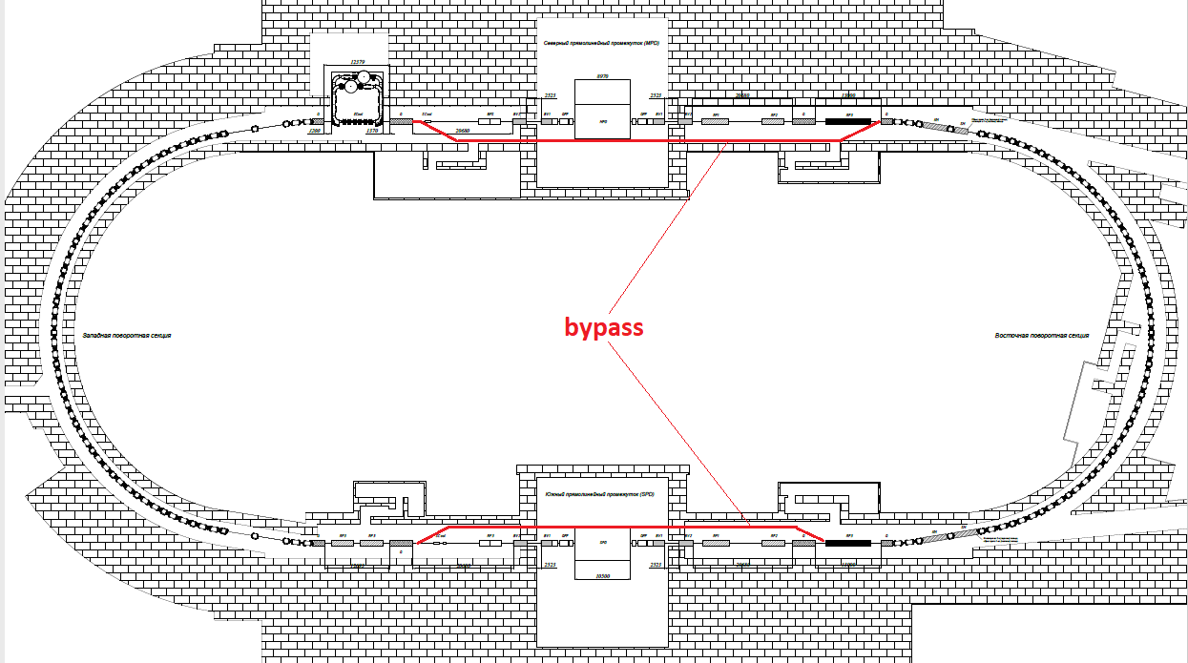
Figure 1. Upgraded lattice of NICA for the EDM search with bypass insertions (red colour).

The bypass sections do not include both detector’s interaction points and are free to accommodate E+B elements. The latter are transparent to the beam dynamics due to the zero Lorentz force and rotate the spin in the direction opposite to the rotation the arc, thus realizing the “quasi-frozen spin” concept.
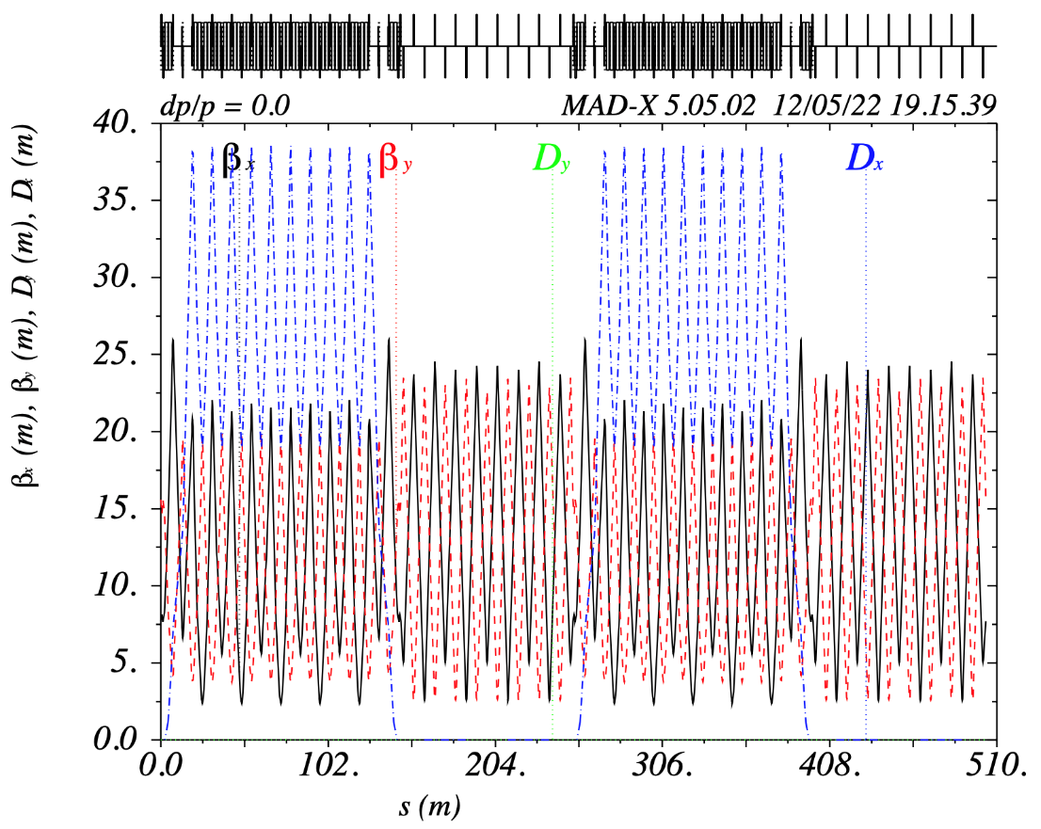
Figure 2. Twiss parameters of NICA with bypass insertion.

Without the interaction points, we have two uncoupled rings, with a possibility of doubling the statistics-collection rate. In figure 2 and figure 3 we show the Twiss functions and the dynamic aperture for the both transverse planes.

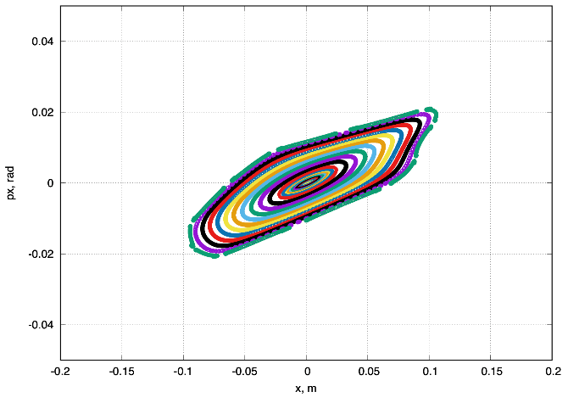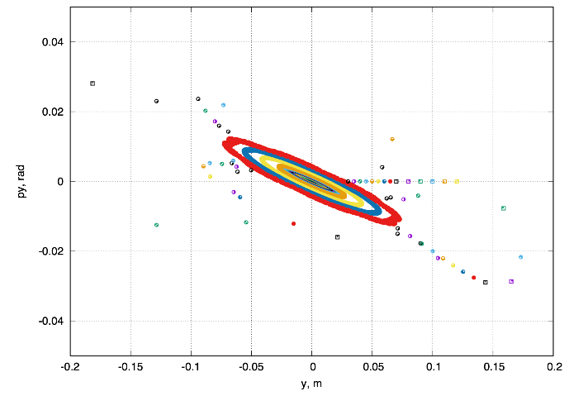
Figure 3. Dynamic aperture for NICA with bypass insertion in horizontal and vertical planes.

As one can see, the linear part of the dynamic aperture of $\sim$2000 mm mrad significantly exceeds the required value in both planes. Taking into account the limiting values of the electric field$\sim 100kV/cm$ and using the obtained expressions for the E+B element parameters, one computes their required net length for one bypass section of ~25-30 meters, which is 30% of the total length of the bypass section. The result of spin-orbit tracking shows the spin changes direction with respect to the momentum within 10 degrees. Despite a change of spin direction, the polarization asymmetry remains constant at the location of the polarimeter.

Параметры структуры
Приведенные во введении особенности поляриметрии являются решающими при выборе энергии эксперимента и сорта частиц. В будущем вся предлагаемая магнитооптика будет рассмотрена для дейтронов с энергией $240 МэВ.$Стоит отметить, что расчеты показывают основные параметры магнитного поля диполей $B_{dip}=0,132 T$, а также магнитную жесткость $Bρ=3,252 T∙m$ (табл. 1).
Таблица 1. Основные параметры эксперимента и ByPass структуры
Частицы | дейтроны
Магнитное поле диполей | $$0,132 T$$
Магнитная жесткость $Bρ$ | $$3,252 T∙м$$
Полная длина ускорителя | $$503,04 м$$
Энергия эксперимента | $240$ МэВ

Магнитооптическая структура
Проектируя накопительное кольцо NICA с обходными секциями ByPass, планируется, оставить геометрию арок неизменной. Возможно лишь изменение полей в уже установленных элементах. Так что NICA можно использовать для различных экспериментов без сложной перестройки магнитооптики канала.
В кольце NICA, арка имеет ненулевую дисперсию. По краям как дисперсия, так и ее производная сведены к нулю. Прямой участок имеет нулевую дисперсию по всему периметру. Общая длина оригинального кольца NICA $L_{acc}=503,04$ м. Длина одной арки равна $L_{arc}=142,15$ m. Итак, доступно $\left(L_{acc}-2L_{arc}\right)/2=109.6$ м. Обходные каналы ByPass включают в себя альтернативные прямые участки, а также секции с отклоняющими диполями. Дипольные магниты выбраны таким образом, чтобы обеспечить отклонение на угол $α= 9°$. Сила диполя $B_{BP}=1$ Т при длине $L_{dip}^{BP}=50$ см. Альтернативный прямой участок находится на расстоянии 1 метра от исходного, поэтому длина обходного участка $L_{BP}=1\text{м}/\sin{α}≈6.4 \text{м}$. Принципиальная схема обходных каналов показана на рис. 1.
Отклоняющие магниты искажают дисперсионную функцию. Таким образом, необходимо было использовать по меньшей мере 2 фокусирующих квадруполя на обходном канале для подавления дисперсия на выходе. Это поможет обеспечить нулевую дисперсию на всем прямолинейном участке. Чтобы обеспечить периодичность и симметрию бета-функций, можно использовать один или три дефокусирующих квадруполя. Будут рассмотрены два случая, с адаптированными прямыми участками, идентичным поворотным аркам, но без магнитов. Это сделано для простоты моделирования в регулярной идеальной структуре. Наконец, мы рассмотрим реальный случай магнитооптики с полностью регулярной FODO прямой секцией.
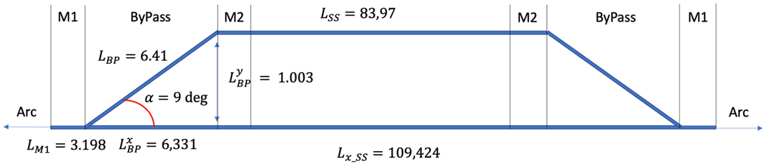
Первичная схема с 3 квадруполями
Рис.2. Принципиальная схема ByPass с 3 квадруполями.
В этом случае участок входа в ByPass состоит из минимально возможных 3 квадруполей: 2 фокусирующих QBP1 и 1 дефокусирующий QBP2 (рис. 2). Согласование арки с каналом ByPass обеспечивается тремя квадруполями QM1, QM2, QM3 (секция согласователя Matching M1). А согласование с прямым участком также симметрично осуществляется такими же квадруполями QM1, QM2, QM3 (M2). Это возможно в силу изначально заложенной симметрии между аркой и прямым участком. Длины упомянутых секций приведены на рис. 2, а также в табл. 2. Тогда общая длина всего ускорителя составит $L{}_{3quad}^{acc}=503,46$ м.
На рис. 3 приведены Твисс-функции, черными линиями указаны границы канала. Максимум бета-функции $β_{y}$ расположен в центре канала. И может принимать большое значение, по сравнению с $β_{ x}$. По этой причине можно рассмотреть случай с 5 квадруполями в обходном канале.
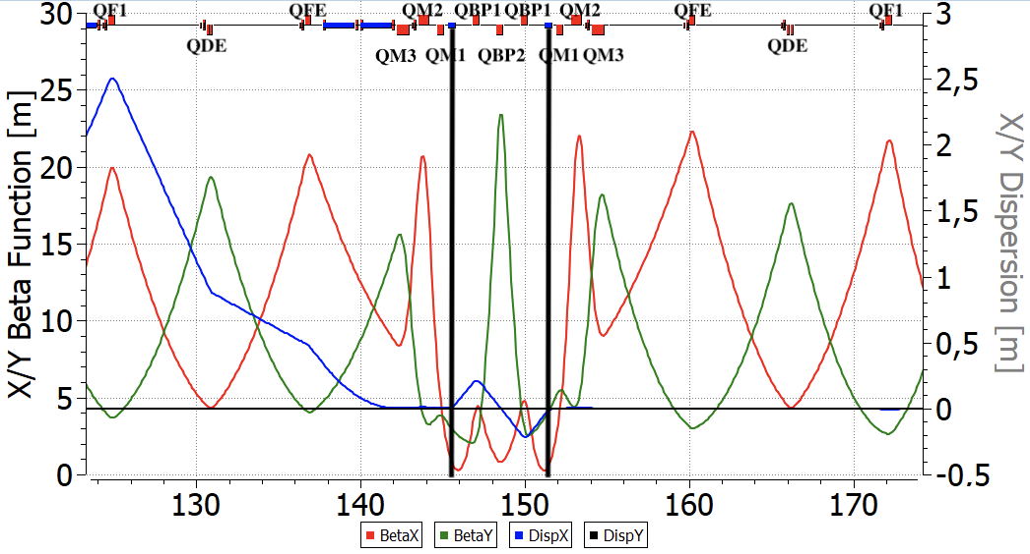
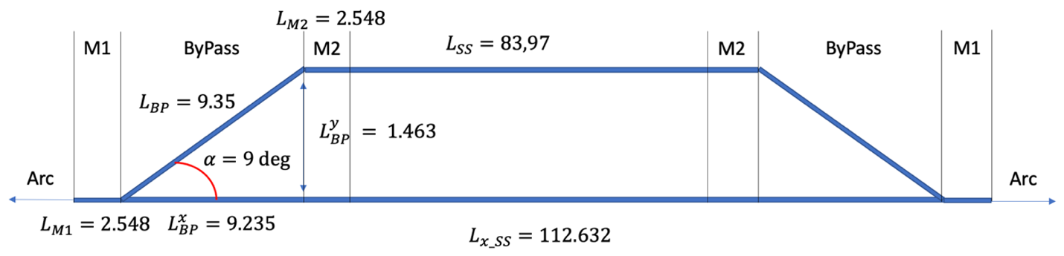
Схема ByPass c 5 квадруполями
Рис. 4. Принципиальная схема ByPass с 5 квадруполями.
Рис. 2. Твисс-параметры для ByPass с 3 квадруполями. Черными линиями показано расположение отклоняющих поворотных магнитов.
По сравнению с предыдущим случаем, обходной канал состоит из 5 квадруполей, которые представлены 2 семействами: фокусирующим QBP1 и дефокусирующим QBP2. Он становится длиннее $L_{5quad}^{BP}=9,35$ м и отклоняется на $1,46$ м (рис. 4). Теперь секции согласования M1 и M2 по-прежнему идентичны, но представлены двумя квадруполями QM1 и QM2 для обеспечения регулярности Твисс-функций. Однако, полная длина ускорителя становится больше, NICA $L_{5quad}^{acc}=510,02$ м. На рис. 5 показаны, что максимум $β_{y}$ становится меньше в центре. Стоит отметить, что максимум дисперсионной функции стал увеличился от $D_{x}^{3 quad} \sim 0.2 м$ до $D_{x}^{5 quad} \sim 0.5 м$. Таким образом, этот случай должен быть адаптирован к реальному.
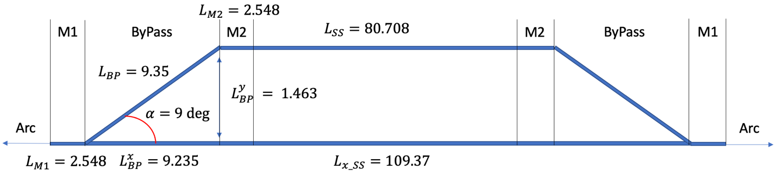
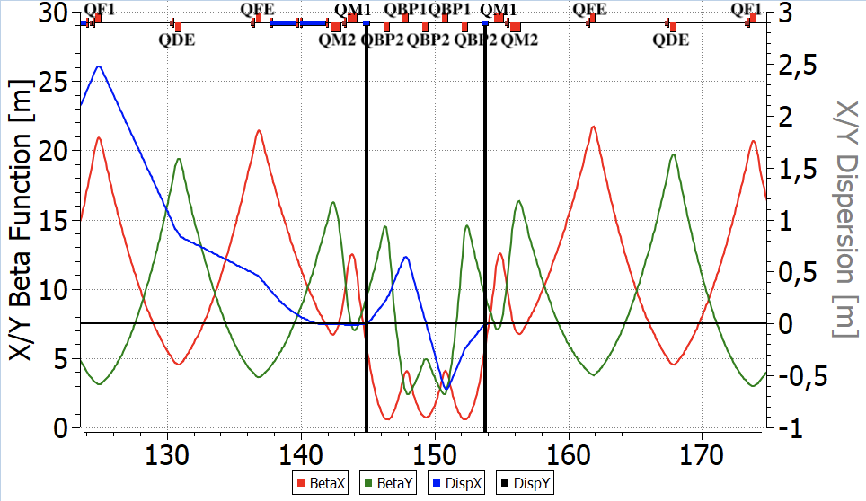
Реальный случай
Рис. 6. Принципиальная схема реального случая ByPass.
Рис. 5. Твисс-параметры для ByPass с 5 квадруполями. Черными линиями показано расположение отклоняющих поворотных магнитов.
Основываясь на рассмотренных примерах, мы, наконец, можем получить структуру, максимально адаптированную к реальности. Теперь рассмотрим полностью регулярный прямой участок, который стал короче $L_{SS}^{BP}=80,71$ м (рис. 6). Дефлекторный канал состоит из 5 квадруполей и отклоняет пучок таким образом, что альтернативная прямая секция отстоит от исходной на 1,46 м. Но для согласования использовались разные секции M1 и M2, чтобы компенсировать асимметрию между поворотной аркой и прямым участком. Наконец, Твисс-функция половины ByPass NICA, представлена на рис. 7. В центре прямой секции расположены фильтры Вина. Все вычисления Твисс-параметров, выполнены с помощью OptiM [5].
Изложенная в этой главе возможность модернизации представлена в работах на конференциях LaPlas’23 [6] и IPAC’23 [7], с последующей публикацией в журналах.
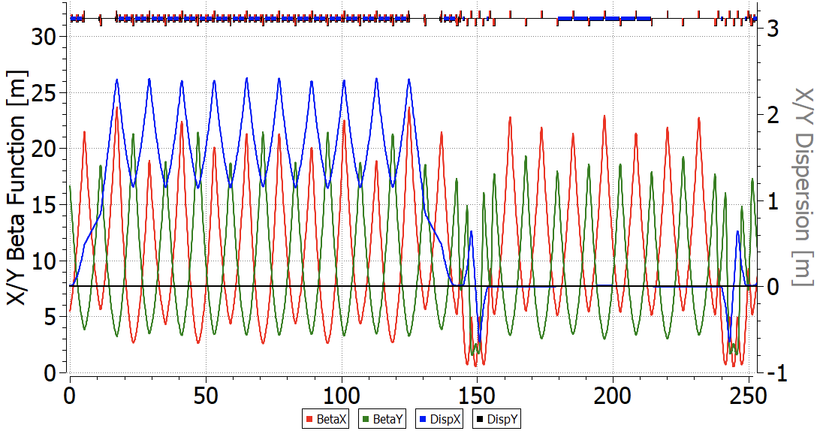
Рис. 7. Twiss-функции для половины кольца NICA ByPass. Фильтры Вина, расположены на прямом участке
Таблица 2. Длины полного кольца, а также соответствующие длины отдельных участков и количество бетатронных колебаний в X-Y плоскости.
Structure | Total Length, m | Straight Section Length, m | ByPass Length, m | Match Section Length, m | Tunes
Ion NICA | 503.04 | 109.6 | – | - | $$9.44/9.44$$
3 quad | 503.46 | 83.97 | 6.41 | 3.198 | $$13.8/11.8$$
5 quad | 510.0 | 83.97 | 9.35 | 2.548 | $$13.44/11.44$$
Real | 503.5 | 80.70 | 9.35 | 2.548 | $$12.8/11.8$$

Оптимизация натуральной хроматичности и динамической апертуры в структуре NICA ByPass
В данной главе рассматривается вопрос обеспечения стабильного орбитального движения. А именно возможность подавления натуральной хроматичности в структуре ByPass NICA.
Хроматичность определяется как зависимость набега бетатронных колебаний $Q$ от разброса по импульсам $δ$[8]:
$$Q^{'}=\frac{dQ}{dδ} (2)$$
Натуральная хроматичность определяется вследствие влияния квадруполей в местах с ненулевой бета-функцией:
$$\frac{∂Q_{x}}{∂δ}=-\frac{1}{4π}\int_{0}^{L}{ }β_{x}\left(s\right)k_{x}\left(s\right)ds, (3)$$
где $β_{x}\left(s\right)$ – значение бета-функции в месте установки квадруполя, $k_{x}\left(s\right)$ – градиент квадрупольной линзы. Возможно осуществить коррекцию натуральной хроматичности при помощи секступолей:
$$\frac{∂Q_{x}}{∂δ}=\frac{1}{4π}\int_{0}^{L}{ }β_{x}\left(s\right)r\left(s\right)D\left(s\right)ds, (4)$$
где $D\left(s\right)$ – дисперсионная функция, $r\left(s\right)$ – градиент секступольной линзы. Как видно, подавление возможно только, если секступоли расположены в местах с ненулевой дисперсией и бета-функцией.
В силу регулярности магнитооптической структуры арки, бета-функции и дисперсионная функция также регулярны на арке. За исключением краев арки, где используется специальный метод подавления дисперсии с использованием «missing magnet», который нарушает регулярность Твисс-параметров (рис. 7). Таким образом, в регулярной части поворотной арки возможно расположить 2 принципиально различных семейства секступолей. Они отличаются местом расположения вдоль поворотной арки: 1) максимум дисперсионной функции $D$, максимум $β_{x}$, минимум $β_{y}$; 2) минимум дисперсионной функции $D$, минимум $β_{x}$, максимум $β_{y}$.
На рис. 8 представлена зависимость набега бетатронных колебаний от разброса по энергии для случаев натуральной хроматичности и подавленной хроматичности 2 семействами.
На рис. 9 представлены динамические апертуры для случая натуральной хроматичности, без подавления. На рис. 10 же динамическая апертура с подавленной хроматичностью. Трекинг выполнен в COSY Infinity.
Таблица 3. Основные параметры кольца ByPass NICA
Натуральная хроматичность | -17/-17
Скорректированная хроматичность | $$-7×{10}^{-6}/7×{10}^{-6}$$
Количество семейств секступолей | 2
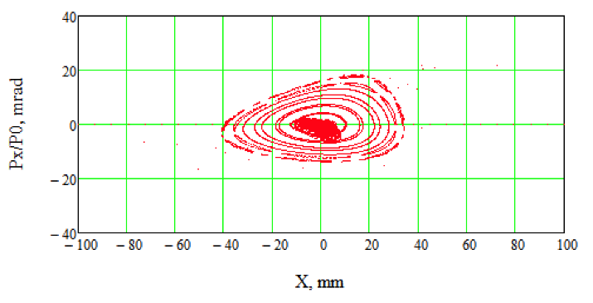
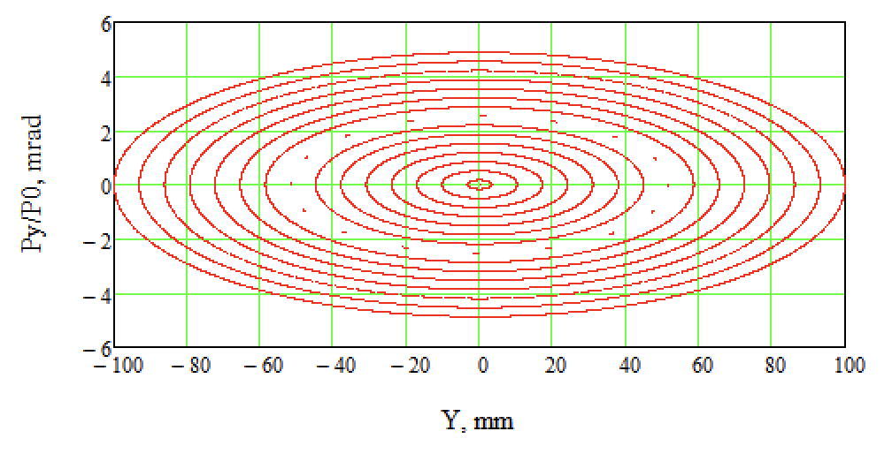
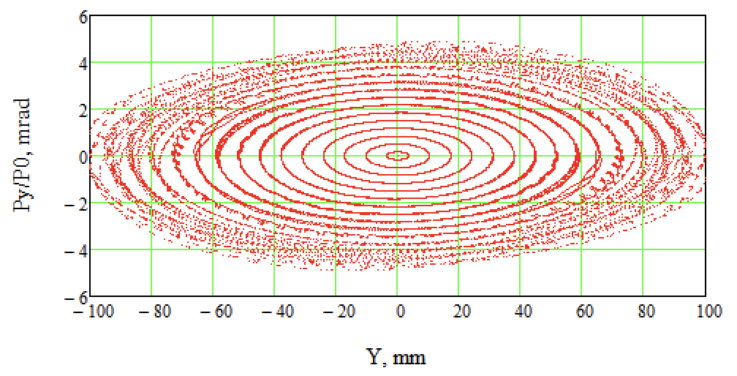
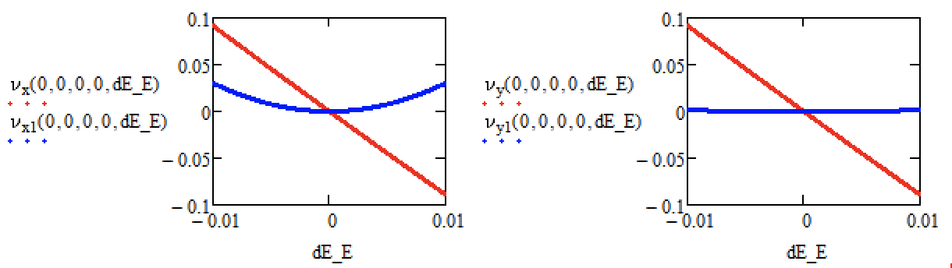
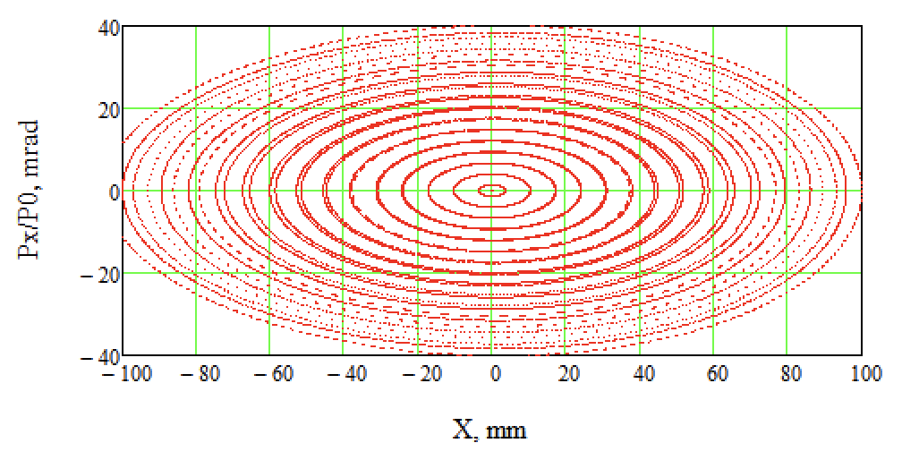
Рис. 8. Зависимость частоты бетатонных от разброса по энергии в X и Y плоскостях. Красная линией – натуральная хроматичность, синяя линии – подавленная хроматичность.
Рис. 9. Динамическая апертура для случая натуральной хроматичности, без секступолей.
Рис. 10. Динамическая апертура с подавленной хроматичностью 2 семействами секступолей.

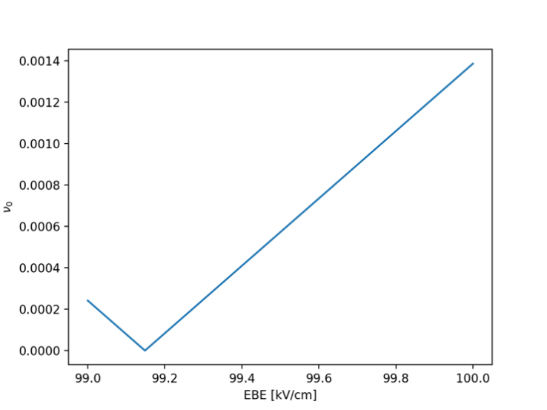
Спин-орбитальное движение в структуре NICA ByPass с оптимизированными Wien-фильтрами (фильтрами Вина)
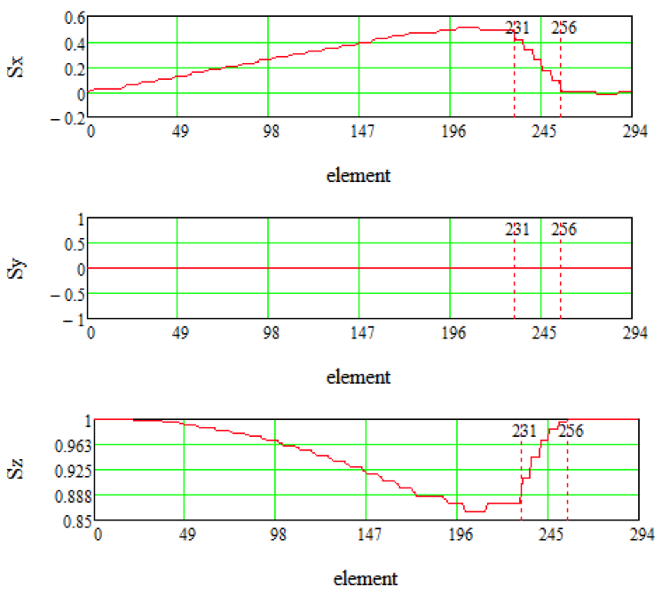
Модификация существующей структуры в первую очередь предназначена для проведения исследований ЭДМ. Это подразумевает, что установка должна быть способна работать в режиме «Квази-Замороженного» Спина и время спиновой когерентности пучка достаточно велико. Предполагается, что первое условие может быть реализовано путем размещения фильтров Вина в прямых участках; стандартной технологией для реализации второго условия является использование нескольких семейств секступолей для коррекции бетатронной и спиновой хроматичности. Оба этих утверждения были исследованы численно с использованием кода COSY Infinity. [9]
Рис. 11. Зависимость спин-тюна $ν_{0}$ референсной частицы от поля в EB-элемента.
В стандартном формализме матрица преобразования спина представляет собой матрицу вращения SO(3), параметризованную нормализованной частотой прецессии спина, $ν$ и инвариантной осью вращения $\vec{n} : T(ν, \vec{n})$. Если выполняется условие квази/замороженного спина, то 𝑇 равно единичной матрице, а спин-тюн $ν = 0$. В предлагаемой модификации это делается путем настройки электрического поля элемента E-B. При этом магнитное B-поле выбирается таким образом, чтобы сохранить замкнутую орбиту. Численное моделирование показывает, что действительно возможно приравнять нулю частоту вращения спина референсной частицы пучка $ν_{0}$, о чем свидетельствует рис. 11. Спин-вектор частицы отклоняется на небольшой угол в поворотной арке, а затем восстанавливает свою ориентацию за счёт влияния фильтров Вина на прямом участке, что и показано на рис. 12.
Рис. 12. Изменение компонент спин-вектора $S_{x},S_{y},S_{z}$ референсной частицы на половине ускорителя (арка и прямая секция).
Спиновая хроматичность – это зависимость частоты прецессии спина частицы от длины ее орбиты. Она является следствием того, что спин-векторы частиц пучка рассеиваются вокруг инвариантной оси вращения 𝑛. Этот процесс называется “спиновой декогеренцией”, он не существенен для экспериментов, имеющих дело с ненулевым ожидаемым значением поляризации пучка, однако для ЭДМ экспериментов представляет интерес по изучению части поляризации, ортогональной 𝑛, ожидаемое значение которой равно нулю – отсюда значимость термина “время спиновой когерентности”.
На вопрос о том, можно ли скомпенсировать спиновую хроматичность пучка с помощью семейств секступолей до уровня, обеспечивающего достаточно длительное время спиновой когерентности, также был дан положительный ответ (рис. 13). Следует, однако, отметить, что классически следует использовать три семейства секступолей, расположенных соответственно в максимумах функций 𝛽𝑥, 𝛽𝑦 и 𝐷. Но исследуемая магнитооптика не допускает эффективного разделения между всеми тремя функциями Твисса. Также установлено, что в полученной комбинированной оптике невозможно одновременно скомпенсировать как бетатронную, так и спиновую хроматичность. О чём будет рассказано в следующей главе.
Рассмотренная в этой главе оптимизация представлена в работах на конференции IPAC’23 [10], с последующей публикацией в журнале.

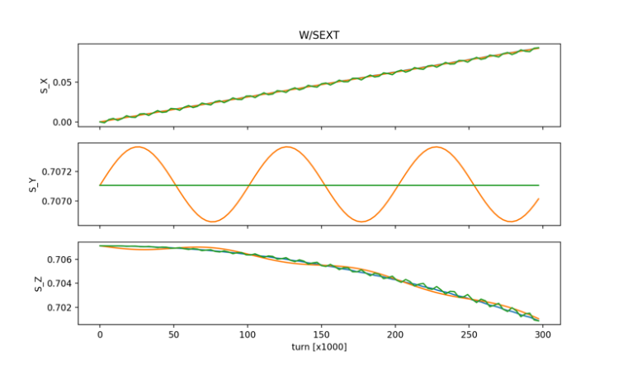
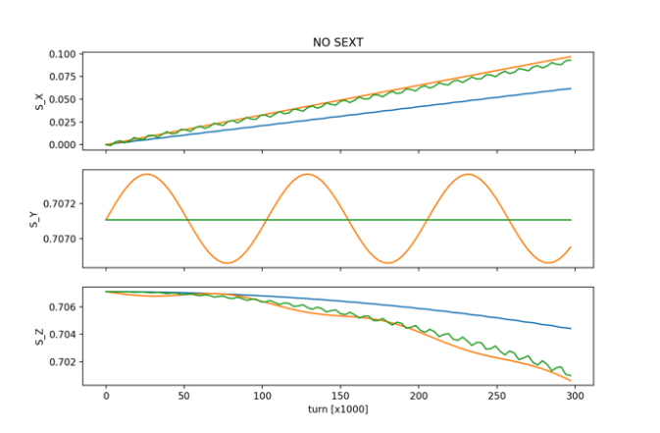
Бетатронная хроматичность и спиновая когерентность
Рис. 13. Компоненты спин-вектора как функции числа оборотов пучка при отсутствии и наличии семейств секступолей для частиц с различными начальными отклонения.
Обозначенная проблема, невозможности одновременной компенсации бетатронной хроматичности и спиновой когерентности, в конце главы 3, является содержанием текущей главы.
Согласно теории изложенной в [11] определяющим фактором, вызывающим декогеренцию пучка, является энергетическое отклонение частицы от равновесной:
$$Δδ_{eq}=\frac{γ_{s}^{2}}{γ_{s}^{2}α_{0}-1}\left[\frac{δ_{m}^{2}}{2}\left(α_{1}+\frac{3}{2}\frac{β_{s}^{2}}{γ_{s}^{2}}-\frac{α_{0}}{γ_{s}^{2}}+\frac{1}{γ_{s}^{4}}\right)+{\left(\frac{ΔL}{L}\right)}_{β}\right] (5)$$
$${\left(\frac{ΔL}{L}\right)}_{β}=\frac{π}{2L}\left[ϵ_{x}ν_{x}+ϵ_{y}ν_{y}\right] (6).$$
Уровень энергии, относительно которого колеблется частица, называется эффективной энергией. Для полного исключения влияния разброса по импульсам на удлинение орбит выражение $κ=η_{1}=α_{1}+\frac{3}{2}\frac{β_{s}^{2}}{γ_{s}^{2}}-\frac{α_{0}}{γ_{s}^{2}}+\frac{1}{γ_{s}^{4}}$ в уравнении должно равняться нулю. Более того, для компенсации удлинения орбиты за счёт бетатронного движения также должно быть скомпенсировано. Что достигается путем установления 3-х независимых семейств секступолей в максимумах бета-функции и дисперсионной функции. Тогда для Формулы (6), необходимо учесть наличие секступолей в структуре и получить более общий вид [12]:
$${\left(\frac{ΔL}{L}\right)}_{β}=-\frac{π}{L}\left[ϵ_{x}ξ_{x}+ϵ_{y}ξ_{y}\right] (7)$$

Магнитное кольцо
Для изучения данного явления, первоначально можно рассмотреть сначала чисто магнитное кольцо, без электрических вставок, подобные расчёты уже были проделаны для кольца COSY в Julich [12].
Чисто магнитное кольцо представляется из себя вариацию NICA, в которой поворотные арки оставлены неизменными, прямые секции полностью FODO регулярные и согласованы с аркой двумя квадруполями. Для такой структуры рассмотрим чувствительность системы к настройкам секступолей с коэффициентами $m$. Расстановка секступолей указана на рис. 14, при этом семейство SF1 и SF2 в этой опции одинаковы и представляют одно семейство фокусирующих секступолей.
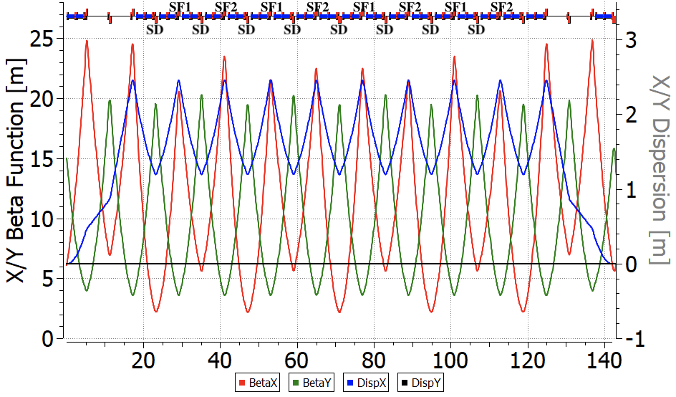
Рис. 14. Поворотная арка коллайдера NICA. С расстановкой секступолей
$$\left\{\begin{aligned}ξ_{x}=-13.302+4522.234×r_{f}+527.934×r_{d} \\ ξ_{y}=-13.337-944.735×r_{f}-2214.642×r_{d} \\ α_{1}=0.037-16.617×r_{f}-2.537×r_{d}\end{aligned}\right. (8)$$
Можно заметить, что с помощью двух семейств секступолей невозможно провести оптимизацию трёх параметров спин-орбитального движения. Можно настраивать пары ($ξ_{x}$, $ξ_{y}$) или ($ξ_{y}$, $α_{1}$). Второй вариант возможно менее целесообразен, так как $α_{1}$ изменяется мало, и энергетический эффект на разброс спин-тюна можно уменьшить с помощью охлаждения пучка.
В полностью магнитной структуре теоретическому описанию полностью поддаётся движение в X-D плоскости. В вертикальной плоскости возможно влияние спиновых резонансов на разброс частот спин-прецессии.
Видно, что оптимум спиновой хроматичности не совпадает с оптимумом бетатронной. Без оптимизации $Δν_{s}\sim 10^{-8}$ при $f_{rev}\sim 1 МГц$ приводит к $SCT\sim 100 c$, что недостаточно для ЭДМ эксперимента. Необходимо оптимизировать вертикальную хроматичность по мере сохранения дин. апертуры. При этом изменение $κ$ порядка $±1$ не является определяющим для SCT.
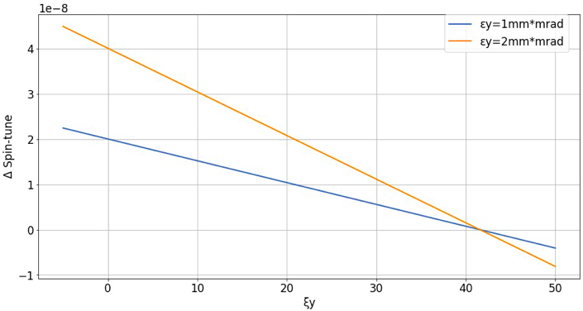
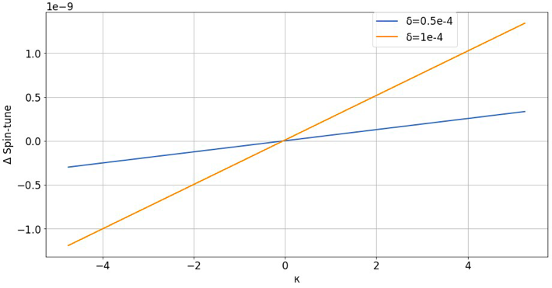
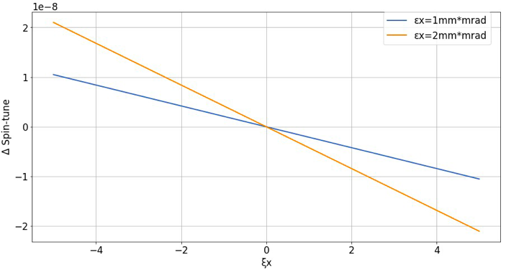
Как было замечено ранее, в вертикальной плоскости появляется дополнительный разброс частот спин-прецессии $Δν_{s}$ из-за влияния спиновых резонансов. При рабочей точке $γG=0.16$ близлежащим резонансом является бетатронный внутренний: $γG=10-Qy=0.2$. Предположим, что сила резонанса $ε=10^{-4}$, тогда при отстройке $δ=0.04$ аналитически можно получить ожидаемый разброс $Δν_{s}$ от резонанса:
$$Δν_{s}=δ-\sqrt{\left(δ^{2}+ε^{2}\right)}\sim 1.2×10^{-7} (9)$$
Данная величина является оценкой $Δν_{s}$ при $ξ_{y}$ на рис. 17. Увеличение вертикальной хроматичности приводит к уменьшению разброса частот спин-прецессии за счёт увеличения бетатронного удлинения орбит. Простая безразмерная оценка для частицы с $ε_{y}\sim 1 мм×мрад$ для $ξ_{y}=40$ составит:
Рис. 17. Влияние вертикальной хроматичности для частиц с отклонением по вертикали на разброс спин-тюна
Рис. 16. Влияние $κ=η_{1}$ для частиц с отклонением по энергии на разброс спин-тюна.
Рис. 15. Разброс частот спин-прецессии для частиц, инжектированных с различным отклонением по радиальной координате в зависимости от горизонтальной хроматичности.
$Δν_{s}=ν_{s}{(ΔL/L)}_{β}=-γGπ/L(ε_{y}ξ_{y})=-4×10^{-8}.$ Что необходимо для подавления характерного разброса спин-тюнов частиц $Δν_{s}$ при $ξ_{y}=0$ на рис. 17.

Структура c Вин-фильтрами (электрическое и магнитное кольцо)
Как следует из рис. 18-20, оптимум бетатронной и спиновой хроматичности в X-D и Y плоскости не совпадают друг с другом в накопителе с электростатическими полями.
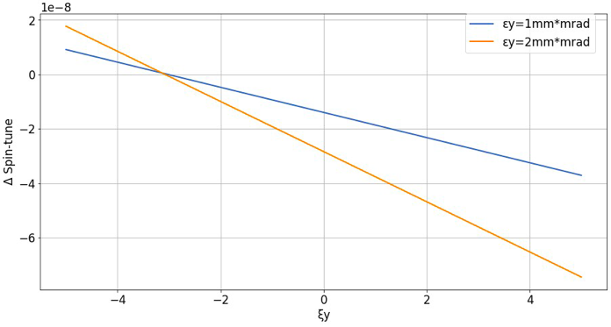
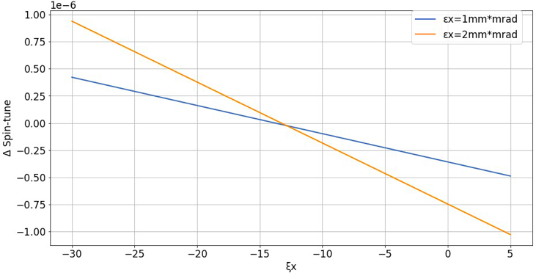
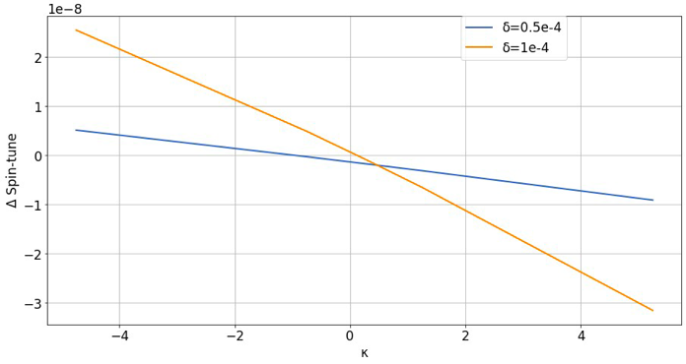
Как и в случае магнитного кольца, предпочтительным вариантом с точки зрения минимизации спин-декогеренции является компенсация пары ($ξ_{x}$, $ξ_{y}$) при вышеописанных параметрах пучка. Остаточное влияние $Δν_{s}\sim 10^{-9}$ в энергетической плоскости приводит к $SCT\sim 1000$ секунд, что является достаточным для эксперимента по поиску ЭДМ. Также техника измерения ($ξ_{x}$, $ξ_{y}$) довольно распространена на накопителях в отличие от измерения $α_{1}$, и при двух семействах секступолей целесообразно оптимизировать пару ($ξ_{x}$, $ξ_{y}$).
Рис. 19. Влияние вертикальной хроматичности для частиц с отклонением по вертикали на разброс спин-тюна.
Рис. 18. Разброс частот спин-прецессии для частиц, инжектированных с различным отклонением по радиальной координате в зависимости от гориз. хроматичности.
Рис. 20. Влияние $κ=η_{1}$для частиц с отклонением по энергии на разброс спин-тюна.
Несовпадение оптимума бетатронной и спиновой хроматичности в X-D плоскости в случае накопителя с электростатическим полем может быть объяснено особенностью движения частиц в электрическом поле. В данном случае движение частиц в радиальном направлении в дефлекторе с радиальным полем приводит к изменению энергии частиц. Это связано с потенциальным характером поля и приводит к связи орбитального движения и энергии частиц.

ByPass NICA
Для полученной модернизации кольца ByPass NICA в главе 1 также с установленными фильтрами Вина проводилась оптимизация отдельно для бетатронной хроматичности и спиновой когерентности.
В случае подавления бетатронной хроматичности необходимо использовать 2 семейства секступолей как было показано в главе 2: одно вблизи фокусирующих квадруполей, другое – рядом с дефокусирующими. Натуральная хроматичность накопительного кольца ByPass NICA равна $ν_{x,y}=-17/-17$. После оптимизации можно отслеживать частоту прецессии спина на рис. 21: красная линия показывает натуральную хроматичность, синяя пунктирная – скорректированную, подавленную до нуля. Для этого случая также был осуществлен спин-трекинг в течение $3×{10}^{5}$ оборотов для частиц с различным начальным отклонением в координатах $x; y; d$ с начальной ориентацией спина ${\vec{S}}_{0}$ под углом 45 градусов в плоскости $y-z$, что показано на рис. 13.
Ключевым параметром является частота вращения спина, которая в общем случае зависит от координат и энергии. Можно видеть, что доминирующим компонентом является квадратичный член в разложении частоты спиновой прецессии. Это видно на рис. 21 для обоих случаев – как для натуральной хроматичности, так и скорректированной хроматичности.
Для достижения спиновой когерентности была рассмотрена возможность компенсация квадратичных членов в разложении с использованием 2-х фокусирующих семейств. Однако, линейно зависимых, так как установлены с места с одинаковыми значениями бета-функций и дисперсионных функций (рис. 14), что характерно для структур с регулярными поворотными арками. Стоит отметить, что COSY Infinity не может работать вблизи нулевого значения частоты прецессии спина. Так как это может привести к вырожденности спин трансфер матрицы в области резонанса и, как следствие, некорректной работе программы, по этой причине необходимо отстроиться от резонанса до уровня $ν_{s}\sim {10}^{-4}$. Однако к частицам предъявляется требование прецессировать синхронно — когерентно. В этом методе мы не влияем на хроматичность, просто отслеживаем её значение при скорректированной спиновой хроматичности $ν_{x,y}=-13/-18$.
Чистая коррекция бетатронной хроматичности не позволила нам получить нулевой разброс частоты вращения спина. Одновременно, получение спиновой когерентности, путем подавления квадратичного члена частоты спиновой прецессии, не подавляет хроматичность. Это возвращает нас к Уравнению 5. Таким образом, чтобы гарантировать нулевой энергетический разброс, хроматичности должны быть подавлены $ξ_{x}, ξ_{y}$ вместе со значением $η_{1}$ до нуля. Это также возможно при использовании 3-х семейств секступолей. Но все равно не позволяет добиться спиновой когерентности. Кроме того, максимальное значение секступольного градиента слишком велико и не может быть реализовано (табл. 4).
Данный эффект был объяснен уже при рассмотрении чисто магнитного кольца, где представлена зависимость спин-тюна от секступольных коэффициентов в Уравнении 8. При наличии электростатического поля, влияние хроматичности $ξ_{x}, ξ_{y}$ на спин-тюн оказывает больше, чем $κ$. И может быть скомпенсировано охлаждением пучка.
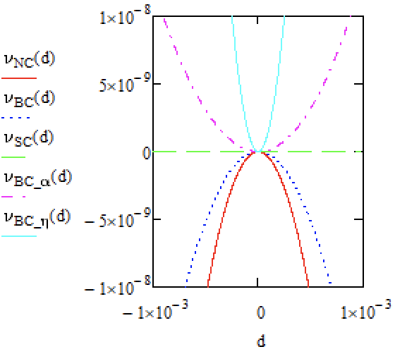
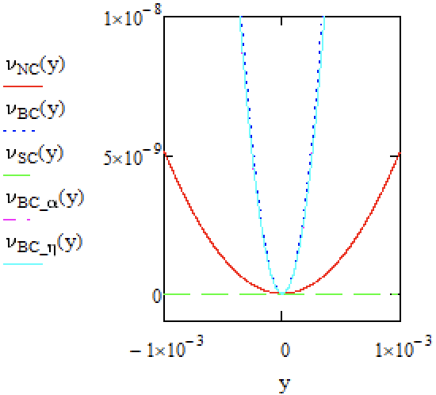
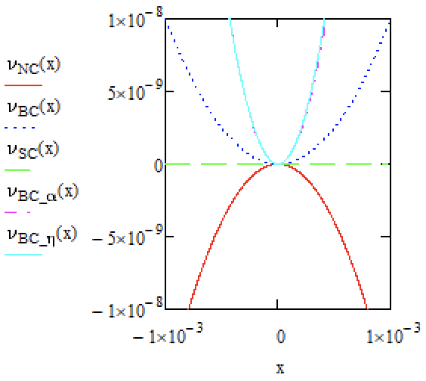
Таблица 4. Основные параметры при оптимизации ByPass NICA
Рис. 21. Зависимость частоты прецессии спина от координат x, y, d для различных случаев оптимизации. NC – натуральная хроматичность (красная линия); BC – нулевая (бетатронная) хроматичность (синяя пунктирная линия); SC – спиновая когерентность (зеленая линия); BC_α – нулевая хроматичность и $α_{1}=0$ (фиолетовая линия); BC_η – нулевая хроматичность и ноль $η_{1}=0$ (светло-голубая линия).
Оптимизация | Без Оптимизации | Хроматич-ность | Спиновая когерентность | Хроматич-ность $+η_{1}$
Хроматичность | $$-17/-17$$ | $$0/0$$ | $$-13/-18$$ | $$0/0$$
коэффициент $α_{1}$ | 0.2 | -0.4 | $$-0.37⋅{10}^{-2}$$ | -0.85
коэффициент $K_{x}$ | $$-0.16⋅{10}^{-1}$$ | $$0.55⋅{10}^{-1}$$ | $$0.27⋅{10}^{-13}$$ | $$0.56⋅{10}^{-1}$$
коэффициент $K_{y}$ | $$0.51⋅{10}^{-2}$$ | $$0.76⋅{10}^{-1}$$ | $$-0.12⋅{10}^{-12}$$ | $$0.78⋅{10}^{-1}$$
коэффициент $K_{z}$ | $$-0.43⋅{10}^{-1}$$ | $$0.20⋅{10}^{-1}$$ | $$0.13⋅{10}^{-12}$$ | $$1.6⋅{10}^{-1}$$
количество семейств  секступолей | Без секступолей | 2 | 3 | 3
Максимальное поле секступолей $m^{-3}$ | - | 2.7 | 19.4 | 104.2

Поднятая в этой главе проблема одновременного подавления хроматичности, а также достижение спиновой когерентности представлена в работах на конференциях LaPlas’23 [13] и IPAC’23 [14], с последующей публикацией в журналах.

Прецессия спина в режиме поиска аксиона
Аксионы Peccei-Quinn, предложенные в качестве решения the strong CP-problem, рассматриваются как один из наиболее вероятных кандидатов на роль темной материи. Согласно изложенной авторами теории, накопительное кольцо может быть использовано в качестве антенны для поиска галактического аксиона.
Современные поиски резонансного вращения спина в накопителях используют разработанную коллаборацией JEDI методику нарастания вертикальной поляризации из горизонтальной плоскости, наличие роста которой диагностирует наличие поля аксиона [15]. На основании аналитической трактовки влияния времени спиновой когерентности на частотный поиск сигнала аксиона предлагается альтернативная схема с поворотом первоначально вертикального спина в горизонтальную плоскость. Эта схема свободна от неоднозначности фазы аксионного поля, не требует радиочастотных спиновых флипперов и может быть легко реализована как с дейтронами, так и с протонами, аккамулированными в накопительных кольцах нуклотрона, NICA.
Рассмотрим построение предполагаемого эксперимента на примере эксперимента по поиску ЭДМ поляризованного пучка дейтронов. В его основе лежит идея введения обводного участка (bypass) с размещением на нем Wien- фильтров. В этом случае особый интерес представляет структура QFS с bypass в NICA. Отличие между экспериментами по поиску ЭДМ и аксиона заключается в том, что в последнем случае для поиска аксиона не требуется условие «замороженности» спина.
Метод поиска основан на взаимодействии аксиона с ЭДМ частиц в сгустке. Это взаимодействие вносит изменение в прецессию спина, согласно Т-БМТ уравнению с увеличением вертикальной компоненты спина. Так как масса аксиона неизвестна, то для её нахождения необходимо произвести сканирование по частоте прецессии спина, что достигается вариацией поля в фильтрах Вина.
Сначала выпишем условия, определяющие поиск ЭДМ. В поворотных магнитных арках коллайдера NICA направление движения (продольный импульс) частицы в 3D пространстве поворачиваются на угол $Φ_{arc}^{B}=π$, с одновременным поворотом спина МДМ дейтрона в противоположную сторону ($γG<0$) в горизонтальной плоскости относительно импульса частицы на угол(см. рис. 22):
$Φ_{s}^{arc}=γG⋅Φ_{arc}^{B}$ (10)
На каждом из двух прямых участках НИКИ прямолинейные элементы с полями E и B (фильтры Вина) обеспечивают вращение спина МДМ в горизонтальной плоскости в противоположном направлении относительно направления импульса в электрическом поле на угол $Φ_{s}^{E}=-\left(γG+\frac{γ}{γ+1}\right)β^{2}⋅Φ_{ss}^{E}$, где $Φ_{ss}^{E}$ – поворот импульса в электрическом поле, и в магнитном поле в том же направлении, что и в арках, на угол $Φ_{s}^{B}=(γG+1)⋅Φ_{ss}^{B}$, где $Φ_{ss}^{B}$ угол поворота импульса в магнитном поле.
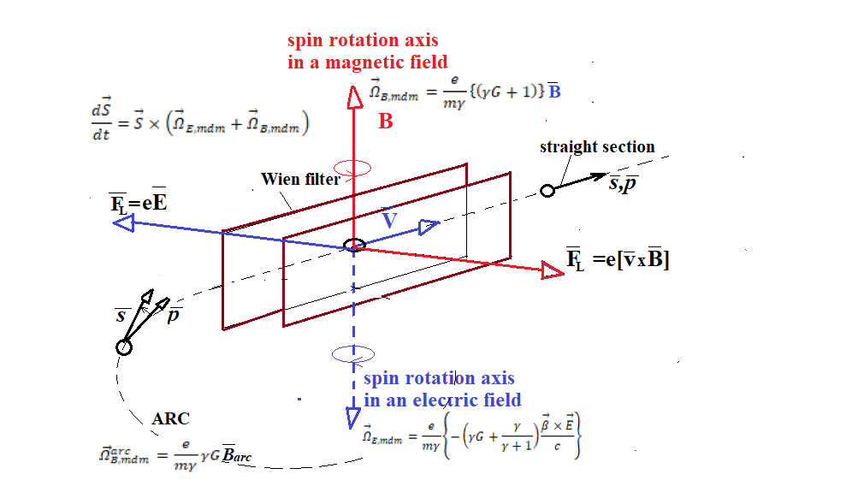
Рис. 22. Векторная диаграмма трансформации спина для дейтрона

Поскольку сила Лоренца в Wien фильтре равна нулю, углы $Φ_{ss}^{E}=Φ_{ss}^{B}$ равны друг другу. Поэтому их можно определить через один из них, например, через магнитное поле как $Φ_{ss}^{B}=\frac{eB_{ss}}{mγv}⋅L_{ss}$, где $B_{ss},L_{ss}$ — магнитное поле и длина прямолинейного элемента соответственно. Чтобы реализовать концепцию QFS, мы должны выполнить условие $Φ_{s}^{B}-Φ_{s}^{E}=Φ_{arc}^{B}$,
$(γG+1)⋅Φ_{ss}^{B}-\left(γG+\frac{γ}{γ+1}\right)β^{2}⋅Φ_{ss}^{E}=γG⋅π$ (11)
Проведя несложные преобразования, получим основное соотношение для параметров прямого элемента для случая выполнения условия «квази-фрозен» спин:

$L_{Σ}E_{ss}=\frac{G}{G+1}⋅\frac{mc^{2}}{e}⋅πβ^{2}γ^{3}$ and$B_{ss}=-\frac{E_{ss}}{cβ}$, (12)
где $L_{Σ}$ – общая длина прямых элементов на одном прямом участке. Для случая максимального электрического поля на уровне 120 кВ/см необходимое магнитное поле ниже 80 мТл.
Для случая поиска аксиона условие (11) видоизменяется до следующего выражения:
$\left(γG+1\right)⋅Φ_{ss}^{B}-\left(γG+\frac{γ}{γ+1}\right)β^{2}⋅Φ_{ss}^{E}=ΔΦ+γG⋅π$, (13)
где $ΔΦ$-фаза разбалансировки по отношению к случаю «квази-фрозен» спин, когда $ΔΦ=0$. При изменении энергии и значения полей $B_{ss}{,E}_{ss}$ Wien фильтра мы меняем значение частоты $f_{spin}$ прецессии вектора спина вокруг вертикальной оси:
$f_{spin}=\frac{ΔΦ cβ}{C_{ring}}$, (14)
где $C_{ring}$ – периметр кольца, $cβ$-скорость обращения пучка по кольцу, $ΔΦ$-фаза разбалансирования, определяемая из соотношения 12. Так, например при $ΔΦ=1 рад$ частота прецессии спина вокруг вертикальной оси равна $270 кГц$, то есть диапазон поиска аксиона определяется частотой $f_{spin}=0÷270 кГц$.
Для случая с протонным пучком опция «квази-фрозен» спин не может быть реализована на NICA, поскольку аномальность магнитного момента протона $G_{p}=1.7$ на порядок выше и спина на арке поворачивается на угол более чем 360 град, что приводит к практически нулевому значению накопленного сигнала ЭДМ. Однако для регистрации аксиона идея остается в силе, но в другом диапазоне $f_{spin}$.
Заключение
Для экспериментов с ЭДМ необходимо использовать NICA в качестве накопительного кольца. По этой причине была рассмотрена модернизация путем создания альтернативных прямых участков, параллельных исходным, с использованием каналов ByPass. Также на прямых участках есть возможность разместить специальные элементы – фильтры Вина для компенсации вращения спина от МДМ компоненты в поворотных арках. Поскольку арки остаются неизменными, это позволяет использовать NICA в различных экспериментах.
Рассмотрены 2 принципиальные схемы обходного канала. И, наконец, получен наиболее реалистичный случай, когда прямой участок полностью регулярный. Конечная конструкция удовлетворяет всем необходимым требованиям к магнитооптике. Исследование спин-орбитальной динамики с оптимизированными значениями полей в фильтрах Вина показывает, спин восстанавливает ориентацию на прямом участке и метод «Квази-Замороженного Спина» может быть реализован в ByPass NICA. Начато исследование одновременного достижения спиновой хроматичности и бетатронной хроматичности.
Подобная структура также позволяет использовать NICA в качестве аксионной антенны.

- MODERNIZED NUCLOTRON
Another accelerator of the NICA complex, which can be considered as a candidate for search for EDM, may be the Nuclotron. The task of adapting the Nuclotron structure to the requirements for the structure for measuring the electric dipole moment of the deuteron can be determined by a set of problems: increasing the straight sections length, suppressing the dispersion in the straight sections, and maintaining the direction of the spin along the momentum. The first problem, increasing straight sections to the required length, is solved by increasing the maximum magnetic field in the bending magnets to a value of 1.8 Tesla. Simultaneously with the first problem, the problem of suppressing dispersion is solved by choosing of the advanced phase of radial oscillations on the arcs. The proposed modernized structure of one super period of the Nuclotron is shown in Fig. 5.
Thanks to an increase in the magnetic field to 1.8 Tesla in the bending magnets, the length of the straight section in each super period is increased from 7.3 m to 10.5 m The third problem of maintaining the direction of the spin relative to the momentum, necessary for diagnosing the EDM signal, is solved by introducing electrostatic deflectors with negative curvature at each super period of the structure (see fig. 6). This allows the average direction of spin to be maintained along the momentum across the entire ring within the concept of “quasi-frozen spin” in the accelerator.
Nuclotron, with the “quasi-frozen” structure should consist of two different parts: magnetic arcs with bend magnets that change the direction of particle motion on each arch by an angle $Φ^{B}=\left(π/N +2α\right)$ and provide rotation of the spin with the tune $ν_{s}^{B}$ in the horizontal plane relative to the momentum by an angle $Φ_{s}^{B}=ν_{s}^{B}⋅Φ^{B}$, and electrostatic arcs with the negative curvature, rotating the beam on each arc by an angle $Φ^{E}=-2α$ and ensuring rotation of the spin with the tune $ν_{s}^{E}$ in the horizontal plane relative to the momentum in the opposite direction by an angle $Φ_{s}^{E}=ν_{s}^{E}⋅Φ^{E}$. To implement the concept of quasi-frozen spin, it is necessary to provide $Φ_{s}^{E}=-Φ_{s}^{B}$. Since in an electrostatic deflector the spin rotates relative to the momentum with a frequency many times greater than in a magnetostatic structure, we have a basic relationship for two different structural arcs:
$ν_{s}^{B}⋅(\frac{π}{N}+2α)=ν_{s}^{E}⋅2α$ и $α=\frac{1}{ν_{s}^{E}/ν_{s}^{B}-1}\frac{π}{N}$. (8)
At the optimum energy for polarimeter W= 270 MeV the angle α=0.026 π and the required length of the electrostatic channel equals 7.3m. In this case, the magnitude of the EDM signal in the “quasi-frozen” structure compared to the “frozen” option ${S_{EDM}^{QFS}}/{S_{EDM}^{FS}}=1-α^{2}$/4 $≈$0.998 decreases by 0.2%.
In addition to this option, we considered a structure with a double number of super periods 16. Due to the separation of the double bend magnets into individual magnets, the number of FODO periods at each super period was doubled, which made it possible to obtain dispersion suppression on every second straight section due to a phase advance of 60 degrees on each FODO cell. In this version of the structure, the rotation angle becomes α=0.013 π, and the magnitude of the EDM signal for the “quasi-frozen” structure compared to the “frozen” structure decreases ${S_{EDM}^{QFS}}/{S_{EDM}^{FS}}=1-α^{2}$/4 $≈$0.9996 by 0.04%, which makes it practically similar the last one. This fact makes it possible to use this structure to study the EDM of the proton, since the spin rotation angle for proton on the magnetic arcs becomes only 30 degrees.

Current Structure of the Nuclotron

Figure 2 shows the NICA accelerator complex, comprising the Booster, the Nuclotron, and the Collider. Two of these components—the Booster and the Nuclotron—functionally serve as an injector of heavy ions, polarized protons, and deuterons into the collider. Initially, the magneto-optical structure of the Nuclotron was designed to be as close to circular as possible, featuring eight superperiods. Figure 3 displays the Twiss functions for a single Nuclotron superperiod, which consists of a bending arc—comprising three FODO cells, each containing four bending magnets with a maximum magnetic field of 1.8 T—and a straight section consisting of one FODO cell. The total length of the Nuclotron is 251 m.

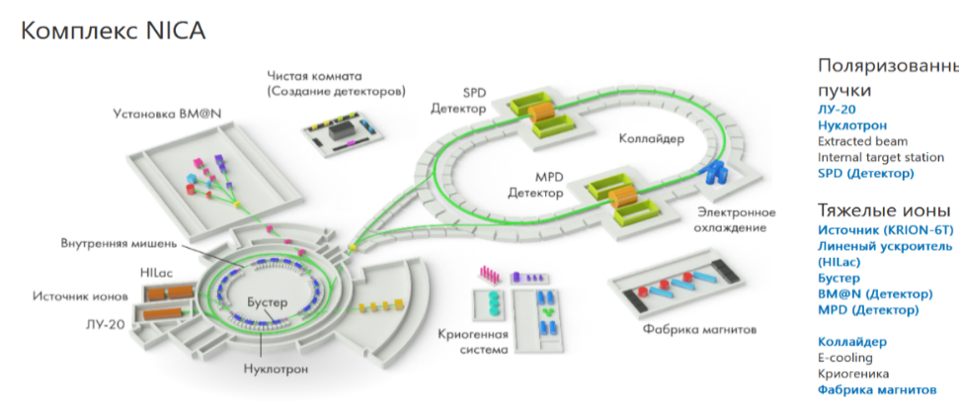
Fig. 2. Accelerator complex NICA

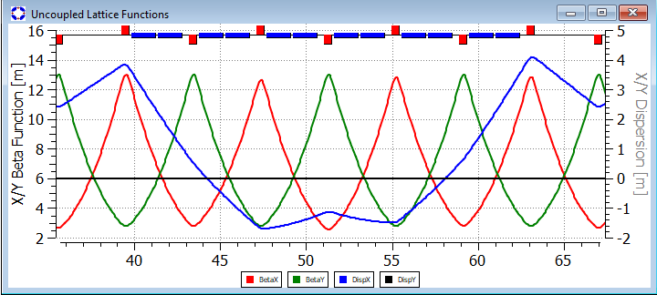
Fig. 3. Twiss functions of one Nuclotron superperiod.

The main drawback of the Nuclotron—both as a collider injector and as a standalone ring—is the limited length of the drift spaces where the equipment required for these two functions must be installed. All subsequent upgrade options for the Nuclotron will be evaluated in terms of addressing this challenge.

Nuclotron Upgrade Options
We have examined two options for upgrading the Nuclotron.
The first option, Nuclotron 2.1, considers a potential magneto-optical structure that preserves all the properties of the existing accelerator while creating conditions for experiments to measure the deuteron electric dipole moment through the installation of electric deflectors or Wien filters in the ring. Each of these devices would make it possible to maintain the spin vector orientation along the direction of the polarized particle beam as it travels around the accelerator ring. Addressing this task requires solving four problems within the framework of an eight-superperiod structure $N_{super}=8$: implementing the "frozen-spin" (or "quasi-frozen-spin") concept in the proposed optics by increasing the length of the straight sections between arcs; ensuring zero dispersion in the straight sections; and, if possible, maintaining the Nuclotron ring's length to accommodate the required equipment within the existing tunnel. The task of searching for axions within this conceptual framework could also be included, though there is currently no full understanding of how to handle the systematic errors involved in the proposed experiment. In the Nuclotron 2.1 option, all key Collider parameters—such as transition energy and electron cooler specifications—remain unchanged. This would create significant issues regarding the interface between the Collider and the Nuclotron, as the passage of the cooled beam through the transition energy would lead to irreversible beam degradation and a consequent reduction in final luminosity.
The Nuclotron 2.2 option proposes modifications to ensure compatibility with the Collider. The injection energy for polarized protons into the Collider remains unchanged at the 2–3 GeV level. However, to eliminate the impact of crossing the transition energy after electron cooling, the plan is to raise the Collider's transition energy to a level above its maximum operating energy. Regarding modifications, the possibility of lowering the maximum energy of heavy ions and polarized particles in Nuclotron 2.2 is also being considered. This would expand the Nuclotron's capabilities for EDM and axion experiments by freeing up additional space on the ring to accommodate Wien filters. Notably, lowering the energy in the Nuclotron would clearly have no adverse effect on the complex as a whole, since the Collider can assume some of the Nuclotron's functions and provide proton and heavy-ion beams across the entire Nuclotron energy range.

нуклотрон 2.1: концепция «квази-замороженного» спина дейтрона
Задача адаптации структуры Нуклотрона под требования к структуре для измерения электрического дипольного момента дейтрона может быть определена совокупностью проблем: увеличение прямых участков, подавление дисперсии на прямых участках и сохранение направления спина вдоль кольца.
Первая проблема, увеличение прямых участков до требуемой длины, решается за счет увеличения максимального магнитного поля в поворотных магнитах до величины 1.8 Тл и объединения двух соседних магнитов между квадрупольными линзами в один магнит. Одновременно с первой проблемой решается проблема подавления дисперсии выбором набега фазы радиальных колебаний на арках. Предлагаемая модернизированная структура одного суперпериода Нуклотрона 2.1 показана на рис. 4. Основные параметры модернизированной структуры Нуклотрона 2.1: общая длина 251 м, бетатронные частоты Q_{x} = 9.78548, Q_{y} = 10.6839, коэффициент уплотнения орбит 0.0134394; коэффициент скольжения −0.0222388; натуральная хроматичность −16.0394 (гор) −17.8984 (вер); D-дефокусирующий квадруполь; F- фокусирующий квадруполь; B- магнитный дипольный магнит; ED-электростатический дефлектор. В дальнейшем все параметры различных опций будут сведены в табл. 1.

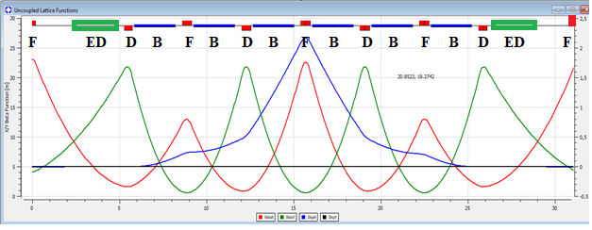
Рис. 4: TWISS функции одного суперпериода модернизированного Нуклотрона 2.1 с двумя электростатическими дефлекторами

Благодаря увеличению магнитного поля до 1.8 Тл в поворотных магнитах длина прямого промежутка в каждом суперпериоде увеличена с 7.3 до 10.5 м. Третья проблема сохранения направления спина относительно импульса, необходимого для диагностирования ЭДМ сигнала дейтронов, решается введением электростатических дефлекторов с отрицательной кривизной на каждом суперпериоде структуры (рис. 5).
В концепции «квази-фрозен» спин магнитные и электрические поля разносятся в разные элементы, что очевидно приведет к осцилляции направления спина относительно направления движения, при этом в магнитных и электростатических поворотных элементах спин вращается в разные направления. Принимая во внимание малое значение аномальности магнитного момента дейтрона $G=-0.142$ и предполагая, что спин совершает колебания относительно импульса на каждой магнитной арке суперпериода в пределах половины величины набега фазы спина $Φ_{s}=+\frac{1}{2N}⋅2π⋅γG$, каждый раз возвращаясь в электростатическом дефлекторе назад на угол $-Φ_{s}$, где $N$ – супер периодичность арок. Это позволяет в среднем сохранять направление спина вдоль импульса во всем кольце в рамках концепции «квази-замороженного спина» в ускорителе.
В случае Нуклотрона $N=8$. Благодаря малой величине $Φ_{s}$ эффективный вклад в ожидаемый ЭДМ сигнал уменьшается в фактор
$J_{0}(Φ_{s})≈1-\frac{{\left(Φ_{s}\right)}^{2}}{4}$ , (7)
что означает уменьшение ЭДМ сигнала лишь на несколько процентов.
Давайте рассмотрим эту проблему более детально, чтобы определить параметры электростатических дефлекторов в режиме «quasi-frozen» спин для дейтронов. То есть структура должна состоять из двух различных частей (см. рис. 5): магнитные арки с поворотными магнитами, изменяющими направление движения частицы на каждой арке на угол $Φ^{B}=(π+2α)$ и обеспечивающими поворот спина в горизонтальной плоскости относительно импульса на угол $Φ_{s}^{B}=ν_{s}^{B}⋅Φ^{B}$, и электростатическими дугами с электрическими дефлекторами отрицательной кривизны, поворачивающей пучок на каждой дуге на угол $Φ^{E}=-2α$ и обеспечивающей поворот спина в горизонтальной плоскости относительно импульса в противоположную сторону на угол $Φ_{s}^{E}=ν_{s}^{E}⋅Φ^{E}$. Для реализации концепции квази-замороженного спина необходимо обеспечить $Φ_{s}^{E}=-Φ_{s}^{B}$. Поскольку в электростатическом дефлекторе спин вращается относительно импульса с частотой, в разы большей, чем в магнитостатической структуре, мы имеем основное соотношение для двух разных структурных дуг:

$ν_{s}^{B}⋅(\frac{2π}{N}+2α)=ν_{s}^{E}⋅2α$ и $α=\frac{1}{ν_{s}^{E}/ν_{s}^{B}-1}\frac{π}{N}=-γ^{2}⋅\frac{G}{G+1}⋅\frac{π}{N}$, (8)
Зная предполагаемые параметры поворотных магнитов и поля $E_{ED}=130 кВ/см$ в электростатическом дефлекторе, мы можем точно посчитать $ν_{s}^{E}/ν_{s}^{B}$ , параметр $α$ и радиус кривизны электростатического дефлектора $R_{ED}=\frac{κ}{E_{ED}}$, где $p_{0}=γmβc$, $κ={p_{0}βc}/e$ – электрическая жесткость, тогда $R_{ED}=\frac{mc^{2}}{e}\frac{γβ^{2}}{E_{ED}}$. В этом случае длина дефлектора определяется $L_{ED}=2α{∙R}_{ED}=-2\frac{γ^{2}G}{G+1}\frac{π}{N}∙R_{ED}$. На рис. 5 показано, как организуется вставка электростатических дефлекторов для реализации «quasi-frozen» структуры кольца Нуклотрон. При энергии W=270 МэВ, $α$= 0.026$π$ и требуемая длина электростатического канала равна 7.3 м. При этом величина ЕДМ сигнала $S_{EDM}=1-α^{2}$/4 $≈$0.998 уменьшается на величину 0.2%.
Электростатическая арка с отрицательной кривизной предполагает размещение необходимого оборудования на прямом участке между двумя магнитными арками, через которое пучок проходит при отключенных электростатических дефлекторах.

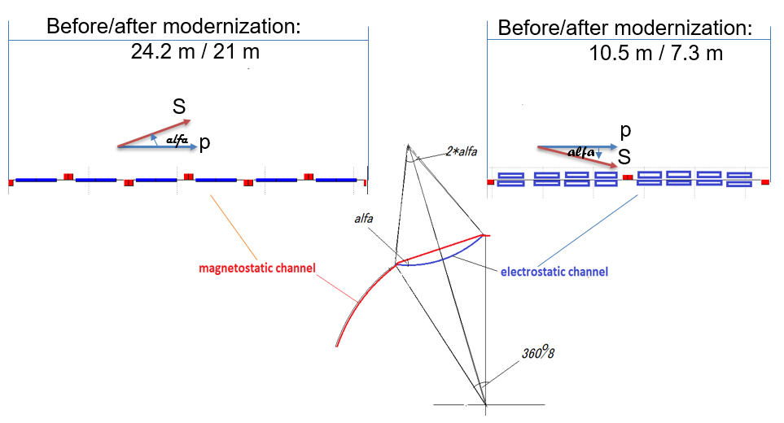
Рис. 5. Электростатическая вставка для компенсации поворота спина в магнитостатической арке.

Концепция «квази-замороженного» спина Нуклотрон 2.2 с фильтрами Вина для дейтронов
В модернизированном варианте магнитооптической структуры Нуклотрон 2.2 мы ввели небольшое вертикальное магнитное поле ~100 мТл, компенсирующее силу Лоренца электрического поля. Тем самым мы перешли к прямым электростатическим дефлекторам. В случае добавления магнитного поля в дефлектор вновь образованный Е+В элемент в полной мере можно отнести к устройствам, называемыми фильтром Вина. В этом случае структура кольца состоит из дуг, соединенных прямолинейными участками, на которых установлены фильтры Вина со скрещенными электрическим и магнитным полями, обеспечивающие прямолинейное движение частиц за счет нулевой силы Лоренца с одновременной компенсацией вращения спина, произошедшего в магнитных дугах. Общая длина всех фильтров Вина определяется параметрами пучка и требованием скомпенсировать поворот спина на арках, а их количество определяется удобством их размещения по кольцу.
В магнитной дуге при совокупном количестве $N$ магнитных дуг частицы поворачиваются на угол $Φ_{arc}^{B}=2π/N$, с одновременным МДМ поворотом спина благодаря магнитному дипольному моменту в горизонтальной плоскости относительно импульса на угол $Φ_{s}^{arc}=γG⋅Φ_{arc}^{B}$. Фильтры Вина с полями E и B обеспечивают МДМ вращение спина в горизонтальной плоскости в противоположном направлении относительно импульса по сравнению с поворотными магнитами на арках:
в электростатическом поле $E_{wf}$ на угол
$Φ_{swf}^{E}=-\left(γG+\frac{γ}{γ+1}\right)β^{2}⋅Φ_{wf}^{E}$, (9)
где $Φ_{wf}^{E}=\frac{eE_{wf}}{m_{0}c^{2}γβ^{2}}⋅L_{wf}$ – вращение импульса в электрическом поле фильтра Вина, и в магнитном поле $B_{wf}$ на угол

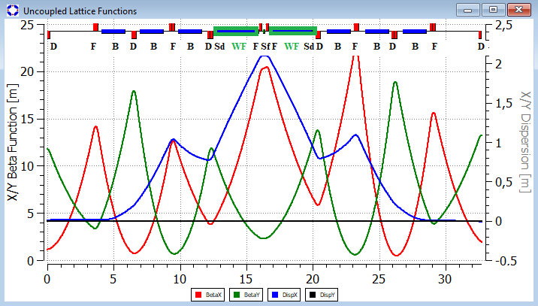

Рис. 6. TWISS функции одного суперпериода модернизированного Нуклотрона 2.2.1 с двумя фильтрами Вина.

$Φ_{swf}^{B}=(γG+1)⋅Φ_{wf}^{B}$, (10)
где $Φ_{wf}^{B}$=$\frac{eB_{wf}}{m_{0}cγβ}⋅L_{wf}$ – вращение импульса в магнитном поле фильтра Вина длиной $L_{wf}$.
Поскольку сила Лоренца в фильтре Вина равна нулю, то углы $Φ_{wf}^{E}=Φ_{wf}^{B}$должны быть равны между собой. Поэтому их можно определить через один из них, например, через электрическое поле и длину фильтра $E_{wf},L_{wf}$, которые размещены на всех N прямолинейных участках, соответственно. В отличии от опции с «замороженным» спином, где совокупная частота вращения спина относительно импульса в магнитном и электрическом полях поворотного устройства с Е+В полями равна нулю, опция «квази-замороженного» спина требует равенству нулю суммарного угла поворота спина за оборот в поле Е и поле В. Таким образом, для реализации концепции «квази-замороженного» спина QFS необходимо выполнить условие $Φ_{wf}^{B}-Φ_{wf}^{E}=Φ_{arc}^{B}$, т.е.
$(γG+1)⋅Φ_{wf}^{B}-\left(γG+\frac{γ}{γ+1}\right)β^{2}⋅Φ_{wf}^{E}=γG⋅2π/N$ (11)
Выполняя преобразования, получаем основное соотношение для параметров одного фильтра Вина прямого элемента:
$L_{wf}E_{wf}=\frac{2π}{N}⋅\frac{G}{G+1}⋅\frac{m_{0}c^{2}}{e}⋅β^{2}γ^{3}$ и $B_{wf}=-\frac{E_{wf}}{cβ}$ (12)
где $L_{wf}$ –длина одного фильтра Вина. В этом случае суммарная длина всех Вин фильтров $L_{wf}^{Σ}E_{wf}=2π⋅\frac{G}{G+1}⋅\frac{m_{0}c^{2}}{e}⋅β^{2}γ^{3}$ является величиной, зависящей только от типа частиц и ее энергии
Уравнения 8 и12 полученное сначала для электростатических дефлекторов, а затем для фильтров Вина показывают, что тип отклоняющего элемента не имеет значения. Таким образом, при неизменной магнитной арке, длина фильтра Вина окажется меньше на суммарную длину киккеров, так как в нём совмещены функции электростатического дефлектора и киккера в один элемент.
На рис. 6 показаны TWISS функции одного суперпериода первой версии модернизированного Нуклотрона 2.2.1. В центральных прямых участках суперпериода установлены два фильтра Вина, которые восстанавливают отклонение направления вектора спина после прохождения магнитной полуарки. Величина угла отклонения вектора спина от направления импульса $α=γG⋅2π/N$ характеризует степень отличия «квази-замороженной» магнитооптической структуры от «замороженной». В данной структуре число арок, определяющих отклонение вектора спина, равно числу суперпериодов $N=8$.
Если принять 130 кВ/см за максимальное электростатическое поле, то магнитное поле должно быть ниже 80 мТл. Такое малое магнитное поле открывает перспективы упрощения общей конструкции фильтра Вина. В частности, можно использовать постоянный магнит или электрическую катушку с воздушным сердечником. При таких значениях электрического и магнитного полей и энергии пучка дейтронов 270 МэВ общая длина фильтров Вина на всех прямолинейных участках составляет около 52 м. При этом длина одного фильтра Вина составляет 3.25 м. При энергии 270 МэВ для дейтронов (135 МэВ на нуклон) максимальный угол отклонения вектора спина составит $α\sim ±3°$ по длине одной дуги, что характеризует достаточно хорошее приближение к регулярной «замороженной» структуре.
Другой модификацией модернизированной структуры 2.2.2 является разнесение фильтров Вина на четыре прямых участка суперпериода, как показано на рис. 7.
В результате каждая арка суперпериода разделяется на две арки, и с точки зрения поворотных магнитов структура становится $N=16$ суперпериодической при сохранении общей суперпериодичности 8 магнитооптической структуры с учетом всех элементов. Это позволяет решить две проблемы: во-первых, иметь форму кольца в виде 16-ти угольника, то есть более круглой и лучше вписаться в существующий туннель и во-вторых, при длинах поворотного магнита 1.77 м и фильтра Вина 1.65 м получить угол отклонения вектора спина $α\sim ±1.5°$ в два раза меньше по сравнению с вариантом 2.2.1. Это в значительной степени сблизит по своим свойствам структуры «квази-замороженного» и «замороженного» спина.

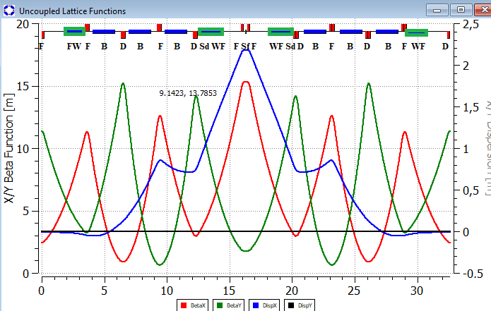
Рис. 7. TWISS функции одного суперпериода модернизированного Нуклотрона 2.2.2 с четырьмя фильтрами Вина.

Для увеличения энергии была рассмотрена модификация Нуклотрона 2.2.3 с меньшим числом пустых промежутков и более длинными магнитами (см. рис. 8). В этой структуре максимальная энергия дейтронов составляет 3.5 ГэВ/нуклон и протонов 7.8 ГэВ, в значительной степени приближает к изначальной опции Нуклотрона.

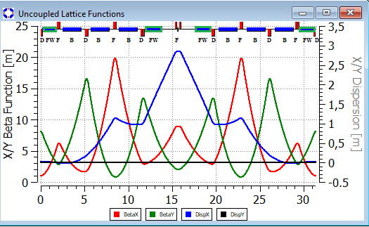

Рис. 8. TWISS функции одного суперпериода модернизированного Нуклотрона 2.2.3 с четырьмя фильтрами Вина.

КОНЦЕПЦИЯ «КВАЗИ-ЗАМОРОЖЕННОГО» СПИНА НУКЛОТРОНА 2.2.2 c ФИЛЬТРАМИ ВИНА ДЛЯ ПРОТОНОВ

Очевидно предположить, что при магнитной суперпериодичности равной 16 можно использовать ее для протонов с пониженной энергией, при этом основным ограничением по энергии здесь является свободное место для фильтров Вина, в нашем случае равное 52 м. Максимальная возможная энергия протонов определяется выражением, полученным из (12):
$γ⋅(γ^{2}-1)=L_{wf}⋅\frac{{eE}_{wf}}{mc^{2}}⋅\frac{N}{2π}⋅\frac{G_{p}+1}{G_{p}}$ , (13)
где $L_{wf}⋅N=52 м$ и $G_{p}=1.798$ –аномальность магнитного момента протона. Решая уравнение относительно $γ$, получаем $γ$=1.08046724, что соответствует энергии W_{p} ⁓80МэВ. При такой энергии отклонение вектора спина в магнитной арке определяется фактором $γG_{p}=1.93711246$, и угол отклонения вектора спина $α=±\frac{1}{2}⋅\frac{γG_{p}}{16}$, в численном выражении будет $α=3.5°$. Для исследования протонов может быть использована та же структура, что и для дейтронов, однако при меньшей энергии и с повёрнутыми на 180 градусов фильтрами Вина, в силу разного знака у аномальных магнитных моментов частиц. То есть при энергии протонного пучка 80 МэВ поведение структуры практически совпадает с опцией «замороженного спина». На рис. 9 показаны результаты расчетов анализирующей способности p-C¹⁴ в терминах «средней анализирующей способности», заимствованные из статьи [10].
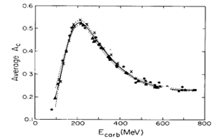
Рис. 9. Графики дискретной энергии (точки) и непрерывная зависимость энергии (сплошная линия) $\overline{A_{c}}$ при $Ө_{lab}=5^{0}-{20}^{0}$. Точки данных взяты из SIN (∆),TRIUMF (×) и LAMPF (∙)

Таблица 1: Основные параметры модификаций Нуклотрона

структура | Длина магнита, м | число магнитов | Общая длина магн-в, м | $B_{max}$, Тесла | $B_{max}R$ _{, T}$⋅m$ | Макс энергия дейтрон, ГэВ | Энергия на нуклон | Макс энергия протон
Nuclotron | 1.44 | 96 | 138.24 | 1.8 | 39.6 | 10.14 | 5.07 | 10.97
Nuclotron 2.1 | 2.35 | 48 | 112.77 | 1.8 | 32.2 | 8 | 4 | 8.79
Nuclotron 2.2.1 | 1.78 | 48 | 85.3 | 1.8 | 24.4 | 5.7 | 2.85 | 6.47
Nuclotron 2.2.2 | 1.78 | 48 | 85.44 | 1.8 | 24.5 | 5.7 | 2.85 | 6.47
Nuclotron 2.2.3 | 2.10 | 48 | 101 | 1.8 | 28.93 | 7.0 | 3.5 | 7.8
Из рис. 9 видно, что анализирующая способность в окрестности 100 МэВ близка к 0.2, что составляет 0.35 от максимального значения A_{c} =0.53 при энергии 230 МэВ. Это дает определенную надежду для исследований ЭДМ протонов при этой энергии в модернизированном варианте Нуклотрон 2.2.2 вместе с полномасштабными измерениями дейтронов.
Поиск галактических аксионов возможен на той же аппаратуре, что и поиск ЕДМ. Вариация частоты прецессии спина при неизменной энергии частиц в кольце делает бустер с фильтрами Вина широкополосной антенной для поиска аксионов по резонансному полному или частичному спин-флипу в осциллирующем пcевдомагнитном поле аксионного гало нашей Галактики [11]. Вызванный аксионами рост горизонтальной поляризации выделяется Фурье-анализом осциллирующей вертикальной асимметрии в внутреннем поляриметре [12].

МАКСИМАЛЬНАЯ ЭНЕРГИЯ ТЯЖЕЛЫХ ЧАСТИЦ И ПРОТОНОВ В МОДЕРНИЗИРОВАННОЙ СТРУКТУРЕ «КВАЗИ-ЗАМОРОЖЕННОГО» СПИНА НУКЛОТРОН 2.2.2
Итак, нами получены расчеты, указывающие на то, что для проведения экспериментов по поиску ЭДМ дейтронов и протонов в модернизированной структуре 2.2.2 необходимо освободить место для размещения фильтров Вина с общей длиной 52 метра. Очевидно, что при сохранении общей длины туннеля 251 метра такое возможно за счет либо увеличения поля в поворотных магнитах, что мы уже приняли на уровне 1.8 Тесла, либо уменьшения их совокупной длин
Предполагая, что максимальное поле в поворотных магнитах не превысит 1.8 Тесла, мы рассмотрели второй вариант, что несомненно приводит к уменьшению максимальной энергии частиц в Нуклотроне.

ОСОБЕННОСТИ МАГНИТООПТИЧЕСКОЙ СТРУКТУРЫ МОДЕРНИЗИРОВАННОГО НУКЛОТРОНА
С точки зрения построения магнитооптической структуры модернизированного Нуклотрона авторы следовали нескольким целям. Во-первых, как мы видим супер-период построен таким образом, чтобы в центральной ячейке было дрейфовое пространство без поворотных магнитов, в том месте, где дисперсионная функция имеет максимальное значение при бесконечном значении кривизны траектории, что позволит поднять критическую энергию:
$α=\frac{1}{C}\int^{C}{\frac{D(s)}{ρ(s)}ds}$ (14)
Во-вторых, число суперпериодов $s$ равное восьми, незначительно превышает частоту бетатронных колебаний $ν_{x}$ в горизонтальной плоскости, что облегчает регулировку коэффициент уплотнения орбит:
$α=\frac{ν^{3}}{R}\sum_{k=0}^{∞}{\frac{{a_{k}}^{2}}{ν_{х}^{2}-s^{2}}}$. (15)
В-третьих, введение центрального дрейфа упрощает размещение трех семейств секступолей, необходимых для регулирования бетатронной и спиновой хроматичностей, в то время, как боковые дрейфовые участки удобны для размещения фильтров Вина.
И наконец, максимальное значение дисперсии в центре суперпериода совпадает с минимальным значением горизонтальной $β_{x}$ функции.

ЗАКЛЮЧЕНИЕ
При использовании Нуклотрона в качестве бустера для коллайдера, конечная энергия Нуклотрона может быть понижена до $2-3$ ГэВ без особого ухудшения всех свойств комплекса НИКА в виду переноса в коллайдер всех физических экспериментов с поляризованными пучками. Это решение является положительным и с другой стороны. Оно позволит сократить общую длину поворотных магнитов, например, за счет уменьшения до одной секции в каждом поворотном двойном магните Нуклотрона и сэкономить на орбите место с общей длиной ⁓70 метров для дополнительного оборудования, в частности для соленоидов, сохраняющих поляризацию. Кроме того, данное решение дает очевидные возможности для дополнительного размещения оборудования для поиска ЭДМ и аксиона непосредственно в Нуклотроне.
В первую очередь коллайдерные эксперименты предъявляют требования к светимости. Которые дают ограничения, помимо прочего, и на продольный фазовый размер конченого сгустка. При ускорении, необходимо как преодолеть критическую энергию, так и разделить пучок на 22 сгустка при помощи ВЧ гимнастики, при этом не раздуть фазовый объём.
Рассмотрена возможная схема скачка критической энергии для NICA. Характерные величинами являются, величина скачка $Δγ_{tr}=0,09$ и темп изменения критической энергии ${dγ_{tr}}/{dt}=8,5 c^{-1}$. Для гармонического ВЧ предложенный скачок оказывает малое влияние на продольную динамику в силу малости скачка и его низкого темпа по сравнению с темпом ускорения. Для барьерного ВЧ, ограничение на величину скачка дает пороговое значение количества частиц в равномерном сгустке, вследствие микроволновой неустойчивости. И не позволяет достигнуть количества частиц $1×{10}^{12}$ в конечном сгустке для достижения максимальной светимости. горизонтальной $β_{x}$ функции.
25-72-30005, https://rscf.ru/project/25-72-30005/

СПИСОК ЛИТЕРАТУРЫ/REFERENCES

- Senichev Yu. A «Resonant» Lattice for a Synchrotron with a Low or Negative Momentum Compaction Factor. Preprint No 97-40. 1997. Tsukuba: KEK.
- Ischi Y. et al. Lattice Design of JHF Synchrotrons. Proc. APAC’98. Tsukuba, Japan. 1998. P. 378.
- Bartosik H. et al. Comparison of PS2 Lattices with Different Geometry. Proc. IPAC’10. Kyoto, Japan. 2010. P. 4557.
- Senichev Y. et al. The Lattice with Imaginary γ-Transition for the CERN Proton Synchrotron PS2. Proc. BEAM’07. Geneva, Switzerland. 2007. P. 171.
- Toelle R. et al. HESR at FAIR: Status of Technical Planning. Proc. PAC’07. Albuquerque, USA. 2007. P. 1442.
- Bargmann V., Michel L., Telegdi V. // Phys. Rev. Lett. 1959. V. 2. P. 435.
- Fukuyama T., Silenko A. // Int. J. Mod. Phys. A. 2013. V. 28. P. 1350147.
- Farley F., Semertzidis Y. // Prog. Part Nucl. Phys. 2004. V. 52 (1). P. 1.
- Senichev Y., Aksentyev A. // J. Phys.: Conf. Ser. 2020. V. 1686. P. 012068.
- McNaughton M. et al. // Nucl. Instrum. Methods Phys. Res. A. 1985. V. 241. P. 435.
- Eversmann D. et al. // Phys. Rev. Lett. 2015. V. 115. P. 094801.
- Nikolaev N. // JETP Lett. 2022. V. 115 (11). P. 639.

Список литературы
- D. Anastassopoulos, V. Anastassopoulos, D. Babusci at al. AGS Proposal: Search for a permanent electric dipole moment of the deuteron nucleus at the 10⁻²⁹ cm level; BNL. — 2008. https://www.bnl.gov/edm/files/pdf/deuteron_proposal_080423_final.pdf
- V. Bargmann, Louis Michel, and V. L. Telegdi Precession of the Polarization of Particles Moving in a Homogeneous Electromagnetic Field, Phys. Rev. Lett. 2, 435, DOI: https://doi.org/10.1103/PhysRevLett.2.435
- P.K. Kurilkin, V.P. Ladygin, et al. The 270MeV deuteron beam polarimeter at the Nuclotron Internal Target Station, Nuclear Instruments and Methods in Physics Research Section A: Accelerators, Spectrometers, Detectors and Associated Equipment, Volume 642, Issue 1, 2011, Pages 45-51, https://doi.org/10.1016/j.nima.2011.03.054.
- Y. Senichev et al. Investigation of Lattice for Deuteron EDM Ring, Proceedings of ICAP2015, Shanghai, China, MODBC4. ISBN 978-3-95450-136-6
- V. Lebedev, OptiM code, Private communication url:www-bdnew.fnal.gov/pbar/organizationalchart/lebedev/OptiM/optim.htm
- S. Kolokolchikov et al., "ByPass optics design in NICA storage ring for experiment with polarized beams for EDM search", in Proc. IPAC'23, Venice, Italy, May 2023, pp. 196-198. doi:10.18429/JACoW-IPAC2023-MOPA072
- ByPass LaPlas
- S. Guiducci, CHROMATICITY, – INFN, Frascati, Italy, CERN 94-01,1994.
- COSY INFINITY. url:www.bmtdynamics.org
- A. Aksentyev et al., "A feasibility study into the Quasi-Frozen Spin regime of operation of the NICA storage ring", in Proc. IPAC'23, Venice, Italy, May 2023, pp. 193-195. doi:10.18429/JACoW-IPAC2023-MOPA071
- Melnikov, A.A., Senichev, Y.V., Aksentyev, A.E. et al. The Nature of Spin Decoherence of a Polarized Beam of Light Nuclei in a Storage Ring for EDM Search. Jetp Lett. (2023). https://doi.org/10.1134/S0021364023603019
- Melnikov, A. et al. Investigation of Polarized Proton Spin Coherence Time at Storage Rings, IPAC2022, Bangkok,Thailand, doi:10.18429/JACoW-IPAC2022-WEPOPT005
- S. Kolokolchikov et al., "Spin coherence and betatron chromaticity of deuteron beam in NICA storage ring", in Proc. IPAC'23, Venice, Italy, May 2023, pp. 190-192. doi:10.18429/JACoW-IPAC2023-MOPA070
- C.Колокольчиков и др., Спиновая Когерентность и Бетатронная Хроматичность Дейтронного Пучка в Режиме Квазизамороженного Спина, ЛАПЛАЗ-2023, стр. 290
- N. N. Nikolaev, Spin of Protons in NICA and PTR Storage Rings as an Axion Antenna, JETP Letters, 2022, Vol. 115, No. 11, pp. 639–643, https://doi.org/10.1134/S0021364022600653

3. Specialized magnetooptical structure

"Frozen-spin" option for the proton beam

The "frozen-spin" structure for a proton beam is the simplest in terms of parameter selection and uniqueness. It consists of electrostatic deflectors, the total length of which $L_{total}$ is determined by the beam energy and the maximum permissible electrostatic field strength:
$L_{total}$ =2π$·\frac{mc^{2}}{eE}∙γβ^{2}$ (7)
In our case, for an energy of 233 MeV and a maximum electrostatic field strength of Е=120 kV/cm the total length of all electrostatic deflectors is $L_{total}=219.55 m$.
Based on the placement of 50 deflectors around the entire ring, the length of a single deflector is L_{def} = 439 cm. The 50 deflectors are divided into 5 groups, each consisting of 5 FODO cells and comprising 10 deflectors (see Fig. 1).

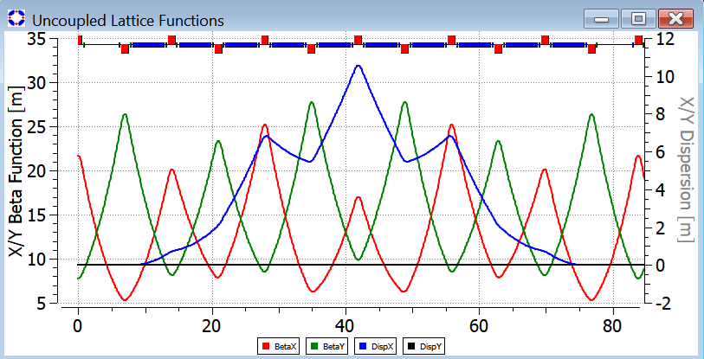
Fig. 1. One superperiod of the ring's electrostatic structure.

Figure 2 shows the entire ring, which consists of five superperiods. Each superperiod comprises an achromat with drift spaces at either end, resulting in a phase advance per superperiod that is not an integer multiple of 2π. The total length of the ring is 419.1 meters.

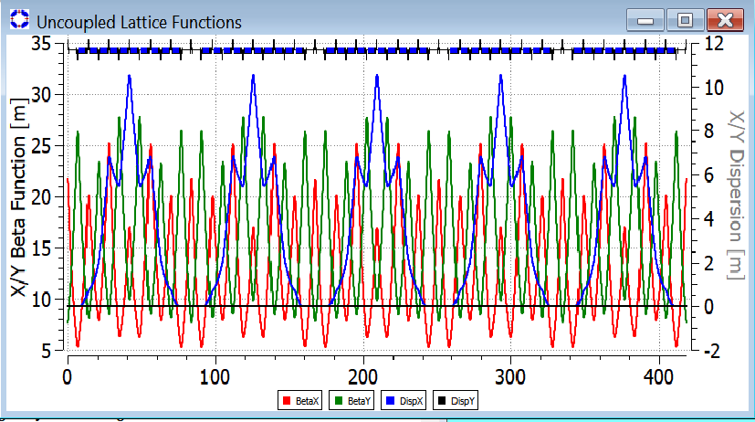
Fig. 2 Twiss functions along the entire length of the electrostatic ring.

Fig. 3 shows the spatial form of the electrostatic ring. It closely resembles a circle.

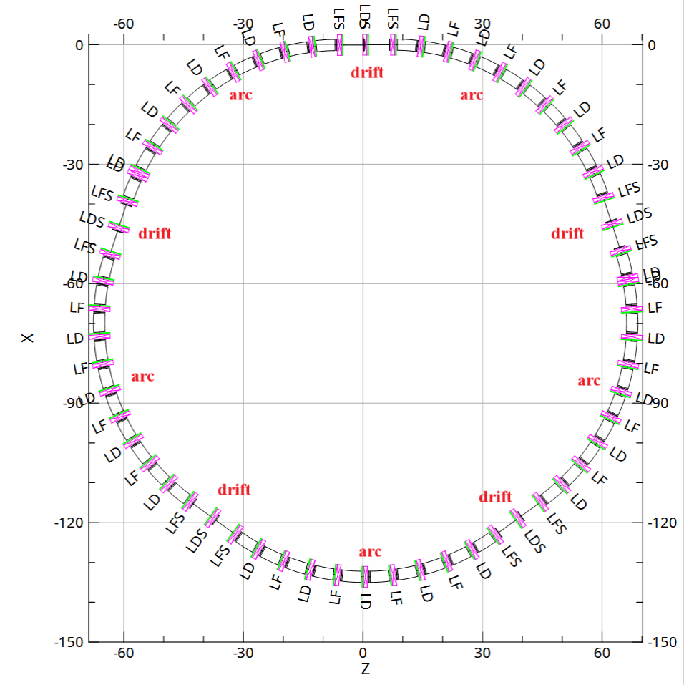
Fig. 3 Spatial form of the electrostatic ring

Table 1 summarizes all the ring parameters required to estimate its geometric dimensions and cost.

Table 1: "Frozen-spin" parameters of the electrostatic ring for the study of the proton EDM

parameters | value
Total length, m | 419.1
Structural symmetry order: number of arches and straight sections | 5
Initial energy, MeV | 20
Anomalous magnetic moment of the proton | 1.78
Final energy, MeV | 233.8
EDM process energy | 233.8
Initial and final relative velocity, Lorentz factor | β=0.2, γ=1.0213  β=0.6, γ=1.248
Orbital revolution frequency at the beginning and end of the cycle, MHz | 0.143÷ 0.429
Harmonic number | 20
RF field frequency at the beginning and end of the cycle, MHz | 2.8÷8.6
arc
Arc length, m | 70.1
Superperiodicity of the arc | regular structure
Arc structure | 5 FODO cells
Number of electrostatic deflectors per arc | 2
Length of the electrostatic deflector, m | 4.39
Deflector type | cylindrical
Maximum electrostatic field of the rotary deflector, MV/m | 12
Number of quadrupoles per arc | 9+1(two extreme halves)
Quadrupole type | electrostatic
Number of quadrupole families | one family of focusing LF and one family of defocusing LD
Maximum quadrupole gradient on the arcs, kV/cm² | LF=6.78,  LD=-6.18
Length of quadrupole lenses, m | 1.0
Number of chromatic sextupoles per arc | 10
Sextupole type | Electric/magnetic
Field gradients in chromatic sextupoles | To be determined later
Betatron tunes 𝞶_{x}/ 𝞶_{y} | preliminarily 6.12/4.72
Natural chromaticities ζ_{x}/ ζ_{y} | To be determined later
Critical energy, GeV | 3.1
Maximum value of βx/βy functions, m | 27.9/34.8
Maximum value of horizontal dispersion, m | 10.8
Straight sections between arcs
Length of straight sections between arcs, m | 5 х 13.5
Optical structure of straight sections | DOFFOD
Quadrupole lens gradients in the straight section, T/m | QF =7.93, QD=-7.11
Lengths of drift spaces between adjacent quadrupoles, m | 6.0

As a second option, we considered another type of arcs. The second type forms a racetrack shape featuring two arcs and dispersion suppressors at the ends of each arc (see Fig. 4).

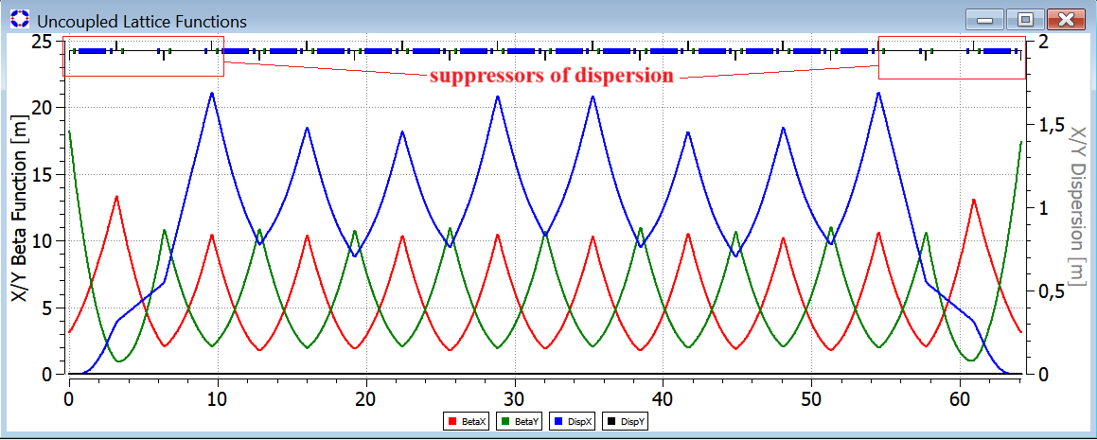

Fig. 4. Arc with dispersion suppressors at the edges.

One of the options will be adopted as the structures are further developed, taking spin decoherence into account.

"Frozen-spin" structure option for the deuteron

The "frozen-spin" structure for a deuteron beam differs from the structure for protons in terms of the composition of the magneto-optical equipment and the specific elements used. In this structure, the bending deflector with $\overset{→}{E}+\overset{→}{B}$ fields consist of electrostatic plates generating a horizontal electric field, inserted into the magnetic gap of a dipole magnet with a vertical magnetic field (see Figs. 5a, b).
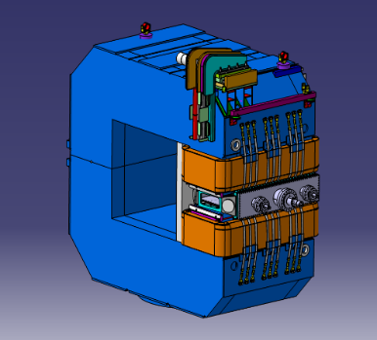
1400
2700
2900
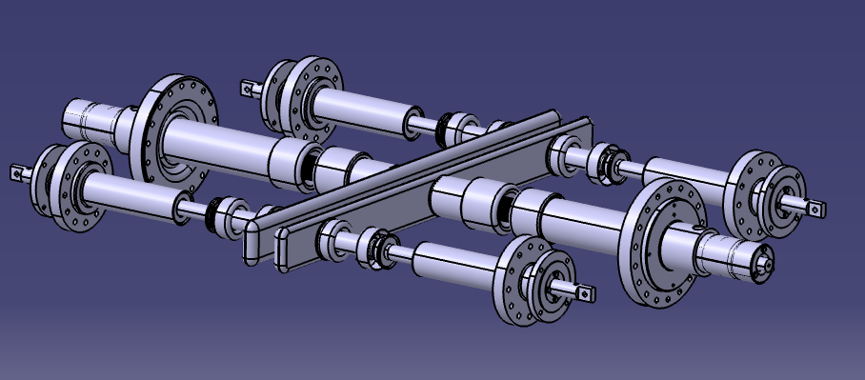
(а) (б)
Fig. 5. Electrostatic deflector (a) and vertical-field magnet (b) with the electrostatic deflector inserted into the magnetic gap.

The equation governing stable motion in an accelerator orbit of radius R is derived by summing the Lorentz force and the centrifugal force:
$R=\frac{γm_{0}v^{2}}{Re\left(\overset{→}{E}+c\overset{→}{β}×\overset{→}{B}\right)}$, (8)
from which the particle momentum precession frequency in combined $\left(\overset{→}{E}+\overset{→}{B}\right)$ fields is determined:
${\overset{→}{Ω}}_{p}=\frac{e\overset{→}{E}}{m_{0}γβc}+\frac{c\overset{→}{β}×\overset{→}{B}}{m_{0}γβc}$. (9)

To determine the spin precession frequency relative to the momentum, we subtract ${\overset{→}{Ω}}_{p}$ from ${\overset{→}{Ω}}_{mdm}$:
${\overset{→}{Ω}}_{mdm}^{p}=\frac{e}{m_{0}γ}\left\{γG\overset{→}{B}+\left(\frac{1}{γ^{2}-1}-G\right)\frac{\overset{→}{β}×\overset{→}{E}}{c}\right\}$ (10)

Designing the "frozen spin" option for the accelerator's magneto-optical structure intended for EDM research requires satisfying two conditions. The first condition defines the relationship between the external fields and the orbit's radius of curvature (see [8]), while the second derives from the requirement that the spin precession frequency relative to the direction of motion be zero ${\overset{→}{Ω}}_{mdm}^{p}=0$ that is $γG\overset{→}{B}=-\left(\frac{1}{γ^{2}-1}-G\right)\frac{\overset{→}{β}×\overset{→}{E}}{c}$. The latter establishes the relationship between the fields $\overset{→}{E}$ and $\overset{→}{B}$:
$\overset{→}{E}=-\frac{G\overset{→}{B}cγ^{2}β^{2}}{β\left(1-γ^{2}β^{2}G\right)}$, (11)
and the radius of curvature of the deflector
$R=\frac{γm_{0}v^{2}}{eE\left(1-\frac{1}{{Gγ}^{2}}\right)}$ (12)
In our case, for an energy of 270 MeV, the deflector radius of curvature is R = 9.20706347, and the total length of all deflectors will be $L_{Σ}$ = $2πR$ =57.8496859 m. With a total of 32 deflectors, the length of a single deflector is $L_{def}=L_{Σ}$ /(16*2)=1.8078026 m.

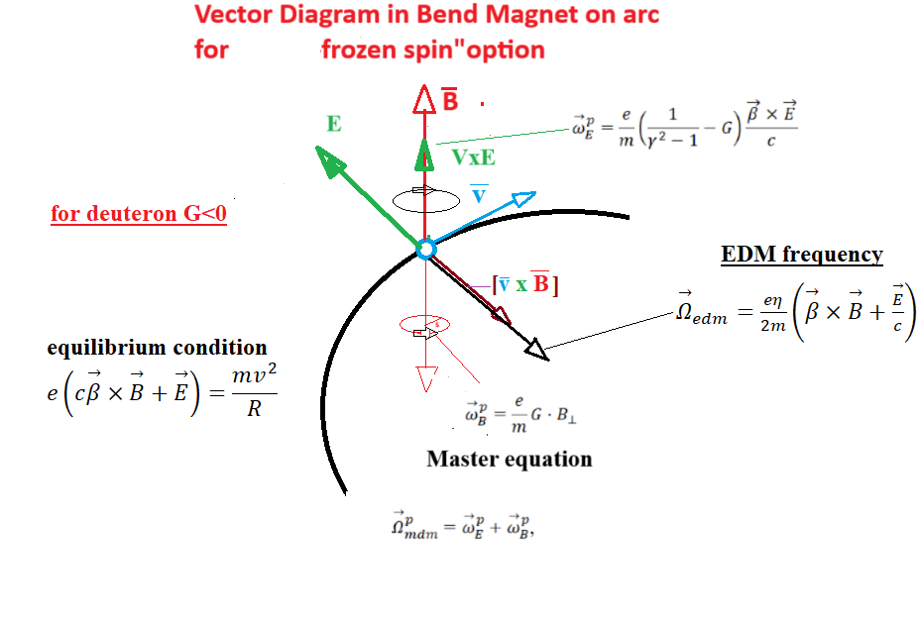
Fig. 6 Vector diagram of fields acting on a polarized deuteron.

Figure 6 shows a vector diagram defining the relative vector directions of the fields $\overset{→}{E}$and $\overset{→}{B}$. The determining factor is the positive vertical direction of the magnetic field, which makes the primary contribution to compensating for the centrifugal force. Given the negative value of the deuteron's anomalous magnetic moment $G=-0.14$, the axis around which $\overset{→}{S}$ precesses points downwards. To achieve a zero-precession frequency, the vector $\overset{→}{β}×\overset{→}{E}$ must point upwards; that is, the electric field must be directed as shown in Figure 6.
Based on all this, a magneto-optical ring structure was developed to implement the “frozen spin” option.
Figure 7 shows the magneto-optical structure of an accelerator arc with "frozen" spin for a deuteron beam. The arc consists of two successive achromats with zero dispersion at the midpoint and at the ends of the arc, and it comprises eight FODO cells (see Fig. 7).

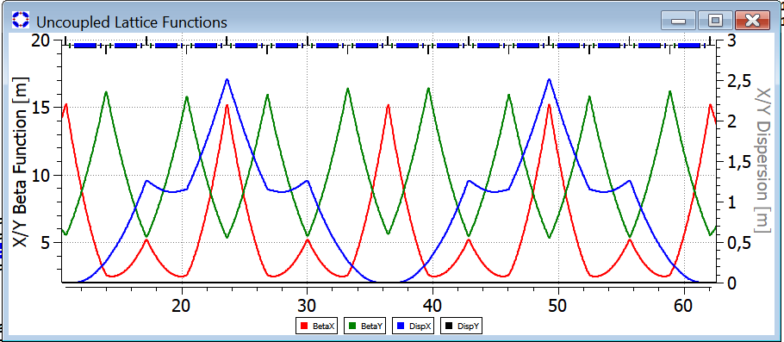

Fig. 7 Twiss functions along the arc of an accelerator with "frozen" spin for a deuteron beam.

As in the case of the electrostatic structure for the proton beam, the dispersion modulation introduced in the structure for deuterons makes it possible to create suitable locations for sextupoles to suppress spin chromaticity. Figure 8 shows the Twiss functions for the entire ring, which has a total length of 146 m. ​​The spatial layout of the ring is shown in Figure 9.

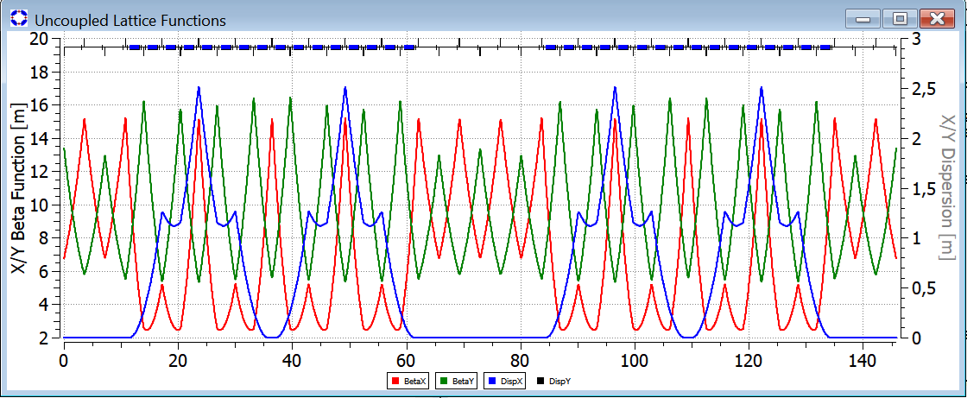

Fig. 8 Twiss functions along the length of the accelerator with "frozen" spin for a deuteron beam.

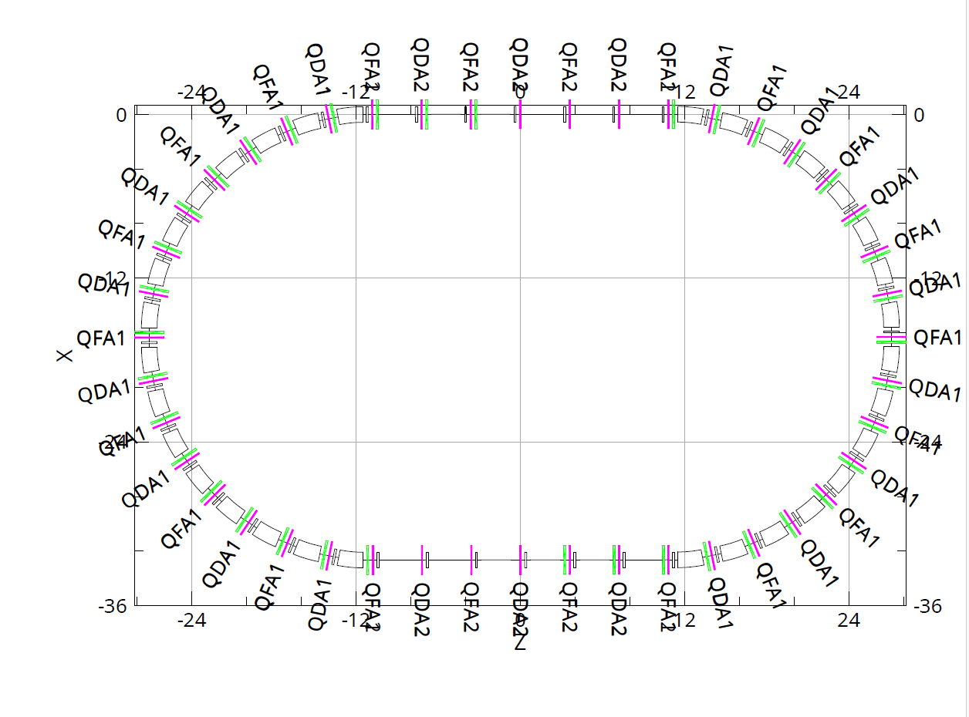
Fig. 9 Spatial dimensions of the "frozen-spin" ring for a deuteron beam.

Table 2 shows the main parameters of the synchrotron for studying the deuteron EDM at an energy of 270 MeV/nucleon.

Table 2: Parameters of the "frozen-spin" magnetostatic ring for the study of the proton EDM.
parameters | value
Total length, m | 145.85
Structural symmetry order: number of arches and straight sections | 2
Initial energy, MeV/nucleon | 40
Final energy, MeV/nucleon | 270.0
EDM experiment beam energy, MeV/nucleon | 270.0
Anomalous magnetic moment of the deuteron | -0.143
Initial and final relative velocity, Lorentz factor | β=0.2, γ=1.0213  β=0.485, γ=1.143
Orbital revolution frequency at the beginning and end of the cycle, MHz | 0.143÷ 0.99
Harmonic number, h | 50
RF field frequency at the beginning and end of the cycle, MHz | 7.15÷49.9
Length of quarter-wave RF chamber, m | 1.50193088
Relative momentum spread of the separatrix at maximum energy | 0.0013118436
Relative momentum spread within the bunch | 0.0005
Arcs
Arc length, m | 51.27
Superperiodicity of the arc | 2
Arc structure | 4+4 FODO cells
Number of E+B combined magnetic-electrostatic deflection units per arc | 16
Length of the deflector, m | 1.80
Deflector type | Magnetic and electric field deflector
Magnetic and electric field deflector | 12
Number of quadrupoles per arc | 15 + 1 (the two end halves)
Quadrupole type | Magnetic multipole
Number of quadrupole families | one family of focusing QF magnets and one family of defocusing QD magnets
Maximum quadrupole gradient on the arcs, kG/cm | QF=1.359,  QD=-1.00
Length of quadrupole lenses, m | 0.1
Number of chromatic sextupoles per arc | 16
Sextupole type | magnetic
Field gradients in chromatic sextupoles kGs/cm² | SF=0.12  SD=0.15
Betatron tunes 𝞶_{x}/ 𝞶_{y} | предварительно 𝞶_{x} =4.70418  𝞶_{y} =2.6140
Natural chromaticity ζ_{x}/ ζ_{y} | ζ_{x}=-4.91629  ζ_{y} =-3.99402
Critical energy, ГэВ | 5.3
Maximum value of βx/βy functions, m | 15.1/16.5
Maximum value of horizontal dispersion, m | 2.5
Straight sections between arcs
Length of straight sections between arcs, m | 2 х 23.3
Optical structure of straight sections | 3 x FODO
Quadrupole lens gradients in the straight section, kG/cm | QF =0.734, QD=-0.782
Lengths of empty spaces between adjacent quadrupoles, m | 12 x 3.2

CONCLUSION
The primary outcome of the work is the development of two types of specialized "frozen-spin" magneto-optical structures designed to investigate the electric dipole moments of the proton and deuteron. These results will be used to create the physical designs for the experimental setups, which will, in turn, enable cost estimations. Unlike "quasi-frozen-spin" concepts, these setups are intended exclusively for experiments investigating the violation of fundamental symmetries.

CONFLICT OF INTEREST
The authors declare no conflict of interest.

ACKNOWLEDGMENTS
This study was supported by a grant from the Russian Science Foundation (No. 25-72-30005).

СПИСОК ЛИТЕРАТУРЫ/REFERENCES

- Bargmann V., Michel L., Telegdi V. // Phys. Rev. Lett. 1959. V. 2. P. 435.
- Fukuyama T., Silenko A. // Int. J. Mod. Phys. A. 2013. V. 28. P. 1350147.
- Farley F., Semertzidis Y. // Prog. Part Nucl. Phys. 2004. V. 52 (1). P. 1.
- D. Anastassopoulos et al., (srEDM Collaboration),“Search for a permanent electric dipole moment of the deuteron nucleus at the 10−29 e· cm level,” proposal as submitted to the BNL PAC, April 2008. https://www.bnl.gov/edm/files/pdf/deuteron_proposal_080423_final.pdf
- Yu.Senichev, R. Maier, D. Zyuzin, Spin tune decoherence effects in electro- and magnetostatic structures, Proceedings of IPAC2013, Shanghai, China, pp. 2579-2581

