PROPOSAL from INR RAS group to be included in the
SPRINT@NICA Conceptual Design Report
A. E. Aksentiev (Institute for Nuclear Research of the Russian Academy of Sciences, Moscow 117312, Russia)
(Moscow Institute of Physics and Technology, Dolgoprudny 141701, Russia)
(National Research Nuclear University MEPhI, Moscow 115409, Russia)
A. S. Belov (Institute for Nuclear Research of the Russian Academy of Sciences, Moscow 117312, Russia)
S. D. Kolokolchikov (Institute for Nuclear Research of the Russian Academy of Sciences, Moscow 117312, Russia)
(Moscow Institute of Physics and Technology, Dolgoprudny 141701, Russia)
A. A. Melnikov (Institute for Nuclear Research of the Russian Academy of Sciences, Moscow 117312, Russia)
(Moscow Institute of Physics and Technology, Dolgoprudny 141701, Russia)
(Landau Institute for Theoretical Physics, Chernogolovka 142432, Russia)
N. N. Nikolaev (Landau Institute for Theoretical Physics, Chernogolovka 142432, Russia)
P. Palamarchuka (Institute for Nuclear Research of the Russian Academy of Sciences, Moscow 117312, Russia)
(National Research Nuclear University MEPhI, Moscow 115409, Russia)
Yu. V. Senichev (Institute for Nuclear Research of the Russian Academy of Sciences, Moscow 117312, Russia)
(Moscow Institute of Physics and Technology, Dolgoprudny 141701, Russia)
A. Ya. Silenko (Joint Institute for Nuclear Research, Dubna 141980, Russia)

Contents
1 Introduction
2 Quasi-frozen spin at a periodic lattice
2.1 Spin motion in electromagnetic fields
2.2 Frozen spin concept
2.3 Two options of the quasi-frozen spin lattice
2.4 Relative spin motion in QFS
2.5 Spin compensation element length
2.6 Features of the deuteron and the proton
2.7 Further research
3 NICA collider with bypasses
3.1 Modified NICA lattice for the EDM search
3.2 Lattice parameters
3.3 Bypass optics
3.4 Natural chromaticity and dynamic aperture
3.5 Spin-orbit motion with optimized Wien filters
3.6 Betatron chromaticity and spin coherence
3.7 Conclusion
4 Modernized Nuclotron
4.1 Present Nuclotron lattice
4.2 Modernization options
4.3 Nuclotron 2.1: quasi-frozen spin for deuterons
4.4 Nuclotron 2.2: quasi-frozen spin with Wien filters for deuterons
4.5 Nuclotron 2.2.2: quasi-frozen spin with Wien filters for protons
4.6 Maximum energy of heavy ions and protons in Nuclotron 2.2.2
4.7 Features of the modernized Nuclotron lattice
5 Specialized frozen spin rings at JINR
5.1 Frozen spin option for the proton beam
5.2 Frozen spin option for the deuteron beam
5.3 Summary
6 Matrix description of spin dynamics for EDM rings
6.1 Introduction
6.2 QFS structure without imperfection fields
6.3 Difference of FS and QFS
6.4 Consideration of imperfection fields
6.5 Spin Precession Axis for a Magnetic Ring with EDM
6.6 QFS Structure with Imperfection Fields
6.7 Spin dynamics perturbations in a resonance state
6.8 EDM Measurement in a Frequency Domain
7 Axion search mode
Acknowledgments
References

1 Introduction
An experiment to search for the electric dipole moment (EDM) at the NICA collider requires an alternative spin-control method based on the “quasi-frozen spin” (QFS) concept. In contrast to the “frozen spin” method proposed at BNL, which requires the construction of a specialized storage ring [1], the quasi-frozen spin method is applicable to virtually any accelerator, including rings that were not originally designed for EDM searches. In this method, the spin does not keep a fixed orientation along the direction of motion over the entire revolution. Instead, it deviates from the momentum in an arc with magnetic dipoles and recovers its original orientation in a straight section. This is achieved with elements combining electric and magnetic fields, known as Wien filters, installed in the straight section: the spin rotation accumulated in the arc is compensated by the opposite rotation in the Wien filters. The fields can be chosen so that the net Lorentz force vanishes and the closed orbit is not perturbed, which allows the Wien filters to be installed in straight sections. Consequently, a polarimeter placed downstream of the Wien filters always observes the same orientation of the spin vector, i.e., from its point of view the spin is “frozen”.
For this purpose, it is proposed to install bypass sections in the NICA collider to house the Wien filters. Apart from the EDM physics goals, there are two reasons for this modification of the lattice. First, the existing straight sections do not have enough free space for the Wien filters. Second, the present lattice is optimized for the collider mode of operation. Therefore, the bypass channels create an alternative straight section parallel to the original one. The NICA collider can then operate as a storage ring for EDM experiments with polarized deuterons in the quasi-frozen spin mode. Beam dynamics studies of the designed bypass channel confirm the feasibility of this approach.
The second facility considered as a candidate for EDM experiments is the modernized Nuclotron. The aim is to define the relationship between the Nuclotron and the NICA collider and to modify the Nuclotron lattice so as to obtain a dual-function accelerator: a booster of polarized proton and deuteron beams for injection into the collider and an independent storage ring for precision EDM experiments with light nuclei. The design follows these conditions:
- the modernized ring must fit into the existing Nuclotron tunnel;
- the proton and deuteron polarization must be preserved and controlled throughout the NICA complex;
- the polarized proton beam must not cross the transition energy in the collider after electron cooling, so that the design luminosity can be reached;
- a frozen or quasi-frozen spin mode must be implemented either in the collider or in the Nuclotron, depending on which ring is more suitable for EDM research.
The developed lattice satisfies all these conditions and provides a basis for implementing this option.
The third option is a specialized ring housed in a separate building. Two lattices of a specialized storage ring for EDM searches with polarized proton and deuteron beams have been developed. In contrast to the NICA and Nuclotron options, which rely on the quasi-frozen spin mode, the specialized rings are based on the frozen spin concept. Owing to the different magnitude and sign of the proton and deuteron magnetic anomalies, the two lattices differ substantially: the proton beam requires a purely electrostatic ring with a total length of about 400 m, whereas the deuteron beam requires a ring with combined E+B deflectors and a total length of about 150 m.
Thus, three options are currently available for EDM research with light charged nuclei at the NICA complex [2–4]. For all of them, the spin coherence time of the beam must reach about 1000 s [5].
The structure of this contribution is as follows. Section 2 collects the lattice design principles of the quasi-frozen spin method, including the minimal length of the spin compensator and the comparison of Wien filters with electrostatic deflectors. Section 3 presents the NICA collider with bypass channels, its optics, chromaticity correction and spin coherence. Section 4 develops the modernized Nuclotron options for deuteron and proton EDM studies. Section 5 describes specialized frozen spin rings for the proton and the deuteron. Section 6 gives a matrix (spinor) description of the spin dynamics for EDM rings and estimates the systematic MDM contribution in the QFS lattice.

2 Quasi-frozen spin at a periodic lattice

2.1 Spin motion in electromagnetic fields
A particle ensemble admits a representation of the spin by a classical vector. Its dynamics in external electromagnetic fields is described by the Thomas–Bargmann–Michel–Telegdi (T-BMT) equation [6,7]. In accordance with the Ehrenfest theorem, it describes the classical spin motion of a charged particle with a hypothetical EDM:
$$\begin{aligned}\frac{d\vec{S}}{dt}&=\left({\vec{Ω}}_{mdm}+{\vec{Ω}}_{edm}\right)×\vec{S}, \\ {\vec{Ω}}_{mdm}&=−\frac{e}{mγ}\left\{(γG+1){\vec{B}}_{⟂}+(1+G){\vec{B}}_{∥}−\left(γG+\frac{γ}{γ+1}\right)\frac{\vec{β}×\vec{E}}{c}\right\}, \\ {\vec{Ω}}_{edm}&=−\frac{eη}{2m}\left(\vec{β}×\vec{B}+\frac{\vec{E}}{c}\right), G=\frac{g−2}{2},\end{aligned} (1)$$
where $γ$ is the Lorentz factor, $\vec{β}$ is the relative velocity, $c$ is the speed of light, $e$ and $m$ are the particle charge and mass, $G$ is the magnetic anomaly, $g$ is the gyromagnetic ratio, $Ω_{mdm}$ and $Ω_{edm}$ are the spin precession frequencies due to the magnetic and electric dipole moments, $η$ is a dimensionless coefficient defined by $d=ηeℏ/4mc$, and $\vec{B}=\{B_{⟂},B_{∥}\}$ and $\vec{E}=\{E_{⟂},E_{∥}\}$ are the magnetic and electric fields. Since no elements with a longitudinal magnetic field are used, we set $B_{∥}=0$; the longitudinal electric field is neglected as well, $E_{∥}=0$, because its contribution is small.
For EDM measurements it is first necessary to compensate the MDM effect. The simplest approach, initially proposed at BNL [1], is the frozen spin method and uses an all-electric lattice, measuring the spin precession due to a non-zero EDM in a radial electric field. This method requires pure-electric optical elements, and the lattice must be designed for and operated with protons.
An alternative approach is the quasi-frozen spin concept [8], based on asynchronous compensation of the spin precession. The spin vector then oscillates back and forth relative to the momentum over one period and, as a result, over the full ring.

2.2 Frozen spin concept
The frozen spin (FS) method relies on the fact that at a specific, so-called “magic” energy the spin precesses in the external fields with the same frequency as the particle momentum, $Ω_{E,B}^{p}=\frac{eE}{mγβc}+\frac{eB}{mγ}$. Subtracting this frequency from ${\vec{Ω}}_{mdm}$ gives the spin precession frequency relative to the momentum:
$${\vec{Ω}}_{mdm}^{p}={\vec{ω}}_{E}^{p}+{\vec{ω}}_{B}^{p}, (2)$$
where ${\vec{ω}}_{E}^{p}=\frac{e}{m}\left(G−\frac{1}{γ^{2}−1}\right)\frac{\vec{E}×\vec{β}}{c}$ and ${\vec{ω}}_{B}^{p}=\frac{e}{m}G {\vec{B}}_{⟂}$ are the contributions of the electric and magnetic fields. In a purely electrostatic ring ($\vec{B}=0$) the frozen spin condition ${\vec{ω}}_{E}^{p}=0$ is satisfied at the magic energy
$$G−\frac{1}{γ_{mag}^{2}−1}=0. (3)$$
In a ring with both magnetic and electric elements, the frozen spin condition ${\vec{Ω}}_{mdm}^{p}=0$ is achieved by balancing the radial electric field $E_{r}$ against the vertical guiding magnetic field $B_{v}$ [1]:
$$E_{r}=\frac{GB_{v}cβγ^{2}}{1−Gβ^{2}γ^{2}}≈GB_{v}cβγ^{2}. (4)$$
A hybrid ring is required for deuterons because their magnetic anomaly is negative, $G=−0.143$, and condition (3) cannot be satisfied.
It is convenient to introduce the spin tune, i.e., the number of spin precessions per revolution. In an electrostatic ring the spin tune relative to the momentum is $ν_{s}^{E}=ω_{E}^{p}/Ω_{E}^{p}$:
$$ν_{s}^{E}=\left(G−\frac{1}{γ^{2}−1}\right)γβ^{2}, (5)$$
and in a magnetic field, $ν_{s}^{B}=ω_{B}^{p}/Ω_{B}^{p}$:
$$ν_{s}^{B}=γG. (6)$$
Thus, the same concept applies to protons and deuterons, but it is realized with different types of deflectors.

2.3 Two options of the quasi-frozen spin lattice
In the NICA ring, an implementation of the FS concept would require a complete rebuild of the optics. Suppose instead that the spin oscillates in the horizontal plane around the frozen spin direction with a small amplitude, $Φ_{s}^{2}≪1$. This can be done with special electric-field elements in the straight sections, which bring the spin back along the momentum after it has deviated in the magnetic arc. The EDM signal growth is then reduced by the factor $J_{0}(Φ_{s})≈1−Φ_{s}^{2}/4$. The deuteron magnetic anomaly $G=−0.143$ is small, and the spin oscillates around the momentum within half of the spin phase advance in the magnetic arc, $Φ_{s}=πγG/2≈0.25$. Therefore, at the optimal parameters of the EDM measurement, $γ=1.12$, the effective EDM signal is reduced by only a few percent.
This gives the essence of the quasi-frozen spin concept [8]: the spin is not frozen relative to the momentum but continuously oscillates around an average fixed direction that coincides with the momentum direction.
Two QFS options exist. In the first one, the magnetic and electric fields are completely separated in space: the magnetic field acts in the arcs and the electric field acts in the straight sections, which are realized as negative-curvature “reverse” electrostatic arcs. This option inherits the drawback of cylindrical electrodes, namely, a whole set of high-order field nonlinearities. In the second option, a small magnetic field of about 100 mT is added to the spin-aligning E+B elements; it compensates the Lorentz force of the electric field and makes the elements straight. Such an E+B element is a Wien filter. The second option is the most appropriate one for rings not designed specifically for the EDM search, in particular for the NICA ring with bypass sections, whereas for the Nuclotron, where the free space is limited, the first option is the baseline.

2.4 Relative spin motion in QFS
Let us introduce the QFS concept by examining orbital and spin rotation in a generalized framework. This approach is based on the dynamics governed by the Lorentz force for orbital motion and the T-BMT equation (1) for spin precession. The foremost QFS condition that needs to be respected is that the orbital trajectory remains unperturbed, maintaining a closed orbit configuration,
$$Φ_{p}^{arc}+Φ_{p}^{comp}=\frac{2π}{N}, (7)$$
where the index $p$ stands for momentum, $Φ_{p}^{arc}$ and $Φ_{p}^{comp}$ are the total momentum rotations in the arcs and in the spin-compensator elements, and $N$ is the lattice periodicity. To set up a lattice suitable for high-energy research, it is essential to employ a pure magnetic guiding field in the arc, given the limitations of achievable electric field strengths. Then for a QFS lattice a corresponding spin compensator should be implemented in the straight section without perturbing the orbit. The conditions this device should satisfy can be formulated as $Φ_{p}^{arc}=2π/N$ and $Φ_{p}^{comp}=0$. The second condition is met by employing both magnetic and electric fields. From Eq. (7), for a spin-compensation element with both magnetic and electric fields,
$$Φ_{pB}^{comp}+Φ_{pE}^{comp}=0, (8)$$
where $Φ_{pB}^{comp}$ and $Φ_{pE}^{comp}$ are the total momentum rotations in the magnetic and electric fields of the spin compensator. One can see from the T-BMT equation (1) that the electric field acts on the spin with maximum effectiveness when it is radial to the momentum. Moreover, it is also maximally efficient with respect to the momentum rotation, which means
$${\vec{Ω}}_{pE}^{max}={\vec{Ω}}_{pE_{⟂}}=\frac{e}{mγ}\frac{\vec{β}×{\vec{E}}_{⟂}}{cβ^{2}}. (9)$$
The second QFS condition that needs to be respected is to compensate for the MDM spin rotation in one period of the ring,
$$Φ_{s}^{arc}+Φ_{s}^{comp}=0, (10)$$
where $Φ_{s}^{arc}$ and $Φ_{s}^{comp}$ are the total spin rotations in the arc and in the spin compensator. The spin and orbital rotation angles are connected by the spin-tune ratios in magnetic and electric fields, Eqs. (6) and (5),
$$ν_{B_{⟂}}=γG, ν_{E}=γβ^{2}\left(G−\frac{1}{γ^{2}−1}\right). (11)$$
The spin-tune difference is responsible for the compensation effect. In the pure magnetic arc $Φ_{s}^{arc}=ν_{B_{⟂}}Φ_{p}^{arc}$, while in the spin compensator $Φ_{sB}^{comp}=ν_{B_{⟂}}Φ_{pB}^{comp}$ and $Φ_{sE}^{comp}=ν_{E}Φ_{pE}^{comp}$. Then Eq. (10) can be rewritten as
$$\begin{aligned}ν_{B_{⟂}}Φ_{p}^{arc}+\left(ν_{B_{⟂}}Φ_{pB}^{comp}+ν_{E}Φ_{pE}^{comp}\right)&=ν_{B_{⟂}}\left(Φ_{p}^{arc}+Φ_{pB}^{comp}\right)+ν_{E}Φ_{pE}^{comp}=0.\end{aligned} (12)$$
Finally, combining the first and second QFS conditions, the compensator electric and magnetic field spin-rotation expressions can be obtained:
$$Φ_{pE}^{comp}=−Φ_{pB}^{comp}=Φ_{p}^{arc}\frac{γ^{2}G}{G+1}=\frac{2π}{N}\frac{γ^{2}G}{G+1}. (13)$$
Note that so far no mention was made of the physical structure of the compensation element, only of the integral features of the presented field components.

2.5 Spin compensation element length
The spin-compensation element length can be calculated as
$$L=Φ_{pB}^{comp}R_{B}=Φ_{pE}^{comp}R_{E}, (14)$$
where $R_{B}$ and $R_{E}$ are the radii of the magnetic and electric fields, respectively. In general, the net curvature of an element with combined magnetic and electric fields is
$$\frac{1}{R}=\frac{1}{R_{B}}+\frac{1}{R_{E}}, R_{B}=\frac{Bρ}{B}, R_{E}=\frac{κ}{E}, (15)$$
where $Bρ=p_{0}/e$ is the magnetic rigidity, $p_{0}=γmβc$, and $κ=p_{0}βc/e$ is the electrical rigidity. Because the element must satisfy the zero net orbital distortion condition, the net Lorentz force must vanish. Therefore, the net curvature is zero, i.e., $1/R=0$, which leads to $R_{B}=−R_{E}$. The electric field strength limitation is considerably more stringent than that of the magnetic field. The compensator length per period can be obtained using Eqs. (13) and (14):
$$\begin{aligned}L_{min}=Φ_{pE}^{comp}R_{E}&=\frac{2π}{N}\frac{γ^{2}G}{G+1}\frac{κ}{E_{max}} \\ &=\frac{2π}{N}\frac{G}{G+1}\frac{mc^{2}}{e}\frac{γ(γ^{2}−1)}{E_{max}},\end{aligned} (16)$$
where $E_{max}$ is the maximum electric field, which limits the minimal achievable length regardless of the particle under study. The total length $L=L_{min}^{total}=N⋅L_{min}$ is independent of the number of periods. Maximum attainable electric fields are 10–13 MV/m [9]; this corresponds to a magnetic field of the order of 70–90 mT.

2.6 Features of the deuteron and the proton

Dependence on beam parameters
The first thing that needs to be accounted for in an efficient analysis of the spin dynamics is the polarimeter analyzing power. It depends on the beam energy and has to be maximal to achieve sufficient statistics. The maximum figure of merit of the polarimeter is reached at a proton beam energy of 270 MeV [10] and the same is true for deuterons [11].
Orbital and spin dynamics vary among different types of particles. In the first place, the deuteron mass-to-charge ratio is twice that of the proton. In the second place, the anomalous magnetic moments are notably different: for the proton, $G_{p}=1.79$, and for the deuterons, $G_{d}=−0.14$. These differences, gathered in Table 1, call for a tailored approach to each particle type when designing experiments as well as when analyzing results.
Table 1. Particles and experiment parameters.
Particle | $A/Z$ | $G$ | $γ_{exp}$ | $E_{exp}$, MeV/u | $L$, m
Deuteron d | $2$ | $−0.14$ | $1.144$ | $135$ | $53$
Proton p | $1$ | $1.79$ | $1.289$ | $270$ | $247$
 |  |  | $1.078$ | $73$ | $53$
In a magnetic field, according to Eq. (11), the direction of spin precession depends solely on the sign of the anomalous magnetic moment, i.e., it is independent of energy. However, the magnitude is influenced by both the energy and the absolute value of the anomalous magnetic moment. For protons, this effect is so important that care must be taken to ensure that the condition for the spin-vector rotation per arc, $γG⋅Φ_{p}^{arc}<π/2$, is satisfied in order to preserve the accumulation of the EDM effect for a longitudinally polarized beam. This implies that QFS lattices only with a periodicity $N=8$ or larger provide the means to measure the proton EDM.
To be more precise, an EDM measurement under QFS conditions is attenuated relative to a frozen spin measurement. To first order the attenuation factor is given by [3]
$$J_{0}(Φ_{s}^{arc})=1−\frac{(Φ_{s}^{arc})^{2}}{4}, (17)$$
where $Φ_{s}^{arc}$ represents the angle associated with the MDM effect in the arc in one period. For various particle types and structure periodicities it is cited in Table 2. The maximum periodicity considered is $N=16$, due to lattice design limitations. The table shows that the frozen and quasi-frozen spin regimes are practically the same for deuterons. For protons, only the 16-periodic lattice offers a real opportunity for practical tests of the QFS approach.
Table 2. Parameters of lattices and experiment at a beam energy of 270 MeV.
Particle | $N$ | $Φ_{s}^{arc}$, deg | $J_{0}(Φ_{s}^{arc})$
Deuteron d | $2$ | $−29.45$ | $0.934$
 | $4$ | $−14.72$ | $0.983$
 | $8$ | $−7.36$ | $0.996$
 | $16$ | $−3.68$ | $0.999$
Proton p | $8$ | $103.83$ | $0.179$
 | $16$ | $51.91$ | $0.795$
In electrostatic fields, the analysis of deuteron and proton behaviors is further complicated by their distinct interactions with the field. For protons, the direction of spin rotation can depend on the energy, particularly around the “magic” energy, where $γ_{mag}=\sqrt{(G_{p}+1)/G_{p}}=1.248$ ($E_{mag}=233 MeV$). Nevertheless, the influence on protons is much lower than for deuterons, as shown in Fig. 1. For deuterons, on the other hand, there is no equivalent “magic” energy, and their spin rotation behavior remains consistent across the entire energy range.
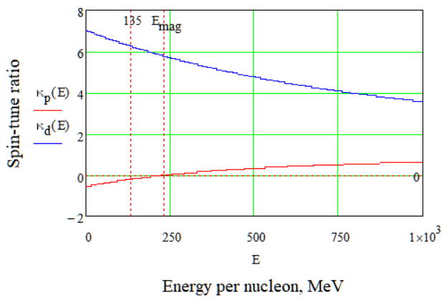
Figure 1. Spin-tune ratio $κ=ν_{B_{⟂}}/ν_{E}$ for deuteron and proton.
These fundamental differences lead to several important consequences for lattice construction. Specifically, modifications are necessary to accommodate both particle types. First, according to Eq. (13), the direction of spin rotation differs between protons and deuterons. This necessitates either switching the polarity of the spin compensator’s fields or rotating it by $π$ along the longitudinal axis. Second, the minimal achievable spin compensator length, as given by Eq. (16), is longer for protons than for deuterons at the optimal polarimeter energy. This discrepancy can be addressed by lowering the experimental energy for protons (Fig. 2). At a spin compensator length equivalent to that used for deuterons, the proton energy should be reduced to 73 MeV, and the analyzing power decreases by a factor of 2–3. Third, two viable approaches for arranging additional EM fields are the implementation of a Wien filter or an electrostatic deflector with a kicker.
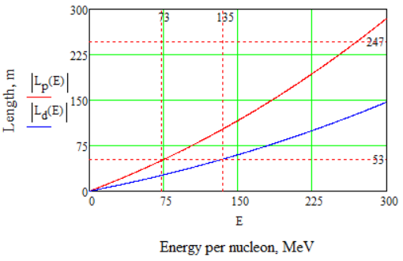
Figure 2. Total length of the spin compensator versus energy per nucleon required to achieve a QFS lattice for deuteron and proton.

Wien filter
The Wien filter serves an important function in a particle accelerator, designed to manipulate spin dynamics without altering the orbital trajectory of particles by utilizing perpendicular electric and magnetic fields that cancel each other out, resulting in zero net Lorentz force. As the EDM T-BMT term is proportional to the Lorentz force, the Wien filter will not exert an EDM force on the spin vector. It is EDM-transparent. It allows particles to move in a straight line while enabling a precise correction of their spin orientations, making it an ideal auxiliary device for experiments requiring spin manipulation. It provides the conditions to facilitate spin navigation. The filter’s design ensures a net absence of deflection along the beamline, minimizing additional space requirements in the ring’s straight sections and allowing for a classical sequential arrangement of ring elements.
It is usable for both deuterons and protons; for deuterons, it can be employed directly at optimal energies, while for protons, the polarity must be switched or the setup rotated by $π$ along the longitudinal axis and used at lower energies (Figs. 3, 4, 5 and 6). This flexibility allows for freedom in developing methods for studying spin dynamics across different particle types. Overall, the Wien filter’s ability to control particle spin without perturbing orbital paths makes it an invaluable component in advanced accelerator experiments.
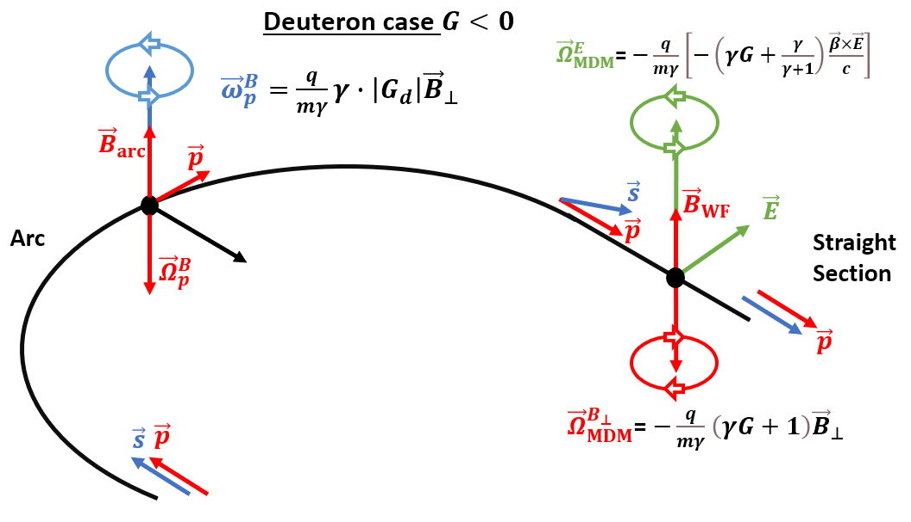
Figure 3. Vector scheme of the QFS turn with a Wien filter for the deuteron case $G<0$.
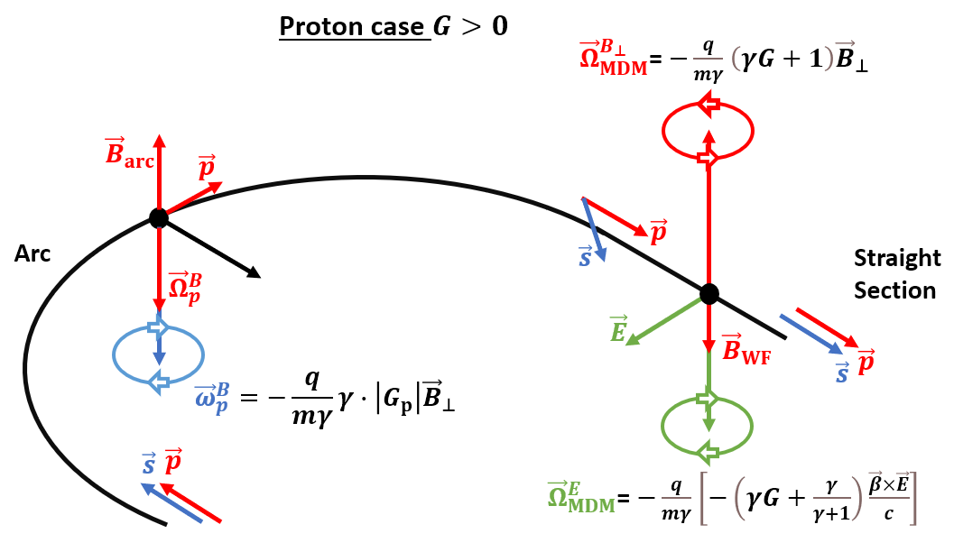
Figure 4. Vector scheme of the QFS turn with a Wien filter for the proton case $G>0$.
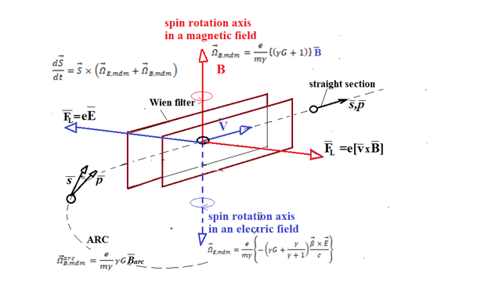
Figure 5. Vector diagram of the spin transformation for the deuteron.
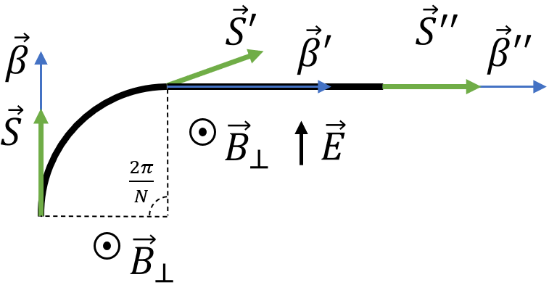 | 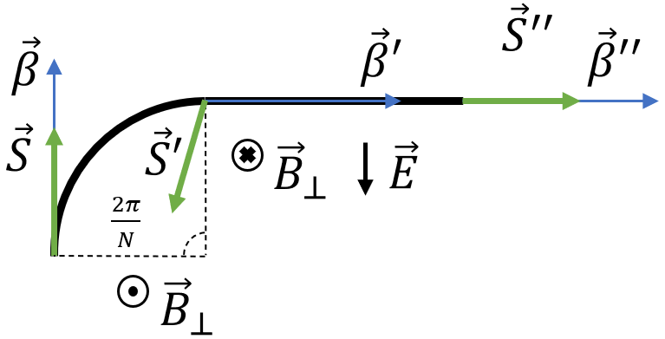
(a) | (b)

Figure 6. One-period conceptual scheme of a QFS lattice with Wien filters for deuterons (a) and protons (b).

Electrostatic deflector with kicker
The pure electrostatic deflector is designed to manipulate particle trajectories and spin dynamics by creating a radial electric field with a nonzero curvature. Unlike the Wien filter, this deflector requires an additional kicker to compensate for orbital deviations, which increases the overall length of the compensator. This setup is particularly useful for creating bypass sections in addition to the native straight sections, allowing for flexible experimental configurations (Fig. 7). However, the distance between the spatial assignment of equipment should be considered to enable the option with an independent section. A key challenge is that each type of particle requires a different curvature, which must be determined at the outset of lattice design. Despite these complexities, the electrostatic deflector with kicker offers a robust solution for controlling particle spin and trajectory.
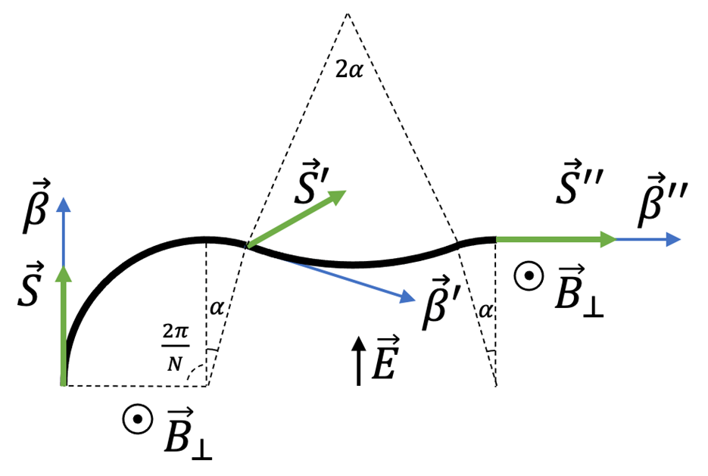
Figure 7. One-period conceptual scheme of a QFS lattice with an electrostatic deflector and a kicker for deuterons.

2.7 Further research
Currently, the proposed energy requirements for EDM studies are set at 270 MeV and lower, but specific conclusions regarding the arc spin rotation have yet to be drawn. The primary condition is to achieve a momentum rotation at a specific angle $Φ_{p}^{arc}$ with a corresponding $Φ_{s}^{arc}$ for the spin. This can be accomplished by carefully selecting the magnetic field integral to ensure precise alignment of momentum and spin dynamics. To maximize efficiency, the magnetic field should be as strong as possible to minimize the effective arc length, in consideration of the unique features of the lattice design. This approach not only optimizes studies at the current energy range but also opens the possibility for other polarized or non-polarized beam research at higher energies, potentially reaching several GeV. The versatility of the QFS setup allows it to be implemented in various lattice designs, including existing accelerator rings, thereby facilitating advanced studies at elevated energy ranges.
Wien filters do not affect beam dynamics and influence only the spin motion. This helps in converting the storage ring into a broadband axion antenna [12].
The material of this section has been reported in [3,8,9,13,14].

3 NICA collider with bypasses

3.1 Modified NICA lattice for the EDM search
The NICA lattice was not designed for EDM research; hence the only option is the quasi-frozen spin concept of Sec. 2, which can be realized for deuterons. The adaptation strategy relies on two facts. First, the straight sections of the collider are fully occupied by the equipment of the MPD and SPD experiments. Second, these detectors and their interaction points are not needed for the EDM search. The simplest solution is therefore to introduce bypasses, as shown in Fig. 8.
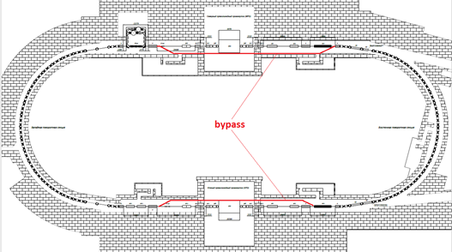
Figure 8. Modified NICA lattice for the EDM search with bypass insertions (red).
The bypass sections avoid both detector interaction points and provide free space for E+B elements. Owing to the zero Lorentz force, these elements are transparent to the beam dynamics, while they rotate the spin opposite to its rotation in the arcs and thus realize the quasi-frozen spin concept. Without the interaction points, the two beams circulate in two uncoupled rings, which doubles the data-taking rate. Figures 9 and 10 show the Twiss functions and the dynamic aperture in both transverse planes.
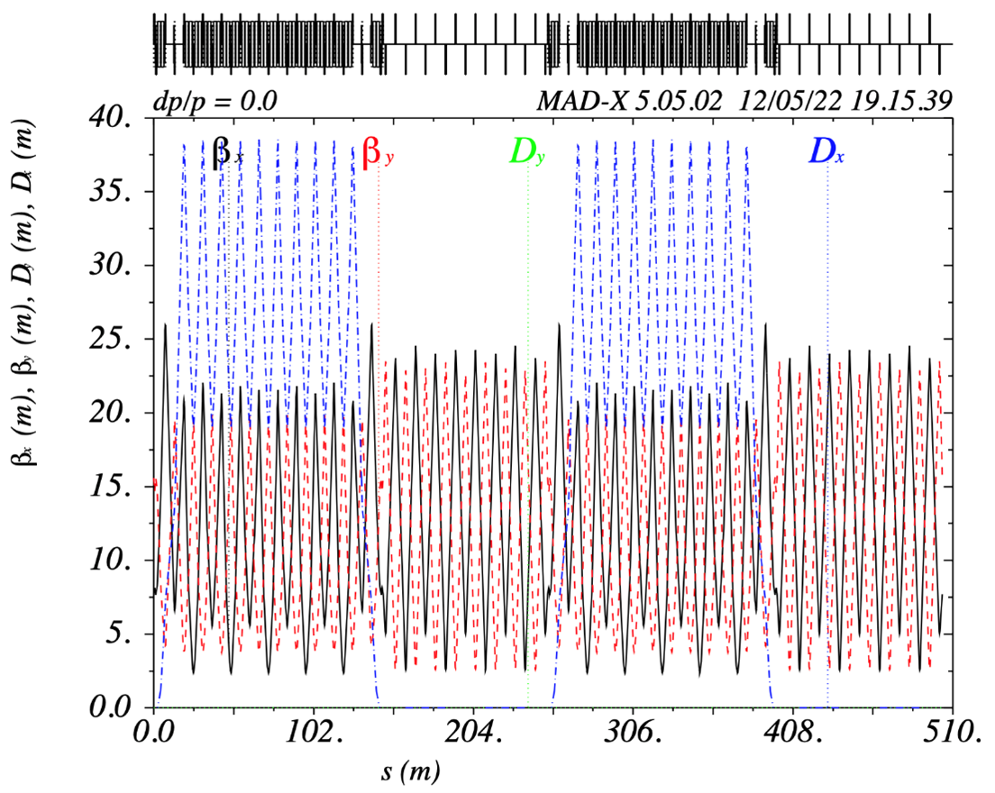
Figure 9. Twiss functions of NICA with bypass insertions.
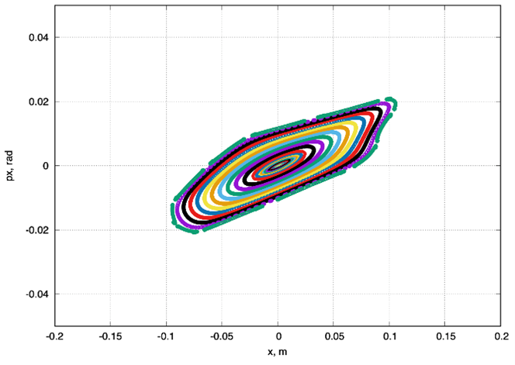 | 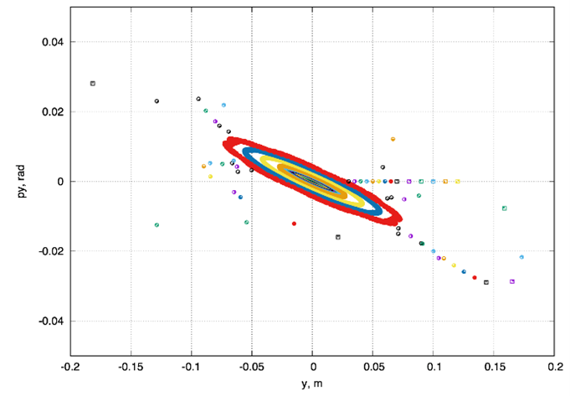
(a) | (b)

Figure 10. Dynamic aperture of NICA with bypass insertions in the horizontal (a) and vertical (b) planes.
The linear part of the dynamic aperture, about 2000 mm·mrad, significantly exceeds the required value in both planes. For an electric field limited to about 100 kV/cm, Eq. (16) gives a total length of the E+B elements of about 25–30 m per bypass, which is 30% of the bypass length. Spin-orbit tracking shows that the spin deviates from the momentum by less than 10°; the simulation for the three spin projections gives a deviation within $±{7.5}^{∘}$. Despite this deviation, the polarization asymmetry measured at the polarimeter location remains constant.

3.2 Lattice parameters
The polarimetry constraints [11] determine the choice of the particle species and the experiment energy. The lattice is designed for deuterons with a kinetic energy of 240 MeV. The corresponding dipole field and magnetic rigidity are listed in Table 3.
Table 3. Main parameters of the experiment and the bypass lattice.
Particles | deuterons
Dipole magnetic field | 0.132 T
Magnetic rigidity $Bρ$ | 3.252 T·m
Ring circumference | 503.04 m
Experiment energy | 240 MeV

3.3 Bypass optics
The arc geometry of the NICA ring is kept unchanged; only the fields in the installed elements may be changed. NICA can therefore be used for different experiments without a major rebuild of the lattice.
The NICA arc has a non-zero dispersion, and both the dispersion and its derivative vanish at the arc ends. The straight sections are dispersion-free along their whole length. The circumference of the original NICA ring is $L_{acc}=503.04 m$ and the length of one arc is $L_{arc}=142.15 m$, which leaves $(L_{acc}−2L_{arc})/2=109.6 m$ for each straight section. The bypass channels contain an alternative straight section and sections with bending dipoles. The dipoles deflect the beam by $α=9^{∘}$; their field is $B_{BP}=1 T$ and their length is $L_{dip}^{BP}=50 cm$. The alternative straight section is displaced by 1 m from the original one, so the length of the bypass channel is $L_{BP}=1 m/sinα≈6.4 m$. The general layout of the bypass channels is shown in Fig. 8.
The bending magnets perturb the dispersion function. At least two focusing quadrupoles in the bypass channel are therefore needed to suppress the dispersion at its exit and to keep the whole straight section dispersion-free. One or three defocusing quadrupoles can be used to keep the beta functions periodic and symmetric. Two cases with adapted straight sections, identical to the arcs but without dipoles, are considered first; this simplifies the modeling of an ideal regular lattice. Finally, a realistic lattice with a fully regular FODO straight section is considered.

Bypass with three quadrupoles.
In this case the bypass channel contains the minimum of three quadrupoles: two focusing quadrupoles QBP1 and one defocusing quadrupole QBP2 (Fig. 11). The arc is matched to the bypass channel by three quadrupoles QM1, QM2 and QM3 (matching section M1), and the bypass is matched to the straight section by the same quadrupoles (M2). This is possible because of the symmetry between the arc and the straight section built into the original lattice. The section lengths are given in Fig. 11 and Table 4. The ring circumference becomes $L_{3quad}^{acc}=503.46 m$.
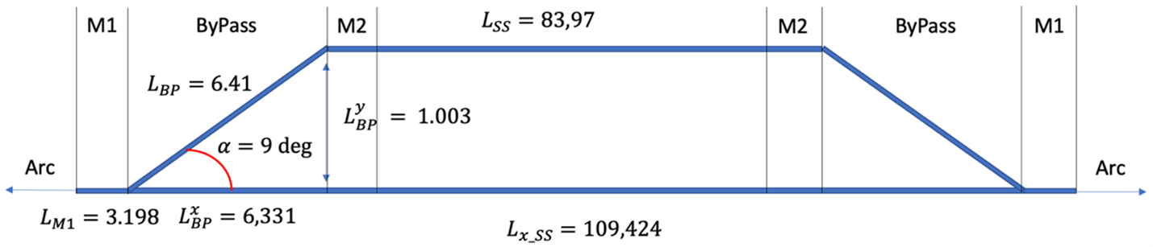
Figure 11. Layout of the bypass with three quadrupoles.
Figure 12 shows the Twiss functions; the black lines mark the channel boundaries. The maximum of $β_{y}$ is located at the center of the channel and can be large compared with $β_{x}$. For this reason, a bypass with five quadrupoles is also considered.
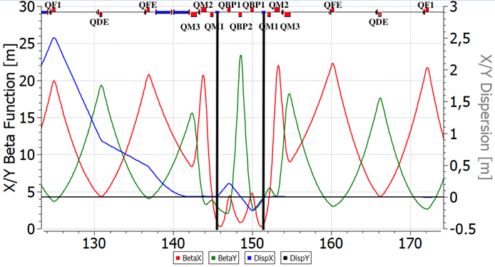
Figure 12. Twiss functions of the bypass with three quadrupoles. The black lines show the positions of the bypass bending magnets.

Bypass with five quadrupoles.
Here the bypass channel contains five quadrupoles of two families, focusing QBP1 and defocusing QBP2. The channel becomes longer, $L_{5quad}^{BP}=9.35 m$, and the displacement increases to 1.46 m (Fig. 13). The matching sections M1 and M2 are still identical but consist of two quadrupoles, QM1 and QM2, which keep the Twiss functions regular. The circumference increases to $L_{5quad}^{acc}=510.02 m$. As Fig. 14 shows, the maximum of $β_{y}$ at the channel center becomes smaller, whereas the maximum of the dispersion grows from $D_{x}^{3quad}∼0.2 m$ to $D_{x}^{5quad}∼0.5 m$. This case therefore has to be adapted to the real lattice.
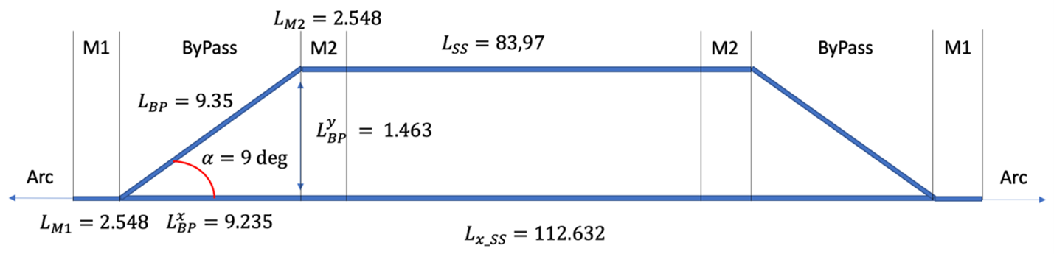
Figure 13. Layout of the bypass with five quadrupoles.
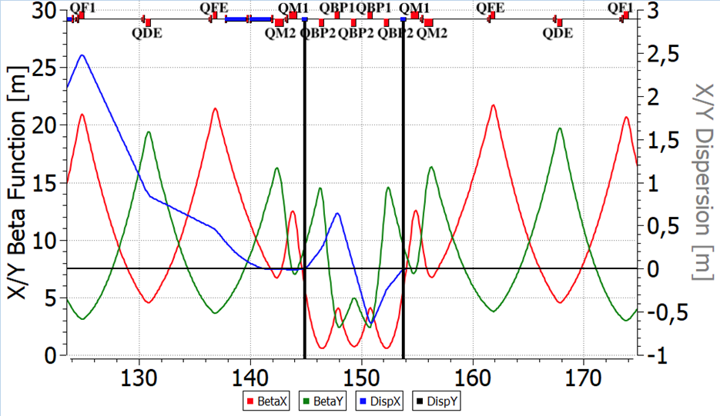
Figure 14. Twiss functions of the bypass with five quadrupoles. The black lines show the positions of the bypass bending magnets.

Realistic lattice.
Based on these two cases, a lattice as close as possible to the real machine has been designed. It has a fully regular straight section, which becomes shorter, $L_{SS}^{BP}=80.71 m$ (Fig. 15). The bypass channel contains five quadrupoles and displaces the alternative straight section by 1.46 m from the original one. Different matching sections M1 and M2 are used to compensate the asymmetry between the arc and the straight section. The Twiss functions of one half of the NICA ring with bypasses are shown in Fig. 16; the Wien filters are placed at the center of the straight section. All Twiss functions were computed with OptiM [15]. The lengths and tunes of all versions are summarized in Table 4.
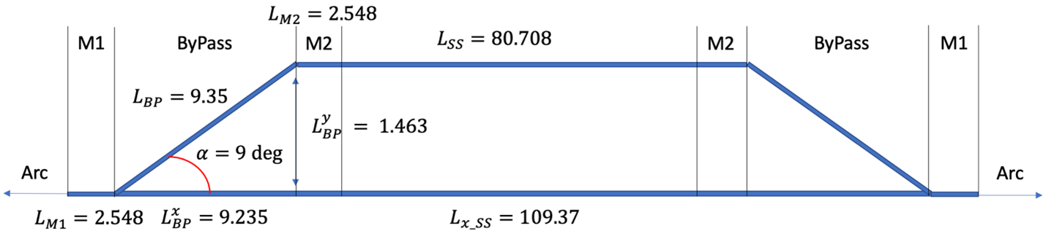
Figure 15. Layout of the bypass in the realistic lattice.
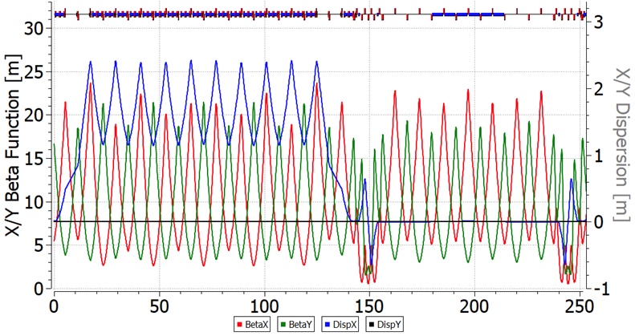
Figure 16. Twiss functions of one half of the NICA ring with bypasses. The Wien filters are located in the straight section.
Table 4. Ring circumference, lengths of the individual sections and betatron tunes $Q_{x}/Q_{y}$ of the lattice versions.
Lattice | Circumference, m | Straight section, m | Bypass, m | Matching section, m | $Q_{x}/Q_{y}$
NICA (ion mode) | 503.04 | 109.6 | – | – | 9.44/9.44
3 quadrupoles | 503.46 | 83.97 | 6.41 | 3.198 | 13.8/11.8
5 quadrupoles | 510.0 | 83.97 | 9.35 | 2.548 | 13.44/11.44
Realistic | 503.5 | 80.70 | 9.35 | 2.548 | 12.8/11.8

3.4 Natural chromaticity and dynamic aperture
This subsection addresses the stability of the orbital motion, namely, the correction of the natural chromaticity of the NICA bypass lattice. The chromaticity is the dependence of the betatron tune $Q$ on the momentum deviation $δ$ [16]:
$$Q^{′}=\frac{dQ}{dδ}. (18)$$
The natural chromaticity is produced by the quadrupoles at locations with non-zero beta function:
$$\frac{∂Q_{x}}{∂δ}=−\frac{1}{4π}\int_{0}^{L}{β_{x}}(s) k_{x}(s) ds, (19)$$
where $β_{x}(s)$ is the beta function at the quadrupole and $k_{x}(s)$ is the quadrupole gradient. The natural chromaticity can be corrected with sextupoles:
$$\frac{∂Q_{x}}{∂δ}=\frac{1}{4π}\int_{0}^{L}{β_{x}}(s) r(s) D(s) ds, (20)$$
where $D(s)$ is the dispersion function and $r(s)$ is the sextupole gradient. Correction is possible only if the sextupoles are placed where both the dispersion and the beta function are non-zero.
Since the arc lattice is regular, the beta and dispersion functions are regular along the arc as well, except at the arc ends. There the dispersion is suppressed with the missing-magnet method, which breaks the regularity of the Twiss functions (Fig. 16). Two essentially different sextupole families can thus be placed in the regular part of the arc: (1) at the maximum of $D$ and $β_{x}$ and the minimum of $β_{y}$, and (2) at the minimum of $D$ and $β_{x}$ and the maximum of $β_{y}$.
Figure 17 shows the betatron tune versus the energy deviation for the natural chromaticity and for the chromaticity corrected with two sextupole families. Figure 18 shows the dynamic aperture without sextupoles and with the chromaticity corrected. The tracking was performed with COSY Infinity [17]. The main parameters are listed in Table 5.
Table 5. Chromaticity of the NICA ring with bypasses.
Natural chromaticity $ξ_{x}/ξ_{y}$ | $−17/−17$
Corrected chromaticity $ξ_{x}/ξ_{y}$ | $−7×{10}^{−6}/7×{10}^{−6}$
Number of sextupole families | 2
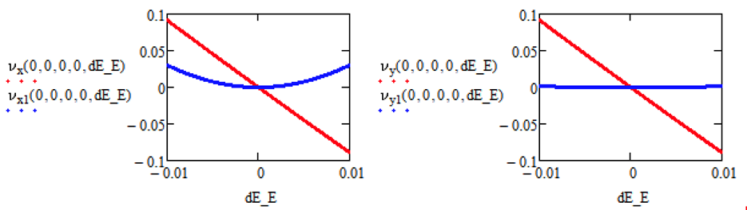
Figure 17. Betatron tune shift versus the energy deviation in the horizontal (left) and vertical (right) planes. Red: natural chromaticity; blue: corrected chromaticity.
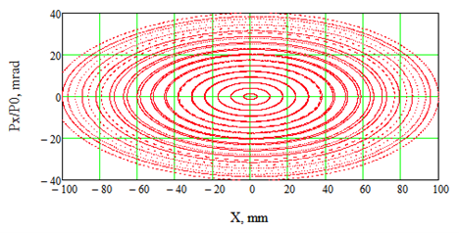 | 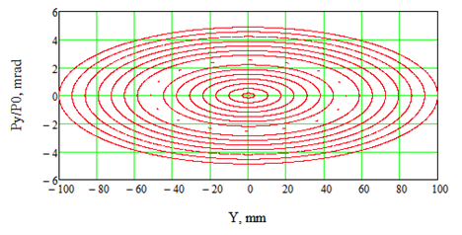
(a) | (b)
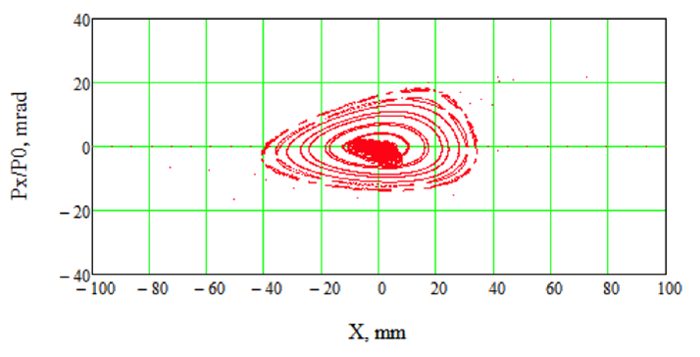 | 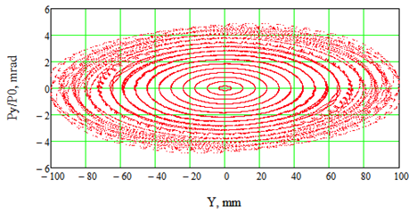
(c) | (d)

Figure 18. Dynamic aperture of the NICA ring with bypasses: (a), (b) natural chromaticity without sextupoles; (c), (d) chromaticity corrected with two sextupole families. Left: horizontal plane; right: vertical plane.

3.5 Spin-orbit motion with optimized Wien filters
The modification of the lattice is intended primarily for EDM research. This implies that the ring must operate in the quasi-frozen spin mode and that the spin coherence time of the beam must be long enough. The first requirement is met by placing Wien filters in the straight sections; the standard way to meet the second one is to use several sextupole families that correct the betatron and spin chromaticities. Both points were studied numerically with COSY Infinity [17].
In the standard formalism, the spin transfer matrix is an SO(3) rotation $T(ν,\overset{‾}{n})$ parametrized by the normalized spin precession frequency (spin tune) $ν$ and the invariant spin axis $\overset{‾}{n}$. If the quasi-frozen spin condition holds, $T$ is the identity matrix and $ν=0$. In the proposed lattice this is achieved by tuning the electric field of the E+B elements, while the magnetic field is chosen so as to keep the closed orbit unchanged. The simulation shows that the spin tune of the reference particle $ν_{0}$ can indeed be set to zero (Fig. 19). The spin deviates by a small angle in the arc and recovers its orientation in the Wien filters of the straight section (Fig. 20).
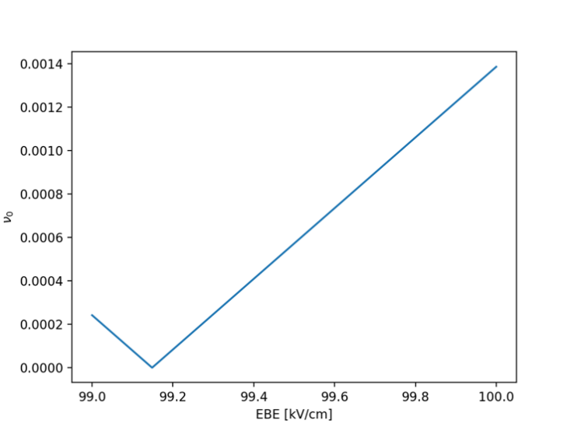
Figure 19. Spin tune $ν_{0}$ of the reference particle versus the electric field of the E+B elements.
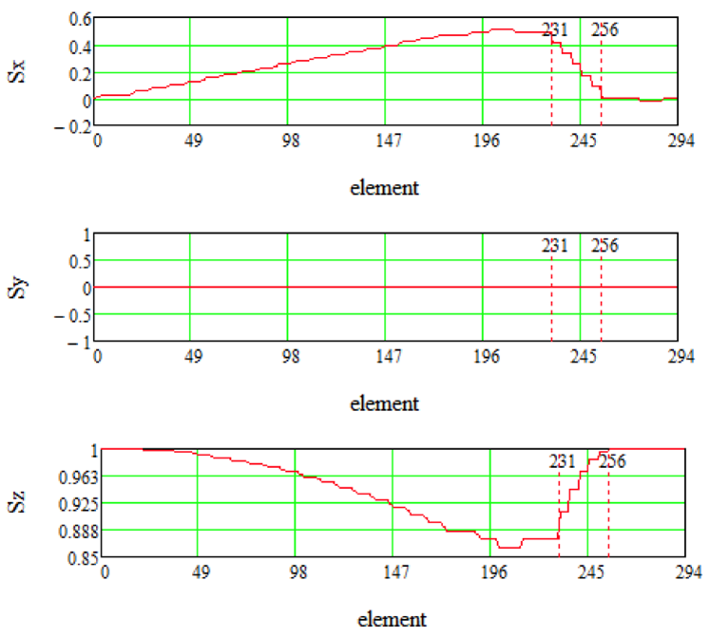
Figure 20. Spin components $S_{x}$, $S_{y}$, $S_{z}$ of the reference particle along one half of the ring (arc and straight section).
The spin chromaticity is the dependence of the spin precession frequency on the particle orbit length [18]. Because of it, the spins of the beam particles spread around the invariant spin axis $\overset{‾}{n}$. This process, called spin decoherence [19–21], is irrelevant for experiments with a non-zero expected polarization along $\overset{‾}{n}$. In EDM experiments, however, the polarization component orthogonal to $\overset{‾}{n}$ is of interest; its expectation value is zero, hence the importance of the spin coherence time (SCT).
The spin chromaticity of the beam can be compensated with sextupole families to a level that provides a sufficiently long spin coherence time (Fig. 21). Classically, three sextupole families placed at the maxima of $β_{x}$, $β_{y}$ and $D$ should be used, but the lattice under study does not allow an efficient separation of all three Twiss functions. It was also found that the betatron and spin chromaticities cannot be compensated simultaneously in this combined lattice; this problem is discussed in the next subsection.
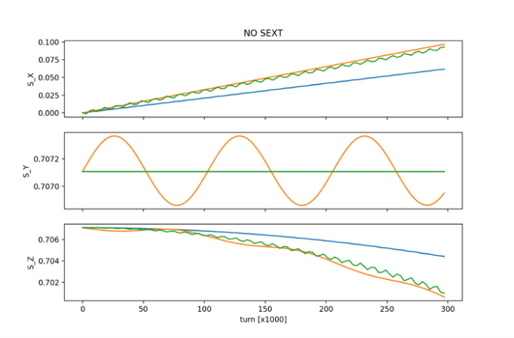 | 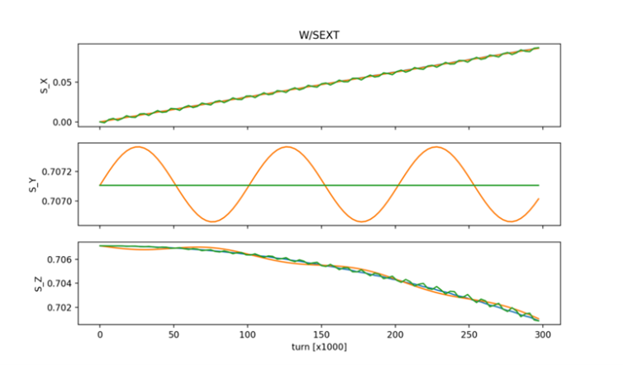
(a) | (b)

Figure 21. Spin components versus the number of turns for particles with different initial offsets, without (a) and with (b) sextupole families.

3.6 Betatron chromaticity and spin coherence
According to the theory of Ref. [22], the main cause of spin decoherence is the deviation of the particle energy from the equilibrium value:
$$Δδ_{eq}=\frac{γ_{s}^{2}}{γ_{s}^{2}α_{0}−1}\left[\frac{δ_{m}^{2}}{2}\left(α_{1}+\frac{3}{2}\frac{β_{s}^{2}}{γ_{s}^{2}}−\frac{α_{0}}{γ_{s}^{2}}+\frac{1}{γ_{s}^{4}}\right)+{\left(\frac{ΔL}{L}\right)}_{β}\right], (21)$$
$${\left(\frac{ΔL}{L}\right)}_{β}=\frac{π}{2L}\left[ϵ_{x}ν_{x}+ϵ_{y}ν_{y}\right]. (22)$$
The energy level around which the particle oscillates is called the effective energy. To eliminate the effect of the momentum spread on the orbit lengthening completely, the factor $κ=η_{1}=α_{1}+\frac{3}{2}\frac{β_{s}^{2}}{γ_{s}^{2}}−\frac{α_{0}}{γ_{s}^{2}}+\frac{1}{γ_{s}^{4}}$ in Eq. (21) must vanish. In addition, the orbit lengthening due to the betatron motion must be compensated as well. Both are achieved with three independent sextupole families placed at the maxima of the beta and dispersion functions. With sextupoles in the lattice, Eq. (22) takes the more general form [23]
$${\left(\frac{ΔL}{L}\right)}_{β}=−\frac{π}{L}\left[ϵ_{x}ξ_{x}+ϵ_{y}ξ_{y}\right]. (23)$$

Magnetic ring.
To study this effect, a purely magnetic ring without electric elements is considered first; similar calculations were carried out for the COSY ring in Jülich [23]. This ring is a version of NICA in which the arcs are unchanged and the straight sections are regular FODO cells matched to the arcs with two quadrupoles. The sensitivity of the lattice to the sextupole strengths $r_{f}$ and $r_{d}$ is considered. The sextupole layout is shown in Fig. 22; here the families SF1 and SF2 are identical and form one focusing family.
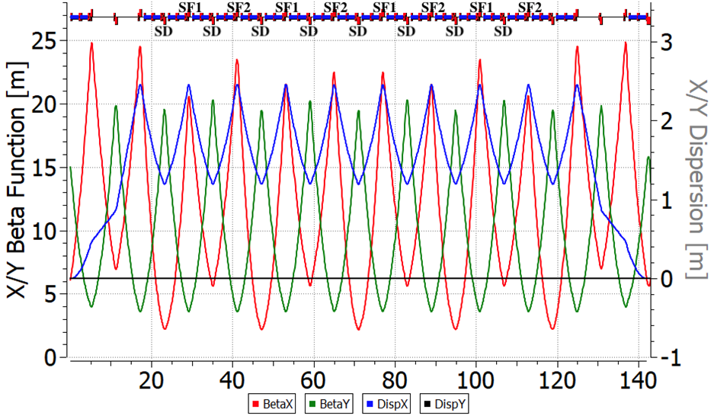
Figure 22. NICA collider arc with the sextupole layout.
$$\left\{\begin{aligned}ξ_{x}&=−13.302+4522.234 r_{f}+527.934 r_{d}, \\ ξ_{y}&=−13.337−944.735 r_{f}−2214.642 r_{d}, \\ α_{1}&=0.037−16.617 r_{f}−2.537 r_{d}.\end{aligned}\right. (24)$$
Two sextupole families cannot optimize all three parameters of the spin-orbit motion. Either the pair $(ξ_{x},ξ_{y})$ or the pair $(ξ_{y},α_{1})$ can be tuned. The second choice is probably less practical, because $α_{1}$ changes only weakly and the energy contribution to the spin tune spread can be reduced by beam cooling.
In a purely magnetic lattice, the motion in the $x$–$δ$ plane is fully described by the theory. In the vertical plane, spin resonances may contribute to the spread of the spin precession frequencies.
As Figs. 23(a)–(c) show, the optimum of the spin chromaticity does not coincide with that of the betatron chromaticity. Without optimization, $Δν_{s}∼{10}^{−8}$ at $f_{rev}∼1 MHz$ gives an SCT of about 100 s, which is insufficient for the EDM experiment. The vertical chromaticity must therefore be optimized while the dynamic aperture is preserved. A change of $κ$ by about $±1$ is not decisive for the SCT.
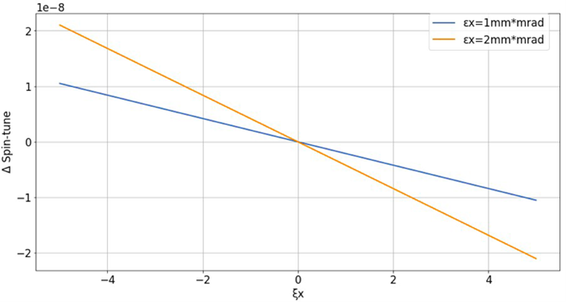 | 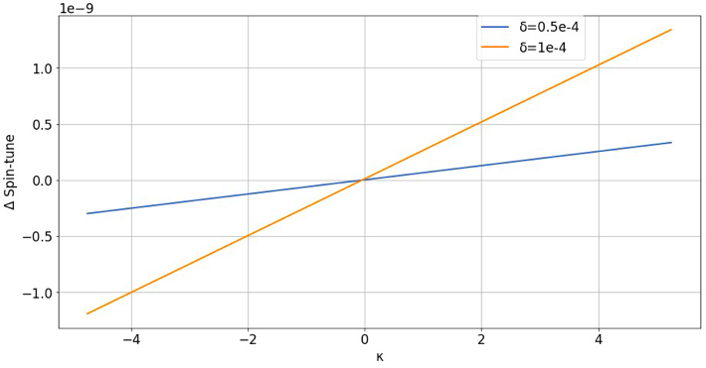 | 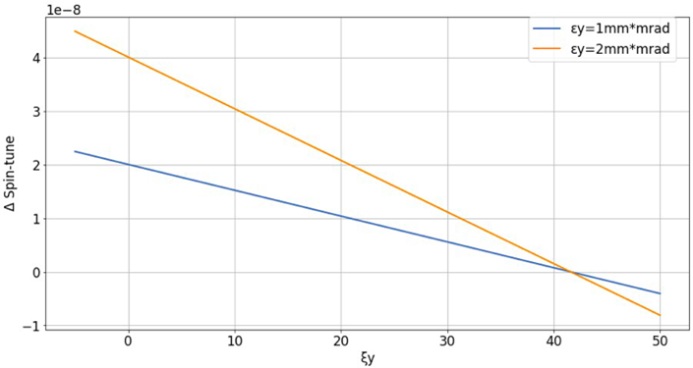
(a) | (b) | (c)

Figure 23. Purely magnetic ring: spin tune spread (a) versus the horizontal chromaticity for particles injected with different radial offsets; (b) versus $κ=η_{1}$ for particles with an energy offset; (c) versus the vertical chromaticity for particles with a vertical offset.
As noted above, spin resonances produce an additional spread of the spin precession frequencies $Δν_{s}$ in the vertical plane. At the working point $γG=0.16$, the nearest resonance is the intrinsic betatron resonance $γG=10−Q_{y}=0.2$. For a resonance strength $ε={10}^{−4}$ and a detuning $δ=0.04$, the expected spread due to the resonance is
$$Δν_{s}=δ−\sqrt{δ^{2}+ε^{2}}∼1.2×{10}^{−7}. (25)$$
This value estimates $Δν_{s}$ at $ξ_{y}=0$ in Fig. 23(c). Increasing the vertical chromaticity reduces the spread of the spin precession frequencies through the betatron orbit lengthening. A simple estimate for a particle with $ε_{y}∼1 mm⋅mrad$ and $ξ_{y}=40$ gives
$$Δν_{s}=ν_{s}{\left(\frac{ΔL}{L}\right)}_{β}=−\frac{γGπ}{L} ε_{y}ξ_{y}=−4×{10}^{−8}, (26)$$
which is what is needed to suppress the typical spin tune spread at $ξ_{y}=0$ in Fig. 23(c).

Lattice with Wien filters.
As Figs. 24(a)–(c) show, in a ring with electrostatic fields the optima of the betatron and spin chromaticities do not coincide either in the $x$–$δ$ plane or in the vertical plane. As in the magnetic ring, the preferred option for minimizing spin decoherence is to compensate the pair $(ξ_{x},ξ_{y})$ for the beam parameters given above. The residual spread $Δν_{s}∼{10}^{−9}$ in the energy plane gives an SCT of about 1000 s, which is sufficient for the EDM experiment. Moreover, measurements of $(ξ_{x},ξ_{y})$ are routine in storage rings, unlike measurements of $α_{1}$; with two sextupole families it is therefore reasonable to optimize the pair $(ξ_{x},ξ_{y})$.
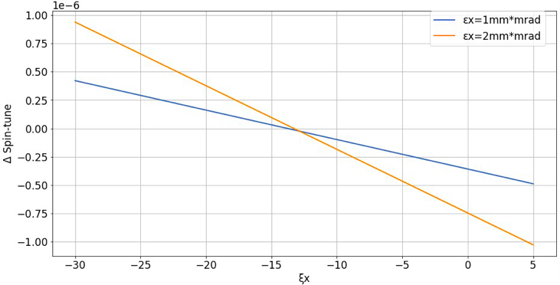 | 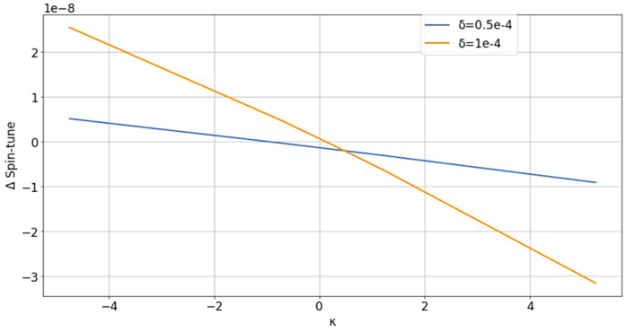 | 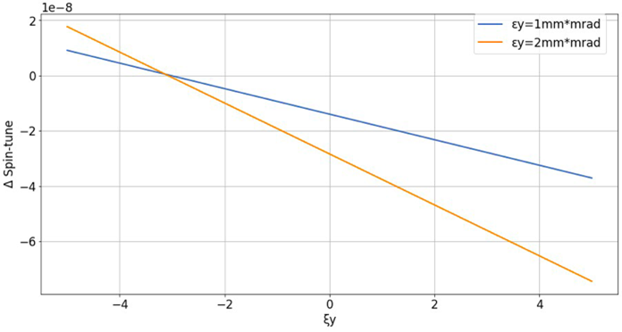
(a) | (b) | (c)

Figure 24. Ring with Wien filters: spin tune spread (a) versus the horizontal chromaticity for particles injected with different radial offsets; (b) versus $κ=η_{1}$ for particles with an energy offset; (c) versus the vertical chromaticity for particles with a vertical offset.
The mismatch between the optima of the betatron and spin chromaticities in the $x$–$δ$ plane of a ring with electrostatic fields is explained by the particle motion in the electric field. A radial displacement of a particle in a deflector with a radial field changes the particle energy. This follows from the potential nature of the field and couples the orbital motion to the particle energy.

NICA with bypasses.
For the modified NICA ring with bypasses and Wien filters described above, the betatron chromaticity and the spin coherence were optimized separately.
To correct the betatron chromaticity, two sextupole families are needed, as shown above: one near the focusing quadrupoles and the other near the defocusing quadrupoles. The natural chromaticity of the NICA ring with bypasses is $ξ_{x,y}=−17/−17$. After the correction, the spin precession frequency can be followed in Fig. 25: the red line shows the natural chromaticity and the blue dotted line shows the chromaticity corrected to zero. For this case, spin tracking over $3×{10}^{5}$ turns was performed for particles with different initial offsets in $x$, $y$ and $δ$ and with the initial spin ${\vec{S}}_{0}$ at 45° in the $y$–$z$ plane (Fig. 21).
The key quantity is the spin precession frequency, which in general depends on the coordinates and the energy. The dominant contribution is the quadratic term in the expansion of the spin precession frequency, as seen in Fig. 25 for both the natural and the corrected chromaticity.
To obtain spin coherence, the quadratic terms of the expansion were compensated with two focusing sextupole families. These families, however, are linearly dependent, because they are located at positions with equal values of the beta and dispersion functions (Fig. 22), which is typical of lattices with regular arcs. COSY Infinity cannot operate near a zero spin precession frequency: the spin transfer matrix becomes degenerate near the resonance and the code fails. The lattice was therefore detuned from the resonance to $ν_{s}∼{10}^{−4}$, while the particles were still required to precess synchronously, i.e., coherently. In this approach the chromaticity is not controlled; its value is only monitored, and with the spin chromaticity corrected it equals $ξ_{x,y}=−13/−18$.
Correcting only the betatron chromaticity does not give a zero spread of the spin precession frequency. Conversely, achieving spin coherence by suppressing the quadratic term of the spin precession frequency does not correct the chromaticity. This brings us back to Eq. (21): to ensure a zero energy deviation, the chromaticities $ξ_{x}$, $ξ_{y}$ and $η_{1}$ must all be set to zero. This is possible with three sextupole families, but it still does not yield spin coherence. Moreover, the required maximum sextupole strength is too high to be realized (Table 6).
This effect has already been explained for the purely magnetic ring, where the dependence of the spin tune on the sextupole strengths is given by Eq. (24). In the presence of electrostatic fields, the chromaticities $ξ_{x}$, $ξ_{y}$ affect the spin tune more strongly than $κ$, whose contribution can be compensated by beam cooling.
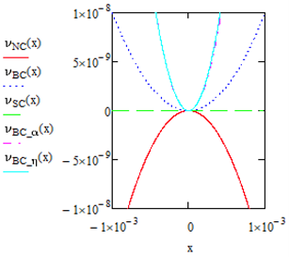 | 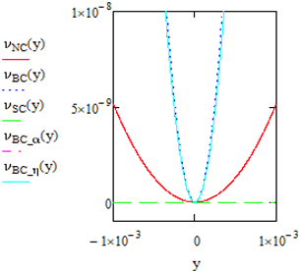 | 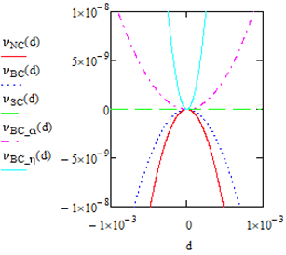
(a) | (b) | (c)

Figure 25. Spin precession frequency versus the coordinates $x$ (a), $y$ (b) and $δ$ (c) for different optimization cases: NC, natural chromaticity (red); BC, zero betatron chromaticity (blue dotted); SC, spin coherence (green); BC$​_{α}$, zero chromaticity and $α_{1}=0$ (violet); BC$​_{η}$, zero chromaticity and $η_{1}=0$ (light blue).
Table 6. Main parameters of the NICA ring with bypasses for different optimization cases. $K_{x}$, $K_{y}$, $K_{z}$ are the coefficients of the quadratic terms of the spin precession frequency in $x$, $y$ and $δ$.
Optimization | None | Chromaticity | Spin coherence | Chromaticity $+ η_{1}$
Chromaticity $ξ_{x}/ξ_{y}$ | $−17/−17$ | $0/0$ | $−13/−18$ | $0/0$
$α_{1}$ | 0.2 | $−0.4$ | $−0.37×{10}^{−2}$ | $−0.85$
$K_{x}$ | $−0.16×{10}^{−1}$ | $0.55×{10}^{−1}$ | $0.27×{10}^{−13}$ | $0.56×{10}^{−1}$
$K_{y}$ | $0.51×{10}^{−2}$ | $0.76×{10}^{−1}$ | $−0.12×{10}^{−12}$ | $0.78×{10}^{−1}$
$K_{z}$ | $−0.43×{10}^{−1}$ | $0.20×{10}^{−1}$ | $0.13×{10}^{−12}$ | $1.6×{10}^{−1}$
Sextupole families | none | 2 | 3 | 3
Max. sextupole strength, m$​^{−3}$ | – | 2.7 | 19.4 | 104.2

3.7 Conclusion
For EDM experiments it is necessary to use NICA as a storage ring. For this reason, a modernization was considered by creation of alternative straight sections parallel to the original ones by using bypass channels. Also, the straight sections have the ability to place special elements—Wien filters—to compensate the spin rotation in the arcs. As the arcs remain unchanged, this allows one to use NICA in various experiments.
Two principal schemes of the bypass channel were considered, and finally the most realistic case was obtained, where the straight section is fully regular. The final structure satisfies all necessary magneto-optics requirements. Spin-tracking research with optimized Wien filters was made, and simulations show that the spin restores its orientation at the straight sections. The quasi-frozen spin method can be implemented in bypass NICA.
The material of this section has been reported in [13,14,20,22,24–30].

4 Modernized Nuclotron

4.1 Present Nuclotron lattice
Figure 26 shows the NICA accelerator complex, which comprises the Booster, the Nuclotron and the Collider. The Booster and the Nuclotron serve as the injector of heavy ions, polarized protons and deuterons into the collider. The Nuclotron lattice was originally designed to be as close to circular as possible and has eight superperiods. Figure 27 shows the Twiss functions of one superperiod, which consists of a bending arc of three FODO cells, each with four bending magnets with a maximum field of 1.8 T, and a straight section of one FODO cell. The Nuclotron circumference is 251 m.
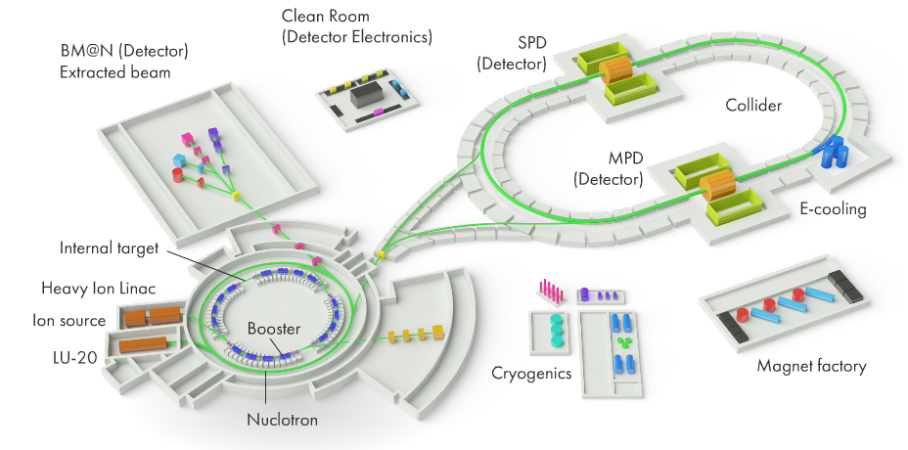
Figure 26. NICA accelerator complex.
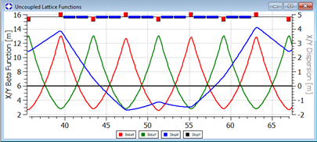
Figure 27. Twiss functions of one Nuclotron superperiod.
The main drawback of the Nuclotron, both as a collider injector and as a stand-alone ring, is the limited length of the drift spaces in which the equipment for these two functions must be installed. All modernization options below are assessed with respect to this limitation.

4.2 Modernization options
Two modernization options of the Nuclotron have been studied. The adaptation of the Nuclotron magneto-optical structure to the deuteron (and proton) EDM search in the quasi-frozen spin regime is developed in [3,31–33].
The first option, Nuclotron 2.1, is a lattice that preserves all properties of the existing accelerator and allows deuteron EDM experiments with electric deflectors or Wien filters installed in the ring. Either device keeps the spin of the polarized beam along its direction of motion around the ring. Within the eight-superperiod lattice, $N_{super}=8$, this requires implementing the frozen (or quasi-frozen) spin concept by lengthening the straight sections between the arcs, ensuring zero dispersion in the straight sections, and, if possible, keeping the ring circumference so that the equipment fits into the existing tunnel [3,31]. An axion search could also be included in this framework, although the treatment of the systematic errors of such an experiment is not yet fully understood. In the Nuclotron 2.1 option, all key collider parameters, such as the transition energy and the electron cooler parameters, remain unchanged. This creates a serious problem at the interface between the collider and the Nuclotron: crossing the transition energy with a cooled beam leads to irreversible beam degradation and a lower final luminosity.
The Nuclotron 2.2 option introduces modifications that ensure compatibility with the collider. The injection energy of polarized protons into the collider remains at 2–3 GeV. To eliminate the effect of transition crossing after electron cooling, the transition energy of the collider is to be raised above its maximum operating energy. In addition, a lower maximum energy of heavy ions and polarized particles in Nuclotron 2.2 is considered. This frees space in the ring for Wien filters and extends the capabilities of the Nuclotron for EDM and axion experiments. A lower Nuclotron energy does not degrade the complex as a whole, since the collider can take over some functions of the Nuclotron and provide proton and heavy-ion beams over the entire Nuclotron energy range.

4.3 Nuclotron 2.1: quasi-frozen spin for deuterons
Adapting the Nuclotron lattice to the measurement of the deuteron EDM involves three problems: lengthening the straight sections, suppressing the dispersion in the straight sections, and keeping the spin direction along the momentum around the ring.
The first problem is solved by raising the maximum field of the bending magnets to 1.8 T and by merging the two adjacent magnets between the quadrupoles into one magnet. At the same time, the dispersion is suppressed by choosing the horizontal phase advance in the arcs. One superperiod of the modernized Nuclotron 2.1 is shown in Fig. 28. The main parameters of Nuclotron 2.1 are: circumference 251 m; betatron tunes $Q_{x}=9.78548$, $Q_{y}=10.6839$; momentum compaction factor 0.0134394; slip factor $−0.0222388$; natural chromaticity $−16.0394$ (horizontal) and $−17.8984$ (vertical). In the figure, D denotes a defocusing quadrupole, F a focusing quadrupole, B a dipole magnet and ED an electrostatic deflector. The parameters of all options are summarized in Table 7.
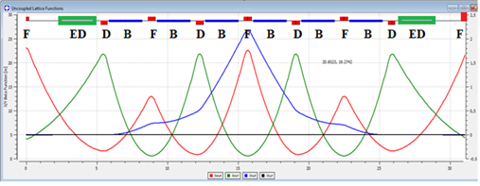
Figure 28. Twiss functions of one superperiod of the modernized Nuclotron 2.1 with two electrostatic deflectors.
With the bending field raised to 1.8 T, the length of the straight section in each superperiod increases from 7.3 to 10.5 m. The third problem, keeping the spin direction relative to the momentum as required for the detection of the deuteron EDM signal, is solved with negative-curvature electrostatic deflectors in each superperiod (Fig. 29).
In the quasi-frozen spin concept, the magnetic and electric fields act in different elements. The spin direction therefore oscillates relative to the direction of motion, since the spin rotates in opposite directions in the magnetic and electrostatic bending elements. The deuteron magnetic anomaly is small, $G=−0.143$. The spin oscillates around the momentum in each magnetic arc within half of the spin phase advance, $Φ_{s}=\frac{1}{2N} 2πγG$, and each time it is turned back by $−Φ_{s}$ in the electrostatic deflector; here $N$ is the arc superperiodicity. This keeps the average spin direction along the momentum around the whole ring, in accordance with the quasi-frozen spin concept [34].
For the Nuclotron, $N=8$. Owing to the small value of $Φ_{s}$, the effective EDM signal is reduced only by the factor
$$J_{0}(Φ_{s})≈1−\frac{Φ_{s}^{2}}{4}, (27)$$
i.e., by a few percent at most.
To determine the parameters of the electrostatic deflectors in the quasi-frozen spin mode for deuterons, consider the lattice as consisting of two different parts (Fig. 29). The magnetic arcs bend the beam by $Φ^{B}=2π/N+2α$ each and rotate the spin in the horizontal plane relative to the momentum by $Φ_{s}^{B}=ν_{s}^{B}Φ^{B}$. The electrostatic arcs with negative-curvature deflectors bend the beam by $Φ^{E}=−2α$ each and rotate the spin relative to the momentum in the opposite direction by $Φ_{s}^{E}=ν_{s}^{E}Φ^{E}$. The quasi-frozen spin condition requires $Φ_{s}^{E}=−Φ_{s}^{B}$. Since in an electrostatic deflector the spin rotates relative to the momentum many times faster than in a magnetic field, the two types of arcs are related by
$$ν_{s}^{B}\left(\frac{2π}{N}+2α\right)=ν_{s}^{E} 2α, α=\frac{1}{ν_{s}^{E}/ν_{s}^{B}−1} \frac{π}{N}=−γ^{2}\frac{G}{G+1} \frac{π}{N}, (28)$$
where $ν_{s}^{E}$ and $ν_{s}^{B}$ are given by Eqs. (5) and (6). For given bending magnets and a deflector field $E_{ED}=130 kV/cm$, one obtains $ν_{s}^{E}/ν_{s}^{B}$, the parameter $α$ and the radius of curvature of the deflector $R_{ED}=κ/E_{ED}$, where $κ=p_{0}βc/e$ is the electric rigidity and $p_{0}=γmβc$, so that $R_{ED}=\frac{mc^{2}}{e}\frac{γβ^{2}}{E_{ED}}$. The deflector length is then $L_{ED}=2αR_{ED}=−2\frac{γ^{2}G}{G+1}\frac{π}{N}R_{ED}$. Figure 29 shows how the electrostatic deflectors are inserted to realize the quasi-frozen spin lattice of the Nuclotron. At the optimal polarimeter energy $W=270 MeV$ [11], $α=0.026π$ and the required length of the electrostatic channel is 7.3 m. The EDM signal relative to the frozen spin case, $S_{EDM}^{QFS}/S_{EDM}^{FS}=1−α^{2}/4≈0.998$, is reduced by only 0.2%.
The electrostatic arc with negative curvature leaves room for the necessary equipment in the straight section between two magnetic arcs; when the electrostatic deflectors are switched off, the beam passes straight through this section.
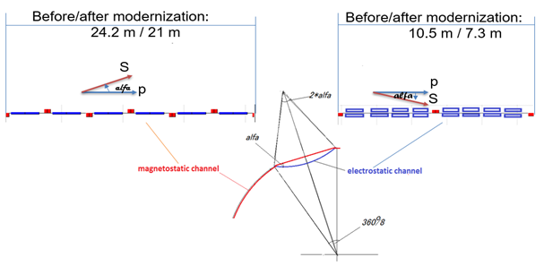
Figure 29. Electrostatic insertion compensating the spin rotation in the magnetic arc.
A lattice with twice the number of superperiods, 16, was also considered. By splitting the double bending magnets into individual magnets, the number of FODO cells per superperiod is doubled, and with a 60° phase advance per FODO cell the dispersion is suppressed in every second straight section. In this version $α=0.013π$, and the EDM signal relative to the frozen spin case is $1−α^{2}/4≈0.9996$, i.e., reduced by only 0.04%, which makes this lattice practically equivalent to the frozen spin one. This lattice can also be used for the proton EDM, since the spin rotation angle of protons in the magnetic arcs is only about 30°.

4.4 Nuclotron 2.2: quasi-frozen spin with Wien filters for deuterons
In the Nuclotron 2.2 lattice, a small vertical magnetic field of about 100 mT is added to compensate the Lorentz force of the electric field, so that the electrostatic deflectors become straight. With the magnetic field added, the E+B element is a Wien filter. The ring then consists of arcs connected by straight sections with Wien filters, in which crossed electric and magnetic fields keep the particles on a straight path (zero Lorentz force) and compensate the spin rotation accumulated in the magnetic arcs. The total length of the Wien filters is determined by the beam parameters and by the required compensation of the spin rotation in the arcs, whereas their number is chosen for convenient placement around the ring.
With $N$ magnetic arcs in total, each arc bends the particles by $Φ_{arc}^{B}=2π/N$ and rotates the spin in the horizontal plane relative to the momentum by $Φ_{s}^{arc}=γG Φ_{arc}^{B}$. The Wien filters rotate the spin relative to the momentum in the opposite direction. In the electric field $E_{wf}$ the spin rotation angle is
$$Φ_{swf}^{E}=−\left(γG+\frac{γ}{γ+1}\right)β^{2} Φ_{wf}^{E}, (29)$$
where $Φ_{wf}^{E}=\frac{eE_{wf}}{m_{0}c^{2}γβ^{2}}L_{wf}$ is the momentum rotation angle in the electric field of the Wien filter, and in the magnetic field $B_{wf}$ it is
$$Φ_{swf}^{B}=(γG+1) Φ_{wf}^{B}, (30)$$
where $Φ_{wf}^{B}=\frac{eB_{wf}}{m_{0}cγβ}L_{wf}$ is the momentum rotation angle in the magnetic field of a Wien filter of length $L_{wf}$.
Since the Lorentz force in the Wien filter vanishes, the angles must be equal, $Φ_{wf}^{E}=Φ_{wf}^{B}$, and they can be expressed through the electric field $E_{wf}$ and the length $L_{wf}$ of the filters installed in all $N$ straight sections. In the frozen spin option, the total spin precession frequency relative to the momentum in the combined E+B bending element is zero. The quasi-frozen spin option instead requires the total spin rotation angle per turn in the E and B fields to vanish. The QFS condition therefore reads
$$(γG+1) Φ_{wf}^{B}−\left(γG+\frac{γ}{γ+1}\right)β^{2} Φ_{wf}^{E}=γG \frac{2π}{N}, (31)$$
which gives the parameters of one Wien filter:
$$L_{wf}E_{wf}=\frac{2π}{N} \frac{G}{G+1} \frac{m_{0}c^{2}}{e} β^{2}γ^{3}, B_{wf}=−\frac{E_{wf}}{cβ}, (32)$$
where $L_{wf}$ is the length of one Wien filter. The total length of all Wien filters, $L_{wf}^{Σ}E_{wf}=2π\frac{G}{G+1}\frac{m_{0}c^{2}}{e}β^{2}γ^{3}$, depends only on the particle species and energy.
Equations (28) and (32), derived for electrostatic deflectors and for Wien filters, show that the type of the compensating element does not matter. With the magnetic arc unchanged, the Wien filters are shorter by the total length of the kickers, since a Wien filter combines the functions of an electrostatic deflector and a kicker in one element.
Figure 30 shows the Twiss functions of one superperiod of the first version of the modernized lattice, Nuclotron 2.2.1. Two Wien filters installed in the central straight sections of the superperiod restore the spin direction after each magnetic half-arc. The spin deviation angle from the momentum, $α=γG 2π/N$, characterizes how much the quasi-frozen spin lattice differs from the frozen spin one. In this lattice, the number of arcs that determine the spin deviation equals the number of superperiods, $N=8$.
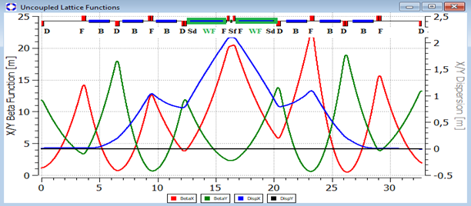
Figure 30. Twiss functions of one superperiod of the modernized Nuclotron 2.2.1 with two Wien filters.
For a maximum electric field of 130 kV/cm, the magnetic field is below 80 mT. Such a low magnetic field simplifies the Wien filter design: a permanent magnet or an air-core coil can be used. For these fields and a deuteron energy of 270 MeV, the total length of the Wien filters in all straight sections is about 52 m, and the length of one Wien filter is 3.25 m. At 270 MeV (135 MeV per nucleon), the maximum spin deviation is $α∼±3^{∘}$ over one arc, which is a good approximation to a regular frozen spin lattice.
In the next version, Nuclotron 2.2.2, the Wien filters are distributed over four straight sections of the superperiod (Fig. 31). Each arc of the superperiod is thus split into two arcs, and with respect to the bending magnets the lattice has the superperiodicity $N=16$, while the overall superperiodicity of the lattice with all elements remains 8. This solves two problems. First, the ring becomes a 16-sided polygon, i.e., closer to a circle, and fits the existing tunnel better. Second, with a bending magnet length of 1.77 m and a Wien filter length of 1.65 m, the spin deviation is $α∼±{1.5}^{∘}$, half that of version 2.2.1. This brings the properties of the quasi-frozen spin lattice much closer to those of the frozen spin lattice.
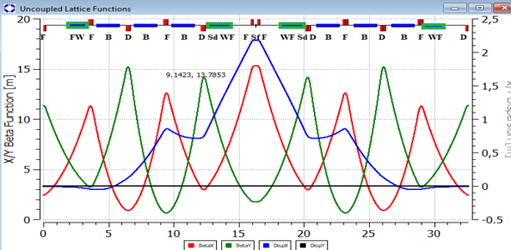
Figure 31. Twiss functions of one superperiod of the modernized Nuclotron 2.2.2 with four Wien filters.
To increase the energy, the modification Nuclotron 2.2.3 with fewer empty drift spaces and longer magnets was considered (Fig. 32). In this lattice, the maximum energy is 3.5 GeV per nucleon for deuterons and 7.8 GeV for protons, which is much closer to the present Nuclotron.
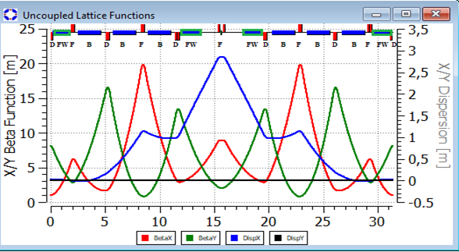
Figure 32. Twiss functions of one superperiod of the modernized Nuclotron 2.2.3 with four Wien filters.
Table 7. Main parameters of the Nuclotron modifications.
Nuclotron lattice | Magnet length, m | Number of magnets | Total magnet length, m | $B_{max}$, T | $B_{max}R$, T$⋅$m | $W_{d}^{max}$, GeV | $W_{d}^{max}$, GeV/u | $W_{p}^{max}$, GeV
Present | 1.44 | 96 | 138.24 | 1.8 | 39.6 | 10.14 | 5.07 | 10.97
2.1 | 2.35 | 48 | 112.77 | 1.8 | 32.2 | 8 | 4 | 8.79
2.2.1 | 1.78 | 48 | 85.3 | 1.8 | 24.4 | 5.7 | 2.85 | 6.47
2.2.2 | 1.78 | 48 | 85.44 | 1.8 | 24.5 | 5.7 | 2.85 | 6.47
2.2.3 | 2.10 | 48 | 101 | 1.8 | 28.93 | 7.0 | 3.5 | 7.8

4.5 Nuclotron 2.2.2: quasi-frozen spin with Wien filters for protons
With a magnetic superperiodicity of 16, the lattice can also be used for protons at a reduced energy. The energy is then limited mainly by the free space for the Wien filters, which is 52 m in this lattice. The maximum proton energy follows from Eq. (32):
$$γ(γ^{2}−1)=L_{wf} \frac{eE_{wf}}{mc^{2}} \frac{N}{2π} \frac{G_{p}+1}{G_{p}}, (33)$$
where $L_{wf}N=52 m$ and $G_{p}=1.793$ is the proton magnetic anomaly. Solving for $γ$ gives $γ=1.08047$, i.e., $W_{p}≈80 MeV$. At this energy, the spin deviation in a magnetic arc is determined by $γG_{p}=1.93711$, and the spin deviation angle is $α=±\frac{1}{2}\frac{γG_{p}}{16}$, which amounts to $α={3.5}^{∘}$. The same lattice as for deuterons can be used for protons, but at a lower energy and with the Wien filters rotated by 180°, since the magnetic anomalies of the two particles have opposite signs. At a proton energy of 80 MeV the lattice thus behaves practically as a frozen spin lattice. Figure 33 shows the p–C analyzing power in terms of the “average analyzing power” taken from Ref. [10].
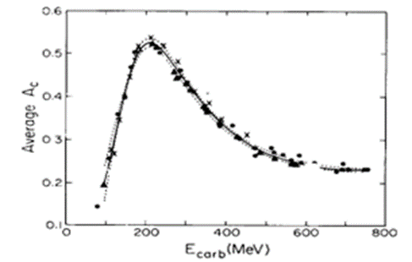
Figure 33. Average p–C analyzing power $\overline{A_{c}}$ for $θ_{lab}=5^{∘}$–20° at discrete energies (points) and its continuous energy dependence (solid line). The data are from SIN ($△$), TRIUMF ($×$) and LAMPF ($•$) [10].
Figure 33 shows that the analyzing power near 100 MeV is about 0.2, i.e., 0.35 of its maximum value $A_{c}=0.53$ at 230 MeV. This makes proton EDM studies at this energy in the Nuclotron 2.2.2 lattice feasible in parallel with full-scale deuteron measurements.
Galactic axions can be searched for with the same equipment as the EDM. Varying the spin precession frequency at a fixed beam energy turns the booster with Wien filters into a broadband antenna that searches for axions through a resonant full or partial spin flip in the oscillating pseudomagnetic field of the axion halo of our Galaxy [12]. The growth of the horizontal polarization induced by axions is extracted by a Fourier analysis of the oscillating vertical asymmetry in the internal polarimeter [35].

4.6 Maximum energy of heavy ions and protons in Nuclotron 2.2.2
The calculations show that deuteron and proton EDM experiments in the Nuclotron 2.2.2 lattice require free space for Wien filters with a total length of 52 m. With the tunnel circumference fixed at 251 m, this is possible either by raising the field of the bending magnets, which is already set to 1.8 T, or by reducing their total length. Assuming that the bending field does not exceed 1.8 T, the second option was chosen, which inevitably lowers the maximum particle energy in the Nuclotron.

4.7 Features of the modernized Nuclotron lattice
The lattice of the modernized Nuclotron was designed with several goals. First, the superperiod has a drift without bending magnets in its central cell, where the dispersion function reaches its maximum and the orbit curvature is zero ($ρ→∞$). This makes it possible to raise the transition energy, since the momentum compaction factor is
$$α=\frac{1}{C}∮\frac{D(s)}{ρ(s)} ds. (34)$$
Second, the number of superperiods $s=8$ is only slightly larger than the horizontal betatron tune $ν_{x}$, which makes the momentum compaction factor easy to adjust, as in the resonant lattices with a low or negative momentum compaction factor [36–40]:
$$α=\frac{ν_{x}^{3}}{R}\sum_{k=0}^{∞}{\frac{a_{k}^{2}}{ν_{x}^{2}−(ks)^{2}}}, (35)$$
where $a_{k}$ are the harmonics of the dispersion-generating perturbation. Third, the central drift simplifies the placement of the three sextupole families needed to control the betatron and spin chromaticities, whereas the side drifts are convenient for the Wien filters. Finally, the maximum of the dispersion at the center of the superperiod coincides with the minimum of the horizontal beta function $β_{x}$.
The material of this section has been reported in [2,3,14,31–33,41].

5 Specialized frozen spin rings at JINR
This section presents two specialized frozen spin lattices designed exclusively for the search for the electric dipole moments of the proton and the deuteron: an all-electrostatic ring for protons and a ring with combined E+B deflectors for deuterons.

5.1 Frozen spin option for the proton beam
The frozen spin lattice for a proton beam is the simplest one in terms of parameter choice and is uniquely defined. It consists of electrostatic deflectors whose total length $L_{total}$ is determined by the beam energy and the maximum permissible electrostatic field strength:
$$L_{total}=2π \frac{mc^{2}}{eE} γβ^{2}. (36)$$
For an energy of 233 MeV and a maximum field of $E=120 kV/cm$, the total length of all electrostatic deflectors is $L_{total}=219.55 m$.
With 50 deflectors placed around the ring, the length of a single deflector is $L_{def}=4.39 m$. The 50 deflectors are divided into five groups, each consisting of five FODO cells and containing ten deflectors (Fig. 34).
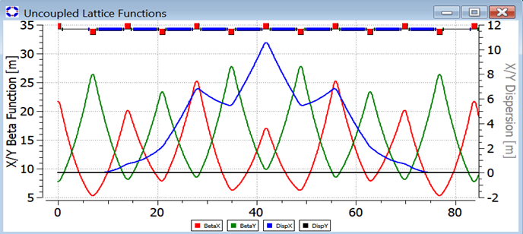
Figure 34. Twiss functions of one superperiod of the electrostatic proton ring.
Figure 35 shows the whole ring, which consists of five superperiods. Each superperiod comprises an achromat with drift spaces at both ends, so that the phase advance per superperiod is not an integer multiple of $2π$. The ring circumference is 419.1 m. The layout of the electrostatic ring is shown in Fig. 36; it closely resembles a circle.
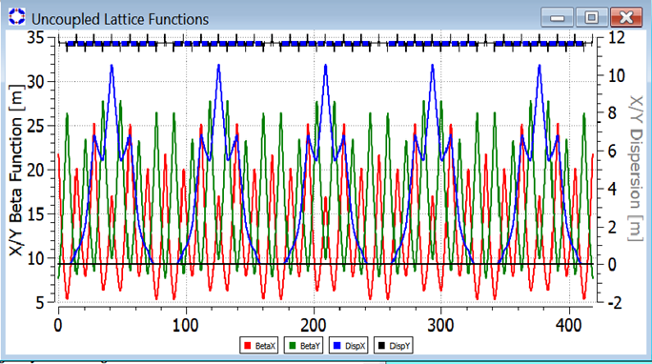
Figure 35. Twiss functions along the whole electrostatic proton ring.
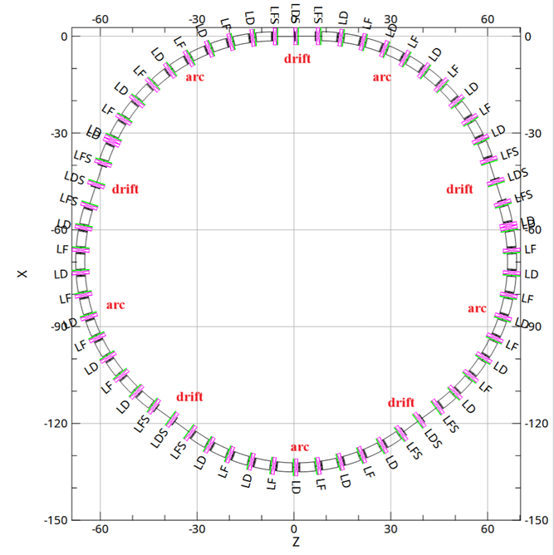
Figure 36. Layout of the electrostatic proton ring.
Tables 8 and 9 summarize the ring parameters required to estimate its dimensions and cost.
Table 8. Parameters of the frozen spin electrostatic ring for the proton EDM search.
Parameter | Value
Circumference, m | 419.1
Symmetry order (number of arcs and straight sections) | 5
Injection energy, MeV | 20
Proton magnetic anomaly $G$ | 1.793
Final energy, MeV | 233.8
EDM experiment energy, MeV | 233.8
Initial and final relative velocity and Lorentz factor | $β=0.2$, $γ=1.0213$; $β=0.6$, $γ=1.248$
Revolution frequency at the beginning and end of the cycle, MHz | 0.143–0.429
Harmonic number | 20
RF frequency at the beginning and end of the cycle, MHz | 2.8–8.6

Table 9. Parameters of the frozen spin electrostatic ring for the proton EDM search (continued).
Parameter | Value
Arcs
Arc length, m | 70.1
Arc superperiodicity | regular lattice
Arc lattice | 5 FODO cells
Number of electrostatic deflectors per arc | 10
Deflector length, m | 4.39
Deflector type | cylindrical
Maximum electric field of the deflector, MV/m | 12
Number of quadrupoles per arc | 9 + 1 (two end halves)
Quadrupole type | electrostatic
Quadrupole families | one focusing (LF), one defocusing (LD)
Maximum quadrupole gradient in the arcs, kV/cm$​^{2}$ | LF $=6.78$, LD $=−6.18$
Quadrupole length, m | 1.0
Number of chromatic sextupoles per arc | 10
Sextupole type | electric or magnetic
Sextupole strengths | to be determined
Betatron tunes $ν_{x}/ν_{y}$ | 6.12/4.72 (preliminary)
Natural chromaticity $ξ_{x}/ξ_{y}$ | to be determined
Transition energy, GeV | 3.1
Maximum $β_{x}/β_{y}$, m | 27.9/34.8
Maximum horizontal dispersion, m | 10.8
Straight sections between arcs
Length of straight sections, m | $5×13.5$
Lattice of straight sections | DOFFOD
Quadrupole gradients, T/m | QF $=7.93$, QD $=−7.11$
Drift length between adjacent quadrupoles, m | 6.0
As a second option, a racetrack ring with two arcs and dispersion suppressors at both ends of each arc was considered (Fig. 37). One of the two options will be adopted in the course of further lattice development, which will take spin decoherence into account [42].
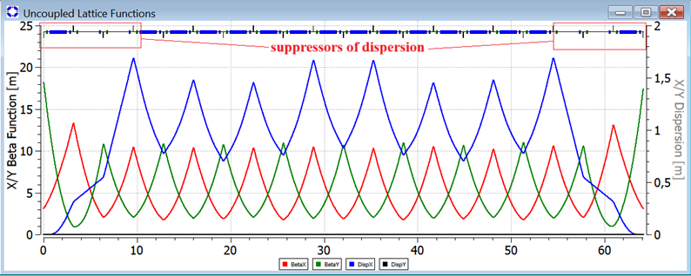
Figure 37. Arc with dispersion suppressors at both ends (racetrack option of the proton ring).

5.2 Frozen spin option for the deuteron beam
The frozen spin lattice for a deuteron beam differs from the proton one in the composition of the equipment and in the elements used. Here the bending deflector with E+B fields consists of electrostatic plates generating a horizontal electric field, inserted into the gap of a dipole magnet with a vertical magnetic field (Fig. 38).
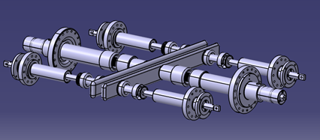 | 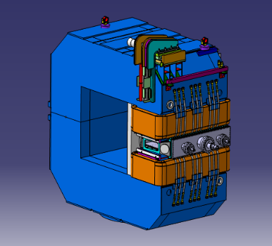
(a) | (b)

Figure 38. Electrostatic deflector (a) and vertical-field dipole magnet with the electrostatic deflector inserted into its gap (b).
The condition of stable motion on an orbit of radius $R$ follows from the balance of the Lorentz and centrifugal forces:
$$R=\frac{γm_{0}v^{2}}{e\left|\vec{E}+c\vec{β}×\vec{B}\right|}, (37)$$
from which the momentum precession frequency in the combined fields is
$${\vec{Ω}}_{p}=\frac{e\vec{E}}{m_{0}γβc}+\frac{e c\vec{β}×\vec{B}}{m_{0}γβc}. (38)$$
Subtracting ${\vec{Ω}}_{p}$ from ${\vec{Ω}}_{mdm}$ gives the spin precession frequency relative to the momentum:
$${\vec{Ω}}_{mdm}^{p}=\frac{e}{m_{0}γ}\left\{γG\vec{B}+\left(\frac{1}{γ^{2}−1}−G\right)\frac{\vec{β}×\vec{E}}{c}\right\}. (39)$$
A frozen spin lattice for EDM studies has to satisfy two conditions. The first relates the external fields to the orbit radius, Eq. (37) (see also [43]). The second requires the spin precession frequency relative to the direction of motion to vanish, ${\vec{Ω}}_{mdm}^{p}=0$, i.e., $γG\vec{B}=−\left(\frac{1}{γ^{2}−1}−G\right)\frac{\vec{β}×\vec{E}}{c}$. This fixes the relation between the fields,
$$\vec{E}=−\frac{G\vec{B}cγ^{2}β^{2}}{β\left(1−γ^{2}β^{2}G\right)}, (40)$$
and the radius of curvature of the deflector,
$$R=\frac{γm_{0}v^{2}}{eE\left(1−\frac{1}{Gγ^{2}}\right)}. (41)$$
For an energy of 270 MeV, the radius of curvature of the deflector is $R=9.207 m$, and the total length of all deflectors is $L_{Σ}=2πR=57.85 m$. With 32 deflectors in total, the length of a single deflector is $L_{def}=L_{Σ}/32=1.808 m$.
Figure 39 shows the vector diagram that defines the relative directions of $\vec{E}$ and $\vec{B}$. The determining factor is the positive vertical direction of the magnetic field, which provides the main compensation of the centrifugal force. Since the deuteron magnetic anomaly is negative, $G=−0.143$, the axis around which $\vec{S}$ precesses points downwards. A zero precession frequency then requires the vector $\vec{β}×\vec{E}$ to point upwards, i.e., the electric field must be directed as shown in Fig. 39.
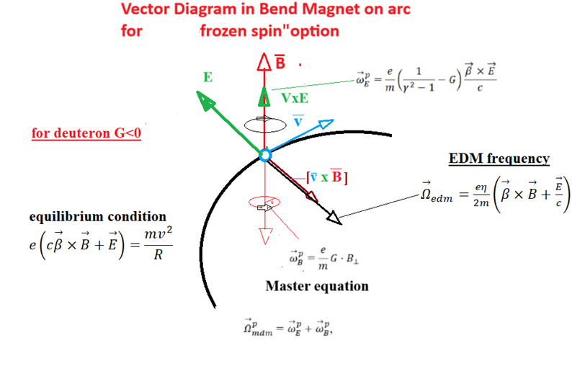
Figure 39. Vector diagram of the fields acting on a polarized deuteron.
Based on these relations, a frozen spin ring lattice was developed. Figure 40 shows the lattice of one arc for the deuteron beam. The arc consists of two successive achromats with zero dispersion at its middle and at its ends and comprises eight FODO cells.
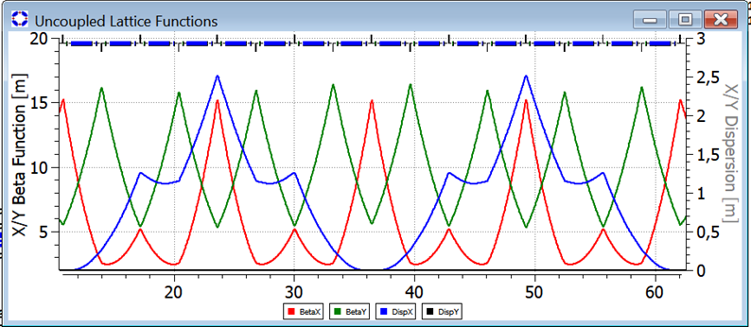
Figure 40. Twiss functions along an arc of the frozen spin deuteron ring.
As in the electrostatic proton ring, the dispersion modulation introduced in the deuteron lattice provides suitable locations for sextupoles suppressing the spin chromaticity. The main parameters of the synchrotron for the deuteron EDM search at 270 MeV per nucleon are listed in Tables 10 and 11. Figure 41 shows the Twiss functions of the whole ring with a circumference of 146 m; its layout is shown in Fig. 42.
Table 10. Parameters of the frozen spin ring with E+B deflectors for the deuteron EDM search.
Parameter | Value
Circumference, m | 145.85
Symmetry order (number of arcs and straight sections) | 2
Injection energy, MeV/u | 40
Final energy, MeV/u | 270.0
EDM experiment energy, MeV/u | 270.0
Deuteron magnetic anomaly $G$ | $−0.143$
Initial and final relative velocity and Lorentz factor | $β=0.2$, $γ=1.0213$; $β=0.485$, $γ=1.143$
Revolution frequency at the beginning and end of the cycle, MHz | 0.143–0.99
Harmonic number $h$ | 50
RF frequency at the beginning and end of the cycle, MHz | 7.15–49.9
Length of the quarter-wave RF cavity, m | 1.502
Momentum acceptance of the separatrix at maximum energy | $1.31×{10}^{−3}$
Relative momentum spread in the bunch | $5×{10}^{−4}$

Table 11. Parameters of the frozen spin ring with E+B deflectors for the deuteron EDM search (continued).
Parameter | Value
Arcs
Arc length, m | 51.27
Arc superperiodicity | 2
Arc lattice | 4 + 4 FODO cells
Number of E+B deflectors per arc | 16
Deflector length, m | 1.80
Deflector type | combined magnetic and electric
Maximum electric field of the deflector, MV/m | 12
Number of quadrupoles per arc | 15 + 1 (two end halves)
Quadrupole type | magnetic multipole
Quadrupole families | one focusing (QF), one defocusing (QD)
Maximum quadrupole gradient in the arcs, kG/cm | QF $=1.359$, QD $=−1.00$
Quadrupole length, m | 0.1
Number of chromatic sextupoles per arc | 16
Sextupole type | magnetic
Sextupole strengths, kG/cm$​^{2}$ | SF $=0.12$, SD $=0.15$
Betatron tunes $ν_{x}/ν_{y}$ | 4.70418/2.6140 (preliminary)
Natural chromaticity $ξ_{x}/ξ_{y}$ | $−4.91629/−3.99402$
Transition energy, GeV | 5.3
Maximum $β_{x}/β_{y}$, m | 15.1/16.5
Maximum horizontal dispersion, m | 2.5
Straight sections between arcs
Length of straight sections, m | $2×23.3$
Lattice of straight sections | $3×$FODO
Quadrupole gradients, kG/cm | QF $=0.734$, QD $=−0.782$
Free drift spaces between adjacent quadrupoles, m | $12×3.2$
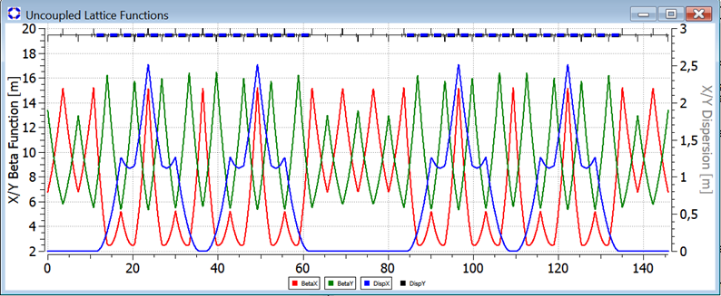
Figure 41. Twiss functions along the frozen spin deuteron ring.
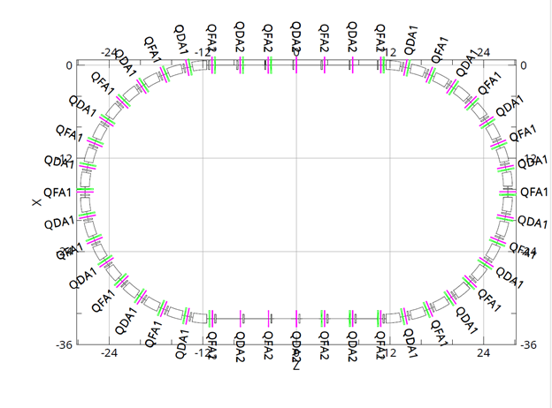
Figure 42. Layout and dimensions of the frozen spin deuteron ring.

5.3 Summary
Two specialized frozen spin lattices have been developed for the search for the proton and deuteron electric dipole moments. These results form the basis for the physical design of the experimental facilities and their cost estimate. In contrast to the quasi-frozen spin options of Sections 3 and 4, these rings are intended exclusively for experiments on the violation of fundamental symmetries.
The material of this section has been reported in [44].

6 Matrix description of spin dynamics for EDM rings

6.1 Introduction
The idea to measure the EDM value comes from the development of the FS method [1,43], where the observed signal is a vertical build-up of polarization due to the EDM for a longitudinally polarized beam. The main concern in the experiment is the influence of systematic effects.
Another method for measuring the EDM of charged particles, which allows achieving an accuracy of ${10}^{−29}$ $e⋅$cm, is the frequency domain method [45–47]. In this case, the spin precession frequency is measured, caused by the presence of both the Magnetic Dipole Moment (MDM) and the Electric Dipole Moment (EDM). The measurements are taken at a polarimeter in a structure with field perturbations in the elements. The MDM-induced spin-precession frequency in a Quasi-Frozen Spin (QFS) [24] state occurs around the axis lying in the ring plane. In the concept of linear contribution of systematic errors to the total value of the measured frequency, it is possible to subtract systematic effects caused by the MDM by injecting the beam in the opposite direction. Therefore, for high precision EDM experiment an analytical expression for the measured frequency and the direction of the spin precession axis has to be derived [4,48]. The correct estimate of the MDM-induced systematics is a necessary guidance to conduct the experiment on the EDM signal evaluation. The estimates of the MDM resonance strength in the QFS lattice are also presented below.
Spin vector of a particle $\vec{S}$ at each element of a storage ring with electric $\vec{E}$ or magnetic $\vec{B}$ field precesses around the local $\vec{Ω}$ with a frequency determined by the T-BMT equation (1).
After each element the $\vec{S}$ is rotated around $\vec{Ω}$ at an angle $ϕ=Ωdt$ that gives a hint that spin motion can be described in matrix notation. The latter is also motivated by the fact that the key measured values in the experiment are the spin-tune $ν_{s}$ and the direction of the invariant axis $\vec{n}$ at the observation point at azimuth $θ$. These properties are the integral characteristics of the ring and can be easily calculated in the spinor formalism.
Here the main features of the spinor algebra [49] are presented briefly. The coordinate frame is specified by the indices: (1, 2, 3) = (radial outward, longitudinal forward, vertical up). The Pauli matrices are: $\vec{σ}$ = ($σ_{1}$, $σ_{2}$, $σ_{3}$). $\vec{σ}$ = $\left(\left[\begin{matrix}0 & 1 \\ 1 & 0\end{matrix}\right], \left[\begin{matrix}0 & −i \\ i & 0\end{matrix}\right], \left[\begin{matrix}1 & 0 \\ 0 & −1\end{matrix}\right]\right)$. The rotation operator $M$ at an angle $ϕ$ around $\vec{n}$ is presented via:
$$M=exp\left[−i(\vec{σ}⋅\vec{n})\frac{ϕ}{2}\right]=cos\left(\frac{ϕ}{2}\right)−i(\vec{σ}⋅\vec{n})sin\left(\frac{ϕ}{2}\right). (42)$$
For a storage ring comprising $N$ elements the total Map is:
$$M=M_{N}M_{N−1}…M_{2}M_{1}. (43)$$
From (42) it is evident that at an observation point at azimuth $θ$:
$$\cos(\pi\nu_s)=\frac{1}{2}\textup{tr}(M(\theta)).
\qquad (44)$$
$$\vec{n}(\theta)=\frac{i/2}{\sin(\pi\nu_s)}\textup{tr}(\vec{\sigma}M(\theta)).
\qquad (45)$$
The method of describing spin dynamics in a storage ring for high precision EDM experiments has been initiated and developed by the JEDI collaboration for the COoler SYnchrotron COSY [50–53]. Mapping technique was used to describe spin motion in a magnetic ring and a resonant radio-frequency Wien filter.

6.2 QFS structure without imperfection fields
Let us consider a structure of the quasi-frozen spin type for searching for the EDM [24], consisting of an ideal magnetic ring and a static Wien filter in the straight section (Fig. 43). The rotation of the spin vector in the magnetic ring occurs around the sum vector $\vec{Ω}={\vec{Ω}}_{MDM}+{\vec{Ω}}_{EDM}$. The angle between ${\vec{Ω}}_{MDM}$ and $\vec{Ω}$ is $ξ$, that follows from Eq. (1) [50]:
$$ξ=\frac{ηβ}{2G}. (46)$$
In the absence of the EDM the local spin precession frequency is strictly vertical and $ξ=0$. In the case of non-zero EDM the spin precession axis in the magnetic ring is [51]:
$$\vec{n}=−sinξ⋅{\vec{e}}_{x}+cosξ⋅{\vec{e}}_{y}. (47)$$
Using Eq. (42) one can get the spin rotation matrix for a magnetic ring at an angle $ϕ_{M}$:
$$M_{r}=cos\left(\frac{ϕ_{M}}{2}\right)+iσ_{1}sinξsin\left(\frac{ϕ_{M}}{2}\right)−iσ_{3}cosξsin\left(\frac{ϕ_{M}}{2}\right). (48)$$
For the straight WF there is no EDM rotation in case the net Lorentz force is zero. Then the matrix of spin rotation at an angle $ϕ_{E}$ is:
$$M_{WF}=cos\left(\frac{ϕ_{E}}{2}\right)−iσ_{3}sin\left(\frac{ϕ_{E}}{2}\right). (49)$$
To obtain the measured values at the polarimeter point let us consider a map $M=M_{r}⋅M_{WF}$ for the full structure up to second order in $ξ$ and assume that the spin rotation in the ring is compensated in the WF:
$$\phi_M+\phi_E=2\pi K, \textup{where}~K\in \mathbb{Z}.
\qquad (50)$$
Using Eq. (44) one can get the spin-tune for the structure [29]:
$$ν_{s_{−}QFS}≃\frac{1}{π}sin\left(\frac{ϕ_{M}}{2}\right)⋅ξ. (51)$$
Note that it is linear in the EDM.
According to Eq. (45) the $\vec{n}$ lies in the ring plane up to terms linear in $ξ$:
$$n_{x}≃−cos\left(\frac{ϕ_{M}}{2}\right), n_{z}≃−sin\left(\frac{ϕ_{M}}{2}\right). (52)$$
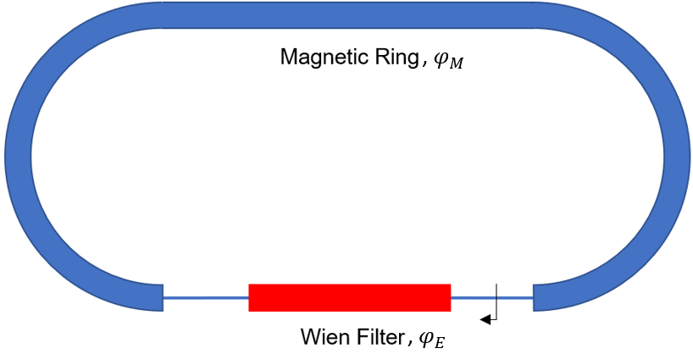
Figure 43. QFS lattice comprising a magnetic ring and a WF. $ϕ_{M}$ and $ϕ_{E}$ – corresponding spin rotation angles.

6.3 Difference of FS and QFS
For the FS structure [43] from Eq. (1) it follows that $\vec{n}={\vec{e}}_{x}$ and the spin-tune is:
$$ν_{s_{−}FS}=\frac{Ω_{EDM}}{Ω_{cycl}}=\frac{ηβγ}{2}. (53)$$
Then the ratio $r$ or the decrement of the EDM signal measured in the QFS structure relative to the FS is [54]:
$$r=\frac{ν_{s_{−}QFS}}{ν_{s_{−}FS}}=\frac{sin\left(\frac{ϕ_{M}}{2}\right)}{\frac{ϕ_{M}}{2}}=j_{0}\left(\frac{ϕ_{M}}{2}\right). (54)$$
From Eq. (54) it follows that to increase the measured EDM signal in the QFS structure it is necessary to decrease the spin rotation angle $ϕ_{M}$ in the magnetic segment of the ring. Also the integer number of spin revolutions in the magnetic ring doesn’t lead to accumulation of the EDM signal. Hence, it is reasonable to consider the structure of the type:
$$ϕ_{M}=−ϕ_{E}, ϕ_{M}→0. (55)$$
Which is a special case of Eq. (50).
For particles with relatively large value of $G$, e.g. protons, it is necessary to place several pairs of magnetic segments with Wien filters. Also, the direction of the invariant spin axis in the QFS structure (52) is not strictly radial, in contrast to the case of the FS structure.

6.4 Consideration of imperfection fields

6.5 Spin Precession Axis for a Magnetic Ring with EDM
For a simple example of imperfection fields caused by magnet rolls around the longitudinal axis by an angle $α$ the direction of the spin precession axis in each element has the following form:
$$\vec{n}=\left(−sinα−ξ⋅cosα\right){\vec{e}}_{x}+\left(cosα−ξ⋅sinα\right){\vec{e}}_{y}. (56)$$
Let us represent the magnetic segment of the ring as a set of misaligned magnets, without loss of generality. Then for $N$ elements one can obtain that [52]:
$$M_{r}\left(\vec{n},ϕ\right)=M_{r}\left(c_{y}{\vec{e}}_{y}+\left[c_{x}+ξ\right]{\vec{e}}_{x}+c_{z}{\vec{e}}_{z},ϕ_{Σ}\right). (57)$$
This expression is obtained in the first order in $ξ$, neglecting terms of the order $ξ⋅α$ and higher. $c_{x},c_{y},c_{z}$ are the components of the spin precession axis for the magnetic ring with misaligned magnets, without the EDM. $ϕ_{Σ}$ is the total spin rotation angle.

6.6 QFS Structure with Imperfection Fields
Let us consider a lattice consisting of a magnetic ring with field imperfections and a Wien filter (Fig. 44). We use expression (57) for the spin rotation matrix in the ring and (49) for the Wien filter. Then one can cast the full matrix for the QFS structure as $M=M_{r}⋅M_{WF}$ and use the property $c_{y}^{2}=1−(c_{x}+ξ)^{2}−c_{z}^{2}$.
Similarly to the case of an ideal structure, we obtain expression for the spin-tune using properties (44) and (55):
$$ν_{s_{−}QFS}≃\frac{1}{π}sin\left(\frac{ϕ_{M}}{2}\right)\sqrt{(c_{x}+ξ)^{2}+c_{z}^{2}}. (58)$$
Linear summation of frequencies caused by the MDM and EDM for $c_{x}≫c_{z}$ allows one to subtract the systematic contribution from the MDM to the measured frequency and detect the EDM signal using the frequency method [45] that will be discussed below.

6.7 Spin dynamics perturbations in a resonance state
As the radial field perturbations play a decisive role and can mimic the EDM, they will be considered in detail. They can arise from rotations of dipole magnets around the longitudinal axis and from vertical shifts of quadrupoles. The latter change the position of the vertical closed orbit $y_{orb}$ in the quadrupoles, and the beam experiences the influence of the dipole component of a radial field: $B_{x}=\frac{dB_{x}}{dy}y_{orb}$.
Let us assume that in a storage ring there is a finite number of perturbations distributed at azimuth $θ$. The latter rotate spins at angles $ψ_{i}≪1$. One can cast the total Map of the ring and apply conditions (44), (45). In the linear approximation in $ψ$ one can show that summation of perturbations in the observation point is equivalent to the summation of vectors from each unit perturbation. Where the phase of spin rotation in an ideal lattice $ϕ$ is taken into account. One can rename spin-tune in a resonance $ν_{s}=|ϵ|$ or resonance strength. Here $Re(ϵ)$ and $Im(ϵ)$ give $n_{r}$ and $n_{z}$. Then:
ϵ=12πi​ψi⋅eiϕ. (59)

Frozen Spin Structure
Let us consider a frozen spin structure for searching for the EDM, consisting of E+B Wien filters [55]. The latter allow for the spin to be codirected with the momentum vector: $\vec{S}∥\vec{P}$. Moreover, the radial perturbations $ψ_{i}$ in the structure commute due to the identical transformation of the spin motion from one perturbation to another. By analogy with formula (60), we can assert that the phase of the spin motion is zero in any segment of the FS structure. Then:
$$\begin{gather}
\nu_{s}=\frac{1}{2\pi}\sum_{i=1}^{N}{\psi_i}, \\
\vec{n} =\vec{e_{r}}, \textup{ if } \sum_{i=1}^{N}\psi_{i}\ne0.
\end{gather}$$
Each radial perturbation results in $\vec{n}$ pointing strictly radial in an observation point. And from (61) it follows that the measured spin-precession frequency is the arithmetic average of local frequencies $Ω_{i}$ given by the T-BMT equation (1).
It is also worth noting that in a fully magnetic structure, the averaged Lorentz force along a closed orbit is zero, and $\sum_{i=1}^{N}{ψ_{i}}=0$. In structures with Wien filters acting on spin dynamics only $\sum_{i=1}^{N}{ψ_{i}}≠0$.

Quasi-frozen Spin Structure
Let us consider a structure of the quasi-frozen spin type for searching for the EDM [24], consisting of an ideal magnetic ring and Wien filter insertions at straight sections (Fig. 43).
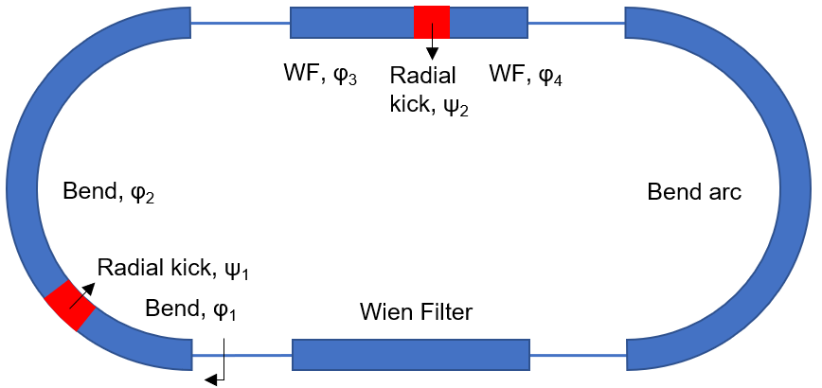
Figure 44. QFS lattice with radial perturbations. $ϕ$ and $ψ$ – corresponding spin rotation angles.
For the case of two perturbations $ψ_{1}$ and $ψ_{2}$ we construct the Map $M_{QFS}(ψ_{1},ψ_{2})$. In the linear approximation in $ψ$ we get:
$$ϵ=\frac{1}{2π}\left[ψ_{1}e^{iϕ_{1}}+ψ_{2}e^{−iϕ_{4}}\right]. (62)$$
In the case of $N$ perturbations we get:
ϵ=12πarc​ψieiϕarc+WF​ψie−iϕWF. (63)
Where
$$\phi_{arc}=\left(\frac{l}{L_{arc}}\right)\phi_{max}, \textup{ } \phi_{WF}=\left(1-\frac{l}{L_{WF}}\right)\phi_{max}.
\qquad (64)$$
From relation (63) it follows that the farther the perturbation is from the origin of the arc and the closer it is to the origin of the Wien filter, the greater the contribution of the radial perturbation to the longitudinal component of $\vec{n}$ at the observation point. Here $l$ is the longitudinal coordinate along the arc or Wien filter; $ϕ_{max}$ is the maximum spin rotation angle. In the QFS state $ϕ_{max}=\left(2π/P\right)⋅γG$. For the case of the structure in Fig. 44 the periodicity $P=2$. When using particles with a small $G$ factor, for example, deuterons or with increasing the periodicity of the storage ring $ϕ_{max}→0$. This fact is necessary to increase the accumulated EDM signal [56]. Moreover, from condition (63) it follows that the prevailing direction of spin precession axis is radial:
$$\vec{n}\sim\vec{e_r} \textup{ for } \phi_{max}\to 0.
\qquad (65)$$
The QFS resonance strength was estimated in a numerical experiment.The characteristic dipole rotation angle is ${10}^{−4}$ rad. This corresponds to alignment error of 100 $μ$m over a magnet length of 1 m. The characteristic RMS deviation of the closed orbit in the quadrupoles is 0.5 mm. The main parameters of the structure in Fig. 44 correspond to the NICA collider lattice with bypass channels [24]. That is, deuterons with a kinetic energy of 240 MeV. The simulation results for estimating the resonance strength are presented in Fig. 45. The QFS resonance strength was found to be $ϵ∼{10}^{−4}$. This corresponds to an angular velocity of spin rotation of $\Omega\sim500\--1000$ rad/s. A leading contribution from radial perturbations is due to vertical orbit shifts in quadrupoles. The effect of dipole rolls is about one order of magnitude lower: $ϵ∼0.5⋅{10}^{−5}$. The results of numerical modeling for the radial projection of $\vec{n}$ at the observation point are presented in Fig. 46. This confirms condition (65).
With finite detuning from the QFS state the vertical projection of $\vec{n}$ emerges (Fig. 47). In the single resonance model (SRM) [57] for the case of positive detuning $ν_{0}$ from resonance with strength $ϵ$ we obtain:
$$\begin{matrix}\vec{Ω}=ν_{0}⋅{\vec{e}}_{y}+ϵ\left[{\vec{e}}_{r}⋅cosϕ+{\vec{e}}_{z}⋅sinϕ\right];Ω=\sqrt{ν_{0}^{2}+ϵ^{2}}, \\ \vec{n}=\vec{Ω}/Ω;ν_{s}=Ω.\end{matrix}$$
The numerical results in Fig. 47 coincide with the SRM prediction. It means that spin resonance description is valid for the QFS state. The corresponding results to conduct the EDM measurement procedure for the QFS state were obtained in a numerical experiment in the COSY Infinity software [17].
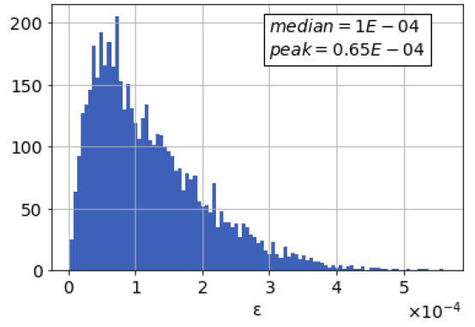
Figure 45. Histogram of the QFS resonance strength $ϵ$, taking into account dipole rolls and orbit shifts in quadrupoles.
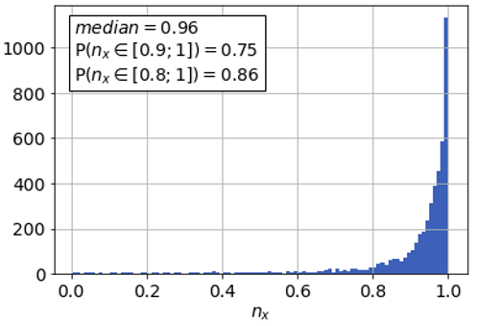
Figure 46. Histogram of the radial projection of $\vec{n}$ at the observation point at the straight section in the QFS structure with dipole rolls and orbit shifts in quadrupoles.
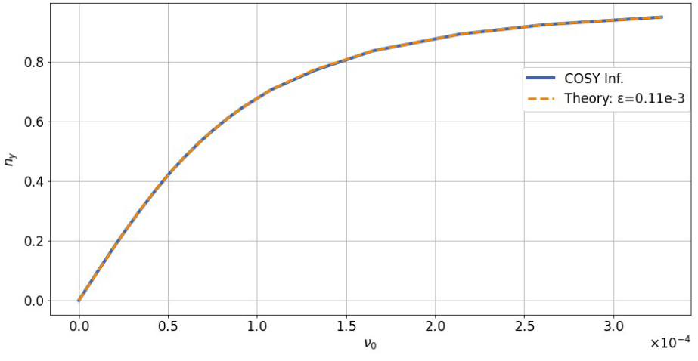
Figure 47. Vertical projection of the invariant axis $\vec{n}$ as a function of the spin-tune of the unperturbed structure $ν_{0}$. The data represent a QFS structure with radial perturbations. The results obtained in the COSY Infinity environment (blue) are compared with the theoretical dependence in the single resonance model SRM (orange). The data are obtained for one particular realization of element misalignments along the ring.

6.8 EDM Measurement in a Frequency Domain
The idea to measure the induced MDM+EDM spin precession frequency without the minimization of MDM rotations in the ring was proposed by Yu. Senichev [45,46] and developed in the spinor formalism in [48]. Here we will summarize the key points.
From the T-BMT equation (1) it follows that the spin precession frequency $Ω$ at the observation point is:
$$Ω=\sqrt{{\left(Ω_{Br}+Ω_{EDM}\right)}^{2}+Ω_{Bv,Er}^{2}+Ω_{Bz}^{2}}. (66)$$
Here $Ω_{Br}$ is the radial component of the measured frequency. It arises due to the misalignments of elements in the absence of the EDM. $Ω_{Bv,Er}$ and $Ω_{Bz}$ are the vertical and longitudinal components respectively. Next we purposely make the radial projection of the frequency vector to be predominant [45]:
$${\left(Ω_{Br}+Ω_{EDM}\right)}^{2}≫Ω_{Bv,Er}^{2},Ω_{Bz}^{2}. (67)$$
Then eq. (66) can be rewritten as:
$$Ω=Ω_{Br}+Ω_{EDM}+\frac{1}{2}\frac{Ω_{Bv,Er}^{2}+Ω_{Bz}^{2}}{Ω_{Br}+Ω_{EDM}}. (68)$$
Next we assure that
$$Ω_{EDM}>\frac{1}{2}\frac{Ω_{Bv,Er}^{2}+Ω_{Bz}^{2}}{Ω_{Br}+Ω_{EDM}}. (69)$$
Then the EDM-frequency can be determined from the first two terms in eq. (68) with the beam injection in the opposite direction and calibrating the $Ω_{Br}$ value in the vicinity of the resonance [45].

7 Axion search mode
The motivation to search for the existence of axion dark matter rests in its capability to solve the strong CP-problem. In a storage ring environment it could be probed by polarized beams. One looks for a resonance between the natural spin precession in the ring and the oscillating axion field. The former is being scanned in the frequency range corresponding to a mass range of interest. Only so-called light axions or axion-like particles (ALPs) , with masses below 0.1 $μ$eV/c$​^{2}$, could be probed in an accelerator, due to the upper limit on the natural spin precession frequency. Ultralight axions could be reached by employing spin freezing technologies such as the strictly or quasi frozen spin, spin transparency induced by Siberian snakes, or the Figure-8 ring. [58]
The pilot experiment to search for axions has been carried out at COSY in 2019. [59] That experiment achieved an upper limit on the axion-induced EDM approaching $d = 5⋅{10}^{−23} e⋅$cm. The concept of that experiment consists in observing a difference between the vertical projections of the beam’s polarization before and after a resonance crossing. Simple statistical considerations [60] show that for that machine the achieved precision is close to the statistical limit. Further improvements could be made by reducing the uncertainty of polarimetry or by lowering the scan speed. The former would lower the observation significance threshold, the latter allow for a greater accumulation of the signal difference. Figure 48 presents the possible improvement on the EDM estimate’s upper bound. The relationship presented in the figure can be formally expressed by
$$Θ=2ξ\sqrt{\dot{f}}, (70)$$
in which $ξ$ is the significance threshold, $\dot{f}$ the scan speed, $Θ$ reflects the axion spin-driving force. The latter quantity converts into the oscillating EDM or the axion wind coupling strength, depending on the theory.
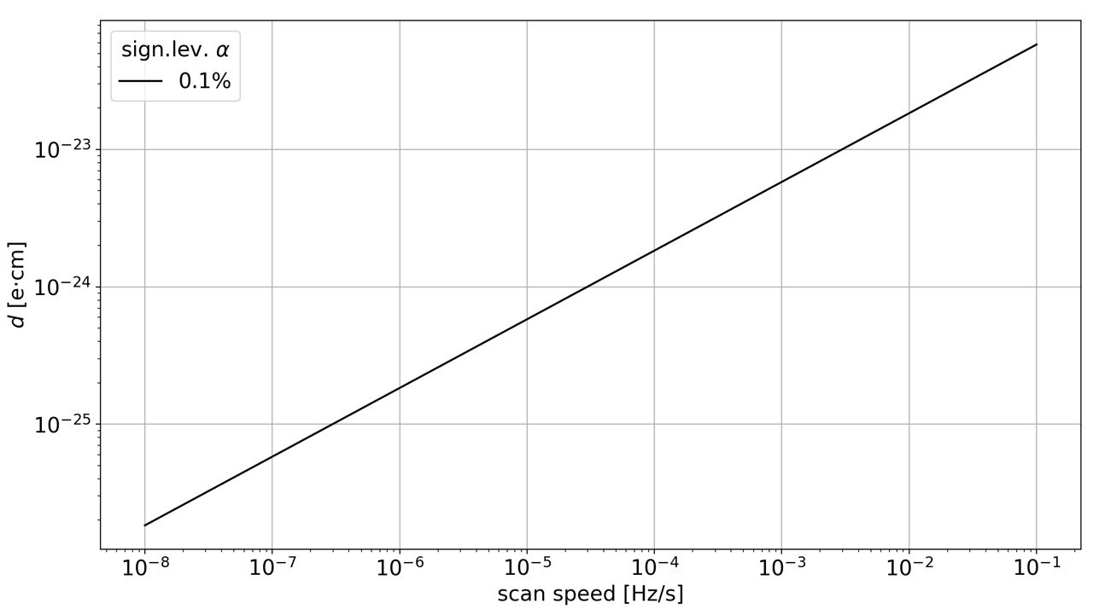
Figure 48. EDM estimate projection for the pilot experiment.

Acknowledgments
This work was supported by the Russian Science Foundation, grant No. 25-72-30005 (https://rscf.ru/project/25-72-30005/).

References
[1] D. Anastassopoulos et al., Search for a permanent electric dipole moment of the deuteron nucleus at the ${10}^{−29} e⋅$cm level, (2008).
[2] Yu. Senichev, A. Aksentyev, S. Kolokolchikov, A. Melnikov, N. Nikolaev, V. Ladygin, and E. Syresin, NICA Facilities for the Search for EDM Light Nuclei, Phys. Atom. Nucl. 87, 436 (2024).
[3] Yu. V. Senichev, A. E. Aksentyev, S. D. Kolokolchikov, A. A. Melnikov, V. P. Ladygin, and E. M. Syresin, Consideration of an Adapted Nuclotron Structure for Searching for the Electric Dipole Moment of Light Nuclei, Phys. Atom. Nucl. 86, 2434 (2023).
[4] A. E. Aksentev, Search for the Electric Dipole Moment of a Deuteron Using a Storage Ring, Phys. Atom. Nucl. 84, 1920 (2021).
[5] G. Guidoboni et al., How to Reach a Thousand-Second in-Plane Polarization Lifetime with 0.97-GeV/c Deuterons in a Storage Ring, Phys. Rev. Lett. 117, 054801 (2016).
[6] V. Bargmann, L. Michel, and V. L. Telegdi, Precession of the polarization of particles moving in a homogeneous electromagnetic field, Phys. Rev. Lett. 2, 435 (1959).
[7] T. Fukuyama and A. J. Silenko, Derivation of Generalized Thomas-Bargmann-Michel-Telegdi Equation for a Particle with Electric Dipole Moment, Int. J. Mod. Phys. A 28, 1350147 (2013).
[8] Y. Senichev, S. Andrianov, M. Berz, S. Chekmenev, A. Ivanov, and E. Valetov, Investigation of Lattice for Deuteron EDM Ring, in 12th International Computational Accelerator Physics Conference (2016), pp. 17–19.
[9] S. D. Kolokolchikov, Y. V. Senichev, A. E. Aksentyev, A. A. Melnikov, and P. I. Palamarchuka, Quasi-frozen spin for both deuteron and proton beams in a periodic EDM storage ring lattice, Nucl. Sci. Tech. 37, 148 (2026).
[10] M. W. Mcnaughton et al., THE P C ANALYZING POWER BETWEEN 100-MEV AND 750-MEV, Nucl. Instrum. Meth. A 241, 435 (1985).
[11] P. K. Kurilkin et al., The 270 MeV deuteron beam polarimeter at the Nuclotron Internal Target Station, Nucl. Instrum. Meth. A 642, 45 (2011).
[12] N. N. Nikolaev, Spin of protons in NICA and PTR storage rings as an axion antenna, Pisma Zh. Eksp. Teor. Fiz. 115, 683 (2022).
[13] Yu. Senichev, A. Aksentyev, S. Kolokolchikov, and A. Melnikov, Features of the Spin-orbital Dynamics of a Polarized Beam in Electrostatic and Magnetostatic Fields in the Study of the Electric Dipole Moment of light Nuclei, Phys. Atom. Nucl. 87, 1467 (2024).
[14] Y. Senichev, A. Melnikov, A. Aksentyev, E. Syresin, P. Palamarchuka, S. Kolokolchikov, and V. Ladygin, Wien filter method for the ”Quasi-frozen” spin lattice, JACoW IPAC2025, TUPS032 (2025).
[15] V. Lebedev, OptiM: computer code for linear and non-linear optics calculations, (2010).
[16] S. Guiducci, Chromaticity, in CERN Accelerator School: Course on General Accelerator Physics (1992), pp. 191–206.
[17] K. Makino and M. Berz, COSY INFINITY Version 9, Nucl. Instrum. Meth. A 558, 346 (2006).
[18] Y. Senichev, A. Aksentyev, and A. Melnikov, Spin Chromaticity of Beam: Orbit Lengthening and Betatron Chromaticity, Phys. Atom. Nucl. 84, 2014 (2021).
[19] A. Melnikov, A. Aksentyev, Y. Senichev, and S. Kolokolchikov, Studies of the spin coherence time of protons at COSY, JACoW IPAC2023, TUPM077 (2023).
[20] A. E. Aksentev, A. A. Melnikov, Y. V. Senichev, V. P. Ladygin, and E. M. Syresin, Investigation of spin-decoherence in the NICA storage ring for the future EDM-measurement experiment, JACoW IPAC2022, WEPOPT006 (2022).
[21] A. E. Aksentev, A. A. Melnikov, and Yu. V. Senichev, Investigation of Spin Decoherence of a Beam with a Nonadiabatic Change in the Orientation of the Stable Axis of the Spin, Phys. Atom. Nucl. 85, 1675 (2022).
[22] A. A. Melnikov, Yu. V. Senichev, A. E. Aksentyev, and S. D. Kolokolchikov, Nature of Spin Decoherence of a Polarized Beam of Light Nuclei in a Storage Ring for EDM Search, JETP Lett. 118, 710 (2023).
[23] A. Melnikov, A. Aksentyev, Y. Senichev, and E. Syresin, Investigation of polarized proton spin coherence time at storage rings, JACoW IPAC2022, 1832 (2022).
[24] Y. Senichev, A. Aksentyev, S. Kolokolchikov, A. Melnikov, V. Ladygin, E. Syresin, and N. Nikolaev, Quasi-frozen spin concept of magneto-optical structure of NICA adapted to study the electric dipole moment of the deuteron and to search for the axion, JACoW IPAC2022, MOPOTK024 (2022).
[25] S. Kolokolchikov, A. Aksentyev, A. Melnikov, Yu. Senichev, V. Ladygin, and E. Syresin, Designing Bypass Channels in NICA Accelerator Complex for Polarized Beam Experiments for EDM Search, Phys. Atom. Nucl. 86, 2423 (2023).
[26] S. Kolokolchikov, A. Aksentyev, A. Melnikov, Y. Senichev, E. Syresin, and V. Ladygin, ByPass optics design in NICA storage ring for experiment with polarized beams for EDM search, JACoW IPAC2023, MOPA072 (2023).
[27] S. Kolokolchikov, A. Aksentyev, A. Melnikov, and Y. Senichev, Spin coherence and betatron chromaticity of deuteron beam in NICA storage ring, JACoW IPAC2023, MOPA070 (2023).
[28] A. E. Aksentev, A. A. Melnikov, Y. V. Senichev, S. D. Kolokolchikov, V. P. Ladygin, E. M. Syresin, and A. V. Butenko, A feasibility study into the quasi-frozen spin regime of operation of the NICA storage ring, JACoW IPAC2023, MOPA071 (2023).
[29] A. Melnikov, A. Aksentyev, Yu. Senichev, and S. Kolokolchikov, Quasi-Frozen Spin Concept at NICA for EDM Search and Its Matrix Analysis, Phys. Atom. Nucl. 87, 447 (2024).
[30] A. E. Aksentev, A. A. Melnikov, Yu. V. Senichev, and S. D. Kolokolchikov, Spin-Flipping When Approaching the Resonant Energy in the Perturbed NICA Collider Facility with Bypasses, Phys. Atom. Nucl. 87, 1363 (2024).
[31] Yu. V. Senichev, A. E. Aksent’ev, S. D. Kolokol’chikov, A. A. Mel’nikov, V. P. Ladygin, and E. M. Syresin, Magneto-Optical Structure of the Nuclotron for Searching for the Electric Dipole Moment of Light Nuclei, Phys. Part. Nucl. Lett. 21, 266 (2024).
[32] Yu. V. Senichev, S. D. Kolokolchikov, A. E. Aksentyev, A. A. Melnikov, N. N. Nikolaev, V. P. Ladygin, and E. M. Syresin, Modernization of the Magneto-Optical Structure of the Nuclotron to Study the Possibility of Measuring the Electric Dipole Moment of Light Nuclei with Preservation of Functions of the Booster of Polarized Beams for the NICA Collider, Phys. Atom. Nucl. 88, 2025 (2025).
[33] Yu. V. Senichev, S. D. Kolokolchikov, A. E. Aksentyev, A. A. Melnikov, N. N. Nikolaev, V. P. Ladygin, and E. M. Syresin, Highly Superperiodic Structure of the Nuclotron with Quasi-Frozen Spin for Studying the Electric Dipole Moment of Light Nuclei, Phys. Part. Nucl. Lett. 23, 206 (2026).
[34] Y. Senichev and A. Aksentyev, Features of Quasi-frozen Spin Concept of Storage Ring for Searching for Electric Dipole Moment of Deuteron, J. Phys. Conf. Ser. 1686, 012068 (2020).
[35] D. Eversmann et al., New method for a continuous determination of the spin tune in storage rings and implications for precision experiments, Phys. Rev. Lett. 115, 094801 (2015).
[36] Y. Senichev, A Resonant lattice for a synchrotron with a low or negative momentum compaction factor, (1997).
[37] Y. Ishi, S. Machida, Y. Mori, and S. Shibuya, Lattice design of JHF synchrotrons, Conf. Proc. C 9803233, 378 (1998).
[38] Y. Papaphilippou, W. Bartmann, H. Bartosik, M. Benedikt, B. Goddard, A. Lachaize, and Y. Senichev, Comparison of PS2 Lattices with Different Geometries, Conf. Proc. C 100523, THPE021 (2010).
[39] Yu. Senichev, The lattice with imaginary gamma-transition for the CERN proton synchrotron PS2, in CARE-HHH-APD Workshop on Finalizing the Roadmap for the Upgrade of the CERN & GSI Accelerator Complex (BEAM’07) (2008).
[40] R. Toelle et al., HESR at FAIR: Status of technical planning, Conf. Proc. C 070625, 1442 (2007).
[41] S. Kolokolchikov, A. Melnikov, A. Aksentyev, E. Syresin, P. Palamarchuka, V. Ladygin, and Y. Senichev, Electrostatic deflector Nuclotron modernization for EDM experiment, JACoW IPAC2025, TUPS031 (2025).
[42] Y. Senichev, R. Maier, D. Zyuzin, and N. Kulabukhova, Spin Tune Decoherence Effects in Electro- and Magnetostatic Structures, in 4th International Particle Accelerator Conference (2013), pp. 2579–2581.
[43] F. J. M. Farley and Y. K. Semertzidis, The 47 years of muon g-2, Prog. Part. Nucl. Phys. 52, 1 (2004).
[44] P. I. Palamarchuka, S. D. Kolokolchikov, A. E. Aksentyev, A. A. Melnikov, and Yu. V. Senichev, Development of a Conceptual Storage Ring Structure for the Study of the Electric Dipole Moment of Light Nuclei, Phys. Part. Nucl. Lett. 23, 365 (2026).
[45] Y. Senichev, A. Aksentev, A. Ivanov, and E. Valetov, Frequency domain method of the search for the deuteron electric dipole moment in a storage ring with imperfections, (2017).
[46] A. E. Aksentev and Y. V. Senichev, Frequency domain method of the search for the electric dipole moment in a storage ring, J. Phys. Conf. Ser. 1435, 012026 (2020).
[47] A. E. Aksentev and Y. V. Senichev, Statistical precision in charged particle EDM search in storage rings, J. Phys. Conf. Ser. 941, 012083 (2017).
[48] A. A. Melnikov, Yu. V. Senichev, A. E. Aksentyev, and S. D. Kolokolchikov, Spinor Description of Frozen and Quasi-Frozen Spin Structures for the EDM Measurement in a Frequency Domain, Phys. Atom. Nucl. 87, 1351 (2024).
[49] A. W. Chao, K. H. Mess, M. Tigner, and F. Zimmermann, editors, Handbook of accelerator physics and engineering: 2nd Edition, 2nd ed. (World Scientific, Hackensack, USA, 2013).
[50] F. Rathmann, N. N. Nikolaev, and J. Slim, Spin dynamics investigations for the electric dipole moment experiment, Phys. Rev. Accel. Beams 23, 024601 (2020).
[51] N. N. Nikolaev et al., Spin decoherence and off-resonance behavior of radio-frequency-driven spin rotations in storage rings, Phys. Rev. Accel. Beams 27, 111002 (2024).
[52] A. Saleev et al., Spin tune mapping as a novel tool to probe the spin dynamics in storage rings, Phys. Rev. Accel. Beams 20, 072801 (2017).
[53] A. Andres et al., First Experimental Limit on the Permanent Electric Dipole Moment of the Deuteron, Phys. Rev. Lett. 136, 241801 (2026).
[54] A. A. Melnikov, Yu. V. Senichev, A. E. Aksentyev, and S. D. Kolokolchikov, Investigation of the Quasi-Frozen Spin Lattice for the EDM Search, Phys. Atom. Nucl. 88, 1999 (2025).
[55] F. Abusaif et al., Storage ring to search for electricdipole moments of charged particles: Feasibility study (CERN, Geneva, 2021).
[56] A. Melnikov, A. Aksentyev, N. Nikolaev, S. Kolokolchikov, and Y. Senichev, Quasi-frozen spin concept to search for the electric dipole moment of the proton and deuteron, JACoW IPAC2025, TUPS033 (2025).
[57] S. R. Mane, Yu. M. Shatunov, and K. Yokoya, Spin-polarized charged particle beams in high-energy accelerators (IOP Publishing, 2005).
[58] Y. N. Filatov, Y. S. Derbenev, R. Suleiman, A. M. Kondratenko, M. A. Kondratenko, V. S. Morozov, A. V. Butenko, and E. M. Syresin, Spin Transparency Method for High Precision Experiments with Polarized Beams, JPS Conf. Proc. 37, 021108 (2022).
[59] S. Karanth et al., First Search for Axionlike Particles in a Storage Ring Using a Polarized Deuteron Beam, Phys. Rev. X 13, 031004 (2023).
[60] A. Aksentev et al., The evaluation of a minimal oscillating EDM detectable in a storage ring, Phys. Part. Nucl. Lett. (2026).

