Scenario 5 – Final diagnosis differs from provisional

diagnosis

A 62-year-old married male named Jayantha Jayalath is admitted to

Colombo North Teaching Hospital (CNTH) with a history of chest pain.

He is admitted to Ward 12 on 18 April 2012 at 10.25 in the evening. On

examination by the admitting doctor (Dr W. Thomas, Admitting Medical

Officer), a **provisional diagnosis** of acute myocardial infarction is made.

The patient is seen by the *Senior House Officer o*f the ward, Dr Kevin

Williams, at 10.39 the same night. The ECG and other investigations reveal

an acute anterolateral myocardial infarction. The patient is given the

necessary treatment. He recovers well and is discharged from the ward on 23 April at 12.25pm

| Hospital Ward Number | Hospital Ward Number | Hospital Ward Number | Hospital Ward Number |
| --- | --- | --- | --- |
| MR Number Date of Admission | MR Number Date of Admission | MR Number Date of Admission | MR Number Date of Admission |
| Attending Physician Time of Admission | Attending Physician Time of Admission | Attending Physician Time of Admission | Attending Physician Time of Admission |
| Patient Name in Full | Patient Name in Full | Patient Name in Full | Patient Name in Full |
| Patient Address | Patient Address | Patient Address | Patient Address |

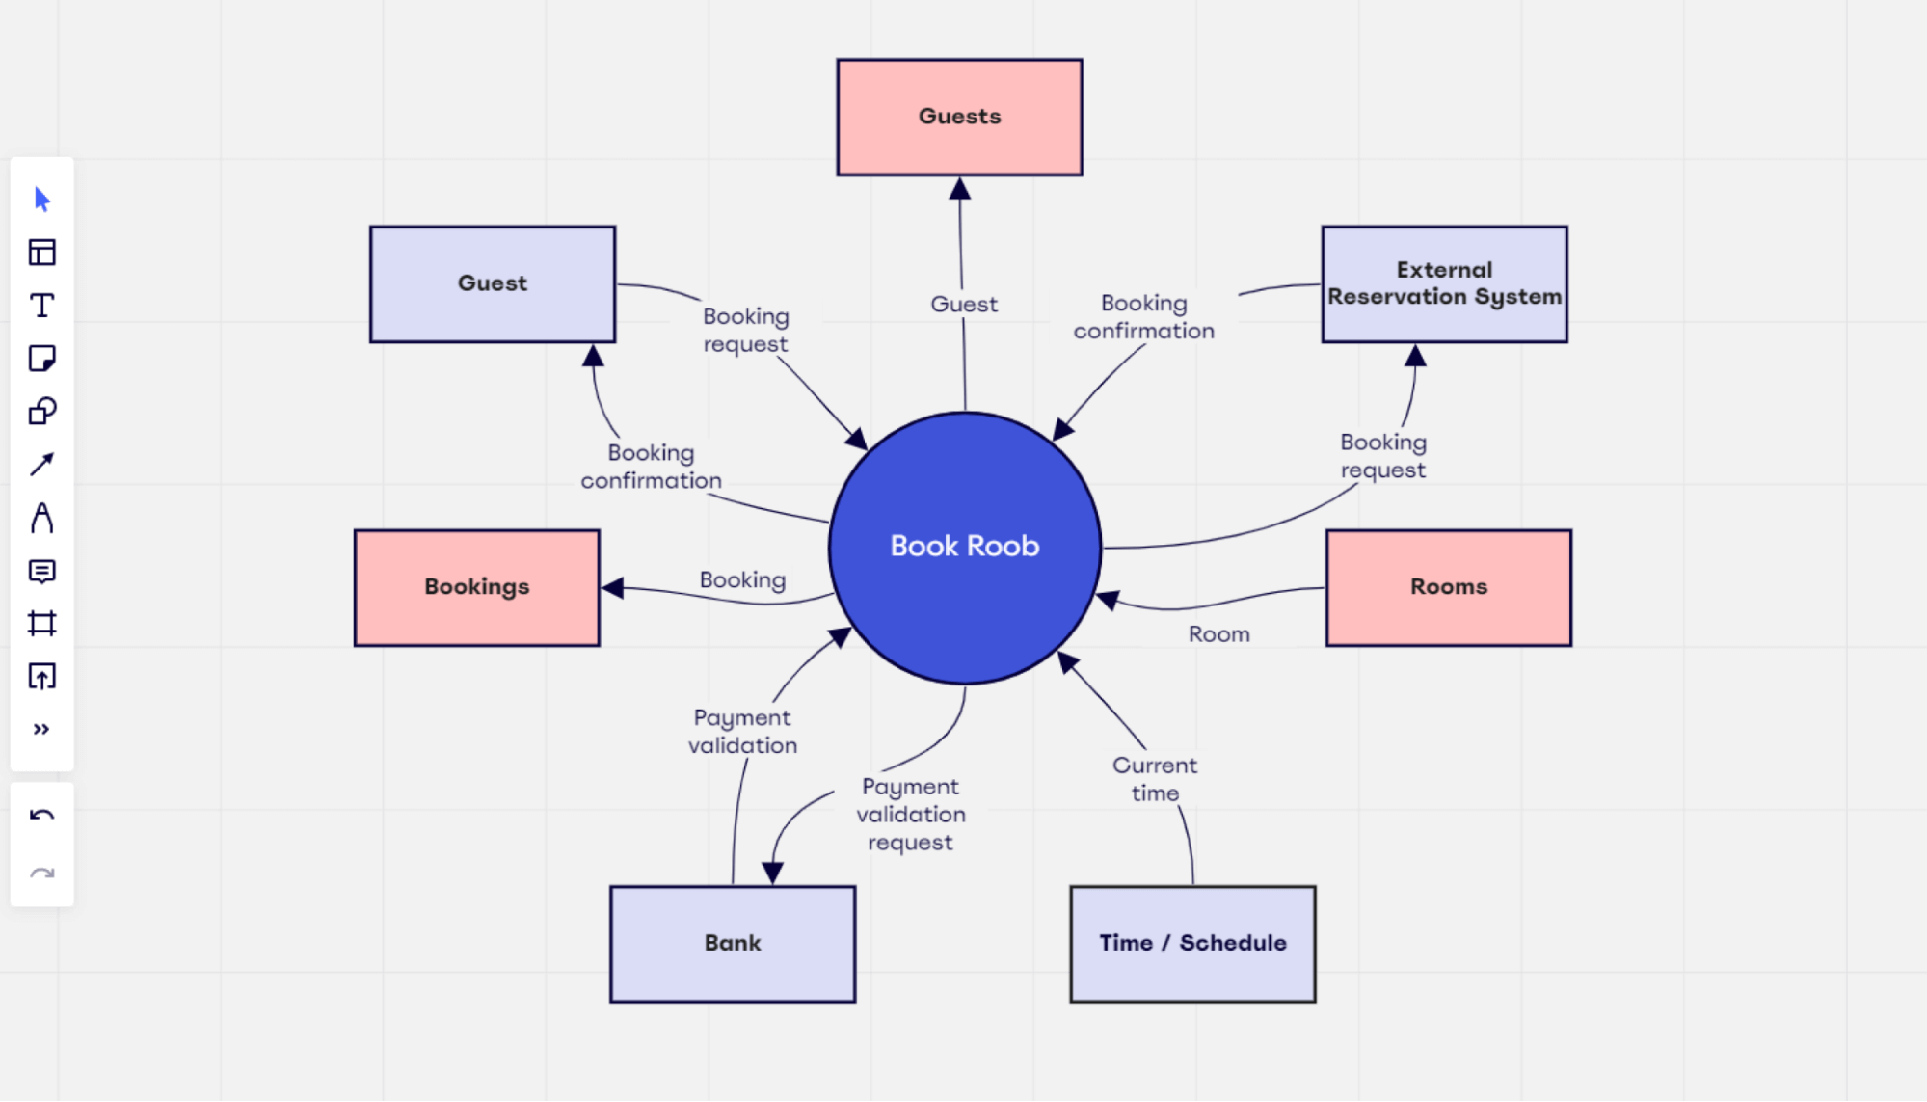

References

**Huffman**, Edna K 1994, Health information management, 10th edn,

Physicians’ Record Company, Berwyn, Illinois.

Lowe, N 2009, ‘Medical record keeping and documentation standards’,

in Managed Health Services provider manual, Managed Health Services,

Milwaukee, Wisconsin.

Royal College of Physicians 2009, Improving clinical records and clinical

coding together, Audit Commission, 1st Floor, Millbank Tower, Millbank,

London.

WHO—see World Health Organization.

World Health Organization 2006, ‘Components of a medical record’, in

Medical records manual: A guide for developing countries, World Health

Organization, Geneva.

—2004, International statistical classification of diseases and related

health problems, 10th revision, vol 2, 2nd edn, World Health Organization,

Geneva.

—2003, Improving data quality: A guide for developing countries, World

Health Organization, Regional Office for the Western Pacific, Manila