Gateway whitelisting application

Part 1. General information
"Whitelisting is foundational for comprehensive information security protection" - Gartner

"A combination of digital signature/publisher and cryptographic hash techniques generally provides the most accurate and comprehensive application whitelisting capability" - NIST guide

The largest challenge organisations face when implementing Application Whitelisting is the creation and maintenance of the whitelist itself. Red Piranha contains simplistic workflows which enable organisations to easily create and maintain a unique hash based whitelist for their organization. This is done for the first time in the gateway infrastructure appliance and not Dependant on end point controls. The Technology is delivered via the Crystal Eye operating system and can be administered, deployed and controlled by the admin remotely. This provides a high level of security, as the whitelist is created and maintained locally without external trust. This also allows applications to be controlled on devices not owned by the organization that may be connected to the corporate network.
Red Piranha’s Gateway application whitelisting works at the network level, uses encrypted transmission to determine the applications used by devices on the network and then allows the administrator to control those applications from communicating on the corporate network

We use a hash for whitelisting this then represents the fingerprint of an SSL/TLS client application as detected via a network sensor or device, in the Crystal Eye operating system. This allows for simple and effective detection of client applications such as Chrome running on OSX (hash=94c485bca29d5392be53f2b8cf7f4304)
or the Dyre malware family running on Windows (hash=b386946a5a44d1ddcc843bc75336dfce)
or Metasploit’s Meterpreter running on Linux (hash=5d65ea3fb1d4aa7d826733d2f2cbbb1d).
Hash for whitelisting allows us to detect these applications and malware families, regardless of their destination, Command and Control (C2) IPs, or SSL certificates.
Such hash is a much more effective way to detect malicious activity over SSL than IP or domain based IOCs. Since hash detects the client application, it doesn’t matter if malware uses DGA (Domain Generation Algorithms), or different IPs for each C2 host, or even if the malware uses Twitter for C2, hash can detect the malware itself based on how it communicates rather than what it communicates to.
TLS fingerprinting is also an excellent detection mechanism in locked-down environments where only a few specific applications are allowed to be installed. In these types of environments it is trivial to build a whitelist of expected applications and then alert on any other communication.

How it works
TLS and it’s predecessor, SSL, both can be refereed as “SSL” for simplicity, are used to encrypt communication for both common applications, to keep your data secure, and malware, so it can hide in the noise. To initiate a SSL session, a client will send a SSL Client Hello packet following the TCP 3-way handshake. This packet and the way in which it is generated is dependent on packages and methods used when building the client application. The server, if accepting SSL connections, will respond with a SSL Server Hello packet that is formulated based on server-side libraries and configurations as well as details in the Client Hello packet.
A common initial approach is to just hash the entire packet, it looks easy. But this doesn’t work as there’s a random string within the packet as well as certain SSL extensions which can hold destination specific information like the “Server_Name” extension which holds the destination domain. Finally following fields were chosen for fingerprinting. They are simple enough and can be easily added to existing tools.

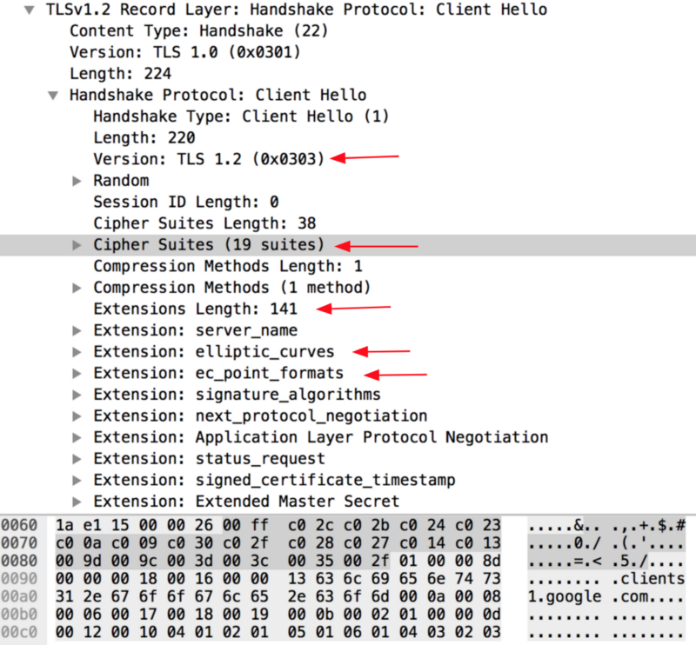
Because SSL negotiations are transmitted in the clear, it’s possible to fingerprint and identify client applications using the details in the SSL Client Hello packet. It's also possible to fingerprint the entire cryptographic negotiation.
Whitelisting hash gathers the decimal values of the bytes for the following fields in the Client Hello packet; SSL Version, Accepted Ciphers, List of Extensions, Elliptic Curves, and Elliptic Curve Formats. It then concatenates those values together in order, using a "," to delimit each field and a "-" to delimit each value in each field.
The field order is as follows:
SSLVersion,Cipher,SSLExtension,EllipticCurve,EllipticCurvePointFormat
Example:
769,47-53-5-10-49161-49162-49171-49172-50-56-19-4,0-10-11,23-24-25,0
If there are no SSL Extensions in the Client Hello, the fields are left empty.
Example:
769,4-5-10-9-100-98-3-6-19-18-99,,,
These strings are then MD5 hashed to produce an easily consumable and sharable 32 character fingerprint. This is the JA3 SSL Client Fingerprint.
769,47-53-5-10-49161-49162-49171-49172-50-56-19-4,0-10-11,23-24-25,0 --> ada70206e40642a3e4461f35503241d5
769,4-5-10-9-100-98-3-6-19-18-99,,, --> de350869b8c85de67a350c8d186f11e6

JA3S
JA3S is JA3 for the Server side of the SSL/TLS communication and fingerprints how servers respond to particular clients.
JA3S uses the following field order:
SSLVersion,Cipher,SSLExtension
With JA3S it is possible to fingerprint the entire cryptographic negotiation between client and it's server by combining JA3 + JA3S. That is because servers will respond to different clients differently but will always respond to the same client the same.
For the Trickbot example:
JA3 = 6734f37431670b3ab4292b8f60f29984 ( Fingerprint of Trickbot )
JA3S = 623de93db17d313345d7ea481e7443cf ( Fingerprint of Command and Control Server Response )
For the Emotet example:
JA3 = 4d7a28d6f2263ed61de88ca66eb011e3 ( Fingerprint of Emotet )
JA3S = 80b3a14bccc8598a1f3bbe83e71f735f ( Fingerprint of Command and Control Server Response )
In these malware examples, the command and control server always responds to the malware client in exactly the same way, it does not deviate. So even though the traffic is encrypted and one may not know the command and control server's IPs or domains as they are constantly changing, we can still identify, with reasonable confidence, the malicious communication by fingerprinting the TLS negotiation between client and server. Again, please be aware that these are examples, not indicative of all versions ever, and are intended to illustrate what is possible.

IDS fingerprints properties

keywords
The Crystal Eye IDS comes with a JA3 integration (https://github.com/salesforce/ja3). JA3 is used to fingerprint TLS clients.
JA3 is enabled in the (set ‘app-layer.protocols.tls.ja3-fingerprints’ to ‘yes’).

ja3_string
Match on JA3 string.
Example:
alert tls any any -> any any (msg:"match JA3 string"; \
ja3_string; content:"19-20-21-22"; \
sid:100002;)
ja3_string is a ‘Sticky buffer’.
ja3_string can be used as fast_pattern.

ja3_hash
Match on JA3 hash (md5).
Example:
alert tls any any -> any any (msg:"match JA3 hash"; \
ja3_hash; content:"e7eca2baf4458d095b7f45da28c16c34"; \
sid:100001;)
ja3_hash is a ‘Sticky buffer’.
ja3_string can be used as fast_pattern.
We use ja3 hash as hash for gateway whitelisting.

Elasticsearch

The Elastic Stack enables Crystal Eye to reliably and securely take data from any source in any format and search, analyze, and visualize it in real time.
For a quick overview, see: https://www.elastic.co/products
Elasticsearch is universal storage for Crystal Eyes output. It stores detailed information about all network packages. Any time we can ask elastic and get exact info about items which are interesting for us.
We can make request about tls packages..
Request looks like:
GET /_search?pretty {
"query": {
"match": {
"event_type": "tls"
}
}
}
Response looks like:
{
"took": 4,
"timed_out": false,
"_shards": {
"total": 16,
"successful": 16,
"skipped": 0,
"failed": 0
},
"hits": {
"total": 758,
"max_score": 3.0513022,
"hits": [ {
"_index": "report_index-2018.04.11",
"_type": "doc",
"_id": "AWKzE5RPEINjbyNsnXy7",
"_score": 3.0513022,
"_source": {
"@timestamp": "2018-04-11T05:00:24.947Z",
"beat": {
"hostname": "localhost.localdomain",
"name": "localhost.localdomain",
"version": "5.6.6"
},
"dest_ip": "185.60.216.19",
"dest_port": 443,
"event_type": "tls",
"flow_id": 315300367630091,
"in_iface": "eno1",
"input_type": "log",
"offset": 66595,
"proto": "TCP",
"source": "/usr/local/var/log/suricata/eve.json",
"src_ip": "192.168.100.144",
"src_port": 44066,
"timestamp": "2018-04-11T08:00:24.841639+0300",
"tls": {
"fingerprint": "bd:25:8c:1f:62:a4:a6:d9:cf:7d:98:12:d2:2e:2f:f5:7e:84:fb:36",
"issuerdn": "C=US, O=DigiCert Inc, OU=www.digicert.com, CN=DigiCert SHA2 High Assurance Server CA",
"ja3": {
"hash": "043a5d2d936910298e36e34acd8da818",
"string": "771,49196-49162-49195-52393-49161-49200-49172-49199-52392-49171-57-51-53-47-10,0-23-65281-10-11-35-16-5-13,29-23-24-25,0"
},
"notafter": "2019-03-22T12:00:00",
"notbefore": "2017-12-15T00:00:00",
"serial": "0B:3C:3B:60:1A:18:F5:9E:E2:B6:BB:05:60:5E:F2:C0",
"sni": "static.xx.fbcdn.net",
"subject": "C=US, ST=California, L=Menlo Park, O=Facebook, Inc., CN=*.facebook.com",
"version": "TLS 1.2"
},
"type": "log"
}
},
...........................…

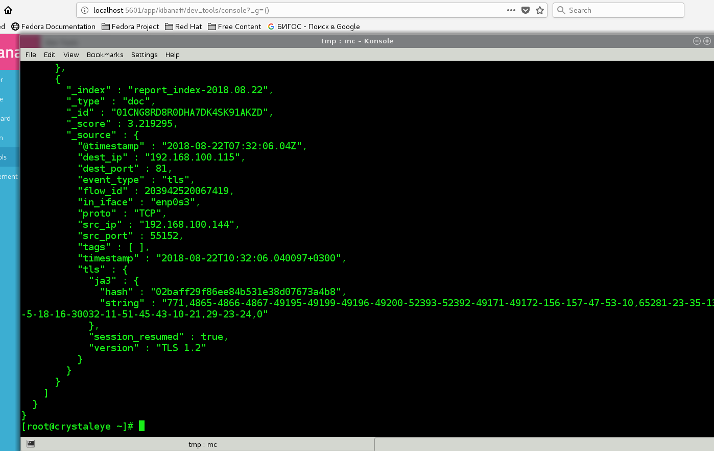
Screenshot from terminal. Elastic response for tls packages.

In order to reduce memory usage whitelisting application uses requests like:
GET
/_search?pretty&filter_path=took,hits.total,hits.hits._source.dest_ip,hits.hits._source.dest_port,hits.hits._source.src_ip,hits.hits._source.proto,hits.hits._source.flow_id,hits.hits._source.in_iface,hits.hits._source.event_type,hits.hits._source.src_port,hits.hits._source.@timestamp,hits.hits._source.alert.category,hits.hits._source.alert.signature_id,hits.hits._source.alert.severity,hits.hits._source.alert.action,hits.hits._source.alert.action,hits.hits._source.alert.signature,hits.hits._source.geoip.country_name
{
"size":10000,
"query": {
"match": {
"event_type": "alert"
}

}
}

or
GET
/_search?pretty&filter_path=took,hits.total,hits.hits._source.dest_ip,hits.hits._source.src_ip,hits.hits._source.tls.fingerprint,hits.hits._source.tls.ja3
{
"size":10000,
"query": {
"match": {
"event_type": "alert"
}

}
}
Also in last versions application uses queries with templates like:
POST /_search?pretty
{
"size":10,
"query": {

"range" : {
"@timestamp" : {
"gte" : "now-50h/h",
"lte" : "now/d"

}

}
}
}

POST /_search?pretty
{

"size": 12,
"query": {
"bool": {
"must": { "match": { "event_type": "tls" }},

"filter": {
"range": { "@timestamp": { "gte": "now-48h/h" }}
}
}
}
}

Part 2. Jparser tools
One important note about hash white listing implementation.
In reality typical IDS IPS doesn't have such white listing property - ja3 hash whitelisting.
And there is no list of "good" "allowed" fingerprints.
Instead of this special programs by Red Piranha were created which analyze tls traffic and list of all known fingerprints.
Content of the file of known fingerprints looks like:
{"#":1,"Ja3_hash":"93948924e733e9df15a3bb44404cd909","category":"Other Software","desc":"Adium 1.5.10 (a)"}
{"#":2,"Ja3_hash":"e4adf57bf4a7a2dc08e9495f1b05c0ea","category":"Other Software","desc":"Adium 1.5.10 (b)"}
{"#":3,"Ja3_hash":"d5169d6e19447685bf6f1af8c055d94d","category":"Android","desc":"AirCanada Android App"}
{"#":4,"Ja3_hash":"0bb402a703d08a608bf82763b1b63313","category":"Android","desc":"AirCanada Android App"}
{"#":5,"Ja3_hash":"662fdc668dd6af994a0f903dbcf25d66","category":"Android","desc":"Android App"}
{"#":6,"Ja3_hash":"515601c4141e718865697050a7a1765f","category":"Android","desc":"Android Google API Access"}
{"#":7,"Ja3_hash":"855953256ecc8e2b6d2360aff8e5d337","category":"Android","desc":"Android Webkit Thing"}
{"#":8,"Ja3_hash":"99d8afeec9a4422120336ad720a5d692","category":"Android","desc":"Android Webkit Thing"}
{"#":9,"Ja3_hash":"85bb8aa8e5ba373906348831bdbed41a","category":"Android","desc":"Android Webkit Thing"}
{"#":10,"Ja3_hash":"1aab4c2c84b6979c707ed052f724734b","category":"Android","desc":"Android Webkit Thing"}
{"#":11,"Ja3_hash":"5331a12866e19199b363f6e903381498","category":"Android","desc":"Android Webkit Thing"}
{"#":12,"Ja3_hash":"25b72c88f837567856118febcca761e0","category":"Android","desc":"Android Webkit Thing"}
{"#":13,"Ja3_hash":"d4693422c5ce1565377aca25940ad80c","category":"Apple","desc":"Apple Push Notification System, Apple.WebKit.Net"}
{"#":14,"Ja3_hash":"3e404f1e1b5a79e614d7543a79f3a1da","category":"Apple","desc":"Apple Spotlight Search (OSX)"}
{"#":15,"Ja3_hash":"69b2859aec70e8934229873fe53902fd","category":"Apple","desc":"Apple Spotlight"}
On this base jparser tools create set of rules - pass rule for good fingerprint and drop-alert rules for malware and unknown.
This is big difference in comparison with usual whitelisting.

New utilites for whitelisting

1. janalyser - tool for tls traffic analysis
It collects records about tls packages from elasticsearch, filters and sorts them. It outputs 3 files:
devices.txt, devices_ip.txt and white_list_connection.txt.
device.txt has format - network interface; ip; name and looks like:

enp0s26u1u2;10.10.1.45;crystaleye
enp0s26u2u2;10.10.1.68;gateway
Unknown;10.10.1.73;Device 2
eth4;10.10.1.77;Device 3
Unknown;10.10.1.88;Device 4
Unknown;192.168.100.151;Device 5

File devices_ip.txt is simply list of devices ips:
10.10.1.45
10.10.1.68
10.10.1.73
10.10.1.77
10.10.1.88
white_list_connection.txt has more detailed and complex format and can be used as a tls report:
src_ip -> 192.168.100.151 ; dest_ip -> 103.70.234.12 ; hash -> 021d3c3f14b88d57a9ce2d946cabe87f ; def -> Android
src_ip -> 192.168.100.151 ; dest_ip -> 104.24.115.11 ; hash -> 021d3c3f14b88d57a9ce2d946cabe87f ; def -> Firefox plugin
src_ip -> 192.168.100.151 ; dest_ip -> 107.189.62.3 ; hash -> 021d3c3f14b88d57a9ce2d946cabe87f ; def -> Firefox
src_ip -> 10.10.1.68 ; dest_ip -> 104.210.208.34 ; hash -> 0318a5772c6150cfc9a3315d0b04f947 ; def -> Chrome group
src_ip -> 192.168.100.151 ; dest_ip -> 104.210.208.34 ; hash -> 0318a5772c6150cfc9a3315d0b04f947 ; def -> Unknown Software
src_ip -> 10.10.1.68 ; dest_ip -> 104.81.208.32 ; hash -> 0318a5772c6150cfc9a3315d0b04f947 ; def -> Unknown Software
src_ip -> 192.168.100.151 ; dest_ip -> 104.81.208.32 ; hash -> 0318a5772c6150cfc9a3315d0b04f947 ; def -> Unknown Software
src_ip -> 10.10.1.68 ; dest_ip -> 104.81.222.83 ; hash -> 0318a5772c6150cfc9a3315d0b04f947 ; def -> Unknown Software
src_ip -> 192.168.100.151 ; dest_ip -> 104.81.222.83 ; hash -> 0318a5772c6150cfc9a3315d0b04f947 ; def -> Unknown Software
src_ip -> 10.10.1.68 ; dest_ip -> 104.81.226.67 ; hash -> 0318a5772c6150cfc9a3315d0b04f947 ; def -> Unknown Software
src_ip -> 192.168.100.151 ; dest_ip -> 104.81.226.67 ; hash -> 0318a5772c6150cfc9a3315d0b04f947 ; def -> Unknown Software
src_ip -> 10.10.1.68 ; dest_ip -> 13.107.21.200 ; hash -> 0318a5772c6150cfc9a3315d0b04f947 ; def -> Unknown Software
src_ip -> 192.168.100.151 ; dest_ip -> 13.107.21.200 ; hash -> 0318a5772c6150cfc9a3315d0b04f947 ; def -> Unknown Software

Usage: janalyser path_to_output_files
All tools use /var/lib/jparser folder for output

2.jmapper
It collects data from net mapping application and produces 2 files on output:
devices.txt, devices_ip.txt. Files have same format as janalyser files, but contain data only about devices behind CE.

3.jreport
Usage: jreport path_to_output_files
This program uses data collected by janalyser and generates json output file - white_list_report.json.

4.jrules (not used atm)
This program generates rules for device
Usage: jrules /folder_with_input_info /output_folder device1_ip device2_ip .... devicen_ip

Output looks:
reject tls 10.10.1.68 any -> any any (msg:"reject match whitelisting hash malware or unknown hash Unknown Software"; ja3_hash; content:"0318a5772c6150cfc9a3315d0b04f947"; sid:1100000;rev:11;)
reject tls 10.10.1.68 any -> any any (msg:"reject match whitelisting hash malware or unknown hash Unknown Software"; ja3_hash; content:"0e2086e1f005e8872c97d9a3c2e56af3"; sid:1100001;rev:11;)
reject tls 10.10.1.68 any -> any any (msg:"reject match whitelisting hash malware or unknown hash Unknown Software"; ja3_hash; content:"13335b8c9503f9dc6ffad97551dc3cad"; sid:1100002;rev:11;)
reject tls 10.10.1.68 any -> any any (msg:"reject match whitelisting hash malware or unknown hash Unknown Software"; ja3_hash; content:"162b4f1e21c7d5a37204e5884f4873a1"; sid:1100003;rev:11;)
reject tls 10.10.1.68 any -> any any (msg:"reject match whitelisting hash malware or unknown hash Unknown Software"; ja3_hash; content:"2e3489bae31cd3e32f38d5293e983c49"; sid:1100004;rev:11;)
reject tls 10.10.1.68 any -> any any (msg:"reject match whitelisting hash malware or unknown hash Unknown Software"; ja3_hash; content:"48216eb48d8fb7124ce9f1946263597e"; sid:1100005;rev:11;)
reject tls 10.10.1.68 any -> any any (msg:"reject match whitelisting hash malware or unknown hash Unknown Software"; ja3_hash; content:"6da03a291c07db5bb31d043bb53c4e59"; sid:1100006;rev:11;)
reject tls 10.10.1.68 any -> any any (msg:"reject match whitelisting hash malware or unknown hash Unknown Software"; ja3_hash; content:"737bd1f00ac3e08ead0eee1dc7e1144d"; sid:1100007;rev:11;)
reject tls 10.10.1.68 any -> any any (msg:"reject match whitelisting hash malware or unknown hash Unknown Software"; ja3_hash; content:"765f7fb49e4a4275fee02c23b92e61c4"; sid:1100008;rev:11;)
reject tls 10.10.1.68 any -> any any (msg:"reject match whitelisting hash malware or unknown hash Unknown Software"; ja3_hash; content:"80db4b83c6775c3635854e24006681a9"; sid:1100009;rev:11;)
reject tls 10.10.1.68 any -> any any (msg:"reject match whitelisting hash malware or unknown hash Unknown Software"; ja3_hash; content:"b6996d6eecf38d22cfca9590f94297b0"; sid:1100010;rev:11;)
reject tls 10.10.1.68 any -> any any (msg:"reject match whitelisting hash malware or unknown hash Unknown Software"; ja3_hash; content:"c06296f6ac29d4ca014a56312534ba8d"; sid:1100011;rev:11;)
reject tls 10.10.1.68 any -> any any (msg:"reject match whitelisting hash malware or unknown hash Unknown Software"; ja3_hash; content:"d8e77cc783b249de6e348525176cdfa3"; sid:1100012;rev:11;)
reject tls 10.10.1.68 any -> any any (msg:"reject match whitelisting hash malware or unknown hash Unknown Software"; ja3_hash; content:"d9bcc0b05a1e67c11abc85bf5ca55c90"; sid:1100013;rev:11;)
reject tls 10.10.1.68 any -> any any (msg:"reject match whitelisting hash malware or unknown hash Unknown Software"; ja3_hash; content:"e3d9d8f7b3d9f626d0696a76b4c4501f"; sid:1100014;rev:11;)
reject tls 10.10.1.68 any -> any any (msg:"not match any whitelisting hash"; sid:1100015;rev:11;)
reject tls any any -> any any (msg:"not match any whitelisting hash"; sid:1100015;rev:11;)

5.jrules_files (not used atm)
This program generates rules for devices listed in file
Usage: jrules_file /folder_with_input_info /output_folder file_with_devices_list

6.Jgenerator
This program generates rules for groups of devices and polices.
It generates awl.yaml file, which must be included in suricata.yaml.
Awl.yaml looks like:
DESKS: "[10.10.1.232,10.10.1.155]"
DEFAULT: "[10.10.1.149]"
GROUP1: "[10.10.1.179, 10.10.1.188]"
and it also generates rules, looking like:
allow tls [$LAPTOPS,$DESKS] any -> any any (msg:"allow match whitelisting known hash Apple"; ja3_hash; content:"e4d448cdfe06dc1243c1eb026c74ac9a"; sid:1102319;rev:11;)
allow tls [$LAPTOPS,$DESKS] any -> any any (msg:"allow match whitelisting known hash Apple"; ja3_hash; content:"f1c5cf087b959cec31bd6285407f689a"; sid:1102320;rev:11;)
allow tls [$LAPTOPS,$DESKS] any -> any any (msg:"allow match whitelisting known hash Other Software"; ja3_hash; content:"f28d34ce9e732f644de2350027d74c3f"; sid:1102321;rev:11;)
allow tls [$LAPTOPS,$DESKS] any -> any any (msg:"allow match whitelisting known hash Dropbox"; ja3_hash; content:"190dfb280fe3b541acc6a2e5f00690e6"; sid:1102322;rev:11;)
allow tls [$LAPTOPS,$DESKS] any -> any any (msg:"allow match whitelisting known hash Chrome"; ja3_hash; content:"20dd18bdd3209ea718989030a6f93364"; sid:1102323;rev:11;)
allow tls [$DEFAULT] any -> any any (msg:"allow match whitelisting known hash Viber"; ja3_hash; content:"e0224fc1c33658f2d3d963bfb0a76a85"; sid:1102324;rev:11;)
allow tls [$LAPTOPS,$DESKS] any -> any any (msg:"allow match whitelisting known hash Other Software"; ja3_hash; content:"01319090aea981dde6fc8d6ae71ead54"; sid:1102325;rev:11;)
allow tls [$LAPTOPS,$DESKS] any -> any any (msg:"allow match whitelisting known hash Other Software"; ja3_hash; content:"84607748f3887541dd60fe974a042c71"; sid:1102326;rev:11;)
allow tls [$LAPTOPS,$DESKS] any -> any any (msg:"allow match whitelisting known hash Other Software"; ja3_hash; content:"c2b4710c6888a5d47befe865c8e6fb19"; sid:1102327;rev:11;)

Usage: jgenerator /folder_with_rules

7.stop_whitelisting
It is script, which deletes all white listing data
#!/usr/bin/env bash
cat /dev/null > /var/lib/jparser/devices.txt
rm -f /var/lib/jparser/white_list_data.txt
rm -f /var/lib/jparser/white_list_connections.txt
rm -f /var/lib/jparser/white_list_report.json
rm -f /var/lib/jparser/devices_ip.txt
rm -f /etc/suricata/rules/white_list.rules

7.General scheme of utilities interaction.
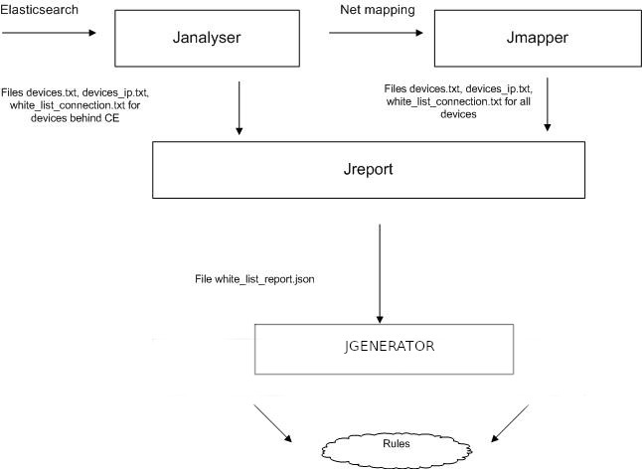

Makefile and build procedure
Usual make file is used to build and install utilities. It looks like:
#Makefile for compiling jtools
CC = g++
LD = g++
INCDIR = -I./include
CFLAGS = -g3 -Wall -c $(INCDIR) -std=c++11
LDFLAG = -g3 -Wall -std=c++11
LDLIB = -ljsoncpp /usr/lib64/libcurl.so.4

all: jparser jreport jrules jrules_file janalyzer jmapper jgenerator
jparser : main.o item.o rule_item.o
$(LD) $(LDFLAG) $^ -o $@ $(LDLIB)
jreport : jreport.o item.o rule_item.o device.o devices.o reportitem.o
$(LD) $(LDFLAG) $^ -o $@ $(LDLIB)
jrules : jrules.o item.o rule_item.o
$(LD) $(LDFLAG) $^ -o $@ $(LDLIB)
jrules_file : jrules_file.o item.o rule_item.o
$(LD) $(LDFLAG) $^ -o $@ $(LDLIB)
janalyzer : janalyzer.o item.o rule_item.o
$(LD) $(LDFLAG) $^ -o $@ $(LDLIB)
jmapper : jmapper.o item.o rule_item.o device.o devices.o
$(LD) $(LDFLAG) $^ -o $@ $(LDLIB)
jgenerator : jgenerator.o group.o groups.o policy.o device.o devices.o policies.o reportitem.o helper.o
$(LD) $(LDFLAG) $^ -o $@ $(LDLIB)
main.o : main.cpp
$(CC) $(CFLAGS) $<
jrules.o : jrules.cpp
$(CC) $(CFLAGS) $<
jrules_file.o : jrules_file.cpp
$(CC) $(CFLAGS) $<
jreport.o : jreport.cpp
$(CC) $(CFLAGS) $<
janalyzer.o : janalyzer.cpp
$(CC) $(CFLAGS) $<
jmapper.o : jmapper.cpp
$(CC) $(CFLAGS) $<
group.o : group.cpp ./include/group.h
$(CC) $(CFLAGS) $<
groups.o : groups.cpp ./include/groups.h
$(CC) $(CFLAGS) $<
policy.o : policy.cpp ./include/policy.h
$(CC) $(CFLAGS) $<
policies.o : policies.cpp ./include/policies.h
$(CC) $(CFLAGS) $<
device.o : device.cpp ./include/device.h
$(CC) $(CFLAGS) $<
devices.o : devices.cpp ./include/devices.h
$(CC) $(CFLAGS) $<
reportitem.o : reportitem.cpp ./include/reportitem.h
$(CC) $(CFLAGS) $<
rule_item.o : rule_item.cpp ./include/rule_item.h
$(CC) $(CFLAGS) $<
item.o : item.cpp ./include/item.h
$(CC) $(CFLAGS) $<
helper.o : helper.cpp ./include/helper.h
$(CC) $(CFLAGS) $<
jgenerator.o : jgenerator.cpp
$(CC) $(CFLAGS) $<
install : jparser jreport jrules jrules_file janalyzer jmapper jgenerator full.json ja3fingerprint.json categories.txt categories_orig.txt
mkdir -p /etc/jparser
cp full.json /etc/jparser
cp ja3fingerprint.json /etc/jparser
cp categories.txt /etc/jparser
cp categories_orig.txt /etc/jparser
cp jparser /usr/bin
cp jrules /usr/bin
cp jreport /usr/bin
cp janalyzer /usr/bin
cp jmapper /usr/bin
cp jgenerator /usr/bin
clean : rm -f jrules jreport jparser janalyzer jrules_file jmapper jgenerator jgenerator.o main.o item.o rule_item.o jrules.o jreport.o janalyzer.o reportitem.o device.o devices.o jrules_file.o jmapper.o group.o groups.o policy.o policies.o helper.o

-std=c++11 option is important;
-g3 should be removed in final version, it only inserts debugging information in exe file

PHP code
All jparser tools are used in php code for gateway_whitelisting application. For example like in fragment below:
public function make_report()
{
crystaleye_profile(__METHOD__, __LINE__);
try{
$shell = new Shell();
$d = "d";
$o = 0;
$retval = $shell->execute("/usr/bin/jreport", "/var/lib/jparser " , true,'log');
if ($retval === 0) {
return true;
} else {
$output = false;
}
return $output;
} catch (Engine_Exception $e) {
return false;
}
}
////////////
public function make_rules_reject()
{
crystaleye_profile(__METHOD__, __LINE__);
try{
$shell = new Shell();
$d = "d";
$o = 0;
$retval = $shell->execute("/usr/bin/jrules_file", "/var/lib/jparser /etc/suricata/rules/ /var/lib/jparser/devices_ip.txt", true,'log');
if ($retval === 0) {
return true;
} else {
$output = false;
}
return $output;
} catch (Engine_Exception $e) {
return false;
}
}

Controlling elastic for number of output records
By default elasticsearch return only 10000 records (it;s parameter index.max_result is equal to 10000).
We control elastic index.max_result_window is to use request
PUT _all/_settings?preserve_existing=true' {
"index.max_result_window" : "300000"
}
We set large index.max to big values before request about tls packages.
And return it to default 10000 after tls request is done.
jparser tools can control elasticsearch max records index and this why elastic cache.

Part 3. GUI
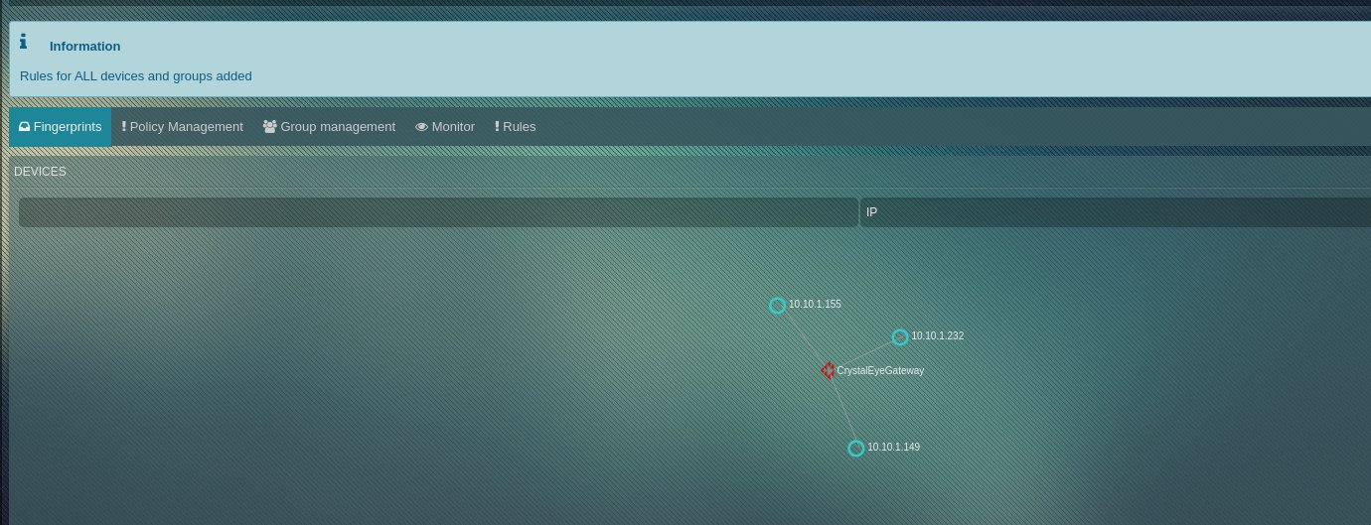
Screen 1. AWL manager.
It has several tabs for general management:
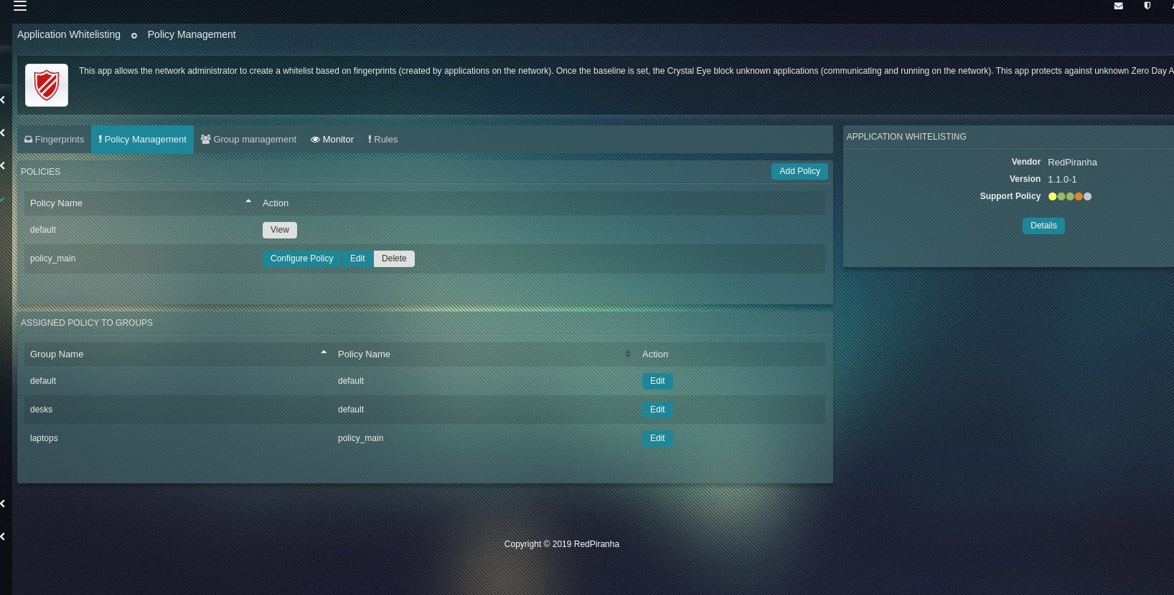
Screen 2. AWL policies manager
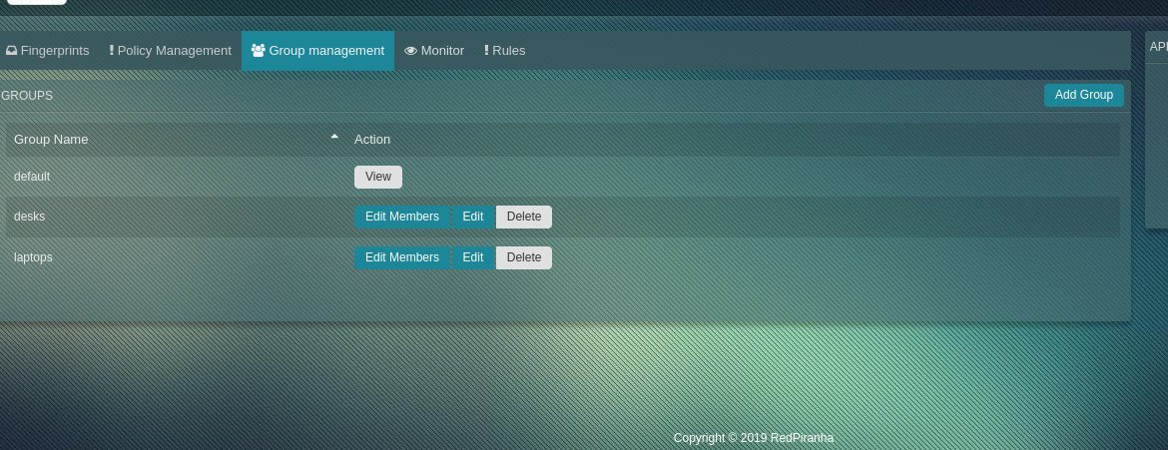
Screen 3. AWL groups manager
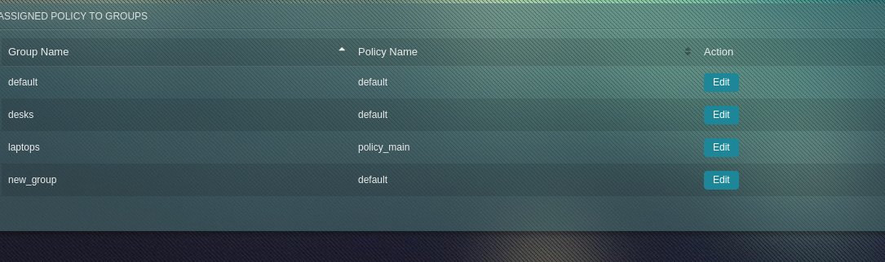
Screen 4. Page for assigning policies to groups

Sceen 5. Alerts monitor

Rules Managment Tab
On this screen we can edit whitelisting rules.
Screen 6. Main page. No rules at start
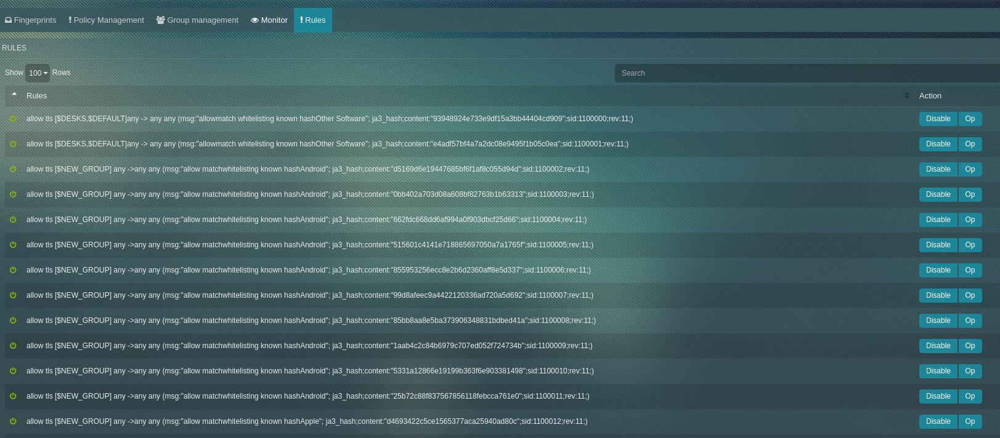
Screen 7. Rules page after rules generation.

