тезис / експериментальне УЗД, в онкології
УДК616-073.43
¹Bubnov R.V., M.D.,
²Melnyk I.M., PhD,
The initial clinical experience of fractal analysis of diagnostic images
¹The Center of ultrasound diagnostics and interventional sonography
Clinical hospital “Pheophania” of State Affairs Department, Kyiv, Ukraine

² V.M. Glushkov Institute of Cybernetics of NAS of Ukraine, Kyiv, Ukraine

e-mail: rostbubnov@gmail.com
Keywords: ultrasonography, mathematical modeling, imaging fractal analysis, fractal dimension.
Background
The purpose of the study was to investigate whether mathematical algorithms can improve the information content in medical imaging, providing an objective measurement. Most objects found in nature is non-Euclidean nature. Biological systems are predominantly irregular, complex and non-linear. Irregularities of biological system cannot be quantified by means of classical Euclidean geometry approach. Fractal image analysis reported in various areas of medicine: pathology, radiology, physiology and others [1-3]. However, fractal analysis must be applied with certain caution in natural objects such as bio-medical ones. The cardio-vascular system remains one of the most important fields of application of these kinds of approach. Fractal geometry gives insights into tumor morphology and can become a useful tool for analyzing complex and irregular tumor growth patterns mathematically [4].
Objectives
Fractal Dimension (FD) is a statistical quantity that gives an indication of how completely a fractal appears to fill space, as one zooms down to finer and finer scales. At the size limits of the measuring element, the linear relationship is no longer maintained and a unique fractal dimension cannot be defined. The various methods of FD measurement were described: 1) modified pixel dilatation; 2) perimeter-area method; 3) ruler counting method and 4) Box counting method. Box counting method is most commonly used for detection of FD. It is a simple and reproducible way of measuring fractal dimension [5].
We propose a method [6] of medical images analysis obtained from a wide range of sources – radiology imaging, diagnostic ultrasound, photographic information of endoscopy, surgery, dentistry, anatomy and microscopy. The values fractal parameters of these images (fractal dimension, fractal index, etc.) are calculated by "covering" the parts of these expertly segmented images by two-dimensional geometric shapes (squares, rectangles, triangles, circles, ellipses) and three-dimensional (cubes, simplices, balls, ellipsoids, pyramids) for vector and voxel three-dimensional models of different directions (for processing ultrasound, CT, MRI, photographic, endoscopic images, etc.).
FD is calculated from the basic generalized formula:
FD=ln N(δ)/ln f(1/δ),
where, FD - fractal dimension and δ – shape diameter; N - the number of identical shapes with δ -diameter necessary for covering image
In practice the perception and interpretation are a component of subjectivity. Fuzzy visual information may be difficult to interpret, the limits for fractal dimension calculation are close to the digital resolution of the image, or at sizes greater than one-third the maximal diameter of the object [5].
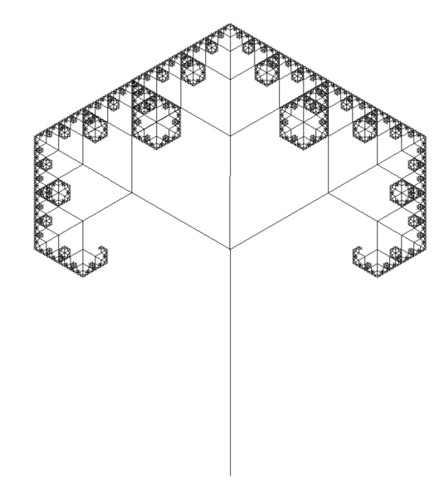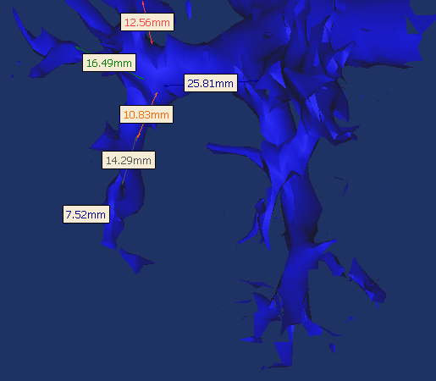
Fig. 1. Fractal dimension calculation of C3-branches tree and three-dimensional reconstruction of portal venous tree. Calculation FD by measurement the similar parts of portal veins. Fd= =1.5849.
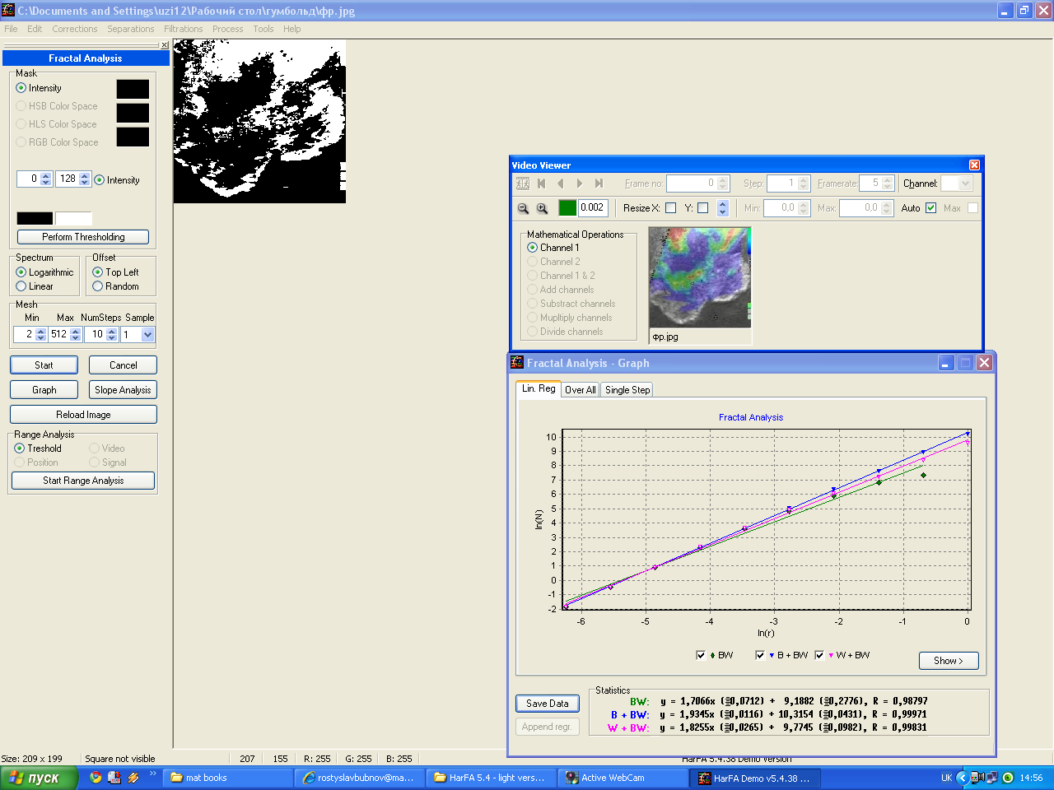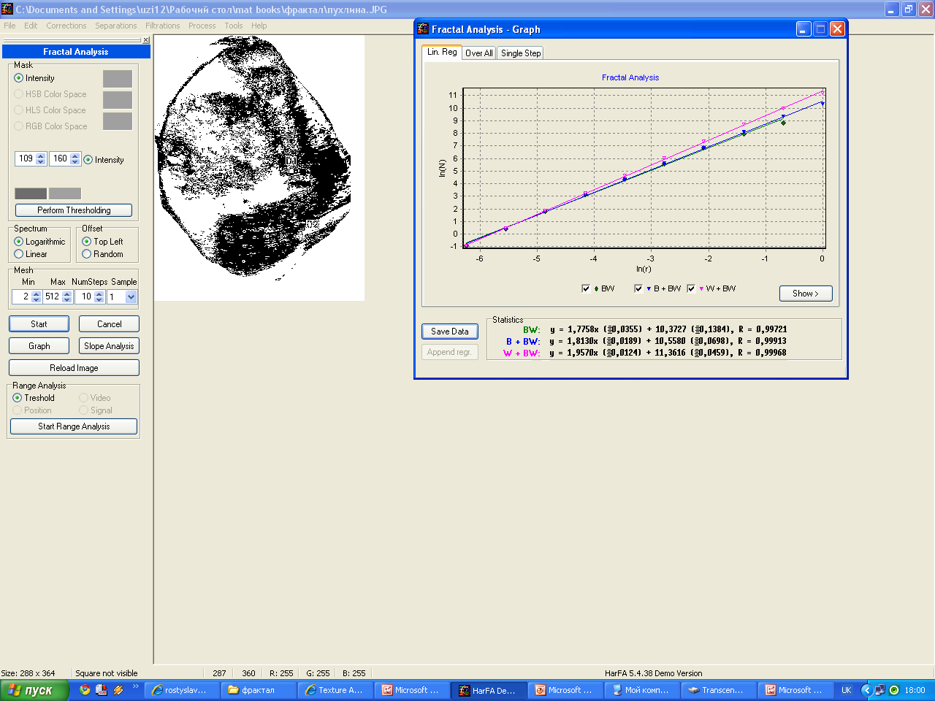
Fig. 2. Fractal dimension calculation in tumors using HarFA software.
Conclusion
Fractal analysis of medical images is a promising direction of development the existing diagnostic methods. It becomes a highly informative indicator of pathological formations using nonlinear mathematical parameters and structure. The proposed method determined the fractal parameters requires expert medical approach, wich is more objective than existing automated. The method can be used in all areas of medicine, where the visual information is used, mostly in oncology. Fractal analysis can be a major factor in determining the prognosis of doubtful clinical conditions. According to preliminary results, the malignant formations have higher fractal dimension. Further research assessing different pathological processes are necessary.
References
- T.Mattfeld Spatial Pattern Analysis using Chaos Theory: A Nonlinear Deterministic Approach to the Histological Texture of Tumours In: Fractals in Biology and Medicine (Basel, Birkhaeuser) Vol II (1997)\~:50-72.
- Vehel J.L.Using fractal and morphological criteria for automatic classification of lung diseases In: Visual Communication and Image Processing IV, Philadelphia, Pennsylvania. Proc SPIE.1989;1989:1-10.
- C.K.Peng et al.Fractal Landscapes in Physiology & medicine:Long Range Correlations in DNA sequences and heart Rate intervals In\~:Fractals in Biology and Medicine (Basel,Birkhaeuser Vrlg Vol I (1994):55-65.)
- James W. Baish and Rakesh K. Jain Fractals and Cancer CANCER RESEARCH 60, 3683–3688, July 15, 2000.
- Kaye BH (1989) A random walk through fractal dimensions. New York: VCH.
- Patent . № u 2011 02941 Ukraine. Method of fractal analysis of medical images / Bubnov R.V., (№ 790559 14.03.2011).

