Sergey Morkovkin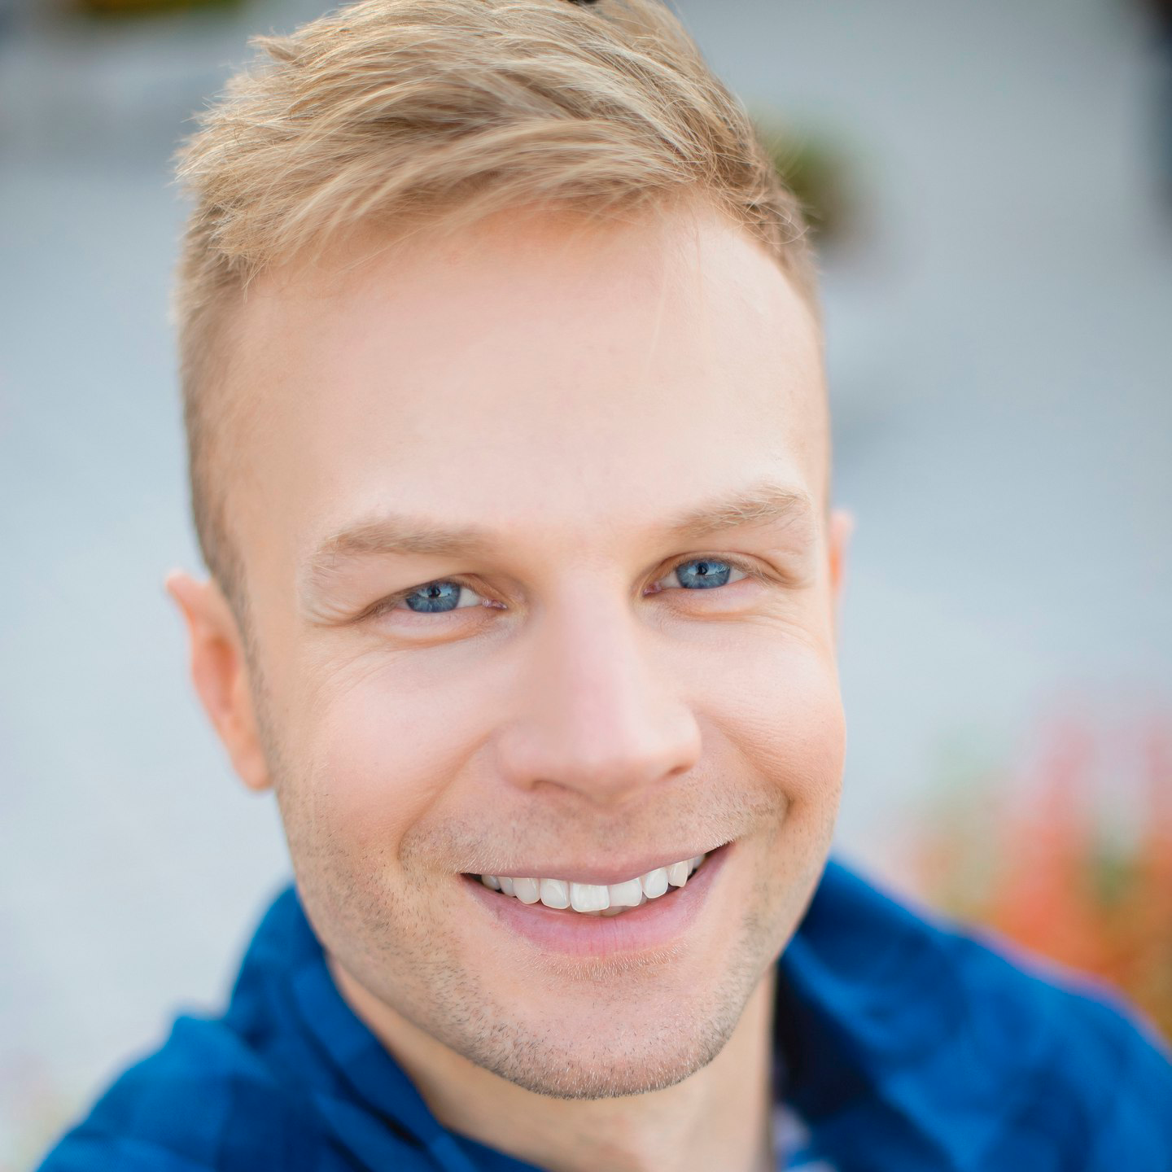

Solution Architect / Software Engineer

Mobile: +38 (050) 445-01-45 (UTC+2)

Email: [sergeymorkovkin@gmail.com](mailto:sergeymorkovkin@gmail.com?subject=Job%20offer)

Skype: sergeymorkovkin or [start chat](skype://sergeymorkovkin?chat)

LinkedIn: [view profile](https://www.linkedin.com/in/sergeymorkovkin/)

Website: <https://edgeof.it>

*I am Sergey, an IT professional working in the industry for the last 19 years. My unique experience combines business and technical roles. This allows me to see things from multiple angles. Therefore, I know exactly what it takes to create solutions that sustain an open business perspective. Its always been my motivation to deliver a top-notch quality and I look forward to contributing to your business through my knowledge and skills.*

*Here are some materials highlighting my professional skills:*

* 1. Detailed project case studies: [PDF](http://bit.ly/2TLN5Cn)
  2. Verbal English speech example: [MP3](http://bit.ly/2TFKnyp)
  3. Some of my UI/UX design examples: [JPGs](http://bit.ly/2DrTdc0)
  4. Making an architectural decision: [MP4](http://bit.ly/2GCcXgy) and [DOC](http://bit.ly/2GCcNFY)
  5. Technical pre-sale skills: [MP4](http://bit.ly/2SuCTlm) and [PDF](http://bit.ly/2SuDeEE) (white paper)
  6. Technical correspondence example: [DOC](http://bit.ly/2tkjqVs)

*Make sure to also check what others say about my work:*

|  |  |  |  |  |  |  |  |
| --- | --- | --- | --- | --- | --- | --- | --- |
| Nicolas Mercier | Andrew Kozin | Manu Lohiya | Christine Shellenbarger | Edward Kogan | Aaron Cowdin | Hiren Sodha | Ted Girata |

—

Thank you.

Services

* Consult on all aspects of the software;
* Set new project onto the right track;
* Lead project out of the legacy trap;
* Improve product quality at all levels;
* Minimize project development costs;
* Optimize development team processes;

Technologies

***RECRUITERS!*** *Even though I have a command of the main-stream technologies, the tech. stack for every project should be crafted with careful consideration of its specifics. If you are looking for a coder to fill in a certain position, please keep in mind that my experience goes beyond and I’m not interested in selling only the part of it.*

***NOTE:*** *If your are interested in POC development, I can do custom technology research intended to find the perfect stack for your project. Pay now, save later.  
*

Diploma

I've got the Bachelor of Information Security in 2006   
in the Institute of Physics and Technology, NTUU «KPI».

***NOTE:*** *My profile education gave me solid understanding of modern cryptography.*

Certificates

* Multiple conference and meet-up speaker in 2016 - 2017;
* Country-wide winner of Ukrainian Dev Challenge in 2016;
* Country-wide winner of Ukrainian Web Challenge in 2011;
* Leader of Dev Challenge conference in 2017;
* Judge of Ukrainian Dev Challenge in 2016;

Professional Ethics

1. I help minimize development costs and avoid unnecessary expenses. Decisions I make always intend to increase corporate profit.
2. I always think strategically few steps in advance and apply efforts to sustain an unproblematic business perspective.
3. I appreciate attention of people I communicate with and present information in the most easily understood form, while considering target audience and context.
4. I strive to optimize all development and team processes in order to save time and efforts.
5. I develop ideas in strict accordance with corporate vision, while still considering other important aspects.
6. I do architectural design with the maximum responsibility, knowing decisions made at the beginning define the future of any project.
7. I estimate projects with high accuracy, always set reasonable costs, deadlines and risk margins.
8. I take initial idea and build around it from the ground up. During this process I think few steps in advance and pay attention to tiny details.
9. I establish a controlled development process and provide regular status updates in a timely manner.
10. I maintain a clear project perspective and inform on all potential consequences of every decision.
11. I always do prototyping and technical research to make sure my decisions are weighted and safe.

Experience

**System Architect and Lead Engineer**

Feb 2018 - Mar 2018 • 2 mos

* Performed careful analysis of customer requirements;
* Made a research on the most suitable 3rd party solutions;
* Prepared project development plan with detailed estimates;
* Developed a performant REST API authorization solution;
* Prepared all AWS integration scripts and guidelines;



**System Architect and Team Leader**

Aug 2017 - Dec 2017 • 5 mos

* Coordinated work across a team of 3 developers;
* Performed deep analysis of the project and situation;
* Determined all causes of a poor system performance;
* Developed a consequential project enhancement plan;
* Created a working POC as a proof of all my concepts;
* Completely reworked data structured and data flow;
* Algorithmically reduced system response time 50-fold;
* Algorithmically reduced resource consumption 5-fold;



**System Architect and Team Leader**

Sep 2015 - Aug 2016 • 1 year

* Handled all communications with the customer;
* Lead and managed a team of 10 developers;
* Developed most critical architectural decisions;
* Significantly improved application performance;
* Delivered 10 features over 13 releases on time;
* Improved team workflow and implemented CI;

**Crisis Manager and Team Leader**

Dec 2016 - Feb 2017 • 3 mos

* Took charge for a project with a breaking deadlines;
* Performed a thorough project and situation analysis;
* Coordinated work across the team of 12 developers;
* Established a healthy relationships with the customer;
* Agreed a one-month delay for the final delivery;
* Restructured and reused existing work to the full;
* Delivered final release on time, saved whole account;

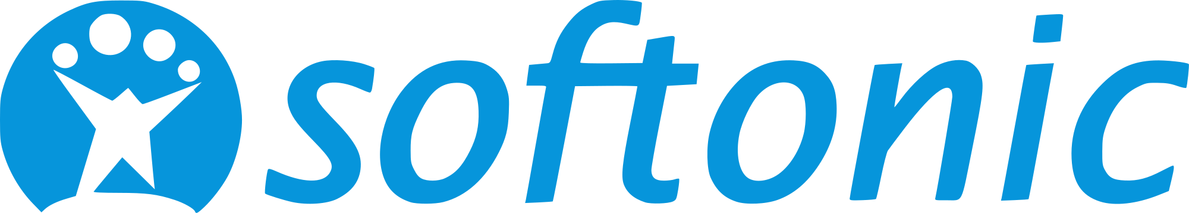

**Full-stack Engineer and System Architect**

Jul 2015 - Sep 2015 • 3 mos

* Designed and implemented a core architectural solution for authorizing a high traffic;
* Designed and developed ACL (access control list) administrator panel;

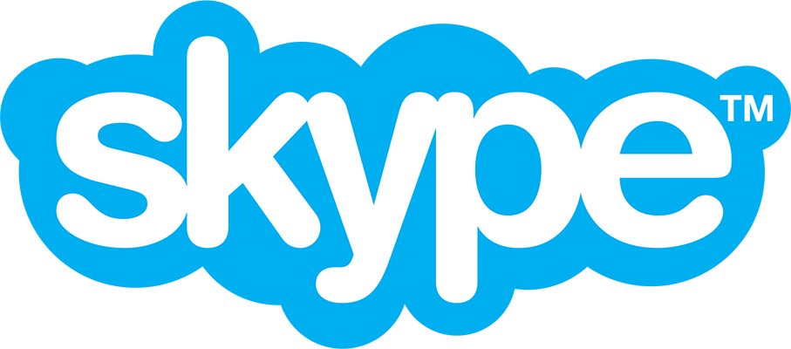

**Full-stack Engineer and Contractor**

Jan 2014 - Jun 2014 • 6 mos

* Optimized Skype’s JavaScript-based ads-rotation app;
* Eliminated multiple memory leaks for old versions of IE;
* Fixed excessive memory and CPU consumption;
* Created complete test coverage (unit & functional tests);
* Designed and developed a caching error analytics panel;
* Worked on multiple Skype’s high-traffic chat bots;

—

**NOTE:** This section contains relevant projects for the past few years. My other works are fairly outdated, but if you *really* need them - feel free to check [my LinkedIn profile](https://www.linkedin.com/in/sergeymorkovkin/).

Reviews

**Name:** Nicolas Mercier  
 **Position:** Project Manager  
 **Company:** Altran US Corp

Sergey is a very talented developer with a vast knowledge of all digital/web areas and the latest technology trends.

Working with Sergey on any project makes the job of a PM 10x easier. He provides frequent updates on his status and next steps and I always felt confident that he would meet due dates and still have time leftover for the unexpected. He clearly outlines what he needs to do his job but doesn't let outstanding items stop him from doing what he can.

He brings a lot of experience across a wide range of leading edge technologies. He is approachable, listens and always strives to produce a solution that satisfies all parties involved - a solid team player who goes beyond to make it happen.

I highly recommend Sergey as his attitude and commitment always contributed positively to the success of the project we worked on together.  
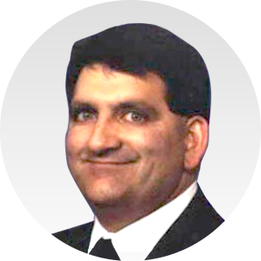

**Name:** Ted Girata **Position:** Project Manager **Company:** Altran US Corp

I had the pleasure to work with Sergey on a demanding engagement with a customer. Sergey is a person you want on your team during these type of situations.  
  
He is very easy to work with, quickly understands customer dynamics, provides excellent team dynamics and direction, and most of all has a great grasp of how to take technology and apply it to the customers benefits.

Sergey is a true team player who jumps in when needed and promotes his team equally to challenge themselves. He also is a very savvy technologist who researches different aspects of the problems at hand and applies his experience and mastery of technology to meet the customer demands.

Another great plus is Sergey is always looking and thinking ahead with the big picture in mind and working to create opportunities with the customer to enable successful future engagements. It was a pleasure working with Sergey and I look forward to future opportunities to do so.  
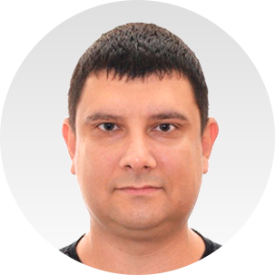

**Name:** Andrey Kozin **Position:** Chief Operating Officer **Company:** Lohika

I worked with Sergey for about 2.5 years and all that time managed him directly. I can say that Sergey is extremely smart, high technical, professional and friendly person. He is strong and professional team lead. He was leading several important projects in Lohika and all of them were successful. Sergey always learns something new, he is eager to get new knowledge. He always listens to what his manager says and, even more important, always hears what his manager recommends and acts according to what's been agreed. Sergey is very proactive and during this time I got many new ideas from Sergey regarding processes, people and clients, that were successfully implemented.

From technical perspective Sergey is a software developer of an architect level. Frequently his architectural recommendations were accepted by clients that allowed to significantly improve products quality, stability and performance.

In addition, Sergey has very good presentation skills and great English. He is able to perform good technical presentation on any topic to any audience. He knows what to highlight, when and how, how to answer tough questions and how to attract audience to his point of view.

In general I can say that Sergey is really professional lead developer who positively impacts any organization, project and process where he works on.

**Name:** Manu Lohiya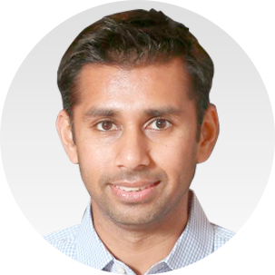 **Position:** Product Leader **Company:** Presence Learning

Sergey worked with Presence Learning for about a year where Sergey served as both the tech lead and project manager. Sergey was our main point of contact for all new feature development.

We set an aggressive goal to enhance our existing tele-therapy room from MVP to fully featured in a short amount of time. Sergey worked extremely hard and smart to ensure that the features we requested were delivered on time and built smartly for scale.

Thanks to Sergey's technical and project leadership, Sergey and team built 10 major features over 13 successful product releases. Additionally, Sergey was also proactive about suggesting improvements to features and processes which further helped us strengthen our process for the long haul.

Needless to say, our customers loved the features and as the product owner, I was satisfied. Would be an honor to work with Sergey again in the future!

**Name:** Christine Shellenbarger **Position:** UI/UX Designer **Company:** Presence Learning

It was a pleasure to work with Sergey while he worked with Presence Learning as both a Technical Lead and Project Manager.

Over the year we worked together, I developed a deep respect for Sergey for his attention to detail (all the way down to the pixel level) and the way he kept his team organized and on task.

He is an excellent communicator and, as the product designer, I found it very valuable to bounce ideas off of him as he always kept the end-user in mind.

In addition, Sergey has an invaluable passion for his craft which shows in the work he has done at Presence Learning as well as in his spare time. I would leap at the opportunity to work with Sergey again.

**Name:** Aaron Cowdin **Position:** DevOps **Company:** Presence Learning

When we originally started working together Sergey and I had very little time to complete some important ramp up work. Sergey was on top of it immediately. He asks the right questions, has creative solutions to problems, and can quickly get to the heart of an issue. Every interaction with him was a good experience and the results of his work were always top notch.  
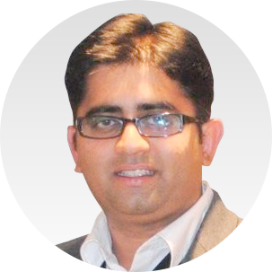

**Name:** Hiren Sodha **Position:** Sr. Software Engineer **Company:** Microsoft Skype

In the short period of 6 months Sergey achieved a lot on his Job at Skype-Microsoft. He is an excellent developer with very good technical skills. He is also a quick learner, a perfect candidate for agile environment. I would highly recommend him for any team/ company looking to hire him.  
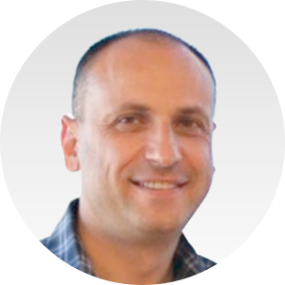

**Name:** Edward Kogan **Position:** Sr. Director of Engineering **Company:** Ring Central

Sergey is a star web developer and system architect. His ability to start a new project from scratch, design, build architecture and bring the product to fruition is second to none. His technical depth and experience is unquestionable. Sergey is one of the best developers/team leads I ever had the pleasure to work with. I highly recommend.