Step 0 - create shared artefacts

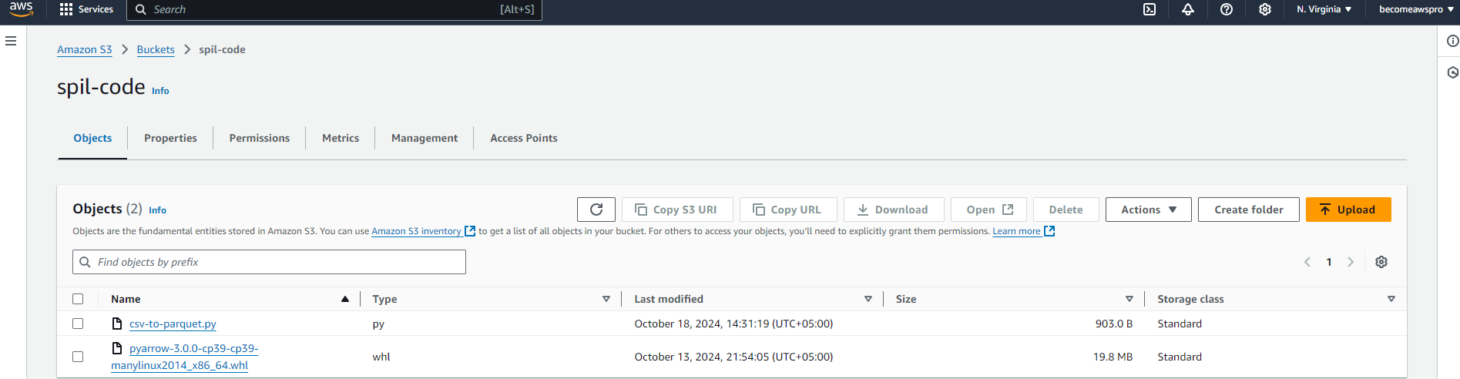

Step 1 - setting up the inputs and outputs

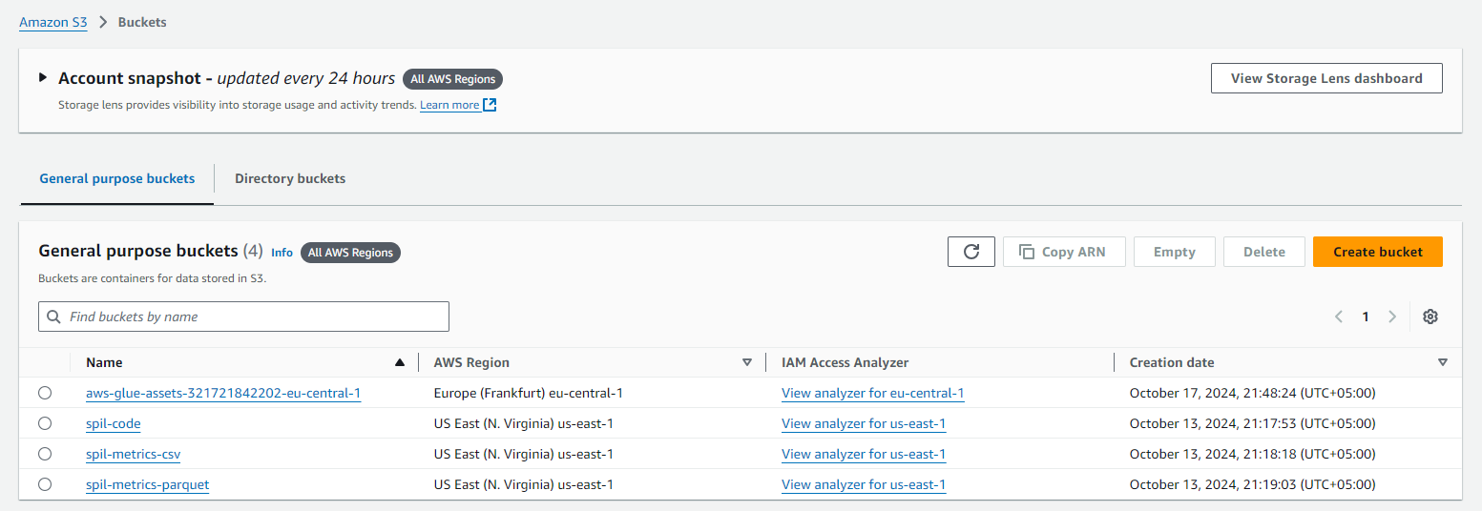

Step 2 - create an ETL job

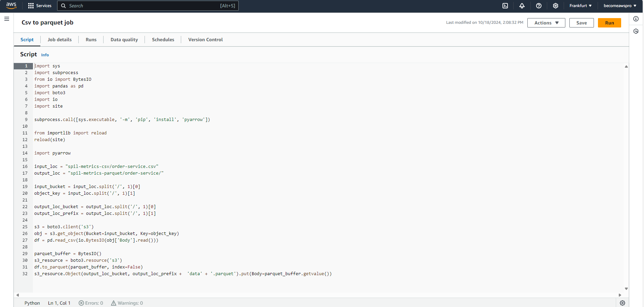

Step 3 - run the ETL job

