Step 1 - create a Glue DataCatalog table

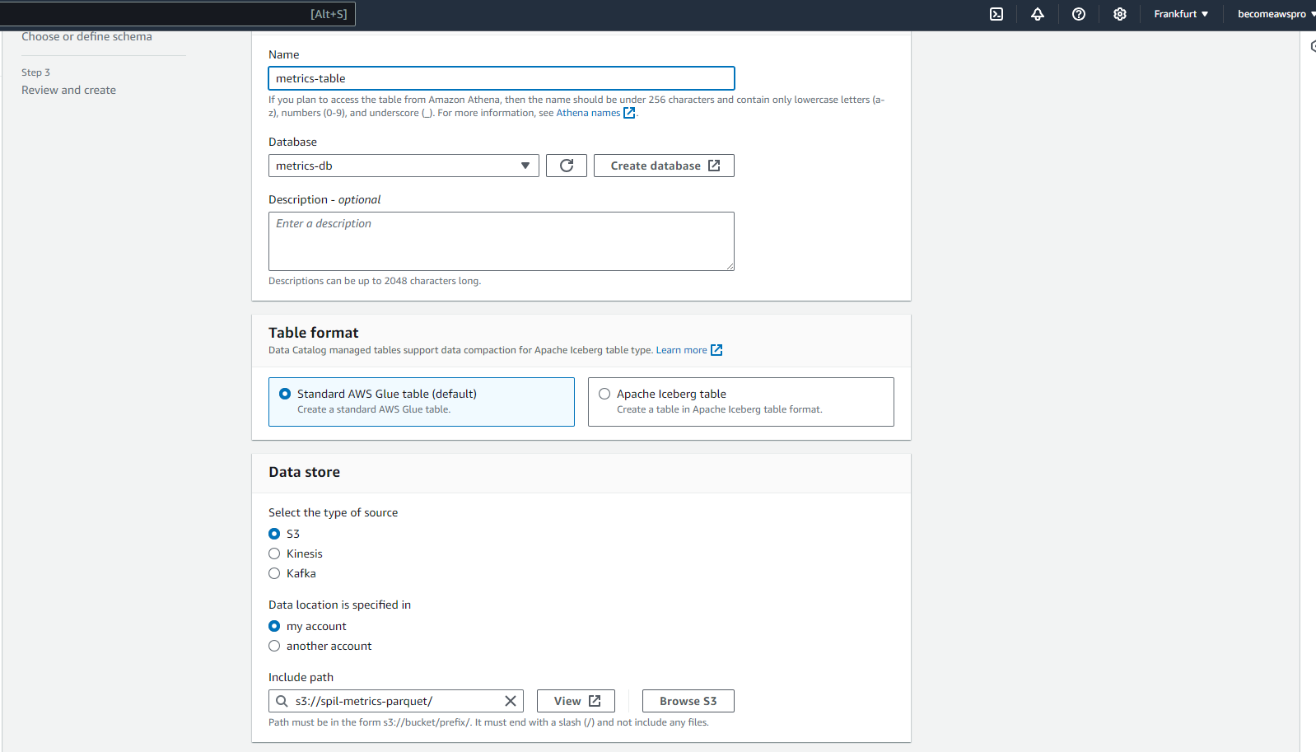

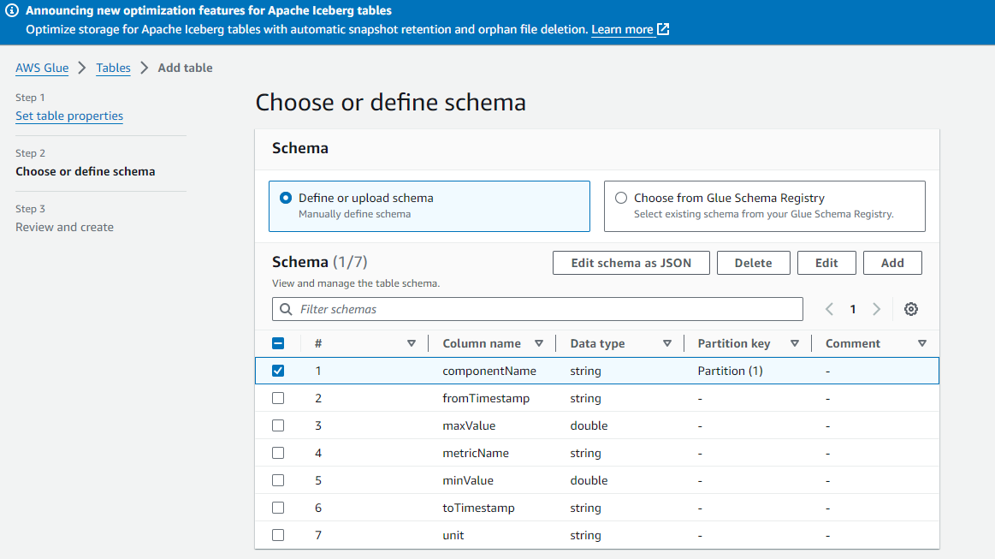

Step 2 - partition the Glue DataCatalog table

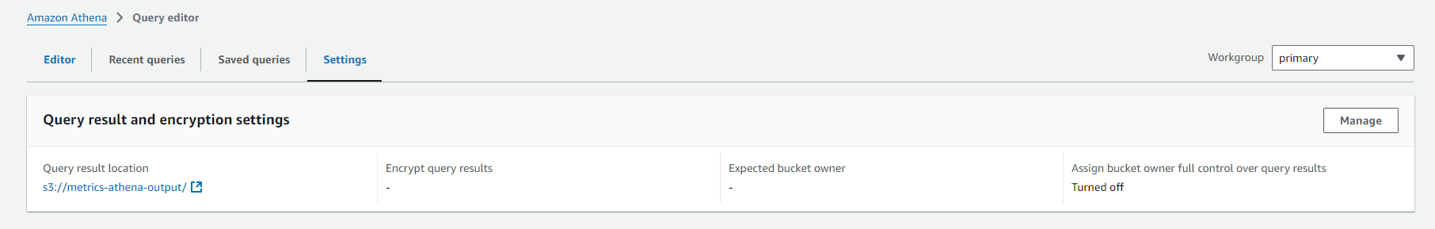

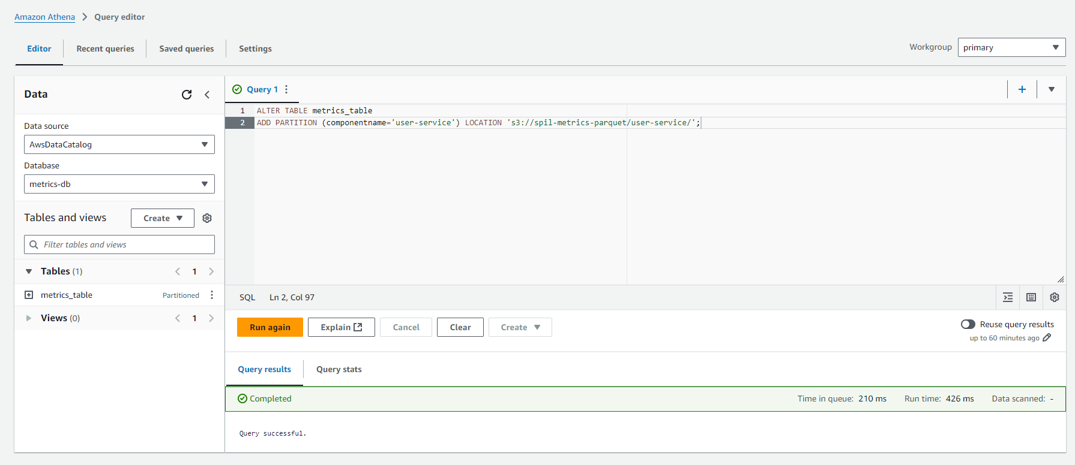

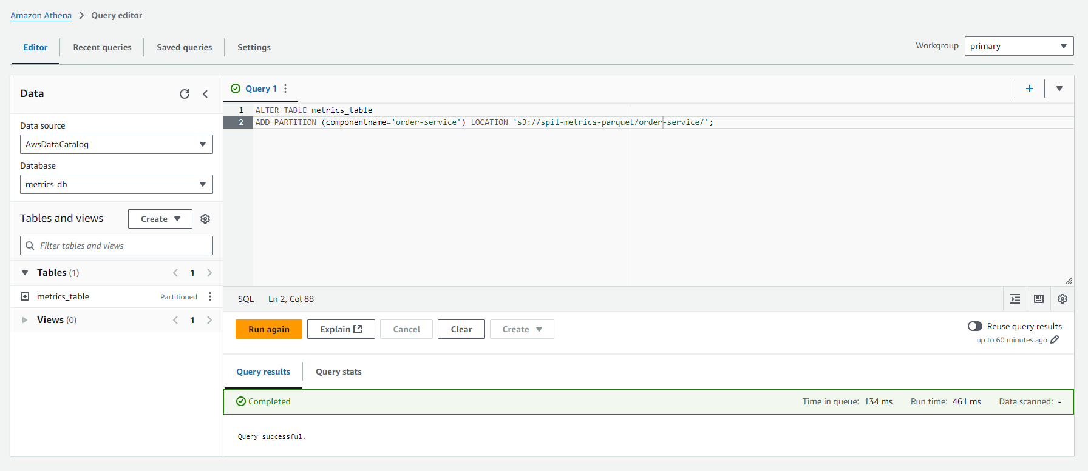

Step 3 - query the Glue DataCatalog table



