java -jar test-data-generator-1.0.0-all.jar kinesis-metrics-stream.json  
create a streaming application

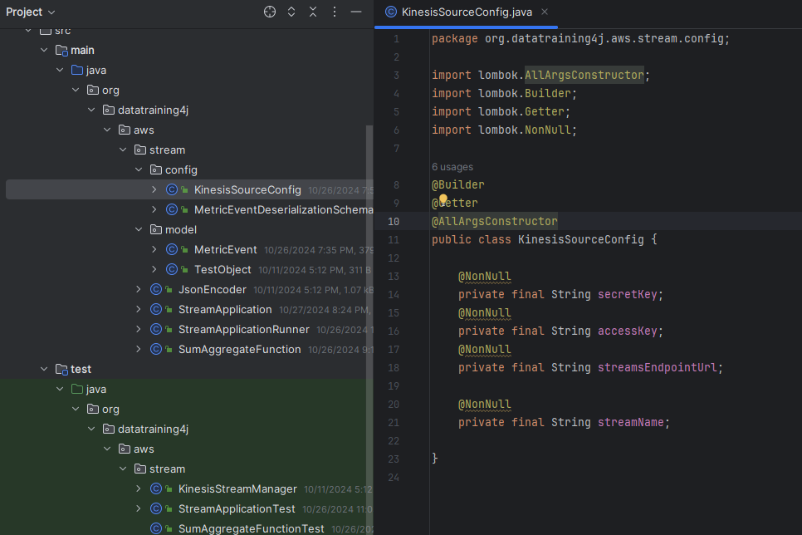

Update:  
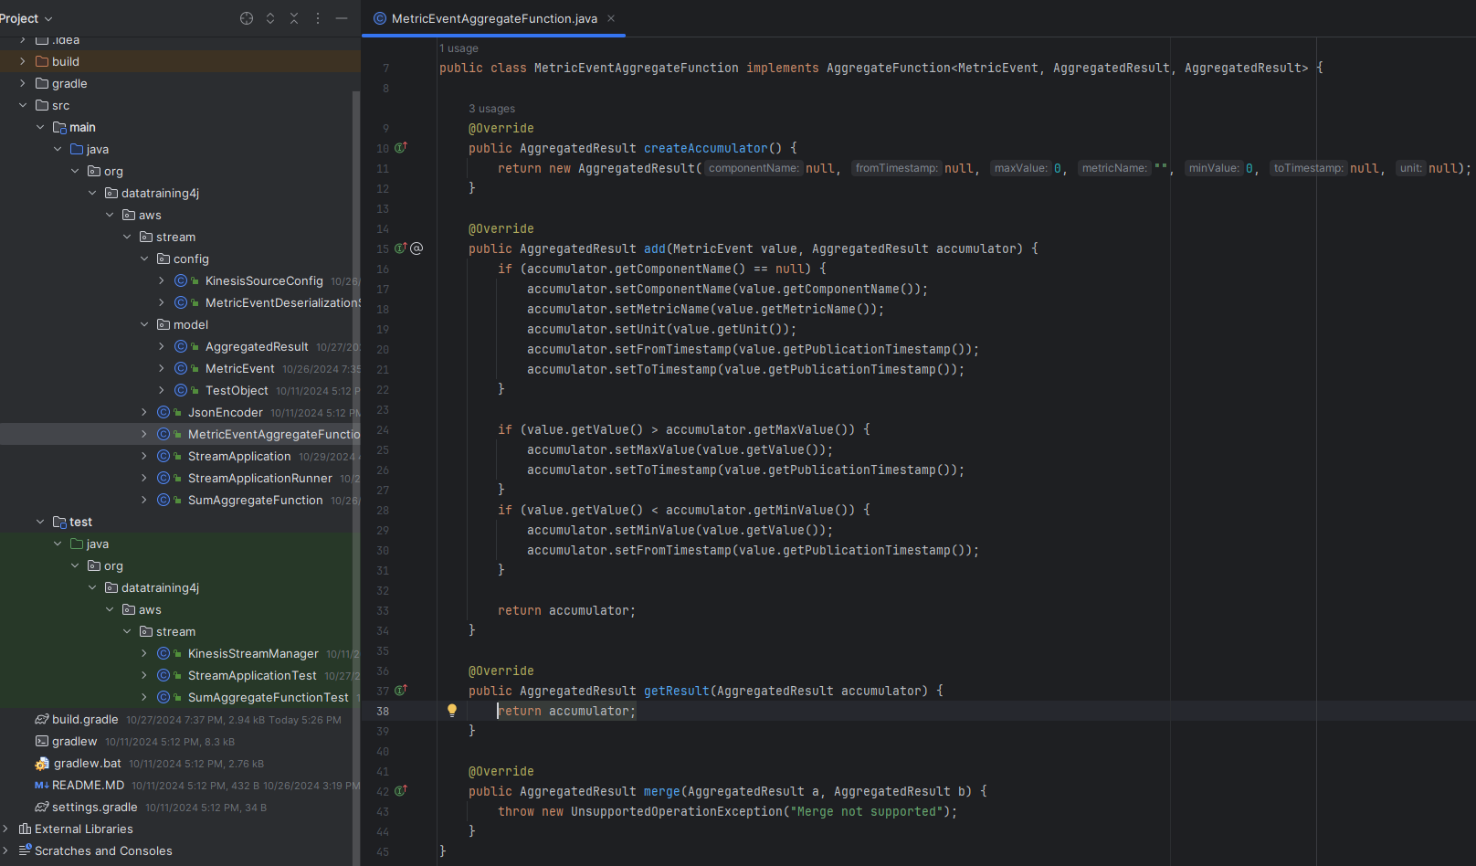

test the streaming application

deploy the streaming application



