Step 1 - set up outputs

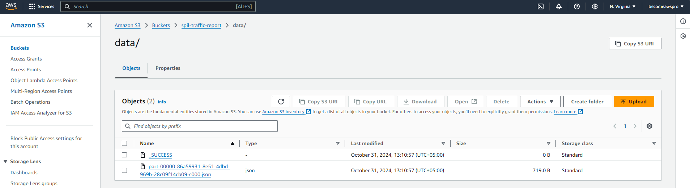

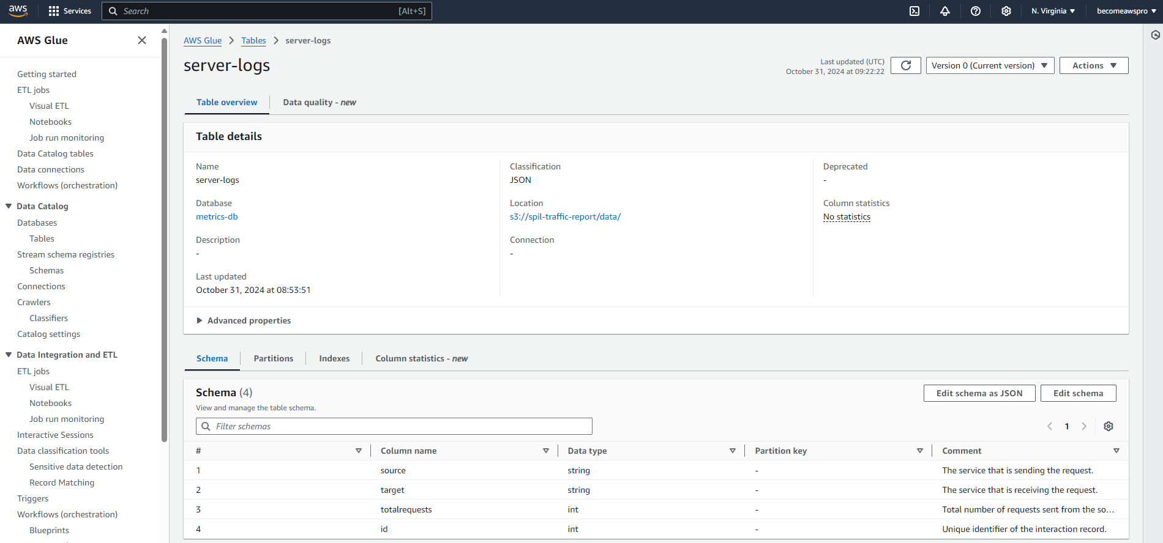

Step 2 - create a Spark application

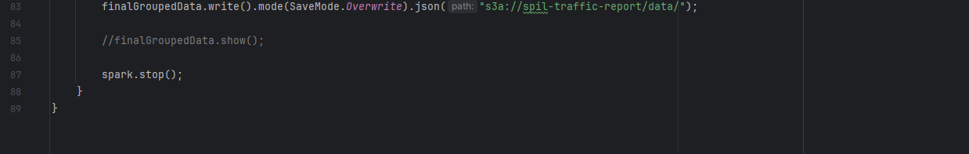

Step 3 - create an EMR Serverless application

Step 4 - run a job

java -jar test-data-generator-1.0.0-all.jar server-access-log.json

Step 5 – visualize

