Step 1 - NeonDB setup  
  
  
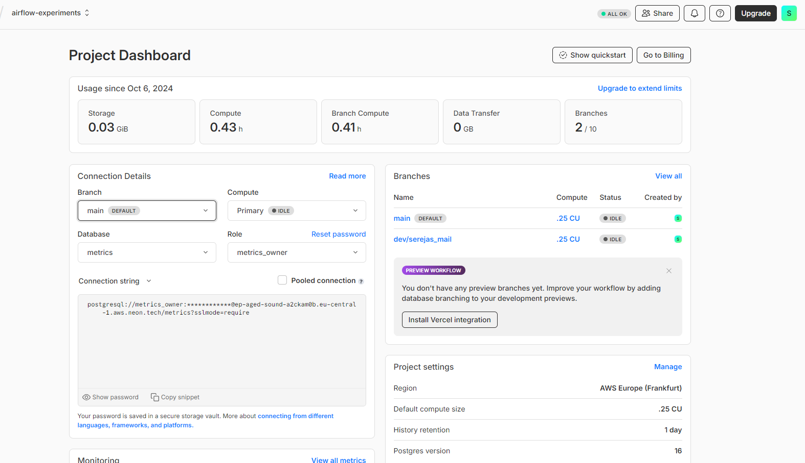

Step 2 - Airflow project setup

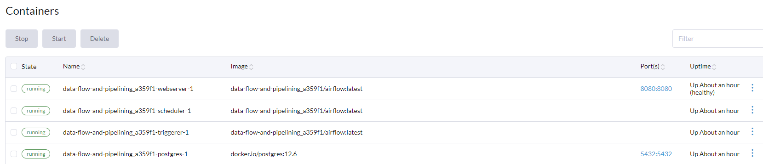

Step 3 - Airflow-NeonDB integration

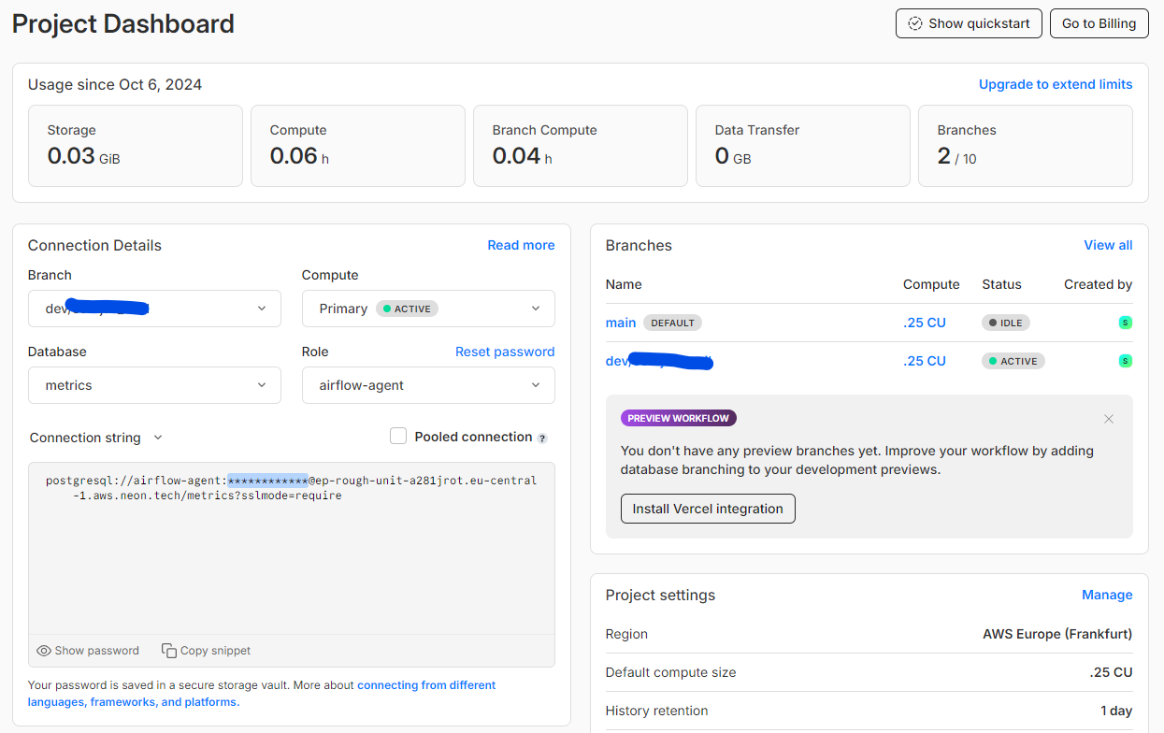

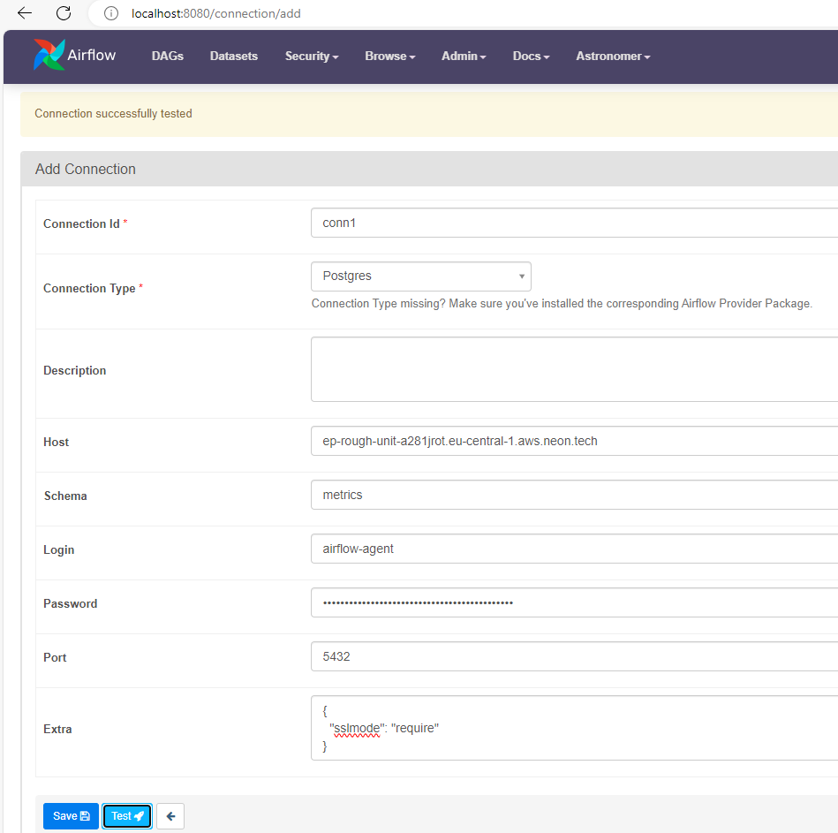

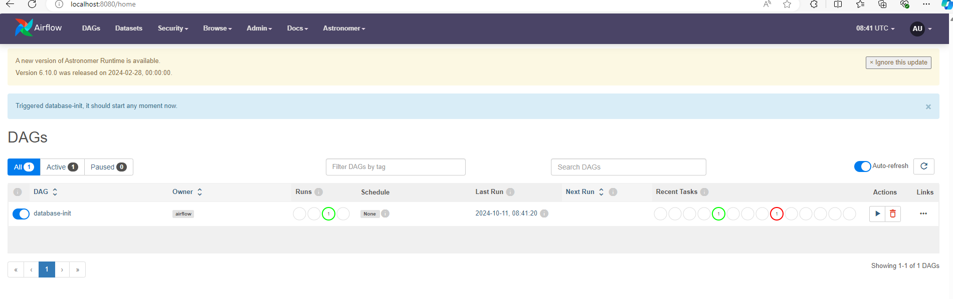  
  
  
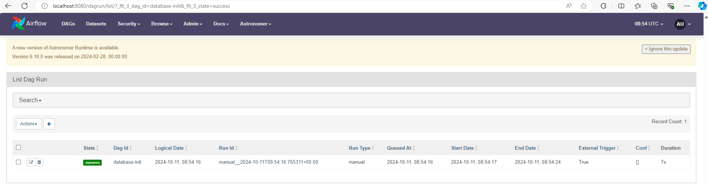

Step 4 - data ingestion setup

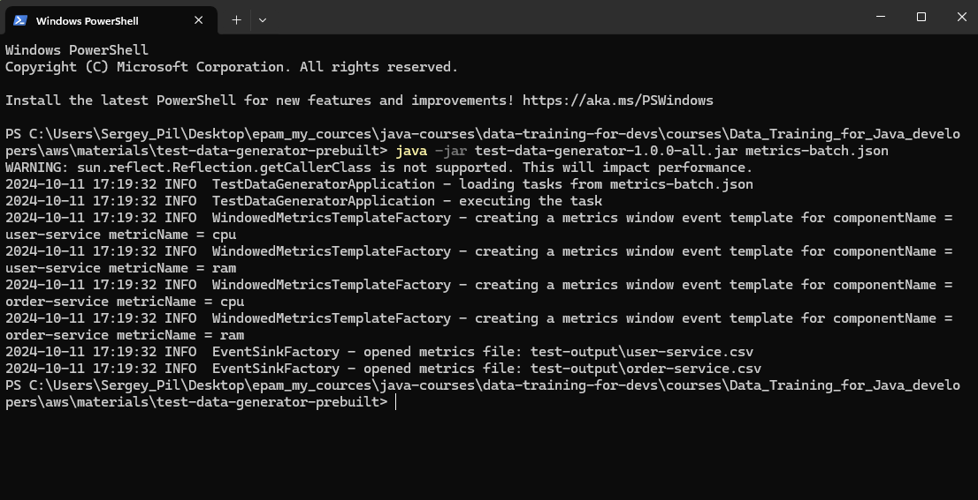

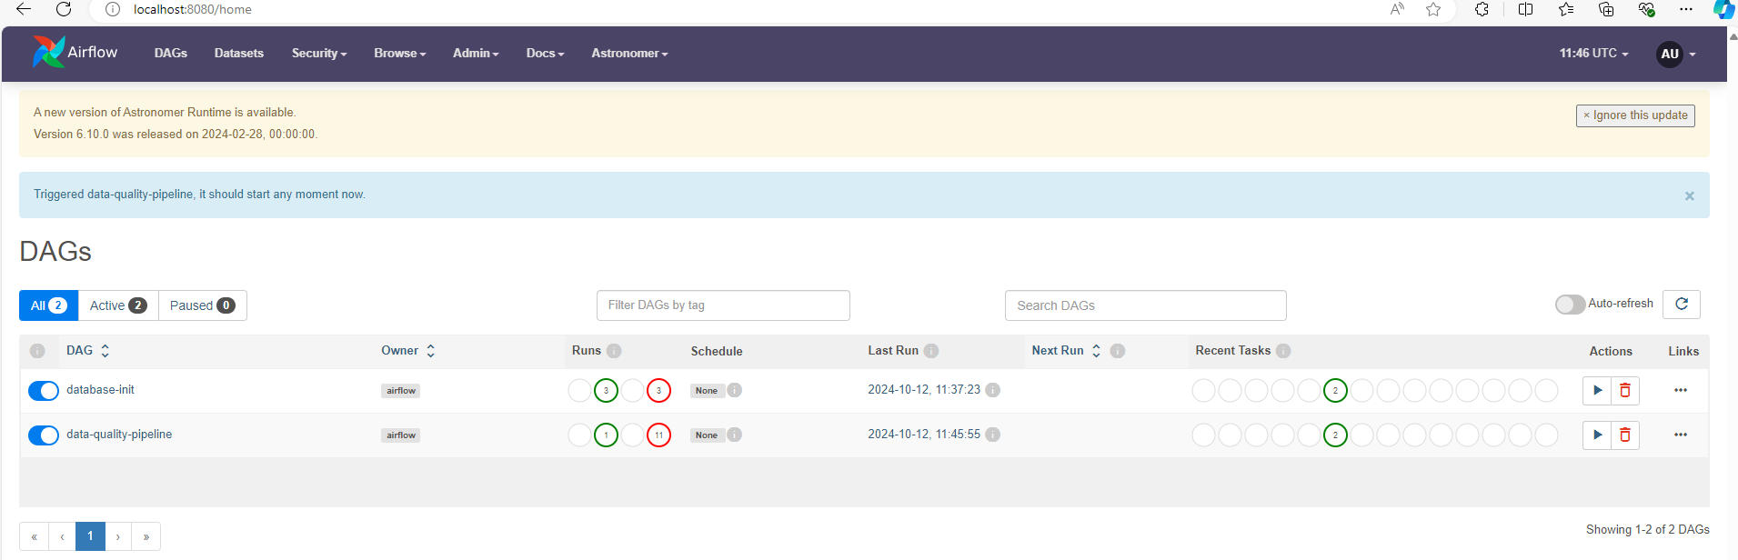

Step 5 - DBT model setup

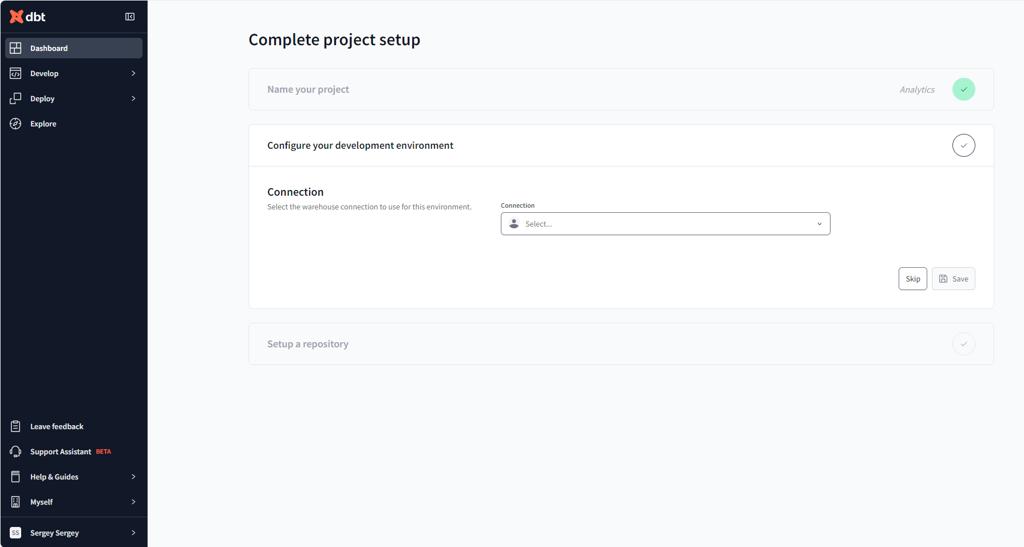

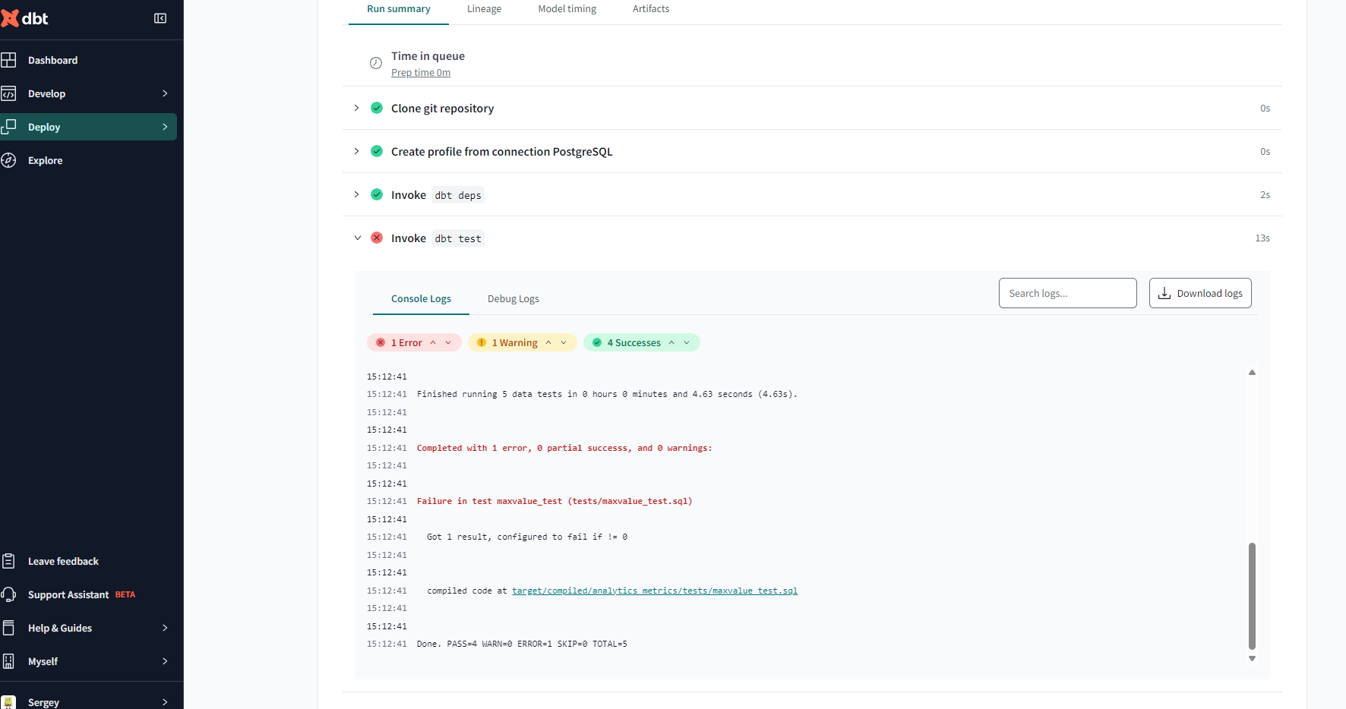  
  
  
  
Step 6 - Airflow-DBT integration  
  




