**Cluster  
  
Spark Filter, Most Widely Used Function**

**Can Query Expressions Be Written in a Better Way**

**User Defined Functions (UDF)**

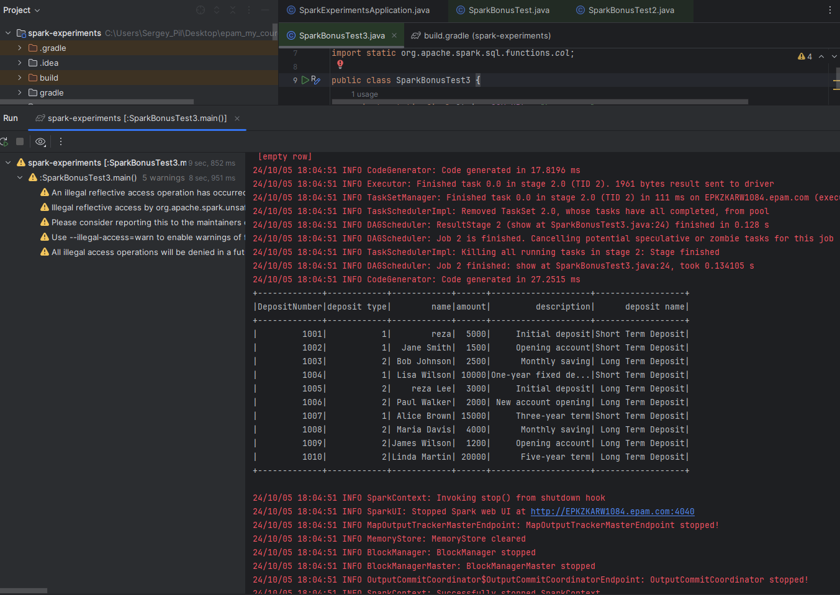

**Spark Aggregate Function**

