Created new discovery-service   
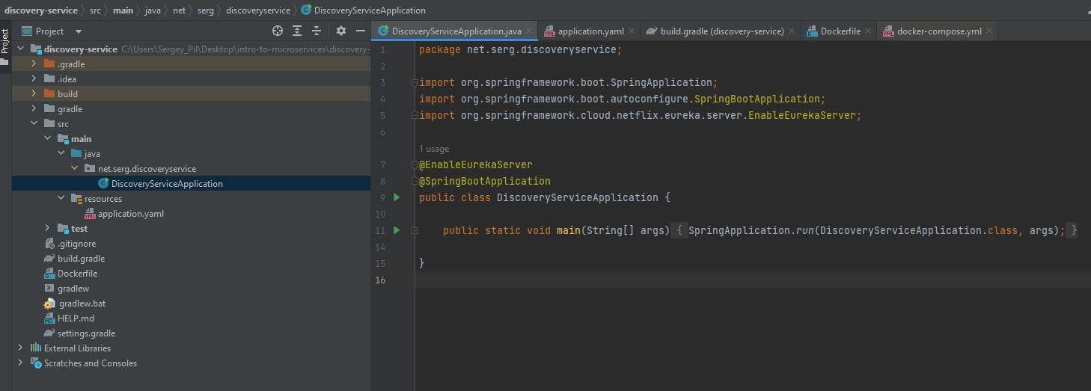

Created Dockerfile 

Added it to docker-compose

Song service is made Eureka client  
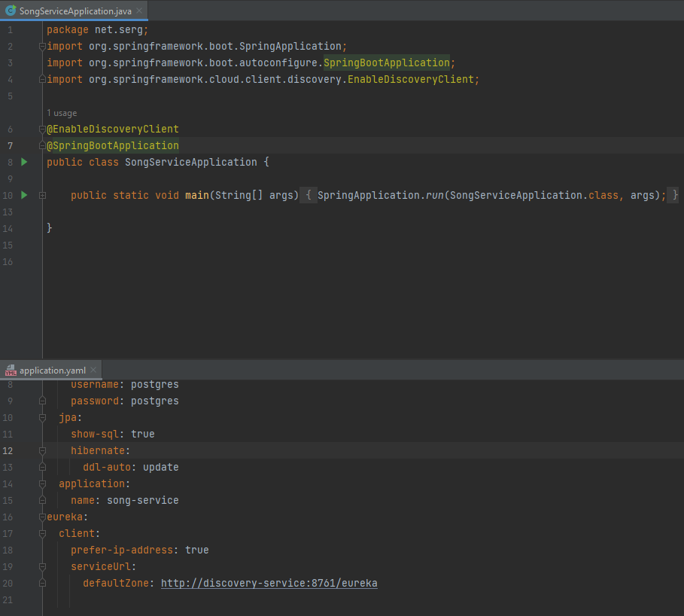  
  
Resource service is made Eureka client too. Updated URL of song service  
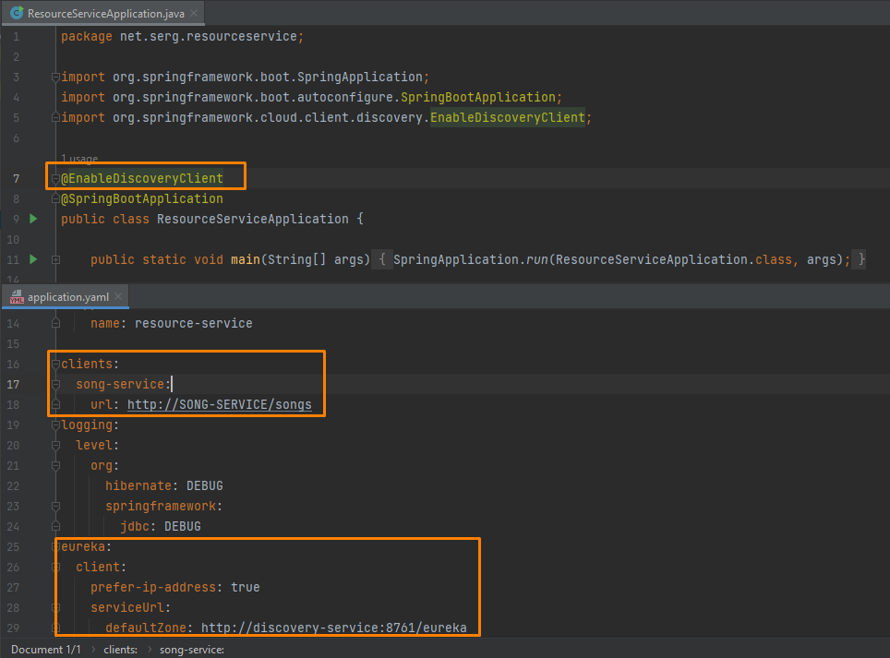

Services registered  
