# OCR A LEVEL COURSEWORK – WEBSITE FOR FINANCIAL ADVISOR

BY SERGEY SHKOLNIK

CONTENTS

Contents

OCR A LEVEL COURSEWORK – WEBSITE FOR FINANCIAL ADVISOR 1

ANALYSIS 3

Description 3

Why is the problem solvable by a computational approach? 4

# ANALYSIS

## Description

My project is a website for a financial advisor who will help them manage their timings and client bookings. The website will give a description about what services are offered by the finance advisor and it will allow the admin (the finance coach) to manage their timetable of meetings with their clients. The website will allow a user to create an account, login and request times for a meeting. Whereas the admin will be able to post free time slots for the day which will be filled up by their clients. The website will then send a reminder to the user and the admin about their scheduled appointment. Furthermore, the website will have a billing system so the clients can view different prices and it will also have a chat system between the client and the finance coach so that plans about meetings can be further discussed.

## Why is the problem solvable by a computational approach?

* The given problem is amenable to a computational approach because it requires the management of large amounts of data from different clients. This can be solved using a database which is able to store different types of data safely and this data is protected and can be fetched at any time by the permitted user. Whereas without the use of a computational method, the user would have to remember their timings for their meetings on their own or use paper to write down their timetable which has a risk of being lost or misplaced.
* Furthermore, to help the user remind themselves of the timings, a computational method can be used to send the user automatic reminders about their scheduled meetings. This will reduce the risk of missing a scheduled meeting as action from the user is not required to remind themselves.
* The use of computational methods also allows the finance coach to keep in touch with their clients with a chat system integrated into the website. This way the user doesn’t have to find the contact of their client elsewhere and can keep all their work-related communications in one place.

## Stakeholders

1. My mum – my first stake holder for this project is my mum as she works as a finance advisor and a finance coach. She has a growing number of clients and meetings getting booked. My mum will represent the admin side and the experience of a finance advisor using my website. The ways in which she will use my website include: logging in and creating an account, allocating free time slots during which she can take meetings, manage her schedule and contact her clients. This is appropriate for her as this will replace a physical diary and save her from scrambling around pieces of paper while trying to keep organised with her tight schedule.
2. Alua Zhunisbekova is one of my mum’s clients who has meetings with her and other financial coaches. She will represent the user of the website from a client’s perspective. The ways in which she will use the website includes: logging in and creating an account, booking meetings with the finance coach, using the chat system to contact her finance advisor about a particular topic and organise and manage her meeting schedule. This is appropriate for her needs as she has a very busy schedule with work and other commitments and my solution will help her keep her meetings organised on top of her daily life.

## Research of existing solutions

**Example 1- Microsoft Outlook**

**Viewing Timetable**

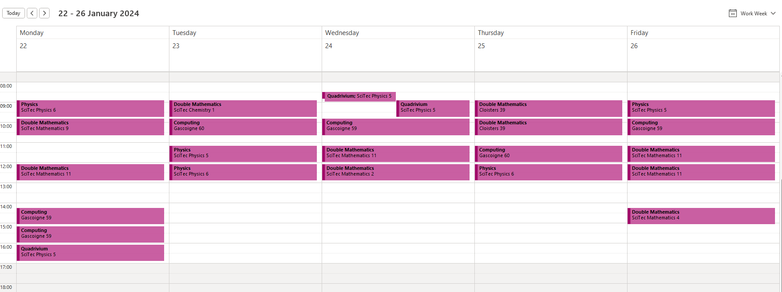

Microsoft Outlook allows a user to view their schedule with a clear visual representation. There are options to change the view from ‘Work Week’ to ‘Day’ to ‘Month’ which allows the user to view their schedules in the distant future. The format of the timetable is in the form of a diary which gives an ‘easy-to-read’ experience for the user.

The scheduled meetings are arranged in chronological order so the timing of the meeting can be easily read and in the Work Week option the days are displayed as columns so different days are clearly separated.

The arrows at the top of this online diary allow you to flick through consecutive weeks and view your schedule in a month’s or a year’s time. Meetings are furthermore clearly highlighted with a different colour, again, allowing the user to clearly visualise and not miss any scheduled meetings.

**Booking Appointments**

Outlook also allows their users to create their own appointments at a specific time. Users also have the option to make the meetings recurring or singular which is convenient for weekly/ daily meetings.

When adding a person to a meeting, the user can view their participants’ schedule and take into account any conflicting meetings. This is useful because the meeting can be booked at a comfortable time for both the admin and the user.

Again, the schedule is presented in chronological order so it is easy to navigate through the booking screen. And you can select the timing of the meeting via the dropdown menu and a visual calendar which displays different dates.

This clear visual representation of the calendar and different times makes Microsoft Outlook one of the best platforms for creating and scheduling meetings.

Another useful feature of Microsoft Outlook is the ability to click a free time slot in your schedule which will automatically direct you to the page that allows you to schedule a new meeting.

**Microsoft Outlook – Meeting Reminders**

Microsoft Outlook sends automated reminders to meeting participants and the timing of the reminders can be set by the creator of the meeting.

This is a good way to ensure that meeting participants don’t forget about their scheduled meetings as the reminder window pops up at the bottom of your screen and makes a distinct sound.



The menu bar, as well as allowing the admin to set reminder timings, also has a scheduling poll which uses analysis of schedules to suggest a comfortable time for all members of the meeting.

The menu bar also allows the admin or user to set their availability status to let all of their teammates know how occupied they are at different times of the day.

**Example 2 – Microsoft Teams (chat system)**

Microsoft Teams allows the user to be able to live chat with any member of the company/team. The chat page is accessible via the nav-bar on the right which makes it easy to access for the user of Teams. There is the option to hide each chat by clicking the drop down arrow at the top.

You can also view the status of each user to see if they are available or ‘Out of Office’ so you can contact them accordingly.

**Examples of different status’**

Busy Offline Away

The user can manipulate their visual layout of their chats by being able to ‘Pop out chat’, ‘Mark as unread’, ‘Pin’, ‘Mute’, ‘Hide’. This gives the user an opportunity to manipulate their personal messages screen to either make it look aresthetically pleasing or have all of their work chats visible on the page.

Microsoft Teams also allows users to send messages of high importance by making them highlighted so that the receiver of the message can take particular notice of them.

The Microsoft Teams chats are extremely versatile as users are able to send each other many things such as files, pictures, text and emoji’s.

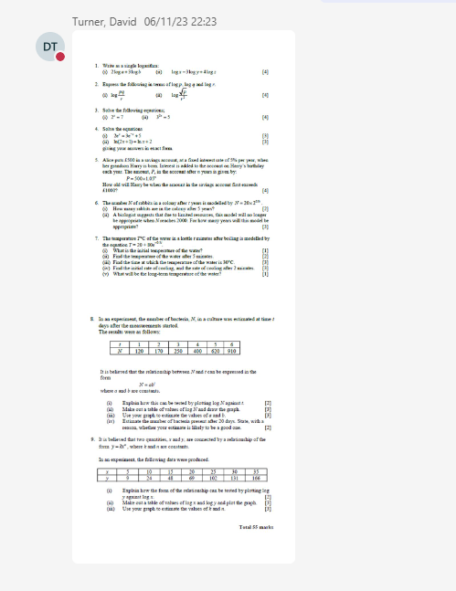

**Microsoft Teams – Channels and Teams**

Microsoft Teams allows users to be a part of a team where admins can post relevant information to their class and this material can be accessed by all members of the class.

Microsoft Teams has a separate section for files where all relevant files for the gives group/ class can be stored. The file system operates in the same way as a normal file explorer where files can be organised in different folders. File types that can be stored in Microsoft Teams include Microsoft Word, Power Point presentations, Excel spreadsheets and PDF files.

