Epochs = 50
batch_size = 64
n_copies = 2
transform = T1
batch_normalization = True
Dropout = True
validation = 0.2

Epoch 1/50 - training: 100%|██████████| 2176/2176 [00:28<00:00, 75.66it/s, acc=0.0901, avg_loss=2.9795]
Epoch 1/50 - validation: 100%|██████████| 272/272 [00:02<00:00, 106.87it/s, acc=0.0882, avg_loss=2.7481]
Epoch 2/50 - training: 100%|██████████| 2176/2176 [00:29<00:00, 75.02it/s, acc=0.1365, avg_loss=2.4599]
Epoch 2/50 - validation: 100%|██████████| 272/272 [00:02<00:00, 108.99it/s, acc=0.1544, avg_loss=2.2698]
Epoch 3/50 - training: 100%|██████████| 2176/2176 [00:28<00:00, 75.28it/s, acc=0.2224, avg_loss=2.1954]
Epoch 3/50 - validation: 100%|██████████| 272/272 [00:02<00:00, 109.30it/s, acc=0.3088, avg_loss=2.0161]
Epoch 4/50 - training: 100%|██████████| 2176/2176 [00:28<00:00, 75.32it/s, acc=0.3171, avg_loss=1.9259]
Epoch 4/50 - validation: 100%|██████████| 272/272 [00:02<00:00, 100.64it/s, acc=0.3750, avg_loss=1.7438]
Epoch 5/50 - training: 100%|██████████| 2176/2176 [00:28<00:00, 75.50it/s, acc=0.3681, avg_loss=1.7889]
Epoch 5/50 - validation: 100%|██████████| 272/272 [00:02<00:00, 108.09it/s, acc=0.3603, avg_loss=1.8131]
Epoch 6/50 - training: 100%|██████████| 2176/2176 [00:28<00:00, 76.64it/s, acc=0.3879, avg_loss=1.6906]
Epoch 6/50 - validation: 100%|██████████| 272/272 [00:02<00:00, 109.19it/s, acc=0.4301, avg_loss=1.5825]
Epoch 7/50 - training: 100%|██████████| 2176/2176 [00:28<00:00, 77.27it/s, acc=0.4908, avg_loss=1.4119]
Epoch 7/50 - validation: 100%|██████████| 272/272 [00:02<00:00, 111.47it/s, acc=0.4522, avg_loss=1.6304]
Epoch 8/50 - training: 100%|██████████| 2176/2176 [00:28<00:00, 77.38it/s, acc=0.4890, avg_loss=1.4635]
Epoch 8/50 - validation: 100%|██████████| 272/272 [00:02<00:00, 111.00it/s, acc=0.4301, avg_loss=1.5860]
Epoch 9/50 - training: 100%|██████████| 2176/2176 [00:28<00:00, 77.53it/s, acc=0.5450, avg_loss=1.2827]
Epoch 9/50 - validation: 100%|██████████| 272/272 [00:02<00:00, 111.08it/s, acc=0.4191, avg_loss=1.8949]
Epoch 10/50 - training: 100%|██████████| 2176/2176 [00:28<00:00, 77.44it/s, acc=0.6108, avg_loss=1.0780]
Epoch 10/50 - validation: 100%|██████████| 272/272 [00:02<00:00, 111.53it/s, acc=0.5147, avg_loss=1.4792]
Epoch 11/50 - training: 100%|██████████| 2176/2176 [00:28<00:00, 76.63it/s, acc=0.6480, avg_loss=1.0369]
Epoch 11/50 - validation: 100%|██████████| 272/272 [00:02<00:00, 112.38it/s, acc=0.4779, avg_loss=1.5843]
Epoch 12/50 - training: 100%|██████████| 2176/2176 [00:28<00:00, 76.50it/s, acc=0.6949, avg_loss=0.8911]
Epoch 12/50 - validation: 100%|██████████| 272/272 [00:02<00:00, 110.00it/s, acc=0.5331, avg_loss=1.8275]
Epoch 13/50 - training: 100%|██████████| 2176/2176 [00:27<00:00, 78.15it/s, acc=0.7243, avg_loss=0.7741]
Epoch 13/50 - validation: 100%|██████████| 272/272 [00:02<00:00, 111.95it/s, acc=0.5110, avg_loss=2.0461]
Epoch 14/50 - training: 100%|██████████| 2176/2176 [00:28<00:00, 77.20it/s, acc=0.7270, avg_loss=0.8146]
Epoch 14/50 - validation: 100%|██████████| 272/272 [00:02<00:00, 106.70it/s, acc=0.4963, avg_loss=1.6073]
Epoch 15/50 - training: 100%|██████████| 2176/2176 [00:28<00:00, 76.36it/s, acc=0.7762, avg_loss=0.6652]
Epoch 15/50 - validation: 100%|██████████| 272/272 [00:02<00:00, 111.29it/s, acc=0.5772, avg_loss=1.6000]
Epoch 16/50 - training: 100%|██████████| 2176/2176 [00:28<00:00, 77.36it/s, acc=0.8286, avg_loss=0.5383]
Epoch 16/50 - validation: 100%|██████████| 272/272 [00:02<00:00, 112.12it/s, acc=0.5662, avg_loss=1.7960]
Epoch 17/50 - training: 100%|██████████| 2176/2176 [00:27<00:00, 77.85it/s, acc=0.8392, avg_loss=0.4899]
Epoch 17/50 - validation: 100%|██████████| 272/272 [00:02<00:00, 110.69it/s, acc=0.5846, avg_loss=1.8009]
Epoch 18/50 - training: 100%|██████████| 2176/2176 [00:27<00:00, 78.20it/s, acc=0.8493, avg_loss=0.4696]
Epoch 18/50 - validation: 100%|██████████| 272/272 [00:02<00:00, 111.51it/s, acc=0.5882, avg_loss=1.6788]
Epoch 19/50 - training: 100%|██████████| 2176/2176 [00:28<00:00, 77.64it/s, acc=0.8699, avg_loss=0.4193]
Epoch 19/50 - validation: 100%|██████████| 272/272 [00:02<00:00, 112.73it/s, acc=0.5956, avg_loss=1.6503]
Epoch 20/50 - training: 100%|██████████| 2176/2176 [00:28<00:00, 77.44it/s, acc=0.8851, avg_loss=0.3911]
Epoch 20/50 - validation: 100%|██████████| 272/272 [00:02<00:00, 113.35it/s, acc=0.5699, avg_loss=1.8238]
Epoch 21/50 - training: 100%|██████████| 2176/2176 [00:28<00:00, 77.40it/s, acc=0.8837, avg_loss=0.3848]
Epoch 21/50 - validation: 100%|██████████| 272/272 [00:02<00:00, 113.04it/s, acc=0.6103, avg_loss=1.9667]
Epoch 22/50 - training: 100%|██████████| 2176/2176 [00:27<00:00, 78.42it/s, acc=0.8851, avg_loss=0.3807]
Epoch 22/50 - validation: 100%|██████████| 272/272 [00:02<00:00, 112.68it/s, acc=0.6029, avg_loss=1.6593]
Epoch 23/50 - training: 100%|██████████| 2176/2176 [00:27<00:00, 77.93it/s, acc=0.9095, avg_loss=0.2995]
Epoch 23/50 - validation: 100%|██████████| 272/272 [00:02<00:00, 112.52it/s, acc=0.6471, avg_loss=1.5739]
Epoch 24/50 - training: 100%|██████████| 2176/2176 [00:27<00:00, 78.98it/s, acc=0.9141, avg_loss=0.2914]
Epoch 24/50 - validation: 100%|██████████| 272/272 [00:02<00:00, 113.15it/s, acc=0.6140, avg_loss=1.8339]
Epoch 25/50 - training: 100%|██████████| 2176/2176 [00:28<00:00, 76.82it/s, acc=0.9191, avg_loss=0.2694]
Epoch 25/50 - validation: 100%|██████████| 272/272 [00:02<00:00, 112.03it/s, acc=0.6360, avg_loss=1.6058]
Epoch 26/50 - training: 100%|██████████| 2176/2176 [00:27<00:00, 78.06it/s, acc=0.9085, avg_loss=0.3231]
Epoch 26/50 - validation: 100%|██████████| 272/272 [00:02<00:00, 113.30it/s, acc=0.5772, avg_loss=2.1463]
Epoch 27/50 - training: 100%|██████████| 2176/2176 [00:27<00:00, 78.97it/s, acc=0.9145, avg_loss=0.2755]
Epoch 27/50 - validation: 100%|██████████| 272/272 [00:02<00:00, 113.01it/s, acc=0.5956, avg_loss=2.0213]
Epoch 28/50 - training: 100%|██████████| 2176/2176 [00:27<00:00, 78.09it/s, acc=0.9389, avg_loss=0.2164]
Epoch 28/50 - validation: 100%|██████████| 272/272 [00:02<00:00, 113.53it/s, acc=0.5846, avg_loss=1.8545]
Epoch 29/50 - training: 100%|██████████| 2176/2176 [00:27<00:00, 78.46it/s, acc=0.9485, avg_loss=0.1907]
Epoch 29/50 - validation: 100%|██████████| 272/272 [00:02<00:00, 113.02it/s, acc=0.5956, avg_loss=1.7718]
Epoch 30/50 - training: 100%|██████████| 2176/2176 [00:27<00:00, 78.79it/s, acc=0.9430, avg_loss=0.2259]
Epoch 30/50 - validation: 100%|██████████| 272/272 [00:02<00:00, 112.09it/s, acc=0.6250, avg_loss=1.6754]
Epoch 31/50 - training: 100%|██████████| 2176/2176 [00:28<00:00, 76.88it/s, acc=0.9320, avg_loss=0.2410]
Epoch 31/50 - validation: 100%|██████████| 272/272 [00:02<00:00, 112.77it/s, acc=0.5846, avg_loss=1.7453]
Epoch 32/50 - training: 100%|██████████| 2176/2176 [00:27<00:00, 77.91it/s, acc=0.9288, avg_loss=0.2603]
Epoch 32/50 - validation: 100%|██████████| 272/272 [00:02<00:00, 111.49it/s, acc=0.5993, avg_loss=1.6418]
Epoch 33/50 - training: 100%|██████████| 2176/2176 [00:28<00:00, 76.62it/s, acc=0.9292, avg_loss=0.2466]
Epoch 33/50 - validation: 100%|██████████| 272/272 [00:02<00:00, 108.98it/s, acc=0.6140, avg_loss=1.5151]
Epoch 34/50 - training: 100%|██████████| 2176/2176 [00:28<00:00, 77.06it/s, acc=0.9311, avg_loss=0.2554]
Epoch 34/50 - validation: 100%|██████████| 272/272 [00:02<00:00, 111.63it/s, acc=0.5882, avg_loss=1.7099]
Epoch 35/50 - training: 100%|██████████| 2176/2176 [00:28<00:00, 75.27it/s, acc=0.9375, avg_loss=0.2132]
Epoch 35/50 - validation: 100%|██████████| 272/272 [00:02<00:00, 110.73it/s, acc=0.5919, avg_loss=1.9102]
Epoch 36/50 - training: 100%|██████████| 2176/2176 [00:28<00:00, 77.37it/s, acc=0.9246, avg_loss=0.2560]
Epoch 36/50 - validation: 100%|██████████| 272/272 [00:02<00:00, 110.73it/s, acc=0.6029, avg_loss=1.4830]
Epoch 37/50 - training: 100%|██████████| 2176/2176 [00:28<00:00, 77.47it/s, acc=0.9439, avg_loss=0.1900]
Epoch 37/50 - validation: 100%|██████████| 272/272 [00:02<00:00, 110.87it/s, acc=0.6140, avg_loss=1.6514]
Epoch 38/50 - training: 100%|██████████| 2176/2176 [00:28<00:00, 77.42it/s, acc=0.9407, avg_loss=0.1917]
Epoch 38/50 - validation: 100%|██████████| 272/272 [00:02<00:00, 109.90it/s, acc=0.6471, avg_loss=1.7239]
Epoch 39/50 - training: 100%|██████████| 2176/2176 [00:28<00:00, 76.16it/s, acc=0.9357, avg_loss=0.2316]
Epoch 39/50 - validation: 100%|██████████| 272/272 [00:02<00:00, 109.53it/s, acc=0.5956, avg_loss=1.7844]
Epoch 40/50 - training: 100%|██████████| 2176/2176 [00:27<00:00, 78.12it/s, acc=0.9196, avg_loss=0.2768]
Epoch 40/50 - validation: 100%|██████████| 272/272 [00:02<00:00, 112.48it/s, acc=0.6103, avg_loss=1.7802]
Epoch 41/50 - training: 100%|██████████| 2176/2176 [00:27<00:00, 77.90it/s, acc=0.9453, avg_loss=0.1904]
Epoch 41/50 - validation: 100%|██████████| 272/272 [00:02<00:00, 112.30it/s, acc=0.6213, avg_loss=1.6559]
Epoch 42/50 - training: 100%|██████████| 2176/2176 [00:27<00:00, 77.97it/s, acc=0.9490, avg_loss=0.1985]
Epoch 42/50 - validation: 100%|██████████| 272/272 [00:02<00:00, 113.01it/s, acc=0.6544, avg_loss=1.5954]
Epoch 43/50 - training: 100%|██████████| 2176/2176 [00:28<00:00, 76.54it/s, acc=0.9485, avg_loss=0.1731]
Epoch 43/50 - validation: 100%|██████████| 272/272 [00:02<00:00, 110.48it/s, acc=0.6213, avg_loss=1.4684]
Epoch 44/50 - training: 100%|██████████| 2176/2176 [00:28<00:00, 77.16it/s, acc=0.9421, avg_loss=0.1936]
Epoch 44/50 - validation: 100%|██████████| 272/272 [00:02<00:00, 111.09it/s, acc=0.6434, avg_loss=1.4248]
Epoch 45/50 - training: 100%|██████████| 2176/2176 [00:28<00:00, 76.98it/s, acc=0.9476, avg_loss=0.1877]
Epoch 45/50 - validation: 100%|██████████| 272/272 [00:02<00:00, 112.44it/s, acc=0.6176, avg_loss=1.5850]
Epoch 46/50 - training: 100%|██████████| 2176/2176 [00:28<00:00, 76.75it/s, acc=0.9554, avg_loss=0.1562]
Epoch 46/50 - validation: 100%|██████████| 272/272 [00:02<00:00, 108.97it/s, acc=0.6324, avg_loss=1.4223]
Epoch 47/50 - training: 100%|██████████| 2176/2176 [00:27<00:00, 78.11it/s, acc=0.9375, avg_loss=0.2279]
Epoch 47/50 - validation: 100%|██████████| 272/272 [00:02<00:00, 114.09it/s, acc=0.6434, avg_loss=1.4392]
Epoch 48/50 - training: 100%|██████████| 2176/2176 [00:28<00:00, 77.17it/s, acc=0.9407, avg_loss=0.2020]
Epoch 48/50 - validation: 100%|██████████| 272/272 [00:02<00:00, 110.61it/s, acc=0.6728, avg_loss=1.3325]
Epoch 49/50 - training: 100%|██████████| 2176/2176 [00:27<00:00, 77.80it/s, acc=0.9380, avg_loss=0.2196]
Epoch 49/50 - validation: 100%|██████████| 272/272 [00:02<00:00, 113.09it/s, acc=0.6544, avg_loss=1.4222]
Epoch 50/50 - training: 100%|██████████| 2176/2176 [00:27<00:00, 78.20it/s, acc=0.9522, avg_loss=0.1809]
Epoch 50/50 - validation: 100%|██████████| 272/272 [00:02<00:00, 110.79it/s, acc=0.6434, avg_loss=1.3553]
--- %s minutes --- 1408.4948847293854

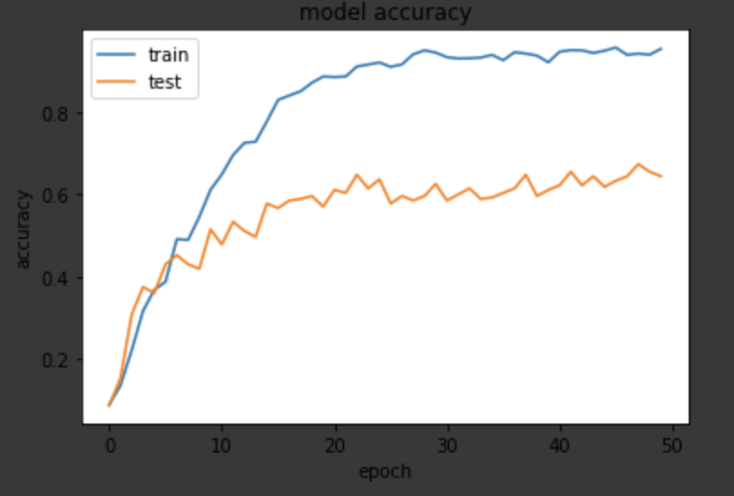
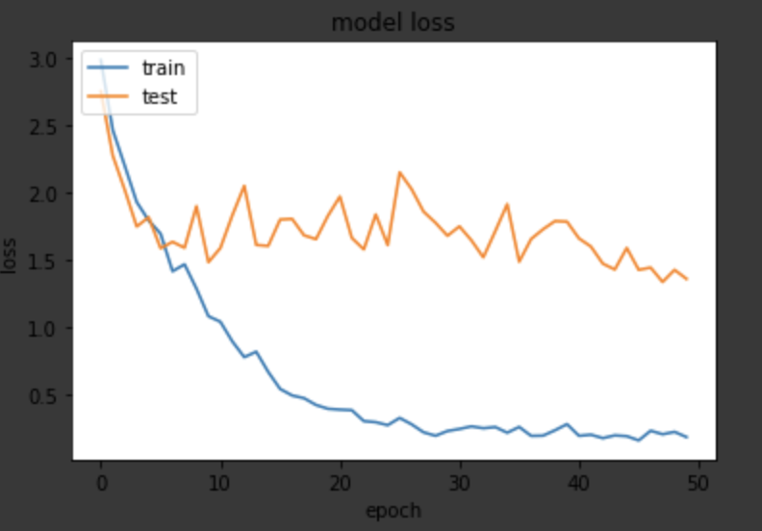

Epochs = 40
batch_size = 32
n_copies = 3
transform = T1
batch_normalization = True
Dropout = True
validation = 0.2

Epoch 1/40 - training: 100%|██████████| 3264/3264 [09:08<00:00, 5.96it/s, acc=0.0980, avg_loss=2.7737]
Epoch 1/40 - validation: 100%|██████████| 272/272 [02:09<00:00, 2.10it/s, acc=0.0882, avg_loss=2.3961]
Epoch 2/40 - training: 100%|██████████| 3264/3264 [00:48<00:00, 67.25it/s, acc=0.2142, avg_loss=2.2055]
Epoch 2/40 - validation: 100%|██████████| 272/272 [00:02<00:00, 101.07it/s, acc=0.2757, avg_loss=2.0136]
Epoch 3/40 - training: 100%|██████████| 3264/3264 [00:48<00:00, 67.49it/s, acc=0.3471, avg_loss=1.8282]
Epoch 3/40 - validation: 100%|██████████| 272/272 [00:02<00:00, 101.82it/s, acc=0.3162, avg_loss=1.8488]
Epoch 4/40 - training: 100%|██████████| 3264/3264 [00:48<00:00, 67.35it/s, acc=0.3919, avg_loss=1.6905]
Epoch 4/40 - validation: 100%|██████████| 272/272 [00:02<00:00, 100.49it/s, acc=0.3603, avg_loss=1.7911]
Epoch 5/40 - training: 100%|██████████| 3264/3264 [00:48<00:00, 67.22it/s, acc=0.4706, avg_loss=1.4943]
Epoch 5/40 - validation: 100%|██████████| 272/272 [00:02<00:00, 101.85it/s, acc=0.4632, avg_loss=1.6402]
Epoch 6/40 - training: 100%|██████████| 3264/3264 [00:47<00:00, 68.10it/s, acc=0.4951, avg_loss=1.4370]
Epoch 6/40 - validation: 100%|██████████| 272/272 [00:02<00:00, 104.35it/s, acc=0.4412, avg_loss=1.6750]
Epoch 7/40 - training: 100%|██████████| 3264/3264 [00:48<00:00, 67.25it/s, acc=0.5291, avg_loss=1.3807]
Epoch 7/40 - validation: 100%|██████████| 272/272 [00:02<00:00, 100.79it/s, acc=0.5037, avg_loss=1.5656]
Epoch 8/40 - training: 100%|██████████| 3264/3264 [00:49<00:00, 65.99it/s, acc=0.5993, avg_loss=1.2162]
Epoch 8/40 - validation: 100%|██████████| 272/272 [00:02<00:00, 102.23it/s, acc=0.5184, avg_loss=1.4697]
Epoch 9/40 - training: 100%|██████████| 3264/3264 [00:48<00:00, 67.03it/s, acc=0.6357, avg_loss=1.0485]
Epoch 9/40 - validation: 100%|██████████| 272/272 [00:02<00:00, 101.93it/s, acc=0.4853, avg_loss=1.4727]
Epoch 10/40 - training: 100%|██████████| 3264/3264 [00:49<00:00, 66.10it/s, acc=0.7132, avg_loss=0.8599]
Epoch 10/40 - validation: 100%|██████████| 272/272 [00:02<00:00, 100.60it/s, acc=0.5147, avg_loss=1.6306]
Epoch 11/40 - training: 100%|██████████| 3264/3264 [00:50<00:00, 64.93it/s, acc=0.7540, avg_loss=0.7529]
Epoch 11/40 - validation: 100%|██████████| 272/272 [00:02<00:00, 99.53it/s, acc=0.5331, avg_loss=1.5880]
Epoch 12/40 - training: 100%|██████████| 3264/3264 [00:49<00:00, 65.72it/s, acc=0.7874, avg_loss=0.6528]
Epoch 12/40 - validation: 100%|██████████| 272/272 [00:02<00:00, 99.51it/s, acc=0.5515, avg_loss=1.8600]
Epoch 13/40 - training: 100%|██████████| 3264/3264 [00:50<00:00, 65.11it/s, acc=0.8097, avg_loss=0.6166]
Epoch 13/40 - validation: 100%|██████████| 272/272 [00:02<00:00, 100.34it/s, acc=0.5478, avg_loss=1.5244]
Epoch 14/40 - training: 100%|██████████| 3264/3264 [00:49<00:00, 65.75it/s, acc=0.8361, avg_loss=0.5118]
Epoch 14/40 - validation: 100%|██████████| 272/272 [00:02<00:00, 101.23it/s, acc=0.5331, avg_loss=1.7161]
Epoch 15/40 - training: 100%|██████████| 3264/3264 [00:49<00:00, 66.10it/s, acc=0.8468, avg_loss=0.4923]
Epoch 15/40 - validation: 100%|██████████| 272/272 [00:02<00:00, 100.53it/s, acc=0.5221, avg_loss=1.7156]
Epoch 16/40 - training: 100%|██████████| 3264/3264 [00:49<00:00, 66.14it/s, acc=0.8713, avg_loss=0.4294]
Epoch 16/40 - validation: 100%|██████████| 272/272 [00:02<00:00, 102.40it/s, acc=0.5846, avg_loss=1.5956]
Epoch 17/40 - training: 100%|██████████| 3264/3264 [00:50<00:00, 64.52it/s, acc=0.8781, avg_loss=0.4119]
Epoch 17/40 - validation: 100%|██████████| 272/272 [00:02<00:00, 103.37it/s, acc=0.5993, avg_loss=1.5422]
Epoch 18/40 - training: 100%|██████████| 3264/3264 [00:49<00:00, 65.52it/s, acc=0.8876, avg_loss=0.3869]
Epoch 18/40 - validation: 100%|██████████| 272/272 [00:02<00:00, 103.18it/s, acc=0.6029, avg_loss=1.4855]
Epoch 19/40 - training: 100%|██████████| 3264/3264 [00:48<00:00, 67.39it/s, acc=0.8909, avg_loss=0.3534]
Epoch 19/40 - validation: 100%|██████████| 272/272 [00:02<00:00, 104.06it/s, acc=0.5846, avg_loss=1.5584]
Epoch 20/40 - training: 100%|██████████| 3264/3264 [00:47<00:00, 68.84it/s, acc=0.8952, avg_loss=0.3336]
Epoch 20/40 - validation: 100%|██████████| 272/272 [00:02<00:00, 103.64it/s, acc=0.5956, avg_loss=1.5976]
Epoch 21/40 - training: 100%|██████████| 3264/3264 [00:48<00:00, 67.75it/s, acc=0.9017, avg_loss=0.3240]
Epoch 21/40 - validation: 100%|██████████| 272/272 [00:02<00:00, 99.99it/s, acc=0.5846, avg_loss=1.6782]
Epoch 22/40 - training: 100%|██████████| 3264/3264 [00:48<00:00, 67.79it/s, acc=0.9017, avg_loss=0.3176]
Epoch 22/40 - validation: 100%|██████████| 272/272 [00:02<00:00, 104.17it/s, acc=0.5662, avg_loss=1.4231]
Epoch 23/40 - training: 100%|██████████| 3264/3264 [00:47<00:00, 68.49it/s, acc=0.9164, avg_loss=0.2981]
Epoch 23/40 - validation: 100%|██████████| 272/272 [00:02<00:00, 104.42it/s, acc=0.6176, avg_loss=1.4218]
Epoch 24/40 - training: 100%|██████████| 3264/3264 [00:47<00:00, 68.51it/s, acc=0.9136, avg_loss=0.2958]
Epoch 24/40 - validation: 100%|██████████| 272/272 [00:02<00:00, 106.60it/s, acc=0.5919, avg_loss=1.6628]
Epoch 25/40 - training: 100%|██████████| 3264/3264 [00:47<00:00, 68.37it/s, acc=0.9213, avg_loss=0.2814]
Epoch 25/40 - validation: 100%|██████████| 272/272 [00:02<00:00, 103.06it/s, acc=0.5772, avg_loss=1.5130]
Epoch 26/40 - training: 100%|██████████| 3264/3264 [00:48<00:00, 67.82it/s, acc=0.9231, avg_loss=0.2690]
Epoch 26/40 - validation: 100%|██████████| 272/272 [00:02<00:00, 101.46it/s, acc=0.6250, avg_loss=1.4273]
Epoch 27/40 - training: 100%|██████████| 3264/3264 [00:48<00:00, 67.70it/s, acc=0.9210, avg_loss=0.2810]
Epoch 27/40 - validation: 100%|██████████| 272/272 [00:02<00:00, 103.33it/s, acc=0.6029, avg_loss=1.4227]
Epoch 28/40 - training: 100%|██████████| 3264/3264 [00:48<00:00, 67.77it/s, acc=0.9262, avg_loss=0.2553]
Epoch 28/40 - validation: 100%|██████████| 272/272 [00:02<00:00, 102.20it/s, acc=0.6360, avg_loss=1.4305]
Epoch 29/40 - training: 100%|██████████| 3264/3264 [00:48<00:00, 66.79it/s, acc=0.9271, avg_loss=0.2582]
Epoch 29/40 - validation: 100%|██████████| 272/272 [00:02<00:00, 103.74it/s, acc=0.6176, avg_loss=1.5017]
Epoch 30/40 - training: 100%|██████████| 3264/3264 [00:47<00:00, 68.16it/s, acc=0.9234, avg_loss=0.2706]
Epoch 30/40 - validation: 100%|██████████| 272/272 [00:02<00:00, 104.01it/s, acc=0.6103, avg_loss=1.4617]
Epoch 31/40 - training: 100%|██████████| 3264/3264 [00:48<00:00, 67.42it/s, acc=0.9317, avg_loss=0.2470]
Epoch 31/40 - validation: 100%|██████████| 272/272 [00:02<00:00, 101.19it/s, acc=0.6140, avg_loss=1.3961]
Epoch 32/40 - training: 100%|██████████| 3264/3264 [00:47<00:00, 68.71it/s, acc=0.9182, avg_loss=0.2616]
Epoch 32/40 - validation: 100%|██████████| 272/272 [00:02<00:00, 104.48it/s, acc=0.6213, avg_loss=1.4443]
Epoch 33/40 - training: 100%|██████████| 3264/3264 [00:48<00:00, 67.87it/s, acc=0.9252, avg_loss=0.2619]
Epoch 33/40 - validation: 100%|██████████| 272/272 [00:02<00:00, 101.79it/s, acc=0.6324, avg_loss=1.3075]
Epoch 34/40 - training: 100%|██████████| 3264/3264 [00:49<00:00, 66.14it/s, acc=0.9354, avg_loss=0.2253]
Epoch 34/40 - validation: 100%|██████████| 272/272 [00:02<00:00, 97.81it/s, acc=0.5551, avg_loss=1.6700]
Epoch 35/40 - training: 100%|██████████| 3264/3264 [00:50<00:00, 65.05it/s, acc=0.9301, avg_loss=0.2445]
Epoch 35/40 - validation: 100%|██████████| 272/272 [00:02<00:00, 99.97it/s, acc=0.6213, avg_loss=1.6582]
Epoch 36/40 - training: 100%|██████████| 3264/3264 [00:48<00:00, 67.10it/s, acc=0.9268, avg_loss=0.2571]
Epoch 36/40 - validation: 100%|██████████| 272/272 [00:02<00:00, 101.76it/s, acc=0.6250, avg_loss=1.6141]
Epoch 37/40 - training: 100%|██████████| 3264/3264 [00:48<00:00, 67.51it/s, acc=0.9249, avg_loss=0.2462]
Epoch 37/40 - validation: 100%|██████████| 272/272 [00:02<00:00, 102.20it/s, acc=0.6176, avg_loss=1.4393]
Epoch 38/40 - training: 100%|██████████| 3264/3264 [00:48<00:00, 67.21it/s, acc=0.9222, avg_loss=0.2559]
Epoch 38/40 - validation: 100%|██████████| 272/272 [00:02<00:00, 103.54it/s, acc=0.6397, avg_loss=1.4085]
Epoch 39/40 - training: 100%|██████████| 3264/3264 [00:48<00:00, 67.55it/s, acc=0.9384, avg_loss=0.2070]
Epoch 39/40 - validation: 100%|██████████| 272/272 [00:02<00:00, 102.84it/s, acc=0.6250, avg_loss=1.5000]
Epoch 40/40 - training: 100%|██████████| 3264/3264 [00:48<00:00, 67.94it/s, acc=0.9228, avg_loss=0.2481]
Epoch 40/40 - validation: 100%|██████████| 272/272 [00:02<00:00, 103.59it/s, acc=0.6581, avg_loss=1.3666]
--- %s minutes --- 2446.8424084186554

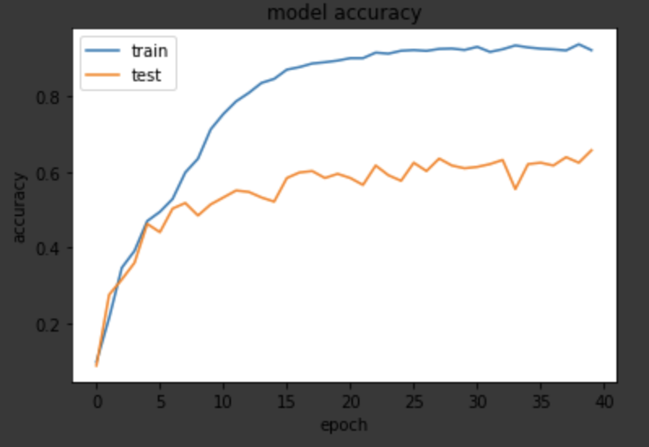
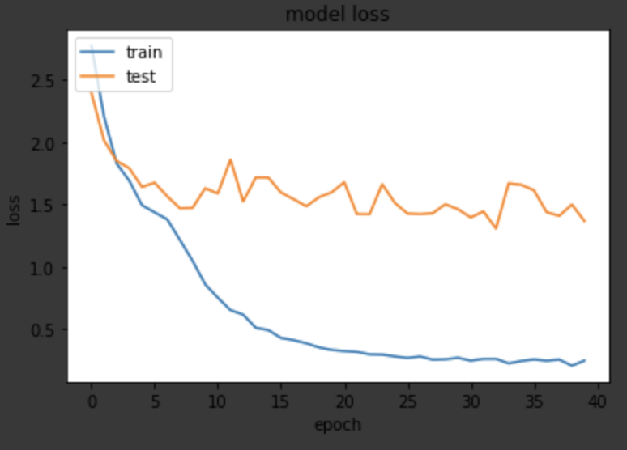
Epochs = 40
batch_size = 32
n_copies = 4
transform = T1
batch_normalization = True
Dropout = True
validation = 0.2
Epoch 1/40 - training: 100%|██████████| 4352/4352 [14:18<00:00, 5.07it/s, acc=0.1149, avg_loss=2.7276]
Epoch 1/40 - validation: 100%|██████████| 272/272 [03:04<00:00, 1.47it/s, acc=0.2059, avg_loss=2.2751]
Epoch 2/40 - training: 100%|██████████| 4352/4352 [01:12<00:00, 59.98it/s, acc=0.2240, avg_loss=2.1849]
Epoch 2/40 - validation: 100%|██████████| 272/272 [00:03<00:00, 89.78it/s, acc=0.2904, avg_loss=2.0068]
Epoch 3/40 - training: 100%|██████████| 4352/4352 [01:13<00:00, 59.42it/s, acc=0.2978, avg_loss=1.9624]
Epoch 3/40 - validation: 100%|██████████| 272/272 [00:02<00:00, 95.44it/s, acc=0.2684, avg_loss=2.0156]
Epoch 4/40 - training: 100%|██████████| 4352/4352 [01:13<00:00, 58.93it/s, acc=0.3787, avg_loss=1.7360]
Epoch 4/40 - validation: 100%|██████████| 272/272 [00:02<00:00, 95.44it/s, acc=0.4007, avg_loss=1.7036]
Epoch 5/40 - training: 100%|██████████| 4352/4352 [01:15<00:00, 57.77it/s, acc=0.4596, avg_loss=1.5554]
Epoch 5/40 - validation: 100%|██████████| 272/272 [00:02<00:00, 95.28it/s, acc=0.4375, avg_loss=1.5847]
Epoch 6/40 - training: 100%|██████████| 4352/4352 [01:11<00:00, 60.49it/s, acc=0.5471, avg_loss=1.3207]
Epoch 6/40 - validation: 100%|██████████| 272/272 [00:02<00:00, 91.11it/s, acc=0.5147, avg_loss=1.4524]
Epoch 7/40 - training: 100%|██████████| 4352/4352 [01:11<00:00, 60.65it/s, acc=0.6103, avg_loss=1.1447]
Epoch 7/40 - validation: 100%|██████████| 272/272 [00:02<00:00, 96.42it/s, acc=0.5551, avg_loss=1.3286]
Epoch 8/40 - training: 100%|██████████| 4352/4352 [01:11<00:00, 60.92it/s, acc=0.6824, avg_loss=0.9764]
Epoch 8/40 - validation: 100%|██████████| 272/272 [00:02<00:00, 95.76it/s, acc=0.5735, avg_loss=1.3132]
Epoch 9/40 - training: 100%|██████████| 4352/4352 [01:12<00:00, 60.37it/s, acc=0.7233, avg_loss=0.8773]
Epoch 9/40 - validation: 100%|██████████| 272/272 [00:02<00:00, 96.11it/s, acc=0.5809, avg_loss=1.5166]
Epoch 10/40 - training: 100%|██████████| 4352/4352 [01:11<00:00, 60.72it/s, acc=0.7672, avg_loss=0.7196]
Epoch 10/40 - validation: 100%|██████████| 272/272 [00:02<00:00, 96.22it/s, acc=0.5956, avg_loss=1.3807]
Epoch 11/40 - training: 100%|██████████| 4352/4352 [01:11<00:00, 60.66it/s, acc=0.8104, avg_loss=0.6106]
Epoch 11/40 - validation: 100%|██████████| 272/272 [00:02<00:00, 95.41it/s, acc=0.5993, avg_loss=1.2634]
Epoch 12/40 - training: 100%|██████████| 4352/4352 [01:11<00:00, 60.90it/s, acc=0.8366, avg_loss=0.5361]
Epoch 12/40 - validation: 100%|██████████| 272/272 [00:02<00:00, 95.06it/s, acc=0.6324, avg_loss=1.4201]
Epoch 13/40 - training: 100%|██████████| 4352/4352 [01:11<00:00, 60.47it/s, acc=0.8552, avg_loss=0.4765]
Epoch 13/40 - validation: 100%|██████████| 272/272 [00:02<00:00, 91.45it/s, acc=0.6176, avg_loss=1.6004]
Epoch 14/40 - training: 100%|██████████| 4352/4352 [01:11<00:00, 60.67it/s, acc=0.8605, avg_loss=0.4651]
Epoch 14/40 - validation: 100%|██████████| 272/272 [00:02<00:00, 96.00it/s, acc=0.6507, avg_loss=1.6263]
Epoch 15/40 - training: 100%|██████████| 4352/4352 [01:11<00:00, 60.82it/s, acc=0.8925, avg_loss=0.3764]
Epoch 15/40 - validation: 100%|██████████| 272/272 [00:02<00:00, 95.79it/s, acc=0.6838, avg_loss=1.4075]
Epoch 16/40 - training: 100%|██████████| 4352/4352 [01:11<00:00, 60.66it/s, acc=0.9005, avg_loss=0.3490]
Epoch 16/40 - validation: 100%|██████████| 272/272 [00:02<00:00, 96.19it/s, acc=0.6507, avg_loss=1.2971]
Epoch 17/40 - training: 100%|██████████| 4352/4352 [01:11<00:00, 60.87it/s, acc=0.9141, avg_loss=0.3158]
Epoch 17/40 - validation: 100%|██████████| 272/272 [00:02<00:00, 96.39it/s, acc=0.6691, avg_loss=1.4287]
Epoch 18/40 - training: 100%|██████████| 4352/4352 [01:11<00:00, 60.66it/s, acc=0.9085, avg_loss=0.3098]
Epoch 18/40 - validation: 100%|██████████| 272/272 [00:02<00:00, 95.41it/s, acc=0.6507, avg_loss=1.4587]
Epoch 19/40 - training: 100%|██████████| 4352/4352 [01:11<00:00, 60.93it/s, acc=0.9173, avg_loss=0.2952]
Epoch 19/40 - validation: 100%|██████████| 272/272 [00:02<00:00, 95.45it/s, acc=0.6544, avg_loss=1.4865]
Epoch 20/40 - training: 100%|██████████| 4352/4352 [01:11<00:00, 60.70it/s, acc=0.9012, avg_loss=0.3349]
Epoch 20/40 - validation: 100%|██████████| 272/272 [00:02<00:00, 96.11it/s, acc=0.6838, avg_loss=1.1365]
Epoch 21/40 - training: 100%|██████████| 4352/4352 [01:11<00:00, 60.85it/s, acc=0.9226, avg_loss=0.2847]
Epoch 21/40 - validation: 100%|██████████| 272/272 [00:02<00:00, 96.60it/s, acc=0.6691, avg_loss=1.3168]
Epoch 22/40 - training: 100%|██████████| 4352/4352 [01:11<00:00, 60.49it/s, acc=0.9235, avg_loss=0.2723]
Epoch 22/40 - validation: 100%|██████████| 272/272 [00:02<00:00, 96.06it/s, acc=0.7279, avg_loss=1.1765]
Epoch 23/40 - training: 100%|██████████| 4352/4352 [01:11<00:00, 60.63it/s, acc=0.9180, avg_loss=0.2928]
Epoch 23/40 - validation: 100%|██████████| 272/272 [00:02<00:00, 95.06it/s, acc=0.6507, avg_loss=1.3198]
Epoch 24/40 - training: 100%|██████████| 4352/4352 [01:10<00:00, 61.35it/s, acc=0.9157, avg_loss=0.2944]
Epoch 24/40 - validation: 100%|██████████| 272/272 [00:02<00:00, 97.79it/s, acc=0.6728, avg_loss=1.2150]
Epoch 25/40 - training: 100%|██████████| 4352/4352 [01:12<00:00, 59.95it/s, acc=0.9244, avg_loss=0.2601]
Epoch 25/40 - validation: 100%|██████████| 272/272 [00:02<00:00, 93.90it/s, acc=0.6875, avg_loss=1.2115]
Epoch 26/40 - training: 100%|██████████| 4352/4352 [01:12<00:00, 59.70it/s, acc=0.9235, avg_loss=0.2692]
Epoch 26/40 - validation: 100%|██████████| 272/272 [00:02<00:00, 94.99it/s, acc=0.6912, avg_loss=1.2709]
Epoch 27/40 - training: 100%|██████████| 4352/4352 [01:12<00:00, 59.99it/s, acc=0.9189, avg_loss=0.2760]
Epoch 27/40 - validation: 100%|██████████| 272/272 [00:02<00:00, 95.24it/s, acc=0.6544, avg_loss=1.2701]
Epoch 28/40 - training: 100%|██████████| 4352/4352 [01:12<00:00, 60.06it/s, acc=0.9258, avg_loss=0.2432]
Epoch 28/40 - validation: 100%|██████████| 272/272 [00:02<00:00, 94.64it/s, acc=0.7022, avg_loss=1.2573]
Epoch 29/40 - training: 100%|██████████| 4352/4352 [01:12<00:00, 60.22it/s, acc=0.9281, avg_loss=0.2459]
Epoch 29/40 - validation: 100%|██████████| 272/272 [00:02<00:00, 95.67it/s, acc=0.7279, avg_loss=1.1306]
Epoch 30/40 - training: 100%|██████████| 4352/4352 [01:13<00:00, 59.59it/s, acc=0.9352, avg_loss=0.2338]
Epoch 30/40 - validation: 100%|██████████| 272/272 [00:02<00:00, 95.16it/s, acc=0.7059, avg_loss=1.1120]
Epoch 31/40 - training: 100%|██████████| 4352/4352 [01:13<00:00, 59.48it/s, acc=0.9274, avg_loss=0.2420]
Epoch 31/40 - validation: 100%|██████████| 272/272 [00:02<00:00, 95.31it/s, acc=0.6875, avg_loss=1.2109]
Epoch 32/40 - training: 100%|██████████| 4352/4352 [01:12<00:00, 60.25it/s, acc=0.9295, avg_loss=0.2420]
Epoch 32/40 - validation: 100%|██████████| 272/272 [00:02<00:00, 95.59it/s, acc=0.6765, avg_loss=1.2216]
Epoch 33/40 - training: 100%|██████████| 4352/4352 [01:12<00:00, 60.34it/s, acc=0.9357, avg_loss=0.2188]
Epoch 33/40 - validation: 100%|██████████| 272/272 [00:02<00:00, 95.22it/s, acc=0.7390, avg_loss=1.1944]
Epoch 34/40 - training: 100%|██████████| 4352/4352 [01:12<00:00, 60.12it/s, acc=0.9377, avg_loss=0.2097]
Epoch 34/40 - validation: 100%|██████████| 272/272 [00:02<00:00, 95.06it/s, acc=0.6618, avg_loss=1.4798]
Epoch 35/40 - training: 100%|██████████| 4352/4352 [01:12<00:00, 60.25it/s, acc=0.9357, avg_loss=0.2209]
Epoch 35/40 - validation: 100%|██████████| 272/272 [00:02<00:00, 95.44it/s, acc=0.6581, avg_loss=1.2375]
Epoch 36/40 - training: 100%|██████████| 4352/4352 [01:11<00:00, 60.55it/s, acc=0.9446, avg_loss=0.1814]
Epoch 36/40 - validation: 100%|██████████| 272/272 [00:02<00:00, 94.07it/s, acc=0.6912, avg_loss=1.2164]
Epoch 37/40 - training: 100%|██████████| 4352/4352 [01:12<00:00, 60.31it/s, acc=0.9299, avg_loss=0.2285]
Epoch 37/40 - validation: 100%|██████████| 272/272 [00:02<00:00, 95.65it/s, acc=0.6912, avg_loss=1.2698]
Epoch 38/40 - training: 100%|██████████| 4352/4352 [01:12<00:00, 59.91it/s, acc=0.9416, avg_loss=0.1953]
Epoch 38/40 - validation: 100%|██████████| 272/272 [00:02<00:00, 95.27it/s, acc=0.6985, avg_loss=1.1110]
Epoch 39/40 - training: 100%|██████████| 4352/4352 [01:12<00:00, 60.32it/s, acc=0.9465, avg_loss=0.1880]
Epoch 39/40 - validation: 100%|██████████| 272/272 [00:02<00:00, 95.03it/s, acc=0.6985, avg_loss=1.1170]
Epoch 40/40 - training: 100%|██████████| 4352/4352 [01:11<00:00, 60.70it/s, acc=0.9458, avg_loss=0.1906]
Epoch 40/40 - validation: 100%|██████████| 272/272 [00:02<00:00, 95.34it/s, acc=0.6875, avg_loss=1.3309]
--- %s minutes --- 3673.4794886112213
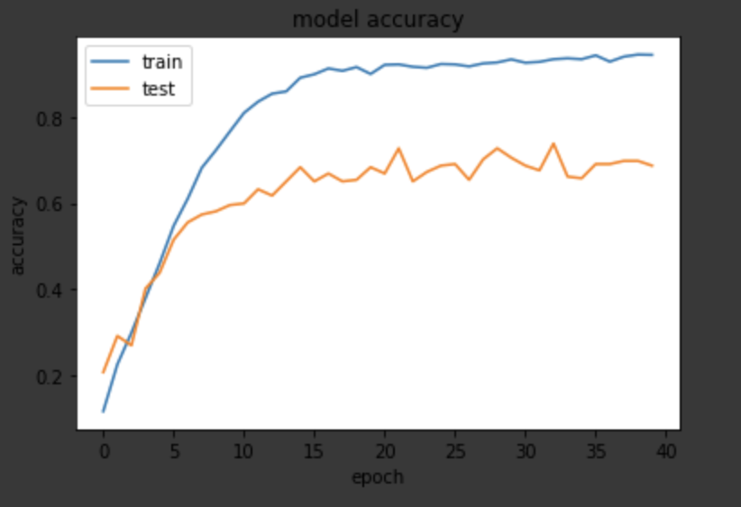
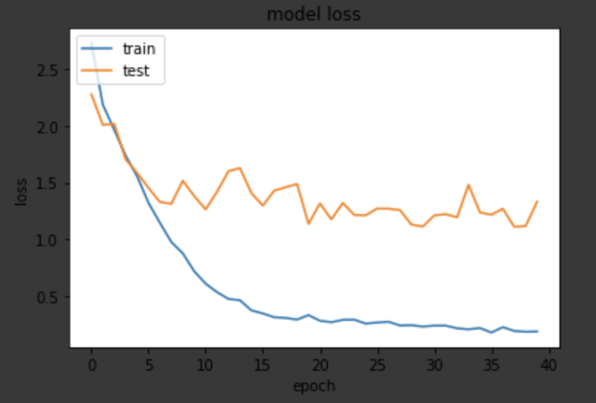

Epoch 1/35 - training: 100%|██████████| 5440/5440 [07:03<00:00, 12.83it/s, acc=0.0540, avg_loss=2.9316]
Epoch 1/35 - validation: 100%|██████████| 272/272 [01:21<00:00, 3.33it/s, acc=0.0404, avg_loss=2.8358]
Epoch 2/35 - training: 100%|██████████| 5440/5440 [01:47<00:00, 50.72it/s, acc=0.0987, avg_loss=2.6097]
Epoch 2/35 - validation: 100%|██████████| 272/272 [00:03<00:00, 88.77it/s, acc=0.1250, avg_loss=2.3625]
Epoch 3/35 - training: 100%|██████████| 5440/5440 [01:47<00:00, 50.72it/s, acc=0.2116, avg_loss=2.1598]
Epoch 3/35 - validation: 100%|██████████| 272/272 [00:03<00:00, 89.10it/s, acc=0.2684, avg_loss=1.9807]
Epoch 4/35 - training: 100%|██████████| 5440/5440 [01:47<00:00, 50.74it/s, acc=0.3645, avg_loss=1.7706]
Epoch 4/35 - validation: 100%|██████████| 272/272 [00:03<00:00, 89.20it/s, acc=0.3750, avg_loss=1.7236]
Epoch 5/35 - training: 100%|██████████| 5440/5440 [01:47<00:00, 50.55it/s, acc=0.4654, avg_loss=1.4794]
Epoch 5/35 - validation: 100%|██████████| 272/272 [00:03<00:00, 88.92it/s, acc=0.4596, avg_loss=1.5742]
Epoch 6/35 - training: 100%|██████████| 5440/5440 [01:47<00:00, 50.42it/s, acc=0.5897, avg_loss=1.1862]
Epoch 6/35 - validation: 100%|██████████| 272/272 [00:03<00:00, 87.45it/s, acc=0.4779, avg_loss=1.3866]
Epoch 7/35 - training: 100%|██████████| 5440/5440 [01:46<00:00, 50.85it/s, acc=0.6910, avg_loss=0.9181]
Epoch 7/35 - validation: 100%|██████████| 272/272 [00:02<00:00, 90.93it/s, acc=0.5404, avg_loss=1.4839]
Epoch 8/35 - training: 100%|██████████| 5440/5440 [01:47<00:00, 50.38it/s, acc=0.7605, avg_loss=0.7236]
Epoch 8/35 - validation: 100%|██████████| 272/272 [00:03<00:00, 87.92it/s, acc=0.5404, avg_loss=1.6360]
Epoch 9/35 - training: 100%|██████████| 5440/5440 [01:48<00:00, 50.28it/s, acc=0.8278, avg_loss=0.5455]
Epoch 9/35 - validation: 100%|██████████| 272/272 [00:03<00:00, 88.34it/s, acc=0.5882, avg_loss=1.5432]
Epoch 10/35 - training: 100%|██████████| 5440/5440 [01:47<00:00, 50.47it/s, acc=0.8570, avg_loss=0.4761]
Epoch 10/35 - validation: 100%|██████████| 272/272 [00:03<00:00, 83.55it/s, acc=0.5478, avg_loss=1.7567]
Epoch 11/35 - training: 100%|██████████| 5440/5440 [01:48<00:00, 50.31it/s, acc=0.8908, avg_loss=0.3753]
Epoch 11/35 - validation: 100%|██████████| 272/272 [00:03<00:00, 89.77it/s, acc=0.5882, avg_loss=1.5480]
Epoch 12/35 - training: 100%|██████████| 5440/5440 [01:48<00:00, 50.37it/s, acc=0.8971, avg_loss=0.3466]
Epoch 12/35 - validation: 100%|██████████| 272/272 [00:03<00:00, 88.13it/s, acc=0.5919, avg_loss=1.8330]
Epoch 13/35 - training: 100%|██████████| 5440/5440 [01:47<00:00, 50.38it/s, acc=0.9000, avg_loss=0.3317]
Epoch 13/35 - validation: 100%|██████████| 272/272 [00:03<00:00, 88.90it/s, acc=0.5699, avg_loss=1.7177]
Epoch 14/35 - training: 100%|██████████| 5440/5440 [01:46<00:00, 50.87it/s, acc=0.9123, avg_loss=0.2973]
Epoch 14/35 - validation: 100%|██████████| 272/272 [00:03<00:00, 84.60it/s, acc=0.5772, avg_loss=2.0754]
Epoch 15/35 - training: 100%|██████████| 5440/5440 [01:47<00:00, 50.79it/s, acc=0.9178, avg_loss=0.2662]
Epoch 15/35 - validation: 100%|██████████| 272/272 [00:03<00:00, 87.34it/s, acc=0.6397, avg_loss=1.4210]
Epoch 16/35 - training: 100%|██████████| 5440/5440 [01:47<00:00, 50.58it/s, acc=0.9215, avg_loss=0.2697]
Epoch 16/35 - validation: 100%|██████████| 272/272 [00:03<00:00, 89.37it/s, acc=0.6176, avg_loss=1.5527]
Epoch 17/35 - training: 100%|██████████| 5440/5440 [01:48<00:00, 50.34it/s, acc=0.9118, avg_loss=0.2765]
Epoch 17/35 - validation: 100%|██████████| 272/272 [00:03<00:00, 89.28it/s, acc=0.5662, avg_loss=1.7965]
Epoch 18/35 - training: 100%|██████████| 5440/5440 [01:46<00:00, 51.20it/s, acc=0.9267, avg_loss=0.2519]
Epoch 18/35 - validation: 100%|██████████| 272/272 [00:03<00:00, 89.46it/s, acc=0.5846, avg_loss=1.9212]
Epoch 19/35 - training: 100%|██████████| 5440/5440 [01:48<00:00, 50.01it/s, acc=0.9228, avg_loss=0.2632]
Epoch 19/35 - validation: 100%|██████████| 272/272 [00:03<00:00, 87.60it/s, acc=0.5919, avg_loss=1.6341]
Epoch 20/35 - training: 100%|██████████| 5440/5440 [01:48<00:00, 50.19it/s, acc=0.9346, avg_loss=0.2131]
Epoch 20/35 - validation: 100%|██████████| 272/272 [00:03<00:00, 87.70it/s, acc=0.5993, avg_loss=2.1772]
Epoch 21/35 - training: 100%|██████████| 5440/5440 [01:48<00:00, 50.33it/s, acc=0.9301, avg_loss=0.2403]
Epoch 21/35 - validation: 100%|██████████| 272/272 [00:03<00:00, 88.27it/s, acc=0.6324, avg_loss=1.4672]
Epoch 22/35 - training: 100%|██████████| 5440/5440 [01:48<00:00, 50.13it/s, acc=0.9268, avg_loss=0.2421]
Epoch 22/35 - validation: 100%|██████████| 272/272 [00:03<00:00, 88.56it/s, acc=0.6140, avg_loss=1.3470]
Epoch 23/35 - training: 100%|██████████| 5440/5440 [01:48<00:00, 50.16it/s, acc=0.9346, avg_loss=0.2214]
Epoch 23/35 - validation: 100%|██████████| 272/272 [00:03<00:00, 88.33it/s, acc=0.6250, avg_loss=1.4054]
Epoch 24/35 - training: 100%|██████████| 5440/5440 [01:48<00:00, 50.29it/s, acc=0.9379, avg_loss=0.2136]
Epoch 24/35 - validation: 100%|██████████| 272/272 [00:03<00:00, 83.78it/s, acc=0.6618, avg_loss=1.4817]
Epoch 25/35 - training: 100%|██████████| 5440/5440 [01:47<00:00, 50.56it/s, acc=0.9316, avg_loss=0.2198]
Epoch 25/35 - validation: 100%|██████████| 272/272 [00:03<00:00, 84.64it/s, acc=0.6140, avg_loss=1.5613]
Epoch 26/35 - training: 100%|██████████| 5440/5440 [01:48<00:00, 50.24it/s, acc=0.9417, avg_loss=0.1928]
Epoch 26/35 - validation: 100%|██████████| 272/272 [00:03<00:00, 88.94it/s, acc=0.5882, avg_loss=1.8467]
Epoch 27/35 - training: 100%|██████████| 5440/5440 [01:47<00:00, 50.41it/s, acc=0.9415, avg_loss=0.2021]
Epoch 27/35 - validation: 100%|██████████| 272/272 [00:03<00:00, 89.55it/s, acc=0.6434, avg_loss=1.4722]
Epoch 28/35 - training: 100%|██████████| 5440/5440 [01:47<00:00, 50.60it/s, acc=0.9393, avg_loss=0.2073]
Epoch 28/35 - validation: 100%|██████████| 272/272 [00:03<00:00, 88.71it/s, acc=0.5772, avg_loss=1.8753]
Epoch 29/35 - training: 100%|██████████| 5440/5440 [01:47<00:00, 50.48it/s, acc=0.9410, avg_loss=0.1978]
Epoch 29/35 - validation: 100%|██████████| 272/272 [00:03<00:00, 88.67it/s, acc=0.6066, avg_loss=1.7287]
Epoch 30/35 - training: 100%|██████████| 5440/5440 [01:47<00:00, 50.53it/s, acc=0.9381, avg_loss=0.2023]
Epoch 30/35 - validation: 100%|██████████| 272/272 [00:03<00:00, 89.06it/s, acc=0.6287, avg_loss=1.3498]
Epoch 31/35 - training: 100%|██████████| 5440/5440 [01:47<00:00, 50.38it/s, acc=0.9471, avg_loss=0.1786]
Epoch 31/35 - validation: 100%|██████████| 272/272 [00:03<00:00, 87.84it/s, acc=0.6544, avg_loss=1.3072]
Epoch 32/35 - training: 100%|██████████| 5440/5440 [01:48<00:00, 50.22it/s, acc=0.9445, avg_loss=0.1806]
Epoch 32/35 - validation: 100%|██████████| 272/272 [00:03<00:00, 88.39it/s, acc=0.6581, avg_loss=1.6899]
Epoch 33/35 - training: 100%|██████████| 5440/5440 [01:48<00:00, 49.99it/s, acc=0.9430, avg_loss=0.1931]
Epoch 33/35 - validation: 100%|██████████| 272/272 [00:03<00:00, 87.65it/s, acc=0.6618, avg_loss=1.2587]
Epoch 34/35 - training: 100%|██████████| 5440/5440 [01:47<00:00, 50.70it/s, acc=0.9460, avg_loss=0.1808]
Epoch 34/35 - validation: 100%|██████████| 272/272 [00:03<00:00, 89.63it/s, acc=0.6140, avg_loss=1.6941]
Epoch 35/35 - training: 100%|██████████| 5440/5440 [01:47<00:00, 50.70it/s, acc=0.9441, avg_loss=0.1843]
Epoch 35/35 - validation: 100%|██████████| 272/272 [00:03<00:00, 89.88it/s, acc=0.6581, avg_loss=1.3278]
--- %s minutes --- 4089.09162402153

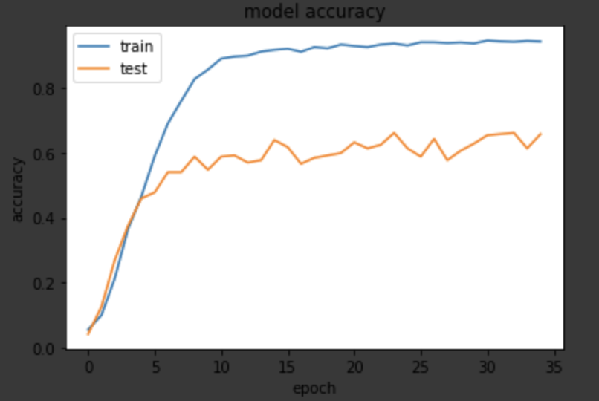
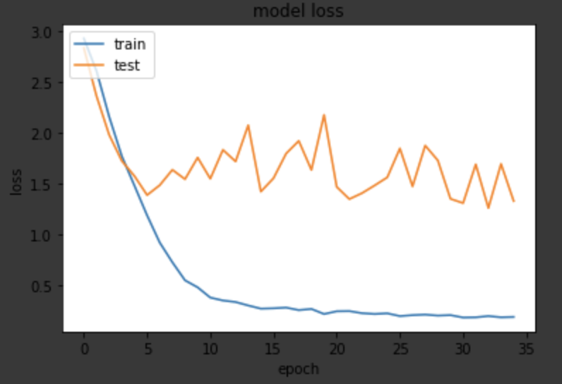
Epochs = 35
batch_size = 32
n_copies = 5
transform = T1
Dropout = True
batch_normalization = True
validation = 0.2

