CONVIVE · Iteration #2 delivery
Team 102_A (Convive Lab) · Mobile Data Challenge 2026, Challenge #2 · Delivery Sun 8 Nov 2026 · Demo Mon 9 Nov 2026 · Draft v0.1: dates and open items to be confirmed by the team

1. What we committed and what we deliver
WBS | Deliverable | Owner | Due | Status | Actual date | File
3.1.0 | Data reception under NDA, inventory | Sergi Cases Alonso | 29/10 | Done | TBD | 3.1.0_data_inventory.md
2.1.1 | Geographic aggregation definition | Ander Barnadas Mendizabal | 02/11 | Done | TBD | 2.1.1_geographic_levels.csv
2.1.2 | Temporal aggregation definition | Devanshi Shroff | 02/11 | Done | TBD | 2.1.2_temporal_levels.md
4.1.3 | Visualisation environment selection | Martí Casas Niubó | 02/11 | Done | TBD | 4.1.3_VisualisationEnvironment.md
4.1.1 | Dashboard layout and navigation | Martí Casas Niubó | 02/11 | Done | TBD | 4.1.1_dashboard_layout.md
3.1.1 | Data loading and initial inspection | Pau Borrell Bullich | 30/10 | Done | TBD | 3.1.1_inspection_summary.md
3.2.0 | Research questions and topics list | Sergi Cases Alonso | 03/11 | Done | TBD | 3.2.0_ResearchQuestions.md
3.1.7 | Switch from synthetic to real data | Pau Borrell Bullich | 04/11 | Done | TBD | CONVIVE_Iteration2.ipynb (repo root)
3.1.2 | Data quality assessment | Ander Barnadas Mendizabal | 06/11 | Done | TBD | 3.1.2_data_quality_report.md
3.1.6 | Preliminary descriptive statistics | Ander Barnadas Mendizabal | 06/11 | Done | TBD | 3.1.6_summary.md
4.2.0 | Preliminary dashboard, general statistics and filters | Pau Borrell Bullich | 08/11 | Done | TBD | 4.2.0_dashboard_notes.md
3.1.3 | Data cleaning and transformation | Pau Borrell Bullich | 09/11 | Done | TBD | 3.1.3_cleaning_log.md
4.2.1 | Interactive maps (first version) | Martí Casas Niubó | 09/11 | Done | TBD | 4.2.1_map_visitors.html

2. The three items the professor asked for
Environment (4.1.3). Streamlit, run locally. We compared it with Jupyter + Plotly + ipywidgets and Power BI Desktop on the 6 PWP criteria. It is NDA-safe, reuses our Python code, and costs 0 EUR. It also follows the request to "keep it simple".
Research questions (3.2.0). 15 questions built from common beliefs about tourists in Barcelona, each with a dataset, metric, chart and limitation. Q1 to Q6 are in the dashboard, and Q7 to Q15 go to Iteration 3.
Preliminary dashboard (4.2.0, with the first version of 4.2.1). It has sidebar filters (year, month range, visitor origin, visitor type) and answers six questions, above the five required by SC-13. It reads only the aggregated tables of 3.1.6 and the neighbourhood map, and it runs on localhost. Start it with: streamlit run app/dashboard.py.
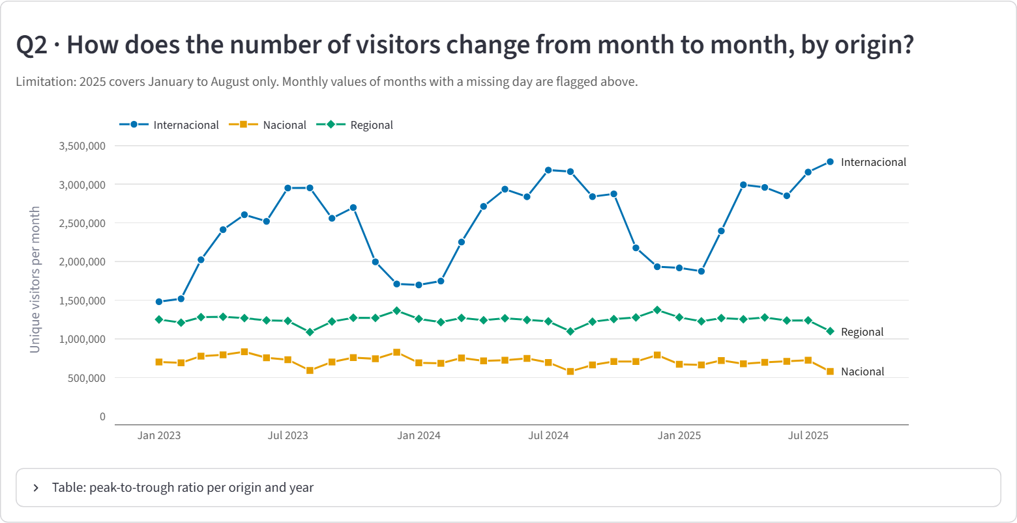
Q2: monthly unique visitors by origin (aggregated, threshold 15).
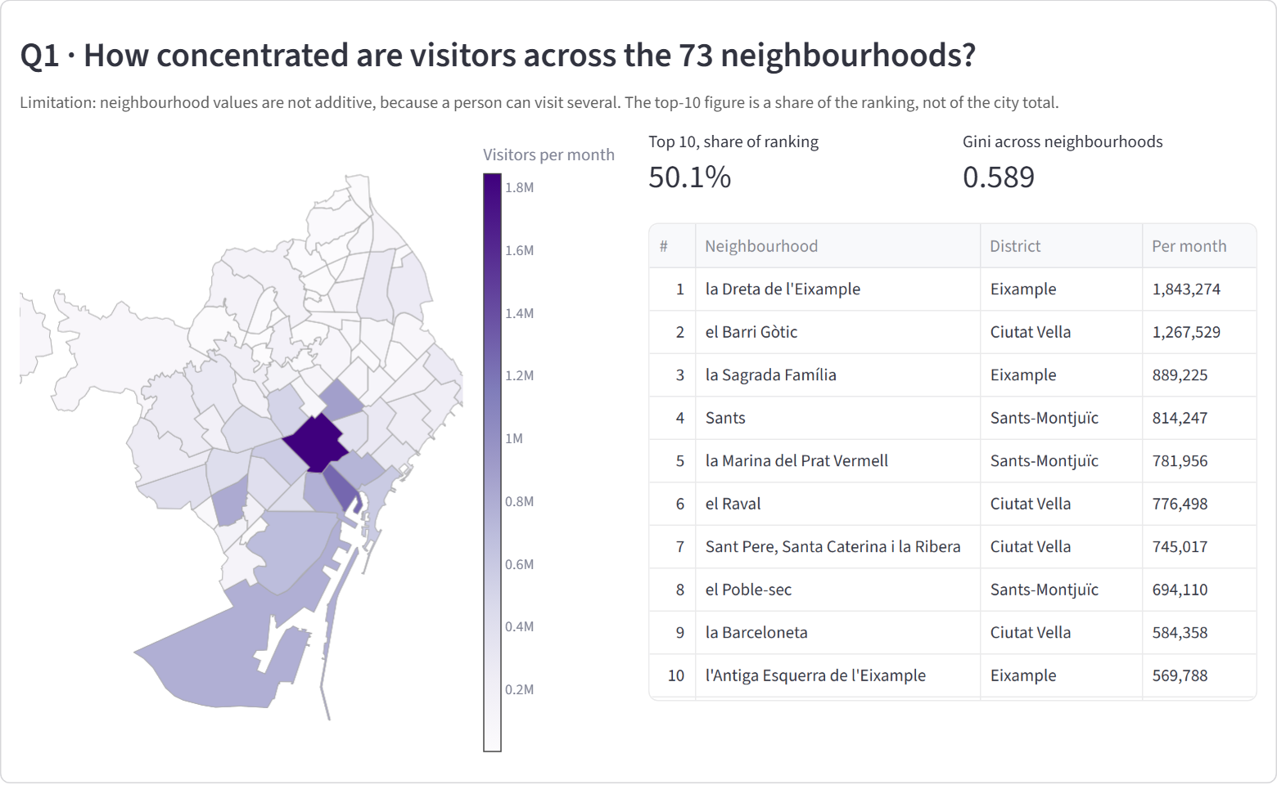
Q1: neighbourhood map, top-10 table and concentration measures.
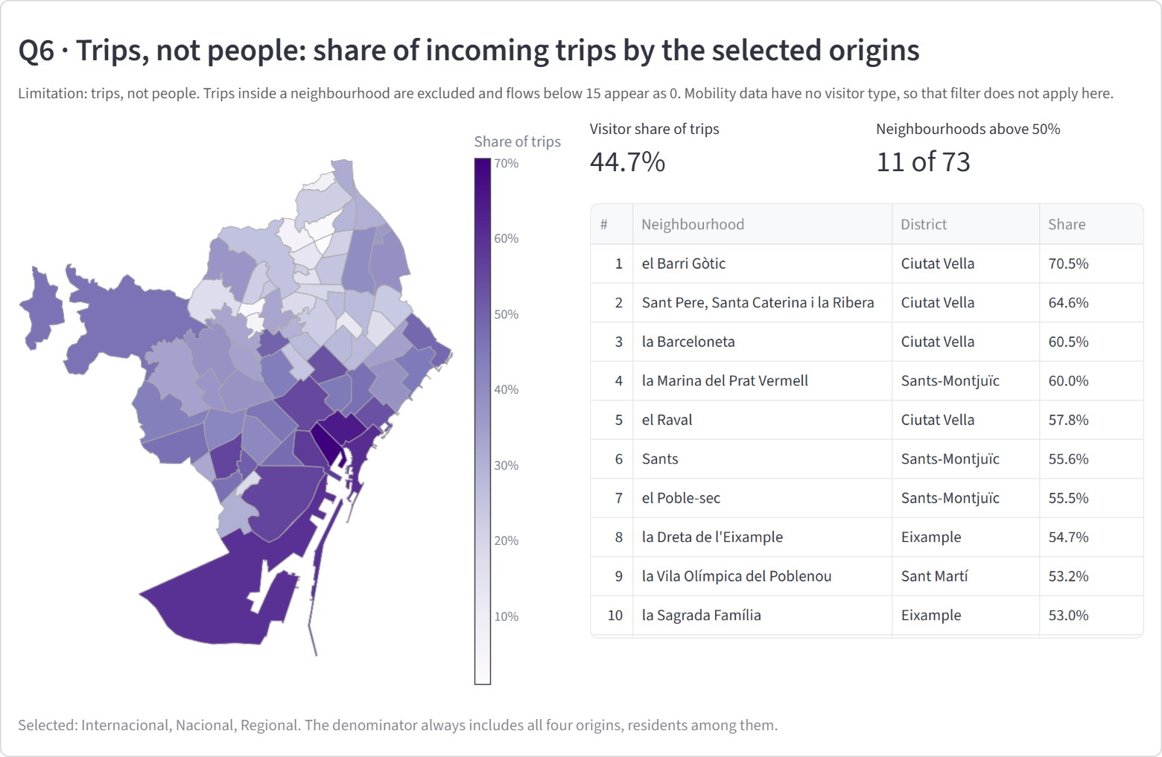
Q6: share of incoming trips by visitors. Trips, not people.

3. The data work behind them
- Reception and loading (3.1.0, 3.1.1). All 12 datasets are complete: 384 monthly files out of 384, 15.3 GB and 168,811,386 rows. Monthly CSVs are converted once to Parquet with DuckDB.
- Geographic levels (2.1.1). The Iteration 1 code rule matched only 6 of 73 neighbourhoods, because Smart Steps numbers neighbourhoods inside each district and uses 9 digits. The corrected correspondence matches all 73, confirmed by rule and by name (73 of 73).
- Temporal levels (2.1.2). Day, weekday and weekend, ISO week, month, year and January to August comparison periods. Three days are missing in all daily files (2024-02-11, 2025-04-13, 2025-05-20), and their months are flagged.
- Quality (3.1.2). Checks S1 to S4, C1 to C4 and X1 to X3 ran on all the data. 42.5% of M1 rows are published zeros (fewer than 15 trips). 43.7% of M3 rows repeat a key, usually with different values, so M3 stays out of Q1 to Q6 until the mentor clarifies it. X1 fails in 29 of 11,622 cells, all in Verdun and la Teixonera, whose tourism counts are far below the median neighbourhood. T9 has no international visitors, although the description lists them.
- Cleaning (3.1.3). Duplicates are checked, categories harmonised, the code correspondence applied and incomplete periods flagged. NA stays NA, a published 0 stays 0, and nothing is imputed. One deviation from the plan: M3 repeats are flagged and not dropped, because dropping them could remove real trips.
- Statistics and switch to real data (3.1.6, 3.1.7). 9 aggregated tables were produced for the dashboard and Iteration 3, with values below 15 shown as <15. CONVIVE_Iteration2.ipynb runs end to end on the real data, and the synthetic mode of Iteration 1 still works.

4. First answers to Q1 to Q6
These describe patterns, not causes. Numbers come from 3.1.6_summary.md.
Q1. How concentrated are visitors across the 73 neighbourhoods? In the median month, the 10 highest neighbourhoods hold 50.2% of the neighbourhood ranking (range 46.2% to 55.2% over 32 months). 10 of 73 is 13.7% of the neighbourhoods. The median Gini across neighbourhoods is 0.590. The highest monthly averages are la Dreta de l'Eixample (1,843,274), el Barri Gòtic (1,267,529), la Sagrada Família (889,225); the lowest is Verdun (986, an unusually low value flagged in 3.1.2). Median top-10 share by origin: Internacional 62.1%, Nacional 47.6%, Regional 38.0%. Limitation: Neighbourhood values are not additive: a person visiting two neighbourhoods counts in both, so this is a share of the ranking, not of the city total.
Q2. How much do visitors change from month to month, by origin? Peak-to-trough ratio of monthly unique visitors: 1.44 in 2023 (peak July 2023, low February 2023) and 1.40 in 2024 (peak July 2024, low January 2024). June to August average is 1.13 and 1.14 times the other months of 2023 and 2024. Ratio by origin in 2024: Internacional 1.87; Nacional 1.37; Regional 1.25. Limitation: 2025 covers January to August only, so it has no full-year ratio. Monthly values of months with a missing day are flagged.
Q3. What share of monthly visitors is international, national or regional, tourist or excursionist? Share of the average month's unique visitors: Internacional 55.8% (range 43.1% to 66.2%), Regional 28.1%, Nacional 16.1%. Tourists are 34.7% and excursionists 65.3%. International tourists alone are 28.6%. Limitation: Regional visitors are always excursionists by definition, which raises the excursionist share.
Q4. Are daily visitors higher at weekends than on weekdays, and for which origins? Mean daily unique visitors are 497,841 on weekend days and 539,023 on weekdays (-7.6%). Weekend difference by origin: Internacional +0.3%; Nacional -14.4%; Regional -13.0%. Highest day by origin: Internacional Friday; Nacional Thursday; Regional Friday. Limitation: Means per day over 971 days; daily values cannot be summed into weekly totals, and 3 days are missing.
Q5. Did visitors grow between equivalent periods (January to August)? Mean monthly unique visitors, January to August: 4,276,902 in 2023, 4,494,996 in 2024 and 4,598,167 in 2025 (+5.1% and +2.3%). From 2023 to 2025 by origin: Internacional +16.1%; Nacional -7.3%; Regional +0.3%. Of 73 neighbourhoods, 53 show a higher value and 20 a lower one in 2025 than in 2023. Limitation: Only the 8 equivalent months are compared, and February 2024, April 2025 and May 2025 each miss one day. Change over two intervals cannot show a long-term trend.
Q6. What share of incoming trips is made by visitors, and by residents? Visitors make 44.7% of published trips between neighbourhoods (bound 44.5% to 47.1%, treating each published 0 as 0 to 14 trips). Visitors make more than half of incoming trips in 11 of 73 neighbourhoods (bound 10 to 21). Highest: el Barri Gòtic (70.5%), Sant Pere, Santa Caterina i la Ribera (64.6%), la Barceloneta (60.5%). Lowest: Verdun (0.9%), la Teixonera (2.5%) (both flagged in 3.1.2). Limitation: Trips, not people. Trips inside the same neighbourhood are excluded, and flows below 15 appear as 0, which hides more visitor flows than resident flows. The bound covers published zeros only; routes with no row in the file are not covered.

5. Pending items, limitations and next iteration
- Pending: the team fills in the actual dates; the professor reviews the question list before the demo (3.2.0); the mentor is asked about M3 repeated keys, the two low neighbourhoods and T9 international visitors.
- Limitations: trips and unique visitors stay separate; unique visitors are not additive; a 0 or NA never means nobody; published zeros make trip totals lower estimates. The visitor-type filter cannot apply to the trips view, because M1 has no visitor type.
- Next iteration (Iteration 3, 10 to 23 Nov): WBS 2.2.x, the exploratory, geographic and temporal analysis (3.2.1 to 3.2.3) for Q7 to Q15, and 4.2.2 and 4.2.3.

