ENHANCE FEASIBILITY STUDY

SOCIAL MEDIA ADVERTISING MATERIALS

Version: 1.0
Date: 20.10.2025
IRAS: 33426

═════════════════════════════════════════════════════

NOTICE
These are example templates submitted for REC approval. Actual social media posts may be adapted for specific contexts, platforms, and local communities whilst maintaining the core messaging, information, and compliance requirements approved herein.
Source: The following have been adapted from the A5 Recruitment Poster previously approved by REC (V1.0 02.12.24, IRAS:33426).

═════════════════════════════════════════════════════

SECTION 1: FACEBOOK POST EXAMPLE

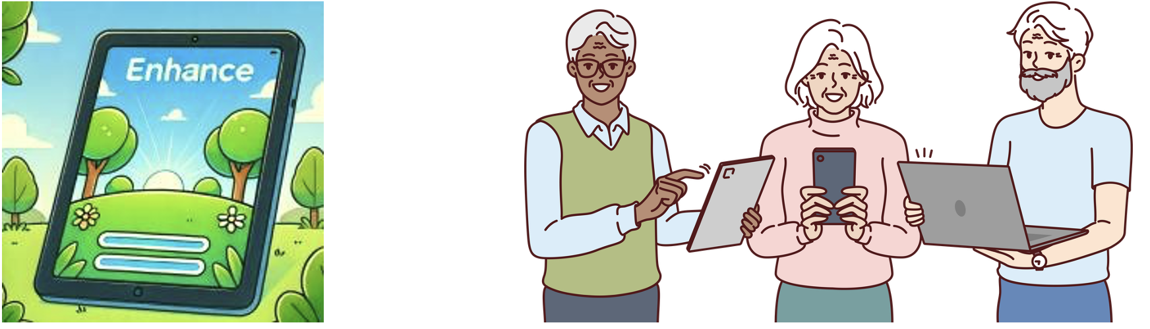
━━━━━━━━━━━━━━━━━━━━━━━━━━━━━━━━━━━━━━━━━

📱 Interested in Brain Health? Join the ENHANCE Study! 🧠

Want to keep your brain healthy? If you’re aged 60–80, you can take part in a UCL study on how small lifestyle changes can help brain health.
✨ What’s Involved
✅ Free health check and personalised brain health advice
✅ 3-month study focused on simple, healthy habits
✅ Some participants receive:
• A tablet with a brain health app + internet access
• One-to-one support from a personal coach
💷 You’ll get shopping vouchers for your time, and travel costs are covered
⏱️ Study length: 3 months
📍 Where: [Adapt for local area]
💪 What You’ll Do
If your results show a few areas to work on, you’ll learn which daily habits can make a difference and get friendly coaching and easy tools to help you build new, healthy routines.
⚠️ There may be no direct benefit to you from taking part.

🔗 Find Out If You Can Join (takes about 5 minutes)
[SCREENING FORM URL]
[QR CODE]

📞 Questions?
📧 Email: enhance@ucl.ac.uk
☎️ Phone: [Local contact number]
📱 Text 'ENHANCE' to [Local text number]
🌐 [Study website]

━━━━━━━━━━━━━━━━━━━━━━━━━━━━━━━━━━━━━━━━━

Funded by the National Institute for Health Research (NIHR)

#ENHANCEstudy #BrainHealth #HealthyAgeing #ResearchStudy #UCL #NHS #NIHR #ClinicalTrial #DementiaResearch #CognitiveHealth #HealthyLiving

━━━━━━━━━━━━━━━━━━━━━━━━━━━━━━━━━━━━━━━━━

SECTION 2: WHATSAPP/SMS POST EXAMPLE

━━━━━━━━━━━━━━━━━━━━━━━━━━━━━━━━━━━━━━━━━

🧠 ENHANCE Brain Health Study 🧠

Aged 60–80? Help us learn how small lifestyle changes can keep the brain healthy.
✅ Free health check & advice
✅ Some get tablet + app + coach during study
💷 Thank-you vouchers + travel costs covered

📋 Check if you can join (5 mins):
[SCREENING FORM URL]

📞 Questions?
enhance@ucl.ac.uk
[Phone number]

UCL research funded by NIHR
[Study website]

━━━━━━━━━━━━━━━━━━━━━━━━━━━━━━━━━━━━━━━━━

SECTION 3: WEB LANDING PAGE EXAMPLE

━━━━━━━━━━━━━━━━━━━━━━━━━━━━━━━━━━━━━━━━━

ENHANCE BRAIN HEALTH STUDY
Helping People Aged 60–80 Keep Their Brains Healthy

━━━━━━━━━━━━━━━━━━━━━━━━━━━━━━━━━━━━━━━━━

ABOUT THE STUDY
The ENHANCE study is testing whether a simple lifestyle programme can help people aged 60–80 keep their brains healthy as they get older.
The study is run by researchers at North London NHS Foundation Trust and University College London (UCL) and funded by the National Institute for Health and Care Research (NIHR).
Everyday things like activity, diet, hearing, mood, and social contact can affect brain health. We are testing whether using a tablet app together with support from a coach can help people make small, positive changes that fit into daily life.

━━━━━━━━━━━━━━━━━━━━━━━━━━━━━━━━━━━━━━━━━

WHAT'S INVOLVED
🏥 FREE Health Check: You'll get a health check looking at daily habits related to brain health.

📱 Personalised Advice” Everyone receives clear advice on simple steps that may help to keep the brain healthy.

🎲 Extra Support for some participants
Two-thirds of people taking part are chosen by chance to get:
- A tablet with the ENHANCE brain health app
- Internet access for the study period
- One-to-one support from a personal coach

📊 Vouchers and travel. You will receive shopping vouchers for your time, and we cover reasonable travel costs.
⏱️ Length of study. About 3 months. We check in with you at the end to see how you are getting on.

💪 What you’ll do
If your results suggest a few areas to work on, you’ll learn which daily habits can make a difference to your brain health and get friendly coaching and simple tools to help you build new, healthy routines. These can include:
- Being more active in ways that suit you
- Eating a bit healthier
- Looking after hearing and mood
- Staying socially connected

⚠️ Important to know

This is a research study. You may not benefit directly, but your participation will help us learn how to better support brain health in the future.

WHO CAN TAKE PART?
You may be able to join if you:
- Are aged 60–80
- Are registered with a participating GP practice, or heard about us at an event, NHS clinic, or online
- Meet a few simple criteria linked to brain health (we will check these with you)
Not everyone will be suitable. The best way to find out is to complete our short form.
━━━━━━━━━━━━━━━━━━━━━━━━━━━━━━━━━━━━━━━━━

📋 CHECK IF YOU CAN JOIN

Fill in our quick online form (takes about 5 minutes):

[LARGE BUTTON: START SCREENING FORM]
[SCREENING FORM URL]

[QR CODE]
Or scan the QR code to open the form on your phone

💬 Don’t like forms?
That’s absolutely fine — just give us a call on [telephone number] ☎️, and we’ll go through the questions together in a friendly chat.

━━━━━━━━━━━━━━━━━━━━━━━━━━━━━━━━━━━━━━━━━

WANT TO KNOW MORE?

📄 Read the Full Participant Information Sheet [LINK TO PIS] This document gives you complete details about the study, what's involved, possible risks and benefits, and your rights as a participant.

❓ Frequently Asked Questions [LINK TO FAQ PAGE - when available – We’ll add more answers as we learn what potential participants usually ask us.]

━━━━━━━━━━━━━━━━━━━━━━━━━━━━━━━━━━━━━━━━━

CONTACT US
We’re happy to answer any questions you may have.

📧 Email: enhance@ucl.ac.uk

☎️ Phone: [Study phone number]
Available: [Office hours]

📱 Text: Send 'ENHANCE' to [Text number]

🌐 Website: [Study website URL]

✉️ Post:
ENHANCE Study Team
Division of Psychiatry
University College London
[Full postal address]

━━━━━━━━━━━━━━━━━━━━━━━━━━━━━━━━━━━━━━━━━

ABOUT OUR RESEARCH TEAM

The ENHANCE study is led by Professor Sergi Costafreda Gonzalez and colleagues at UCL’s Division of Psychiatry and other universities and NHS trusts across the country. Our team has long experience studying how lifestyle can support healthy ageing and brain health. ENHANCE is funded by NIHR and run in partnership with local GP practices and NHS services across [regions].

━━━━━━━━━━━━━━━━━━━━━━━━━━━━━━━━━━━━━━━━━

Study Information:
IRAS ID: 33426
Version: 1.0
Dated: 20.10.2025

━━━━━━━━━━━━━━━━━━━━━━━━━━━━━━━━━━━━━━━━━

NOTES FOR IMPLEMENTATION

1. IMAGES: All images referenced in this document (ENHANCE logo, tablet illustration, three people illustration, organisational logos) are available from the REC-approved A5 leaflet (V1.0 02.12.24, IRAS:33426).

2. CUSTOMISATION: Specific contact details (phone numbers, text numbers, local area names) should be customised for each deployment context.

3. SCREENING FORM: All materials link to the ENHANCE Screening Form (separate REC submission document).

4. QR CODES: QR codes will be generated to link directly to the screening form URL.

5. PLATFORM ADAPTATION: These templates may be adapted for specific social media platforms (e.g., Facebook, Instagram, Twitter/X, Nextdoor, local community groups) whilst maintaining approved messaging.

6. ACCESSIBILITY: Web landing page will be designed to meet accessibility standards.

7. BRANDING: Consistent use of ENHANCE visual identity and organisational logos as shown in approved materials.

═════════════════════════════════════════════════════

END OF DOCUMENT

═════════════════════════════════════════════════════

