Analyzing the NYC Subway Dataset

Questions

Overview

This project consists of two parts. In Part 1 of the project, you should have completed the questions in Problem Sets 2, 3, and 4 in the Introduction to Data Science course.

This document addresses part 2 of the project. Please use this document as a template and answer the following questions to explain your reasoning and conclusion behind your work in the problem sets. You will attach a document with your answers to these questions as part of your final project submission.

**Section 0. References**

Please include a list of references you have used for this project. Please be specific - for example, instead of including a general website such as stackoverflow.com, try to include a specific topic from Stackoverflow that you have found useful.

Answer:

<http://pandas.pydata.org/pandas-docs/stable/>

<https://github.com/ivanov/vim-ipython#id2>

<http://goo.gl/HBbvyy>

[http://docs.python.org/2/library/datetime.html](http://docs.python.org/2/library/datetime.html#datetime.datetime.strptime)

<http://statsmodels.sourceforge.net/0.5.0/generated/statsmodels.regression.linear_model.OLS.html>

<http://scikit-learn.org/0.14/modules/generated/sklearn.linear_model.LinearRegression.html>

<http://docs.scipy.org/doc/scipy/reference/generated/scipy.stats.mannwhitneyu.html>

<http://pandas.pydata.org/pandas-docs/stable/visualization.html#histograms>

<http://scikit-learn.org/0.14/modules/generated/sklearn.linear_model.SGDRegressor.html>

<http://ggplot.yhathq.com/docs/index.html>

<https://pypi.python.org/pypi/ggplot/>

<http://en.wikipedia.org/wiki/Mann%E2%80%93Whitney_U_test>

<http://en.wikipedia.org/wiki/Student%27s_t-test>

<http://www.statsdirect.com/help/default.htm#nonparametric_methods/mann_whitney.htm>

<https://statistics.laerd.com/premium-sample/mwut/mann-whitney-test-in-spss-2.php>

**Section 1. Statistical Test**

* 1. Which statistical test did you use to analyze the NYC subway data? Did you use a one-tail or a two-tail P value? What is the null hypothesis? What is your p-critical value?

Answer:

Statistical test: Mann-Whitney U test

Two-tail P value

Null hypothesis: average numbers of entries per hour are the same on rainy or non-rainy days.

Two tailed p critical: p = 0.05

* 1. Why is this statistical test applicable to the dataset? In particular, consider the assumptions that the test is making about the distribution of ridership in the two samples.

Answer:

According to histogram of ENTRIESn_hourly, data are not normally distributed. There are enough observations to guarantee normality of the mean according to CLT. However t-test assumption is that the observations are drawn from the normal distribution. Therefore using t-test may produce wrong results in our case. Therefore we use Mann-Whitney U test that doesn’t require the normality of the distributions.

Mann-Whitney U test is valid if the following assumptions are satisfied:

* Observations are independent of each other inside groups and between groups.
* Two groups have the same shape of the distribution. This is true according to histograms of ENTRIESn_hour on rainy days and non-rainy days.
* Dependent variable is continuous or ordinal. In our case we can assume ENTRIESn_hour is continuous.
  1. What results did you get from this statistical test? These should include the following numerical values: p-values, as well as the means for each of the two samples under test.

Answer:

Two tailed p value: p = 0.0498

Mean with rain: 1105.44

Mean without rain: 1090.27

* 1. What is the significance and interpretation of these results?

Answer:

Given significance level of 5% the results are statistically significant and the average usage of subway on rainy days statistically differs from the usage on non-rainy days.

**Section 2. Linear Regression**

2.1 What approach did you use to compute the coefficients theta and produce prediction for ENTRIESn_hourly in your regression model:

1. OLS using Statsmodels or Scikit Learn
2. Gradient descent using Scikit Learn
3. Or something different?

Answer: OLS and Gradient descent.

2.2 What features (input variables) did you use in your model? Did you use any dummy variables as part of your features?

Answer: Hour, minute, day_of_week

Dummy variables to represent UNIT were used

2.3 Why did you select these features in your model? We are looking for specific reasons that lead you to believe that the selected features will contribute to the predictive power of your model.

* Your reasons might be based on intuition. For example, response for fog might be: “I decided to use fog because I thought that when it is very foggy outside people might decide to use the subway more often.”
* Your reasons might also be based on data exploration and experimentation, for example: “I used feature X because as soon as I included it in my model, it drastically improved my R2 value.”

Answer: Hour, minute, day_of_week and dummy variables for UNIT appear to be statistically significant in predicting the ridership. Other existing variables in the dataset are not statistically significant. This can be seen in two ways. Firstly, inclusion of Hour, minute, day_of_week and dummy variables into the model improves R2 in the first to third digits of accuracy, while inclusion of any other variable does not. Secondly, the statistical model produces p-values for every predictor. It can be seen that only for the Hour, minute, day_of_week and dummy variables this p-value is less than 0.05 significance level and we can conclude they are significant.

2.4 What are the parameters (also known as "coefficients" or "weights") of the non-dummy features in your linear regression model?

Answer:

Intercept: 1147.48

Hour: 65.49

Day of Week: -84.36005743

Minute: -11.26721228

2.5 What is your model’s R2 (coefficients of determination) value?

Answer: 0.4868

2.6 What does this R2 value mean for the goodness of fit for your regression model? Do you think this linear model to predict ridership is appropriate for this dataset, given this R2value?

Answer: R2 tells us that only 48.68% of ridership is explained by the selected predictors (Hour, minute, day_of_week and UNIT). One thought to improve the model is to split a dataset by stations and apply the linear model for each station, if we have enough observations for each station. Or we could group stations into similar clusters before application of the mode. This would reduce the dimensionality of data and we could get a better fit. We could also use higher-order predictors, for example Hour^2, Hour^3, because the number of entries dependency on the hour of the day is non-linear.

**Section 3. Visualization**

Please include two visualizations that show the relationships between two or more variables in the NYC subway data.

Remember to add appropriate titles and axes labels to your plots. Also, please add a short description below each figure commenting on the key insights depicted in the figure.

3.1 One visualization should contain two histograms: one of  ENTRIESn_hourly for rainy days and one of ENTRIESn_hourly for non-rainy days.

* You can combine the two histograms in a single plot or you can use two separate plots.
* If you decide to use to two separate plots for the two histograms, please ensure that the x-axis limits for both of the plots are identical. It is much easier to compare the two in that case.
* For the histograms, you should have intervals representing the volume of ridership (value of ENTRIESn_hourly) on the x-axis and the frequency of occurrence on the y-axis. For example, each interval (along the x-axis), the height of the bar for this interval will represent the number of records (rows in our data) that have ENTRIESn_hourly that falls in this interval.
* Remember to increase the number of bins in the histogram (by having larger number of bars). The default bin width is not sufficient to capture the variability in the two samples.

Answer:

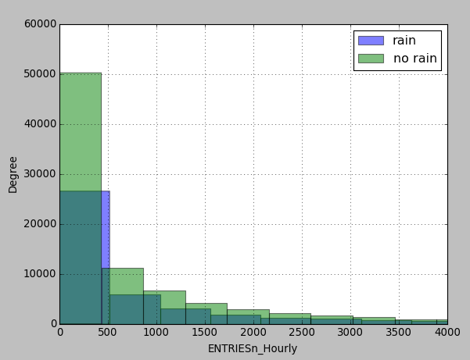

3.2 One visualization can be more freeform. You should feel free to implement something that we discussed in class (e.g., scatter plots, line plots) or attempt to implement something more advanced if you'd like. Some suggestions are:

* Ridership by time-of-day
* Ridership by day-of-week

**Section 4. Conclusion**

*Please address the following questions in detail. Your answers should be 1-2 paragraphs long.*

4.1 From your analysis and interpretation of the data, do more people ride  
the NYC subway when it is raining or when it is not raining?

4.2 What analyses lead you to this conclusion? You should use results from both your statistical

tests and your linear regression to support your analysis.

**Section 5. Reflection**

*Please address the following questions in detail. Your answers should be 1-2 paragraphs long.*

5.1 Please discuss potential shortcomings of the methods of your analysis, including:

1. Dataset,
2. Analysis, such as the linear regression model or statistical test.

5.2 (Optional) Do you have any other insight about the dataset that you would like to share with us?