The classical vibrationally adiabatic potential curve is defined as:
(1)
being ω_{i} the corresponding vibrational frequencies of the geometry s. The corresponding vibrationally adiabatic transmission coefficient can be calculated, under the Wentzel–Kramers–Brillouin (WKB) approximation, as:
(2)
where the approximation is valid at low temperatures. Additionally, the recrossing factor can be also estimated:
(3)
being the barrier from the reactant to the transition state, and to the maximum of the adiabatic potential (the transition state may not be a maximum on the adiabatic potential...). The value of the tunneling probability for a given potential E is defined by:
(4)
where s< and s> are the values of the path coordinate at the left and right turning points, and is the effective reduced mass along s. If is taken constant along the reaction path, we obtain the Zero-curvature theory (ZCT). On the other hand, the centrifugal-dominant small-curvature tunneling approximation allows to express the dependence of :
(5)
where a(s) and t(s) (the maximum concave-side vibrational displacement along the curvature direction) are:
(6)
being the magnitude of the curvature, and the reaction path curvature components:
(7)
In this expression, L_{i}(s) corresponds to the ith eigenvector of the hessian H, and g is the gradient vector (all in mass-weight coordinates: ). Thus, the B_{i}(s) values represent the change in the direction of the ith eigenvector induced by the variation of the reaction coordinate.

For the particle in a box, the tunneling effect arises from the presence of a finite potential of the shape:

The Schrödinger time-independent equation is solved for each region, thus obtaining three wave-functions, satisfying the continuity at each region, as well as in the first derivatives:

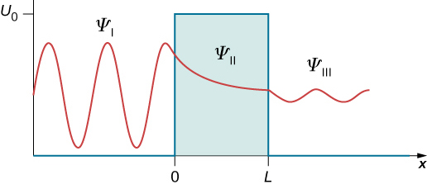

The transmission coefficient represents the probability flux of the transmitted wave relative to that of the incident wave. Using the WKB approximation, one can obtain a tunneling coefficient that looks like (which depends on the particular system):

where x₁, x₂ are the two classical turning points for the potential barrier.

A description of the Variational Transition-State theory can be found at J.Phys.Chem. 1980 (84) 1730-1748

Equations 49, 50 from J.Phys.Chem. 1980 (84) 1730-1748
Equations 44, 45 from J.Phys.Chem. 1992 (96) 5758-5772; or 1a from J.Am.Chem.Soc. 2002 (124) 3093-3124
Equations 52, 51, 50, 44 from Comput. Phys. Commun. 1992 (71) 235-262; and 3 from J.Am.Chem.Soc. 2002 (124) 3093-3124
See chapter 8 of “Introduction to Quantumn Mechanics” (ISBN: 0-13-191175-9)

