The classical vibrationally adiabatic potential curve is defined as:
(1)
being ∆V_{MEP} the potential energy relative to reactants, and ω_{i} the corresponding vibrational frequencies of the geometry s. The corresponding vibrationally adiabatic transmission coefficient can be calculated, under the Wentzel–Kramers–Brillouin (WKB) approximation, as:
(2)
where the approximation is valid at low temperatures. The value of the tunneling probability for a given adiabatic potential E is defined by:
(3)
where s< and s> are the values of the path coordinate at the left and right turning points (values of the reaction coordinate with a value for the adiabatic potential of E), and is the effective reduced mass along s. If is taken constant along the reaction path (equal to 1), we obtain the Zero-curvature theory (ZCT). On the other hand, the centrifugal-dominant small-curvature tunneling approximation allows to express the dependence of :
(4)
where the exponential only is evaluated if the exponent is negative, and a(s) and τ(s) (the maximum concave-side vibrational displacement along the curvature direction) are defined as follows:
(5)
being the magnitude of the curvature, and the reaction path curvature components:
(6)
In this expression, L_{i}(s) corresponds to the ith eigenvector of the hessian H, and g is the gradient vector (all in mass-weight coordinates: ). Thus, the B_{i}(s) values represent the change in the direction of the ith eigenvector induced by the variation of the reaction coordinate.

For the particle in a box, the tunneling effect arises from the presence of a finite potential of the shape:

The Schrödinger time-independent equation is solved for each region, thus obtaining three wave-functions, satisfying the continuity at each region, as well as in the first derivatives:

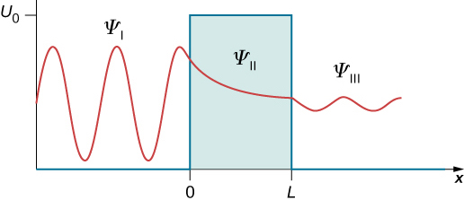

The transmission coefficient represents the probability flux of the transmitted wave relative to that of the incident wave. Using the WKB approximation, one can obtain a tunneling coefficient that looks like (which depends on the particular system):

where x₁, x₂ are the two classical turning points for the potential barrier.

A description of the Variational Transition-State theory can be found at J.Phys.Chem. 1980 (84) 1730-1748
See also J.Am.Chem.Soc. 1993 (115) 2408-2415 for SCT.

Equations 49, 50 from J.Phys.Chem. 1980 (84) 1730-1748
Equations 44, 45 from J.Phys.Chem. 1992 (96) 5758-5772; or 1a from J.Am.Chem.Soc. 2002 (124) 3093-3124
Equations 44, 50, 51, 52 from Comput. Phys. Commun. 1992 (71) 235-262; and 3 from J.Am.Chem.Soc. 2002 (124) 3093-3124
See chapter 8 of “Introduction to Quantumn Mechanics” (ISBN: 0-13-191175-9)

