A Dynamic Web Application that Implements and Analyzes Static and Dynamic Security with Pipeline Implementation

Sérgio Oliveira
StudantID: 23170981
Cloud DevOpsSec, MSc in Cloud Computing
National College of Ireland Dublin, IRELAND
x23170981@student.ncirl.ie. www.ncirl.ie
Deployed Application URL: https://mini-erp-network-load-balance-bac4aa0fb93bafdd.elb.eu-west-1.amazonaws.com:8080

Abstract— This project offering a comprehensive overview of implementations of the dynamic web application by using a completely automated lifecycle. It discusses several approaches to building, deploying, monitoring, maintaining, optimizing, and securitizing of solution and is covered under the three umbrellas of the Continuous Integration, Continuous Delivery and Continuous Deployment – CI/CD/CD.
The proposed solution is using Spring Boot – Java and is containerized through AWS Elastic Container Service - ECS. Its complete infrastructure is provisioned and orchestrated using Infrastructure as Code - IaC through Terraform. It generally integrates wide range of securitizing tools SAST - Static Application Security Testing and DAST - Dynamic Application Security Testing test methodologies to ensure full automated, high quality, and secure lifecycle.
The application itself is orchestrated by AWS – Amazon Web Services native solutions which handles the processes of building, testing and deploying of the Docker image. This is done using DevSecOps practices and identification of artifacts such are SonarQube and ZAP where the SAST and DAST is applied.
The goal is to ensure that the deviations either in vulnerabilities or high-spread quality malleability are always recognized and treated in the shortest possible time so that no deviations reaching production ever jeopardize the quality of the lifecycle.
The presented pipeline validates that the application development in the public cloud can be not only secure, but also comprehensive and fully automated while reaching high quality standards from the long term application perspective.
Keywords—Continuous Integration (CI), Continuous Delivery (CD), Continuous Deployment (CD), DevOpsSec, Analysis Static and Dynamic

Introduction
The software industry is undergoing a process of constant evolution and modernization, facilitating the daily lives of individuals. Cloud computing stands out for promoting mobility and flexibility for users, enabling access to analytical, storage, and processing resources remotely via the internet. In addition to mobility, cloud-hosted software excels in terms of cost, eliminating the need for investments in local services and infrastructure, including maintenance.
However, as systems become more flexible with respect to mobility, vulnerabilities emerge, challenging the security and integrity of data. In this context, information security can no longer be treated as an isolated phase in the development cycle. For this reason it is essential to integrate security practices that actively contribute to the protection of the application.
This work presents the implementation of an automated pipeline that incorporates security practices into the development cycle, aligned with the principles of DevOpsSec. In order to validate and demonstrate the effectiveness of the methodology discussed herein, the object of study of this work refers to a simple inventory management application, operating functionalities for the creation, reading, updating, and deletion of products persisted in a database. The methods that were assigned to this project are straightforward to reflect an ideal test case for evaluating the security and automation practices implemented throughout the pipeline.
To present this proposal clearly, the structure of this project details the implementation of the pipeline, addressing the services utilized in Sec. II. A critical analysis of the adopted security practices, including the integration of static and dynamic code analysis tools and the adjustments made within the model, is presented in Sec. III. In Sec. IV, the conclusions drawn based on the approach utilized are discussed. Finally, the references used are presented in Sec. V.

Automation of Infrastructure Deployment and Provisioning
The primary objectives achieved in the implementation of the infrastructure were to automate the entire application lifecycle, which involves the building of the source code and its provisioning up to deployment in a production environment. This approach focuses on eliminating unnecessary human interventions, thereby emphasizing the reduction of human errors beyond creating an organization of the flow of construction, testing and delivery for each change in the repository. With this in mind, it is possible to ensure the consistency, traceability, and reproducibility of each delivery.
To this end, the pipeline was designed by integrating various tools and services that constitute the concept of a stage. These include compilation, execution of automated tests, code quality analysis, and deploy. In this manner, the pipeline becomes a significant mechanism wherein all subsystems can perform their activities in an automated and monitorable fashion, ensuring auditability of the process and transparency during the development stage.
Subsequently, subsection II.A. Architecture and Overview of the Workflow presents the overall structure of the pipeline, highlighting the main services, including the execution flow among them and the diagram that illustrates the sequence of the automated stages.

Architecture and Overview of the Workflow
Identify applicable funding agency here. If none, delete this text box.
The pipeline’s architecture is designed to orchestrate the process of building, validating, and deploying the application in an automated, trackable, and reproducibility-aligned way, based on the best practices of contemporary DevOps procedures. In this case, the solution is based on native services provided by Amazon Web Services, where AWS CodePipeline takes the central orchestrator role in orchestrating the entire CI/CD workflow.
The pipeline is constructed in a modularly manner consists of five major stages – Source, Build, Test, Deploy, Monitoring. Each of the stages is responsible for a specific area in the automation process and is executed in a controlled and sequenced way, ensuring that any change in the code is subject to a standard, trackable process.
Automation is triggered when GitHub notices that there has been a change in the repository and CodePipeline is initiated to carry out the entire workflow. During the following stages, the application is built, validated, and deployed in a controlled environment utilizing services such as CodeBuild and ECS for container orchestration and supplemental quality observability and security tools, such as CloudWatch, and SonarQube.
The interaction of services creates a highly responsive, scalable, and traceable Continuous Delivery/Integration environment that tracks each execution and allows for the reproduction of the entire end-to-end process. By combining versioning, build automation, quality validation, and continuous deployment, the deployment is ensured to be reliable and standardized across the development lifecycle.
The proposed architecture is characterized in Figure 2, a schematic diagram showing the flow in the pipeline and the relations between the main components and services of AWS.
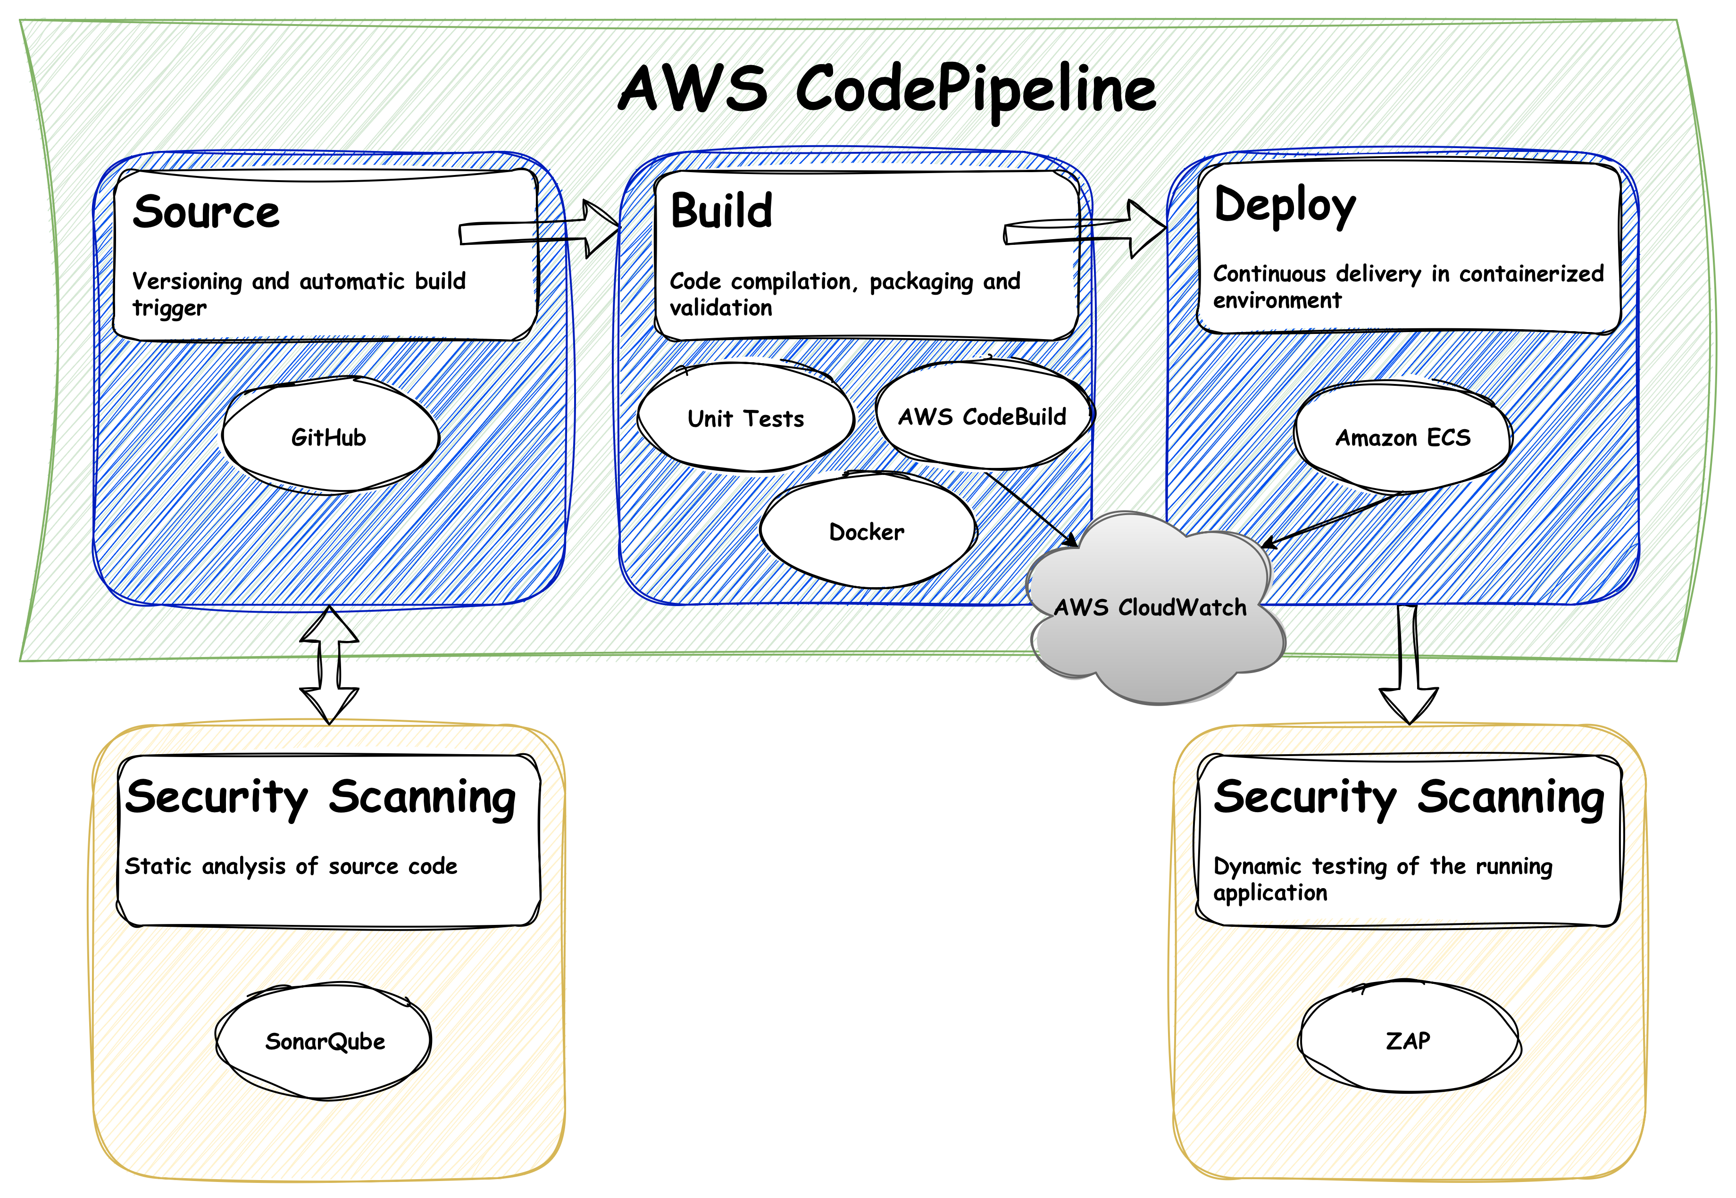
Figure 2. Schematic diagram of the CI/CD pipeline, representing the flow between the main AWS services and auxiliary tools.
The diagram demonstrates a flow from the submission of code in the repository, through the integration and compilation of the application, including quality assessment and automated deployment, thus demonstrating an architecture aligned with the principles of automation and delivery, CI and CD.

Prepare Your Paper Before Styling
Before you begin to format your paper, first write and save the content as a separate text file. Complete all content and organizational editing before formatting. Please note sections A-D below for more information on proofreading, spelling and grammar.
Keep your text and graphic files separate until after the text has been formatted and styled. Do not use hard tabs, and limit use of hard returns to only one return at the end of a paragraph. Do not add any kind of pagination anywhere in the paper. Do not number text heads-the template will do that for you.

Abbreviations and Acronyms
Define abbreviations and acronyms the first time they are used in the text, even after they have been defined in the abstract. Abbreviations such as IEEE, SI, MKS, CGS, sc, dc, and rms do not have to be defined. Do not use abbreviations in the title or heads unless they are unavoidable.

Units
- Use either SI (MKS) or CGS as primary units. (SI units are encouraged.) English units may be used as secondary units (in parentheses). An exception would be the use of English units as identifiers in trade, such as “3.5-inch disk drive”.
- Avoid combining SI and CGS units, such as current in amperes and magnetic field in oersteds. This often leads to confusion because equations do not balance dimensionally. If you must use mixed units, clearly state the units for each quantity that you use in an equation.
- Do not mix complete spellings and abbreviations of units: “Wb/m2” or “webers per square meter”, not “webers/m2”. Spell out units when they appear in text: “. . . a few henries”, not “. . . a few H”.
- Use a zero before decimal points: “0.25”, not “.25”. Use “cm3”, not “cc”. (bullet list)

Equations
The equations are an exception to the prescribed specifications of this template. You will need to determine whether or not your equation should be typed using either the Times New Roman or the Symbol font (please no other font). To create multileveled equations, it may be necessary to treat the equation as a graphic and insert it into the text after your paper is styled.
Number equations consecutively. Equation numbers, within parentheses, are to position flush right, as in (1), using a right tab stop. To make your equations more compact, you may use the solidus ( / ), the exp function, or appropriate exponents. Italicize Roman symbols for quantities and variables, but not Greek symbols. Use a long dash rather than a hyphen for a minus sign. Punctuate equations with commas or periods when they are part of a sentence, as in:
a  b    
Note that the equation is centered using a center tab stop. Be sure that the symbols in your equation have been defined before or immediately following the equation. Use “(1)”, not “Eq. (1)” or “equation (1)”, except at the beginning of a sentence: “Equation (1) is . . .”

Some Common Mistakes
- The word “data” is plural, not singular.
- The subscript for the permeability of vacuum μ₀, and other common scientific constants, is zero with subscript formatting, not a lowercase letter “o”.
- In American English, commas, semicolons, periods, question and exclamation marks are located within quotation marks only when a complete thought or name is cited, such as a title or full quotation. When quotation marks are used, instead of a bold or italic typeface, to highlight a word or phrase, punctuation should appear outside of the quotation marks. A parenthetical phrase or statement at the end of a sentence is punctuated outside of the closing parenthesis (like this). (A parenthetical sentence is punctuated within the parentheses.)
- A graph within a graph is an “inset”, not an “insert”. The word alternatively is preferred to the word “alternately” (unless you really mean something that alternates).
- Do not use the word “essentially” to mean “approximately” or “effectively”.
- In your paper title, if the words “that uses” can accurately replace the word “using”, capitalize the “u”; if not, keep using lower-cased.
- Be aware of the different meanings of the homophones “affect” and “effect”, “complement” and “compliment”, “discreet” and “discrete”, “principal” and “principle”.
- Do not confuse “imply” and “infer”.
- The prefix “non” is not a word; it should be joined to the word it modifies, usually without a hyphen.
- There is no period after the “et” in the Latin abbreviation “et al.”.
- The abbreviation “i.e.” means “that is”, and the abbreviation “e.g.” means “for example”.
An excellent style manual for science writers is [7].

Using the Template
After the text edit has been completed, the paper is ready for the template. Duplicate the template file by using the Save As command, and use the naming convention prescribed by your conference for the name of your paper. In this newly created file, highlight all of the contents and import your prepared text file. You are now ready to style your paper; use the scroll down window on the left of the MS Word Formatting toolbar.

Authors and Affiliations
The template is designed for, but not limited to, six authors. A minimum of one author is required for all conference articles. Author names should be listed starting from left to right and then moving down to the next line. This is the author sequence that will be used in future citations and by indexing services. Names should not be listed in columns nor group by affiliation. Please keep your affiliations as succinct as possible (for example, do not differentiate among departments of the same organization).

For papers with more than six authors: Add author names horizontally, moving to a third row if needed for more than 8 authors.

For papers with less than six authors: To change the default, adjust the template as follows.

Selection: Highlight all author and affiliation lines.

Change number of columns: Select the Columns icon from the MS Word Standard toolbar and then select the correct number of columns from the selection palette.

Deletion: Delete the author and affiliation lines for the extra authors.

Identify the Headings
Headings, or heads, are organizational devices that guide the reader through your paper. There are two types: component heads and text heads.
Component heads identify the different components of your paper and are not topically subordinate to each other. Examples include Acknowledgments and References and, for these, the correct style to use is “Heading 5”. Use “figure caption” for your Figure captions, and “table head” for your table title. Run-in heads, such as “Abstract”, will require you to apply a style (in this case, italic) in addition to the style provided by the drop down menu to differentiate the head from the text.
Text heads organize the topics on a relational, hierarchical basis. For example, the paper title is the primary text head because all subsequent material relates and elaborates on this one topic. If there are two or more sub-topics, the next level head (uppercase Roman numerals) should be used and, conversely, if there are not at least two sub-topics, then no subheads should be introduced. Styles named “Heading 1”, “Heading 2”, “Heading 3”, and “Heading 4” are prescribed.

Figures and Tables

Positioning Figures and Tables: Place figures and tables at the top and bottom of columns. Avoid placing them in the middle of columns. Large figures and tables may span across both columns. Figure captions should be below the figures; table heads should appear above the tables. Insert figures and tables after they are cited in the text. Use the abbreviation “Fig. 1”, even at the beginning of a sentence.
- Table Type Styles
Table Head | Table Column Head
 | Table column subhead | Subhead | Subhead
copy | More table copyª
- Sample of a Table footnote. (Table footnote)
- Example of a figure caption. (figure caption)
Figure Labels: Use 8 point Times New Roman for Figure labels. Use words rather than symbols or abbreviations when writing Figure axis labels to avoid confusing the reader. As an example, write the quantity “Magnetization”, or “Magnetization, M”, not just “M”. If including units in the label, present them within parentheses. Do not label axes only with units. In the example, write “Magnetization (A/m)” or “Magnetization {A[m(1)]}”, not just “A/m”. Do not label axes with a ratio of quantities and units. For example, write “Temperature (K)”, not “Temperature/K”.

Acknowledgment (Heading 5)
The preferred spelling of the word “acknowledgment” in America is without an “e” after the “g”. Avoid the stilted expression “one of us (R. B. G.) thanks ...”. Instead, try “R. B. G. thanks...”. Put sponsor acknowledgments in the unnumbered footnote on the first page.

References
The template will number citations consecutively within brackets [1]. The sentence punctuation follows the bracket [2]. Refer simply to the reference number, as in [3]—do not use “Ref. [3]” or “reference [3]” except at the beginning of a sentence: “Reference [3] was the first ...”
Number footnotes separately in superscripts. Place the actual footnote at the bottom of the column in which it was cited. Do not put footnotes in the abstract or reference list. Use letters for table footnotes.
Unless there are six authors or more give all authors’ names; do not use “et al.”. Papers that have not been published, even if they have been submitted for publication, should be cited as “unpublished” [4]. Papers that have been accepted for publication should be cited as “in press” [5]. Capitalize only the first word in a paper title, except for proper nouns and element symbols.
For papers published in translation journals, please give the English citation first, followed by the original foreign-language citation [6].

- G. Eason, B. Noble, and I. N. Sneddon, “On certain integrals of Lipschitz-Hankel type involving products of Bessel functions,” Phil. Trans. Roy. Soc. London, vol. A247, pp. 529–551, April 1955. (references)
- J. Clerk Maxwell, A Treatise on Electricity and Magnetism, 3rd ed., vol. 2. Oxford: Clarendon, 1892, pp.68–73.
- I. S. Jacobs and C. P. Bean, “Fine particles, thin films and exchange anisotropy,” in Magnetism, vol. III, G. T. Rado and H. Suhl, Eds. New York: Academic, 1963, pp. 271–350.
- K. Elissa, “Title of paper if known,” unpublished.
- R. Nicole, “Title of paper with only first word capitalized,” J. Name Stand. Abbrev., in press.
- Y. Yorozu, M. Hirano, K. Oka, and Y. Tagawa, “Electron spectroscopy studies on magneto-optical media and plastic substrate interface,” IEEE Transl. J. Magn. Japan, vol. 2, pp. 740–741, August 1987 [Digests 9th Annual Conf. Magnetics Japan, p. 301, 1982].
- M. Young, The Technical Writer’s Handbook. Mill Valley, CA: University Science, 1989.
- K. Eves and J. Valasek, “Adaptive control for singularly perturbed systems examples,” Code Ocean, Aug. 2023. [Online]. Available: https://codeocean.com/capsule/4989235/tree
- D. P. Kingma and M. Welling, “Auto-encoding variational Bayes,” 2013, arXiv:1312.6114. [Online]. Available: https://arxiv.org/abs/1312.6114
- S. Liu, “Wi-Fi Energy Detection Testbed (12MTC),” 2023, gitHub repository. [Online]. Available: https://github.com/liustone99/Wi-Fi-Energy-Detection-Testbed-12MTC
- “Treatment episode data set: discharges (TEDS-D): concatenated, 2006 to 2009.” U.S. Department of Health and Human Services, Substance Abuse and Mental Health Services Administration, Office of Applied Studies, August, 2013, DOI:10.3886/ICPSR30122.v2
IEEE conference templates contain guidance text for composing and formatting conference papers. Please ensure that all template text is removed from your conference paper prior to submission to the conference. Failure to remove template text from your paper may result in your paper not being published.

