|  |
| --- |
| Jugador |
| -int soles |

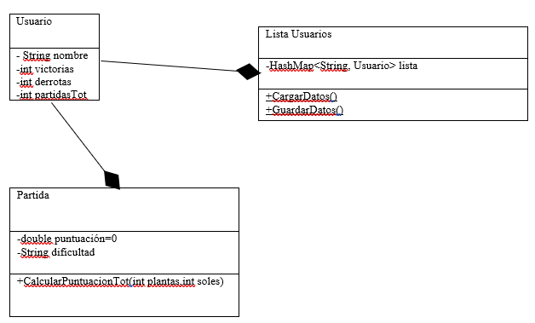

|  |
| --- |
| ZombieComun |
| -JLable zombieComunImg |

|  |
| --- |
| ZombieGrandullon |
| -JLabel zombieDeportistaImg |

|  |
| --- |
| <<abstract>>  Personaje |
| -int resistencia  -int daño  -int rango  -int contador |
| + muerto():boolean  + atacar(Personaje)  +abstract crearImagen(int i,int j):JLabel  +abstract getImagen():JLabel |

|  |
| --- |
| <<abstract>>  Zombie |
| -int frecuenciaMov |

|  |
| --- |
| ZombiePistolero |
| -JLable zombiePistoleroImg |

|  |
| --- |
| ZombieDeportista |
| -JLabel zombieDeportistaImg |

|  |
| --- |
| ZombieCaraCubo |
| -JLabel zombieCaraCuboImg |

|  |
| --- |
| <<abstract>>  Planta |
| -int coste  -int frecuencia |

|  |
| --- |
| Girasol |
| -int solesGenerado  -JLabel girasolImg |

|  |
| --- |
| FrutaEstrella |
| -JLabel frutaEstrellaImg |

|  |
| --- |
| ColBoxeadora |
| -JLabel colBoxeadoralImg |

|  |
| --- |
| Nuez |
| -JLabel nuezImg |

|  |
| --- |
| Petacereza |
| -JLabel petacerezaImg |

|  |
| --- |
| LanzaGuisantes |
| -JLabel lanzaguisantesImg |

|  |
| --- |
| <<extend>> |

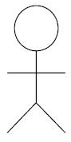

|  |
| --- |
| <<include>> |

|  |
| --- |
| <<extend>> |

|  |
| --- |
| <<extend>> |

|  |
| --- |
| <<include>> |

|  |
| --- |
| <<include>> |

|  |
| --- |
| <<extend>> |

|  |
| --- |
| <<extend>> |



|  |
| --- |
| <<extend>> |

|  |
| --- |
| <<extend>> |

|  |
| --- |
| <<extend>> |

|  |
| --- |
| <<include>> |

|  |
| --- |
| <<extend>> |

|  |
| --- |
| <<include>> |

|  |
| --- |
| <<extend>> |

|  |
| --- |
| <<extend>> |



|  |
| --- |
| <<extend>> |

|  |
| --- |
| <<include>> |

|  |
| --- |
| <<extend>> |

|  |
| --- |
| <<include>> |

|  |
| --- |
| <<include>> |

|  |
| --- |
| <<extend>> |

|  |
| --- |
| <<include>> |

|  |
| --- |
| <<extend>> |

|  |
| --- |
| <<include>> |

|  |
| --- |
| <<extend>> |

|  |
| --- |
| <<include>> |

|  |
| --- |
| <<extend>> |