Apple

# Introduction

Apple is perhaps the ultimate definition of a company that has positioned itself as a metric of quality within the niche it operates in, and this prominence associated with Apple narrows down to its mission and vision statements. In fact, Apple has grown as the driving force of innovation for over 20 years now, ever since it was founded by Steve Jobs, Steve Wozniak and Ronald Wayne in 1976.

Today, it is seen as the single source of revolution in designs of personal computers among other software transformations. Ideally, the vision statement of a company details what it is all about with a focus on specified range of products and quality for its customers.

The apple logo suffered changes threw history, it was first based on the scientific revolution being Issac Newton the center theme.

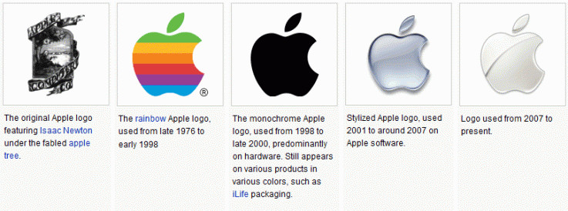

The last symbol was considered has a genius decision of Steve Jobs when the company was going threw a financial crisis, simplifying by removing the colors and giving it a new look, clean and simple.

# Mission

Apple mission statement is “ to bringing the best user experience to its customers through its innovative hardware, software, and services. ” In this current mission statement, the company highlights the scope of its operations and how it exploits these to satisfy the needs of its client base. While focusing on the dynamic technological changes over time, Apple stays clear that impacting positive change through innovation is its central objective. The following components arise from this mission statement.

* **Improving the lives of people**. In the first component of its mission statement, Apple reiterates the duty of the company to stimulate ease in the lives of its users through simplified and user-friendly technology. The recognition of the vulnerabilities in the online space has particularly pushed the company to link this component with the demand for security features that improve the user’s experience. While doing so, the company has broadened the services its customers can enjoy as shown in its education, business and healthcare reach.
* **Empowerment of the public.** The approach adopted by Apple in meeting this element of its mission statement shows that the company considers its products to be more than mere tools of entertainment. They are instead a source of empowerment, and this explains the extensive presence of apple at work. In fact, this emerges as a major source of innovation motivation for the company
* **Top-quality products.** The popularity associated with Apple products is evidence of how far the company goes to fulfill the third component of its mission statement. Most importantly, one rule remains unbent in this company, and that is providing the customers with the best quality products.

# Vision

Apple vision statement is “We believe that we are on the face of the earth to make great products and that’s not changing. “ It gives a detailed account of how the company approaches its operations to position itself as the dominant player in the sector it operates in. Some of the components associated with this statement include:

1. Innovations
2. Integration of partners and excellence
3. Market specialization

The first component shows that Apple is all about technological innovations. It does this by stimulating its employees with the best innovative resources that are also client-focused. To achieve this, Apple believes in the power of collaboration in such a competitive era to stay ahead of the rest. It also promotes this by specially targeting its resources in areas where it can have maximum quality impacts.

# Core Values

Apple core values include “inclusion and diversity, education, accessibility, environment, supplier responsibility and privacy.” Values reveal the aspects that Apple considers integral to its overall success as a technological and innovation leader. Apple is critical about the principles that have seen it model itself as a quality-oriented company in over two decades. To stay true to these standards, the company ensures that all its operations are in line with each of these values as highlighted in its statement of core values.

**Apple’s slogan is:** Think different

# Company culture

In order to apply for a job ate Apple you only have a one shot opportunity, there is allot of peer pressure forcing employees to be in shape and well groomed. They take serious to protect their trademark and proprietary valuable information, working at apple is a lifestyle because work comes first and competition is a big thing.

Apple selects the best, has a liberal working environment always with the purpose of innovation and bringing the best product to the customer.